**A STUDY ON EMPLOYEE MOTIVATION OF LA HOSPIN HOTELS AND RESORTS PVT LTD RAJAHMUNDRY, A.P, INDIA**

**Ghantasala Hemanth Rakesh, MBA 2nd year**

Email ID : hemanthrakesh144@gmail.com

And

Mr.K.Vinod varma, *MBA ,PGDTA,M.Phil,(Ph.D).*

**Assistant Professor**

Department of Management Studies

Godavari Institute of Engineering and Technology (Autonomous)

Rajamahendravaram, Andhra Pradesh, India.

Email ID: vinodvarmak@giet.ac.in

**ABSTRACT**

Employee motivation is essential to organizational success, impacting job satisfaction, productivity, and retention. This study investigates employee motivation levels at La Hospin Hotels and Resorts Pvt Ltd in Rajahmundry, Andhra Pradesh, India, to identify key motivational drivers in the hospitality industry and analyze their influence on performance. Both intrinsic motivators, such as personal growth, recognition, and job satisfaction, and extrinsic motivators, including financial incentives, benefits, and work environment, are examined.Using a mixed-methods approach, the research integrates quantitative surveys of 100 employees from various departments and qualitative interviews with managers and HR personnel. The aim is to assess motivational preferences and satisfaction while exploring strategies and challenges in fostering employee motivation. Findings reveal that while financial rewards and job security are significant, employees highly value non-monetary factors like career development and recognition. Opportunities for skill enhancement and constructive feedback notably impact job satisfaction. However, a gap exists in employees’ perception of management’s consistent delivery of these motivators, suggesting areas for improvement in HR practices. An inclusive and supportive work culture also emerged as a critical motivation driver.This study offers valuable insights for La Hospin Hotels and similar organizations in the hospitality sector, contributing to improved workforce motivation and organizational performance.

*****

Key words: employee motivation, job satisfaction, intrinsic motivators.

##### INTRODUCTION

##### Most of the time, people don't live or work alone since they are social creatures. We constantly, consciously and subconsciously, plan, grow, and control our relationships. As a result of our activities, the quality of our relationships is highly dependent on how well we control our behaviors. At a young age, every person learns the basics of social interaction and how to act appropriately in any given circumstance. As time goes on, we apply what we've learned to the management of our relationships at work. The whole field of Human Resource Management is based on this fundamental principle of managing interactions in the workplace.There are two aspects that determine an individual's efficiency: their degree of skill and their will to put in the necessary effort. Education and training may help with the first aspect, but intrinsic drive is what really makes a difference when it comes to the second. There could be a lot of wants and needs that a person has. Only deeply felt needs may be transformed into motivations. Thus, motivations are the result of wants and needs; motives are many, ever-evolving, unseen, and goal-oriented.The root term of the concept of "motivation"—the inner force that drives an individual to do an action—is "motivation," which in turn describes the process by which an individual becomes inspired to undertake a task.A person's intrinsic desires and behaviors may be guided and channeled via the process of motivation, which entails devoting one's efforts to the accomplishment of certain objectives. Starting with perceived needs, it triggers motivations, which in turn cause tension, which in turn causes action to be taken towards objectives. The term refers to the steps used to motivate employees to voluntarily work towards the accomplishment of set objectives. Motivation may be described as the actions taken by a management to influence their subordinates to behave in a desirable way by catering to their wants and needs.

**PROFILE OF HOSPITALITY INDUSTRY:**

The study of how the hospitality industry runs is known as hospitality management. Everything from hotels and restaurants to cruise ships and amusement parks, as well as conference centers and country clubs, are within the purview of hospitality management. Hospitality management is the study and practice of overseeing establishments such as hotels, restaurants, resorts, and the like. Additionally, it is relevant to those who choose to work in the hospitality industry and those who want to study in this field.

**LA HOSPIN HOTELS AND RESORTS PRIVATE LTD:**

Founded in 1983, La Hospin Hotels and Resorts Pvt. Ltd., Rajahmundry, was established with a vision to offer world-class hospitality services in this vibrant city. The brainchild of Mr. Chowdary S Garapati, the hotel has quickly become synonymous with elegance, luxury, and impeccable service. The strategic location along the banks of the Godavari River provides guests with stunning views and a serene environment, making it a preferred choice for both business and leisure travelers.“La Hospin Hotels and Resorts Private Limited, Rajahmundry”is situated on the banks of River Godavari on land admeasuring 2235sq yards and a built-up area of 56116Sft. The hotel is promoted by M/s. La Hospin Hotels and Resorts Private Limited. The Company was incorporated in 1977 and commenced operations under the name of Mahalaxmi Residency in 1983. In 2008 the Company was taken over by the current promoters renovated, modernized (upgraded to 3-Star standards) and renamed as La Hospin Hotel. All the required statutory permissions have been obtained from the specified authorities.

**LITERATURE REVIEW:**

Employee motivation Motivation is fundamentally meant to facilitate behavioral alteration. It is a force that enables an individual to act in the direction of a particular objective. According to the study of Grant (2008) held on employee motivation; motivation forced such result as productivity, performance and persistence (Grant, 2008). According to the studies of (Ryan and Deci, 2000; Thomas, 2002, as cited in Grant, 2008); motivated employees are more oriented towards autonomy and freedom and are more self driven as compared to less motivated employeeswhich lead to availing developmental opportunities more correctly. Similarly employee commitment with their work and jobs is more, if they are motivated as compared to less motivated employees (Guay et al., 2000; Vansteenkiste et al., 2007).Employee performance is actually influenced by motivation because if employees are motivated then they will do work with more effort and by which performance will ultimately improve (Azar and Shafighi, 2013). Intrinsic reward emerges in a person after the accomplishment of certain task or work (joy, satisfaction, pride etc.); while extrinsic motivation comes from outside sources or forces as salary, money or grades etc. (Scott and Bruce, 1994).Even though there does not exist a direct connection in literature between job satisfaction and training yet Rowden (2002) and Rowden and Conine (2005), suggest that training can be an effective device to enhance satisfaction from the job.

**NEED OF STUDY**

1. A dedicated workforce is the bedrock of every thriving business, and that dedication is born out of intrinsic desire and work fulfillment.
2. It is the driving force that directs workers to achieve the goals of the company. Organizational performance cannot be achieved in the absence of dedication.
3. Organizations must have competitive personnel policies and procedures to establish a competitive edge.

**OBJECTIVE OF STUDY**

1. To assess the current degree of staff motivation at La Hospin Hotels & Resorts pvt Ltd.
2. Identifying the barriers to motivation at La Hospin Hotels and Resorts pvt Ltd.
3. To investigate the elements motivating and pertaining to cleanliness.
4. To inspire workers to advance in their current positions.
5. To propose strategies for enhancing the incentive.

**METHODOLOGY OF STUDY**

The primary reason to study methodology is to prepare for the project's research process, as well as the designs and instruments that will be used. Customer satisfaction based on product may be found with the use of research methods. "A STUDY ON EMPLOYEE MOTIVATION" will be the focus of this iteration of the study strategy.”

**PRIMARY DATA**

Gathered by the researcher carrying out the study.

i. Meeting face-to-face with account managers

ii By asking a variety of inquiries to employees.

**SECONDARY DATA**

Is compiled from a wide range of sources, including published publications, research and review papers, journals, and statistics.

1. Annual reports of the company
2. Various reports submitted to financial institutions
3. Databases stores in the computers
4. Journals in the accounts offices
5. Magazines

**RESULTS DISCUSSION:**

The results of the study is discussed in the following tables:

**Table -1**

**Employee opinion on Factors which increase the motivation level at workplace**

|  |  |  |
| --- | --- | --- |
| PARTICULARS | NO.OF.RESPONDENTS | PERCENTAGE |
| AWARDS | 20 | 20% |
| REWARDS | 14 | 14% |
| PROMOTION | 51 | 51% |
| RECOGNITION | 15 | 15% |

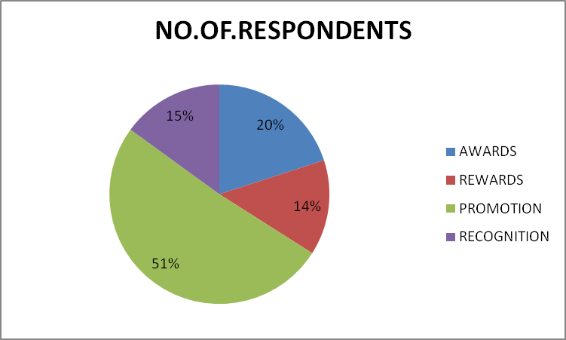

Source: Table -1

* In the table half of the employees are motivated by Promotion
* And least number of employees (I.e 14%) are motivated through Rewards.

**Table -2**

**Employee opinion on Types of approaches motivates you more**

|  |  |  |
| --- | --- | --- |
| PARTICULARS | NO.OF.RESPONDENTS | PERCENTAGE |
| PHYSIOLOGICAL | 19 | 19% |
| BEHAVIORAL | 29 | 29% |
| COGNITIVE | 28 | 28% |
| SOCIAL | 18 | 18% |
| PROMOTIONS | 3 | 3% |
| JOB SECURITY | 1 | 2% |
| CAREER | 1 | 1% |
| BEHAVIORAL | 1 | 1% |

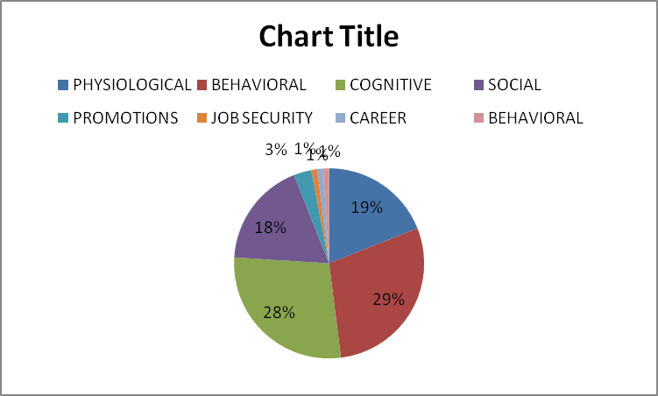

Source:Table -2

* + In the table nearly thirty percentage of employees(I.e 29%) are motivated through behavioral approaches .
  + And least number of employees are motivated through Career approach.

**Table -3**

**Which of the following factors motivates you most**

|  |  |  |
| --- | --- | --- |
| PARTICULARS | NO.OF.RESPONDENTS | PERCENTAGE |
| SALARY INCREASE | 37 | 37% |
| PROMOTION | 43 | 43% |
| LEAVE | 4 | 4% |
| MOTIVATIONAL TALKS | 10 | 10% |
| RECOGNITION | 6 | 6% |

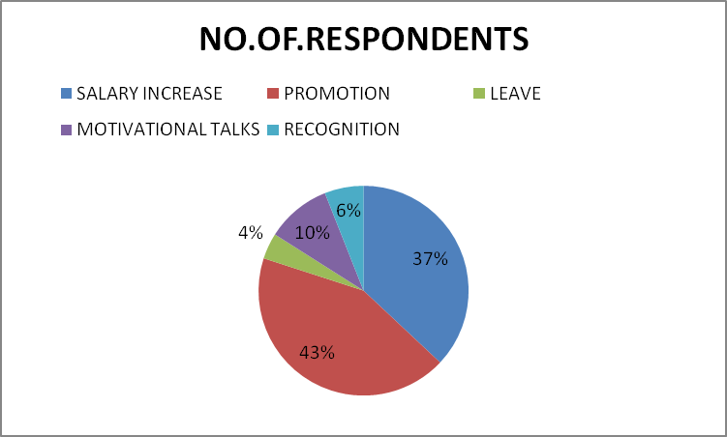

Source: Table -3

* In the table maximum number of employees (I.e 43%) are motivated through Promotion
* And minimum number of employees (I.e 4%) are motivated by Leave.

**Table -4**

**Employee opinion on Salary as the motivational factor to employees performance**

|  |  |  |
| --- | --- | --- |
| PARTICULARS | NO.OF.RESPONDENTS | PERCENTAGE |
| STRONGLY DISAGREE | 0 | 0% |
| DISAGREE | 3 | 3% |
| NEUTRAL | 19 | 19% |
| AGREE | 61 | 61% |
| STRONGLY AGREE | 17 | 17% |

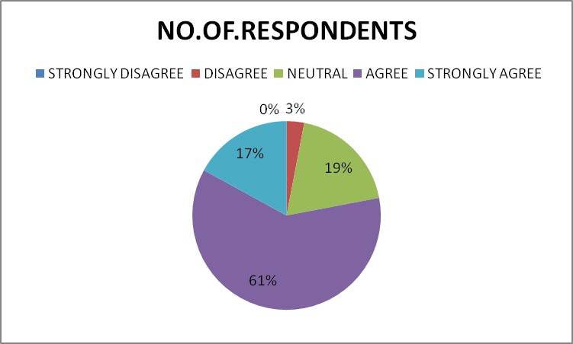

Source: Table -4

* In the table more than half of the employees Agree that salary is the motivational factor.
* And none of the employees Strongly Disagree that salary is the motivational factor.

**Table-5**

**Employee opinion on Increment as the motivational factor to employees performance**

|  |  |  |
| --- | --- | --- |
| PARTICULARS | NO.OF.RESPONDENTS | PERCENTAGE |
| STRONGLY DISAGREE | 0 | 0% |
| DISAGREE | 0 | 0% |
| NEUTRAL | 16 | 16% |
| AGREE | 64 | 64% |
| STRONGLY AGREE | 20 | 20% |

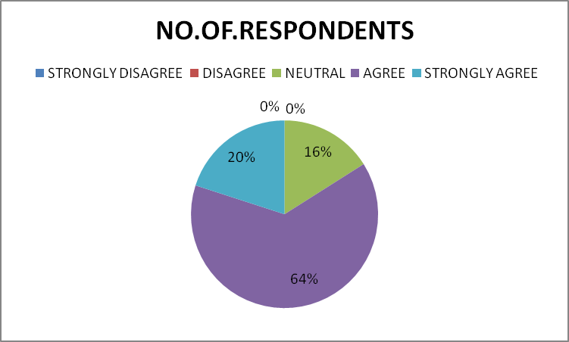 Source: Table -5

* In the table more than half of the employees (I.e 64%) Agree that increment is the factor of motivation.
* And none of the employees Strongly Disagree and Disagree that increment is the factor of motivation.

**FINDINGS:**

* Over 40% of employees identified promotions as a primary motivator, indicating that advancement opportunities are highly valued.
* A minimal percentage (14%) of employees are motivated by rewards, suggesting a potential need to revisit the reward structure or communication regarding available rewards.
* Approximately 29% of employees report motivation through behavioral approaches, emphasizing the importance of positive interpersonal practices and managerial behavior.
* The majority of employees view salary and regular increments as essential motivators, with a large portion agreeing that these financial incentives impact their motivation.
* Good working conditions are recognized as a motivational factor, with 71% of employees agreeing that their work environment contributes positively to their performance.
* Over half of the employees believe compensation significantly enhances their performance, showing that financial rewards play a critical role.
* A significant portion of employees hold a neutral stance on management’s effectiveness and their involvement in decision-making, pointing to an area where engagement could be improved.
* Nearly half of the employees remain neutral regarding the relationship with superiors as a motivator, suggesting mixed experiences or a need for strengthened supervisor- subordinate relationships.

**SUGGESTIONS:**

* To leverage the strong motivational effect of promotions, the organization could establish clearer career advancement paths and ensure transparent criteria for promotions.
* Given the low motivational impact of current rewards, consider redesigning reward programs to make them more meaningful and aligned with employee preferences, such as performance-based rewards or public recognition.
* Conduct training for managers on effective communication, recognition, and positive behavioral techniques to enhance motivation through better interpersonal approaches.
* Since salary and increments are significant motivators, regular reviews of compensation packages and scheduled increments could increase employee satisfaction and motivation.
* Invest in maintaining and enhancing the physical work environment, ensuring comfort and safety to meet the expectations of employees.
* Create structured opportunities for employees to participate in decision-making, such as through feedback sessions or suggestion programs, to foster a greater sense of ownership and engagement.
* Encourage supervisors to engage in regular one-on-one check-ins, provide constructive feedback, and acknowledge achievements to improve employee perceptions of their superiors.

**CONCLUSION**

This study reveals that employee motivation at La Hospin Hotels and Resorts Pvt Ltd is influenced by a range of intrinsic and extrinsic factors, with a significant emphasis on promotion, salary, and working conditions. While financial incentives and career advancement are substantial motivators, the analysis indicates potential improvements in management practices, reward systems, and employee-supervisor relationships. By addressing these areas and fostering an inclusive work environment, La Hospin Hotels can enhance employee satisfaction, motivation, and overall performance, ultimately contributing to better service delivery and organizational success.

**References:**

1. Armstrong, M. (2014). Armstrong's Handbook of Human Resource Management Practice. Kogan Page Publishers.
2. Herzberg, F., Mausner, B., & Snyderman, B. (1959). The Motivation to Work. Wiley.
3. Dessler, G. (2019). Human Resource Management. Pearson.
4. Deci, E., & Ryan, R. (1985). Intrinsic Motivation and Self-Determination in Human Behavior. Springer.
5. Vroom, V. (1964). Work and Motivation. Wiley.
6. Locke, E.A., & Latham, G.P. (2002). Building a Practically Useful Theory of Goal Setting and Task Motivation: A 35-Year Odyssey. American Psychologist.