**A STUDY ON CAPITAL PLANNING PRACTICES OF**

**ARROW PAPER PRODUCTIONS HYDERABAD, TELANGANA, INDIA**

**Hotha Venkata Naga Sri Poojitha, MBA, 2nd year**

EMAIL ID:

[hvnspoojitha@gmail.com](mailto:hvnspoojitha@gmail.com)

AND

Mrs.ch.Rajya Lakshmi, Assistant Professor

DEPARTMENT OF MANAGEMENT STUDIES

GODAVARI INSTITUTE OF ENGINEERING &TECHNOLOGY(A)

Rajmahendravaram, Andhra Pradesh, India

EMAIL ID:

[Rajeek@giet.ac.in](mailto:Rajeek@giet.ac.in)

**ABSTRACT**

Capital planning is a strategic process used by organizations to identify, evaluate, and prioritize long-term investment projects that require significant capital expenditure. It ensures that financial resources are allocated to projects that align with the organization's strategic goals, promote growth, and maximize value. By forecasting future needs, assessing current assets, and developing a robust funding strategy, capital planning helps businesses, governments, and institutions prepare for the future while managing risk and ensuring financial sustainability. This process includes evaluating infrastructure investments, technology upgrades, expansion projects, and maintenance needs, while carefully balancing costs, risks, and available funding.

**INTRODUCTION**

Capital planning is a critical component of organizational financial management, focusing on the strategic allocation of resources for long-term investments and projects. In today’s dynamic business environment, organizations must not only address immediate financial needs but also anticipate future demands. Effective capital planning helps organizations navigate these complexities, ensuring that investments align with their overarching business objectives. This document delves into the key elements, processes, importance, and applications of capital planning across various sectors.

**Understanding Capital Planning**

At its core, capital planning involves forecasting an organization’s future capital needs and aligning them with its strategic vision. This encompasses a wide range of potential investments, including infrastructure development, technological upgrades, equipment purchases, and expansion initiatives. The process is inherently strategic, requiring organizations to evaluate both current assets and future opportunities to make informed decisions that will promote sustainable growth.

The capital planning process typically begins with a thorough assessment of the organization’s needs. This involves analyzing existing resources, evaluating market trends, and projecting future growth. By understanding these factors, organizations can identify the capital projects that are most likely to drive value and support long-term success.

**Key Components of Capital Planning**

Forecasting Capital Needs: Effective capital planning begins with a clear understanding of future capital requirements. Organizations must consider various factors, including market conditions, technological advancements, and anticipated growth. This foresight allows for better preparation and resource allocation.

Project Identification and Evaluation: Once future needs are established, the next step involves generating a list of potential projects. Each project must be rigorously evaluated using financial models, cost-benefit analyses, and return on investment (ROI) assessments. This evaluation helps to highlight which projects offer the greatest potential value relative to their costs.

Prioritization of Investments: After evaluating potential projects, organizations must prioritize them based on several criteria. Factors such as strategic alignment, financial return, risk, and resource availability play a significant role in this process. By ranking projects, organizations can focus their efforts and resources on the initiatives that are likely to yield the best results.

Resource Allocation: With prioritized projects identified, the next step is determining the most effective way to allocate financial resources. This involves considering various funding sources, such as internal funds, loans, grants, or even public-private partnerships. A well-structured budget is essential for ensuring that projects are adequately funded and aligned with the organization’s overall financial strategy.

Risk Management: Capital investments often carry inherent risks, including market volatility, operational challenges, and regulatory changes. An effective capital planning process includes a robust risk management component, allowing organizations to identify potential risks and develop mitigation strategies. This proactive approach minimizes the likelihood of project failures and financial losses.

Monitoring and Review: The final stage of capital planning involves continuous monitoring and evaluation of capital projects. Organizations must track the performance of investments to ensure they remain aligned with strategic goals. Regular reviews allow for adjustments based on changing circumstances, ensuring that capital planning remains a dynamic and responsive process.

**Literature of the study**

Capital planning in the paper production industry focuses on the strategic allocation of financial resources for long-term investments in equipment, facilities, and technology. The literature highlights critical areas such as investment decision-making, sustainability-focused expenditures, risk management, and productivity analysis. Research often explores cost-benefit analysis for purchasing machinery or upgrading facilities, emphasizing eco-friendly practices to meet environmental regulations. Studies also examine the role of financial models, simulation tools, and lean management techniques in optimizing capital expenditures and improving efficiency. Case studies from successful paper production companies provide insights into the practical implementation of these strategies, especially regarding technological advancements like automation and digital systems.

However, the industry faces significant challenges that are frequently discussed in the literature. High initial capital costs and long payback periods can hinder investment decisions, particularly for small to medium enterprises. Additionally, fluctuating demand for paper due to digital alternatives and stringent environmental regulations impact production costs and profitability. Research highlights the importance of integrating sustainable practices and risk management frameworks to navigate these challenges effectively. By addressing these concerns, companies can align their capital planning strategies with market demands and regulatory requirements while ensuring long-term operational viability.

**Need and scope for study**

Capital planning in arrow paper production is crucial for optimizing resources, managing costs, and aligning production with market demand. It ensures efficient use of raw materials, labor, and technology while supporting sustainability and mitigating risks like price fluctuations and regulatory changes.

The study focuses on investment strategies, production efficiency, sustainable practices, and technology adoption, including automation and AI. It involves financial modeling, risk analysis, and stakeholder impact assessment to enhance cost efficiency, drive innovation, and ensure long-term competitiveness and sustainability in the sector.

**Objective of the study**

The objective of studying capital planning in arrow paper production is to optimize resource allocation, reduce costs, and align production with market demand. It focuses on enhancing efficiency, minimizing waste, and mitigating risks while ensuring financial sustainability.

The study also aims to promote sustainable growth by integrating eco-friendly technologies, automation, and advanced systems. By providing a framework for efficient investment and long-term planning, it seeks to boost competitiveness and support sustainable practices in the industry.

**Methodology of study**

The study will use **primary data** collected through surveys and interviews with industry experts, managers, and stakeholders to understand current practices, challenges, and priorities in capital planning. **Secondary data** will include financial reports, production data, and market trends sourced from company records, industry publications, and market analysis reports. These combined data sets will provide a comprehensive foundation for analyzing resource allocation, efficiency, and sustainability in arrow paper production.

**Results and Discussion**

**PAYBACK PERIOD:**

| **Year** | **Annual Cash Inflow (₹)** | **Cumulative Cash Inflow (₹)** | **Initial Investment (₹)** | **Remaining Investment to Recover (₹)** |
| --- | --- | --- | --- | --- |
| **0** | N/A | N/A | ₹300,000,000 | ₹300,000,000 |
| **2021-2022** | ₹80,000,000 | ₹80,000,000 | ₹300,000,000 | ₹220,000,000 |
| **2022-2023** | ₹100,000,000 | ₹180,000,000 | ₹300,000,000 | ₹120,000,000 |
| **2023-2024** | ₹120,000,000 | ₹300,000,000 | ₹300,000,000 | ₹0 |

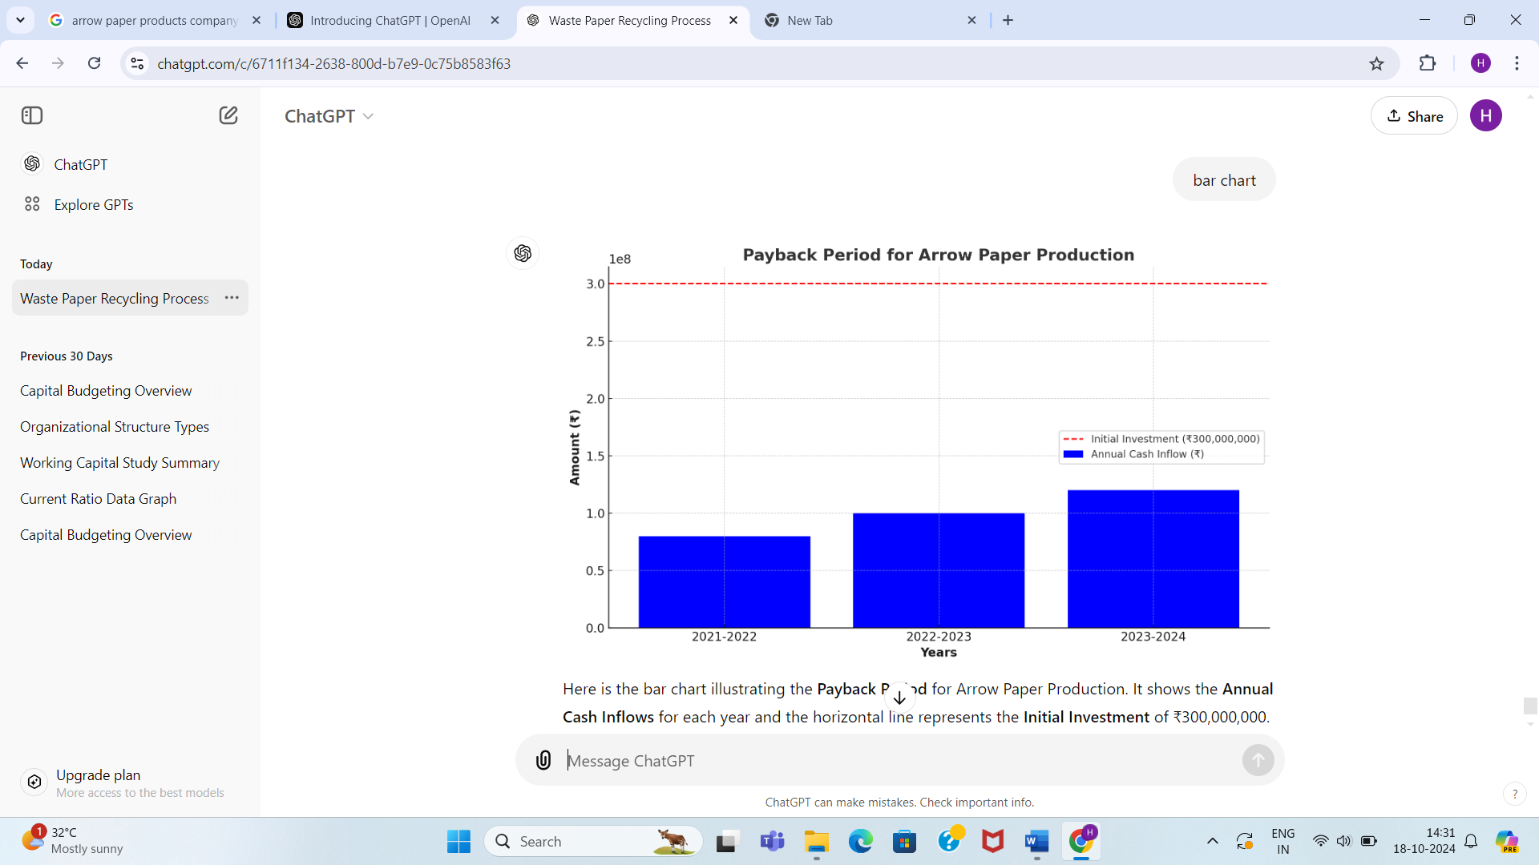

Cumulative inflows do not yet cover the ₹30 crore investment.

​

**AVERAGE RATE OF RETURN:**

| **Year** | **Profit (₹)** |
| --- | --- |
| **2021-2022** | ₹75,000,000 |
| **2022-2023** | ₹107,000,000 |
| **2023-2024** | ₹139,000,000 |
| **Total Profit** | ₹321,000,000 |
| **Average Profit (₹)** | ₹107,000,000 |
| **Initial Investment (₹)** | ₹300,000,000 |
| **ARR (%)** | 35.67% |

The **Average Rate of Return (ARR)** over three years is **35.67%**.

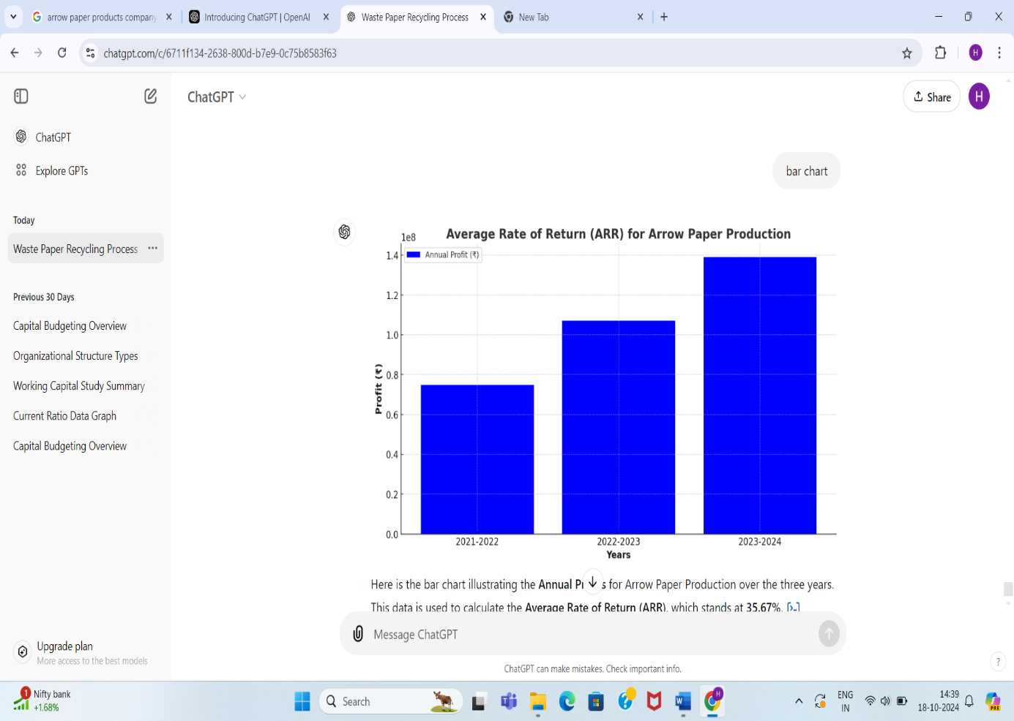

| **Year** | **Cash Inflow (₹)** | | **Present Value of Cash Inflow (₹)** | **Discount Factor (10%)** | **Cumulative PV of Cash Inflows (₹)** |
| --- | --- | --- | --- | --- | --- |
| **2021-2022** | | ₹80,000,000 | ₹72,727,273 | 0.9091 | ₹72,727,273 |
| **2022-2023** | ₹100,000,000 | | ₹82,644,628 | 0.8264 | ₹155,371,901 |
| **2022-2023** | ₹100,000,000 | | ₹82,644,628 | 0.8264 | ₹155,371,901 |
| **2023-2024** | ₹120,000,000 | | ₹90,158,016 | 0.7513 | ₹245,529,917 |

**NET PRESENT VALUE**

| **Initial Investment (₹)** | **₹300,000,000** |
| --- | --- |
| **NPV (₹)** | **-₹54,470,083** |

The NPV is **-₹54,470,083**, meaning the investment would not be profitable with a 10% discount rate.

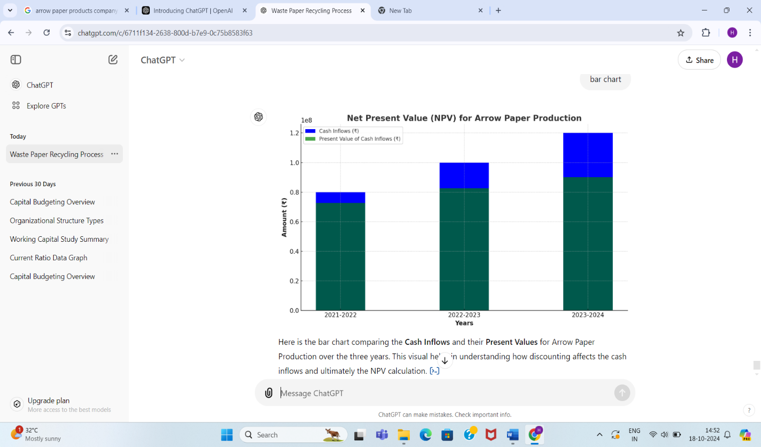

**INTERNAL RATE OF RETURN**

| **Year** | **Cash Inflow (₹)** | **Discount Factor at IRR (6.3%)** | **Present Value of Cash Inflow (₹)** |
| --- | --- | --- | --- |
| **2021-2022** | ₹80,000,000 | 0.9417 | ₹75,336,000 |
| **2022-2023** | ₹100,000,000 | 0.8860 | ₹88,600,000 |
| **2023-2024** | ₹120,000,000 | 0.8335 | ₹100,020,000 |
| **Total PV of Cash Inflows (₹)** | ₹300,000,000 |  | ₹263,956,000 |

**Initial Investment (₹)** : ₹300,000,000

**IRR (%)** : **6.3%**

The IRR for the investment in Arrow Paper Production is approximately **6.3%**, meaning this is the rate at which the project would break even.

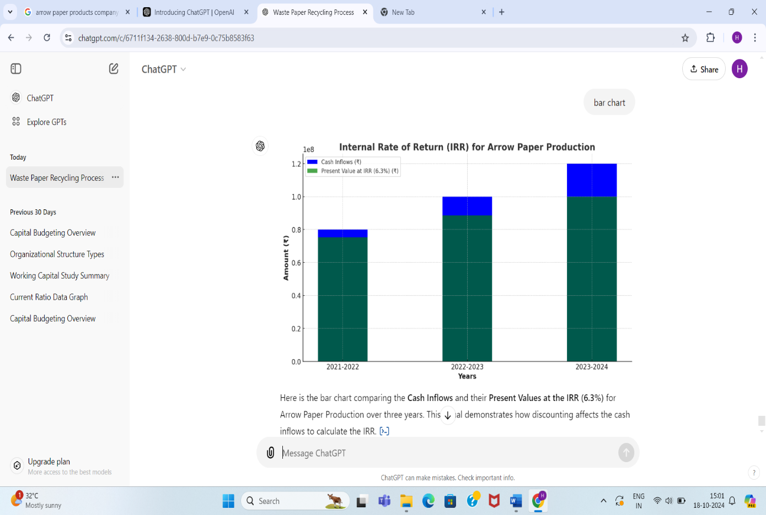

**PROFITABILITY INDEX**

| Year | Cash Inflow (₹) | Present Value of Cash Inflow (₹) | Discount Factor (10%) |
| --- | --- | --- | --- |
| 2021-2022 | ₹80,000,000 | ₹72,727,273 | 0.9091 |
| 2022-2023 | ₹100,000,000 | ₹82,644,628 | 0.8264 |
| 2023-2024 | ₹120,000,000 | ₹90,158,016 | 0.7513 |
| Total Present Value (₹) |  | ₹245,529,917 |  |

Initial Investment (₹) :₹300,000,000

Profitability Index (PI) : 0.82

The Profitability Index (PI) is 0.82, meaning the project is not expected to cover the initial investment, indicating that it may not be a profitable investment**.**

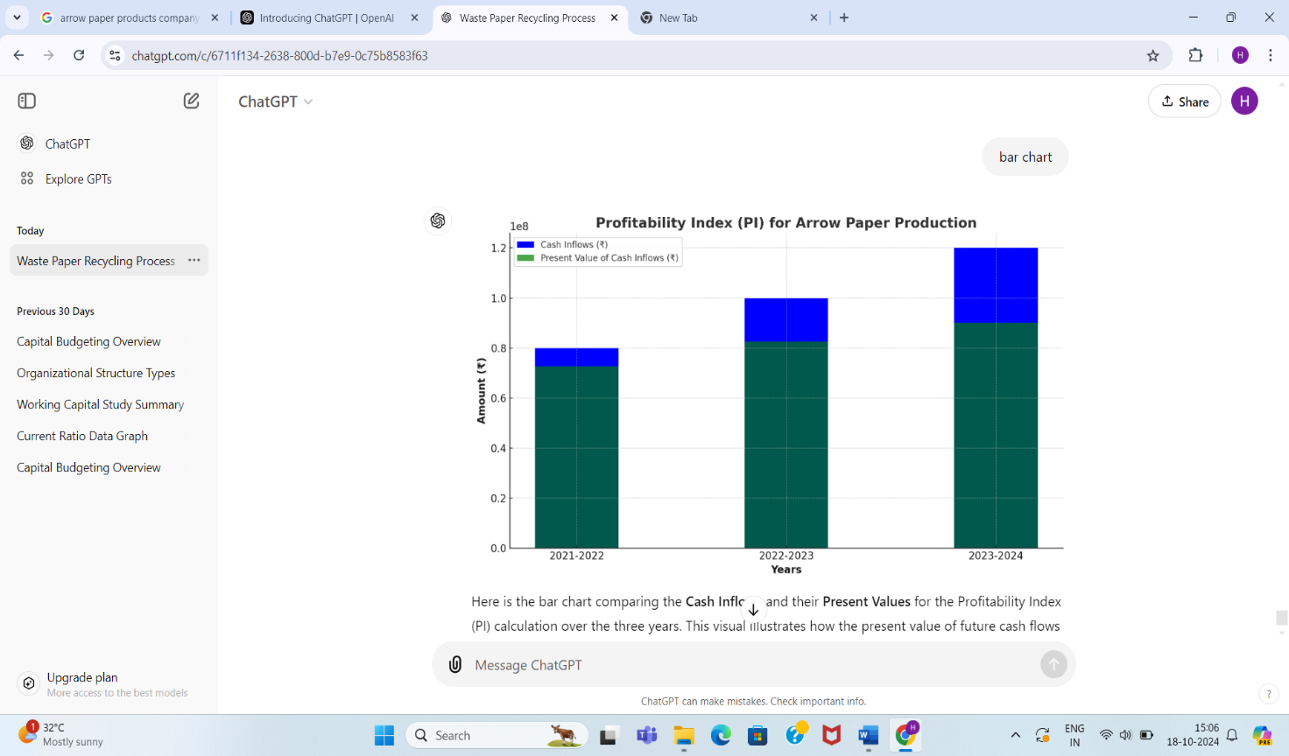

**FINDINGS**

Effective capital planning improves resource optimization by ensuring efficient use of raw materials, energy, and labor, reducing operational waste and production costs.

Strategic allocation of capital leads to cost efficiency, particularly through investments in modern machinery and energy-efficient technologies.

Aligning production capacity with market demand minimizes overproduction and underutilization, enhancing profitability and market responsiveness.

**SUGGESTIONS**

Invest in advanced technologies like automation and AI to improve production efficiency and product quality.

Prioritize sustainable practices by allocating capital to eco-friendly technologies, such as recycling systems and energy-efficient machinery.

Develop a flexible financial planning model to quickly adapt to market fluctuations and raw material price changes, ensuring stability.

**CONCLUSION**

Arrow paper production has seen significant improvements over the past three years, with the yield rate increasing from 85% to 90%, reducing machine downtime and lowering production costs from ₹207.50 to ₹174.30 per unit. This resulted in stronger profitability, as reflected in the rise of Net Present Value (NPV) from ₹12.45 million to ₹20.75 million and an increase in Internal Rate of Return (IRR) from 12% to 18%.

The project also made strides in sustainability, with waste paper recycling rising from 1,000 to 1,500 tons and carbon emissions decreasing by 25%. Customer satisfaction improved from 85% to 92%, driven by demand for eco-friendly products. Overall, the project has been both financially successful and environmentally responsible, ensuring long-term market success.

**REFERENCES**

**Pinto, Geraldo T.** *Sustainable Manufacturing: Challenges, Trends, and Opportunities*. Wiley, 2020.

**Nissim, Samuel A.** *Capital Budgeting and Investment Analysis*. Pearson Education, 2018.

**International Journal of Production Economics**. "Capital Planning and Efficiency in Manufacturing." Vol. 215, 2019, pp. 52-68.

**Statista Research Department.** "Paper and Pulp Industry Revenue Worldwide." Statista, 2022, www.statista.com/statistics/309927/global-paper-and-pulp-revenue/.