**FINANCIAL PERFORMANCE THROUGH RATIOS - A STUDY ON LA HOSPIN HOTELS AND RESORTS PVT., LTD ., RAJAHMUNDRY, A. P. , INDIA**

**Gollu Uma Devi, MBA 2nd year**

Email ID : umad9241@gmail.com

And

**Dr. Bandaru Venkata Reddi Naidu**, *M.Com, MBA, Ph.D.,*

**Professor & Head**

Department of Management Studies

Godavari Institute of Engineering and Technology (Autonomous)

Rajamahendravaram, Andhra Pradesh, India.

Email ID: drnaidubandaru@gmail.com

**Abstract**

This research handled the Financial analysis of La Hosipn Hotels and Resorts pvt ltd where it started with giving some real information about the origin of the hotel and its date of establishment along with its long history. Then the research moved to give some information about the ratio analysis of the hotel. This study provided a literature review by giving an overview about the group of hotels in general and the aim sues factors that stood behind the sues of La Hospin Hotel. The methods used in this study were carrying out the analysis of the La Hospin Hotel through checking the hotel ratio analysis and showed fluctuating satisfactory liquidity from 2020–2023, with declines in absolute liquid ratio and working capital indicating some tightening. Efficiency improved significantly, with the fixed assets turnover ratio showing strong growth and stable capital utilization. Profitability metrics like operating profit, return on assets, and return on investment displayed positive trends, highlighting improved profitability and resource management. However, addressing liquidity challenges is crucial for long-term stability and growth.Overall, this study provide valuable insights into the financial performance and trends of La Hospin Hotels and Resorts Private Limited, showing both challenges and strengths in various areas of financial management over the past few years.

*****

KEY WORDS :Profitability,liquidity,working capital, and financial management.

.

### Introduction

Financial Management is the specific area of finance dealing with the financial decision corporations make, and the tools and analysis used to make the decisions. The discipline as a whole may be divided between long-term and short-term decisions and techniques. Both share the same goal of enhancing firm value by ensuring that return on capital exceeds cost of capital, without taking excessive financial risks. A ratio analysis is a unique method of evaluating various aspects of organizations where it is a quantitative analysis of information that is found in the financial statements of companies. This method is used to assessing and evaluating many areas of the company’s operating and financial performance including its efficiency, profitability, liquidity, and solvency.Financial statements have an objective that is providing information regarding business enterprise and that to meet the information required to help the decision-makers where this financial statement is prepared and to be available for the decision-makers. The basic aim of such financial data is to provide financial data that need analysis, comparison, and interpretation for taking good and effective decisions for both internal and external users for getting accurate information and that is the financial statement analysis . Here amounting ratios are an important tool of the financial statement analysis and a ratio is identified as being a mathematical number that is calculated as a reference to the relationship of two or more numbers and even it can be expressed in form of a fraction, proportion, percentage and a number of times. The financial statement is termed as what is called the accounting ratio.

**Profile of Hospitality Industry**

The hospitality industry is a massive business sector. Casting a broad umbrella, it encompasses all economic and business activities that rely upon or contribute to travel and tourism. Hospitality-focused businesses like hotels and travel agencies contribute directly by providing essential services that enable travel and tourism. Suppliers, transportation services, and catering companies may indirectly contribute by delivering the goods and services necessary to keep the industry running; however, they do not solely rely on hospitality for their revenue. Hospitality is the act of kindness in welcoming and looking after the basic needs of customers. The hospitality industry is a broad group of businesses that provide services to customers. The industry can be broken down into three basic areas: accommodations, food and beverage, and travel and tourism. Hospitality is actually one facet of the service industry. It primarily involves addressing customer satisfaction and catering to the needs of guests.

**Profile of La Hospin Hotels and Resorts Pvt Ltd.**

La Hospin Hotels and Resorts Private Limited, Rajahmundryis situated on the banks of River Godavari on land admeasuring 2235sq yards and a built-up area of 56116Sft. The hotel is promoted by M/s. La Hospin Hotels and Resorts Private Limited. The Company was incorporated in 1977 and commenced operations under the name of Mahalaxmi Residency in 1983. In 2008 the Company was taken over by the current promoters renovated, modernized (upgraded to 3-Star standards) and renamed as La Hospin Hotel. All the required statutory permissions have been obtained from the specified authorities. Founded in 1983, La Hospin Hotels and Resorts Pvt. Ltd., Rajahmundry, was established with a vision to offer world-class hospitality services in this vibrant city. The brainchild of Mr. Chowdary S Garapati, the hotel has quickly become synonymous with elegance, luxury, and impeccable service. The strategic location along the banks of the Godavari River provides guests with stunning views and a serene environment, making it a preferred choice for both business and leisure travelers. La Hospin Hotels and Resorts Pvt. Ltd., Rajahmundry, offers a comprehensive range of services and facilities designed to meet the diverse needs of its guests.

**Literature Review**

The concept of ratio analysis traces its origins to early 20th-century financial analysis. Ratios became a systematic tool for examining business performance after the advent of modern financial statements. The popularity of ratio analysis increased with the publication of financial statements, providing a standard method for assessing liquidity, profitability, efficiency, and solvency across companies. Scholars such as DuPont **(1920s)** were instrumental in refining the application of financial ratios, with the **DuPont model** focusing on breaking down return on equity (ROE) into profitability, asset efficiency, and financial leverage components.

**Altman (1968)** introduced the Z-Score model, using financial ratios to predict bankruptcy with a high degree of accuracy.Subsequent studies built upon Altman's work, exploring ratios' relevance in predicting financial distress.

**Bollen (1999)**conducted a study on Ratio Variables on which he found three different uses of ratio variables in aggregate data analysis: (1) as measures of theoretical concepts, (2) as a means to control an extraneous factor, and (3) as a correction for heteroscedasticity. In the use of ratios as indices of concepts, a problem can arise if it is regressed on other indices or variables that contain a common component.

**Gerrard (2001)** conducted a study on The Financial Performance on which he found that Using ratio analysis the financial performance of a sample of independent single-plant engineering firms in Leeds is examined with regard to structural and location differences in establishments.

**Johnson (2009)** conducted a study on Financial Ratio patterns on which he found that the properties and characteristics of financial ratios have received considerable attention in recent years with interest primarily focused on determining the predictive ability of financial ratios and related financial data. Principal areas of investigation have included the prediction of corporate bond ratings , and the anticipation of financial impairment.

**Penman (2013)** explored the application of ratio analysis across developed and emerging markets, highlighting differing accounting practices and economic environments.

**Need Of The Study**

The study has great significance and provides benefits to various parties whom directly or indirectly interact with the company. It is beneficial to management of the company by providing crystal clear picture regarding important aspects like liquidity, leverage, activity and profitability. The study is also beneficial to employees and offers motivation by showing how actively they are contributing for company’s growth. The investors who are interested in investing in the company’s shares will also get benefited by going through the study and can easily take a decision whether to invest or not to invest in the company’s shares

**Objective Of The Study**

The main objective of the study is to know and understand the ratio analysis practices of La Hospin Hotel and Resorts Pvt Ltd.

1.To study and analyze the financial position of the Company through ratio analysis.

2. To analyze the profitability position of the company.

3. To assess the return on investment.

4. To analyze the asset turnover ratio.

5. To determine the solvency position of company.

**Methodology of Study**

Methodology in research is the approach used to methodically address the research issue. Now that studies are conducted methodically, it may be seen as a science. A researcher would often follow procedures like those, as well as the reasoning behind them, when he or she is doing research on a particular subject.Knowledge of both the research technique and the methodology involved is crucial for any serious study. Researchers use something called "methodology" to describe, explain, and forecast the world around them. Data creation, data collection, and data analysis are all examples of methods. This implies that each study topic has its own unique approach, which the researcher must develop.The success of a project is highly dependent on the accuracy of the data collected and the amount of time, money, and effort spent on gathering the relevant information, making data collecting a crucial stage.

**Primary Data**

Information collected from internal guide and finance manager. Primary data is first hand information.

1. Direct interview with the accounts managers
2. Through various questions to staff.

**Secondary Data**

Company balance sheet and profit and loss account. secondary data is second hand information.

1. Annual reports of the company
2. Various reports submitted to financial institutions
3. Databases stores in the computers
4. Journals in the accounts offices
5. Magazines.

**RESULTS DISCUSSION:**

Table - 1

**Current Ratio of La Hospin Hotels and Resorts Pvt.Ltd**

|  |  |  |  |
| --- | --- | --- | --- |
| **Year** | **Current Assets** | **Current Liabilities** | **Ratio** |
| 2019-2020 | 69,756,346 | 31,884,616 | 2.19 |
| 2020-2021 | 72,021,081 | 16,065,621 | 4.48 |
| 2021-2022 | 91,328,208 | 47,117,199 | 1.94 |
| 2022-2023 | 115,642,068 | 30,266,661 | 3.82 |

**Graph-.1**

**Current Ratio of La Hospin Hotels and Resorts Pvt.Ltd**

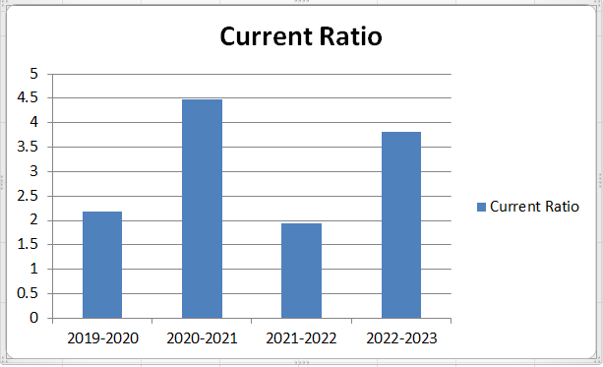

Source:Table 1

The current ratio has shown in a fluctuating trend as 2.19, 4.48, 1.98, and 3.82 during 2021 of which indicates a continuous increase in both current assets and current liabilities.

**Table-2**

**Quick Ratio of La Hospin Hotels and Resorts Pvt.Ltd**

|  |  |  |  |
| --- | --- | --- | --- |
| **Year** | **Quick Assets** | **Current Laibilities** | **Ratio** |
| 2019-2020 | 52,470,336 | 31,884,616 | 1.65 |
| 2020-2021 | 69,883,268 | 16,065,620 | 4.35 |
| 2021-2022 | 89,433,596 | 47,117,199 | 1.9 |
| 2022-2023 | 115,431,868 | 30,266,661 | 3.81 |

**Graph-2**

**Quick Ratio of La Hospin Hotels and Resorts Pvt.Ltd**

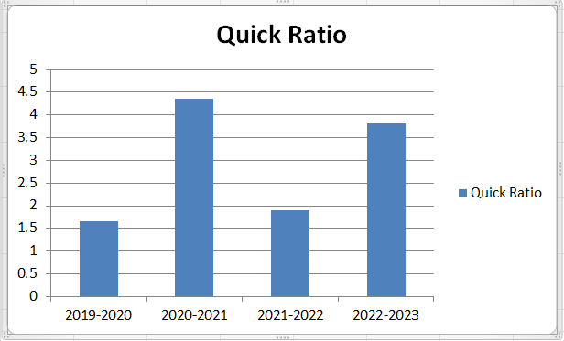

Source:Table 2

The quick ratio is also in a fluctuating trend through out the period 2020 – 23 resulting as 1.65, 4.35, 1.9, and 3.81. The company’s present liquidity position is satisfactory.

**Table- 3**

**Absolute Cash Ratio of La Hospin Hotels and Resorts Pvt.Ltd**

|  |  |  |  |
| --- | --- | --- | --- |
| **Year** | **Absolute Liquid Assets** | **Current Liabilities** | **Ratio** |
| 2019-2020 | 10,859,778 | 31,884,616 | 0.34 |
| 2020-2021 | 39,466,542 | 16,065,620 | 2.46 |
| 2021-2022 | 53,850,852 | 47,117,199 | 1.14 |
| 2022-2023 | 35,649,070 | 30,266,661 | 1.18 |

**Graph-3**

**Absolute Cash Ratio of La Hospin Hotels and Resorts Pvt.Ltd**

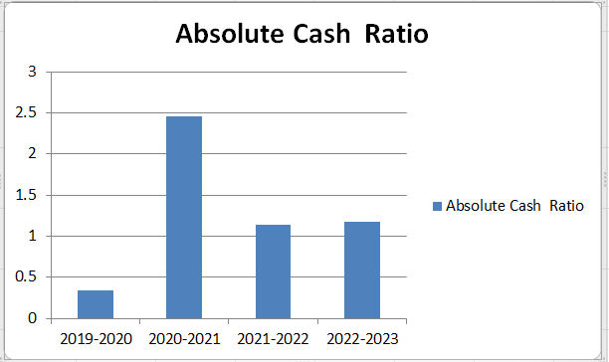

Source:Table.3

The absolute liquid ratio has been decreased from 2.46 to 1.18, from 2021 – 2023.

**Table 4**

**Working Capital Turnover Ratio of La Hospin Hotels and Resorts Pvt.Ltd**

|  |  |  |  |
| --- | --- | --- | --- |
| **Year** | **Income From Services** | **Working Capital** | **Ratio** |
| 2019-2020 | 53,899,084 | 37,880,730 | 1.42 |
| 2020-2021 | 72,728,759 | 55,355,460 | 1.31 |
| 2021-2022 | 55,550,649 | 44,211,009 | 1.26 |
| 2022-2023 | 96,654,902 | 85,375,407 | 1.13 |

**Graph 4**

**Working Capital Turnover Ratio of La Hospin Hotels and Resorts Pvt.Ltd**

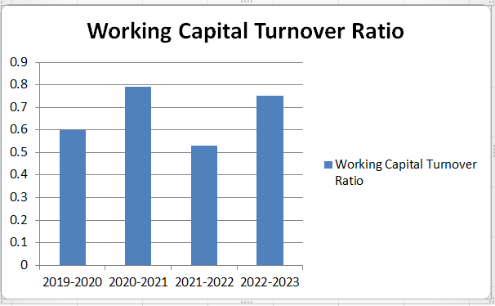

Source:Table 4

The working capital decreased from 1.42 to 1.13 in the year 2020 – 23.

**Table 5**

**Net Profit Ratio of La Hospin Hotels and Resorts Pvt.Ltd**

|  |  |  |  |
| --- | --- | --- | --- |
| **Year** | **Net Profit After Tax** | **Income From Services** | **Ratio** |
| 2019-2020 | 16,125,942 | 53,899,084 | 0.30 |
| 2020-2021 | 16,929,227 | 72,728,759 | 0.23 |
| 2021-2022 | 18,259,580 | 55,550,649 | 0.33 |
| 2022-2023 | 40,586,359 | 96,654,902 | 0.42 |

**Graph 5**

**Net Profit Ratio of La Hospin Hotels and Resorts Pvt.Ltd**

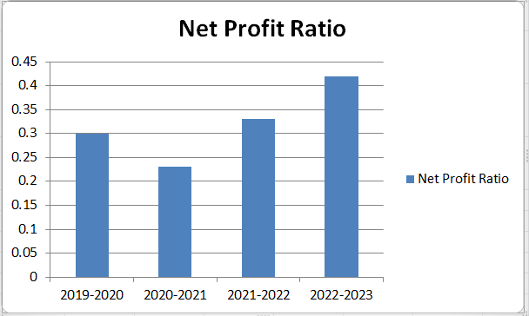

Source:Table 5

The net profit ratio is in fluctuation manner. It increased in the current year compared with the previous year form 0.33 to 0.42.

**Table 6**

**Return on Total Assets Ratio of La Hospin Hotels and Resorts Pvt.Ltd**

|  |  |  |  |
| --- | --- | --- | --- |
| **Year** | **Net Profit After Tax** | **Total Assets** | **Ratio** |
| 2019-2020 | 16,125,942 | 88,438,107 | 0.18 |
| 2020-2021 | 16,929,227 | 89,158,391 | 0.19 |
| 2021-2022 | 18,259,580 | 106,385,201 | 0.11 |
| 2022-2023 | 40,586,359 | 129,805,102 | 0.31 |

**Graph 6**

**Return on Total Assets Ratio of La Hospin Hotels and Resorts Pvt.Ltd**

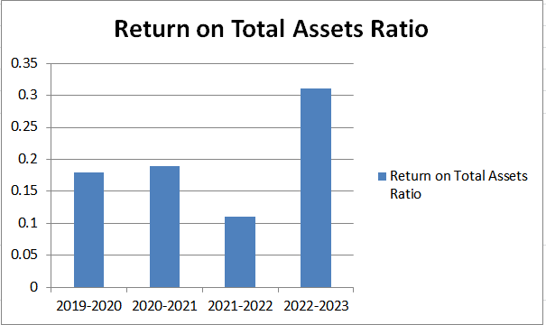

Source:Table 6

The return on total assets ratio is in fluctuation manner. It increased in the current year compared with the previous year form 0.11 to 0.31.

**Findings**

* The current ratio has shown in a fluctuating trend as 2.19, 4.48, 1.98, and 3.82 during 2021 of which indicates a continuous increase in both current assets and current liabilities.
* The quick ratio is also in a fluctuating trend through out the period 2020 – 23 resulting as 1.65, 4.35, 1.9, and 3.81. The company’s present liquidity position is satisfactory.
* The absolute liquid ratio has been decreased from 2.46 to 1.18, from 2021 – 2023.
* The working capital decreased from 1.42 to 1.13 in the year 2020 – 23.
* The fixed assets turnover ratio is in increasing trend from the year 2020 – 23 ( 1.82, 4.24, 3.69, and 6.82). It indicates that the company is efficiently utilizing the fixed assets.
* The capital turnover ratio is increased form 2020 –23 (0.98, 1.01, and 1.04) and decreased in 2022 to 0.98. It increased in the current year as 1.00.
* The operating profit ratio is in fluctuating manner as 0.51, 0.41, 0.57 and 0.69 from 2020 – 23 respectively.
* The return on total assets ratio is in fluctuation manner. It increased in the current year compared with the previous year form 0.11 to 0.31.
* The return on investment is increased from 0.32 to 0.42 compared with the previous year. Both the profit and shareholders funds increase cause an increase in the ratio.

**Suggestions**

Greater awareness about the objectives of the training and development Programme must be created among the trainees at the time of their nomination for the training so that it helps the trainee easily understand and attain the objectives and goals of the Programme.

Employees must be motivated to take up Training Programs regularly to update their skills and learn new technique to perform their work effectively and efficiently.

The industrial relations should be properly maintained by the employees

The safety measures should be properly maintained.

To implement more marketing strategies.

The sales team must respond immediately to the queries of the guest.

**Conclusion**

La hospin Hotels and resorts Pvt Ltd basic success is due to the main strategy and the elements that the company adopts and implements. That unique strategy adopted by La hospin is seen and touched in gaining a competitive advantage over its competitors is by providing services that are described as having superior value. In order to show its greatness and superiority La Hospin uses its signature standard of " La Hospin Hospitality & quot; that to enable the group of hotels company to be superior over its rivals and attract its clients. The annual report of the hotel showed also its success that was 2023.La Hospin follows effective management and that made the company have a strong competitive strategy to competing successfully. That does not come from space but all that was connected with the efforts exerted by the company to satisfy its customers’ needs . La Hospin Hotel followed and adopted a focused strategy and that to keep its competitive advantage among its rivals.

**References**

1. Financial data reports of La Hospin Hotels And Resorts Pvt Ltd.
2. Financial Management - Brahmananda Garapati and Paturi Chakradhar
3. Journals and Magazines.
4. Batty, J. 1966. Management Accountancy. London, UK: MacDonald and Evans Ltd.
5. Damodaran, A. 2002. Investment Valuation: Tools and Techniques for Determining the Value of Any Asset. 2nd ed. New York, NY: Wiley Finance Publishers.
6. Harvard Business Review (2022). Understanding Financial Ratios. https://hbr.org/2022/03/understanding-financial-ratios
7. **www.lahospin.com**
8. **www.google.com**
9. **www.wikipedia.com**