**A STUDY ON** **EFFECTIVENESS RECUITMENT AND SELECTION PROCESS PRACTICES OF APRNA ENTERPRISES LIMITED, VISAKHAPATNAM , AP.**

**DEVABATTULA RAJU, 2ND MBA**

Email ID: rajadevabattula@gmail.com

And

**Dr. R. RAJA**

**Assistant Professor**

Department of management studies

Godavari Institute of Engineering and Technology (Autonomous)

Rajahmahendravaram, Andhra Pradesh, India

Email ID: rachagundlaraja123@gmail.com

**ABSTRACT**

In order to accomplish its goals, every business must employ a staff that is both capable and experienced. The degree of expertise required in the workplace must rise, as must workers' adaptability and flexibility. Investment in employee Recruitment and selection is not just a good idea, but a must for any company that wants to keep its workforce competitive and well-informed.

The purpose of the research was to determine how successful Recruitment and selection strategies are in improving the knowledge and skills of staff members at the APARNA ENTERPRICES LIMITED in Visakhapatnam. The information was gathered from 120 workers who were chosen at random. Currently employed by the APARNA ENTERPRICES LIMITED The vast majority of respondents to a recent survey agreed that Recruitment and selection programs are effective in increasing workers' levels of expertise. The workers agreed that specialized recruitment significantly improved their specialized knowledge and expertise, which in turn increased their job performance. In light of this, the study's major aim is to examine the efficacy of Recruitment and selection approaches. The goal of this effort has been to compile a body of information on Recruitment and selection that may be used as a resource by anyone doing Recruitment-related research.

**\*\*\***

**KEYWORDS:** Recruitment, Selection, Organization, Effectiveness.

**INTRODUCTION**

## Introduction to Human Resource Management (HRM)

Human Resource Management (HRM) is a strategic approach to managing an organization's most valuable asset its people. It involves recruiting, training, developing, and maintaining a motivated workforce. HRM aims to maximize employee performance and ensure that an organization can achieve its goals effectively and efficiently.

**PROFILE OF CERAMIC INDUSTRY:**

The word Ceramic comes from the Greek word "Karamo’s" which means stoneware; it is identified with an old Sanskrit root signifying "to consume" yet was principally used to signify "consumed stuff". In the good 'old days the tiles were handcrafted, hand shaped and hand painted. In any case, today the clay tile isn't high quality or hand painted for a large portion of the part. Indeed, in the cutting-edge house all through utilize artistic tiles for their restrooms and kitchens and in each essential space of the reason. Aside from embellishing look fired tiles are principally cleanliness items and that is obvious from its utilization pouring from restrooms and kitchens in normal Indian families to clinical focuses, labs, milk corners, school, public persuades and so on an artistic tile is fundamentally a "utility item" and mainstream lodging items are progressively exchanging over to fire from the conventional mosaic and even rock or marble, attributable to a few elements viz. ease in laying capacity, flexibility, low cost and above all cleanliness.

The primary item portions are the divider tiles, Floor tiles, Vitrified tiles and porcelain tile fragments. The portions of the overall industry are 35%, 53% and 12 percent separately for divider, floor and vitrified/porcelain tiles.

**PROFILE OF APARNA ENTERPRISES**

Aparna undertakings Limited (AEL) is a piece of the profoundly effective Aparna Group. Established in the year 1990, AEL prides in having the biggest piece of the pie in south India through a scope of organizations in building-material items, like RMC (Ready Mix Concrete), uPVC windows and entryways, uPVC profiles, Tiles and sterile product fittings. Related benchmarks in innovation, examination, plan, and quality.

What at first began as a business in fired tile conveyance today stands tall as a pioneer in various business ventur3es. Aparna's set of experiences maintains its real ability in giving an assorted scope of building material items. With in fact strong arrangements, building-materials are still at the centre of what we do. Aparna Enterprises continually accepts new advances to create the most developed and best quality yields.

Today, AEL is a recognized industry pioneer giving determines, project workers, and partners with a scope of top-notch items fabricated to the most noteworthy standards. EL can meet any particular models while guaranteeing full consistence with principles.

**LITERATURE AND REVIEW:**

Researchers debate the advantages and disadvantages of internal (promoting from within) versus external (hiring from outside the organization) recruitment. Internal recruitment is often viewed as cost-effective and motivating for current employees, while external recruitment can bring in fresh perspectives and diverse skills (Barber, 1998). Traditional methods include job advertisements in newspapers, job boards, and recruitment agencies. More recently, digital platforms, such as LinkedIn and online job portals, have revolutionized recruitment by increasing reach and reducing costs (Breaugh, 2013). Social media recruitment, employer branding, and employee referral programs are also key trends in modern recruitment practices.

The concept of employer branding has gained significant attention. Companies with a strong employer brand are able to attract high-quality candidates who resonate with their values and culture (Backhaus & Tikoo, 2004). Positive employer branding is linked to reduced recruitment costs and higher employee engagement. Bias can occur at various stages of recruitment and selection, including unconscious bias in interviews and selection decisions. Researchers like Bertrand and Mullainathan (2004) have documented how resumes with "ethnically distinctive" names are less likely to receive callbacks, highlighting racial discrimination in hiring.

**Need For the Study:**

Recruitment and selection are the most critical and significant human resources functions. Unless the organization has the best available employees, it will not be able to grow and flourish in the market. The drive and motivational levels of the employees need to be high to enable the company to attain its goals. All the steps of the recruitment and selection processes are equally important in attracting and retaining the right talent.

A major part of management's job is establishing the requirements of each position within the organization. Managers then need to match the positions with employees possessing the right skills and aptitude for the job.

**Scope Of the Study:**

Recruitment plays a vital role in every organization. Manpower requirements are to be estimated far beyond the actual requirements. This study reveals the Recruitment procedure in different wings such as Engineering, Accounts, Security, Medical, and General Services of Aparna enterprises. Study will conclude the sources of Recruitment, better source, satisfactory rate and whether there is definite Recruitment procedure or not in Aparna enterprises.

**Objectives Of the Study**:

The objectives of the project study include:

* To obtain the feedback of the employees about the recruitment and selection procedures followed in the company.
* To evaluate the various sources of recruitment and their availability at Aparna Enterprises.
* To find out the effectiveness of the selection procedure at Aparna Enterprises.
* To find out what is the process of recruitment and selection that should be followed

**Methodology Of the Study:**

The data required for this study is collected from two major sources. They are

**Primary data:**

The primary data is collected from employees through a structured questionnaire

**Secondary data:**

The secondary source of data was collected from various journals, company records and websites

**RESULTS AND DISCUSSIONS**

**Table: 5.1**

### **MODE OF INTERVIEWS FACED IN APARNA ENTERPRISES**

|  |  |  |  |
| --- | --- | --- | --- |
| **S. No** | **Dimensions** | **Respondents** | **% of Respondents** |
| 1. | Group discussion | 80 | 67 |
| 2. | Presentation | 15 | 13 |
| 3. | Telecom/personal | 5 | 4 |
| 4. | Written test | 15 | 12 |
| 5. | Technical interview | 5 | 4 |
|  | **Total** | **120** | **100** |

Source: Aparna enterprises

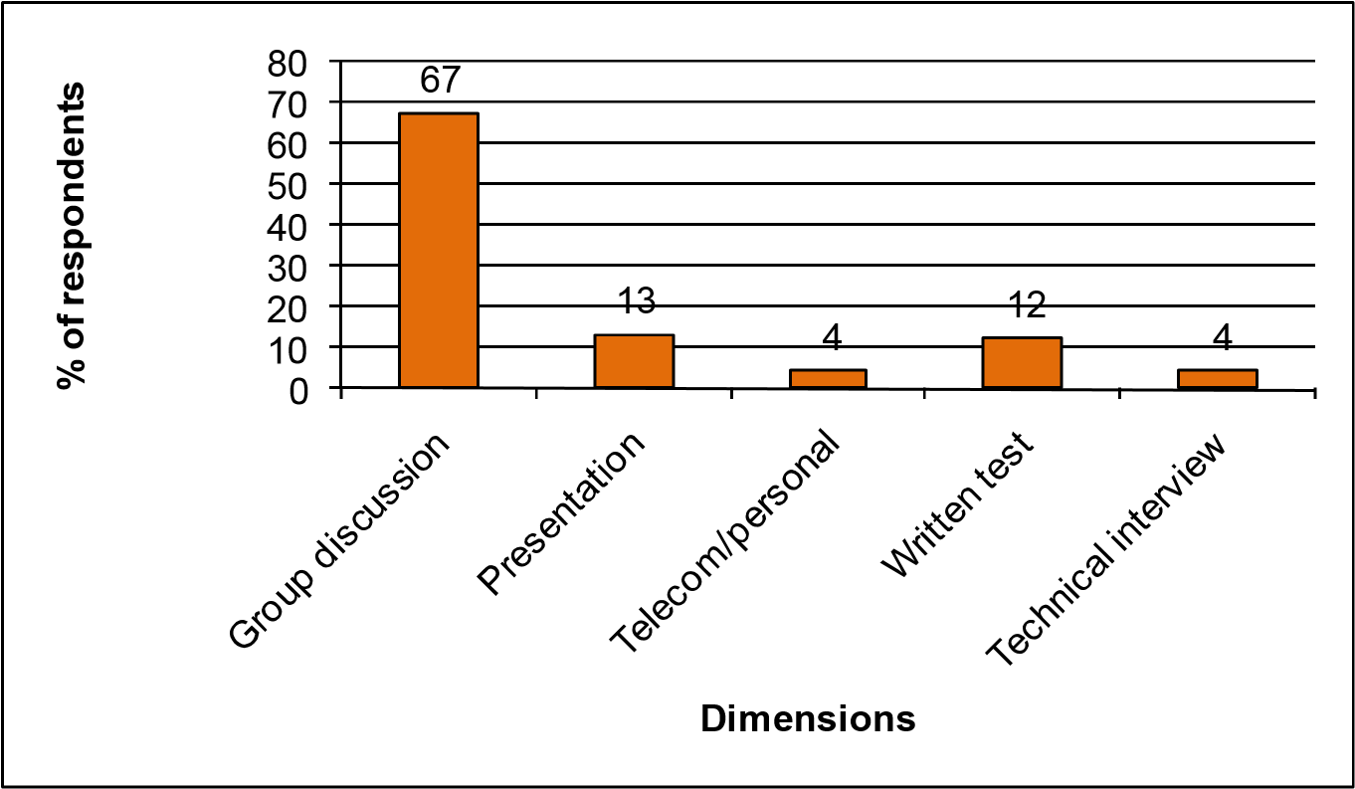

Source **Table: 5.1** Mode of Interviews Faced in Aparna Enterprises

Table 5.1 explains 67% of the candidates faced group discussion, 13% faced presentations, 4% through telecom or personal interview, 12% faced written test and only 4% through technical interview.

**Table: 5.2**

**INTERVIEW HELPS TO MEASURE STRENGTH AND WEAKNESS**

|  |  |  |  |
| --- | --- | --- | --- |
| **S. No** | **Dimensions** | **Respondents** | **% of Respondents** |
| 1. | Strongly agree | 55 | 46 |
| 2. | Agree | 30 | 26 |
| 3. | Neither agree nor disagree | 25 | 21 |
| 4. | Disagree | 7 | 5 |
| 5. | Strongly disagree | 3 | 2 |
|  | **Total** | **120** | **100** |

Source: Aparna enterprises

46

26

21

5

2

0

5

10

15

20

25

30

35

40

45

50

Strongly

agree

Agree

Neither

agree nor

disagree

Disagree

Strongly

disagree

**% of respondents**

**Dimensions**

Source **Table: 5.2** Interview Helps to Measure Strength and Weakness

Table 5.2 explains that 46% of the candidates strongly agree that interview helps to measure strength and weakness, 26% also agree, 21% neither agree nor disagree, 5% of them disagree and remaining 2% are strongly disagree.

**Table: 5.3**

**FOLLOW SAME RECRUITMENT PROCEDURES TO SELECT EXECUTES AND REGULAR STAFF IN YOUR ORGANIZATION.**

|  |  |  |  |
| --- | --- | --- | --- |
| **S. No** | **Dimensions** | **Respondents** | **% of Respondents** |
| 1. | Strongly agree | 72 | 61 |
| 2. | Agree | 25 | 21 |
| 3. | Neither agree nor disagree | 13 | 10 |
| 4. | Disagree | 5 | 4 |
| 5. | Strongly disagree | 5 | 4 |
|  | **Total** | **120** | **100** |

Source: Aparna enterprises

61

21

10

4

4

0

10

20

30

40

50

60

70

Strongly

agree

Agree

Neither

agree nor

disagree

Disagree

Strongly

disagree

**% of respondents**

**Dimensions**

Source **Table: 5.3,** Follow Same Recruitment Procedures to Select Executes and Regular Staff in Your Organization**.**

Table 5.3 explains that 61% of the candidates strongly agree that it is good to follow same recruitment procedures to select executives and regular staff 21% were agree, 10% were neither agree nor disagree, 4% were disagree whereas 4% were strongly disagree.

**Table: 5.4**

**RECRUITING CANDIDATES THROUGH INTERNAL SOURCES IS BENEFIT TO ORGANIZATION.**

|  |  |  |  |
| --- | --- | --- | --- |
| **S. No** | **Dimensions** | **Respondents** | **% of Respondents** |
| 1. | Strongly agree | 79 | 66 |
| 2. | Agree | 20 | 17 |
| 3. | Neither agree nor disagree | 12 | 10 |
| 4. | Disagree | 9 | 7 |
| 5. | Strongly disagree | 0 | 0 |
|  | **Total** | **120** | **100** |

Source: Aparna enterprises

66

17

10

7

0

0

10

20

30

40

50

60

70

Strongly

agree

Agree

Neither

agree nor

disagree

Disagree

Strongly

disagree

**% of respondents**

**Dimensions**

Source **Table: 5.4** Recruiting Candidates Through Internal Sources Is Benefit to Organization.

Table 5.4 explains that the 66% of the candidates strongly agree that selecting candidates through internal source is benefit to organization, 17% were agree, 10% were neither agree nor disagree whereas, 7% disagree.

**Table: 5.5**

**VERIFICATION FOR RECRUITING EMPLOYEES IN APARNA ENTERPRISES**

|  |  |  |  |
| --- | --- | --- | --- |
| **S. No** | **Dimensions** | **Respondents** | **% of Respondents** |
| 1. | Educational qualification | 65 | 55 |
| 2. | Professional back ground | 33 | 27 |
| 3. | Reference check | 12 | 10 |
| 4 | Family background | 10 | 8 |
|  | **Total** | **120** | **100** |

Source: Aparna enterprises

70

18

4

8

0

10

20

30

40

50

60

70

80

Education

nal

qualification

Profession

nal

background

Reference

Family

background

**% of respondents**

**Dimensions**

Source **Table 5.5** Verification for recruiting employees in Aparna Enterprises

Table 5.5 explains that 70% of the candidates are recruiting on the basis of educational qualification, 8% are based on legal back ground check ,10% through professional background check,4% through reference check and remaining 8% through family background check.

**FINDINGS:**

**The following are the various important findings based on the data analysis.**

* It is found that 67% of the respondents faced group discussion and 4% through technical interview.
* It is found that 46% of the respondents strongly agree that interview helps to measure strength and weakness and 2% are strongly disagree.
* It is found that 61% of the respondents strongly agree that it is good to follow same recruitment procedures to select executives and regular staff and 4% were strongly disagree.
* It is found that 66% of the respondents strongly agree and 7% are disagree that selecting the candidates through internal sources is benefit to organization.
* It is found that 70% of the respondents are recruiting on the basis of educational qualification and 8% of them through family background check.

**SUGGESTIONS:**

• The strength of any organization is its human resource, so in order to change human resource into valuable assets. Recruitment and selection process helps so much to the organization.

• The company should be more effective to choose employee referral as process for recruitment rather than consultancies which would help them to reduce the cost.

• The company should be more effective when they recruit the employees through external sources, because they select the candidates based on skills, knowledge and talent.

**CONCLUSION:**

From the above findings we can conclude that recruitment and selection process followed in Aparna Enterprises is well structured. At Aparna Enterprises the recruitment is done through consultancies which in turn lead to high HR cost. Candidates are satisfied with the present selection process. The delay in the interview process is mainly due to client round where the recruiter needs to line the candidate for an interview based on the client’s availability.

**REFERENCE:**

1. Lievens, F., & Chapman, D. (2019). Recruitment and selection. *The SAGE handbook of human resource management*, 123-150.
2. Searle, R. H., & Al-Sharif, R. (2018). Recruitment and selection. In *Human resource management* (pp. 215-237). Routledge.
3. Zhao, H., & Liden, R. C. (2011). Internship: A recruitment and selection perspective. *Journal of Applied Psychology*, *96*(1), 221.
4. Roberts, G. (1997). *Recruitment and selection*. CIPD publishing.
5. Coller, X., Cordero, G., & Echavarren, J. M. (2018). Recruitment and selection. *Political Power in Spain: The Multiple Divides between MPs and Citizens*, 83-102.