**Artificial Intelligence Use in Health Care-to**

**Improve Patient Outcomes**

***Abstract*—** Artificial intelligence is integrated into the healthcare sector; this has been affecting patient care and diagnostics, as well as streamlining operations in the hospitals. Data-driven models of AI can enable health care providers to provide personalized treatments, optimize hospital operations, and enhance patients' experiences greatly. This paper discusses critical applications of AI in the healthcare context, which include predictive analytics on patient outcome, AI-assisted diagnostics, personalized medicine, and the position of AI in finding drugs as well as optimizing drug use.

It also entails examining challenges like data privacy, problems with security, and the unbelievable cost of applying AI into healthcare systems.

.

rising costs, increased size of patient population, and complex clinical decisions, health care systems struggle, and therefore emerging AI technologies are now powerful tools to handle these issues.

AI encompasses a range of technologies that include machine learning and, more broadly, natural language processing and computer vision, and they each contribute uniquely to the ability of patient care. They process mountains of data-from electronic health records to genomics information-and provide providers with actionable insights that were otherwise not possible for organizations seeking to increase their pace and remain relevant in the current market.

**Keywords—** Artificial Intelligence (AI), Healthcare, Predictive Analytics, Diagnostics, Personalized Medicine, Data Privacy, Drug Discovery.

# I. INTRODUCTION

AI is transforming healthcare by making use of enormously large volumes of patient data for better diagnosis, treatment, and even operational efficiency. AI- based tools assist healthcare workers in the analysis of large datasets to predict outcomes, optimize treatment protocols, and improve patient experience. The health sector is rapidly changing with applications such as virtual assistants that support patients and more advanced machine learning models that detect diseases early enough.

Not long ago, the health care revolution indicated by the introduction of artificial intelligence (AI) had been expected to revolutionize patient outcomes by offering new solutions. Although huge, the sector of health care has turned out to be challenging with technology, and AI technologies are applied in the reduction of processes but rather to aid clinical decision-making and personalizing care for every patient. All the way from how predictive analytics can predict what the patients will expect any time, natural language processing that adjusts communication, AI, is changing the approach of how health care providers diagnose and treat the patient by resorting to the following points:.

It is rapidly integrating into health care as it reshapes the landscape of medical practice and provides great opportunities for improving patient outcome. Because of

II. EFFECTS OF AI IN HEALTHCARE DELIVERY

The integration of AI in the health care sector is making medical services delivery dramatically different, thereby improving the outcome for patients and streamlining the process. Here are the major impacts that AI has on health care delivery.

## A. Predictive Analytics for Patient Outcomes

Predictive analytics in healthcare applies data, statistical algorithms, and artificial intelligence through machine learning techniques to determine the likelihood of future outcomes based upon historical data. This is an enormously powerful tool with significant implications in terms of patient outcomes, improvement in the delivery of care, and optimization in resource usage. Here's a look at that role and impact of predictive analytics in healthcare.

* Identification of at-risk patients**:** Predictive analytics has a potential ability to analyze the patient data and identify those who are at risk of a particular condition such as heart disease, diabetes, or readmission after being hospitalized. Such early detection of such patients will enable the health care providers to start proactive interventions by developing a personalized care plan or preventive measures that can be adopted to avoid complications and improve outcomes.

* Improved Clinical Decision Making: Predictive analytics can be used by the clinicians towards

the purpose of clinical decision-making. Integration of the predictive models into EHR systems allows providers to receive real-time alerts about potential patient risks, such as deterioration in the health status of patients. This enables timely interventions and informed treatment decisions that help improve care for these patients.

## B. AI-Assisted Diagnostics

Machine learning algorithms can read medical images, find anomalies, and aid doctors in treatments for diseases such as cancer and heart disease. These systems decrease diagnostic mistakes and enable quicker decision-making, ultimately enhancing the quality of care.

* Gains in accuracy and precision**:** AI algorithms, especially those based on deep learning, can quickly analyze medical images, such as X-rays, MRIs, and CT scans. AI systems can identify subtle abnormalities that human eyes would miss, leading to earlier diagnoses of conditions like cancer, fracture, or neurological disorders.
* Advocate for Clinical Decision-Making**:** By applying the logic of evidence-based recommendations and insights garnered from large datasets, AI-assisted diagnostics equip clinicians with the ability to overlay their judgment with data-driven analysis-all supportive in clinical decision-making and reducing errors while promising better outcomes for patients.

## C. Personalized Medicine

Personalized medicine, also known as precision medicine, is a novel approach to medical health care tailored to the unique characteristics of each patient through medical treatment. Tailoring therapeutic treatment based on the genetic, environmental, and lifestyle factors will enable personalized medicine to enhance both therapeutic efficacy with reduced adverse effects and better health outcomes. See below for in-depth discussions on the theory, applications, and benefits of personalized medicine.

* Disease Management Application of Personalized Medicine: Personalized medicine remains to date to positively advance in the management of diseases in most medical specialties. Such an

approach is enhanced by tailoring treatment strategies to a patient's individual characteristics, thus making therapies effective in managing the illnesses of patients and further improving their outcomes as a whole. Here are some significant applications of personalized medicine in the management of disease

* Advantages of Personalized Medicine**:**

Personalized medicine can be considered as a revolutionary approach to health care; tailoring treatment strategies according to the specific characteristics of an individual. With this shift in the paradigm, several benefits are rendered over the quality of care as a whole.

## D. Drug Discovery and Development

The discovery and development of a drug is a multi-stage process that changes a new concept into a commercialized drug. The exploration of new drugs through vast research, laboratory tests, and check-up with the regulatory bodies ensures that the newly developed drugs are safe and effective for use among the patients. Here's a step-by-step guide on the stages of drug discovery and development, along with current trends and challenges.

* Drug Discovery**:** The first step of the process of pharmaceutical development is drug discovery: discovering and developing possible new medicines. This is a multidisciplinary, scientific inquiry, innovative technology, and rigorous testing applied to transforming the therapeutic idea into a viable drug candidate. Here's a comprehensive insight into the process of drug discovery, methods, and current trends.

* Current Trends and Challenges: It is a very dynamic field of emerging and ever-changing drug discovery. Issues that have driven growth in this area include advances in technology, shifting scientific paradigms, and changes in regulation. Let's discuss some of the main trends in drug discovery today and challenges for researchers and developers.

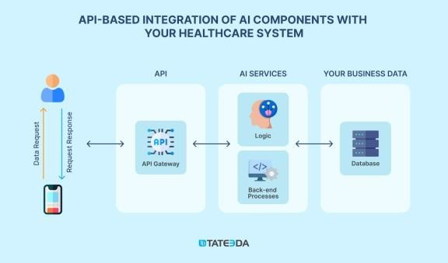

### Fig:1. Diagram of AI in healthcare

III. OPERATIONAL EFFICIENCY ENHANCEMENT

AI can automate some common administrative work such as scheduling, billing, and implementation of electronic health records. This leaves room for more time being spent by healthcare workers to focus on direct care to patients. AI also optimizes the use of hospital resources, both human and equipment, with resultant efficiency in operations and cost-effectiveness.

Integration of AI in health can significantly enhance operational efficiencies across domains. Automation improves the quality of decision-making while using resources optimally, thus making AI capabilities helpful for health-care organizations to deliver better patient care while reducing cost.

## A. . Improving Clinical Workflows

Some of the health clinical workflows that AI improves include converting many processes to make them efficient, accurate, and better for the patients. One of the key improvements targeted is the automation of documentation or note-taking. Here, an NLP for an AI system can record clinician-patient interactions in real time, transcribing spoken dialogue into structured medical notes. This reduces the administrative burden on the healthcare providers, who would spend much more time on patient care rather than paperwork. Smart templates can also be incorporated into such systems, thus suggesting relevant fields based on the context of the visit to further expedite documentation.

Clinical decision support systems, powered by AI are very important in workflow improvement. This is achieved through giving recommendations in real time, based on a number of analyses of patient data such as a patient's medical histories and lab results. They can alert a clinician to critical information such as abnormal lab results or possible medication interactions allowing for interventions in due time and fewer errors. That is how CDSS improves the process of making decisions at the point of care and creates a clinically efficient environment.

## B. Real-Time Monitoring

Real-time monitoring in the healthcare sector, following the footprints of AI, is changing the manner of how patient care is delivered and administered. Advanced technologies can track detailed health data of the patients as well as the performance of the system continuously, thus improving its operational efficiency, patient outcomes, and resource optimization for health service providers.

The most common application of real-time monitoring is in remote patient monitoring (RPM). Wearable devices and smart sensors constantly get the vital signsone of them being heart rate, blood pressure, and glucose levels-and analyze this in real time through AI algorithms. Healthcare providers will be alerted immediately if there is a significant change or anomaly that may call for early intervention. This will be placed on a better preventive course against hospital readmission and emergency visits; hence, there will be an opportunity for timely adjustments in treatment and better patient outcomes.

## C. Personalised Patient Care

Predictive analytics is one of the most critical features that represents personalized care for patients. AI can discern various hidden patterns within very large volumes of patient data-from genetic information to medical history and lifestyle factors-in order to predict the way different types of patients might respond to specific treatments. By this very fact, healthcare providers can now address patients through specifically tailored therapies that work .

Another significant role is played by AI in generating a personalized treatment plan. For instance, in the case of oncology, algorithms are used on the genetics of the tumours, which then come up to suggest particular therapies that may work better based on the molecular characteristics of one's cancer. It not only enhances the chances of a better outcome but also minimizes the trial- and-error process that has characterized traditional approaches, hence saving valuable time and resources.

## D. AI in Financial Services: Risk Management and Fraud Detection in Health Care

Artificial Intelligence in Financial Services: Risk Management and Detection of Healthcare Fraud Similar to the change role in financial services, AI in healthcare, particularly in relation to risk management and fraud detection, enables sophisticated algorithms and machine learning techniques to assist healthcare organizations extend their capability in identifying, assessing, and managing risks as well as fraud detection.

AI has shown to raise risk management and fraud detection in health care by giving organizations the tools to identify possible risks, ensure patients' safety, and fight fraudulent activities. Using predictive analytics, anomaly detection, and automated processes, AI helps healthcare providers be efficient and provide top-tier patient care. The future of health care is increasingly an approach of combinations comprising AI systems, assuring that the financial resources of the organization and the well-being of the patients are secured.

## E. Challenges and Ethical Issues in Improving AI Operational Efficiency in Healthcare

The integration of AI in the health sector promises significant implications for bringing about improvements in operational efficiency. However, there are many challenges and ethical dilemmas to be addressed so that such technologies are properly implemented and responsibly used.

AI systems rely on large caches of patient data, bringing issues with privacy and security. It also demands caution over sensitive information related to health, since its breach can bring about serious legal and financial repercussions. For example, ensuring HIPAA compliance is inescapable for hospitals in the United States, but managing consent and usage is complicated when dealing with shared data across multiple systems.

In light of AI's application in patient care, ethical questions arise about informed consent: patients may not understand how their data is used and the implications of AI-driven decisions about their health. Thus, informed patients whose autonomy in matters of their health is respected remain very important for making ethics in AI application relevant in health care.

IV. METHODOLOGY

The AI methodology in health care focuses on understanding health care challenges, preparing and gathering data and developing as well validating AI models; also, it will strictly ensure that the model is compliant with the regulations. Its implementation involves interaction with stakeholders to understand their needs. It must be able to identify the appropriate algorithms for model development and evaluation techniques must be stern. An implementation concern addresses how to integrate a developed AI solution with an existing system and prepares necessary training and support.

## A. Identification of problems in healthcare

Artificial Intelligence health care methodology involves carefully identifying specific challenges in the field of health care that can be evaluated and addressed using AI- based solutions. This starts with contextual understanding, which involves conducting a literature review and analyzing current practices to identify inefficiencies or inaccuracies in the existing workflows.

Engaging stakeholders, from clinicians and nurses to administrators and patients, with interviews and focus groups helps derive insights about their pain points. The subsequent step is the clear articulation of the problem, analysis of its probable impact on patient outcomes, and operational efficiency, and prioritization based on both feasibility and urgency. By setting SMART objectives, it makes things clear about what AI should achieve, while exploratory data assessment ascertains data that may be of relevance for the challenge at hand. This means that by taking a comprehensive approach to AI development, it aligns the same with actual needs in the health care system.

That is, the organization will be able to clearly and specifically define the actual problems AI can help them solve, thus creating targeted but impactful AI solutions for the healthcare sector.

## B. Methods of Data Collection

Primary Data Collection

Firstly, the companies were surveyed, interviewed, or case-studied on direct basis of collecting the primary data.

Surveys: Primary data collection in health care is a process undertaken for collecting original data directly from sources for specific research objectives. In this way, it is needed to acquire first hand insights with regard to patient experiences, behaviour’s, and treatment results. With the use of surveys, interviews, and focus groups, qualitative and quantitative data are collected. In this respect, methods permit in-depth understanding of various issues connected with healthcare. For example, it can be measurable through a survey. Interviews can permit probing into deeper emotions and psychological issues of the treatment experience of a patient.

Surveys are one of the widely practiced techniques for collecting primary data in health care. It involves soliciting information from individuals about their experiences, attitude, and behavior. Surveys are a very powerful tool in health care research and, as such, give valuable insights that trigger translation into practice, policy, and patient care. Through the types of survey designs and implementations by the researcher, much-needed information will be achieved to help improve health outcomes and deepen understanding of the patient's experience.

Among the most common methods used for collecting qualitative data in healthcare research, interviews enable researchers to obtain deep information relevant to experiences, perceptions, and attitudes of individuals. Interviews enable the interviewer and the respondent to experience things more closely as this makes deeper exploration of sensitive topics more enriching.

Case Studies: Case studies are actually a qualitative research technique whereby deep exploration is used to explore a particular individual, group, or situation in a realworld setting. In healthcare, the case study is useful for the examination of a complex clinical scenario, understanding the patient experience, and assessment of the effectiveness of an intervention. Case studies become a powerful tool in health care research, which would gain much more knowledge from a very individualized patient experience coupled with the treatment outcome as well as from the nuances in healthcare delivery. With such proper designing and executing case study research, it would add value knowledge to the field. *B. Secondary Data Collection*

Secondary data collection for AI in healthcare is the collection of data that already exists, gathered for purposes other than providing information in relation to AI in healthcare. Such a wide and diverse range of sources and types of data can be exploited for training, improving healthcare delivery, and conducting research.

Government Health Surveys: A government health survey, therefore, refers to the systematic collection of data related to health that is conducted by governmental organizations with a monitor of assessment of populations' health status. Usually, such surveys collect information on virtually all subjects, including prevalence rates for diseases, health behaviour’s, health care access, and some demographic factors. These are intended to guide public health policy, resource allocation, and program evaluation and effectiveness. They make use of standard methodologies and sampling techniques such that the data turns out to be representative and generalizable to the large population.

Data Quality and Validity: Primary in the considerations of ensuring that secondary data collected for use in AI applications in healthcare are safe to use and applicable to research and decision-making are issues of data quality and validity.

## C. Data Analysis

Following the collection of data, relevant qualitative and quantitative analysis techniques were undertaken to analyze the findings. Quantitative Analysis

Quantitative analysis in health care is the systematic review of numerical data to identify patterns, test hypotheses, and make informed decisions based on data. This method relies on statistical techniques for analysis to get the information, from sources like electronic health records, clinical trials, and patient surveys. Descriptive statistics helps researchers summarize data sets, providing information on patient demographics, the effectiveness of a treatment, and health outcomes. Inferential statistics enables the researcher to generalize the data obtained from samples to a larger population and determine whether some relationship exists between variables so that predictions may be made. Quantitative analysis makes it possible for healthcare professionals to measure how effective their interventions are, decide if a treatment should continue being used based on whether or not it is serving its purpose, and make policy decisions that may ultimately result in better patients and resources.

Correlation Analysis: It measures the changes in one variable related to changes in another, providing information on possible associations. The most widely used measure of correlation is Pearson's correlation coefficient, which falls within the -1 to 1 range; a value of 1 signifies a perfect positive relationship, -1 is a perfect negative relationship, and 0 says there is no relationship at all. In healthcare, correlation analysis will guide in establishing the connection between factors for example lifestyle choices and health outcomes, or relating treatment methods and patient recovery rates.

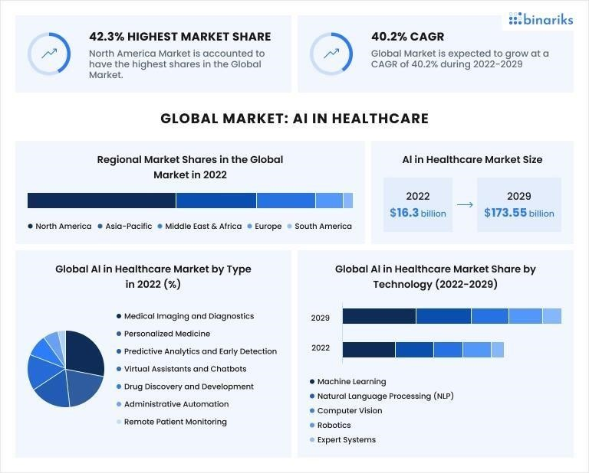

Fig:2 Relationship Between AI and healthcare

## D. Research Limitations

Research limitations to date regarding data collection from AI in healthcare are huge. One such major limitation is data quality: just one poor record and possibly an entire incomplete dataset can cancel out a perhaps well- conducted analysis, thus affecting the overall integrity of research. For example, if there are errors in electronic health records or patient data is absent, the conclusions drawn from such data would not reflect real life and, therefore, would undermine the strength of AI models.

Sample size and representation also play critical roles. A small sample size makes the results less generalizable; on the other hand, too narrow of a data set may miss the most crucially important demographic difference. This homogeneity, therefore leads to biased conclusions since the results obtained may not necessarily hold true for underrepresented groups. For instance, an AI model which is predominantly trained with data from one demographic group will fail at the test run on other population groups outside of this demographic and thereby perpetuate present health disparities.

Data privacy regulations add yet another layer of constraint in the gathering of data. As such, for example, while HIPAA protects patient confidentiality, similar restrictions will oftentimes prevent vast access to comprehensive data about a patient. Such a limitation could severely constrain researchers' ability to gather wide and diverse datasets, important for robust AI model training. Further, anonymization processes under such regulations can also remove important content, making the data less useful for nuanced analysis.

Temporal variations bring complexities to data gathering. Data gathered over a period may not represent the current scenario about health care practices or patient behavior, hence bringing in unrepresentative conclusions. Constant change in medical technology, treatment protocols, and health policies at a rapid pace may make the previously gathered data inappropriate, and datasets need to be updated constantly to represent their applicability. Without considering these temporal variations, AI models would become more or less irrelevant or unaligned with current health care situations.

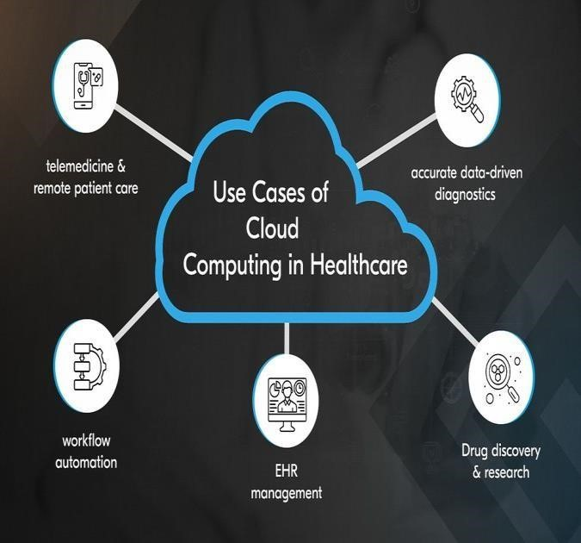

Fig:3 Cloud Governance Use Case Diagram for AI and healthcare0

TABLE I. IMPACT OF AI AND HEALTHCARE

|  |  |  |  |
| --- | --- | --- | --- |
| **AI and healthc are** | **Categories** | |  |
| ***Description*** | ***Benefits*** | ***Challenge***  ***s*** |
| AI in  Diagno sis | AI helps in the detection of diseases by using algorithms in analyzing medical data such as scans and tests, among others. | It helps  patients obtain  faster,  more accurate diagnoses and  reduces human error. | Data quality,  explainab  ility,  acceptanc  e by medical professio nals. |
| AI in  Treatm ent | Personalized treatment plans based on AI-driven insights gained from patient history and current data | More individu alized treatme  nts for patients | Ethical issues, AI  systems  are very expensive |
| AI in  Monito ring Patient s | The doctor can monitor the patient vitals round the clock and alert the doctor in real-time about any irregularity. | The  quality of patient care improves, while also reducing the workload on healthcare providers. | Data security, the dependabi lity of AI output prediction  s in case  of an  emergenc  y. |

# V. LIMITATIONS

While AI promises incredible potential to revolutionize healthcare delivery, its limitations must be acknowledged and addressed. Innovation will need to be balanced with an understanding of the ethics, regulatory requirements, and practical implementation challenges- critical elements in the actualization of AI within healthcare. Continuous collaboration between technologists, clinicians, policymakers, and patients will be necessary for such effective negotiation of these complexities.

## A. Data Quality Issues

This is the biggest challenge when effectively using AI in the health sector. One article on "Challenges in Implementing Machine Learning in Healthcare" (2019) by scholars stated that if the training is going to affect AI algorithm performance, it will have to be in terms of the quality and completeness of the data on which the AI algorithm was trained. More often than not, data in many healthcare settings may be inconsistent, incomplete or biased, leading to models which do not reflect actual real- world scenarios. For instance, wrong EHR input may be associated with wrong entry or variations in data collection among various entities that could reflect in the accuracy of algorithms for AI. Again, if the diversity of the patient population in the datasets fails to achieve various diversities, it could negatively impact models to generalize adequately and therefore lead to disparities in care and treatment outcomes.

## B. Lack of Interpretability

The lack of interpretability of AI models is one major deterrent to their adoption and usage in healthcare settings. Most of the current AI models, developed notably through deep learning techniques, are "black boxes," or opaque objects that provide little insight into how they arrive at certain predictions or decisions. The study "The Explainability Dilemma in Artificial Intelligence" 2020 stresses that this lack of transparency is likely to be harmful to the potential clinicians' ability to trust an AI recommendation since their understanding of the rationale behind any model's output would be wanting. In clinical decision-making where the decisions might have consequential effects on patients, this inability to interpret the AI-generated results will continue to raise skepticism and reluctance among healthcare professionals to integrate these technologies in their practice.

## C. Generalization Issues

Generalization problems pose a major challenge to AI development in health care and, hence, performance and fairness of AI-informed solutions. The work "Generalization in Machine Learning: Challenges and Solutions in Healthcare" (2019) reported that AI models generally perform very well on training datasets but are poor at generalizing their derived results to more diverse populations of patients. The main limitation of such developments may also lead to critical differences in effectiveness when it comes to treatment between different AI systems working in clinical settings differing from those in which the training took place. For example, a model that was learned over data generated from a predominantly young, urban population is unlikely to deliver any meaningful predictive outcomes for older, rural patients, because the model may be insensitive to differences in demographics, health conditions, or other social determinants of health. to integrate these technologies into their practice.

*D. Technical Performance Ethical Concerns* Critical issues in the use of AI are moral and should be addressed as a creation of responsibility in implementing AI and fostering trust among the users. In "Ethical

Challenges of Artificial Intelligence in Health Care" (2020), the authors outline diverse ethical issues concerning patient privacy, informed consent, and accountability of the technologies by AI. The more the AI systems deploy great amounts of patient data for training and decision-making, the higher the risk to patient information or health data privacy. Protecting sensitive health information while at the same time enabling AI systems to function effectively is a challenging task requiring robust data governance frameworks.

## E. Limited Regulatory Hurdles

An important regulatory challenge to the spread of AI across healthcare is uncertainty and complexity for developers and providers, but it has been identified that the rapidly changing nature of AI surpasses existing regulatory frameworks in ways that create gaps that can jeopardize patient safety and trust. As "Regulatory Challenges of Artificial Intelligence in Health Care" (2021) points out, another potential issue with the adoption of AI is how the very definition of what gets regulated is rapidly changing due to the ever-changing state of AI. Current regulations appear vague on the assessment of such AI systems, causing confusion among organizational compliance practices. This unclearness slows down the new innovation awaiting approval, and hence the integration in clinical practice will be delayed when urgency is required in innovations to better the care of patients.

# VI. CONCLUSION

AI in health care holds revolutionary potential for the transformation of patient outcomes, facilitation of processes, and presentation of customized medicine. However, issues related to data privacy, ethical considerations, and statutory regulatory mechanisms need appropriate and robust structuring and development. The benefits of AI include improved diagnosis, predictability analytics, and efficiency are evident. Such incorporation of these technologies into the health sector will call for thorough collaboration between clinicians, technologists, and policymakers in order to responsibly and equitably deploy AI in ways that result in an efficient and effective health care system.

*A. Major Findings*

Some of the key findings from the reviewed papers include:

Artificial Intelligence in Health Care: Looking to the Future: Ethics, Privacy, and Bias Authors: D. M. Obermeyer et al.

Published: 2019

Evidence: This paper highlights the potential ethical issues that AI technologies bring, mainly concerning algorithms involving potential issues of bias. The authors further outline, as steps in avoiding health disparities and inequalities in treatment, clear data sourcing and balanced training.

"Deep Learning for Health Care: Review, Opportunities,

and Threats" A. Esteva, et al.

Published: 2019

Evidence: This great review paper provides for an overall review of how deep learning can provide a means to better the diagnostic accuracy up to a certain extent, such as in radiology and dermatology. However, this paper is determined about the introduction of AI tools into the workflow at the clinical level and suggests that AI tools need to complement physician expertise rather than substitute.

"AI in Healthcare: Transforming the Future of Patient

Care"

Authors: C. D. Y. Lee et al.

Published: 2022

Evidence: The author referred to the potential of AI techniques by which administrative work could become less cumbersome, increase the involvement of patients in those procedures, and improve clinical outcomes. They proposed interdisciplinarity in order to implement and evaluate AI technologies better in a hospital setting.

Artificial Intelligence in Radiology: The Future is Here Authors: J. E. Geis, et al.

Published: 2020

Evidence: The role of AI in radiology in this paper was discussed: this has undoubtedly made tremendous contributions in image analysis and interpretation. The results of the case studies in which application of AI tools improved the diagnostic accuracy and efficiency of the diagnosis call for rigorous validation studies before widespread adoption.

1. *General Conclusions*

The introduction of AI into healthcare represents a paradigm shift in how medical professionals might diagnose, treat, and manage patient care. The literature reviewed underlines tremendous potential AI technologies carry for more effective clinical decision-making, increased diagnostic accuracy, and streamlined operational efficiencies. Based on studies, AI applications, including machine learning, natural language processing, and predictive analytics, can process huge volumes of data that may not be possible for human clinicians to analyze. In fact, there are cases in which AI may suggest insights or patterns that the human clinician may fail to notice. From the examples in radiology, AI has proved quite promising since it gives a level of precision that is as good as, if not better than, any human radiologist with earlier diagnosis and better patients' outcomes.

Nonetheless, the health-based application of AI brings its own set of problems. Ethical considerations abound, primarily concerning issues on data privacy, algorithmic bias, and patient consent. The potential of bias in AI algorithms compound healthcare's problems by focusing the disparities between its different aspects and applications. It begins to underscore the importance of transparent data sources with equitable model training. Among the lessons learned from many of the previous studies, it has been found that training AI systems on diverse and representative datasets results in better fair and effective healthcare solutions. At the same time, there are also several complexities surrounding AI in the legal and regulatory fronts accompanied by clear regulation safeguarding the rights of patients and imposing accountability in AI-driven decisions.

1. *Future Research Focus Areas*

Several areas have been indicated for research in the future based on the current gaps:

Areas of Future Research Based on Current Gaps

Bias Mitigation and Fairness: Research should focus on developing techniques for bias detection, measurement, and mitigation in AI algorithms, as well as the creation of diverse and representative datasets that promote equitable healthcare outcomes between different demographic populations.

Explainable AI: Explainability is a major requirement for clinical adoption of AI. Follow-up studies should have interpretability embedded within AI models to provide explanations for AI-generated recommendations to health professionals.

Integration with Clinical Workflows: Another very important area to consider for study is whether AI tools can be integrated effectively with existing healthcare systems. This includes the impacts that the integration of AI tools may have on clinician workflow, patient outcomes, and health care productivity.

Patient-Centric AI Solutions: Finally, future research also should study how AI can help interact and engage patients. A very important consideration should be development tools that may be presented to facilitate communication between the patient and the provider as well as applications that support health-self management.

Longitudinal studies on AI impact: Longitudinal studies will be required on the actual impact of AI interventions in care processes on real patients, outcomes, and cost of care. In this way, the feasibility and effectiveness of AI technologies can be understood.

Development of Strong Ethical Frameworks and

Regulation Structures: Scientific research is required to develop strong ethical guidelines and regulation structures that would govern the use of AI in healthcare. This could even go to the stage of developing specific implications for the use of AI systems about patient privacy, consent, and accountability in clinical decision-making.

# VII. REFERENCES

1. Esteva, A., Kuprel, B., Garg, M., et al. "Dermatologist- Level Classification of Skin Cancer with Deep Neural Networks." Nature, 2017, vol. 542, no. 7639, pp. 115-118. DOI: 10.1038/nature21056
2. Rajkomar, A., Dean, J., & Kohane, I. "Machine Learning in Medicine." New England Journal of Medicine, 2019,vol.380,no.14,pp.1347-1358.DOI:

10.1056/NEJMra1814256

1. Obermeyer, Z., & Emanuel, E. J. "Predicting the Future — Big Data, Machine Learning, and Clinical Medicine." New England Journal of Medicine, 2016, vol. 375, no. 13, pp. 1216-1219. DOI: 10.1056/NEJMp1606205
2. Wang, J. D. H., et al. (2021). "Natural Language Processing in Health Care: A Systematic Review." Journal of the American Medical Informatics Association, 28(5), 1089-1099. DOI: 10.1093/jamia/ocab011
3. Challen, R., Denny, J., et al. (2019). "Artificial Intelligence, Bias and Clinical Safety." Health Informatics Journal,25(4),1461-1475.DOI:

10.1177/1460458218783988

1. Kwon, J. M., & Lee, J. H. (2020). "AI-Based

Approaches in Healthcare: An Overview." Healthcare,

8(3), 328. DOI: 10.3390/healthcare8030328