**A STUDY ON WORKING CAPITAL MANAGEMENT WITH REFERENCE TO THE BHARAT HEAVY ELECTRICALS LIMITED HP&VP – VISAKAPATNAM**

**Addala Mounika Sri Lakshmi Sai Sowjanya - II MBA**

email. Id: monikasowjanya314@gmail.com

And

**Dr. B. V. R. Naidu, M.Com., MBA., Ph.D.,**

**Prof and HOD**

*Department of Management Studies*

**Godavari Institute of Engineering and Technology (Autonomous)**

**Rajamahendravaram, Andhra Pradesh, India**

email. Id: drnaidubandaru@gmail.com

**ABSTRACT**

Working capital management is important for a company's financial statements and performance. It helps a company maintain a balance between its current assets and liabilities, and ensure future solvency.  Working capital management aims to ensure that a company has enough cash to meet its short-term debt obligations and operating expenses. It also aims to invest a company's assets in the most successful direction possible. Working capital management involves tracking cash and cash needs, forecasting needs, monitoring cash balances, and optimizing cash flows.

The critical role of Working capital management in ensuring the financial health and operational efficiency of businesses. Effective management of working capital comprising inventory, accounts receivable, and accounts payable directly influences a company's liquidity, profitability, and overall performance. The findings underscore the necessity for companies to adopt a proactive approach to working capital, as it can enhance financial stability and competitive advantage in an ever-evolving business landscape. This paper aims to provide valuable insights for financial managers and decision-makers looking to improve their working capital strategies. BHEL follows rules and regulations to maintain a balance between current assets and liabilities. A study on BHEL found that the company has short term solvency and a satisfactory level of net working capital. The study also recommended that BHEL employees continuously work to improve the company's working capital position.

**\*\*\*\***

**KEYWORDS:** Working Capital Management, Current Assets & Liabilities, Financial Statements

**INTRODUCTION:**

Working capital management is concerned with the problems that arise in attempting to manage the current assets, current liabilities and the relationship that exists between them. The term current assets refer to those assets which in the ordinary course of business can be, or will be, converted into cash within one year without undergoing a diminution in value and without disrupting the operations of the firm. The major current assets are Cash, Marketable securities, Accounts receivables and Inventory. Current liabilities are those liabilities which are intended at their inception to be paid in the ordinary course of business, within a year, out of current assets or earnings of the concern. The basic current liabilities are accounts payable, bills payable, bank overdraft and outstanding expenses. The goal of working capital management is to manage the firms’ current assets and liabilities in such a way that a satisfactory level of working capital is maintained.

### **CONCEPTS OF WORKING CAPITAL:**

There are two concepts of working capital

* + 1. Balance Sheet Concept
    2. Operating Cycle or circular Flow concept

##### **BALANCE SHEET CONCEPT**

There are two interpretations of working capital under the balance sheet concept:

**Gross Working Capital:** Gross working capital refers to the firm’s investment in current assets. Current assets are the assets, which can be converted into cash with in an accounting year and include cash, short-term securities, debtors (accounts receivables or book debts), bills receivables and stock (inventory).

**Net Working Capital:** Net working capital refers to the difference between current assets and current liabilities. Current liabilities are those claims of outsiders which are expected to mature for payment with in an accounting year and include creditors (accounts payable), bills payable and outstanding expenses.

**𝑁𝑒𝑡 𝑊𝑜𝑟𝑘𝑖𝑛𝑔 𝐶𝑎𝑝𝑖𝑡𝑎𝑙 = 𝐶𝑢𝑟𝑟𝑒𝑛𝑡 𝐴𝑠𝑠𝑒𝑡𝑠 − 𝐶𝑢𝑟𝑟𝑒𝑛𝑡 𝐿𝑖𝑎𝑏𝑖𝑙𝑖𝑡𝑖𝑒𝑠**

Net working capital can be positive or negative. A positive working capital will arise when current assets exceed current liabilities. A negative working capital will occur when current liabilities are in excess of current assets.

### **OPERATING CYCLE OR CIRCULAR FLOW CONCEPT:**

Working capital refers to that part of firm’s capital which is required for financing short- term or current assets such as cash, inventories, marketable securities etc. Funds thus invested in current assets keep revolving fast and are being constantly converted into cash and this cash flows out again in exchange for other current assets. Hence it is also known as revolving or circulating capital. This concept is based upon working capital cycle of a firm. The cycle starts with purchase of raw material and other resources, its conversion into stock of finished goods through work in progress, conversion of finished goods into sales, debtors and ultimately realizing cash and it continues.

**INTRODUCTION TO INDUSTRY:**

The engineering sector is the largest segment of the overall Indian industrial sector. India has a strong engineering and capital goods base. The important groups within the engineering industry include machinery & instruments, primary and semi-finished iron & steel, steel bars & rods, non-ferrous metals, electronic goods and project exports. The engineering sector employs over 4 million skilled and semi-skilled workers (direct and indirect). The sector can be categorized into heavy engineering and light engineering segments. Heavy engineering segments forms the majority of the engineering sector in India. In the year 2003-04, out of the total engineering production of US$ 22 billion, the heavy engineering market contributed over 80 percent with the light engineering segment accounting for the remaining. India has a well-developed and diversified industrial machinery/capital base capable of manufacturing the entire range of industrial machinery. The industry has also managed to successfully developed advanced manufacturing. The industry has also managed to successfully developed advanced manufacturing technology over the years. Among the developing countries, India is a major exporter of heavy and light engineering goods, producing a wide range of items. The bulk of capital goods required for power project, fertilizer, and cement, steel and petrochemical plants and mining equipment are made in India. The country also makes construction machinery, equipment for irrigation project, diesel engines, tractors, transport vehicles, cotton textile and sugar mill machinery.

**ABOUT BHARAT HEAVY ELECTRICALS LIMITED HP & VP- VISAKHAPATNAM:**

“BHARAT HEAVY PLATES & VESSELS LIMITED”is established in 1966 at Visakhapatnam, Andhra Pradesh. At present it got merged with “BHARAT HEAVY ELECTRICALS LIMITED”and is renamed as BHARAT HEAVY ELECTRICALS LIMITED – HEAVY PLATES & VESSELS PLANT (BHEL-HP & VP).Now it became the 17th unit of BHEL and it is the first coastal unit of BHEL. Foreseeing the country’s need for an exclusive factory for fabricating heavy engineering equipment and with the main object of reducing dependence on foreign suppliers and become self-sufficient ourselves BHEL-HP&VP was established as a public limited company (a Govt. of India Undertaking). It is a job order/ shop production industry. According to customer specifications and requirements it produces various products. Thus, BHEL-HP&VP took birth in the year 1966 to meet the demands of process equipment for core industry like fertilizers, petrochemicals and oil refineries initially. Using different types of materials, BHEL-HP&VP manufactured and supplied several built equipment’s such as pressure vessels, heat exchangers, columns, internal trays etc. After executing some important orders, BHEL-HP&VP gained full confidence of customers which cleared the way to enter the line of cryogenic field, pulp cooking plant, evaporation plant and industrial boilers on a total turnkey basis which of later years helped in augmenting turnover of the company and increasing profitability.

In the liberalized economy of India and in the era of globalization a company must rethink its business mission and all functional strategies. In these days companies find themselves competing in a race where the road signs and rules keep on changing. Where there is no finish line, no “permanent win”. In these days when it is not “business as usual” companies can succeed only by having innovative ideas combined with effective financial management.

Therefore, it is not surprising that today’s winning companies are those which foresee the future and manage the finance effectively. One can manage finance effectively by managing working capital, capital structure and taking decision on capital budgeting. Ultimately, finance is at its best about value adding, developing new products and raising the world’s standards of living. The heavy engineering industry is a major strength of any economy. These heavy engineering industries which produce capital goods are the most modern of the entire industrial group.

### **LITERATURE REVIEW**

The research papers reviewed in this study is from 1974 to 2016 all research papers discussed about the working capital management. Working Capital Management deals with all the aspects of working capital of which in depth study has been carried out as discussed below.

Chakraborthy S. K. (1974) tries to distinguish cash working capital v/s balance sheet working capital. The analysis is based on the following dimensions: a) Working capital in common parlance b) Operating cycle concept b) Computation of operating cycle period in all the four cases. The purpose of the analysis is to demonstrate operating cycle concepts based on published annual reports of the firms.

Batra Gurdeep Singh (1999) gives an overview of working capital and its determinants. According to the author working capital management involves deciding upon the amount and composition of current assets and how to finance them. He emphasizes on the hedging approach to finance current assets. He also adds that a management can use ratio analysis of working capital as a means of checking upon the efficiency with which working capital is being used in the enterprises

Bhunia Amalendu (2010) has made an attempt to study the liquidity position of the private sector steel companies in India. Working capital determining the short-term liquidity position and short-term solvency of the firm and at the same time proper plan of profitability is also required for the business enterprises.

Kushal Appa S and Kunder Sharmila (2012) closely study the relationship between working capital management policies and profitability of the thirteen listed manufacturing firms in Ghana. At the end of the study, a significantly negative relationship between profitability and accounts receivable days is found to exist. Profitability is significantly positively influenced by the firm’s cash conversion cycle (CCC), current assets ratio and current asset turnover. It is also suggested that managers can create value for the shareholders by creating incentives to reduce their accounts receivable to 30 days.

Farrah Wahieda Kasiran, Noredi Azhar Mohamad, Othman chin (2016) closely study Working Capital Management Efficiency on the small medium enterprise in Malaysia utilization index is good; because most of the companies have >1 index value

**SCOPE OF THE STUDY:**

The significance of the study is evaluating The Working capital position of the Bharat Heavy Electricals Limited–Heavy Plates and Vessel Plant. The study provides the conceptual understanding of working capital. It also provides deep insights into fundamentals of working capital and various forces influencing the level of working capital requirement.

The working capital management study has been carried out to determine whether the company is in a position to raise the cash needed to meet the daily activities. The study reviews the performance of the company for the period of 5 years from 2019 to 2024, as revealed by the annual reports and other accounting records oh BHEL – HP&VP. The study also provides suggestions based upon findings. They may serve as for drawing cut the future plans for future.

**OBJECTIVES OF THE STUDY:**

The study has been under taken with the following objectives:

1. To know the importance of working capital management in the concern.
2. To examine optimum level of current assets and current liabilities of the company.
3. To know the liquidity position through various working capital related ratios.
4. To know the profitability of the firm through calculation of profitability ratios.
5. To know the sources and uses of working capital.
6. To suggest measures to increase the efficiency of working capital management.
7. To examine the overall operational efficiency and performance of BHEL-HP&VP.

**METHODOLOGY OF THE STUDY:**

The analysis of the project was based on the available information. Any information about the topic is called the data. The data was gathered from various sources i.e., Primary and Secondary sources.

#### **Type of Data:**

* + Primary Data
  + Secondary Data

**Primary Data:**

Any information that is collected afresh and for the first time is called Primary data. The primary data happen to be original in character. The Information is gathered from concerned employees. The employees and manager of the financial department have provided the information needed for the study.

**Secondary Data:**

Information which has already been collected by somebody else or some other agency with definite purpose and which has already been processed is called secondary data. The secondary data for the study have been gathered from annual reports, other books and manuals of the BHEL-HP&VP.

**RESULTS AND DISCUSSIONS:** The results of the study are discussed in the following tables

**TABLE – 5.1**

## **WORKING CAPITAL STATEMENT FOR A PERIOD OF FIVE YEARS 2019-20 TO 2023-24**

**(Rs. In lakhs)**

|  |  |  |  |  |  |
| --- | --- | --- | --- | --- | --- |
| **Particulars** | **2019-2020** | **2020-2021** | **2021-2022** | **2022-2023** | **2023- 2024** |
| **(A)Current Assets** |  |  |  |  |  |
| **Inventory** | 4569.06 | 5257.09 | 6699.86 | 5717.84 | 6211.15 |
| **Debtors** | 9320.91 | 9559.62 | 13834.62 | 18921.7 | 19569.83 |
| **Cash** | 1564.04 | 720.99 | 1069.14 | 2793.24 | 290.63 |
| **Loans** | 7213.09 | 8100.04 | 4884.59 | 4501.34 | 3373.89 |
| **Total of Current Assets** | 22667.10 | 23637.74 | 26488.21 | 31934.12 | 29445.50 |
| **(B)Current Liabilities** |  |  |  |  |  |
| **Creditors** | 3183.80 | 2845.31 | 4510.19 | 5223.71 | 11415.24 |
| **Deposits** | 805.39 | 863.15 | 956.82 | 1013.38 | - |
| **Advance from Customers** | 4164.61 | 5676.07 | 5301.82 | 4401.66 | 3132.76 |
| **Other liabilities** | 9638.72 | 8910.68 | 8935.89 | 10401.21 | 3438.04 |
| **Provisions** | 2109.55 | 2712.28 | 2870.09 | 3176.71 | 27390.5 |
| **Total of Current Liabilities** | 19902.07 | 21007.49 | 22574.81 | 24216.67 | 45376.54 |
| **Working Capital (CA- CL)** | 2765.03 | 2630.25 | 3913.40 | 7717.45 | -15931.04 |

**SOURCE:** **SOURCE:** Compiled from the annual reports of BHEL-HP&VP

**FIGURE 5.1**

**WORKING CAPITAL STATEMENT FOR A PERIOD OF FIVE YEARS 2019-20 TO 2023-24**

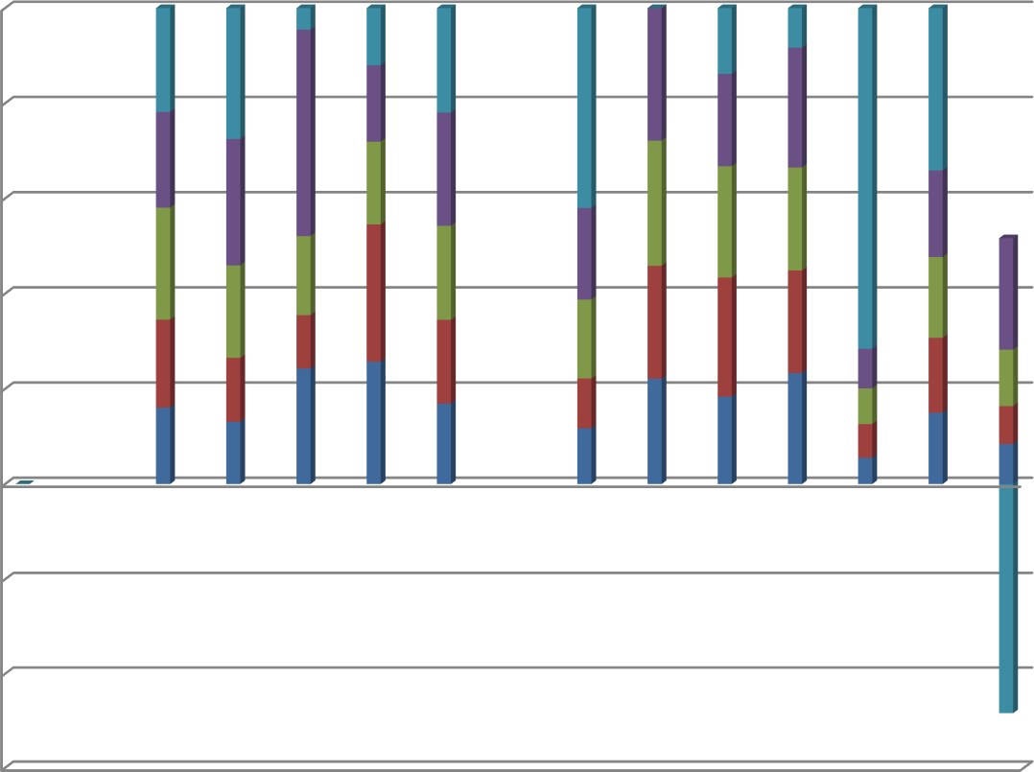

100%

80%

60%

40%

20%

0%

-20%

-40%

-60%

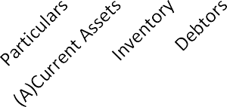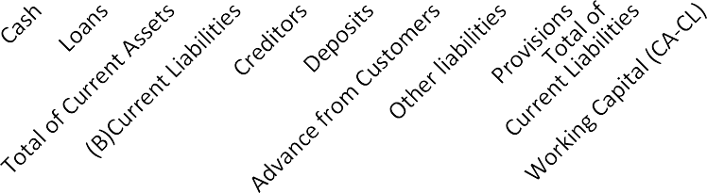

**SOURCE:** From the Table 5.1

During the 5-year period, the working capital position of BHEL-HP&VP is fluctuating. From the year 2019-20 to 2020-21 the working capital has been declined slightly. During 2021- 22 to 2023-24 the working capital showed an upward trend. From the above table we can observe that the net working capital i.e., difference between current assets and current liabilities is low in the year 2019-20 i.e., 2630.25 when compared to 2019-20 ie.,2765.03 and it was increased to 3913.40 and 7717.45 in the year 2020-21 and 2022-23 respectively. But there has been a great fall in working capital in the year 2023-24 i.e., -15931.04.

#### **TABLE-5.2**

#### **STATEMENT OF CHANGES IN WORKING CAPITAL OF BHEL-HP&VP FOR THE PERIOD 2022-2023 & 2023-2024**

**(Rs. In lakhs)**

|  |  |  |  |  |
| --- | --- | --- | --- | --- |
| **Particulars** | **2022-2023** | **2023-2024** | **Increase in working capital** | **Decrease in working capital** |
| **(A) Current Assets** |  |  |  |  |
| **Inventory** | 5717.84 | 6211.15 | 493.31 |  |
| **Debtors** | 18921.7 | 19569.83 | 648.13 |  |
| **Cash** | 2793.24 | 290.63 |  | 2502.61 |
| **Loans** | 4501.34 | 3373.89 |  | 1127.45 |
| **Total of Current Assets** | 31934.12 | 29445.50 |  |  |
| **(B) Current Liabilities** |  |  |  |  |
| **Creditors** | 5223.71 | 11415.24 |  | 6191.53 |
| **Deposits** | 1013.38 | - | 1013.38 | - |
| **Advance from Customers** | 4401.66 | 3132.76 | 1268.9 |  |
| **Other liabilities** | 10401.21 | 3438.04 | 6963.17 |  |
| **Provisions** | 3176.71 | 27390.5 |  | 24213.79 |
| **Total of Current Liabilities** | 24216.67 | 45376.54 |  |  |
| **Working Capital (CA- CL)** | 7717.45 | -15931.04 |  |  |
|  |  | 23648.49 | 23648.49 |  |
| **Total** | 7717.45 | 7717.45 | 34035.38 | 34035.38 |

**SOURCE:** Compiled from the annual reports of BHEL-HP&VP

**FIGURE 5.2**

#### **STATEMENT OF CHANGES IN NET WORKING CAPITAL IN THE YEARS 2022-2023& 2023-2024**

**10000**

**Working Capital**

**2022-2023**

**5000**

**0**

**-5000**

**-10000**

**-15000**

**-20000**

**2023-2024**

**YEARS**

**SOURCE:** From the Table 5.2

From the Table 5.2 we can observe that in between 2022-2023 & 2023-2024 the net working capital decreased from 7717.45 to -15931.04 because there is more increase in the current liabilities position i.e. Creditors and provisions and huge fall in cash reserves which reduces the working capital when compared to previous year.

#### **TABLE-5.3**

#### **STATEMENT OF CHANGES IN WORKING CAPITAL OF BHEL-HP&VP FOR THE PERIOD 2021-2022 TO 2022-2023**

**(Rs. In lakhs)**

|  |  |  |  |  |
| --- | --- | --- | --- | --- |
| **Particulars** | **2021-2022** | **2022-2023** | **Increase in working capital** | **Decrease in working capital** |
| **(A) Current Assets** |  |  |  |  |
| **Inventory** | 6699.86 | 5717.84 |  | 982.02 |
| **Debtors** | 13834.62 | 18921.7 | 5087.08 |  |
| **Cash** | 1069.14 | 2793.24 | 1724.1 |  |
| **Loans** | 4884.59 | 4501.34 |  | 383.25 |
| **Total of Current Assets** | 26488.21 | 31934.12 |  |  |
| **(B) Current Liabilities** |  |  |  |  |
| **Creditors** | 4510.19 | 5223.71 |  | 713.52 |
| **Deposits** | 956.82 | 1013.38 |  | 56.56 |
| **Advance from Customers** | 5301.82 | 4401.66 | 900.16 |  |
| **Other liabilities** | 8935.89 | 10401.21 |  | 1465.32 |
| **Provisions** | 2870.09 | 3176.71 |  | 306.62 |
| **Total of Current Liabilities** | 22574.81 | 24216.67 |  |  |
| **Working Capital (CA- CL)** | 3913.4 | 7717.45 |  |  |
|  | 3804.05 |  |  | 3804.05 |
| **Total** | 7717.45 | 7717.45 | 7711.34 | 7711.34 |

**SOURCE:** Compiled from the annual reports of BHEL-HP&VP

**FIGURE 5.3**

#### **STATEMENT OF CHANGES IN NET WORKING CAPITAL IN THE YEARS 2021-2022 & 2022-2023**

**Working**

**Capital**

**9000**

**8000**

**7000**

**6000**

**5000**

**4000**

**3000**

**2000**

**1000**

**0**

**2022-2023**

**2021-2022**

**Years**

**SOURCE:** From the Table 5.3

From the Table 5.3 we can observe that between 2021-2022 and 2022-2023 the net working capital position shows a ward upward trend i.e. because there is a more proportionate decrease in current assets position (inventory, debtors and loans advances) over the proportionate increase in current liabilities position (liabilities and provisions) which ultimately resulted in decrease in working capital position management at BHPVL during the above-mentioned period. During this period the current assets position is not satisfactory.

#### **TABLE-5.4**

#### **STATEMENT OF CHANGES IN WORKING CAPITAL OF BHEL-HP&VP FOR THE PERIOD 2020-2021 TO 2021-2022**

**(Rs. In lakhs)**

|  |  |  |  |  |
| --- | --- | --- | --- | --- |
| **Particulars** | **2020-2021** | **2021-2022** | **Increase in working capital** | **Decrease in working capital** |
| **(A)Current Assets** |  |  |  |  |
| **Inventory** | 5257.09 | 6699.86 | 1442.77 |  |
| **Debtors** | 9559.62 | 13834.62 | 4275 |  |
| **Cash** | 720.99 | 1069.14 | 348.15 |  |
| **Loans** | 8100.04 | 4884.59 |  | 3215.45 |
| **Total of Current Assets** | 23637.74 | 26488.21 |  |  |
| **(B)Current Liabilities** |  |  |  |  |
| **Creditors** | 2845.31 | 4510.19 |  | 1664.88 |
| **Deposits** | 863.15 | 956.82 |  | 93.67 |
| **Advance from Customers** | 5676.07 | 5301.82 | 374.25 |  |
| **Other liabilities** | 8910.68 | 8935.89 |  | 25.21 |
| **Provisions** | 2712.28 | 2870.09 |  | 157.81 |
| **Total of Current Liabilities** | 21007.49 | 22574.81 |  |  |
| **Working Capital (CA-CL)** | 2630.25 | 3913.4 |  |  |
|  | 1283.15 |  |  | 1283.15 |
| **Total** | 3913.4 | 3913.4 | 6440.17 | 6440.17 |

**SOURCE:** Compiled from the annual reports of BHEL-HP&VP

**FIGURE 5.4**

#### **STATEMENT OF CHANGES IN NET WORKING CAPITAL IN THE YEARS 2020-2021& 2021-2022**

**4500**

**2021-2022**

**4000**

**Working Capital**

**3500**

**3000**

**2020-2021**

**2500**

**2000**

**1500**

**1000**

**500**

**0**

**Years**

**SOURCE:** From the Table 5.4

From the Table 4 we can observe that between 2020-21 and 2021-22 the working capital position shows an upward trend i.e., 1283.15 because the increase in the current assets (Inventory and Debtors) is more than the increase in current liabilities (creditors) which ultimately increased the working capital.

#### **TABLE-5.5**

#### **STATEMENT OF CHANGES IN WORKING CAPITAL OF BHEL-HP&VP FOR THE PERIOD 2019-20 TO 2020-21**

**(Rs. In lakhs)**

|  |  |  |  |  |
| --- | --- | --- | --- | --- |
| **Particulars** | **2019-2020** | **2020-2021** | **Increase in working capital** | **Decrease in working capital** |
| **(A)Current Assets** |  |  |  |  |
| **Inventory** | 4569.06 | 5257.09 | 688.03 |  |
| **Debtors** | 9320.91 | 9559.62 | 238.71 |  |
| **Cash** | 1564.04 | 720.99 |  | 843.05 |
| **Loans** | 7213.09 | 8100.04 | 886.95 |  |
| **Total of Current Assets** | 22667.10 | 23637.74 |  |  |
| **(B)Current Liabilities** |  |  |  |  |
| **Creditors** | 3183.80 | 2845.31 | 338.49 |  |
| **Deposits** | 805.39 | 863.15 |  | 57.76 |
| **Advance from Customers** | 4164.61 | 5676.07 |  | 1511.46 |
| **Other liabilities** | 9638.72 | 8910.68 | 728.04 |  |
| **Provisions** | 2109.55 | 2712.28 |  | 602.73 |
| **Total of Current Liabilities** | 19902.07 | 21007.49 |  |  |
| **Working Capital (CA-CL)** | 2765.03 | 2630.25 |  |  |
|  |  | 134.78 | 134.78 |  |
| **Total** | 2765.03 | 2765.03 | 3015 | 3015 |

**SOURCE:** Compiled from the annual reports of BHEL-HP&VP

**FIGURE 5.5**

**STATEMENT OF CHANGES IN WORKING CAPITAL IN THE YEARS 2019-2020& 2020-2021**

**2800**

**Working Capital**

**2750**

**2700**

**2650**

**2600**

**2550**

**2019-2020 2020-2021**

**Years**

**SOURCE:** From the Table 5.5

From the Table-5.5 we can observe that between 2019-20 and 2020-21 the net working capital position shows a down ward trend i.e., 134.78 because there is a more proportionate decrease in current assets position (inventory and debtors) over the proportionate increase in current liabilities position (bonds repayable and interest accrued on loans) which ultimately resulted in decrease in working capital position posing a negative sign of working capital management at BHEL-HP&VP during the above mentioned period.

**FINDINGS:**

1. Between 2019-2020 & 2021-2022 the net working capital decreased from 7717.45 to -15931.04 because there is more increase in the current liabilities position i.e. Creditors and provisions and huge fall in cash reserves.
2. Between 2019-20 and 2021-22 the net working capital position showed a upward trend i.e. because there is more decrease in current assets position (inventory, debtors and loans advances) than increase in current liabilities position (liabilities and provisions).
3. Between 2020-21 and 2023-24 the working capital position showed a upward trend because the increase in the current assets (Inventory and Debtors) is more than the increase in current liabilities (creditors).
4. Between 2021-22 and 2022-23 the net working capital position showed a down ward trend because there is a more proportionate decrease in current assets position (inventory and debtors) over the proportionate increase in current liabilities position (bonds repayable and interest accrued on loans)
5. There is continuous increase in current ratio from 2022-23 to 2023-24 and it represents improvement in liquidity position of BHEL-HP&VP year after year but the liquidity position is not satisfactory since it is less than the ideal ratio.
6. Throughout the years the Quick ratio is more than 1:1 which indicates that BHEL- HP&VP have good amount of liquid assets.
7. The absolute liquid ratio is below the ideal ratio for the considered period. So BHEL-HP&VP need to improve its liquidity position.
8. The Inventory turnover ratio indicates the improper management of inventory which leads to the unnecessary blocking of working capital which is not good for the organization.
9. The Debtor turnover ratio implied that BHEL-HP&VP has inefficient management of debtors.
10. In the year 2022-2023 Working capital turnover ratio is -3.5 which indicates that the management failed to use working capital efficiently.

## **SUGGESTIONS**

* + 1. Interest free advances should be collected from the customers. With this the liquidity position improves.
    2. ABC analysis is to be followed for effective management of inventory. This is required because; the raw material portion is around 60% for every Rs 100 spent by the company.
    3. The company must follow best measures to collect the dues from debtors.
    4. In order to increase its production and profitability, BHEL-HP&VP has to secure more export orders. The company has to identify new export markets. Effort is to be made to earn more return on capital employed.
    5. There must be better coordination among purchase, production, marketing and financial divisions. This will help in achieving greater efficiency in inventory management.
    6. The marketing department can be further strengthened for order book of more legacy products.
    7. Implementation of SAP / ERP is immediate requirement in BHEL-HP&VP. This area must be concentrated especially keeping in view of high targets set by the company in the coming years.
    8. BHEL-HP&VP has to check the man power as per the requirement and existed at present.
    9. The cost control mechanism of the firm should be improved so that wasteful expenditure can be avoided and areas of costs reduction can be identified.

**CONCLUSION:**

The study on the working capital management of BHEL. was taken with a view to explore the scope for improvement of working capital management:

* + The study finds out company have got negative working capital past two years
  + The company can take a challenge with its competitive and high spirit to face the market.
  + Working capital position is good, but then there is always some scope improvement and growth
  + The due consideration to analysis, findings and suggestions the company can achieve further success in terms of increasing sales and profitability.
  + As with the minute changes that has been occurred in the ratios there can also be covered with slow increases in the sales
  + The study finds out the company has higher current liabilities. So, it is better to reduce the liabilities portion

**REFERENCE:**

1. ANNUAL REPORTS OF BHEL-HP&VP
2. MANAGEMENT ACCOUNTING - R.S.N. Pillai, Bhagavathi

3. FINANCIAL MANAGEMENT - R.K. Sharma and Shashi K. Gupta

4. FINANCIAL MANAGEMENT - Institute of Chartered Accountants of India.

5. JOURNALS AND MAGAZINES.

#### 6. **WEBSITES:** **www.bhel.com**

**www.google.com**