**A STUDY ON WORKING CAPITAL MANAGEMENT PRACTICES OF**

**K.C.P SUGERS & INDUSTRIAL CORPORTAION LTD, VUYYURU, AP., INDIA.**

**Abbisetti Bhumika Udaya Lakshmi, 2nd MBA**

Email ID: Bhumika.abbisetti@gmail.com

And

**Dr. Bandaru Venkata Reddi Naidu**, *M.Com., MBA., Ph.D.,*

## Professor & Head

*Department of management studies*

## Godavari Institute of Engineering and Technology(Autonomous)

## Rajahmahendravaram, Andhra Pradesh, India

Email ID: drnaidubandaru@gmail.com

**Abstract**

Financial Management is that managerial activity which is concerned with the planning and controlling of firm’s financial resources. Working Capital Management is an important tool of financial management. It helps to provide more information regarding financial operations. It deals with the management of all short-term assets and short-term liabilities. It helps to know about the day-to-day liquidity position of the company, and day to day operations of the company. All techniques will surround around the working capital management. It places an important role in financial management. Comparing all others techniques under financial management, it provides more information regarding the firm.To reach optimal working capital Management firm manager should control the trade-off between profitability and liquidity accurately. Efficient management of working capital is one of the pre- conditions for the success of an enterprise. From this point of view, the purpose of this study is to investigate the relationship between working capital management and profitability of K.C.P Sugers & Industrial Corportaion Ltd, Vuyyuru. In this study the effect of different variables of working capital management including the Cash conversion cycle and Current ratio on the profitability of the firm has been studied. The study shows that there is positive relationship between Current Ratio and Profitability of firms. This increasing the current ratio results into profitability increase.

# ***

Key words: profitability, current ratio, short-term liabilities.

**Introduction:**

The term financial management can be defined as the management of flow of funds in a firm and it deals with the financial decision making of the firm. It encompasses the procurement of the funds in the most economic and prudent manner and employment of these funds in the most optimum way to maximize the return for the owner. Broadly speaking, the financial management includes any decision made by a business/ investor that affects its finances. Financial Management is that managerial activity which is concerned with the planning and controlling of firm’s financial resources. Subject of financial management is of immense importance to academicians and managers. Managers are interested in this subject because among most crucial decisions of firm are those which relate to finance.

**Concept of Working Capital Management:**

Working Capital is what makes or breaks a business, and no business can run successfully without enough capital to cover both short- and long-term needs. Maintaining sufficient levels of short-term capital is a constantly ongoing challenge, and in today’s turbulent financial markets and uncertain business climate external financing has become both harder and more costly to obtain. Company is therefore increasingly shifting away from traditional sources of external financing and turning their eyes towards their own organizations for ways of improving liquidity. One efficient but often overlooked way of doing so is to reduce the amount of capital tied-up in operations, that is, to improve the working capital management of the company. Working capital is a financial metric of operating liquidity which describes the amount of cash tied up in operations and defines the short-term condition of a company. A positive working capital position is required for the continuous running of a company’s operations, i.e. to pay short term debt obligations and to cover operational expenses. A company with a negative working capital balance is unable to cover its short-term liabilities with its current assets.

## Indian Sugar Industry :

The sugar Industry Act 1932 was started to the sugar industry and for the cane growers. The government here after passed Central Sugarcane Act 1924 the state government fix minimum price for sugarcane to be paid by the sugar thorough subsidiary industries such is confectionery. Sugar cultivation and Suger industry occupies an important role in the Indian Economy. It is the second largest agro-processing industry to the economy. It comprises over 500 Mills in the private, public and cooperative sector with capital employed totaling Rs 50,000 crores and annual turnover of Rs 25,000 crores. The sector provides direct annual turnover of Rs 25,000 crores. The sector provides direct employment to over 5 lakh persons while nearly 4.5 crores farmers are engaged in cane cultivation an related activities. The various agencies distributive trade and thorough subsidiary Industries such is confectionery. It is also an important source of excise duty for central governement. In India sugar production started in 1903 with one factory each Bihar and U.P. The growth of sugar industry in the World War – 1 was rather slow and production capacity of sugar industry was not very significance with theon set of First World War. Sugar imports declined and indigenous sugar committee was set up in 1919 to suggest measures for its rapid growers.

**KCP Sugars &Industrial Corporation Ltd., :**

In the early thirties, Vuyyur was like any other Indian village, snore; slow and wedded to conventional ways of agriculture raising mostly, a single crop of the thirties is today enjoying a good boon, which is understandable. K.C.P Sugers & Industrial Corportaion Ltd, factory disburses in a radius of 40 Kms. The wards of many of the growers also get gainful employment in the sugar mill. Late Sri. Velagapudi Ramakrishna, the founder of K.C.P Sugers & Industrial Corportaion Ltd., encouraged and enthused the ryots of Krishna delta to take to sugarcane cultivation and start a sugar factory in the co-operative sector. His dream was realized with the establishment of co-operative sugar factory of 600 M.T. cane crushing capacity in the year 1936 at Vuyyur. Late Sri Adusumilli Gopala Krishnaiah, Late Sri Saheb of Vuyyur and late Sri Raja Saheb of Challapalli where some prominent personalities who took active could think much ahead the need for encouraging Agro – based industries. He part in establishing the sugar factory in co-operative sector. In the year 1941, when the co-operative venture failed, the K.C.P Sugers & Industrial Corportaion Ltd, acquired the sugar factory from Co-operative sector as going concern. The K.C.P. sugar factory earned a permanent place in the export of sugar from 1959 onwards. Raw sugar and white sugar being exported every by the K.C.P Sugers & Industrial Corportaion Ltd, between 10-50 per cent of its total production sugar export from the Vuyyur sugar factory due to non – profitability. Presently the sugar is being sold to tender basis at different places on with in the country.

**Literature review:**

**Lazaridis and Tryfonidis (2006)** corroborated these findings by studying Greek firms listed on the Athens Stock Exchange. They established that reducing the CCC leads to improved profitability, emphasizing the necessity of managing inventory and receivables efficiently.

**García-Teruel and Martínez-Solano (2007)** analyzed SMEs in Spain and demonstrated that minimizing working capital requirements significantly improves profitability. Their findings were echoed by Pais and Gama (2015) in the Portuguese SME sector, where efficient WCM strategies, including faster receivables turnover and shorter inventory periods, were shown to be crucial for firms with limited access to external financing.

**Raheman and Nasr (2007)** examined Pakistani firms and identified a strong negative relationship between WCM variables and profitability, advocating for a balanced approach to liquidity and growth. Similarly, **Mohamad and Saad (2010)** studied Malaysian firms and showed that market valuations are influenced by working capital policies, with aggressive strategies leading to higher profitability.

**Miller and Orr (1966)** introduced a groundbreaking cash management model that provided a mathematical framework for determining optimal cash balances, helping businesses reduce holding costs while ensuring sufficient liquidity.

**Scope of the Study :**

The area of the study is limited to K.C.P Sugers & Industrial Corportaion Ltd, the financial analysis and trends are all made within the scope of the company. And the data provided by the company is limited i.e., 2019-2023 five years balance sheets. The managers and guide in the organization has given limited information due to confidentiality.

**Objectives of the Study:**

The present study has been taken up to achieve the following objectives:

1. To study the profile of KCP Sugars & Industrial Corporation Ltd.
2. To study the theoretical aspects of working capital.
3. To examine the changes of working capital of the company.
4. To analyze profitability, liquidity position of the company.

**Methodology of Study :**

Methodology in research is the approach used to methodically address the research issue. Now that studies are conducted methodically, it may be seen as a science. A researcher would often follow procedures like those, as well as the reasoning behind them, when he or she is doing research on a particular subject.

**Primary Data :**

Primary data is information that is first-hand, never before used, and completely novel. Primary data may be backed up by questionnaires, surveys, in-person interviews, and other methods.

**Secondary Data:**

Secondary data refers to information that has already been gathered and kept. Records, journals, annual reports, etc., are all good sources of this kind of secondary data. It will reduce the resources used in gathering the data. Secondary sources such as periodicals, financial statements, books, etc., also provide access to useful information.

**Result Discussions:**

The results of the study are discussed in the following tables:

**Table-1**

**GROWTH OF NET WORKING CAPITAL OF KCP SUGARS &INDUSTRIAL CORPORATION LTD.,**

|  |  |
| --- | --- |
| **Year** | **Net Working Capital (Rs.)** |
| 2019-20 | 954629060 |
| 2020-21 | 1100453195 |
| 20221-22 | 1571313117 |
| 2022-23 | 1305801996 |
| 2023-24 | 1319978732 |

Source: Compiled from the annual reports of the KCP Sugars and Industrial Corporation Ltd

**Graph-1**

**NET WORKING CAPITAL**

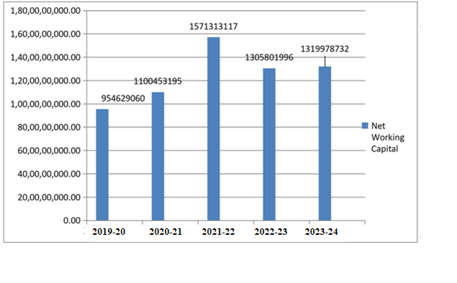

Source: Table.1

Table 1 Explains Growth of Net working capital of K.C.P Sugers & Industrial Corportaion Ltd, between 2019 and 2024. The chart clearly shows the net working capital is fluctuating. By observing the chart, the lowest working capital is noticed in the year of 2019-20 and the highest working capital is noticed in the year of 2021-22 and against it is decreased to “1319978732” in the year of 2023-24 among the five final year.

**Table-2**

**NET PROFIT RATIO OF KCP SUGARS &INDUSTRIAL CORPORATION LTD.,**

|  |  |  |  |
| --- | --- | --- | --- |
| **Year** | **Net profit**  **(Rs.)** | **Net Sales**  **(Rs.)** | **Net profit ratio**  **(%)** |
| 2019-20 | 264249562 | 2056754175 | 8.06 |
| 2020-21 | 387613081 | 3279517425 | 9.30 |
| 2021-22 | 276644491 | 4167768899 | 8.15 |
| 2022-23 | -161729515 | 3393930039 | -4.09 |
| 2023-24 | 87580826 | 3945149476 | 2.35 |

Source: Compiled from the Annual reports of the KCP Sugars and Industrial Corporation Ltd

**Graph-2**

**NET PROFIT RATIO**

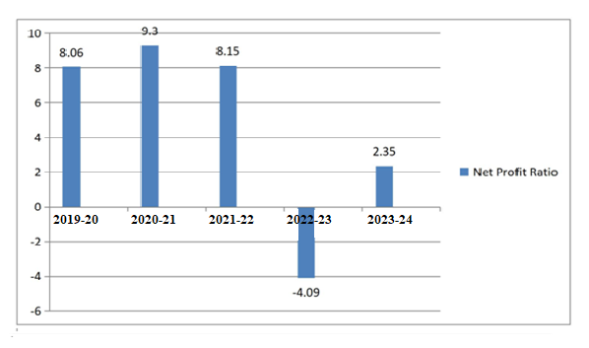

Source: Table.2

Table 2 Explains Net profit ratio of K.C.P Sugers & Industrial Corportaion Ltd, between 2019 and 2024. The chart clearly shows the net profit ratio has been noticed as 8.06% in the year 2019-20. It Increased to 9.3 per cent in the year 2020-21 Again it is decreased to 8.15% in the year 2021-22 from that year onwards it is decreasing and it decreased up to 2.35% in the year 2023-2024.

**Table-3**

**CURRENT RATIO OF KCP SUGARS &INDUSTRIAL CORPORATION LTD.,**

|  |  |  |  |
| --- | --- | --- | --- |
| Yar | Current Assets  (Rs.) | Current liabilities  (Rs.) | Current ratio  (%) |
| 2019-20 | 2747470236 | 1792841176 | 1.53 |
| 2020-21 | 2662456042 | 1562002847 | 1.70 |
| 2021-22 | 3330959581 | 1759646464 | 1.89 |
| 2022-23 | 2985652151 | 1679850155 | 1.77 |
| 2023-24 | 3456205742 | 2136227010 | 1.61 |

Source: Compiled from the Annual reports of the KCP Sugars and Industrial Corporation Ltd

**Graph-3**

**CURRENT RATIO**

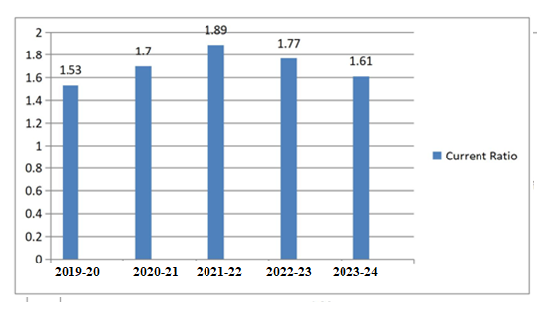

Source: Table.3

Table 3 Explains Current ratio of K.C.P Sugers & Industrial Corportaion Ltd, between 2019 and 2024. The chart clearly shows According to the company rule current ratio of 2:1 is considered satisfactory. The company is maintaining current ratio of 1.89 in the year of 2022-23 is very high as compare to other years. But it is very low in the year of 2023-24 i.e.,0.18.

**Table-4**

**QUICK RATIO OF KCP SUGARS &INDUSTRIAL CORPORATION LTD.,**

|  |  |  |  |
| --- | --- | --- | --- |
| **Year** | **Quick Assets**  **(Rs.)** | **Current Liabilities**  **(Rs.)** | **Quick Ratio**  **(%)** |
| 2019-20 | 468116576 | 1792841176 | 0.26 |
| 2020-21 | 491935463 | 1562002847 | 0.31 |
| 2021-22 | 523529876 | 1759646464 | 0.29 |
| 2022-23 | 582771186 | 1679850155 | 0.34 |
| 2023-24 | 781477944 | 2136227010 | 0.36 |

Source: Compiled from the Annual Reports of the KCP Sugars and Industrial Corporation Ltd

**Graph-4**

**QUICK RATIO**

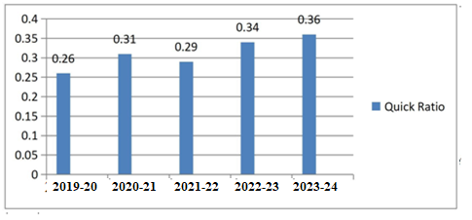

Source: Table 4

Table 4 Explains Quick ratio of K.C.P Sugers & Industrial Corportaion Ltd, between 2019 and 2024. The chart clearly shows Quick ratio of liquidity is 1:1 is considered as satisfactory. The company quick ratio is 0.36 in the year 2023-24 which is very high as compared to other financial years. The lowest company quick ratio is 0.26 occurred in the year of 2019-20. The Quick ratio maintained by the company is satisfactory because it is slowly reaching the standard ratio 1 :1.

**Table-5**

**WORKING CAPITAL TURNOVER RATIO OF KCP SUGARS &INDUSTRIAL CORPORATION LTD.,**

|  |  |  |  |
| --- | --- | --- | --- |
| **Year** | Net Sales  (Rs.) | Net Working Capital  (Rs.) | Working Capital  Turnover Ratio (%) |
| 2019-20 | 3279517425 | 954629060 | 3.43 |
| 2020-21 | 4167768899 | 1100453195 | 3.78 |
| 2021-22 | 3393930039 | 1571313117 | 2.15 |
| 2022-23 | 3945149476 | 1305801996 | 3.02 |
| 2023-24 | 3724577967 | 1319978732 | 2.82 |

Source: Compiled from the Annual reports of the KCP Sugars and Industrial Corporation Ltd

**Graph-5**

**WORKING CAPITAL TURN OVER RATIO**

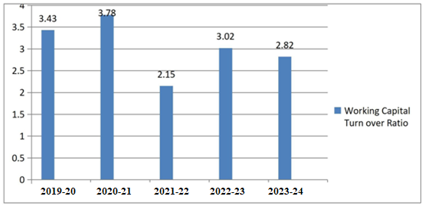

Source: Table 5

Table 5 Explains Working capital turn over ratio of K.C.P Sugers & Industrial Corportaion Ltd, between 2019 and 2024. The chart clearly shows According to convenrational rule a Working Capital Turnover Ratio of the company is maintaining Working Capital Turnover Ratio of 3.78 in the year 2020-21 is very high as compared to other financial years. But it is very low in the year 2021-22 with 2.15. Again, it was decreased to 2.82 in the year 2023-24.

**Findings:**

The Following are the Findings made frome the above Analysis .

* It is found that the cash and bank balance of the company was fluctuating very much over the period. The highest bank balance of the company was in the year 2023-24
* It is found that the company’s loans and advances were fluctuating very much during the study period.
* It is found that the company’s gross working capital was fluctuating very much over the study period. The highest gross working capital was in the year 2023-24 and the lowest gross working capital was in the year 2020-21
* It is found that the net working capital was fluctuating during the study period. The highest net working capital was occurred in the year 2021-22 And the lowest net working capital was in the year 2019-20
* It is found that the net profit ratio was also fluctuating during the study period. The highest net profit ratio was occurred in the year 2020-21. And the lowest net profit ratio was in the year 2022-23
* It is found that the net profit ratio was also fluctuating during the study period.
* It is found that the current ratio was fluctuating very much during the study period
* It is found that quick ratio or acid test ratio of the company never reached the ideal ratio 1:1. Liquid assets position was very poor in every year. The company didn’t have the ability to pay its short-term obligations.
* It is found that the working capital turnover ratio was varying very much during the study period. It was increased during the period of 2020-21 It is found that the debt equity was also fluctuating over all period. the highest debit equity ratio 2018-19. And the lowest debit equity ratio 2020-21
* It is found that the company’s debt equity was fluctuating during the study period.
* It is found that the sales products and services of the company were low in the year 2019-20 and then sales were high in the year 2020-21 The present position of the sales was decreased.

**Suggestions :**

* 1. It can be suggested that the company must maintain the proper and adequate cash and bank balance to meet its future operations and for its needs.
  2. It can be suggested that the company need to concentrate on the loans and advances.
  3. It can be suggested that the company must have to concentrate on the gross working capital while investing more in the current assets.
  4. It can be suggested that the company must concentrate on the operating cycle of the company in a more efficient manner.

**Conclusion :**

The KCP Sugar and Industrial Corporation Limited Is Leading mini sugar Mill and allo agro base winch Is locale It vendeurs in Krishna District of A.P. This has been running Under Professional management and allo production ide range of Sugars the présent study wasp undertaken to evaluate the financial performance of KCP Sugar Limited for the period of five years through financial ratio analysis the details regarding the financial performance of the company are the liquidity current to meet the contingencies the debt also creating problem of payment of high interest. The firm has been maintained high ratio inventory turnover i which is always desirable. The firm is unable to set more percentage of grow profit on sales due to high cost production. Which is effected net earnings of the company on every year. The firm has not been obtained more net profit and in some years the firm incurred net losses also due to high burden of Interest and taxes.

**References :**

1. Filbeck, G., & Krueger, T. M. (2005). An analysis of working capital management results across industries. *American journal of business*, *20*(2), 11-20.
2. Pratap Singh, H., & Kumar, S. (2014). Working capital management: a literature review and research agenda. *Qualitative Research in Financial Markets*, *6*(2), 173-197.
3. Preve, L., & Sarria-Allende, V. (2010). *Working capital management*. Oxford University Press.
4. www.kcpsugars.com.