# A STUDY ON TRAINING AND DEVELOPMENT PRACTICES OF

# ANDHRA PRADESH PAPER MILLS LIMITED, RAJAMAHENDRAVARAM

**Boyidi Swamy, 2nd MBA**

Email ID: **swamiboyidi@gmail.com**

**And**

**Dr. PRK Raju**

**Professor (DMS)&Director (Skill development)**

*Department of management studies*

**Godavari Institute of Engineering and Technology (Autonomous)**

**Rajahmahendravaram, Andhra Pradesh, India**

Email ID:prkraju008@gmail.com

**Abstract**

This project explores the role and impact of training and development within organizations, focusing on how effective programs can improve employee performance, enhance job satisfaction, and support overall organizational goals. The research investigates various training methods, including on-the-job training, workshops, e-learning, and mentoring, evaluating their effectiveness in skill enhancement and knowledge transfer. Through a combination of literature review, case studies, and employee feedback analysis, this study highlights best practices for designing and implementing successful training programs. Findings suggest that when tailored to individual and organizational needs, training initiatives not only increase productivity but also reduce turnover rates, creating a positive workplace culture and fostering long-term professional growth. The project concludes with recommendations for aligning training programs with strategic business objectives and using continuous evaluation to adapt to evolving workforce demands.

*****

KEYWORDS: Training, Development, Organization, Effectiveness.

**Introduction:**

Management of Human Resources, as a subject of study even though of relatively recent origin-the concept upon which the theory is based –dates back to 400 BC. The Chinese as early as 1650 BC had originated the ‘Principle of Division’ of labour (specialization). The ‘span of management’ and the related concepts of organization were well understood by Moses around 1200 BC. In India, Kautilya observed a sound base for systematic management of human resources, as early as 4th century BC. Prior to Industrial Revolution, the status of labour was extremely low and the human relationships among the employees were characterized by slavery, serfdom and the guild system. The guild system involving the master craftsmen (the owner), the journeyman (the traveling worker) and the apprentice marked the beginning of HRM for selection, training and development of workers and emergence of collective bargaining for wages and working conditions.

**Training and development:**

Training and Development in Human Resource Management is the process of acquiring knowledge, skills, and attitude that helps improve employees’ job performance and enables future career growth. Training refers to acquiring specific knowledge and skills for a particular job or task. It is usually a short-term activity concerned with improving an employee’s current job performance. It includes formal training courses, on-the-job training, or coaching sessions. Development is concerned with the long-term growth of an individual’s career. It usually covers acquiring knowledge that goes beyond the requirements of their current job to prepare the employees for their future job role or career advancement opportunities. Development activities include job shadowing, mentoring, attending conferences, or pursuing further education. Employees can enhance their job performance, career growth, and job satisfaction through training and development. In contrast, organizations can benefit from better employee engagement, retention and higher productivity. Effective training and development programs can improve employee performance, increase productivity, and help organizations remain competitive in today’s dynamic business environment. Human Resource Management plays a vital role in designing efficient employees training and development programs.

**Indian Paper Industry:**

Paper, which is manufactured from wood fibre, is the wildly used medium for communication even in this computer-dominated era. China is the origin of paper in its current form though the Egyptians used a paper like substance called pipes in 4000 BC. Three countries, viz., USA, Japan and China account for nearly half the global paper production and consumption: in the world. Indian industries contribution to the global paper production is presently just two percent. This offers a good potential for the paper makers in India. The signs are already visible as the industry is growing at a faster rate in India (around five percent per year) than in the rest of the world (around three percent) The report analyses the state of Indian paper industry in detail. Starting with a brief introduction about the paper industry, the report tracks its history, with emphasis on facts like raw materials scenario in India, role of forestry, the manufacturing processes. Importance of pulp and classification of paper products etc. A comprehensive comparison of Indian paper industry with global industry is given to substantiate the fact that vast potential exists for paper manufacturers in India. The report features demand and supply analysis for pulp, paper and paperboards and newsprint along with a detailed analysis of the user industries of paper. The level of imports and its significance in Indian paper market and negligible paper exports from India have been analysed in good measure. The main reason for poor export is the lack of quality paper producers in India. This indirectly implies that quality paper makers can effectively use India as base for their operation as the other conditions are positive. This facet has been substantiated by requisite analysis.

**Andhra paper limited:**

Andhra Paper Limited; situated on the bank of river Godavari is one of the oldest and at the same time most modern paper units in the country today. The history of the Andhra Paper mills Ltd dates back to 1924. In 1921 a retired Forest officer proposed to set up the paper mill in Rajahmundry before there was no paper mill in Andhra Pradesh and southern region also. The construction work was going in 3 years i.e., up to 1924 it started its production with a capacity of 1 ton per day under the name of ‘“CARNATIC PAPER MILL AND COMPANY LIMITED”. After the independence it came under the state govt. in 1953 and functioned as “Andhra Paper Limited” with 10 tonnes per day capacity under the reigns of the A.P government during 1956-64. On June 29th 1964 it saw incorporated as one of the first joint sectors companies under the stewardship of the Bangor group with its present popular name “The Andhra Pradesh Mills Limited”. Since then, it has been making rapid strides in its growth by taking up several expansion projects concurrently and attained the status of one of the biggest paper mills in the country today with installed capacity of 92,500 TPA. The company uses 80-85% hard wood and 15-20% bamboo as the fibrous raw materials. Versatile Kraft pulping process is being adopted in this mill. The company has produced 84,237 tonnes of paper during 1994-95. The govt. of India in recognition of the excellent capacity utilization has reindorsed the industrial license for the expansion of the capacity up to 1, 46,477 TPA**.**

**Literature review:**

**Gary Dessler's 2020** is a foundational text that highlights the strategic role of T&D in achieving organizational goals. Key contributions include: Emphasizing the importance of needs analysis to align training programs with organizational objectives. Advocating for blended learning approaches that combine traditional and digital methods.

**Raymond A. 2022**, focuses on the role of training in employee growth. Key insights include: Detailed frameworks for designing effective training programs. The concept of experiential learning, where employees learn through real-world tasks. A discussion on mentoring and coaching as integral components of employee development.

**Salas et al. 2012** have conducted extensive research on team training and its impact on organizational performance: Identified key components for effective team training, including clear goals, role clarity, and communication skills. Stressed the importance of post-training reinforcement to sustain learning outcomes.

**Garvan and colleagues 2020** focus on strategic human resource development (SHRD), linking T&D to broader organizational strategy: Emphasize the role of leadership in fostering a culture of continuous learning. Discuss emerging trends like digital learning and their implications for workforce development.

**Scope of the study:**

To know and understand how Andhra Pradesh papers limited Unit: Rajahmundry is following the HRD functions especially Training and Development and to evaluate the effectiveness of training and development programmes. The scope of the present study is as follows:

* Visiting the plant.
* Meet the HR Managers and the Asst. Managers to know the employee profile.
* Meet the training Managers to collect the details of employee training techniques and related data that are in practice.
* Participated in the meeting conducted by the allotted guide in the organisation.
* Research included only two years report i.e. 2021-22 and 2022-23.
* Around 2000 employees in that paper board unit of Andhra Pradesh papers limited Unit: Rajahmundry100 employees at a random are considered for the study.
* Library, training records of previous year and the internal magazine (spring board) of Andhra paper mills Limited; Unit: Rajahmundry are used for the study.

**Need for the study:**

* This study analyses the training and development activities taken up by the organization.
* Stipulate information to diagnose deficiency in employees regarding skill, knowledge; determine training & development needs & to prescribe the means for employee growth, which provides information for placement.
* Now a days it is very important for the HR Managers to achieve their objectives in the company.
* The need for training and development arises right from the initial stages of recruitment. The organisation recruits new talents to work in their organisation. They are to be trained properly so that they can get practical experience of their work.
* The need for development arises when the already trained employees are required to refine their skills so that can be made suitable to serve the organisation in a multi-dimensional way.

**Objectives of the present study:**

1.To analysis the present training and development in the organization

2.To study the employee attitude towards the training program

3.To find out obstacles of the training programs

4.To know whether there is any development change in the mindset of the Employees after training and development programs.

5.To understand whether there is any positive improvement in interpersonal skills of the employees.

**Methodology:**

Training and development play a very important role in every organisation. It is an integral function of Human resource development. It is regarded as a means of achieving the highest level of efficiency from the employees by providing them the necessary skills needed for the job. It is a continuous process in every organization. So, to know and understand or to analyse the training techniques adopted and procedure followed in evaluating the effectiveness of training and development in Andhra Pradesh Paper mills Limited; Unit: Rajahmundry.

**Primary Data:**

The majority of the data relating to functioning of training and development in Andhra Pradesh Paper mills Limited; Unit: Rajahmundry is drawn from primary sources. The questionnaires are administered to the respondents and the relevant information is gathered from the responses.

**Secondary Data:**

The secondary data has been collected from annual reports, partly from records, company magazines and library sources. Some information is also gathered through personal talks with the concerned officials.

**Result Discussions:**

The results of the study are discussed in the following tables:

1. Employees opinion on importance of training programme to improve the productivity

**Table-1**

|  |  |  |  |
| --- | --- | --- | --- |
| **S.no** | **Item of scale** | **No. Of respondents** | **In (%)** |
| 1 | Strongly agree | 31 | 31% |
| 2 | Agree | 67 | 67% |
| 3 | Disagree | 2 | 2% |
| 4 | Strongly disagree | 0 | 0% |
|  | Total | 100 | 100 % |

Source: compiled from the questionnaire

**Graph-1**

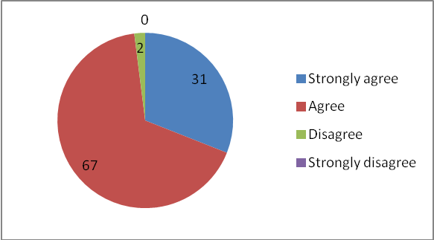

Source: Table-1

Table-1 explain the Most of the employees up to 67% have agreed to the fact that Education & Training helped them to increase the ability to perform at their best to increase the productivity. The track record of the also indicates the same thing.

2.employees’ opinion on extension on training program in competitive atmosphere

|  |  |  |  |
| --- | --- | --- | --- |
| S.no | Items of scale | No. Of respondents | In (%) |
| 1 | Large extent | 55 | 55% |
| 2 | Small extent | 44 | 44% |
| 3 | Very little extent | 1 | 1% |
| 4 | Not at all | 0 | 0% |
|  | Total | 100 | 100 % |

**Table-2**

Source: compiled from the questionnaire

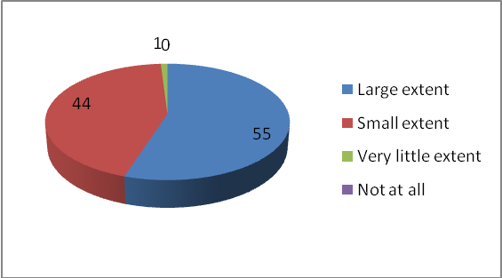 **Graph-2**

Source: Table-2

Table-2 explains the response of 55% acceptance to a large extent indicates that the trainings given increases competent atmosphere in the organization, this also helps in improving skill levels.

1. Employees opinion on training programme volunteer attendance

**Table-3**

|  |  |  |  |
| --- | --- | --- | --- |
| S.no | Items of scale | No. Of respondents | In (%) |
| 1. | Yes | 98 | 98% |
| 2. | No | 2 | 2% |
|  | Total | 100 | 100% |

Source: compiled from the questionnaire

**Graph-3**

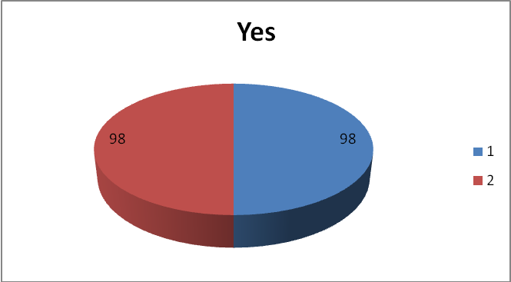

Source: Table-3

Table-3 explain the Motivational levels in Andhra Pradesh Limited; Unit Rajahmundry are high which encourages the employees in attending the training program and get benefitted from it.

4. Employees opinion on requirement training programmes

|  |  |  |  |
| --- | --- | --- | --- |
| S. No | Items of scale | No. of respondents | In (%) |
| 1 | Related to job | 26 | 26% |
| 2 | Personal development | 7 | 7% |
| 3 | Communication skills | 20 | 20% |
| 4 | All the above | 47 | 47% |
|  | TOTAL | 100 | 100 % |

**Table-4**

Source: compiled from the questionnaire

**Graph-4**

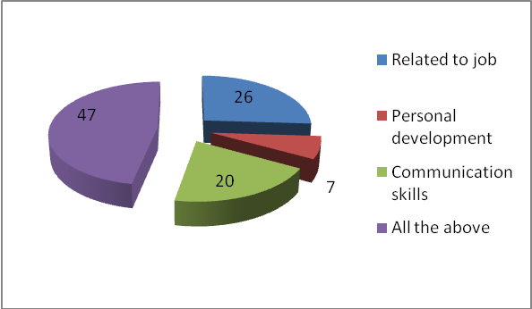

Source: Table-4

Table-4 explains the participants expressed the view of getting training in all the aspects of personal development, communication skills and also related to their job.

5. Employees opinion on working conditions that is safety and productivity

|  |  |  |  |
| --- | --- | --- | --- |
|  | Items of scale | Respondents | In (%) |
| 1 | 100% | 45 | 45% |
| 2 | 80% | 37 | 37% |
| 3 | 60% | 13 | 13% |
| 4 | 40% | 5 | 5% |
|  | Total | 100 | 100% |

**Table-5**

Source: compiled from the questionnaire

**Graph-5**

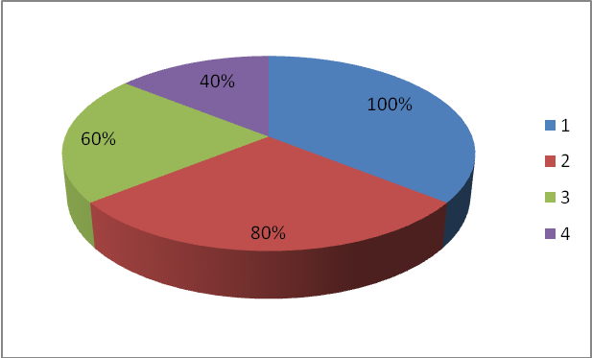

Source: Table-5

Table-5 explains the According to the of view of the respondents, the TPM initiative alone can’t serve the purpose of improving plant-working conditions, safety & productivity.

**FINDINGS:**

The Following are the Findings made from the above Analysis.

* Most of the employees agreed to the fact that Education & Training helped them to increase the ability to perform at their best to increase the productivity. The track record of the Andhra Pradesh paper mills limited Rajahmundry also indicates the same thing.
* The response indicates that the trainings given increases competent atmosphere in the organization, this also helps in improving skill levels.
* Motivational levels in Andhra Pradesh paper mills Ltd Rajahmundry are high which encourages the employees in attending the training program and get benefited from it.
* The participants expressed the view of getting training in all the aspects of personal development, communication skills and also related to their job.
* The View of the respondents is that the TPM initiative alone can’t serve the purpose of improving plant-working conditions, safety & productivity.
* All the respondents agreed to the point that the material available for the training is adequate and quantitative.
* The participants in the survey totally agreed that the practice sessions during the training help them to a great extent in enhancing their skills.

**SUGGESTIONS**

To the organisation point of view:

* The organization should note that the training programs did not prove stressful and hence should encourage the employees to attend training.
* Training session must be made more interactive.
* Training material must be in the form of multimedia presentation.
* More number of trainings related to job responsibilities is to be given.

To the Employees point of view:

* Regular attendance of training sessions.
* Avoid absenteeism and a positive attitude should be developed in respect of training programmes.
* Believe in themselves and should trust the management that they bring good results with whatever function they perform.

**CONCLUSION:**

All the respondents are satisfied with the training programs conducted in the ANDHRA PRADESH PAPER MILLS LIMITED UNIT: RAJAHMUNDRY. The courses and training and development activities are interesting, interactive and enlightens the staff members. The faculty was well experienced and were able to communicate effectively. All the employees are well aware of the goals and standards of the work to be done in the organization. Training is the main pillar of TPM (Total productivity maintenance), it improves skills among employees.

**References:**

Author Book Name

L.M. Prasad (2007) -Human Resource management

P. Subba Rao (2010 -Essentials of HRM and IR

C. B. Memoria (1994) -Personnel Management

Mahanthappa (2010) -Human Resource & Management

C.B. Memoria (2016) -Dynamics of industrial relations

Deepak Kumar Bhattacharya (2008) - Human Resource management

**WEBSITE:**

* www.andhrapaper.com
* www.andhratrainingmannual.com
* www.andhracalendarofcompany.com