**A STUDY ON FINANCIAL PERFORMANCE OF LOANS AND ADVANCES DIVISIN OF IDBI BANK,VIJAYAWADA**

**Bangaru Venkata Mani Raj, MBA 2nd year**

Email ID : manirajbangaru804@gmail.com

And

**Dr. Bandaru Venkata Reddi Naidu**, *M.Com, MBA, Ph.D.,*

**Professor & Head**

Department of Management Studies

Godavari Institute of Engineering and Technology (Autonomous)

Rajamahendravaram, Andhra Pradesh, India.

Email ID: [drnaidubandaru@gmail.com](mailto:drnaidubandaru@gmail.com)

**ABSTRACT**

In order to accomplish its goals, every business must employ a staff that is both capable and experienced. The degree of expertise required in the workplace must rise, as must workers' adaptability and flexibility. Investment in employee Training and Development is not just a good idea, but a must for any company that wants to keep its workforce competitive and well-informed. The purpose of the research was to determine how successful financial performances and strategies are in improving the knowledge and skills of staff members at the IDBI Bank The information was gathered from 100 workers who were chosen at random. Currently Working at the IDBI Bank. The goal of this effort has been to compile a body of information on financial performance that may be used as a resource by anyone doing.

**\*\*\***

KEYWORDS: Finance, loans and Advancements, Organization, Effectiveness.

### INTRODUCTION

### Financial Management is about preparing, directing and managing the money activities of a company such as buying, selling and using money to its best results to maximize wealth or produce best value for money. It is basically applying general management concepts to the cash of the company. Financial Management can also be defined as – The management of the finances of a business / organization in order to achieve financial objectives

### “Financial management is concerned with raising financial resources and their effective utilization towards achieving the organizational goals” Dr. S. Maheshwari

### “Financial management is the process of putting the available funds to the best advantage from the long-term point of view of business objectives” Richard A. Brealey

### It is crucial for both public and private sector organizations.

### Scenario of Banking Industry:

Banks are the most significant players in the Indian financial market. They are the biggest purveyors of credit, and they also attract most of the savings from the population. Dominated by public sector, the banking industry has so far acted as an efficient partner in the growth and the development of the country. Driven by the socialist ideologies and the welfare state concept, public sector banks have long been the supporters of agriculture and other priority sectors. They act as crucial channels of the government in its efforts to ensure equitable economic development.

The Indian banking can be broadly categorized into nationalized (government owned), private banks and specialized banking institutions. The Reserve Bank of India acts a centralized body monitoring any discrepancies and shortcoming in the system. Since the nationalization of banks in 1969, the public sector banks or the nationalized banks have acquired a place of prominence and has since then seen tremendous progress. The need to become highly customer focused has forced the slow-moving public sector banks to adopt a fast-track approach. The unleashing of products and services through the net has galvanized players at all levels of the banking and financial institutions market grid to look anew at their existing portfolio offering.

**PROFILE OF BAJAJ ALLIANZ LIFE INSURANCE ;-**

Industrial Development Bank of India (IDBI) was constituted under the Industrial Development Bank of India Act, 1964 as a Development Financial Institution (DFI) and came into being on July 01, 1964, vide GoI notification dated June 22, 1964.

Industrial Development Bank of India Limited In response to the felt need and on commercial prudence, it was decided to transform IDBI into a Bank. Accordingly, by virtue of the Industrial Development Bank of India (Transfer of Undertaking and Repeal) Act, 2003 (hereinafter referred to as “the Transfer Act”) read with Notification dated 29.09.2004 issued by the Central Government in exercise of the powers conferred under Section 3 (1) of the Transfer Act, Industrial Development Bank of India Act, 1964 was repealed and the business and undertaking of IDBI was transferred to and vested in a company by name Industrial Development Bank of India Limited, with effect from 01.10.2004. Amalgamation of IDBI Bank Ltd. with IDBI Ltd. Towards achieving the faster inorganic growth of the Bank, IDBI Bank Ltd., a wholly owned subsidiary of IDBI Ltd. was amalgamated with IDBI Ltd. in terms of the provisions of Section 44A of the Banking Regulation Act, 1949 providing for voluntary amalgamation of two banking companies. The amalgamation became effective from April 02, 2005.

Our mission is to be "a World Class Indian Bank", benchmarking ourselves against international standards and best practices in terms of product offerings, technology, service levels, risk management and audit & compliance. The objective is to build sound customer franchises across distinct businesses so as to be a preferred provider of banking services for target retail and wholesale customer segments, and to achieve a healthy growth in profitability, consistent with the Bank's risk appetite. We are committed to do this while ensuring the highest levels of ethical standards, professional integrity, corporate governance and regulatory compliance.

**LITERATURE AND REVIEW;**-

**Alexander Wall (1919):** One of the earliest advocates for ratio analysis, Wall discussed its role in understanding the financial condition of companies, emphasizing its importance in detecting trends in financial health.

**Horrigan (1968)**: In his seminal work, *A Short History of Financial Ratio Analysis*, Horrigan reviewed the historical development of ratio analysis and its transition from mere descriptive tools to predictive tools.

**Altman (1968)**: Developed the Altman Z-Score model, combining various financial ratios into a single predictive metric for bankruptcy.

**Lev and Sunder (1979)**: Questioned the reliability of ratio analysis, particularly when applied across industries with differing norms and benchmarks.

**Brigham and Houston (2016)**: In their book, *Fundamentals of Financial Management*, they highlighted the application of ratio analysis across industries, focusing on liquidity, profitability, and solvency ratios.

**NEED OF THE STUDY ;-**

In India out of the institutional sources of finance, co-operatives have been regarded as the most desirable form of institutional credit for agricultural and it occupies a unique place Credit provided by those banks has catalyzed the process of agriculture development more particular through the creation of irrigation facilities farm mechanization energization of pump sets land development moisture conservation and horticulture plantation and forestry development investment credit together with production credit helped a large number of farmers use high yielding variety seeds (HYV), fertilizers, pesticides, irrigation which ultimately reflected on sizeable production of crops, fruits, vegetables. Similarly animal husbandry including dairy, poultry and fishery development too got tremendous boost. Post harvest facilities supporting hi-tech projects in the area of floriculture, mushroom, aquaculture, and tissue culture, ago-processing also started receiving attention.

**OBJECTIVES OF THE STUDY ;-**

The objective of the study of loans and advances are: -

1. To assess the past, present and future earnings capacity profitability.

2. To study financial stability of the bank.

3. To assess the performances of the bank.

4. To know the key performances indicators focused by bank especially on loans and advances.

5. To study the operational efficiency of the bank as a whole and its various parts of departments.

**METHODOLOGY OF THE STUDY;-**

The research design and methodology are the specification of procedure for collection and analyzing the data necessary to help co identify to react to a problem of opportunity such that the difference between the cost of obtaining various levels of accuracy and their expected value of the information associated with each level of accuracy is maximize.

### Primary data:

Data used in research originally obtained through the direct efforts of the Researcher through surveys, interviews and direct observation. Primary data is More costly to obtain than secondary data, which is obtained through published Sources, but it is also more current and more relevant to the research project.

### Secondary data:

Information that has been collected by someone else but is being used for your Research is secondary data. The census can be an example of secondary data -- it is The Result of questions asked over many years.

### RESULTS DISCUSSION

##### **Table - 5.1**

**SHORT TERM AGRICULTURAL LOANS**

| **Years** | 2019-20 | 2020-21 | 2021-22 | 2022-23 |
| --- | --- | --- | --- | --- |
| **Amount** | 4842.74 | 5151.64 | 6061.04 | 6246.23 |

Source: Primary data

**CHART - 1**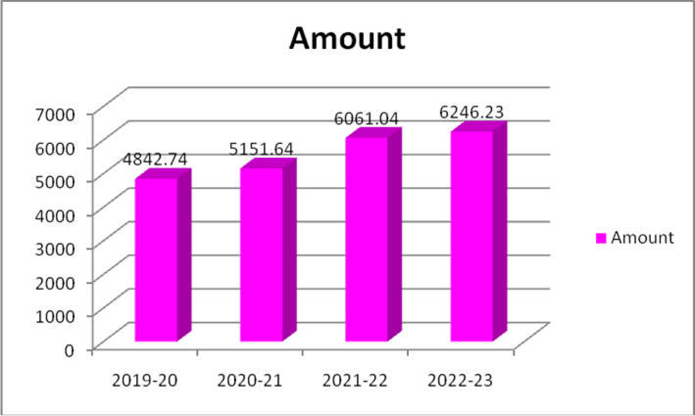

Source table 5.1 short term agricultural loans

Table 5.1 explains that the above graph is showing the amount sanctioned by the bank towards short term agriculture loans. Every year bank participation in the helping of the formers by giving more amounts to them. In the year 22-23 an amount of 6246.23 lakhs disbursed to the formers. Nearly 185.19 lakh rupees additional amount is given for short term agriculture sector in comparison with the last year.

##### **Table No: 5.2**

### LONG TERM IRRIGATIONAL LOANS

| **Years** | 2019-20 | 2020-21 | 2021-22 | 2022-23 |
| --- | --- | --- | --- | --- |
| **Amount (Rs)** | 18083.35 | 18217.16 | 19863.86 | 17947.56 |

Source: Primary data

**CHART – 2**

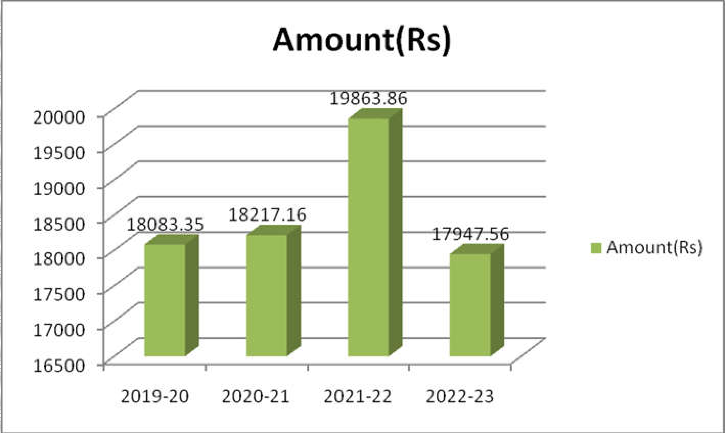

### 

Table 5.2 explains that the above graph is showing loans given to the long-term irrigational sector. It is observed that in comparison with the last year the total amount of loan given to sector is decreased by 1916.3 lakh rupees. Bank is somehow neglected the importance of long-term irrigational loans and it is advised that the bank should concentrate on this issue also.

#### TABLE NO 5.3

### CASH CREDIT LOANS

| **Years** | 2019-20 | 2020-21 | 2021-22 | 2022-23 |
| --- | --- | --- | --- | --- |
| **Amount** | 55.00 | 55.00 | 60.50 | 71.00 |

Source: Primary data

**CHART - 3**

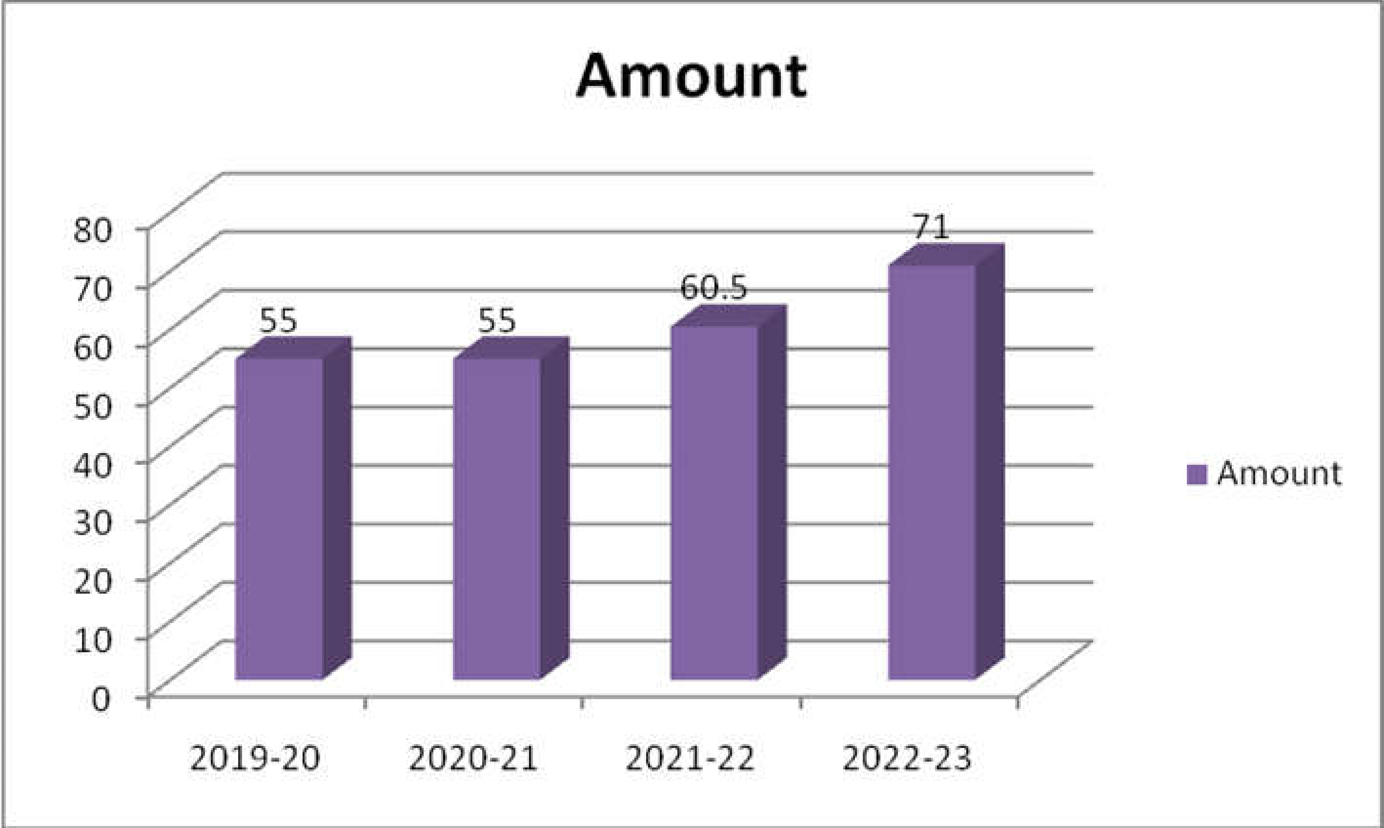

### source table 5.3 Cash Credit Loans

### Table 5.3 explains that the above graph is showing amount given by the bank towards cash credits. Loans given by the bank in the nature of cash credits is regularly in increasing trend. In comparison with the last year this loan amount is increased with 10.5 lakh rupees. Cash credits sanctioned to the members is in the satisfactory position.

### 

### TABLE – 5.4

### THEOLINS

| **YEAR** | 2019-20 | 2020-21 | 2021-22 | 2022-23 |
| --- | --- | --- | --- | --- |
| **Amount** | 372.29 | 96.12 | 43.07 | 2.33 |

Source: Primary data

CHART – 4

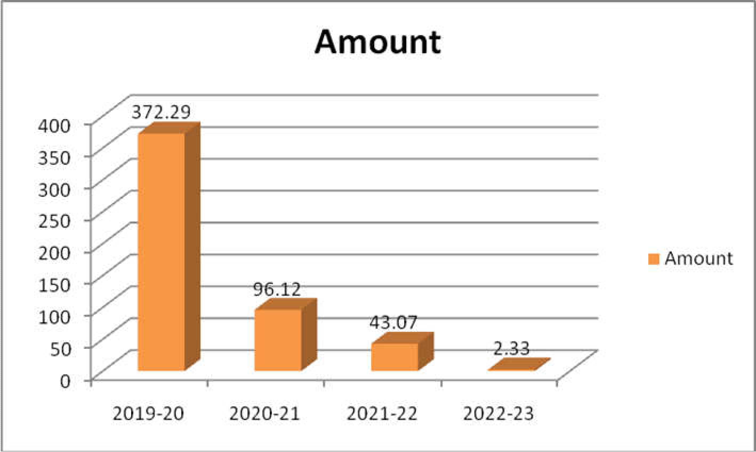

### source table 5.4 THEOLINS

Tabler 5.4 shows that other loans given by the bank towards other sectors of members. It is observed that there is a big fall in this type of loans given by the bank. In comparison with the last year an amount of 40.74 lakh rupees is decreased in the loan amount. May be the bank is neglecting other areas development. Bank has to take measures in the development of other areas also.

TABLE – 5.5

### Statement of Loans Outstanding

**SHORT TERM OUTSTANDING LOAN**

| **Years** | 2019-20 | 2020-21 | 2021-22 | 2022-23 |
| --- | --- | --- | --- | --- |
| **Amount** | 12268.91 | 13722.01 | 16160.67 | 15343.77 |

Source: Primary data

**CHART – 5**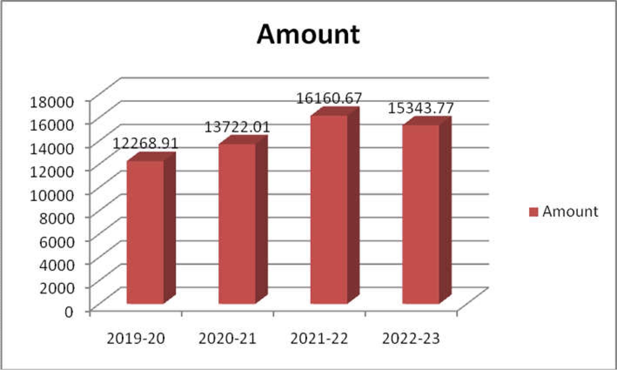

**source table 5.5** Short Term Outstanding Loan

### Tabler 5.5 explains that the amount of loan outstanding with the members of the bank. The total amount of due for the year 20-21 reached to 15343.77 lakhs. If this much amount is due with the members, it will create problems to the bank for further sanctioning of new loans to other members. So, it is advised that bank has to take serious steps in collecting the amount.

### FINDINGS

* Except other loans reaming all the loans are increased in the current financial year. It showing bankers participation in the development program of the district.
* In short term agricultural loans capital increasers to 4842.74 to 6246.23 in last 4 year
* In loan term irrigation loans, it is observed that in comparison with the last year the total amount of loan given to sector is decreased by 1916.3 lakh rupee.
* Capital of the company increased in the current year as it is compared with last 4 years.
* Out of the 8500 lakhs deposits target collection so far banker’s collection of deposits reached to 7816.05 lakhs. This is almost attainment of the target what bank is targeted to achieve.

#### **SUGGESTIONS ;-**

1. Mobilize low-cost deposits and improve its position.
2. Decrease the non-performing assets.
3. Increase the share capital.
4. Provide timely credit to the needy persons.
5. Minimize the expenditure.
6. Liberalize the loan sanctioning procedure.

#### **CONCLUSION;-**

The failure of certain banks in achieving their objectives cannot be looked as isolated issue. This general tendency prevailing in the entire cooperative movement and particular problems faced by PACs or influencing the marketing organizations involved in the cooperative movement. The highly distressing problem is mounting over dues. The main issue in the new millennium is to reorient the structure functioning and management of the cooperative institutions. There should be a well-conceived action programmed to provide specific guide points to cooperative in the areas of professionalism and efficiency induction of modern technology. Systematic training through effective interplay of inter cooperative relationship mobilization of resources and enhancing participation of members in decision making process and reducing dependence Gove assistance.

**REFERENCES ;-**

* I.M Pandey, 2012, Financial Management, 9th Edition, Vikas publishing House private Limited, New Delhi.
* Prasanna Chandra 2014, Financial Management, 5th Edition, TATA- McGraw HILL, New Delhi.
* S.P. Jain, K.L Narang, 2015, Advanced Accountancy, Volume II, 15thEdition, Kalyani publishers, Ludhiana.