# The Pharmacognostic profile of Lantana camara and Cymbopogon citrus ﻿for their therapeutic activities: A review

**Ms. Gore Sanika1*, Ms. Khule Priyanka2, Ms. Gunjal Supriya3 Ms. Dange Shamali4**

*1,2,3 Student, Ashvin College Of Pharmacy, Manchi Hill, India.

*4 Assistant professor, Ashvin College Of Pharmacy, Manchi Hill, India.

**Abstract:**

Plantsare a store of valuable or delightful thingsof biological materials containing numerous potential phytochemicals that are target-specific, quickly biodegradable, environmentally benign, and have a variety of therapeutic actions. New antibiotics, antioxidants, and biopesticide were discovered as a result of the emergence of resistance to synthetic pesticides and antibiotics. Additionally, this has resulted in the development of novel drugs that are highly effective. The goal of the current study is to prove that ornamental plants have unique active ingredients that are employed in a number of biological functions.

**Keyword:** Lantana camara, Cymbopogon citrus, Morphology, essential oil, Carvone, Citral, Pharmacological activity.

**Introduction:**

Lantana camara is a flowering ornamental blooming plant. It is used to treat a number of illnesses and is used in many traditional medical preparation. According to Linnaeus' in 1753, the genus Lantana included seven species, six are comes from South America and one from Ethiopia. The word "lantana," which comes from the Latin "lento," which means "to bend," most likely comes from the old Latin name of the genus Viburnum, which it somewhat resembles to its leaf and inflorescence.[1] The most common species in this genus is Lantana camara L., also called as wild or red sage, which grows lushly at heights of up to 2000 m in tropical, sub-tropical, and temperate areas. [2]This article reviewed that plant’s botanical and taxonomical information, it’s phytochemisty and pharmacological activity.

Lemongrass (*Cymbopogon citratus*) is a warm-season perennial grass. It is a native plant with medicinal and fragrant characteristics. At local levels, it have various common names, such as ‘Gawati Chah’, ‘Nibugrass’, and ‘Puthiganda’. In the subcontinent region, approximately three lemongrass species have been identified. The lemongrass that is grown in the eastern region of India is well known for its oil and has a developing market.[40]

* **Plant Profile**:

**1) Lantana camara**

**Scientific name**: Lantana camara linn

**Synonyms**: Marathi: Ghaneri,

Sanskrit Name: Chaturangi, Vanacchedi

Hindi: Raimuniya

English: Spanish flag, Wild sage

French: Lantanier, Verbene.

**Biological source** : It is a flowering ornamental plant of Lantana camara Linn. belonging to the family- Verbenaceae[3]

**Geographical source**: Lantana camara is originated from the Caribbean islands and South and Central America, lantanas can also be found in Brazil, Trinidad, Florida, Mexico, and Jamaica. Also, certain species of lantana were thought to have originated in Africa and India.[4]

**Taxonomical classification**

Kingdom: Plantae, Subkingdom: Tracheobionta, Superdivision: Spermatophyta, Division: Magnoliopsida, Subclass: Asteridae, Order: Lamiales, Family: Verbenaceae, Genus:Lantana, Species: Lantana camara. [5]

* **Morphology:**

**Plant description**: Morphology of L. camara is reported in Figure 1. L. camara is a low erect or subscandent vigorous shrub with tetrangular stem, stout recurved pickles and a strong odour of black currents. Plant grows up to 1 to 3 meters and it can spread to 2.5 meter in width. Leaves are ovate or ovate oblong, acute or sub-acute, crenate serrate, rugose above, scabrid on both sides[6]. It is a woody straggling plant has small spherical head with various flower colours, red, pink, white, yellow and violet. 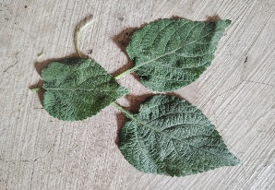 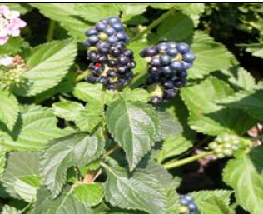

a)**Leaves b)Fruit** 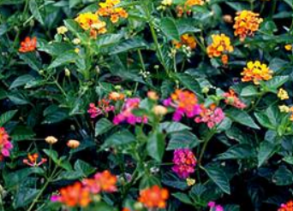 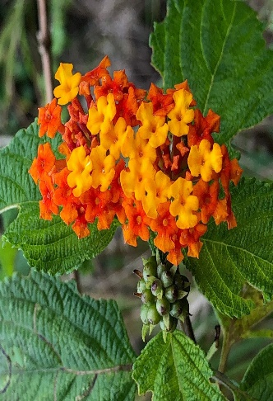

**c)Whole plant d)Flower [7]**

**Leaves:**

The leaves are acute or subacute, ovate or ovate-oblong, crenate-serrate, rugose above, and scabrid on either side. (**Fig.**a) The leaves are green in colour and typically the length is 3–8 cm and 3–6 cm in width. Rough hairs present on the stems and leaves. Leaves are the primary supplier of potassium and phosphorus. [8]

**Inflorescence:**

The leaves are oval, rough, short-haired and grouped in opposing pairs and have sharply toothed edges and many veins that give them a wrinkled look. It contains 20-40 sessile flowers.[9]

**Flower:**

The clusters of Lantana camara blooms are white, pink, lavender, or a mix of yellow, orange, and red. The flowers act as Nectar source for butterflies and moths. Also provide perch spot over flowers.[10]

**Fruit:**

The fruits are fleshy berries in clusters, shiny and globose in shape, green in colour in early stage which on ripening turns to black.[11]

**Seed**:

Between September and May, one to twenty seeds are mature on each flower head. Up to 12,000 seeds can be produced per year.[12]

**Root:**

The root system of this plant grows even after repeated cuttings; it gives out new fresh shoots. The roots of L. camara are very strong, having a main taproot with many small side roots.[13]

* **Phytochemisty**

The plant extract of L. camara contains flavonoids, alkaloids, tannin, protein, catechin, phenol, saponin, steroids, anthraquinone, reducing sugar, and several tri-terpenoids—which contain a number of significant phytomolecules like verbascoside, linaroside, lanatoside, ursolic acid, carminic acid, caprylic acid, and phytol. These phytochemical use in various biological activity. [14,15]

The major constituents of leaves oil are *cis*-3-hexen-1-ol (11.3%), 1-octen-3-ol (8.7%), spathulenol (8.6%), caryophyllene oxide (7.5%) and 1-hexanol (5.8%), while the main compounds of the oil from flowers are caryophyllene oxide (10.6%), *β*-caryophyllene (9.7%), spathulenol (8.6%), *γ*-cadinene (5.6%) and *trans*-*β*-farnesene (5.0%).[16] Also lantadene A, lantadene B, and lantadene C were isolated from the aerial parts of Lanata camara.

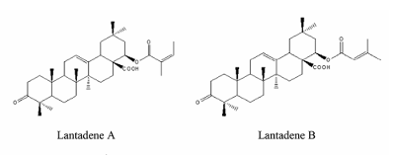

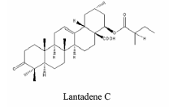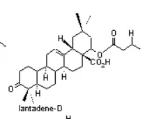[17]

* **Pharmacological activity*:***

1] **Antimicrobial Activy:**

The antimicrobial properties of the aqueous and ethanol extracts of L. camara flowers, leaves, stems, and roots in comparison with selected commercial mouthwashes (Crest, ACT, Ultra Care, Cari-Med, and Listerine) against Streptococcus mutans, E. coli, Streptococcus pneumoniae, and P. aeruginosa from oral cavity. The results showed that L. camara extracts possessed higher zone of inhibition against the oral microorganisms compared to the commercial mouthwashes. S. pneumoniae being the most susceptible organism to L. camara ethanolic extracts (red flower) in all concentrations (10–50 mg). The growth of S. mutans bacteria was inhibited by L. camara extracts; it was the most sensitive organism to the ethanolic extracts of pink flower L. camara. E. coli was susceptible to L. camara aqueous extracts at high concentrations and resistant at low concentrations. The growth of P. aeruginosa was strongly inhibited by L. camara ethanolic extracts (pink flower).[18]

2] **Wound Healing Activity**:

The leaf extract of L. camara was investigated for wound healing in rat. The efficacy of L. camara leaf extract ointment (5% and 10%) on the healing of the dermal wound infected with S. epidermidis was studied in rats. Wound healing was qualitatively better and bacterial colonies were lower in group treated with 5% leaf extract ointment, than group treated with 10% leaf extract ointment, fusidate 2%, and untreated group (p<0.05) [19]

3] **Anti-Fungal Activity:**

The in vitro antifungal activity of L. camara leaf extract studied with successive extraction using different solvents, acetone, chloroform, ethanol, and methanol. For this antifungal activity research used the poisoned food technique. In that mycelial growth zone of fungus in Petri plates and percentage inhibition of fungal growth was measured. Antifungal activity of leaf extract was tested on Aspergillus flavus and Aspergillus niger fungal strains. Methanol and Chloroform extract shows maximum zone inhibition.[20]

4]**Antiulcerogenic Activity:**

The in vivo antiulcerogenic activity, pre-treatment studied with methanol extract of L. camara leaves produced a significant antiulcer effect which can be compared with an aspirin-induced ulcer on rats. The methanolic extract of leaves was administered orally in pyloric ligated rats, ethanol-induced gastric ulcer, and cysteamine-induced duodenal ulcer. The plant extract shows healing of gastric ulcers and also prevents the development of duodenal ulcers in rats. The extract shows dose-dependent antiulcerogenic activity in all models. [21]

5] **Anti Hyperglycemic Activity:**

The leaf extract of L. camara was investigated for in vivo anti-hyperglycemic activity in rat. Oral administration of a methanol extract of L. camara leaves in alloxan induced diabetic rats showed significant dose-dependent reduction of blood glucose concentration and also promising anti-hyperglycemic activity against alloxan-induced diabetic rats. Aqueous extract of the leaves of it was evaluated using both alloxan-induced hyperglycemic rats and normoglycemic rats also show anti-hyperglycemic activity.[22]

6]**Anthelmintic activity:**

Girme et al. (2006) studied that in vitro helminth infection is the most common infection in men. On specific worms, the leaf extracts of L. camara show effective anthelmintic activity. Anthelmintic activity by methanol extract from the stems, leaves, and roots of the plant was investigated against Pheritima posthuma. The methanolic extract of the stem was found to be more effective. The ethanolic extract was also shows potent anthelmintic activity. [23]

* **Plant Profile:**

**2) Lemongrass**

**Scientific name: Cymbopogon citratus**

**Synonyms:** English: Lemongrass, Citronella

Hindi: Sera, Verveine

**Biological source:**

Cymbopogon citratus also called West Indian Lemongrass, which comes under the family “Poaceae” (Graminae) family and the genus Cymbopogon. [24]

**Geographical source:**

Although lemongrass, scientifically known as Cymbopogon citratus, is native to regions in Asia, particularly Southeast Asia, and Australia. It has been widely grown in tropical and subtropical regions around the world due to its and therapeutic benefits.[25]

**Taxonomical classification:**

Kingdom – Plantae, Subkingdom – Tracheobionta, Super division – Spermatophyta, Division – Magnoliophyta, Class – Liliopsida, Subclass - Commelinidae Order - Cyperales Family – Poaceae, Genus - Cymbopogon Spreng, Species - Cymbopogon citratus.[26]

* **Morphology**

**Plant Description :**

Lemon grass is a big perennial sedge with thick clusters of leaves on a dense rhizome. Up to 1.8 meters in height, the cliff is erect. Leaves are long, glaucous, green, which tapered upwards in a linear pattern and along the margins. The leaf blades are linear, conical at both ends and can grow up to 50 cm in length and 1.5 cm in width.[27] 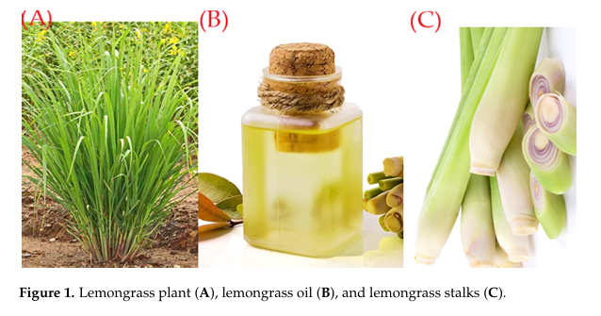[28]

**Parts of plant and description:**

[29, 30, 31]

* **Phytochemistry:**

The chemical composition of the essential oil of *Cymbopogon citratus* is the compounds as hydrocarbon terpenes, alcohols, ketones, esters and mainly aldehydes have constantly been registered. The essential oil (0.2–0.5%, West Indian lemon grass oil) consists of, mainly, citral. Citral is a mixture of two stereoisomeric monterpene aldehydes; the trans isomer geranial (40–62%) dominates over the cis isomer neral (25–38%). [32] Geranial has a strong lemon odor, while neral is less intense and sweeter with a floral-herbal odor. Phenolic compounds constitute a diverse class of secondary metabolites, including flavonoids, lignans, stilbenes, curcuminoids, coumarins, and various other polyphenolic compounds[33]

**Chemical structure of the major constituents of lemongrass essential oil [32]**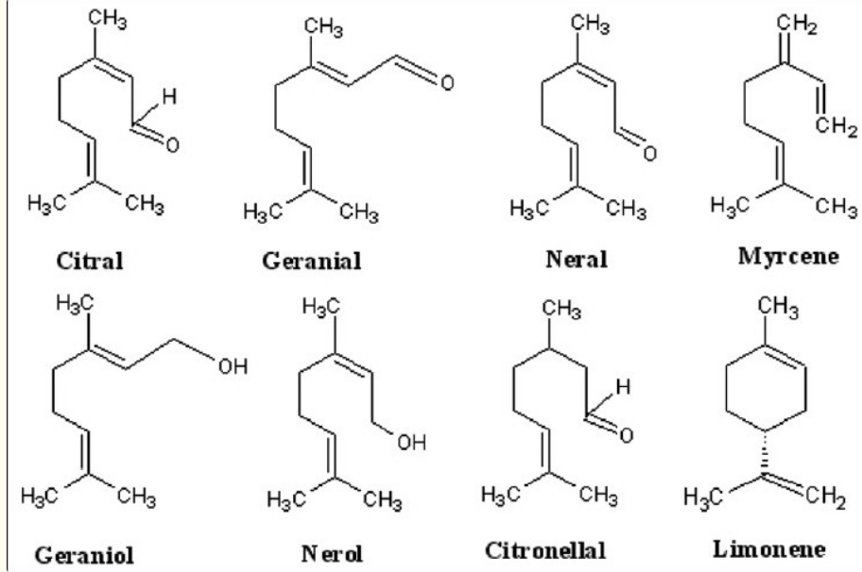

* **Pharmacological activity**

1] **Antihypertensive activity:**

This plant has been utilised to maintain blood glucose level to treat hyperinsulinemia It lowers blood pressure, which minimises the risk of hypertension. Citral, isolated from C. citratus, acts as an endothelium-independent vasodilator by blocking Ca2+ inflow and the prostacyclins (PGI2) channel. [34]

**2]** **Antibacterial Activity:**

On Bacillus subtilis, Escherichia coli, Staphylococcus aureus, Salmonella paratyphi, and Shigella flexneri, the chromatographic fraction of the essential oil in agar plate was active. Two of the three primary components of the oil identified using chromatographic and mass spectrometric techniques exhibit evidence of these actions. The -citral (geranial) and -citral (renal) components both have antibacterial activity against gram-negative and gram-positive bacteria. [35]

3] **Anti-obesity:**

Lemon grass is used in hypolipidemic and hypoglycemic medications. It has been used in Ayurvedic medicine to control glucose, lipid, and fat levels in the blood serum, which may help to avoid obesity and hypertension. It is generally consumed as tea.[36]

4] **Anti-diarrhoeal activity**:

In practise, the entire stalk and lemongrass leaf decoction is consumed to cure diarrhoea. The anti-diarrheal effectiveness of C. citrates stalk decoction and its primary chemical component citral was investigated due to its widespread usage in traditional medicine. [37]

5]**Anti-tussive activity:**

In this study it validates the traditional claims of C. citratus ethanolic leaf extract in the treatment of cough. Antitussive activity of C. citratus ethanolic leaf extract was studied by inducing cough with citric acid in guinea pigs. The number of violent coughing fits was measured, while codeine phosphate was used as reference control. Both doses of C. citratus (100 and 200 mg/kg) significantly reduced the violent coughing fits in a dose dependent manner. Actually, the number of violent coughing fits observed with 100 and 200 mg/kg of C. citratus extract after citric acid administration was significantly reduced, by 65.36% and 85.43%, respectively. The antitussive effect produced by the C. citratus ethanolic leaf extract at 200 mg/kg was equipotent as that of the reference control codeine phosphate.[38]

6]**Anti-inflammatory:**

Citral derived from C. citratus inhibits inflammatory mediators significantly and can be used as an ingredient in lotions and ointments to treat topical inflammation. It has also been reported to suppress tumour necrosis factor (TNF)-induced neutrophil adherence at concentrations as low as 0.1 percent, inhibit inducible nitric oxide synthase (iNOS), nitric oxide production (NO), and other LPS-induced pathways, covalently bind to receptors, thereby inhibiting the nuclear factor-kappa B (NF-B) pathway, and suppress COX-2 by 60–70%. [39]

**Conclusion:**

From the above review we can conclude that the plant Lantana camara and Cymbopogon citratus which is having a wide range of medicinal value due to presence of variety of chemical constituents. The specific part of the plant has to identified for their pharmacological use and the different pharmaceutical approach has to applied to formulate suitable dosage form.

**Referance:**

1.Girish C.S. Negi, Subrat Sharm et al., Ecology and use of lanata camara in india, The Botanical Review(2019) vol 85:109-130

2. E.L. Ghisalberti, *Lantana camara* L. (Verbenaceae) Fitoterapia 2000, vol-71(5):467-486

3. Ashwini R. Wagh, Yogita N. Ingale et al., “LANTANA CAMARA: A VALUABLE MEDICINAL PLANT” International Journal of Novel Research and Development,2023,Vol8(3):a462-a463

4. Aamir Nawaz, Muhammad Adnan Ayub et al., Lantana (Lantana camara): A Medicinal Plant Having High Therapeutic Potentials – A Comprehensive Review, International Journal of Chemical and Biochemical Sciences,2016, vol-10: 52-59

5 Akash Ved, Tarannum Arsi, Om Prakash et al., A REVIEW ON PHYTOCHEMISTRY AND PHARMACOLOGICAL ACTIVITY OF LANTANA CAMARA LINN., International Journal of Pharmaceutical Sciences and Research 2018; Vol. 9(1): 37-43

6. Sanjeeb Kalita, Gaurav Kumar et al., A Review on Medicinal Properties of Lantana camara Linn., Research J. Pharm. and Tech.2012 vol 5(6)::711-715

7. M.K. Lonare, M. Sharma, S.W. Hajare et al., LANTANA CAMARA: OVERVIEW ON TOXIC TO POTENT MEDICINAL PROPERTIES, International journal of pharmaceutical science and research, 2012; Vol. 3(9): 3031-3035

8 L. D. Battase and D. L. Attarde, PHYTOCHEMICAL AND MEDICINAL STUDY OF LANTANA CAMARA LINN. (VERBENACEAE) - A REVIEW, International Journal of Pharmacognocy, 2021, vol 8(8):317-328

9. Piush Sharma, B Shrivastava, Ganesh N. Sharma et al., Phytochemical and Pharmacological profile of lanata camara l: An Overview, Journal of Advanced Pharmacy Education & Research,2013 Vol 3 (4):294-305

10. R. Lakshmi Shree, R. Geetha, K.M. Buvaneswari et.al, R. Lakshmi Shree1, R. Geetha1, K.M. Buvaneswari, YMER 2022,vol 21(12):98-99

11. Basu S., Ghosh A. and Hazra B., “Evaluation of the antibacterial activity of Ventilago madraspatana Gaertn., Rubia cordifolia Linn. and Lantana camara Linn.: Isolation of emodin and physcion as active antibacterial agents”, Phytother. Res., 19; 2005:888 894.

12. Sankaran, K.V. Asia-Pacific Forest Invasive Species Network. The fact sheet is supported by the Food and

Agriculture, Organization of the United Nations (FAO) and USDA Forest Service 2007.

13. Khandare Sakshi, Khandale Priti et al., Review On Phytochemical and Pharmacological Investigation of Lantana Camara Extract, INTERNATIONAL JOURNAL OF PHARMACEUTICAL SCIENCES,2024, Vol 2, Issue 1: 42-48

14. 14. Sousa EO, Almeida TS, Menezes IR, Rodrigues FF, Campus AR, Lima SG, et al. Chemical composition of essential oils of Lantana camaraL.(Verbenaceae) and synergistic effect of the amino glycosides gentamicin and amikacin. Rec Nat Prod 2012;6:144-50

15. Begum S, Wahab A, Siddiqui B, Qamar F. Nematicidal constituents of the aerial parts of Lantana camara. J Nat Prod 2000;63:765-7

16.Khan M, Mahmood, Alkhathlan H.Z., Characterization of leaves and flowers volatile constituents of Lantana camara growing in central region of Saudi Arabia, Arabian Journal of Chemistry 2016, 9(6):764–774

17. HH SAPARIA*, M BAIDYA, AR MAHESH,THE DETAIL STUDY OF LANTANA CAMARA PLANT FOR THEIR MEDICINAL IMPORTANCE -A REVIEW, PHARMATUTOR-ART-1460

18.Onywere G, Gyles P, Lewin J, Bandoo T, Mundell K, Bailey D, et al. A Jamaican study: In vitro comparison of the effects of Lantana camara, Gouania lupuloides and commercial mouth washes on oral microorganisms. Am J Public Health Res 2016,4 :128-33.

19. Parwanto ML. Efficacy of Lantana camara leaf extracts ointment on dermal wound healing were infected with Staphylococcus epidermidis. Int J Basic Clin Pharmacol 2017;6 :503-10.

20. Mudasir F, Musadiq HB, Mufida F, Kumar A, Jain AK. Antifungal activity of Lantana camara L. leaf extracts in different solvents against some pathogenic fungal strains. Pharmacologia 2017;8 :105-12.

21. Thamotharan G, Sekar G, Ganesh T, Sen S, Chakraborty R, Kumar NS. Antiulcerogenic effects of Lantana camara Linn. Leaves on in vivo test models in rats. Asian J Pharm Clin Res 2010;3 :57-60.

22. Ganesh T, Sen S, Thilagam E. Pharmacognostic and anti-hyperglycemic evaluation of Lantana camara var. aculeate leaves in alloxan-induced hyperglycemic rats. Int J Res Pharm Sci 2010;1 :247-52

23. Girme AS, Bhalke RD, Ghogare PB, Tambe VD, Jadhav RS, Nirmal SA. Comparative in vitro anthelmintic activity and metha piperita and lantana camara from western India: Dhaka Univ J Pharm Sci 2006;5 :5-7.

24. P. P. Joy Baby P. Skaria Samuel Mathew Gracy Mathew Ancy Joseph, Lemongrass (2006), Kerala Agricultural University Aromatic and Medicinal Plants Research Station Odakkali, Asamannoor-683 562, Ernakulam District, Kerala, India Email: amprs@satyam.net.in, Website: [www.kau.edu/amprs](http://www.kau.edu/amprs).

25. Gagan Shah, Richa Shri(2011) Scientific basis for the therapeutic use of Cymbopogon citratus, Stapf (Lemon grass),Journal of Advanced Pharmaceutical Technology & Research | Jan-Mar 2011 | Vol 2 | Issue 1,doi: 10.4103/2231-4040.79796

26. http://gernot-katzers-spice pages.com/engl/Cymb_cit.html

27. N. Tajidin, S. Ahmad, A. Rosenani, H. Azimah, M. Munirah. (2012). Chemical composition and citral content in lemongrass (Cymbopogon citratus) essential oil at three maturity stages. African Journal of Biotechnology. 11(11): 2685.

28.Hafiza Sehrish Kiani, Akhtar Ali et al., Phytochemical Composition and Pharmacological Potential of Lemongrass (Cymbopogon) and Impact on Gut Microbiota, *AppliedChem* 2022, *2*(4): 229-246

29. TAJIDIN N.E., AHMAD S.H., ROSENANI A.B., AZIMAH H. and MUNIRAH M. (2012) Chemical composition and citral content in lemongrass (Cymbopogon citratus) essential oil at three maturity stages. African Journal of Biotechnology, 11:2685-2693.

30. Reitz R. Flora ilustrada catarinense. Itajaí American Fern Journal Publisher: 1982. p. 1309 14

31.Ross IA. Medicinal plants of the world, Part 1: Chemical constituents, Traditional and Modern medicinal uses. New Jersery: Humana Press Inc; 1999. p. 119-25

32. Gagan shah, Richa shri, Vivek Panchal et al., Scientific basis for the therapeutic use of *Cymbopogon citratus*, stapf (Lemon grass), Journal of Advanced Pharmaceutical Technology and Research, 2011 Jan-Mar;2(1):3–8

33. Gayyur Fatima, Mohammad Irfan Khan et al., An updated review on the phytopharmacological significance of genus Cymbopogon, Annals of Phytomedicine, 2023, 12(2): 346-359

34. Shimono K, Hiroaki O, Masato S, Kanae S, Shoji K. Aromatic antihypertensive agent, and method for lowering blood pressure in mammals, US Patent 20 (100) (2010) 89

35. Wannissorn B, Jarikasem S, Siriwangai T. Antibacterial properties of essential oils from Thai medicinal plants.Fitoterapia 2005; 76:233 6.

36. Shah G, Shri R,Panchal V,Sharma N,Singh B,Mann A.Scientific basis for the therapeutic use of Cymbopogon citratus , staff(Lemongrass), J. Adv. Pharmaceut. Techn. Res. 2011;2(1):3–8

37. Tangpu V, Yadav AK. Antidiarrhoeal activity of Cymbopogon citrates and its main constituent, citral. Pharmacologyonline 2006; 2:290-298.

38. MANI M., SOMASUNDARAM G. and JAIKUMAR S. (2017) Anti-tussive activity of ethanolic leaf extract of Cymbopogon citratus against citric acid induced cough in guinea pigs. Scholars Academic Journal of Biosciences, 5:638-641.

39. Sumeet Magotra, Ajeet Pal Singh et al., A review on pharmacological activities of cymbopogon citratus, International Journal of Pharmaceutics and Drug Analysis, Vol: 9, Issue: 2, 2021; 151-157

40.Mujaffar S, John S. Thin-layer drying behavior of West Indian lemongrass (Cymbopogan citratus) leaves. Food Sci Nutr 2018;6(4):1085-1099