**PRACTICE SCHOOL SUBMITTED TO THE JAWAHARLAL NEHRU**

### **TECHNOLOGICAL UNIVERSITY ANANTAPUR** *C:\Users\Pharmacy\Desktop\cropped-logo-1.png*

**SUBMITTED BY**

# **KURUVA RAVI TEJA**

**21ER1R0037**

***Under the Supervision of***

**DR. J GOPALA KRISHNA M.S [PHARM]Ph.D.**

**ASSOCIATE PROFESSOR**

Department of Pharmaceutical Chemistry



**Dr. K. V. Subba Reddy Institute of Pharmacy,**

NAAC A+

**Dupadu, Kurnool–518218, A.P**

**Oct/Nov -2024**

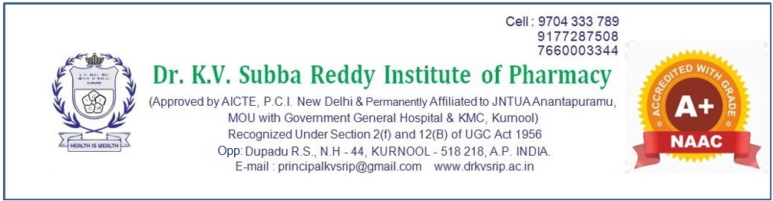**CERTIFICATEBY SUPERVISOR**

This is to certify that the work contained in the Practice School Report **“A Short review on Artificial intelligence (AI) and machine learning (ML) approaches on Pancreatic Cancer”** submitted by **Name of the Student (Regd. No.: 21ER1R0037)** to the **Dr. K. V. Subba Reddy Institute of Pharmacy**, is a record of bonafide practice work carried out by him under my direct supervision and guidance.

I considered that he/she work has reached the standards and fulfilling the requirements of the rules and regulations relating to the nature of the Practice School Report.

## **Date:**

## **Place:**

## **Signature of Supervisor(s) and designation**

## **Name(s)**

## **Department(s)**

**CERTIFICATE BY HEAD OF THE INSTITUTE**

This is to certify that the Practice school Report. A Short review on Artificial intelligence (AI) and machine learning (ML) approaches on Pancreatic Cancer”was done for the partial fulfilment of B. Pharm IV Year I semester and has been carried out by **KURUVA RAVITEJA** **(21ER1R0037)** under the guidance and supervision of **Dr. J. GOPALA KRISHNA, M. S. Pharm, Ph. D.,** (**Department of Pharmaceutical chemistry**) at **DR. K. V. Subba Reddy Institute of Pharmacy, DUPADU, Kurnool**, during the period of 2024-2025. It is further certified that this has not been submitted in part or full for the award of any degree or fellowship.

Date:

Place:

Signature of the Principal

**ACKNOWLEDGEMENTS**

I would like to express my special thanks of gratitude to all those who contributed to the completion of this work. A Short review on Artificial intelligence (AI) and machine learning (ML) approaches on Pancreatic Cancer”Especially I would like to express my sincere gratitude to my guide **Dr. J. GOPALA KRISHNA, M. S. Pharm, Ph. D** for their exceptional support throughout the project. Their guidance and encouragement were indispensable in bringing this project to completion. Secondly, I would like to thanks my peers and mentors in the field of pharmacy whose feedback and encouragement have been fundamental to the completion of this project. Lastly, I am deeply grateful to my guide who guided for their continuous encouragement, support throughout this journey.

**Name of the Student**

KURUVA RAVITEJA

Contents

Abstract 5

**Key Steps** 8

**Benefits:** 8

**Types of pancreatic cancer** 9

**Integration of Artificial Intelligence in Drug Discovery** 9

**AI Techniques** 9

**CASE STUDIES AND EXAMPLES** 11

**Challenges and Future Directions** 12

**Treatment for pancreatic cancer** 13

**DRUGS USED IN PANCREATIC CANCER** 13

**Causes of pancreatic cancer** 14

**Ways to keep pancreas clean naturally:** 17

**References** 18

# 

# **Abstract**

Pancreatic cancer is the deadliest disease, with a five-year overall survival rate of just 11%. The pancreatic cancer patients diagnosed with early screening have a median overall survival of nearly ten years, compared with 1.5 years for those not diagnosed with early screening. Therefore, early diagnosis and early treatment of pancreatic cancer are particularly critical. However, as a rare disease, the general screening cost of pancreatic cancer is high, the accuracy of existing tumor markers is not enough, and the efficacy of treatment methods is not exact. In terms of early diagnosis, artificial intelligence technology can quickly locate high-risk groups through medical images, pathological examination, biomarkers, and other aspects, then screening pancreatic cancer lesions early. At the same time, the artificial intelligence algorithm can also be used to predict the survival time, recurrence risk, metastasis, and therapy response which could affect the prognosis. In addition, artificial intelligence is widely used in pancreatic cancer health records, estimating medical imaging parameters, developing computer-aided diagnosis systems, etc. Advances in AI applications for pancreatic cancer will require a concerted effort among clinicians, basic scientists, statisticians, and engineers. Although it has some limitations, it will play an essential role in overcoming pancreatic cancer in the foreseeable future due to its mighty computing power.

***Key words:*** Pancreas**,** Adenocarcinoma**,** Tumor Metastasis Symptoms, Diagnosis Imaging, Biopsy Surgery, Whipple procedure, Chemotherapy Radiation therapy Risk factors Genetics BRCA, KRAS, Prognosis Palliative care Clinical trials Survival rates Endoscopic ultrasound Early detection Lifestyle factors

**Introduction**

Pancreatic cancer (PC) is the deadliest form of all cancer. The five-year relative survival rate for PC is only 11% in the USA, which is the lowest among all cancers [1]. In China, the incidence and mortality of PC among tumors are 2.47% and 3.64%, respectively. The main reason for such a poor prognosis of PC is the late diagnosis, with only about 20% of patients being diagnosed at an early stage. Most patients have non-specific first symptoms, such as jaundice, fatigue, change in bowel habits, and indigestion, that make it difficult to distinguish from non-cancer diseases. Most chemotherapy targeted therapy and immunotherapy are ineffective because most patients are already in the progressive stage with local invasion and distant metastases at the detection time [2]. The common symptoms of pancreatic cancer include abdominal pain, changes in the consistency of faces, nausea, bloated body, co-morbidities, such as diabetes and jaundice, abnormal liver function parameters, loss of weight, etc. [3]. Pancreatic cancer affects the pancreas, a gland in your abdomen that aids in digestion. Pancreatic cancer symptoms include nausea, bloating, fatigue, jaundice and lack of appetite. Treatments include surgery, chemotherapy and radiation therapy. Pancreatic cancer survival rates are low because the disease is difficult to detect in the early stages [4]

Pancreatic cancer is a highly fatal disease with a 5-year survival rate of approximately 10% in the USA, and it is becoming an increasingly common cause of cancer mortality. Risk factors for developing pancreatic cancer include family history, obesity, type 2 diabetes, and tobacco use. Patients typically present with advanced disease due to lack of or vague symptoms when the cancer is still localized. High quality computed tomography with intravenous contrast using a dual phase pancreatic protocol is typically the best method to detect a pancreatic tumor and to determine surgical respectability [5]. Endoscopic ultrasound is an increasingly used complementary staging modality which also allows for diagnostic confirmation when combined with fine needle aspiration. Patients with pancreatic cancer are often divided into one of four categories based on extent of disease: respectable, borderline respectable, locally advanced, and metastatic; patient condition is also an important consideration. Surgical resection represents the only chance for cure, and advancements in adjuvant chemotherapy have improved long-term outcomes in these patients [6]. The term “chemotherapy” was coined by German chemist Paul Ehrlich who investigated the use of drugs to treat infectious diseases. He was also the first scientist to study animal models to screen a series of chemicals regarding their potential activity against diseases. Historical documents suggest the use of arsenicals started in the 1900s. Radiotherapy ad surgery were the mainstays of cancer management in the1960s. Systemic chemotherapy combinations including FOLFIRINOX (5-fluorouracil, folinic acid [leucovorin], irinotecan, and oxaliplatin) and gemcitabine plus nab-paclitaxel remain the mainstay of treatment for patients with advanced disease. Data on the benefit of PARP inhibition as maintenance therapy in patients with germline BRCA1 or BRACA2 mutations might prove to be a harbinger of advancement in targeted therapy [7]. Pancreatic cancer occurs when cells in your pancreas mutate (change) and multiply out of control, forming a tumor. Your pancreas is a gland in your abdomen (belly), between your spine and stomach. It makes hormones that control blood-sugar levels and enzymes that aid in digestion [8].

United States there are 28,000 to 30,300 newly diagnosed cases of pancreatic cancer and approximately an equal number of deaths per year from pancreatic cancer. Deaths from pancreatic ductal adenocarcinoma, also known as pancreatic cancer, rank fourth among cancer-related deaths in the United States, yet the causes of pancreatic cancer remain unknown. This review article summarizes recent progress in the understanding and management of pancreatic cancer. Most pancreatic cancers start in the ducts of your pancreas. The main pancreatic duct connects your pancreas to your common bile duct. Staging is a method of describing pancreatic cancer based on its size and how far it has metastasized Early-stage pancreatic tumors don’t show up on imaging tests. For this reason, many people don’t receive a diagnosis until the cancer has spread (metastasis) [9].

Pancreatic cancer affects your pancreas, a gland in your abdomen that aids in digestion. Pancreatic cancer symptoms include nausea, bloating, fatigue, jaundice and lack of appetite. Treatments include surgery, chemotherapy and radiation therapy. Pancreatic cancer survival rates are low because the disease is difficult to detect in the early stages.

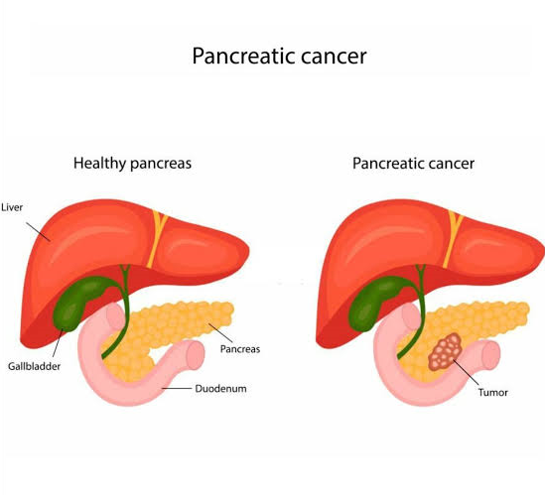figure-1

# **Key Steps**

Data Collection: Gather extensive datasets from previous drug studies, genomic data, and clinical outcomes related to pancreatic cancer. Target Identification: Use AI algorithms to identify key molecular targets and pathways involved in pancreatic cancer progression. Screening: Employ high-throughput screening methods to test various drug combinations. AI can predict potential synergies based on mechanisms of action and resistance patterns. Predictive Modeling: Utilize machine learning models to analyze the effects of drug combinations on cancer cell viability, apoptosis, and other biomarkers. Validation: Confirm promising combinations in preclinical models (e.g., cell lines, animal models) and ultimately in clinical trials. Continuous Learning: Incorporate new data from ongoing studies to refine algorithms and improve prediction accuracy over time.

# **Benefits:**

Enhanced Efficacy: Targeting multiple pathways can overcome resistance and improve treatment outcomes. Personalization: AI can help tailor combinations to individual patient profiles based on genetic and molecular characteristics. Reduced Development Time: Computational approaches can significantly accelerate the drug discovery process. By integrating AI into the discovery process, researchers aim to uncover effective treatments for pancreatic cancer, a disease known for its poor prognosis and limited therapeutic options.

# **Types of pancreatic cancer**

There are two main types of pancreatic tumors i.e., exocrine tumors ***(***exocrine tumors: Over 90% of all pancreatic tumors are exocrine tumors). The most common type of pancreatic cancer is adenocarcinoma, which begins in the cells that line your organs. And the other one is Neuroendocrine tumors Neuroendocrine tumors: Less than 10% of pancreatic tumors are neuroendocrine tumors (NETs)). Apart from this another carcinoma exists i.e., Islet cell carcinoma [10].

# **Integration of Artificial Intelligence in Drug Discovery**

Machine Learning Algorithmsis a supervised Learning: Uses labeled datasets to predict the efficacy of drug combinations based on known outcomes. Unsupervised Learning is a Identifies patterns and relationships in data without prior labels, which can reveal novel combination strategies.Network Analysis is a systems biology approaches map interaction between genes, proteins, and drugs, helping identify potential synergistic effects.Natural Language Processing (NLP) analyzes scientific literature and clinical trial databases to extract relevant information about drug interactions and patient responses.Reinforcement Learning isOptimizes drug combination strategies through trial-and-error simulations, continually refining approaches based on simulated outcomes [11].

## **AI Techniques**

The successful application of artificial intelligence (AI) in identifying individuals at high risk for pancreatic cancer opens avenues for a nuanced discussion on the broader implications and potential applications of AI in pancreatic cancer care [12]. Beyond the remarkable achievement of early risk prediction, exploring the specific AI techniques and models employed in diagnostics and personalized medicine becomes imperative. The primarily utilizes AI algorithms trained on extensive patient records to predict pancreatic cancer risk, showcasing the potential for population-wide screening [13]. However, a more in-depth examination of the underlying AI methodologies, such as machine learning or deep learning techniques, could provide insights into the robustness and adaptability of these models in handling diverse datasets. Furthermore, delving into the prospects of integrating AI into personalized medicine approaches for pancreatic cancer would enrich the discussion. AI has the potential to tailor diagnostic and treatment strategies based on individual patient profiles, optimizing clinical decision making and potentially improving outcomes. Discussing the scalability of these AI applications in diverse healthcare settings, the need for standardized protocols, and the integration of AI into existing clinical workflows would contribute to a comprehensive understanding of how AI could reshape the landscape of pancreatic cancer care [14].

**AI Models for the Diagnosis of Pancreatic Cancer**

Medical imaging has been widely used for locating and diagnosing cancerous tissue in the gastrointestinal tract. Current analysis is largely dependent upon the expertise and experience of the clinician. The quality of the images also influences the diagnosis through conventional methods [15]. The field of digital pathology continues to evolve from the first generation of image processing that involved the use of image processing tools to analyse a single slide, to much more advanced second-generation tools that could scan, analyse, and store records of whole tissue samples. The current paradigm in digital pathology involves the use of AI-based algorithms to analyse images, diagnose the condition with a high accuracy, and even predict the possibility of developing the disease even before the onset of the disease. The development of AI-based tools has enabled the rapid and high precision diagnosis of cancer using different medical images. In the context of pancreatic cancer, AI-based diagnostic tools have been employed for risk prediction, survival prediction, and the distinction of cancer masses from other pancreatic lesions as well as for the evaluation of the response post-therapy [16].

**Workflow for Discovery**

Data Integration is a combine multi-omics data (genomics, transcriptomics, proteomics) with clinical data to create a comprehensive understanding of pancreatic cancer biology. Drug Interaction Databases Utilize existing databases like Drug Bank, ChEMBL, and others to identify potential drug candidates and known interactions. Synergy ScoringApply models such as the Bliss Independence model or Loewe Additivity to quantify synergy between drug pairs based on their effects on cancer cell lines. In Silico ScreeningUse computational simulations to predict the effects of various drug combinations before testing them in the lab [17].

**AI-Driven Diagnosis Based on Cancer**

The serological detection of PC is based on the quantification of a biomarker whose levels are altered in cancerous conditions. However, a single marker could not accurately diagnose a specific type of cancer as there are several other conditions that could modulate the levels of said biomarker. Hence, multiple biomarkers need to be analysed, to accurately diagnose PC. In an earlier work, protein markers from the serum of 27 normal and 27 individuals diagnosed with pancreatic cancer, were profiled using surface-enhanced laser desorption ionization (SELDI), and were classified using a decision tree algorithm, based on which six serum proteins were identified as pancreatic cancer [18]. Analysis of datasets from microarray and the next generation sequencing of samples for the gene expression or serum protein expressions using deep learning and machine learning algorithms, could aid in identifying the most promising protein biomarkers that aid in the early detection of pancreatic cancer. For instance, the SVM based algorithm, in combination with the recursive feature elimination (RFE), was employed to screen the gene expression datasets of 78 samples, for additional pancreatic cancer biomarkers. Seven gene targets were short-listed among the genes encoding for the proteins FOS that encodes for the leucine zipper protein, MMP7 (matrix metalloproteinase-7), and A2M (alpha-2-macroglobulin), were predicted to be more accurate diagnostic markers for pancreatic cancer, not only in serum, but also in urine samples. The histological analysis or tissue biopsies have been conventionally employed for the identification and stratification of cancers. However, this is a time-consuming process. Further, there is a constant increase in the number of samples that are sent for analysis to the anatomical pathological laboratory and this, coupled with insufficient skilled pathologists, leads to long turn-around-times [19].

# **CASE STUDIES AND EXAMPLES**

A 49-year-old female was found to have a pancreatic head mass and multiple low-density lesions in the liver on computed tomography (CT) in October 2020, consistent with pancreatic head cancer with liver metastases. A liver biopsy was conducted, and subsequent cytological analysis confirmed the presence of cancer. Positron emission tomography-computed tomography (PET-CT) showed a pancreatic mass with high 18F-fluorodeoxyglucose (FDG) uptake, suggesting metastasis, liver metastasis, portal vein tumor thrombus, and metastasis to peripancreatic and retroperitoneal lymph nodes. Histopathological examination of the liver biopsy showed poorly differentiated carcinoma with an adenocarcinoma-like tendency. Based on the clinical presentation, pancreatic cancer with metastasis cannot be excluded. Notably, there exists an absence of prior tobacco and alcohol consumption within the patient’s history, as well as an absence of previous exposure to pharmaceutical treatments. There is no reported history of malignant tumors within the patient’s familial lineage.

# **Challenges and Future Directions**

Data Quality is the accuracy of AI predictions depends heavily on the quality and comprehensiveness of the input data. Clinical Validation Promising combinations identified in silico must undergo rigorous clinical trials to ensure safety and efficacy. Future efforts may focus on tailoring drug combinations based on individual patient profiles, leveraging AI for precision medicine. By advancing our understanding of drug interactions and optimizing treatment strategies, AI has the potential to significantly improve outcomes for patients with pancreatic cancer. Targeted Therapies AI has identified combinations of targeted agents (like PARP inhibitors) and conventional chemotherapy that may enhance efficacy against specific pancreatic cancer subtypes. Immune Modulation Investigations into combining immune checkpoint inhibitors with standard chemotherapy have shown promise, with AI helping to optimize dosages and scheduling

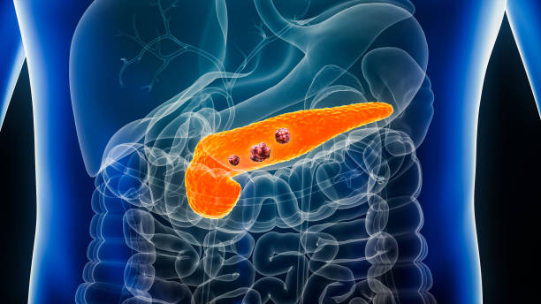

Figure-2

# **Treatment for pancreatic cancer**

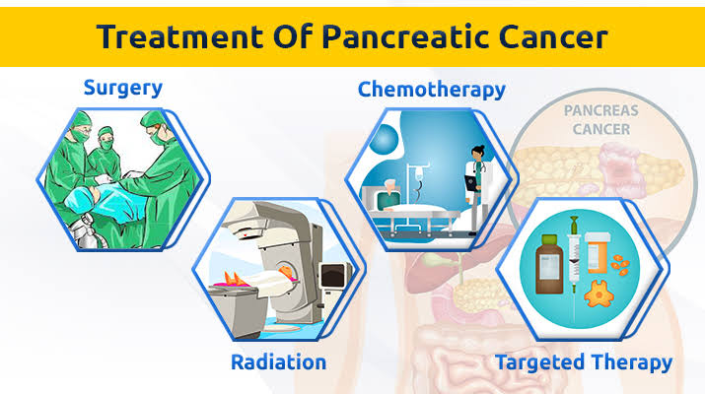Pancreatic cancer treatment often involves a combination of surgery, chemotherapy, radiation therapy, and targeted therapies. Chemotherapy is the main treatment of the cancer GemcitabineOften used as a first-line treatment. FOLFIRINOX combination of fluorouracil, leucovorin, irinotecan, and oxaliplatin, typically for patients in good health. Nab-paclitaxel (Abraxane) is used

Figure-3

in combination with gemcitabine. Erlotinib is used for patients with advanced pancreatic cancer, often in combination with gemcitabine.

Immunotherapy is the pembrolizumab (Keytruda): For patients with specific genetic markers like MSI-high or mismatch repair deficiency. Radiation Therapy often used in conjunction with chemotherapy. Treatment plans are highly individualized based on the stage of cancer and the patient’s overall health. Always consult a healthcare professional for specific treatment options.

# **DRUGS USED IN PANCREATIC CANCER**

* FOLFIRINOX
* GEMCITABINE
* CAPECITABINE

These are the main drugs that used in pancreatic cancer

**DETAIL ABOUT DRUGS**

**FOLFIRINOX** - Mechanism of action main mechanism of fluorouracil is thought to be the binding of the deoxyribonucleotide of the drug and the folate cofactor methylenetetrahydrofolate, to thymidylate synthase (TS) to form a covalently bound ternary complex.

**Gemcitabine -** Mechanism of action allows nucleic acid synthesis to proceed even in the presence of methotrexate.

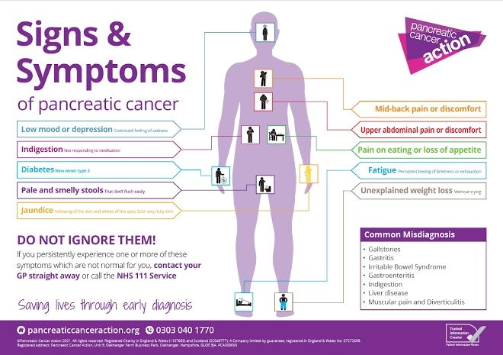**Irinotecan-** Mechanism of action: bind to the topoisomerase I-DNA complex and prevent the relegation of single-strand breaks.

Figure-4

**SYMPTOMS**

**Pancreatic cancer symptoms may include:** Jaundice (yellowing of your skin). Dark urine (pee). Light-colored stool (poop).Upper abdominal pain .Middle back pain. Fatigue. Itchy skin. Nausea and vomiting. Gas or bloating. Lack of appetite. Blood clots. Weight loss [20].

# **Causes of pancreatic cancer**

Smoking is one of the most important risk factors, accounting for. around 20% of pancreatic cancers. Diabetes Pancreatic cancer is more common in people with diabetes, especially those who have recently been diagnosed. Obesity People with a body mass index (BMI) of 30 or more are about 20% more likely to develop pancreatic cancer. Genetic syndromes some genetic syndromes are known risk factors for pancreatic cancer. Chemicalsexposure to chemicals in the dry cleaning and metalworking industries can increase your risk.

**Precautions of pancreatic cancer**

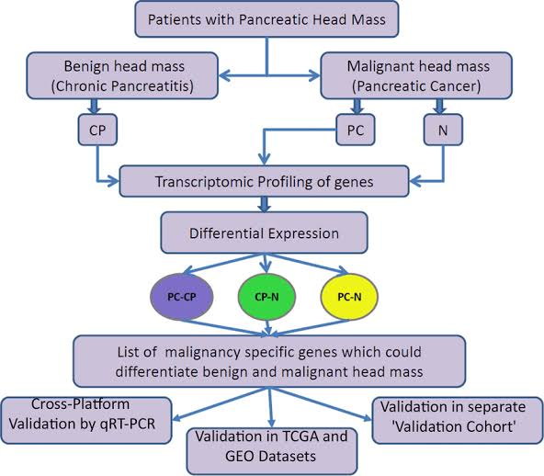Maintain a healthy weightobesity is a major risk factor for pancreatic cancer. If you need to lose weight, aim for a steady loss of 1–2 pounds per week.Exercise regularlyexperts recommend 30 minutes of physical activity per day, including moderate exercise, strenuous exercise, and strength training.Eat a healthy diet eat lots of fresh fruits, vegetables, and whole grains, and limit your intake of red meat, sugary drinks, and processed foods.Stop smokingif you smoke, talk to your health care team about ways to help you stop. Limit alcoholLimit your alcohol intake. Limit exposure to harmful chemicals Limit your exposure to harmful chemicals, such as

Figure-5

asbestos, pesticides, and petrochemicals.Manage stress can trigger physiological responses that promote the growth of pancreatic cancer [21].

**RISKFACTORSOFPANCREATICCANCER**

Since pancreatic cancer is a highly aggressive form of cancer that is largely asymptomatic in the early stages and has a tendency to spread rapidly, leading to poor survival duration post-diagnosis, the AI-based prediction of the risk of developing pancreatic cancer could be an immensely useful strategy for improving the prognosis for an individual. Muhammad et al. had successfully employed ANNs from personal health data to predict and stratify the pancreatic cancer risk as a low, medium, or high risk ,with a sensitivity and specificity of 80.7%.This study highlights the ability of the AI-based predictive tools for the effective management of the pancreatic cancer risk even before the manifestation of symptoms. Similarly, Corral et al. had employed an AI algorithm to identify pancreatic cysts that pose a high risk of transforming into cancerous lesions. Such a pre-diagnosis could help clinicians in designing adequate preventive interventions to save lives. The detection of subtle textural and morphological changes in CT and MRI scans of the pancreas could also be facilitated through customized AI algorithms . Several attempts have also been reported to employ AI tools to predict the risk of developing pancreatic cancer from biomarker measurements, as well as abdominal scans to discern pre-cancerous abnormalities [22].

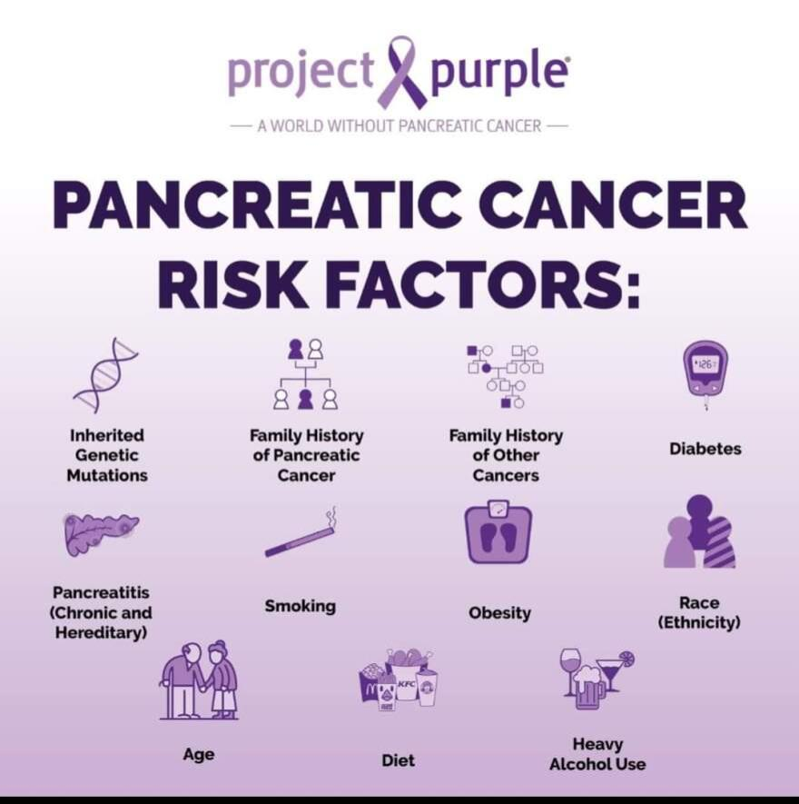.

Figure-6

**The risk of developing pancreatic cancer increases with age:**

Age the percentage of new cases of pancreatic cancer by age group is as follows

< 20 years old: 0.1% ,20-34 years old: 0.7% ,35-44 years old: 1.9%,45-54 years old: 7.7% ,55-64 years old: 21.7% ,65-74 years old: 31.0% ,75-84 years old: 24.5% ,>84 years old: 12.4%

Diagnosis the average age of diagnosis is 70 years old. Incidence the incidence of pancreatic cancer increases with age, with the highest rate in people aged 80 and older. Pancreatic cancer is diagnosed at an older age than most other types of cancer. The reason for this late age onset is not clear, but it may be that it takes several years for a pancreatic lesion to turn into a malignant neoplasm. Survival rates for pancreatic cancer also decrease with age

Other factors that affect survival rates include the cancer’s stage, the individual’s overall health, the treatment plan, and how the cancer responds to treatment. For patients who are diagnosed before the tumor grows much or spreads, the average pancreatic cancer survival time is three to three and a half years. Pancreatic cancer can be a frightening diagnosis. Compared to most other cancers, survival rates are much lower and death often occurs at a more rapid pace.

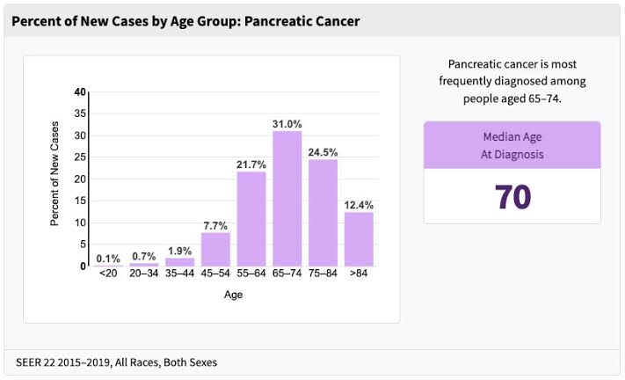

Figure-7

# **Ways to keep pancreas clean naturally:**

Reducing sugar-rich food, drinking plenty of water, taking small but frequent meals, avoid taking alcohol and smoking, taking low animal fat, Taking lentils, clear soups, lean meats, almond milk, Eat a healthy diet: Eat a low-fat diet with lots of fruits, vegetables, whole grains, and lean meats. You can also try eating

Limit unhealthy substances: Avoid smoking and excessive alcohol consumption. Alcohol is a known risk factor for pancreatitis and pancreatic cancer. Exercise regularly try to exercise for at least 30 minutes a day. Maintain a healthy weight avoid fad diets that promise quick weight loss. Drink plenty of water drinking water can help your pancreas function. Get your pancreas checked regularly: Catching pancreatic cancer early can help prevent it from spreading

.

# **References**

1.Siegel RL, Miller KD, Fuchs HE, Jemal A. Cancer statistics, 2022. CA: A Cancer Journal for Clinicians.

2. Sung H, Ferlay J, Siegel RL, Laversanne M, Soerjomataram I, Jemal A. et al. Global Cancer Statistics 2020: GLOBOCAN Estimates of Incidence and Mortality Worldwide for 36 Cancers in 185 Countries. CA: A Cancer Journal for Clinicians.

3. Kamisawa, T.; Wood, L.D.; Itoi, T.; Takaori, K. Pancreatic Cancer. *Lancet* **2016**, *388*, 73–85.

4.Gordon-Dseagu, V.L.; Devesa, S.S.; Goggins, M.; Stolzenberg-Solomon, R. Pancreatic Cancer Incidence Trends: Evidence from the Surveillance, Epidemiology and End Results (SEER) Population-Based Data. *Int. J. Epidemiol.*

5. Noori, A.; Alfi, A.; Noori, G. An Intelligent Control Strategy for Cancer Cells Reduction in Patients with Chronic Myelogenous Leukaemia Using the Reinforcement Learning and Considering Side Effects of the Drug. *Expert Syst.*

6. Liu, S.-L.; Li, S.; Guo, Y.-T.; Zhou, Y.-P.; Zhang, Z.-D.; Li, S.; Lu, Y. Establishment and Application of an Artificial Intelligence Diagnosis System for Pancreatic Cancer with a Faster Region-Based Convolutional Neural Network. *Chin. Med.*

7. Hamidinekoo, A.; Denton, E.; Rampun, A.; Honnor, K.; Zwiggelaar, R. Deep Learning in Mammography and Breast Histology, an Overview and Future Trends. *Med. Image Anal.*

8. Carter, S.M.; Rogers, W.; Win, K.T.; Frazer, H.; Richards, B.; Houssami, N. The Ethical, Legal and Social Implications of Using Artificial Intelligence Systems in Breast Cancer Care.

9.Castellanos J, Manifacio G, Lillehei RC, Shatney CH. Total pancreatectomy for ductal carcinoma of the head of the pancreas: current status. Am J Surg

10.Hirshberg Foundation for Pancreatic Cancer Research.

11.Rajkomar, A.; Dean, J.; Kohane, I. Machine Learning in Medicine. *N. Engl. J. Med.* **2019**, *380*, 1347–1358.

12.Hameed, B.S.; Krishnan, U.M. Artificial Intelligence-Driven Diagnosis of Pancreatic Cancer. *Cancers* **2022**, *14*, 5382.

13. Huang, B.; Huang, H.; Zhang, S.; Zhang, D.; Shi, Q.; Liu, J.; Guo, J. Artificial Intelligence in Pancreatic Cancer. *Theranostics* **2022**, *12*, 6931–6954.

14. Yin, H.; Zhang, F.; Yang, X.; Meng, X.; Miao, Y.; Noor Hussain, M.S.; Yang, L.; Li, Z. Research Trends of Artificial Intelligence in Pancreatic Cancer: A Bibliometric Analysis. *Front. Oncol.* **2022**, *12*, 973999.

15. Gassenmaier, S.; Afat, S.; Nickel, D.; Mostapha, M.; Herrmann, J.; Othman, A.E. Deep Learning–Accelerated T2-Weighted Imaging of the Prostate: Reduction of Acquisition Time and Improvement of Image Quality. *Eur. J. Radiol.* **2021**, *137*, 109600.

16. Xu, J.; Jing, M.; Wang, S.; Yang, C.; Chen, X. A Review of Medical Image Detection for Cancers in Digestive System Based on Artificial Intelligence. *Expert Rev. Med. Devices* **2019**, *16*, 877–889.

17. Chen AM, Cao M, Hsu S, et al. Magnetic resonance imaging guided reirradiation of recurrent and second primary head and neck cancer. Adv Radiat Oncol.

18. Qureshi, T.A.; Javed, S.; Sarmadi, T.; Pandol, S.J.; Li, D. Artificial Intelligence and Imaging for Risk Prediction of Pancreatic Cancer: A Narrative Review. *Chin. Clin. Oncol.*

19. Wang, Y.; Liu, K.; Ma, Q.; Tan, Y.; Du, W.; Lv, Y.; Tian, Y.; Wang, H. Pancreatic Cancer Biomarker Detection by Two Support Vector Strategies for Recursive Feature Elimination. *Biomark. Med.*

20. R.J. Slebos et al. K-ras and p53 in pancreatic cancerassociation with medical history, histopathology, and environmental exposures in a population-based study

21. 21. erlay J, Soerjomataram I, Ervik M, Dikshit R, Eser S, Mathers C, Rebelo M, Parkin DM, Forman D, Bray F. GLOBOCAN 2012 v1.0, Cancer Incidence and Mortality Worldwide: IARC CancerBase No. 11. Lyon, France: International Agency for Research on Cancer;

22. Qureshi, T.A.; Javed, S.; Sarmadi, T.; Pandol, S.J.; Li, D. Artificial Intelligence and Imaging for Risk Prediction of Pancreatic Cancer: A Narrative Review. *Chin. Clin. Oncol.*