EXPERIMENTAL INVESTIGATION ON STRENGTH CHARACTERISTICS OF CERAMIC WASTE AGGREGATE CONCRETE

Pavalan V ¹, Jeevanantham D ²

¹ Assistant Professor^{, 2} M.E Scholar, Department of Civil Engineering, Sengunthar Engineering College (Autonomous), Tiruchengode

Abstract: This paper presents the strength characteristics of ceramic waste aggregate concrete. Ceramic waste fragments obtained from local industry is crushed and sieved to produce coarse aggregates. The standard size of concrete cubes of 150x150x150mm, cylinders of 150x300mm and prisms of 100 x100 x 500mm are casted in the laboratory. After 24 hours, the casted specimens are de-moulded and then immersed in water for curing .The compressive, splitting tensile and flexural strengths of the hardened concrete specimens are determined after curing them for 7 and 28 days. The experimental results indicate that good workability of ceramic waste coarse aggregate concrete and the strength characteristics are comparable to those of the conventional concrete.

Keywords: ceramic waste, coarse aggregate, strength characteristics

1. INTRODUCTION
The necessity of sustainability and recycling has been recognized and understood in academia and industry (T.C. Hansen 1992; K. Watson 1993; R.J. Collins and P.T. Sherwood 1995; F. Pacheco et al. 2011). In India, a large amount of ceramic insulator waste has been found in electricity board due to heavy voltage insulator becomes breaks. This ceramic insulator waste has not been reused after breaking. This work investigates the possibility of replacing the conventional coarse aggregate by crushed ceramic insulator in making of concrete. Several researches have indicated that ceramic wastes are good materials which could substitute conventional aggregates in concrete. R.M. Senthamarai et al. (2005) substituted conventional crushed stone aggregate with ceramic electrical insulator. Different water cement ratio of 0.35, 0.40, 0.45, 0.50, 0.55 and 0.60 were adopted. Compressive strength, split tensile strength, flexural strength and Modulus of elasticity were found out. It is found that the compressive, split tensile and flexure strength of ceramic coarse aggregate are lower by 3.8%, 18.2% and 6% respectively when compared to conventional concrete. A. Mohd Mustafa et al. (2008) studied on various types of ceramic waste like flower pots, tiles and clay bricks. Different water cement ratios were adopted such as 0.4, 0.5 and 0.7 with concrete of characteristics strength of 20 MPa. Flower pots gave the best results for compressive strength of about 2.50% lesser than that of conventional concrete.

T. Sekar (2011) studied on strength characteristics of concrete utilizing waste materials viz: ceramic tiles, ceramic insulator waste and broken glass pieces. Ceramic tiles gave the best results when compared to the other two type of waste. The concrete produced by ceramic tile aggregate produced similar strength in compression, split tensile and flexure as conventional concrete. C. Medina et al. (2012) investigated on the reuse of waste as recycled coarse aggregate in partial substitution of 15%, 20% and 25% in the manufacture of structural concrete. Compressive strength is found out t 7, 28 and 90 days. There is an increase in strength with increase of percentage replacement, the best results shown is at 25% with increase of 21.12%, 11.04% and 6.70% at 7, 28 and 90 days respectively. Senthamarai et al. (2011) studied the durability properties of ceramic industry waste as coarse aggregate in concrete. Water cement ratios from 0.35- 0.60 were used and properties such as volume of voids, water absorption, chloride penetration and sorption were studied. Water absorption ranges from 3.74-7.21% whereas that of conventional concrete from 3.1 – 6.52%. Concrete with Ceramic shows higher results in all tests.

Y. Tabak et al. (2012) studied on the mechanical and physical properties of concrete produced form Floor Tiles Waste Aggregate (FTWA). Two samples were made, the first one substitution by Floor Tile Waste Dust (FTDA) and the other a combination of Floor Tile Waste Dust (FTDA) and Floor Tile Waste Aggregate (FTWA).Best result is shown b FTWA substitution. Increase in compression strength is 13.53%, 16.70% and 2.91% for 2, 7 and 28 days. Similarly there is an increase of 23.21%, 0.1% and 19.47% respectively for flexure strength. There is a reduction of specific density and water absorption of 0.284Kg/m³ and 0.158% respectively when compared to conventional concrete. V. Giridhar et al.(2015) experimented on concrete with ceramic waste as natural coarse aggreagate at 0%, 20%, 40%, 60%, 80% and 100%. M20 concrete is adopted. Maximum compression attained at 20% replacement reached 93.45% and 98.84% to that of conventional concrete. Similarly split tensile strength reaches 97.38% and 93.78% to that of conventional concrete at 7 and 28 days respectively. R. Janarthanan et al. (2015) experimented on ceramic waste as a construction material by replacing it as coarse aggregate for 25%, 50% and 100%. M30 concrete mix is chosen. Best results were found out at 25% replacement with 34.63N/mm² Compression strength which is close to conventional concrete being 34.23 N/mm².

2. EXPERIMENTAL PROGRAMME

2.1 Materials

2.1.1 Ceramic insulator waste coarse aggregate

Ceramic waste aggregate used in this study is obtained from ceramic industries in Nellore. Ceramic waste pieces are generally too large in size (Fig.1), so they were broken by a hammer into smaller pieces. These small pieces were crushed using a jaw crusher to get the required 20 mm maximum size (specific gravity 2.48, fineness modulus 6.92) coarse aggregate. The photograph of crushing and sieving of ceramic waste is shown in Fig.2.

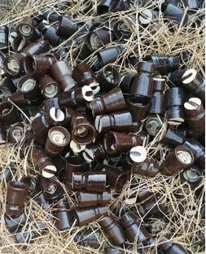

Fig.1 Ceramic Electric Insulator Waste

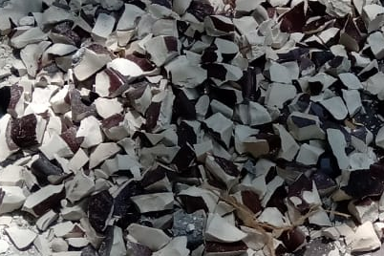

Fig.2 Crushing of Ceramic Waste

2.1.2 Other concrete mix components

Ordinary Portland Cement 53 Grade conforming to IS 12269-1987 , locally available river sand (specific gravity 2.63,fineness modulus 2.37) conforming to IS 383-1970 and natural crushed stone aggregate of maximum size 20 mm (specific gravity 2.72, fineness modulus 6.96) conforming to IS 383-1970 were used in the conventional concrete.

2.1.3 Mix proportions

The detailed mix ratio of cement-water- fine aggregate - coarse aggregate -superplasticizer is 1:0.38:1.56:2.72:0.005.This mix ratio is used to cast both ceramic waste coarse aggregate concrete and the conventional concrete.

3. TEST PROCEDURE

3.1 Compressive Test

The Compressive test is carried out in accordance with IS 516-1959. For the tests, 150x150x150 mm size cube specimens are used. The cubes are casted using M40 grade of concrete. During casting the cubes are manually compacted using tamping rods. After 24 hours, the moulds are removed and the specimens is placed in a curing tank at temperature 27º 2ºC. These specimens are tested by compression testing machine after 7 and 28 days curing (Fig.3). The load is applied continuously at the rate of 140 kg/cm² per minute till the specimens fails. Finally, the maximum load applied to the specimen is recorded and type of failure is observed. The compressive strength of the specimen was calculated by using the formula

f_{c} = $\frac{P}{A}$ (1)

Where,
P = Load at which the specimen fails (N)
A = Area over which the load is applied (mm)
f_{c} = Compressive stress (N/mm²)
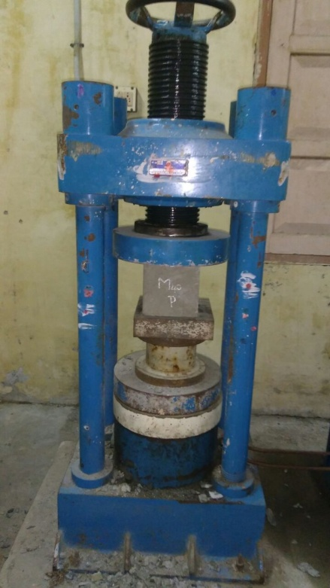
Fig.3 Compression test on concrete cubes

3.2 Splitting tensile test

The splitting tensile test is carried out in accordance with IS 5816-1999 standards conducted on concrete cylinders of 150 mm diameter and 300 mm length. The specimen should be cast and cured in the same manner as for casting of cubes. After 7 and 28 days curing, the specimen is placed longitudinally in the universal testing machine (Fig.4). The load is applied continuously at the rate within, the range of 689 to 1380 KPa/min until failure of the specimen. The Splitting tensile strength is determined by using the formula
f_{ct} = $\frac{2p}{π\text{dl}}$ (2)

Where,
p = Maximum load applied to the specimen (mm)
d = Length of the specimen (mm)
l = Diameter of the specimen (mm)
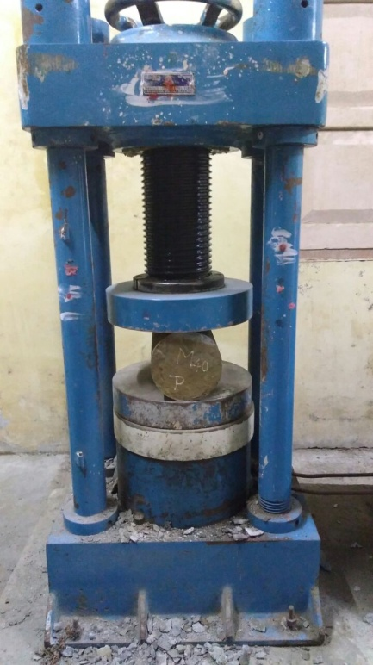
f_{ct} = Splitting tensile strength (N/mm²)
Fig.4 Testing of concrete cylinders
3.3 Flexural test

The flexural test is carried out in accordance with IS 516-1959. For the tests, 100x100x500 mm size prism specimens are used. The prisms are casted and tested using 5T capacity Flexural Testing Machine (FTM). The specimen is placed perpendicular to normal axis on the platform of the flexural testing machine. The load is applied gradually until the failure stage (Fig.5). The ultimate load is noted and calculated the flexural strength of corresponding specimen. The flexural strength of the specimen is calculated by using the formula

$f_{b}$= $\frac{p×l}{b×d^{2}}$ (3)
Where,
b = width of the specimen (mm)
d =depth of the specimen (mm)
l = length of the span on which the specimen was supported (mm)
p = maximum load applied to the specimen (N)

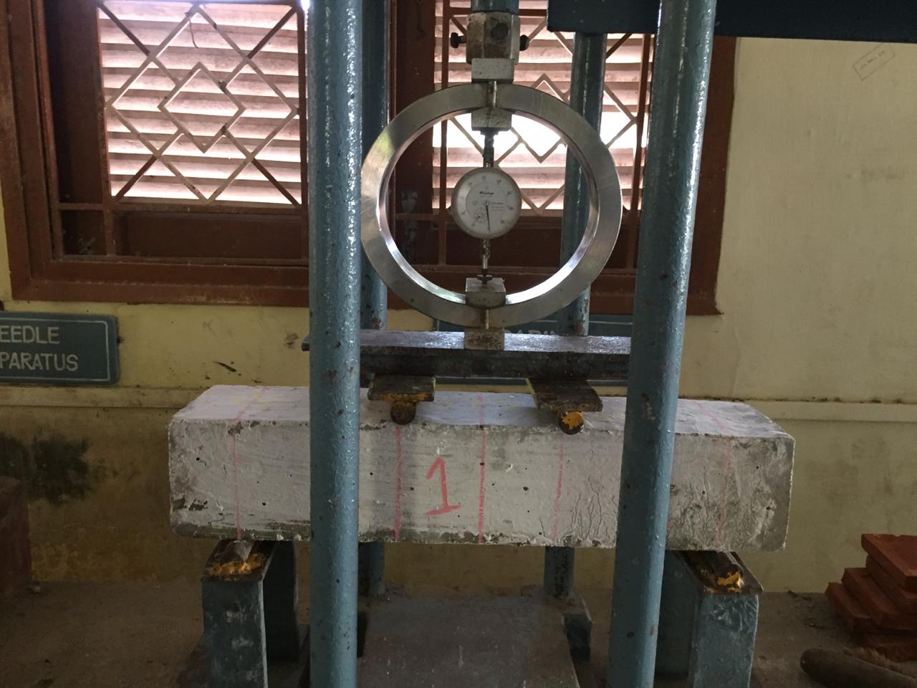
Fig.5 Testing of concrete prisms

4. RESULTS AND DISCUSSION

4.1 Compressive test

The compressive strength of concrete with different coarse aggregates is given in Table 1.The compressive strength varied from 25 MPa to 28 MPa for 7 days strength. Also, it varied from 52 MPa to 55 MPa for 28 days. The compressive strength of concrete cubes made with ceramic waste coarse aggregate concrete is found to be 8.3% greater than that of conventional concrete. It is found that, there is not much variation in the compressive strength of conventional concrete and ceramic waste coarse aggregate concrete.

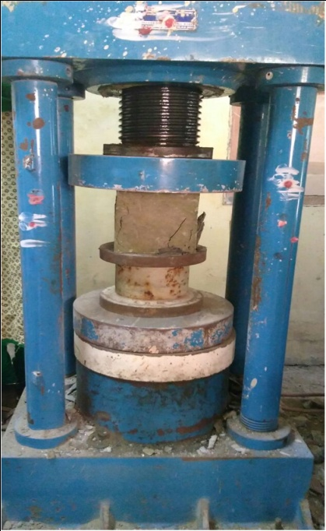
Fig.6 Failure of cube specimen

Table 1 Compressive strength of ceramic waste coarse aggregate concrete and
conventional concrete at 7 and 28 days

Specimen-ID | Ceramic waste coarse aggregate concrete |  | Conventional  concrete
Specimen-ID | Compressive strength (N/mm²)
 | 7 days | 28 days | 7 days | 28 days
M40 | 26.5 | 54 | 24 | 51
M40 | 25 | 52 | 22 | 49
M40 | 28 | 55 | 22.5 | 48.5

4.2 Splitting tensile test

The splitting tensile strength of concrete with different coarse aggregates is given in Table 2.The splitting tensile strength varied from 0.9 MPa to 0.96 MPa at 7 days and 4.2 to 4.5 MPa at 28 days. The modulus of elasticity of concrete varied from 23.4 to 26.1 GPa. It is observed that the splitting strength of ceramic coarse aggregate concrete gave values nearer to that of conventional aggregate concrete.

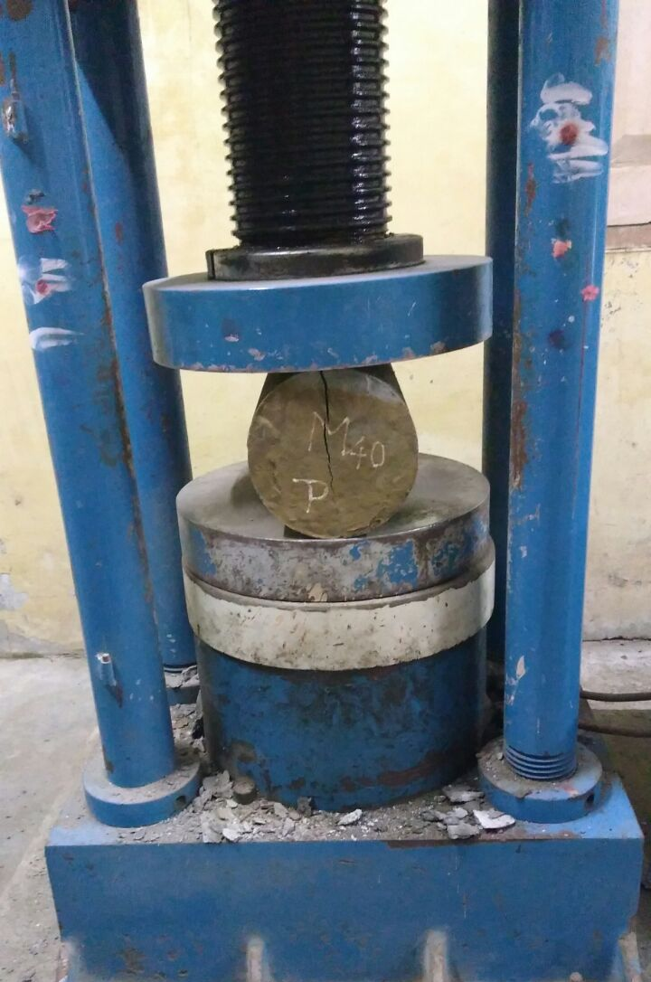
Fig.7 Failure of cylindrical specimen

Table 2 Splitting tensile strength of ceramic waste coarse aggregate concrete and conventional concrete at 7 and 28 days

Specimen ID | Ceramic waste coarse aggregate concrete |  | Modulus of elasticity, E  (GPa) | Conventional  concrete |  | Modulus of elasticity, E  (GPa)
Specimen ID | Splitting tensile strength (N/mm²) |  | Modulus of elasticity, E  (GPa) | Splitting tensile strength (N/mm²) |  | Modulus of elasticity, E  (GPa)
 | 7 days | 28 days | Modulus of elasticity, E  (GPa) | 7 days | 28 days | Modulus of elasticity, E  (GPa)
M40 | 0.96 | 4.5 | 25.2 | 1.1 | 4.8 | 31.6
M40 | 0.92 | 4.3 | 23.4 | 1.2 | 4.5 | 28.4
M40 | 0.9 | 4.2 | 26.1 | 1.2 | 4.6 | 32.8

4.3 Flexural test

The flexural strength of concrete with different coarse aggregates is given in Table 3. The flexural strength varied from 6.2 to 6.5 MPa. The variations in flexural strength between ceramic waste coarse aggregate concrete and conventional concrete are very small.

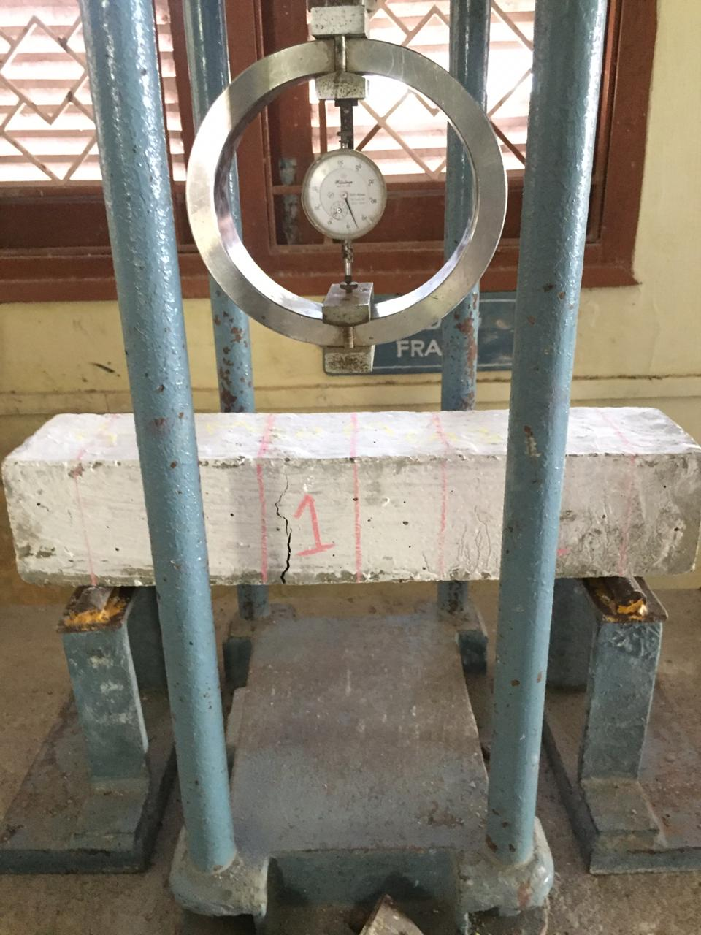
Fig.8 Failure of prism specimen

Table 3 Flexural strength of ceramic waste coarse aggregate concrete and conventional concrete at 7 and 28 days
Specimen-ID | Ceramic waste coarse aggregate concrete |  | Conventional  concrete
Specimen-ID | Flexural strength (N/mm²)
 | 7 days | 28 days | 7 days | 28 days
M40 | 3.1 | 6.5 | 3.4 | 6.7
M40 | 2.9 | 6.2 | 3.1 | 6.4
M40 | 3.0 | 6.3 | 3.2 | 6.7

5. CONCLUSION

In the Present paper, the strength properties of ceramic waste aggregate concrete are investigated. The following conclusions are drawn from the experimental results. The compressive strength of concrete cubes made with ceramic waste coarse aggregate concrete is 8.3% greater than that of conventional concrete. The splitting tensile and flexural strength of ceramic coarse aggregate concrete give values nearer to that of conventional aggregate concrete. The strength properties of ceramic waste coarse aggregate concrete are not significantly different from those of conventional concrete.

REFERENCES

[1] IS 12269:1987, “Specification for 53grade ordinary portland cement”, Bureau of Indian Standards, New Delhi.
[2] IS 383:1970, “Specification for coarse and fine aggregates from natural sources for Concrete”, Bureau of Indian Standards, New Delhi.
[3] IS 516:1959 , “Method of tests for strength of Concrete”, Bureau of Indian Standards, New Delhi.
[4] IS 5816:1999, “Method of tests for Splitting tensile strength of Concrete”, Bureau of Indian Standards, New Delhi.
[5] IS 7320: 1974, “Specification for concrete slump test apparatus”, Bureau of Indian Standards, New Delhi.
[6] S.R Hunchate, G. Valikala and V.G.Ghorpade, “Influence Of Water Absorption of the Ceramic Aggregate on Strength Properties Of Ceramic Aggregate Concrete”, International Journal of Innovative Research in Science, Engineering and Technology, Vol. 2, No. 11, Pp. 6329-6335, 2013.
[7] D.Tavakoli, A.Heidari and M.Karimian, “Properties of Concrete Produced withWaste Ceramic Tile Aggregate”, Asian Journal Of Civil Engineering, Vol. 14 No.3, Pp. 369-382, 2013.
[8] T.M.Maya and Nivin Philip “Mechanical Properties of Concrete Containing Roof Tile Aggregate Subjected To elevated Temperature”, International Journal of Innovative Research in Advanced Engineering, Vol. 1, No.8, Pp. 255-261, 2014.
[9] U.Umapathy, C.Mala and K.Siva“Assesment of Concrete Strength Using Partial Replacemnt of Coarse Aggregate for Waste Tiles and Cement For Rice Husk Ash in Concrete”, International Journal of Engineering Research and Applications, Vol. 4, No. 5, Pp. 72-76, 2014.
[10] A. Javed, S. Siddique and V.S. Ram Prasad, “Investigation On Ceramic Waste and Stone Dust as Aggregate Replacement in Concrete”, International Journal of Engineering Technology, Management and Applied Sciences, Vol. 3, ISSN. 2349-4476, Pp. 127-130, 2015.
[11] D.Aruna, Rajendra Prabhu, Subhash C Yaragal, Katta Venkataramana, “Studies On Usage Potential Of Broken Tiles As Part Replacement To Coarse Aggregates In Concrete”, International Journal of Research In Engineering and Technology, Vol. 4, No.7, Pp.110-114, 2015.
[12] Hemanth Kumar Ch, Ananda Ramakrishna K, Sateesh Babu K, Guruvaiah T, Naveen N and Jani Sk, “Effect of Waste Ceramic Tiles in Partial Replacement of Coarse and Fine Aggregate of Concrete”, International Advanced Research Journal in Science, Engineering and Technology, Vol. 2,No.6,Pp. 13-16, 2015.
[13] J.Swathi and V.Gnanadevi, “An Experimental Investigation On Concrete By Partial Replacement Of Copper Slag For Fine Aggregate And Ceramic Waste With Coarse Aggregate”, International Journal of Emerging Technology in Computer Science And Electronics, Vol.13, No. 4, ISSN.0976-133, 2015.
[14] Janarathanan R, Radha Srinivasan and Muthu Mariappan P, “Effective Utilisation Of Ceramic Waste as a Raw Material in Concrete,” International Journal for Scientific Research and Development, Vol. 3, No. 1, Pp. 904–906, 2015.
[15] T.Subramani and B.Suresh, “ Experimental Investigation Of Using Ceramic Waste As a Coarse Aggregate Making A Light Weight Concrete”, International Journal of Application or Innovation in Engineering and Management, Vol. 4, No. 5, Pp. 153-162, 2015.
[16] R.M.Senthamarai and P. Devadas Manoharan, “Concrete With Ceramic Waste Aggregate”, Elsevier, Cement and Concrete Composites, No. 27, Pp. 910-913, 2005.
[17] A. Mohd Mustafa Al Bakri, M.N. Norazian, H.Kamarudin and G.Che Mohd Ruzaidi, “The Potential of Recycled Ceramic Waste as Coarse Aggregates For Concrete”, Malaysian Universities Conferences on Engineering and Technology, Pp.1-3, 2008.
[18] C.Medina, M.I.Sanchez de Rojas and M.Frias, “Reuse of Sanitary Ceramic Wastes as a Coarse Aggregate in Eco-Efficient Concrete”, Elsevier, Cement and Concrete Composites, No.34, Pp. 48-54, 2012.
[19] V.Pavalan, M.Jithendra, “Using Crushed Ceramic Insulator as Coarse Aggregate in Concrete”, International Journal for Research in Applied Science & Engineering Technology, Volume 8 Issue III, Pp 1120-1125, 2020.
[20] R.M.Senthamarai, P.Devadas Manoharan and D.Gobinath, “Concrete Made From Ceramic Industry Waste: Durability Properties”, Elsevier, Construction and Building Materials, No. 25, Pp. 2413-2419, 2011.
[21] M.Roobini and R.Loganathan,“Study On Concrete Strength By Utilisation of Waste Ceramic Tiles As Aggregate In Concrete”, Integrated Journal Of Engineering Research and Technology, ISSN N0. 2348 - 6821, Pp. 227-232, 2015.

