**MICROSTRUCTURAL AND CHEMICAL ANALYSIS OF POLYPROPYLENE/PIG-BONE-ASH/HAMBURGER SEED SHELL COMPOSITE.**

**N.B NNAJI 1, K.C OWUAMA 2, V.C EZECHUKWU 3,**

1 Ph.D student Department of Mechanical Engineering Chukwuemeka Odumegwu Ojukwu University, Uli, Anambara State, Nigeria.

2, 3 Department of Mechanical Engineering Chukwuemeka Odumegwu Ojukwu University Uli, Anambara State, Nigeria.

Corresponding authors e-mail address: [ndubuisinnaji028@gmail.com](mailto:ndubuisinnaji028@gmail.com)

**Abstract**

The micro-structural and chemical analysis of Run 14 Polypropylene/Pig Bone Ash/ Hamburger Seed Shell (PP/PBA/HSS) composite was investigated in this study. The polymer composite was characterized using Ultraviolet Radiation Analysis (UVR), Scanning Electron Microscopy – Energy Dispersive X-ray Spectroscopy (SEM-EDX), X-Ray Diffraction (XRD), Fourier Transform Infrared Spectroscopy (FTIR) and Electrochemical Corrosion Test (ECT). The analysis results revealed that the developed polymer composite exhibited the following characteristics: an absorbance value of 4.16, presence of notable functional groups including carboxylic acids, alkynes, ethers and peroxides, significant micro-structural interactions and reactions between the polypropylene and the pig bone ash/hamburger seed shell fillers. EDX analysis presented the presence of O, C, K, Mg, P and Si elements. XRD results identified quartz, orthocolase, illite, and albite in the polymer composite. The PP/PBA/HSS composite exhibited resistance to electrochemical corrosion. The polymer composite had an oval and granular structure. This study recommends PP/PBA/HSS composite for sustainable applications including biodegradable packaging and renewable energy. The research contributes to knowledge by advancing understanding of the composites chemical and micro-structural properties. The analysis reveals a correlation between the micro-structure and chemical stability.

Key words: polypropylene, pig bone ash, hamburger seed shell, micro-structure, chemical analysis.

1. **Introduction**

The rising need for sustainable materials has accelerated research towards development of eco-friendly composites. A polymer composite combines two or more materials with a polymer as the primary component, resulting in a material with better properties (Callister and Rethwisch, 2019)

The components of a polymer composite are:

1. Polymer matrix: It is the continuous phase which binds the reinforcement together.
2. Reinforcement: This is the discontinuous phase that provides improved mechanical properties (Agarwal etal, 2017)
3. Fillers: They are materials added to the polymer composite to improve some specific properties such as thermal conductivity impact resistance, hardness etc. (ASTM 6247-18)
4. Coupling agents: They are chemicals used to improve the bonding/link between the polymer matrix and the reinforcement.

This study emphasis on the chemical and micro-structural characteristics of a unique composite material that is made up of polypropylene, pig bone ash and hamburger seed shell. The combination of these components provides a good combination of the mechanical, thermal and environmental advantages as follows: (A) Light weight and High strength to weight ratio (Callister and Rethwisch, 2019) (B) Good corrosion resistant abilities (Chawla, 2012) (C) Can be designed and fabricated easily (D) Prevents environmental pollution because it is recyclable, reusable and biodegradable (Rothon, 2014).

According to Quazi etal (2011) polypropylene is a thermoplastic polymer produced through polymerization of polypropylene molecules. Bei su etal (2007) stated that polypropylene is a polyolefin polymer applied in plastic production due to these advantages: low density, high stiffness, high softening temperature, good chemical inertness and easy processing. Pig bone ash is a type of biomass ash obtained from thermal processing of pig bones derived from slaughter house waste. Some characteristics of pig bone ash are: high calcium and phosphorus content, porous structure, good thermal stability and suitable as a potential filler/reinforcement in composites (Oladele and Adewuyi, 2020).

Hamburger seed shell is the hard black covering of the hamburger bean seed. It is a natural polymer and fiber. Hamburger seed shell has been used by some researchers like: Ajala etal (2021) to treat waste water and Igbokwe (2019) in making activated carbon used for regeneration purpose. Material characterization is the process of getting information on the structure, composition, chemical, physical and mechanical properties of the material (Kumar and Kumar 2019). Characterization techniques applied in this research are scanning electron microscopy, energy dispersive x-ray spectroscopy, x-ray diffraction analysis, Fourier transform Infrared spectroscopy, ultraviolet radiation analysis and electrochemical corrosion test. Microstructure is defined as the external surface and internal structure of a material that can be obtained at the micro level using a microscope at magnifications greater than 25X. Micro-structures consider grain arrangement, grain boundaries and inclusions.

Scanning Electron Microscopy (SEM) is a method of characterization that uses a focused beam of high energy electrons to produce a high resolution images of the surface morphology texture, size, crystalline and elemental composition o the material. (Goldstein etal, 2017 and Egerton, 2019) Energy Dispersive X-ray spectroscopy shows the elements that are present in the material. X-Ray Diffraction (XRD) is a non-destructive analytical method that involves scattering of x-rays by atoms within a crystalline material providing valuable information on material and its structural properties. (Cullity and Stock, 2001). Information obtained in XRD are: crystal structure, lattice parameters, phase composition, crystallite size, strain and stress within a mineral and minerals. (Jenkins and Synder, 1996).

Fourier Transform Infrared Spectroscopy (FTIR) is a technique that is applied to identify and analyze the functional groups present in a material due to the absorption of infrared radiation by the vibration modes of the functional groups (Silverstein and Webster, 2014, Pavia, 2015). Ultraviolet Radiation (UV) was defined by Smith (2013) as electromagnetic radiation with wavelengths between 100-400 nanometers, beyond the visible spectrum. Polymer composite corrosion is the degradation or deterioration of polymer matrix composites due to chemical or electrochemical reactions with their environment, resulting in a loss of mechanical properties, structural integrity or functional performance (Callister and Rethwisch, 2019)

Bio-composites have been extensively studied by researchers such as Azizi etal, (2020), Kabir etal, (2019) and Mohanty etal, (2018). Their work focuses on understanding the chemical and micro-structural characteristics of these materials. The studies examine the composition, structure and properties of bio-composites derived from renewable biomass sources.

**1.1 Aim and Objectives of the Study:**

The aim of this study is to conduct micro-structural and chemical analysis on the optimal polypropylene/ pig-bone-ash/hamburger seed shell composite (Run 14). The specific objectives are:

1. To carryout Ultraviolet Radiation (UVR) analysis on polypropylene/pig-bone -ash/hamburger seed shell composite.
2. To carry out Scanning Electron Microscopy-Energy Dispersive X-ray Spectroscopy analysis on polypropylene/pig-bone-ash/hamburger seed shell composite.
3. To Perform Fourier Transform Infrared Spectroscopy and X-ray diffraction analysis on polypropylene/pig-bone-ash/hamburger seed shell composite.
4. To study the electrochemical corrosion behaviour of the polypropylene/pig-bone-ash/hamburger seed shell composite in NaoH and Hcl solution.
5. **Materials and Methods**

**2.1 Materials**

**2.1.1 Matix Material**

The matrix material used for the research work is polypropylene.

The polypropylene was sourced from chemical zone, Ariaria market Aba. The polypropylenes were in granular form and grey in color. The polypropylene had a density of 0.8991cm3, a melting point of 118oc and a softening temperature of 153oc. It is oval in shape.

**2.1.2 Filler Materials**

**2.1.2a Pig bone ash**

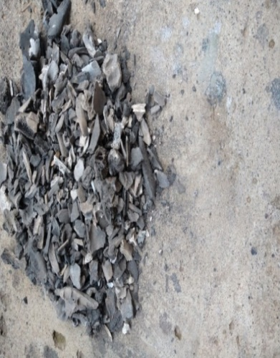Pig bone ash is among the filler materials applied in this study. The pig bone ash was obtained from waste pig bones collected from pig slaughter houses in Umuahia, Abia State, Nigeria.

Plate 1: Uncrushed pig bone ash

**2.1.2b Hamburger Seed Shell**

The hamburger seed shell used in this study was sourced from a local market in Umuahia, Abia State, Nigeria. The shell is a byproduct of hamburger seed processing. A substantial quantity of these shells was collected from the market, where they are typically discarded.

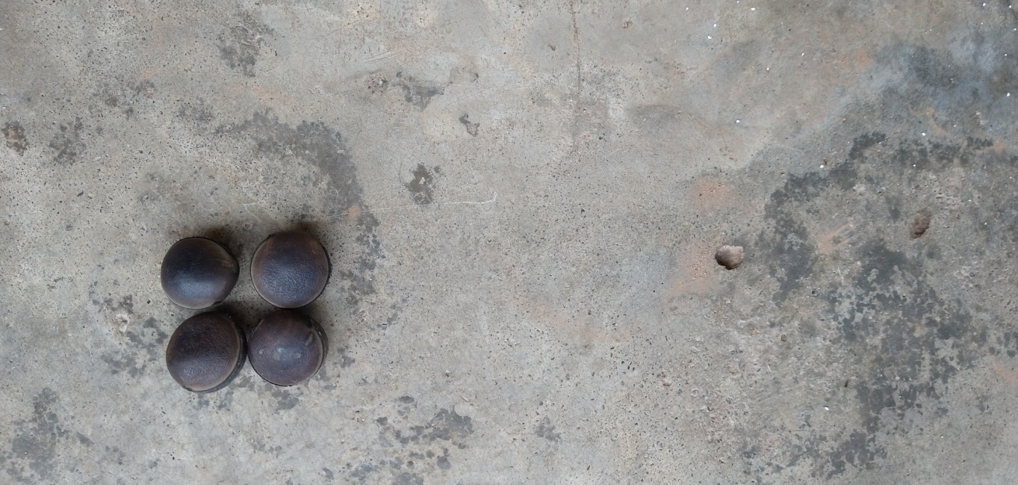

Plate 2: Hamburger Seed Shell

**2.2 Methods**

**2.2.1 Processing of Pig Bone Ash (PBA)**

Pig bone specimens were collected from a dumpsite, washed to remove impurities and sun-dried for five days. The dried pig bones were then crushed into particles at Ariaria market, Aba, Abia State, Nigeria subsequently the particles were incinerated at TEASAC, Aba in an oven for six hours, cooled and ground into fine powder.

**2.2.2 Processing of Hamburger Seed Shell**

Hamburger Seed Shells underwent a preparation process, involving washing, sun-drying for a day and grinding. The resulting powder had a particle size of 10 $μ m$.

**2.2.3 Design Matrix for the Polymer Composite Production**

Table 1 represents the factors (components) for the mixture of the composite polymer to be produced. The central composite design method was used by applying the Design Expert Software.

**Table 1: Matrix Design for the Polymer Composite Mixture**

|  |  |  |  |  |
| --- | --- | --- | --- | --- |
| **Design order** | | **Component**  **1** | **Component**  **2** | **Component**  **3** |
| **Std** | **Run** | **A:Polypropylene** | **B:Pig Bone Ash** | **C:Hamburger Seed Shell** |
|  |  | **Wt.%** | **Wt.%** | **Wt.%** |
| 7 | 1 | 82.65 | 8.74 | 8.61 |
| 17 | 2 | 71.81 | 16.92 | 11.26 |
| 16 | 3 | 76.98 | 13.64 | 9.38 |
| 13 | 4 | 81.59 | 5 | 13.41 |
| 10 | 5 | 71.81 | 16.92 | 11.26 |
| 18 | 6 | 74.39 | 5.61 | 20 |
| 15 | 7 | 63 | 20 | 17 |
| 8 | 8 | 73.8 | 20 | 6.2 |
| 20 | 9 | 80.91 | 14.09 | 5 |
| 3 | 10 | 86.32 | 5 | 8.68 |
| 6 | 11 | 89.79 | 5.21 | 5 |
| 2 | 12 | 68.13 | 16.22 | 15.66 |
| 19 | 13 | 80.91 | 14.09 | 5 |
| 5 | 14 | 72.91 | 10.44 | 16.65 |
| 14 | 15 | 68.79 | 11.21 | 20 |
| 11 | 16 | 77.4 | 9.01 | 13.59 |
| 4 | 17 | 72.91 | 10.44 | 16.65 |
| 12 | 18 | 82.65 | 8.74 | 8.61 |
| 9 | 19 | 64.48 | 15.52 | 20 |
| 1 | 20 | 71.81 | 16.92 | 11.26 |

**2.2.4 Preparation of the Composite**

The preparation of the composite employed the hand layup technique. The hand layup technique was applied to produce the composites based on the compositions of matrix polypropylene and the fillers (pig bone ash and Hamburger seed shell) obtained from the design of experiments software. Table 1 above shows the design of experiments for the composite preparation. To prepare sample for each experimental run of the composite from run 1 to run 20 required measuring the adequate amount of the matrix materials and fillers using a digital weighing balance. The mass used was in grams. After adequate measurement of the required quantity of the matrix and filler materials. The polypropylene, pig bone ash and hamburger seed shell particles were placed in a sizeable mold (1ft by1.2ft) and heated on a bursen burner for 20 minutes. The reason for applying heat was to ensure adequate melting of the matrix and impregnation with the filler materials. The mold was rubbed with a suitable mold release agent after solidification the polypropylene – pig bone ash – hamburger seed shell composite was formed. The produced composite was demolded. The process was repeated for each run.

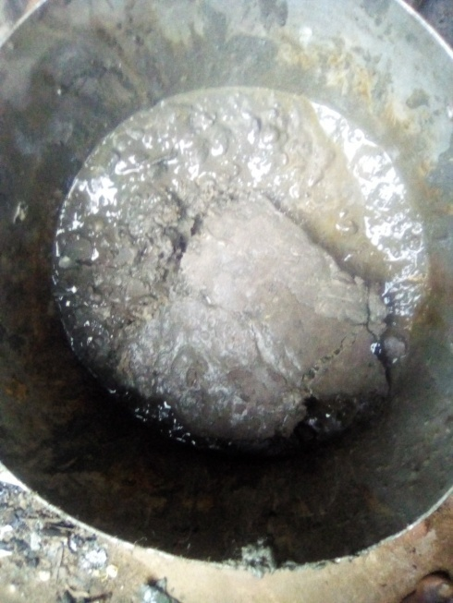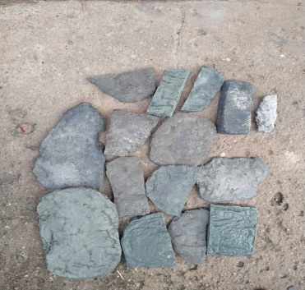

Plate 3: Molding of

PP/PBA/HSS Composites

Plate 4: PP/PBA/HSS

Composites

**2.2.5 Sample Selection and Characterization**

For the purpose of this study a representative sample **Run 14** of the experimental series was selected for microstructural and chemical analysis. The sample was characterized using SEM-EDX, XRD, FTIR, UVR and Electro Chemical Corrosion Test. The composition of run 14 is 72.91wt% polypropylene, 10.44wt% pig bone ash and 16.65 wt% hamburger seed shell. (481.14g PP, 68.71 g PBA, 109.89g HSS).

**2.2.6 Ultraviolet Radiation Analysis (UVR)**

The UV – V is spectrophotometer in the department of chemical engineering Ahmadu Bello University Zaria was used for the analysis. The composite sample (run 14) was prepared and exposed to the ultraviolet radiation for four hours. The absorbance spectrum was measured through the information presented as a graph of absorbance versus wavelength.

**2.2.7 Scanning Electron Microscope and Energy Dispersive X-Ray Spectroscopy Analysis (SEM-EDX).** A Hitachi model (Carl Zees) of Scanning Electron Microscope with an attached Energy Dispersive X-ray Spectrophotometer was used in the analysis. The polymer composite sample (PP/PBA/HSS run 14) was labeled as sample C. The polymer composite sample was prepared and cut into a suitable size. The sample surface was cleaned with compressed air to remove dirt and mounted on aluminum stubs with the help of conductive adhesives. SEM images were captured at various magnifications of 26,000X, 28,000X and 30,000X to examine the composite morphology. The EDX Spectrum was collected to determine the elemental composition of the polymer composite.

**2.2.8 Fourier Transform Infrared Spectroscopy Analysis (FTIR)**

FTIR analysis was performed in the department of Chemical Engineering, Ahmadu Bello University Zaria using a Fourier Transform Infrared Spectrophotometer of model Agilent Cary 630 FTIR. The steps used to perform FTIR analysis on the polypropylene/pig bone ash/hamburger seed shell composite sample were: preparing the sample, loading the sample into FTIR instrument, setting wavelength range to 4000-400cm-1 , collecting background and sample spectrum, subtracting background and analyzing results to identify functional groups and molecular structure.

**2.2.9 X-Ray Diffraction Analysis (XRD)**

The XRD analysis was done in the Chemical Engineering Laboratory of Ahmadu Bello University, Zaria using an X-ray diffractometer. The parts of the equipment are:

1. X-ray tube: it serves as the x-ray source
2. Incident beam optics: it conditions/setup the x-ray beam before it hits the sample
3. Goniometer: it is what holds the sample, optics detector and tube
4. The sample and sample holder
5. Receiving side optics: it condition the x-ray beam after it has encountered the sample
6. Detector: it counts the number of x-rays scattered by the sample. The XRD analysis was performed to obtain information about the phases, crystallo graphic structure and mineral composition of the samples. The sample was labeled C (polypropylene/Pig-bone-ash/Hamburger seed shell composite run 14). The model of the x-ray diffractometer is schimadzu 6000.

A cukδ radiation and graphite monochrometer was used (Λ= 1.54Ao) the particles were ground into powder of particle size 10UM. The voltage level of the diffractometer was 42V while the current level was 33A. The XRD analysis was performed on the sample by directing a beam of X-rays separately on each of the samples. The X-ray beams generated scattered x-rays. The strength of the scattered X-rays was measured due to the separation of the beam. The scatter provided diffraction pattern which indicated the samples crystalline structure. This X-ray diffraction pattern was between 00 to 1200 theta bragg angle according to Bragg’s law. Interpretations of the diffraction peaks was done to identify the phases.

**2.2.10 Electrochemical Corrosion performance Test**

Electrochemical corrosion test involved measuring the corrosion response obtained in the polymer bio composite polymer material when exposed to the NaoH and Hcl environment. Electrochemical corrosion methods used in the test are OCP (Open Circuit Potential) and Tafel analysis. The electrochemical corrosion test was performed in the metallurgy laboratory of University of Nigeria, Nsukka using the model 600E series CH instruments electrochemical analyzer. The electrochemical analyser has these features: control system, analytical software, frequency response analyzer pontiostat/Galvanostat. A personal computer was also used in analysis when carrying out the test. The OCP method was used in performing the test. The best optimal mix design of the polypropylene – pig bone ash – hamburger seed shell composite which is the 14th run was dipped separately in NaoH 10wt% and 10wt% Hcl solutions which served as the electrolytes (aggressive environment).

The OCP uses counter electrode. In the OCP the variation with time is measured by determining the voltage difference between the test materials (polymer composite) immersed in electrolyte and appropriate reference electrode. The reference electrode used was Ag/Agcl, graphite rod served as counter electrode and the polypropylene – pig bone ash-hamburger seed shell composite acted as the working electrode. The corrosion test was carried out in accordance with ASTM G3-14 of performing electrochemical corrosion test on polymer composites. Temperature was 30oc, scan rate 0.01v/s, voltage + 1.5v.

In the OCP test only resting potential is measured between the reference and working electrode. After the analysis Tafel plot enabled the display of results.

EOCP = EWKG – EREF. (1)

EOCP = Means Open Circuit Potential electrode

EWKG = means Working Electrode

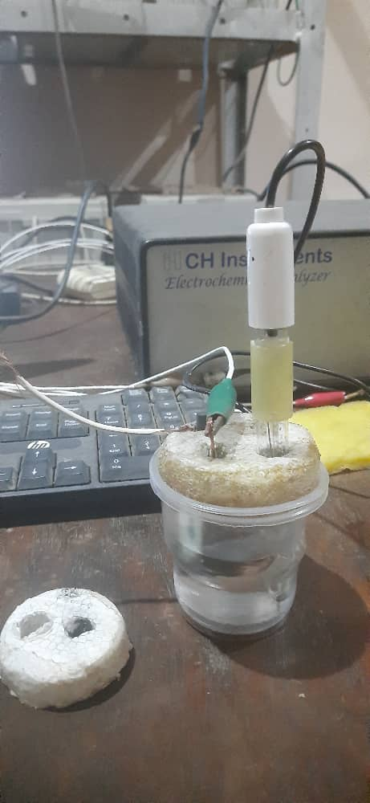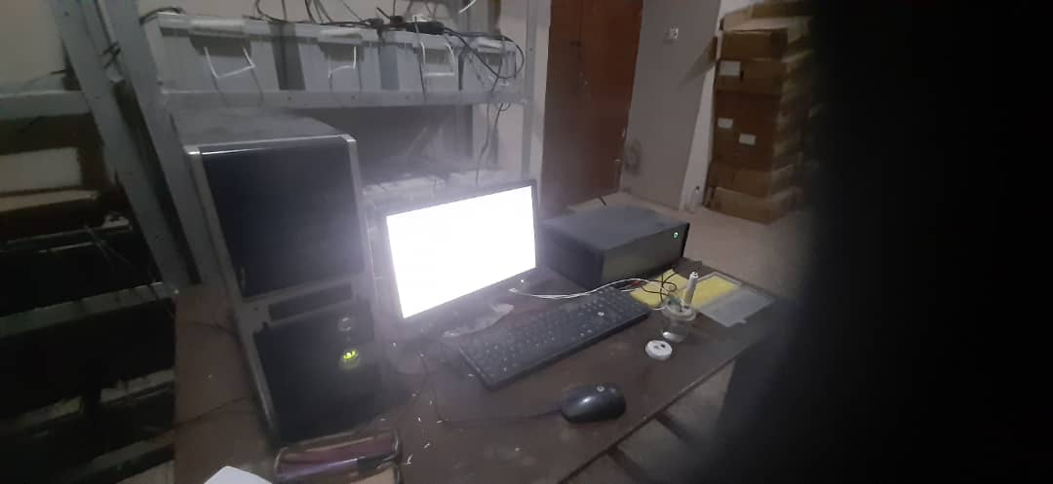EREF = means Reference Electrode

Plate 5: Electrochemical Corrosion Test

**3.0 Results and Discussion**

**3.1 Ultra Violet Radiation**

Ultra violet radiation test was performed to verify the intensity of absorption of light by sample C (polypropylene/pig-bone-ash/hamburger seed shell composite).

Absorbance is defined as a measure of the quantity of light that enters a material at a specific wavelength

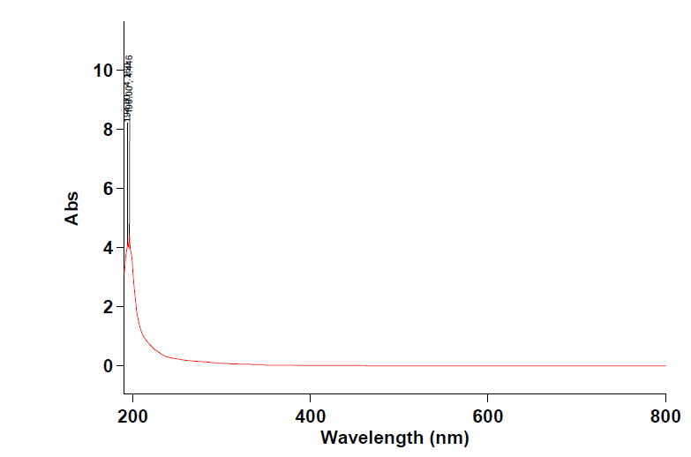The absorbance spectrum versus wavelength of the polypropylene/pig bone ash/ Hamburger seed shell composite (sample c) is shown in Figure 1 the peak of the wavelength was at 196nm with an absorbance value of 4.46.

**Figure 1 Absorbance spectrum versus wavelength polypropylene – pig bone ash – hamburger Seed shell composite**

Range 800.00nm to 190.00nm

Wavelength (nm) 196.00, Abs4.446

The absorbance value of 4.46 means that 55.4% of light can be absorbed by the composite material. This implies that the plastic bucket and other items produced from these composite material will retain heat. This can save the cost of energy used in boiling especially for domestic application.

**3.2 Scanning Electron Microscopy and Energy Dispersive X-Ray Spectroscopy (SEM-EDX) Analysis.**

Scanning electron microscopy analysis was performed to study the structure, morphology and interactions of the sample. The sample was Polypropylene/pig bone ash/hamburger seed shell composite (sample C). EDX analysis was done to obtain the chemical elements that occurred due to electron and sample interaction.

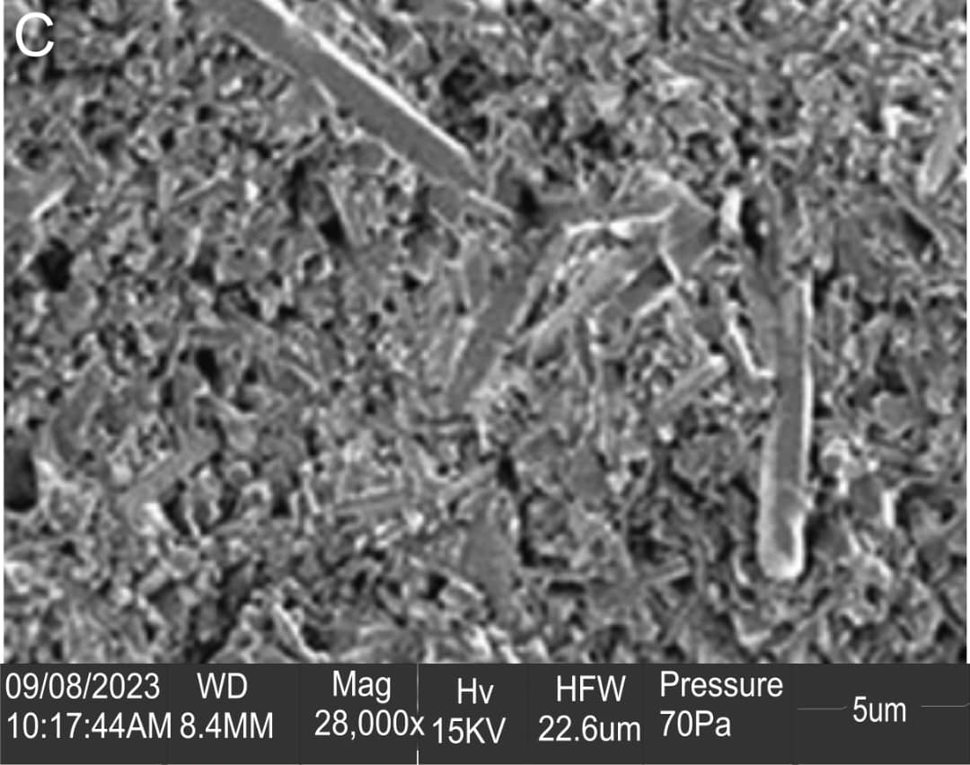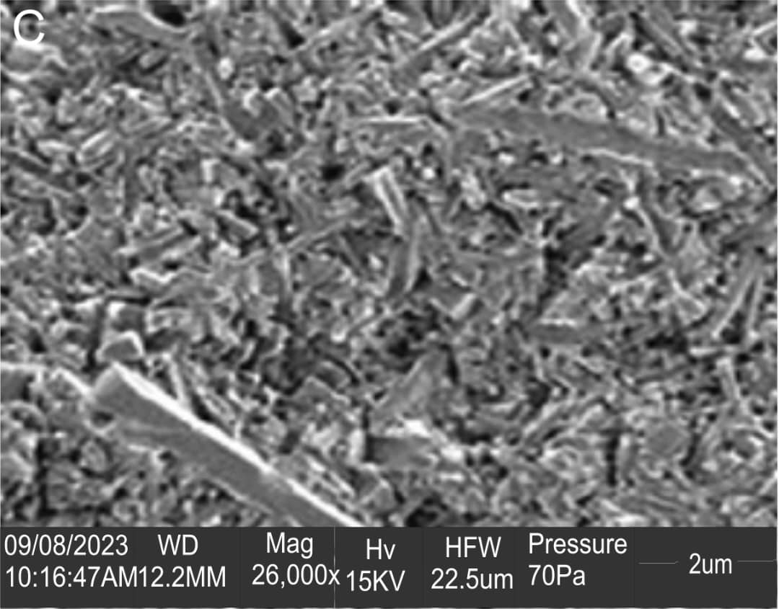The scanning electron photomicrographs of the polypropylene – pig bone ash – hamburger seed shell composite is shown in figures 2, 3 and 4.

**Fig 3**

Photomicrograph of Polypropylene – Pig bone

Ash – hamburger seed shell composite

at the magnification of 28,000X

**Fig 2**

Photomicrograph of Polypropylene – Pig bone ash – hamburger seed shell composite at the magnification

of 26,000X

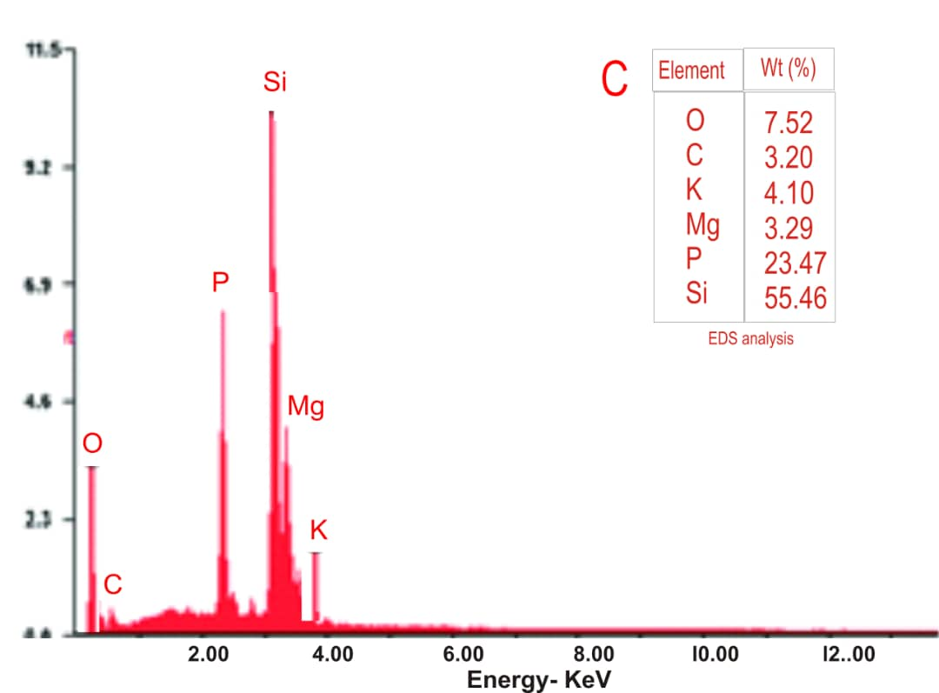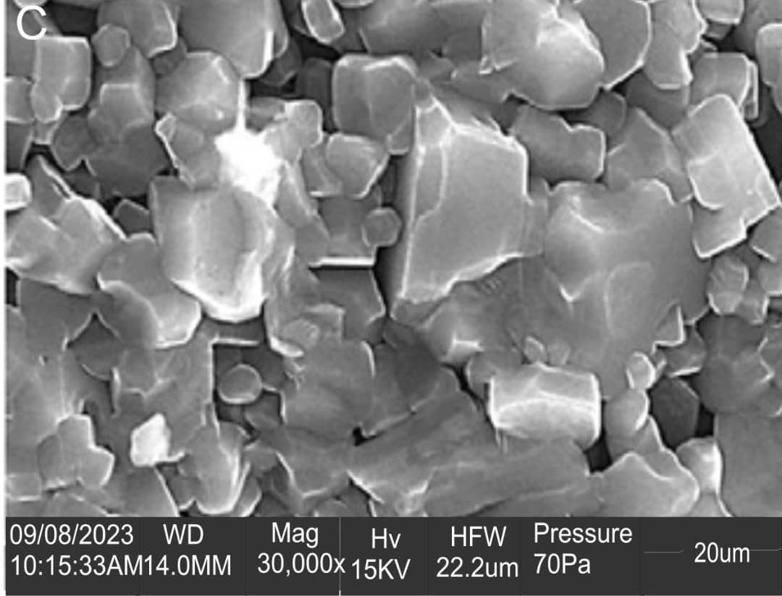

**Fig 5**

EDX Spectrum of Polypropylene – Pig bone ash – hamburger seed shell composite

**Fig 4**

Photomicrograph of Polypropylene – Pig bone ash – hamburger seed shell composite at the magnification of 30,000X

From these figures it was observed that there were interfacial adhesion between the pig bone ash, hamburger seed shell and polypropylene matrix. These interfacial adhesions resulted in the better mechanical properties of run 14 which was used as the standard for a production of the plastic buckets. At 2600X magnification there was even distribution of the filler particles within the polypropylene matrix. There were pileups of the filler particles at some points. This pile up could act as sites to prevent dislocation and deformation of the material leading to enhanced mechanical properties. When the composite was viewed at 28,000X magnification, an adequate bonding of the filler and matrix material was observed. The polypropylene – pig bone ash – hamburger seed shell presented a granular and oval structure. The grain boundaries were adequately aligned. Although few pores and Micro crack were observed along the grain boundaries. These little defects will be covered by pile up of particles that surround them along the grain boundaries. When the composite was viewed at 30,000X magnification a homogeneous micro structure was observed due to strong interfacial bounding between the filler materials and the polypropylene matrix. Some of the grains in the micro structure were moving on top each other. The EDX spectrum of the composite is shown in Fig 5. There were interfacial reactions between the filler and the polypropylene matrix due to the formation of heterogeneous elements. The elements present in the composites are O, C, K, Mg, and Si. Si had the highest composition of 55.46wt% while C had the least composition of 3.20wt%.

**3.3 Fourier Transform Infrared Spectroscopy (FTIR)**

The FTIR analysis was done to identify the functional groups present in polypropylene – pig bone ash – hamburger seed shell composite (Sample C). Figure 6 and table 2 illustrates the FTIR spectrum and the functional groups identified in polypropylene – pig bone ash – hamburger seed shell composite.

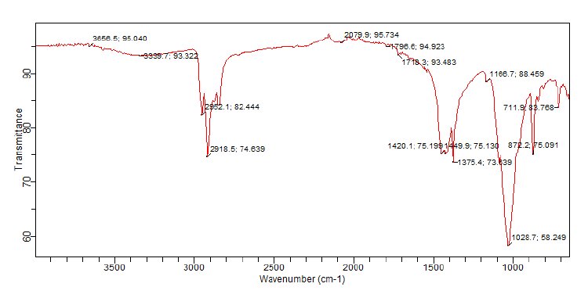

**Figure 6 FTIR spectrum of the polymer composite (Sample C).**

**Table 2: Functional groups of the polymer composite (sample C)**

|  |  |  |  |
| --- | --- | --- | --- |
| **Absorption wave number (cm-1)** | **Class of compound** | **Intensity** | **Assignment** |
| 3666.5 | Carboxylic acid | Strong | O – H stretch |
| 3335.7 | CH3 C ≡ C – H  Alkynes | Strong | ≡ C – H stretch |
| 2952.1 | Alkanes & Alkyls | Strong | C – H stretch |
| 2918.5 | Alkanes & Alkyls | Strong | C – H stretch |
| 2079.9 | Alkyenes | Variable | C ≡ C Stretch |
| 1796.6 | Acylchlorides | Strong | C = O stretch |
| 1713.3 | Carbonyl group | Medium |  |
| 1713.3 | CH3 C(O) – OH | Medium |  |
| 1449.9 | Aromatic compound | Medium – strong | Ring C = C stretch |
| 1420.1 | Alkyl halide | Strong | C – F stretch |
| 1376.4 | Nitro compounds  CH3 – NO2 | Strong | N – O symmetric |
| 1166.7 | Ketones  C = C – C(0) – CH3 | Medium | C = O stretch |
| 1028.7 | Ethers | Medium – strong | = C – O – C symmetric |
| 872.275 | Peroxides | Medium | C – O – O Stretch |
| 711.5 | Alkyl halide CH3 – CL | Strong | C – CL |

It was observed from the table that the composite contained carboxylic acid, alkynes, Alkanes and alkyls, Acyl chlorides and Nitro compounds. These functional groups will help to predict other areas where the composite can be applied. The functional groups identified affect the chemical properties of materials and will help to understand the performance of the polypropylene –pig bone ash –hamburger seed shell composite. Functional group is a group of atoms or bond inside a substance which is responsible for the substances particular chemical reactions.

**3.4 X-Ray Diffraction Analysis**

The XRD analysis was performed to analyze the structure of polypropylene – Pig bone ash – hamburger seed shell composite (Sample C). The XRD results showed different minerals present in the sample, their crystallite sizes and strains, the peaks, orientation and phases present in these materials.

**Table 3: Peak list observed in the polymer composite (sample C).**

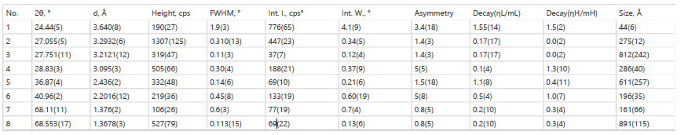

Table 3 illustrates the phases present from the qualitative analysis of the sample it can be seen that quartz, orthoclase, illite and allbite were contained in the developed composite.

**Table 4: Phases identified in the polymer composite (Sample C)**

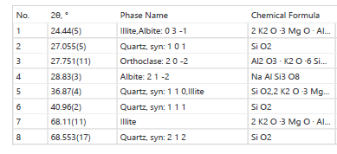

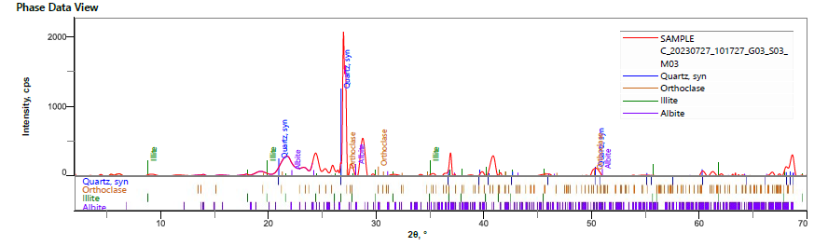

**Figure 7: phase data view of the polymer composite (sample C)**

The phase da++ta view of the XRD analysis of the composite is shown in Fig 4.13.7

This showed the different phases that were analyzed which later resulted to generating the main phases or minerals (quartz, orthoclase, illite and Albite contained in the composite).

Fig 8 and table 4 showed the qualitative composition of the mineral (phase) identified in the composite which gives quartz 68%, orthoclase 7.1%, illite 15% and albite 9.8%.

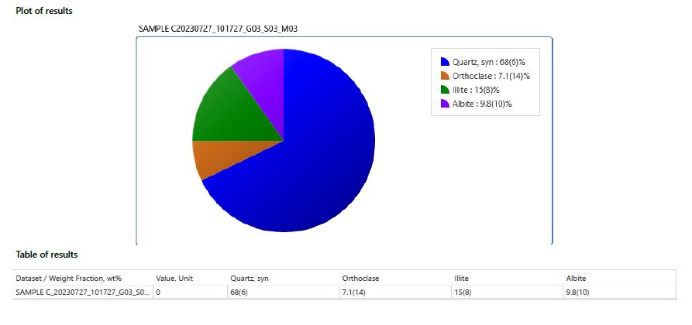

**Figure 8 and table 4 plot and table of results for XRD minerals in polymer composite.**

3.5 **Electrochemical Analysis**

The electrochemical corrosion test was done to check the corrosion resistance of the polypropylene-pig bone ash – hamburger seed shell composite in corrosive environment. This was done by measuring its electro chemical behavior through measuring the potential and current flow between the polymer composite and the reference electrode placed in the same solution. Two solutions were used Hcl and NaoH.

Corrosion rate is determined by equilibrium between the opposing electrochemical reactions. At the Anodic reaction oxidization takes place, electrons while at the Cathode reduction takes place removing electrons. Fig. 9 and table 5 show the tafel plot and electrochemical corrosion values for the polymer composite when immersed in 10wt% Hcl solution. The Tafel plot gives the linear relationship between the logarithm of the current and the over potential.

The slope of the curve is the Tafel slope that shows the activation energy of the reaction that signifies the reaction rate. Tafel plot in fig. 9 shows that the Anode reactions in the right hand side is more than the cathodic reactions at the left hand side indicating lower current and less corrosion. The lower corrosion of the polymer composite in Hcl solution could be attributed to the chemical composition and structure of the fillers that formed a passivation region on the material. The corrosion rate of 2.884e+001 (mil/year) of the polymer composite translates 85% corrosion protection efficiency showing that the polymer composite will show slow degradation when subjected to aggressive environments like chemicals. The Anode slope of 4.102v-1 compared to the cathodic slope of 4.889v-1 is a good corrosion protection value. The Anode reactions have higher current density than the cathodic reactions.

Figure 10 and table 6 shows the Tafel plot and electrochemical values for polypropylene-pig bone-ash – hamburger seed shell composite when immersed in NaoH solution.

From figure 10 there are larger anodic reactions than cathodic reactions indicating good corrosion resistance of the developed composite. The polymer composite had a corrosion rate of 2.451e+002 (mil/year) indicating a slow degradation. The Anodic slope of 3.608v-1 is more than the cathodic slope which is 3.105v-1. In conclusion the two tafel plots of the corrosion behavior of the polymer composite in Hcl and NaoH solution showed that the polymer composite is passive to corrosion because they underwent more reactions at the anodic.



**Figure 9 Tafel plot of the polymer composite in Hcl solution.**

**Table 5 Electrochemical parameters of polymer composite immersed in Hcl solution**

|  |  |
| --- | --- |
| **Parameter** | **Value** |
| Initial E (V) | * 1.5 |
| Final E (V) | 1.5 |
| Segment | 1 |
| Hold time at EF (s) | 0 |
| Scan Rate (V/S) | 0.01 |
| Quiet Time (S) | 2 |
| Cat SlP (1/v) | 4.889 |
| Ano Slp (1/v) | 4.102 |
| Cat Int (Logi) | * 4.366 |
| Ano Int (Logi) | * 4.444 |
| Lin Pol R (ohm) | 762 |
| Corri (A) | 6.344e – 005 |
| Corrosion Rate (mil/year) | 2.884e+001 |
| Corrosion Rate (Angs/min) | 1.394e+001 |
| Corrosion Rate (gram/hr) | 2.877e-005 |
| Protection efficiency (%) | 85 |



**Figure 10 (Tafel plot for the polymer composite in NaoH solution.**

**Table 6: Electrochemical parameters of polymer composite immersed in NaoH solution**

|  |  |
| --- | --- |
| **Electrochemical parameter (Unit)** | **Value** |
| Init E (V) | -1.5 |
| Final E (V) | 1.5 |
| Segment | 1 |
| Hol d time at EF (s) | 0 |
| Scan Rate (v/s) | 0.01 |
| Quiet time (s) | 2 |
| Cat s/p (1/v) | 3.105 |
| Ano slp (1/v) | 3.608 |
| Cat Int (logi) | -3.690 |
| Ano Int (logi) | -2.657 |
| Lin pol R (ohm) | 132 |
| Corri (A) | 4.915e -004 |
| Corrosion Rate (mil/year) | 2.451e+002 |
| Corrosion Rate (Angs/min) | 1.185e+002 |
| Corrosion Rate (gram/hr) | 2.445e-004 |
| Protection efficiency (%) | 95 |

**4.0 Conclusion:**

In conclusion this study provides novel understanding into the chemical and microstructural properties of a sustainable polypropylene composite reinforced with pig bone ash and hamburger seed shell. The Ultra Violet Radiation (UVR) analysis showed that this composite material can absorb heat offering significant environmental and economic benefits. Fourier Transform Infrared Spectroscopy (FTIR), X-ray Diffraction (XRD), Scanning Electron and Energy Dispersive X-ray Spectroscopy (SEM-EDX) analysis revealed significant functional groups, mineral, morphological features, chemical interactions, reactions and elements in the microstructure of the polymer composite. There was uniform dispersion of the fillers (pig bone ash and hamburger seed shell) within the polypropylene matrix showing favorable compatibility. The identification of specific functional groups like carboxylic acid, alkynes, alkanes, alkyls etc. shows the successful incorporation of the fillers. The developed polymer composite was resistant to corrosion damage. These findings have contributed new knowledge into materials characteristics of polymer composites. Based on the findings the polymer composite can be applied in the following: Light weight automotive components, insulation materials, biodegradable packaging, plastic buckets, soil remediation, energy storage and electronics.

**5.0 Recommendations:**

* Potential applications of this composite material in various industries like construction, packaging, plastic and automotive should be investigated.
* Thermal degradation behavior of the composite need to be studied to determine its suitability for various applications.
* There is need for assessment of the potential for large scale production of the composite material and its economic implications.
* There is need to investigate the effects of filler particle sizes on agro waste filled polypropylene composites mechanical and thermal properties.
  1. **Contribution to Knowledge**

The study makes the following contributions to knowledge:

* Exposed innovative knowledge into the microstructural and chemical behavior of polypropylene/pig bone ash/hamburger seed shell composite.
* Developed a novel, ecofriendly polypropylene composite in-cooperating agro-waste fillers (pig bone ash and hamburger seed shell), providing a resource-efficient alternative for materials development and waste reduction.
* Establishes the viability of agricultural waste as a sustainable reinforcement material for composite production, offering a dual benefit of enhanced waste management and reduced material costs.

**7.0 REFERENCES**

1. Adewuyi, A.P and Oladele, I.O (2020).Mechanical and thermal properties of pig bone ash- reinforced polyester composite. Journal of composite materials, 54 (11), 1411-1423
2. Agarwal etal (2017): “Reinforced polymer composites: processing, properties and Applications” chapter I: introduction to reinforced polymer composites. (CRC press)
3. Ajala, L.O, Ali E.E, Obasi, N.A, Fasuan, T.O (2021). Insights into purification of contaminated water with activated charcoal derived from hamburger seed coat. International Journal of Environmental Science and Technology: IJEST 19(7) : 6541-6554
4. ASTM D6247-18:’’ Standard test and method for determination of fillers in Polymeric Materials”(ASTM International)- section 3.1.1 filler.
5. Azizi,M.A.S etal (2020) .Chemical and microstructural characterization of sugar cane bagasse-reinforced poly(lactic acid)bio composites. Journal of Bio based Materials and Bioenergy 14 (1), 34 -41.
6. Beisu , A., YingGuo, Z .,Hai -Hong,W.(2017).Infulence of mechanical properties of polypropylene/low density polyethylene nanocomposites:compartability and crystallization .SAGE Journals (http://doi:org/10.1177/.184980417715929)
7. Callister, W.D & Rethwisch, D.G (2019). Materials science and engineering: An Introduction John Wiley and Sons 543-574,129-166.
8. Chawla, K.K (2018). Composite material science and engineering. springer 155-186
9. Cullity B.D., &Stock, S.R (2001). Elements of X-ray diffraction (3rd ed.) Prentice Hall 1-2
10. Egerton, R.F (2019). Physical principles of electron microscopy: An introduction to TEM, SEM and AEM. Springer.
11. Goldstein, J.I etal (2017). Scanning Electron Microscopy and X-ray Microanalysis. Springer.
12. Igbokwe etal (2019) “Activated carbon from hamburger seed shell: a low cost-adsorbent for heavy metal removal. Journal Chemical Technology and Biotechnology.
13. Jenkins, R.S & Snyder, R.L (1996). Introduction to X-ray powder diffractometry. Wiley.
14. Kabir, M. M etal (2019). Microstructural and chemical characterization of flax fiber reinforced polypropylene bio composites. Journal of composite materials, 53(19),2611-2623
15. Kumar, P. etal (2019). Polymer matrix composites: processing, properties and applications. Springer.
16. Kumar, P. and Kumar, N (2019).Materials characterization. In Material Science and engineering CRC press (1-5)
17. Mohanty, A.K etal (2018). Chemical and microstructural characterization of biocomposites derived from renewable resources. ACS Sustainable Chemistry and Engineering 6(5) 5539-5548
18. Pavia, D.L etal (2015). Introduction to Spectroscopy. Cengage Learning.
19. Quazi, T.H.S, Alam, A.K.N, Quaiyyam, M.A (2013). Mechanical properties of polypropylene composites: A review journal of thermoplastic Composites materials (26)3 362-391 Doi: 1177/0892705711428659
20. Rothon, R.N (2014). Particulate-filed polymer composites. Rapra Technology.
21. Silverstein, R.M & Webster, F.X (2014). Spectrometric identification of organic compounds, John Wiley and Sons.
22. Smith,B.C (2013). Infrared Spectral Interpretation: a Systematic approach, CRC Press.