**INVESTIGATION INTO THE UTILIZATION OF BY-PRODUCTS AND INDUSTRIAL WASTES IN THE CONTEXT OF ROAD CONSTRUCTION**

**MUNEEB RATHER1, Mr. ASHISH KUMAR2**

**1** M Tech Scholar, RIMT University Mandi Gobindgarh Punjab, India

2 Assistant Professor, RIMT University Mandi Gobindgarh Punjab, India

## **ABSTRACT**

There are now major environmental and disposal issues as a result of the continuously growing output of waste materials and industrial byproducts. Alternative, sustainable materials that might lessen the industry's environmental impact are desperately needed in the road building scenario. The possible use of industrial wastes and by-products, such as fly ash, slag, recycled concrete aggregates, and materials produced from tires, as workable substitutes in the building of road infrastructure are examined in this thesis. In order to assess these materials' viability for enhancing road building procedures while reducing environmental effects, the research investigates their mechanical, chemical, and physical characteristics. In order to evaluate the strength, durability, and resistance to wear and environmental conditions of road materials including these by-products, a thorough investigation was carried out using laboratory tests and field testing. The study also looks into the possible financial savings, less landfill trash, and environmental advantages of using industrial byproducts in place of traditional building materials.

According to the research, a number of these materials, when mixed and treated appropriately, can enhance road longevity and performance while simultaneously lowering the need for virgin resources. The study also outlines obstacles to the widespread use of these materials, including technical standards, material uniformity, and regulatory restrictions. However, the study highlights the substantial environmental and economic benefits of integrating industrial wastes into road construction practices.

In conclusion, this thesis provides a pathway toward more sustainable road construction, promoting the circular economy while addressing waste management and resource depletion in the industry.

**Key Words**: industrial by-products, road construction, sustainable materials, waste utilization, fly ash, slag, recycled concrete aggregates,

# INTRODUCTION

**Introduction:**

The rapid pace of industrialization and urbanization has significantly increased the production of by-products and waste materials, posing serious challenges in terms of environmental management and disposal. While industrial wastes are often considered as pollutants, they also represent a valuable resource that can be repurposed for various applications. One of the most promising areas for utilizing these by-products is in road construction, where they can serve as alternative materials to traditional aggregates, binders, and other construction components. The incorporation of such materials not only addresses the issue of waste disposal but also contributes to more sustainable practices in the construction industry.

Road construction is a resource-intensive process, relying heavily on natural materials such as sand, gravel, and crushed stone. However, the extraction of these materials can lead to environmental degradation, including deforestation, soil erosion, and habitat destruction. Additionally, the production of conventional construction materials often requires high energy consumption, leading to a large carbon footprint. In light of these concerns, the construction industry is increasingly seeking ways to reduce the reliance on virgin materials and explore more sustainable alternatives. By using industrial by-products and waste materials, there is an opportunity to minimize environmental impacts, reduce waste sent to landfills, and lower the overall carbon footprint of infrastructure projects.

This research focuses on evaluating the feasibility of using industrial by-products such as fly ash, slag, recycled concrete aggregates, and tire-derived materials in road construction. These materials possess unique properties that, when appropriately processed, can enhance the performance of road infrastructure. For example, fly ash can improve the workability and strength of concrete, while recycled aggregates offer a sustainable alternative to natural stone. Tire-derived materials can also provide benefits in terms of elasticity and durability. The main objective of this study is to investigate the mechanical, durability, and environmental properties of these materials when integrated into road construction projects, thereby contributing to the development of more sustainable, cost-effective, and environmentally friendly infrastructure solutions.

# OBJECTIVES

The objectives are as follow:

1. To investigate the optimal WFS percentage and stabilizer combination for maximizing CBR values in soil mixtures.
2. To evaluate the impact of fly ash and red mud proportions on the strength and stability of WFS-based mixtures.
3. To determine the influence of curing duration on UCC strength in mixtures with varying WFS, fly ash, and red mud content.
4. To assess how different stabilizers, specifically cement and lime, affect permeability and strength in WFS mixtures.
5. To analyse the pH variations in mixtures due to red mud, WFS, and fly ash percentages and their effects on leachate pH.

# LITERATURE REVIEW

**Alawag et al. (2024)** performed a bibliometric analysis to evaluate the integration of industrial by-products such as steel slag, fly ash, and red mud in asphalt mixtures for sustainable road construction. The study analyzed 909 scientific articles to identify trends, gaps, and future research opportunities. Key findings emphasized the necessity of field validation and further laboratory testing to address challenges like aging, moisture resistance, and chemical interactions affecting long-term pavement performance. Additionally, the research highlighted the importance of expanding the use of these materials across various asphalt mixes, promoting resource efficiency and environmental sustainability. This study provides a roadmap for engineers and researchers to develop innovative, eco-friendly practices, aligning with the global push for reducing dependency on natural aggregates and minimizing industrial waste's environmental impact. Future recommendations include broader implementation, testing under diverse conditions, and interdisciplinary collaboration for widespread adoption.

**Baarimah et al. (2024)** explored the potential of blast furnace slag and fly ash in constructing road sub-layers. Their study highlighted the enhanced structural stability these materials offer, making them suitable alternatives to traditional construction resources. By incorporating these industrial by-products, the research emphasized a significant reduction in the reliance on natural aggregates, promoting resource conservation and cost-effectiveness. This approach also supports sustainability by repurposing waste materials, minimizing environmental impact. The study advocates broader application of such methods in future road construction projects.

**Bansal, Kushwah, Garg, & Sharma (2023)** explored the use of plastic waste in road construction in India, specifically in asphalt layers. Their study found that incorporating processed plastic waste into asphalt significantly enhanced the durability of the roads. The plastic-modified asphalt exhibited improved resistance to wear, weathering, and deformation, making it more suitable for high-traffic areas. Furthermore, the use of plastic waste helped reduce the environmental impact by diverting non-biodegradable materials from landfills and repurposing them in infrastructure projects. This approach offers an eco-friendly and cost-effective solution for managing plastic waste while strengthening road construction practices.

**Gupta et al. (2023)** examined the reuse of industrial by-products, specifically fly ash and foundry sand, in the construction of rural roads. Their research demonstrated that these materials offered a sustainable and cost-effective alternative to traditional construction aggregates. The study revealed that using fly ash and foundry sand not only reduced the overall cost of road construction but also contributed to environmental sustainability by recycling waste materials. The findings underscore the potential of industrial waste as a viable solution to improve infrastructure in rural areas while promoting greener construction practices. This approach also aids in reducing the environmental burden caused by industrial by-products.

The **Indian Road Congress (2022)** launched the "Waste to Wealth Mission," focusing on the integration of industrial waste, such as slag and ash, into road embankments. This initiative aimed to enhance the subgrade strength of roads while promoting sustainability. By incorporating these by-products, the mission offered a dual advantage: improving road performance and reducing environmental impact. It also supported the recycling of industrial waste, decreasing reliance on natural resources and contributing to the overall reduction of landfill waste. The initiative emphasizes a sustainable approach to road construction and resource management.

**Patil & Kumar (2022)** investigated the use of coal ash in bitumen mixtures to enhance the resilience of asphalt pavements. Their research found that incorporating coal ash, a by-product of thermal power plants, significantly improved the durability and performance of bitumen in road construction. This approach not only enhanced the mechanical properties of the mixture but also contributed to the recycling of thermal power plant waste, reducing environmental impacts. The study demonstrated the feasibility of using coal ash as a valuable resource in road construction, offering a sustainable solution for managing industrial by-products while improving infrastructure quality. The findings encourage the broader use of coal ash in road construction, supporting the development of environmentally friendly and resilient roads.

**Sharma & Singh (2021)** explored the use of recycled construction debris in pavement base layers, aiming to promote sustainability in road construction. The study demonstrated that utilizing this recycled material reduced the demand for virgin aggregates, cutting both costs and environmental impact. The research found that recycled construction debris provided adequate strength and stability for pavement layers, making it a viable alternative to traditional materials. This practice not only aligned with sustainability goals but also helped manage waste from the construction industry, offering a circular economy solution. By incorporating recycled materials, the study contributed to reducing landfill waste while promoting eco-friendly construction practices. This approach also helped meet the growing need for sustainable infrastructure development, particularly in areas with limited access to natural aggregates.

**Reddy et al. (2021)** studied the application of red mud and fly ash mixtures in road sub-base construction, addressing both industrial waste disposal challenges and the need for durable infrastructure. Their research demonstrated that these industrial by-products, often considered waste, could be effectively used to replace conventional materials in road construction. The study found that mixtures of red mud and fly ash provided adequate strength and stability for sub-base layers, making them a viable and sustainable option. This not only helped mitigate environmental issues related to waste disposal but also contributed to resource conservation in the construction industry. The incorporation of such waste materials aligns with circular economy principles by reducing landfill waste while enhancing the performance of road infrastructure. Overall, the study offers a promising solution for improving the sustainability and cost-effectiveness of road construction projects.

# METHODOLOGY

**UTILISED SUBSTANCES, WFS**

After receiving WFS from a foundry plant in J&K India, it was noted that the sand had a black color. In order to eliminate any clumps, foreign particles, and fine particles, the WFS underwent an initial filtration process using a coarse sieve with a size larger than 4.75. Afterwards, an analysis was conducted on both the physical and chemical features of the WFS. The WFS utilized mostly sand particles that were able to pass through a 2.36 mm screen, making up almost the whole sample. A sieve examination was performed to ascertain the gradation Characteristics of the WFS, which unveiled homogeneity in the size of sand particles. The physical Examination revealed that the WFS exhibited a lack of substantial cohesive properties. Figure 4.1 depicts the WFS image utilized in this work, while Figure 4.2 depicts the distribution of particle size curve derived for the alike.

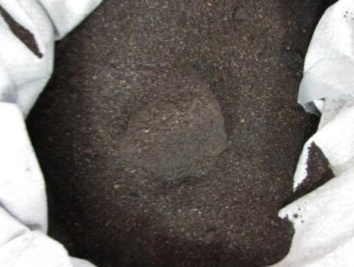

**Figure 4.1** WFS utilized

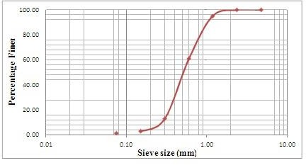

**Figure 4.2** Curve of Particle Size Distribution for WFS

**Fly Ash**

Industrial furnace stack gases, upon cooling, generate fly ash in the form of a finely powdered substance. The Characteristics and attributes of the fly ash are determined by the specific kind of fuel utilized. Fly ash generally comprises of spherical particles that enhance flow characteristics and reduce the quantity of water needed in combinations. The material exhibits a low specific gravity, a consistent particle size distribution, and a lack of malleability. The specific gravity of fly ash ranges from 2.0 to 2.6, depending on its chemical makeup. When fly ash comes into contact with water, its pH level may vary from 8 to 12. Fly ash is often utilized in the building industry as a substitute for natural pozzolanas, owing to its comparable qualities to cement. When fly ash is combined with water, it displays cement-like characteristics that are similar to cement, resulting in the formation of hydration compounds. Therefore, it is often utilized in construction as a replacement for cement, giving cohesiveness to the combinations being studied. Fly ash is categorized into two distinct classifications: Class C and Class F.

Class C fly ash is regarded preferable than Class F fly ash beautifies it has greater cementitious properties. Nevertheless, this Examination utilized Class F fly ash. Figure 4.3 depicts the Class F fly ash that was employed in this Examination. Table 4.2 lists the chemical characteristics of the fly ash utilized in this research.

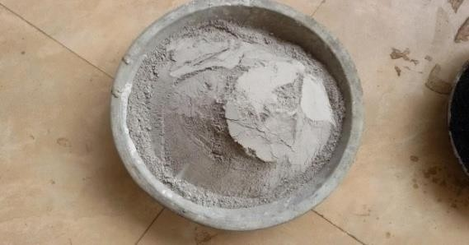

**Figure 4.3** Fly ash of Class F type

**Table 4.1** Fly ash chemical composition

|  |  |  |
| --- | --- | --- |
| **S. No** | **ingredients** | **%** |
| **1** | **quantity of SiO2** | **52.30** |
| **2** | **Total quantity of Alumina** | **18.50** |
| **3** | **Total quantity of Ferric oxide** | **10.70** |
| **4** | **Total quantity of calcium** | **7.90** |
| **5** | **Free lime content** | **2.90** |
| **6** | **Magnesium content** | **0.85** |
| **7** | **Titanium** | **0.25** |
| **8** | **Potassium** | **3.30** |
| **9** | **Sodium** | **0.15** |
| **10** | **Loss on ignition** | **1.95** |

The sieve analysis revealed a fineness modulus of 0.058. Fly ash with a specific gravity of 2.28.

**Red Mud**

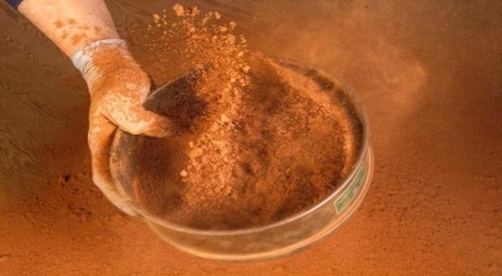This is an intractable residue resulting from the Beyer's process utilized in the production of aluminum. Red dirt is collected from the aluminum industry in J&K India. The scarlet mud was pulverized into a fine dust. Figure 3.4 illustrates a specimen of red mud utilized in the study.

**Figure 4.4** Red Mud Utilized

The material was completely dried before utilize. The Atterberg limits of red mud are determined using IS-2720. Red mud particles range in size from 75 to 100 microns. The results of the sieve analysis of red mud utilized in this experiment are shown in Table A1.3 in Appendix 1. The effective size of red dirt was determined to be 0.012 mm. The particle size distribution curvature for red mud is presented in Figure 3.6. The chemical Characteristics of the red mud conceded out in current experiment are shown in Table 4.2.

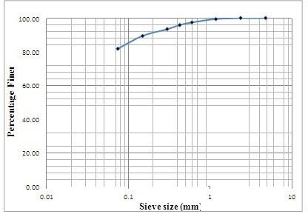**Table 4.2** Chemical Composition

|  |  |  |
| --- | --- | --- |
| **S.N.** | **Constituents** | **%** |
| 1 | Iron oxide | 25.34 |
| 2 | Aluminum Oxide | 17.76 |
| 3 | Silica | 6.90 |
| 4 | CaO | 21.50 |
| 5 | Sodium oxide | 4.80 |
| 6 | Titanium Oxide | 6.0 |
| 7 | Potassium Oxide | 0.06 |
| 8 | Sc2O3 | 0.80 |
| 9 | V2O5 | 0.28 |
| 10 | Nb2O5 | 0.011 |
| 11 | Losses | 7.85 |

**Figure 4.5** Distribution of red mud particle sizes

**Cement**

The research study utilized Ordinary Portland Cement (OPC) Grade 53, following the standards stated in IS 12269 (1987). The full characteristics of the cement utilized in the research are outlined in the table provided below.

**Table 4.3** Cement Characteristics

|  |  |  |
| --- | --- | --- |
| **S. No** | **Property descriptions** | **Observed Value** |
| 1 | Cement SP.GR | 3.17 |
| 2 | Cement having Fineness modulus | 10% |
| 3 | Cement having Consistency | 27.3% |
| 4 | Cement having Initial setting time | 35 minutes |

## **Lime**

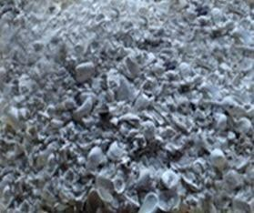Figure 4.5 Illustrates the acquisition of lime, which served as a stabilizing ingredient in the field experiment, from a nearby marketplace.

**Figure 4.5** Seashells were employed in the experiment

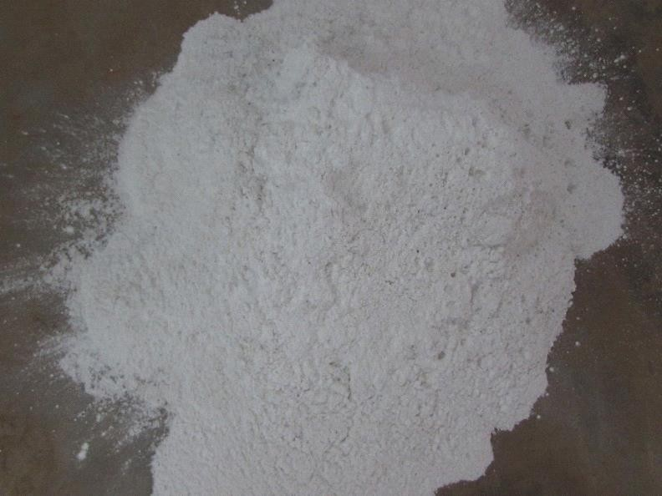The lime utilized in the present study was produced by the process of calcination of seashells followed by the application of water, resulting in the formation of a powdered substance.

**Figure 4.**6 Lime was employed in the research

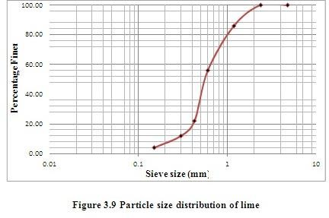

## **STUDY OF EXPERIMENTATION**

Using various mix quantities of industrial offshoot and waste, the experimental Examination examines strength characteristics such as the UCC, CBR and Split Tensile Strength. The industrial by-product percentages vary to accommodate a wide range of mix formulations.

## **The CBR test considers each component of the mixtures.**

The field of inquiry has a grand total of 55 samples. The Examination utilized samples consisting mostly of WFS and fly ash. By substituting different quantities of fly ash for WFS, many combinations may be created.

**Table 4.4** CBR testing consider the amounts of the combination.

|  |  |  |  |  |  |
| --- | --- | --- | --- | --- | --- |
| **ID** | **Industrial effluents/industrial offshoot** | | | **Stabilizing agent** | |
| **W.F.S.** | **Fly ash** | **Red mud** | **Cement** | **Lime** |
| S1 | 80 | 5 | 5 | 5 | 5 |
| S2 | 70 | 10 | 5 | 5 | 5 |
| S3 | 90 | 10 | 5 | 5 | 5 |
| S4 | 60 | 20 | 5 | 0 | 5 |
| S5 | 50 | 40 | 5 | 0 | 5 |
| S6 | 80 | 10 | 0 | 5 | 5 |
| S7 | 70 | 5 | 0 | 0 | 5 |
| S8 | 60 | 5 | 0 | 0 | 5 |
| S9 | 70 | 20 | 0 | 0 | 5 |
| S10 | 60 | 30 | 0 | 0 | 5 |
| S11 | 70 | 10 | 5 | 0 | 5 |
| S12 | 60 | 20 | 15 | 0 | 5 |
| S13 | 70 | 30 | 5 | 0 | 5 |
| S14 | 60 | 40 | 5 | 0 | 0 |
| S15 | 80 | 10 | 5 | 0 | 0 |
| S16 | 60 | 20 | 5 | 0 | 0 |
| S17 | 80 | 30 | 5 | 0 | 0 |
| S18 | 80 | 40 | 5 | 0 | 0 |
| S19 | 70 | 10 | 10 | 5 | 0 |
| S20 | 90 | 15 | 0 | 5 | 0 |
| S21 | 80 | 15 | 0 | 5 | 0 |
| S22 | 70 | 25 | 0 | 5 | 0 |
| S23 | 80 | 35 | 0 | 5 | 0 |
| S24 | 70 | 10 | 0 | 5 | 0 |
| S25 | 60 | 20 | 0 | 5 | 0 |
| S26 | 55 | 15 | 0 | 5 | 0 |
| S27 | 65 | 25 | 0 | 5 | 0 |

# RESULTS

The results and comments of the This section presents both practical and analytical investigations. The findings and comments related to the experiments are provided first, followed by the findings and discussions related to the analytical work.

**STRENGTH PARAMETERS**

**CBR (California Bearing Ratio)**

Table 5.1 CBR Test: Results of Mixture Quantities are taken into account

|  |  |  |  |  |  |  |  |  |  |  |  |  |
| --- | --- | --- | --- | --- | --- | --- | --- | --- | --- | --- | --- | --- |
| **ID** | | **Industrial effluents/industrial offshoot** | | | | | | **Stabilizing agent** | | | | **CBR** |
| **W.F.S.** | | **Fly ash** | | **Red mud** | | **Cement** | | **Lime** | |
| S1 | | 90 | | 5 | | 5 | | 5 | | 5 | | 11 |
| S2 | | 100 | | 0 | | 5 | | 0 | | 5 | | 52 |
| S3 | | 70 | | 10 | | 5 | | 5 | | 5 | | 71 |
| S4 | | 80 | | 20 | | 5 | | 5 | | 5 | | 81 |
| S5 | | 70 | | 25 | | 5 | | 0 | | 5 | | 68 |
| S6 | | 80 | | 5 | | 0 | | 5 | | 5 | | 36 |
| S7 | | 70 | | 0 | | 0 | | 0 | | 0 | | 68 |
| S8 | | 60 | | 15 | | 0 | | 5 | | 5 | | 83 |
| S9 | | 70 | | 20 | | 0 | | 5 | | 5 | | 74 |
| S10 | | 60 | | 30 | | 0 | | 0 | | 5 | | 61 |
| S11 | | 70 | | 0 | | 5 | | 5 | | 5 | | 49 |
| S12 | | 80 | | 10 | | 5 | | 5 | | 5 | | 71 |
| S13 | | 70 | | 20 | | 5 | | 0 | | 0 | | 62 |
| S14 | | 60 | | 30 | | 5 | | 5 | | 0 | | 42 |
| S15 | | 80 | | 0 | | 5 | | 0 | | 0 | | 34 |
| S16 | | 70 | | 5 | | 5 | | 5 | | 0 | | 47 |
| S17 | | 50 | | 10 | | 5 | | 5 | | 0 | | 51 |
| S18 | | 70 | | 20 | | 5 | | 5 | | 0 | | 44 |
| S19 | | 80 | | 5 | | 0 | | 5 | | 0 | | 27 |
| S20 | | 90 | | 15 | | 0 | | 5 | | 0 | | 44 |
| **ID** | | **Industrial effluents/industrial offshoot** | | | | | | **Stabilizing material** | | | | **CBR** | | |
| **WFS** | | **Fly ash** | | **Red mud** | | **Cement** | | **Lime** | |
| S21 | | 60 | | 15 | | 0 | | 5 | | 0 | | 55 | | |
| S22 | | 70 | | 25 | | 10 | | 5 | | 0 | | 50 | | |
| S23 | | 60 | | 35 | | 10 | | 5 | | 0 | | 37 | | |
| S24 | | 90 | | 10 | | 5 | | 5 | | 0 | | 30 | | |
| S25 | | 60 | | 20 | | 5 | | 0 | | 5 | | 48 | | |
| S26 | | 70 | | 20 | | 5 | | 0 | | 5 | | 46 | | |
| S27 | | 60 | | 40 | | 5 | | 0 | | 5 | | 35 | | |

The impact of changing the percentage of WFS (WFS) with different percentages of red mud, together with the addition of 5% cement as a stabilizing agent, on the California Bearing Ratio (CBR) value of mix quantities is visually shown in Figures 5.1–5.3

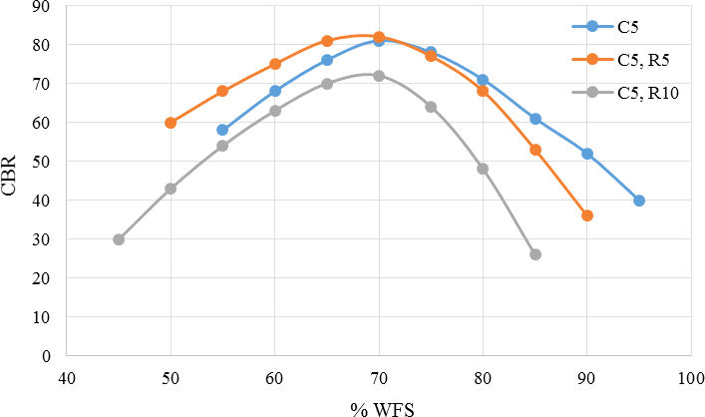

**Figure 5.1** CBR differentials based on the percentage utilization of WFS, Red Mud, and Cement

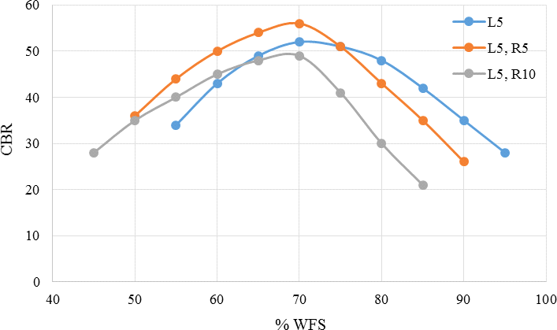

**Figure 5.2** CBR differentials based on the percentage utilization of WFS, Red Mud, and Lime

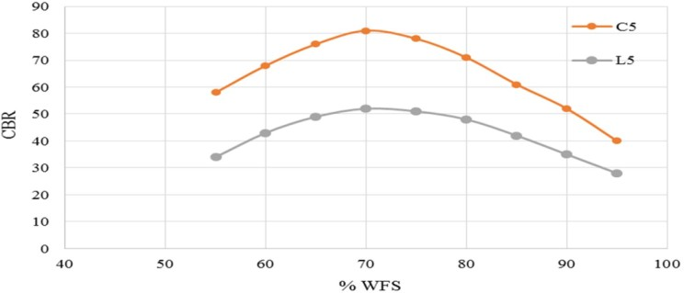The relationship between the CBR and the percentage of WFS exhibits a non-linear fluctuation, as seen in Figures 5.1 and 452. Moreover, for both types of stabilizing Substances utilized, there exists an optimum percentage of WFS that leads to a higher CBR value. Figures 5.1 and 5.2 demonstrate that including 5% red mud increases the CBR value when the proportion of WFS is below the optimal quantity. When ten percent red mud is added, the CBR value reduces for both of the tested stabilizing Substances. The utilize of 10% red dirt significantly reduces the CBR value for all tested versions of WFS.

**Figure 5.3** Effect of Stabilizing Agent on CBR

# CONCLUSION

1. The relationship between CBR values and WFS percentages in the mixture appears non-linear. Optimally, a certain percentage of WFS combined with stabilizers like cement and lime yields higher CBR values, though adding 10% red mud generally reduces CBR across different WFS percentages. Moreover, utilizing WFS for 70% of the duration contributes positively to strength, while combining 5.5% red mud with the ideal WFS percentage enhances CBR.

2. Fly ash, at around 20% in mixtures alongside 5% red mud and 70% WFS, was identified as optimal in experimental analyses, although its presence reduces CBR by over 20%. Comparatively, using cement instead of lime as a stabilizer boosts CBR by about 60%, yet red mud quantities notably influence this strength increase. Red mud differentials lead to varied changes in CBR, with fly ash proportions playing a key role in these variations.

3. The influence of red mud on the CBR of different WFS-fly ash ratios is limited, especially at ratios below 5% where its impact on strength is higher. Increasing WFS or fly ash content can produce nearly equivalent strength levels, while UCC strength tends to improve as WFS content rises up to 70%. Extending curing periods generally enhances UCC strength, with red mud affecting the rate of UCC strength changes.

4. Longer curing times amplify the UCC strength of lime-based mixes, and adding red mud seems less effective in increasing UCC strength when lime is present. Notably, a higher red mud percentage does improve UCC strength, with curing duration significantly impacting strength variations. The optimal WFS percentage shows a larger UCC strength difference than other percentages, following a non-linear fluctuation with WFS usage.

5. Increasing fly ash enhances split tensile strength, while higher red mud levels reduce it. Cement as a stabilizer notably decreases permeability more than lime, with WFS and fly ash percentages affecting permeability linearly. Mixtures with only WFS exhibit lower pH, and cement raises leachate pH compared to lime, while red mud inclusion lowers it, showing a linear pH response to WFS and fly ash variations.

# REFERENCES

1. Ayano Kuramoto, O & Sakata, K 2000, ‘Concrete with copper slag fine aggregate’, Society of Substances Science, vol. 49, no.10, pp. 10971102
2. Akihiko, Y & Takashi, Y, 1996, ‘Study of utilization of copper slag as fine aggregate for concrete’, Ashikaya Kogyo Daiga kuKenkyu Shuroku, vol. 23, pp.79-85.
3. Gorai, B & Jana, RK 2003, ‘Characteristics and utilization of copper slag-A review’, Resources, Conservation and Recycling, vol. 39, no. 4, pp. 299-313
4. Bhanja, S & Sengupta, B 2002, ‘Examinations on the compressive strength of silica fume concrete using statistical methods’, Cement and Concrete Research, vol. 32, no. 9, pp. 1391-1394.
5. Goodhue, M, Edil, TB& Benson, CH 2001, ‘Interaction of foundry sand with geosynthetics’, Journal of Geotechnical and Geoenvironmental Engineering, vol. 127, no.4, pp. 353-362.
6. Guney, Y, Aydilek, AH & Demirkan, MM 2006, ‘Geoenvironmental behavior of foundry sand amended mixtures for highway sub-bases’, Waste management, vol. 26, no.9, pp.932–945. doi:10.1016 / j. wasman.2005.06.007
7. Kalkan, E 2006, ‘Utilization of red mud as a stabilization material for the preparation of clay liners’, Engineering Geology, vol.87, pp.220-229.
8. Bhanja, S &Sengupta, B 2005, ‘Influence of silica fume on the tensile strength of concrete’, Cement and Concrete Research, vol. 35, no. 4, pp. 743-747.
9. Bilodeau, A, Somasundaram, V, Painter, KE &Malhotra, VM, 1994 ‘Durability of concrete incorporating high volumes of fly ash from sources in the USA’, ACI Substances Journal, vol. 91, no.1, pp.3-12.
10. ANONYMUS, 1996 “Anhang 51: Oberirdische Ablagerung von Abfällen. Allgemeine Rahmen-Verwaltungs vorschrift über Mindestanforderungen and as Einleiten von Ab-wasser in Gewässer,” German Regulation.
11. ASTM 1883-14. Standard Test Method for California Bearing Ratio (CBR) of Laboratory-Compacted Soils
12. Dawson, AR, Elliot, RC, Rowe, RC& Williams, GM 1995, ‘Assessment of suitability of some industrial offshoot for utilise in pavement bases in the United Kingdom’, Transportation Research Record 1486, pp. 114-23.
13. Dhawan, PK, Swami, RK, Mehta, HS, Bhatnagar, OP &Murty, AVRS, 1994, Bulk utilization of coal ashes from road works,Indian highways, vol. 22, no.11, pp. 21-30.
14. Shi, C, Meyer, C & Behnood, A 2008, ‘Utilization of copper slag in cement and concrete. Resources’, Conservation and Recycling, vol. 52, pp. 1115-1120.
15. Berry, EE & Malhotra, VM 1980, ‘Fly ash for utilise in concrete: a critical review’, Journal of the American concrete institute, vol. 77, no.1, pp.59-73.
16. Tsonis, P, Christoulas, S & Kolias, S 1983, ‘Soil improvement with coal ash in road construction’, In: Proc. 8th VIII EC SMFE, Helsinki, Balkema, vol. 2, pp. 961-964.
17. URL-1: http://www.un.org/sustainabledevelopment/cities/;
18. URL-2: http://greenliving.lovetoknow.com/Why_Is_Sustainable_Development
19. Shi, C, Meyer, C & Behnood, A 2008, ‘Utilization of copper slag in cement and concrete. Resources’, Conservation and Recycling, vol. 52, pp. 1115-1120.
20. Singh, M, Upadhayay, SN & Prasad, PM 1996, ‘Preparation of Special Cements from red mud’, Waste Management, vol. 16, no. 8, pp. 665- 670.