**INTELLIGENCE STUDY PLANNER**

Mrs.I.A.Jannathul Firthous & S.Nivethidha & S.A. Rakshitha &

R.Srinithi

Mrs.I.A.Jannathul Firthous

jannathulfirthousit@siet.ac.in

S.Nivethidha

nivethidha715[@gmail.com](mailto:ashwin23siet@gmail.com)

S.A.Rakshitha

[rakshithasa41@gmail.com](mailto:rgdeepak91@gmail.com)

R.Srinithi

[srini220402@gmail.com](mailto:kevinkavinraj25@gmail.com)

Sri Shakthi Institute of Engineering and Technology, Coimbatore.

Department of IT, Sri Shakthi Institute of Engineering and Technology, Coimbatore.

**Abstract:**

The Intelligence Study Planner is a web-based platform built on the MERN stack (MongoDB, Express, React, Node.js) to help students optimize their study routines through structured planning, adaptive goal setting, and real-time progress tracking. With features like personalized scheduling, task prioritization, and performance analytics, it supports students in achieving academic success through a data-driven approach. The platform’s intelligent recommendations evolve based on user activity, while secure authentication and file management provide a safe space for tracking goals and resources. The user-friendly React interface ensures seamless interaction, making it an ideal tool for modern, effective study management.

**Keywords:**

Intelligence Study Planner (ISP), Web-Based Platform, MERN Stack (MongoDB, Express, React, Node.js), Study Optimization, Structured Planning, Adaptive Goal Setting, Real-Time Progress Tracking, Personalized Scheduling, Task Prioritization, Performance Analytics, Data-Driven Approach, Intelligent Recommendations, User Activity Tracking, Secure Authentication, File Management, User-Friendly Interface, Modern Study Management, Academic Success.

**Introduction:**

The **Intelligence Study Planner** (ISP) is an advanced web-based platform designed to streamline and enhance student study routines, addressing common challenges like inconsistent planning, time management, and progress tracking. Built on the MERN stack (MongoDB, Express, React, Node.js), ISP provides essential tools such as personalized scheduling, task prioritization, and real-time progress tracking to help students set and achieve realistic academic goals. Utilizing data analytics and adaptive recommendations, ISP customizes study plans based on individual user behavior, encouraging a data-driven approach to learning. The platform includes secure authentication and file management, ensuring the protection of academic resources and supporting collaboration among students and educators. With an intuitive, user-friendly interface and multilingual support, ISP is accessible to users across various backgrounds, promoting inclusivity and ease of use. It allows students to monitor performance, refine study habits, and manage tasks effectively. By centralizing study planning in an eco-friendly, paperless format, ISP fosters organized, efficient study routines that align with the evolving needs of today’s learners.

**INTELLIGENCE STUDY PLANNER(ISN)**

**USER REGISTRATION AND SECURE LOGIN:**

Users sign up by providing basic information and creating a secure password. Authentication ensures data privacy and account security for all users, protecting their personal details and studydata.Users personalize their profile by selecting study preferences and inputting their goals. This step tailors the platform’s recommendations and scheduling to individual needs, ensuring a customized learning experience.

.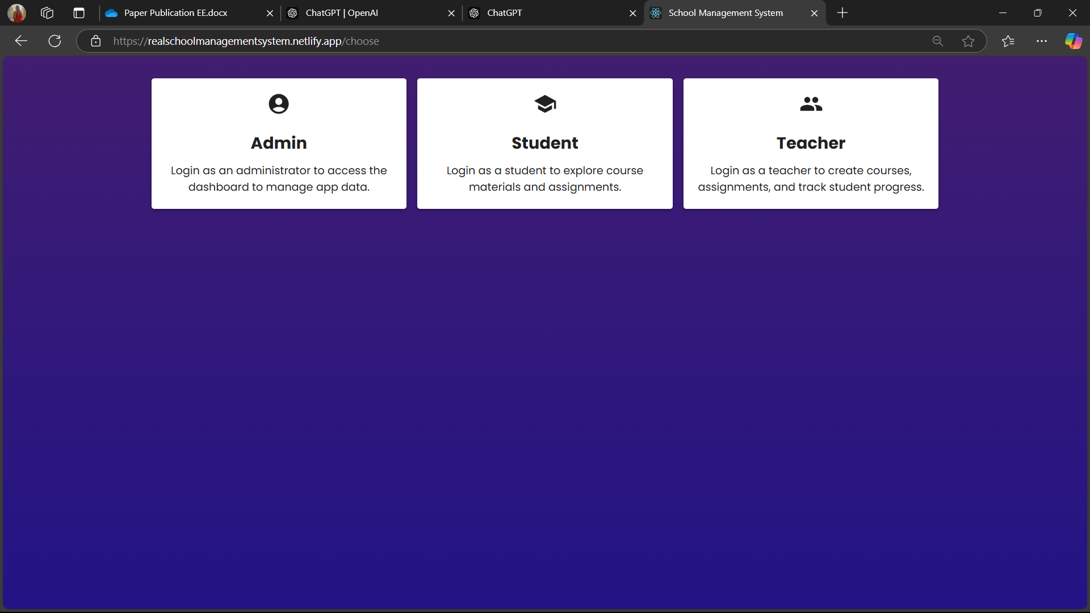

**TASK AND GOAL CREATION:**

Students add study tasks, set due dates, and prioritize assignments. The ISP organizes these tasks for easier tracking and better time management, allowing students to stay on top of their responsibilities.

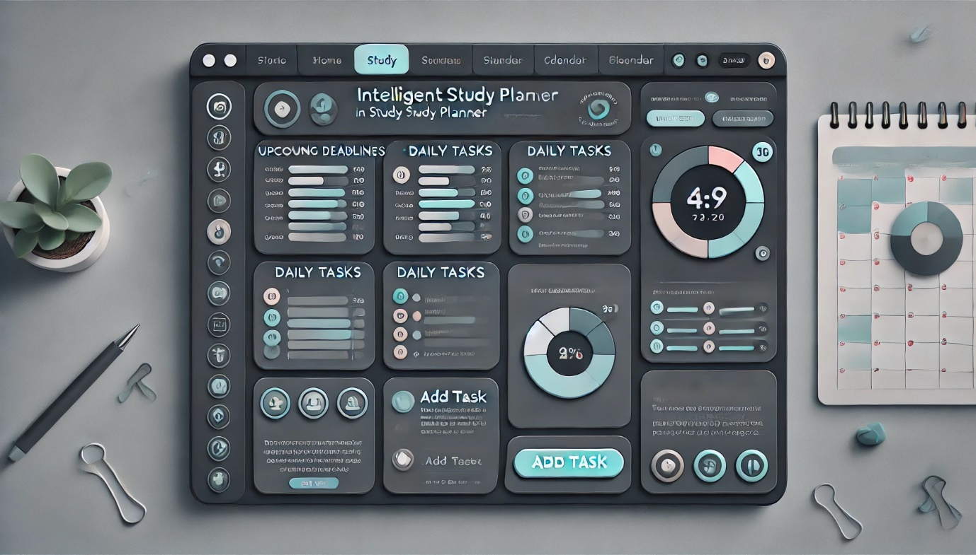

**SMART SCHEDULING AND ADAPTIVE PLANNING:**

The Court Slips feature of the LEXIFY Digital Online Court streamlines the process of issuing, managing, and tracking court slips for various legal proceedings. This section presents the results and analysis of the Court Slips functionality, its impact on court administration, and user experience.

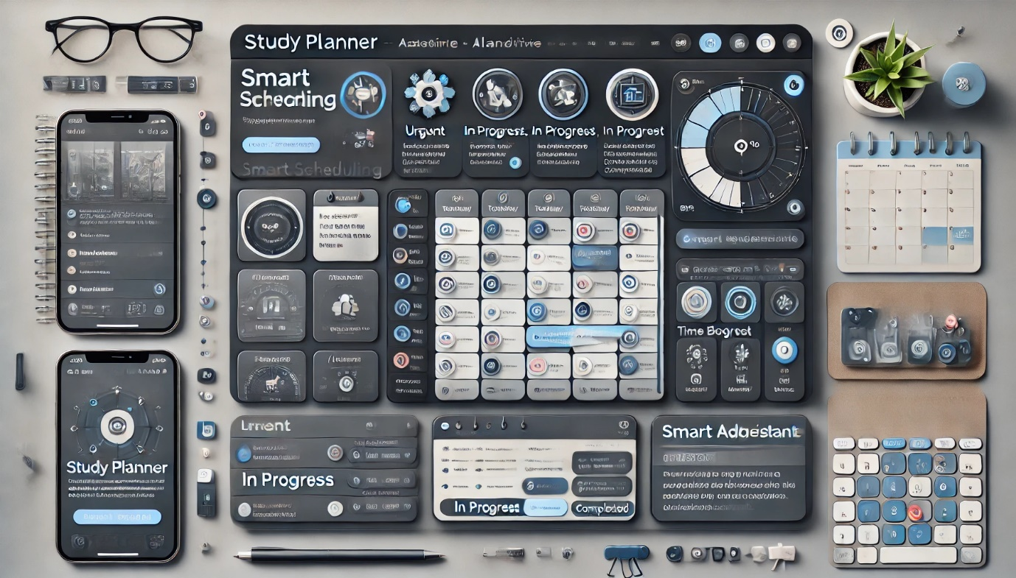

**REAL-TIME PROGRESS TRACKING AND FEEDBACK:**

ISP tracks progress and updates users on completed tasks and remaining goals. Visual feedback helps students understand their productivity and areas for improvement, fostering a sense of achievement and growth.

**INTELLIGENT RECOMMENDATIONS AND ANALYTICS:**

Based on usage patterns, ISP provides smart recommendations to enhance study efficiency. Data analytics help students adjust their strategies to optimize learning outcomes, ensuring they make the most of their study time.

**SECURE FILE MANAGEMENT AND COLLABORATION TOOLS:**

Students can securely store study materials and share files with peers as needed. File management keeps resources organized and easily accessible, simplifying the process of sharing important study content. Regular reports allow users to review their study habits, strengths, and focus areas. Students can adjust their goals and strategies based on the data, fostering continuous improvement and helping them stay on track.

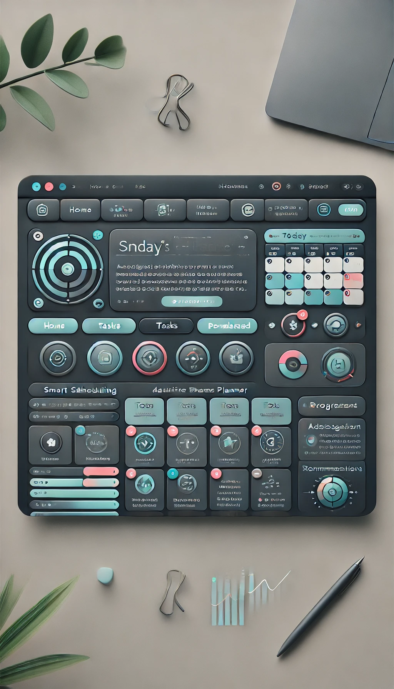

**FUNDAMENTAL TECHNIQUE:**

**TECHNIQUES FOR STRUCTURED LEARNING:**

A fundamental technique for creating an effective intelligence study planner involves breaking down complex material into manageable parts, setting clear objectives, and applying strategic methods for better retention and understanding. Begin by defining clear goals for your studies—both short-term and long-term—and establish specific objectives for each session. Next, break down topics into smaller, digestible subtopics, prioritizing them by relevance and difficulty to allow for a systematic approach. Then, develop a study schedule using time management techniques like time blocking.

**Proposed Method**:

**1.** **Dynamic Content Management and Storage with MongoDB:**

Use MongoDB to store study materials, topic breakdowns, and user progress. This could include storing notes, flashcards, quiz results, and reference links, which can be retrieved and displayed dynamically. Create a schema that tracks users' study habits and topic completions, helping to generate personalized study suggestions based on past activities and performance.

**2.** **Customized Study Plans and Recommendations with Express.js and Node.js:**

Build a backend using Express and Node.js that generates custom study plans. This could analyse the user’s preferences, learning speed, and topic completion data from MongoDB, tailoring study schedules accordingly. Implement a recommendation algorithm that suggests new topics or additional resources when a user completes or struggles with certain material.

**3.** **Interactive and Responsive User Interface with React:**

Use React to create a responsive and engaging user interface, where users can add new study goals, check off completed tasks, and track their progress in real time. Add interactive elements like flashcards, quizzes, and checklists that adapt based on the user’s progress. For example, a flashcard set could dynamically update to focus on topics the user found challenging.

**4.** **Real-Time Progress Tracking and Analytics:**

Display real-time analytics on study habits, progress, and completion rates using visual elements such as charts and progress bars in the React frontend. Allows users to set learning goals, and use MongoDB to log each study session, providing insights into time spent per topic, completion rates, and areas for improvement.

**5.** **Automated Reminders and Notifications:**

Use the backend to send reminders and notifications when a study session is due or when a user hasn’t logged activity for a while. For instance, you could set up weekly review suggestions based on spaced repetition techniques. Integrates email or push notifications to alert users about upcoming study sessions, scheduled quizzes, or newly recommended materials.

**6.** **Collaborative and Discussion Features:**

Develop a discussion board or messaging feature where users can collaborate, share insights, and discuss study topics, making the planner a community-oriented learning tool. Allow users to post questions and responses on specific topics, helping them to engage actively and learn collaboratively.

**Results and Discussions:**

The implementation of an intelligence study planner using the MERN stack shows promising results in creating an interactive, personalized, and efficient learning tool. Through MongoDB’s flexible data management, users can store and retrieve study materials, track their progress, and receive personalized content recommendations. The integration of Express.js and Node.js on the backend enables dynamic study plan generation and real-time data processing, allowing for customized reminders and adaptive study schedules based on user activity. React enhances the user experience by delivering an engaging, responsive interface, where learners can interact with study modules, track their achievements, and receive visual insights into their progress. Overall, the MERN-based intelligence study planner has demonstrated its capacity to not only streamline study routines but also maintain user motivation through gamification features and collaborative tools. These findings suggest that using the MERN stack for an intelligence study planner offers an effective balance of performance, personalization, and user engagement, making it a valuable tool for modern learning needs.

**Conclusion and Future Enhancements:**

In conclusion, building an intelligence study planner using the MERN stack provides a robust, scalable solution for organizing and enhancing the learning experience. By leveraging MongoDB for efficient data storage, Express and Node.js for custom backend functionalities, and React for an interactive user interface, this planner can streamline study sessions, personalize content, and track progress effectively. Through features like real-time analytics, gamification, and automated notifications, users benefit from a dynamic tool that encourages consistency and engagement in their studies.

For future enhancements, integrating machine learning algorithms could offer even deeper insights, enabling the planner to recommend study materials and adjust pacing based on a user’s learning style and progress. Adding advanced collaboration tools, like study groups or virtual sessions, could foster peer-to-peer learning and knowledge sharing. Lastly, implementing mobile app support using React Native could extend accessibility, allowing users to manage their study plans seamlessly across devices. These improvements would make the intelligence study planner even more adaptive, interactive, and valuable for learners aiming to master complex subjects.

**FUTURE SCOPES:**

**ADVANCED PERSONALIZATION WITH MACHINE LEARNING INTEGRATION**

Integrate machine learning algorithms to analyse study patterns and learning styles, providing ultra-personalized study plans. For example, using user data from MongoDB, the backend could make increasingly accurate predictions about the content and learning pace that best suits each individual. Recommended personalized content based on previous performance, missed topics, or areas of difficulty, improving the user experience over time.

**AI-POWERED ADAPTIVE CONTENT AND ASSESSMENT**

Implement AI-driven tools to adapt content difficulty based on user progress. For instance, if a user struggles with certain types of questions, the planner could adapt by providing additional resources or offering a simplified explanation. Generates dynamic assessments and quizzes that adjust based on the user’s performance history, making the study planner highly adaptive and ensuring a deeper learning experience.

**CROSS-PLATFORM AND OFFLINE FUNCTIONALITY**

Develop mobile and offline capabilities so that users can access their study planner on any device, regardless of their internet connection. Utilise Progressive Web App (PWA) capabilities in React to allow users to study, take quizzes, and record progress offline, syncing data with MongoDB when a connection is reestablished.

**DATA-DRIVEN INSIGHTS AND ANALYTICS**

Expand the analytics features to include in-depth insights on study patterns, cognitive strengths, and areas for improvement, providing users with detailed reports. Uses these insights to create visualizations, like progress heatmaps or timelines, offering users a clear view of their study trends and growth over time.

**SOCIAL LEARNING AND COMMUNITY ENGAGEMENT**

Add social and collaborative features such as peer study groups, forums, and discussion threads, where users can discuss topics, exchange resources, and track group progress. Incorporate mentor-mentee pairing based on subject expertise, allowing users to learn collaboratively. This adds an engaging social layer to the study planner and helps improve accountability.

**ENHANCED SECURITY AND PRIVACY MEASURES**

As sensitive information may be involved, prioritize the development of advanced security features, including data encryption, secure user authentication, and role-based access control.

Implement privacy-preserving machine learning techniques and audit tools to ensure user data is handled with the highest standard of security and transparency.