**1 INTRODUCTION:**

* Stroke is the 5th leading cause of death in the US, with one person dying every 4 minutes. For black people, stroke is the 3rd leading cause of death. It is the second leading cause of death in the world.
* Approximately 800,000 people have a stroke each year; about one every 40 seconds.
* Strokes occur due to problems with the blood supply to the brain: either the blood supply is blocked or a blood vessel within the brain ruptures, causing brain tissue to die.
* A stroke is a medical emergency, and treatment must be sought as quickly as possible.

**DEFINITION:**

* A stroke is defined as the clinical syndrome of rapid onset of cerebral deficit lasting more than 24 hours or leading to death with no apparent cause other than a vascular one.
* A stroke is a rapid loss of brain function due to the disturbance in the blood supply to brain. A stroke happens when blood flow to a part of the brain stops and it is sometimes called a "brain attack"
  1. 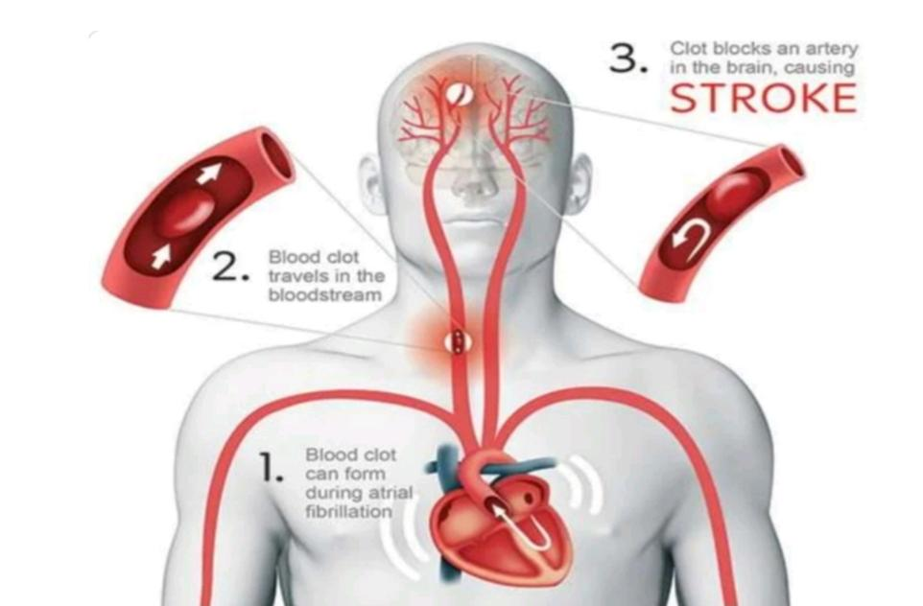**Epidemiology:**

**Fig :no. 1: Causes of heart & brain stroke**

• Third most common cause of death after cancer and ischeamic heart disease

• Most common cause of severe physical disability

• Prevalence of stroke in India is about 1.54 per 1000

• Death rate is about 0.6 per 1000

• Incidence and prevalence of stroke is on the rise due to increasing adoption of unhealthy lifestyle & an increasing life expectancy

**1.2 TYPES**

There are three main kinds of stroke:

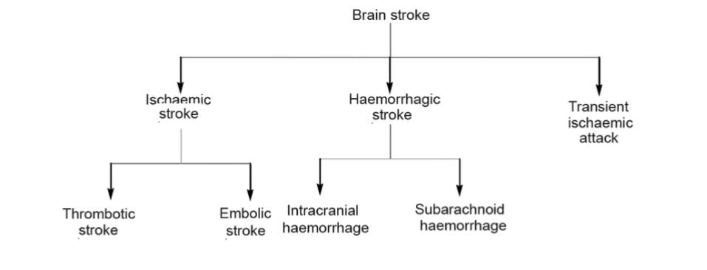**Fig no.:2 classification of brain stroke.**

► Ischemic strokes

▸ Haemorrhagic strokes

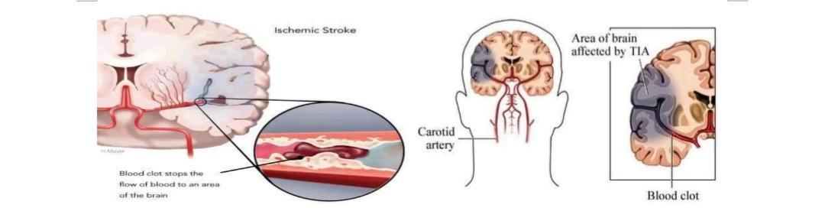► Transient ischemic attacks (TIAs), also referred to as mini stroke.

* 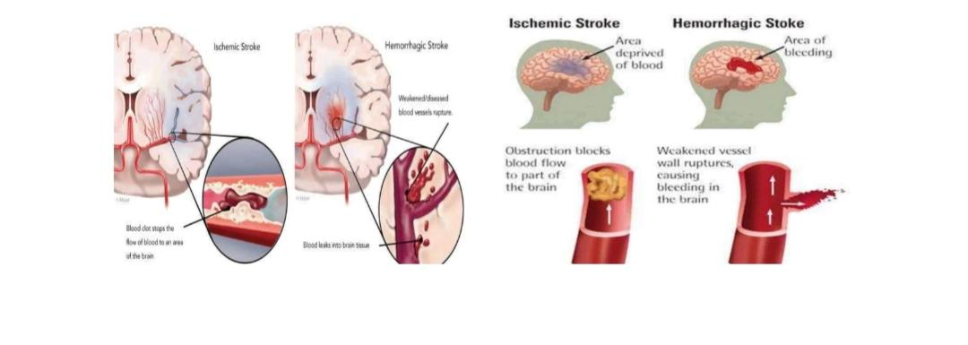**ISCHEMIC STROKE**

**Fig.no: 3 blood clot by brain stroke in different segments of brain.**

▸ Ischemic stroke is the most common form of stroke, accounting for around 85% of strokes.

▸ This type of stroke is caused by blockages or narrowing of the arteries that provide blood to the brain, resulting in ischemia severely reduced blood flow.

► These blockages are often caused by blood clots. Clots can be caused by fatty deposits within the arteries called plaque.

* **HEMORRHAGIC STROKE:**

▸ Hemorrhagic stroke are caused by arteries in the brain either leaking blood or bursting open.

▸ The ruptures can be caused by conditions such as hypertension, trauma, blood-thinning medications and aneurysms (weaknesses in blood vessel walls).

► Intra cerebral hemorrhage is the most common type of hemorrhagic stroke and occurs when brain tissue is flooded with blood after an artery in the brain bursts.

► Subarachnoid hemorrhage is the second type of hemorrhagic stroke and is less common. In this type of stroke, bleeding occurs in the subarachnoid space the area between the brain and the thin tissues that cover it.

* **TRANSCIENT ISCHEMIC ATTACK : (TIA)**

► TIAs are different from the aforementioned kinds of stroke because the flow of blood to the brain is only briefly interrupted. TIAs are similar to ischemic strokes in that they are often caused by blood clots or other debris.

► TIAs should be regarded as medical emergencies.

▸ They serve as warning signs for future strokes and indicate that there is a partially blocked artery or clot source in the heart.

▸ According to the Centers for Disease Control and Prevention (CDC), over a third of people who experience a TIA go on to have a major stroke within a year if they have not received any treatment. Between 10-15% will have a major stroke within 3 months of a TIA.

**1.3 SYMPTOMS**

Strokes occur quickly and, as such, symptoms of stroke often appear suddenly without warning.

The main symptoms of stroke are as follows:

► Confusion, including trouble with speaking and understanding

▸ Headache, possibly with altered consciousness or vomiting

► Numbness of the face, arm or leg, particularly on one side of the body

▸ Trouble with seeing, in one or both eyes

▸ Trouble with walking, including dizziness and lack of co-ordination.

In addition to the persistence of the problems listed previously, patients may also experience the following:

▸ Bladder or bowel control problems

▸ Depression

▸ Pain in the hands and feet that gets worse with movement and temperature changes

▸ Paralysis or weakness on one or both sides of the body

▸ Trouble controlling or expressing emotions.

**1.4 DIAGNOSIS:**

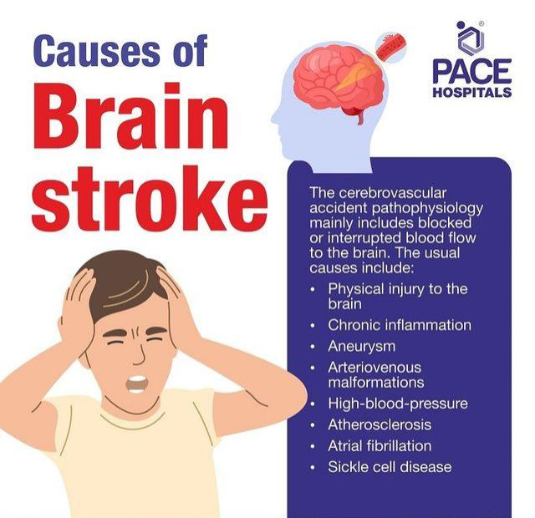Strokes happen fast and will often occur before an individual can be seen by a doctor for a proper diagnosis.

**Fig .no:4 causes of brain stroke**

> The acronym F.A.S.T. is a way to remember the signs of stroke, and can help identify the onset of stroke more quickly:

▸ Face drooping: if the person tries to smile does one side of the face droop?

▸ Arm weakness: if the person tries to raise both their arms does one arm drift downward?

▸ Speech difficulty: if the person tries to repeat a simple phrase is their speech slurred or strange?

► Time to call 911( In USA) and 108 (In India): if any of these signs are observed, contact the emergency services.

There are several different types of diagnostic tests that doctors can use in order to determine which type of stroke has occurred:

► CT scans of the brain are one of few ways to determine which type of stroke a person has had.

▸ Physical examination: a doctor will ask about the patient's symptoms and medical history. They may check blood pressure, listen to the carotid arteries in the neck and examine the blood vessels at the back of the eyes, all to check for indications of clotting

▸ Blood tests: a doctor may perform blood tests order to find out how quickly the patient's blood clots, the levels of particular substances (including clotting factors) in the blood, and whether or not the patient has an infection

► CT scan: a series of X-rays that can show hemorrhages, strokes, tumors and other conditions

within the brain

► MRI scan: radio waves and magnets create an image of the brain to detect damaged brain tissue

▸ Carotid ultrasound: an ultrasound scan to check the blood flow of the carotid arteries and to see if there is any plaque present

▸ Cerebral angiogram: dyes are injected into the brain's blood vessels to make them visible under X-ray, in order to give a detailed view of the brain and neck arteries

▸ Echocardiogram: a detailed image of the heart is created to check for any sources of clots that could have traveled to the brain to cause a stroke.

* 1. **TREATMENT OF STROKE**
* **ISCHEMIC STROKES**
* Aspirin can be given, as can an injection of a tissue plasminogen activator (TPA).
* A carotid endarterectomy
* Angioplasty
* **HEMMORHAGIC STROKE**
* Treatment can begin with drugs being given to reduce the pressure in the brain, overall blood pressure, prevent seizures and prevent sudden constrictions of blood vessels. If the patient is taking anti-coagulant or anti-platelet medication like Warfarin or Clopidogrel, they can be given drugs or blood transfusions to counter the medication's effects.
* Surgery can be used to repair any problems with blood vessels that have led or could lead to hemorrhagic strokes. Surgeons can place small clamps at the base of aneurysms or fill them with detachable coils to stop blood flow to them and prevent rupture.
* Surgery can also be used to remove small arteriovenous malformations (AVMs) if they are not too big and not too deep within the brain. AVMs are tangled connections between arteries and veins that are weaker and burst more easily than other normal blood vessels

**1.6 REHABILITATION:**

* Strokes are life-changing events that can affect a person both physically and emotionally, temporarily or permanently. After a stroke, successful recovery will often involve specific rehabilitative activities such as:
* Speech therapy to help with problems producing or understanding speech. Practice, relaxation and changing communication style, using gestures or different tones for example, all help
* Physical therapy to help a person relearn movement and co-ordination. It is important to get out and about, even if it is difficult at first
* Occupational therapy to help a person to improve their ability to carry out routine daily activities, such as bathing, cooking, dressing, eating, reading and writing
* Joining a support group to help with common mental health problems such as depression that can occur after a stroke. Many find it useful to share common experiences and exchange information

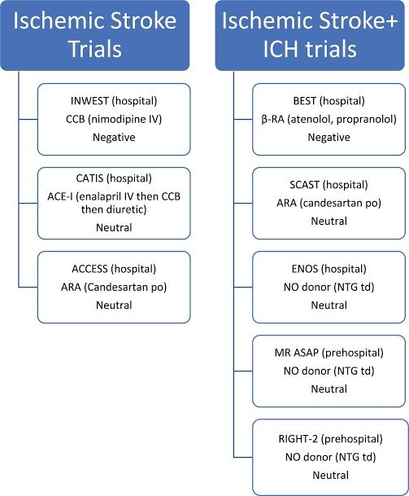► Support from friends and family - to provide practical support and comfort. Letting friends and family know what can be done to help is very important.

**Fig.no:5 ischemic stroke & ICH trails**

**2 LITERATURE SURVEY**

1. Feigin et al. (2016). Global, regional, and national life expectancy, all-cause mortality, and cause-specific mortality for 249 causes of death, 1980–2015.

2. Johnston et al. (2019). Global and regional burden of stroke, 1990–2016.

3. Mohan et al. (2018). Risk of recurrent stroke in patients with ischemic stroke.

4. American Heart Association. (2022). Heart Disease and Stroke Statistics—2022 Update.

5.World Health Organization. (2019). Stroke.

6.Centers for Disease Control and Prevention. (2022). Stroke.

7.Global incidence: 15 million people annually.

8. Leading cause of disability and death worldwide.

9. High recurrence rate: 1 in 4 survivors experience another stroke.

* **Some old drugs used to treat brain stroke include aspirin, rapamycin, and noradrenergic drugs:**

Aspirin: A well-known antiplatelet drug that reduces the risk of stroke recurrence and severity. It's often given to patients immediately after an ischemic stroke.

**Rifampacin:** An old drug that may improve neurovascular function by inhibiting mTOR.

Noradrenergic drugs: A class of drugs that may promote stroke recovery by amplifying neuronal activity and increasing excitability.

Other drugs used to treat stroke include:

Clopidogrel: An antiplatelet drug that may be used after aspirin

Dipyridamole: An antiplatelet drug that may be used after aspirin

Ticagrelor: An antiplatelet drug

Cilostazol: An antiplatelet drug

Ticlopidine: An antiplatelet drug

Lorazepam (Ativan): A short-acting benzodiazepine used to treat active seizures

Diazepam (Valium): A drug that produces a calming effect and is used to control active seizures active.

**3 RECENTLY THE NEW DRUG APPROVED BY FDA FOR BRAIN STROKE “DAYBUE”:**

* **Generic Name**: trofinetide oral solution
* **Brand Name**: Daybue
* **Drug Class:** Insulinlike Growth Factors

**Drug Summary**

* **What Is Daybue?**

Daybue (trofinetide) is indicated for the treatment of Rett syndrome in adults and pediatric patients 2 years of age and older.

* What Are Side Effects of Daybue?

**Daybue may cause serious side effects including:**

* hives,
* difficulty breathing,
* swelling of your face, lips, tongue, or throat,
* fever,
* seizure,
* anxiety,
* loss of appetite,
* fatigue, and
* cold symptoms (runny nose, sneezing, and coughing)
* **Side effects of Daybue include:**
* diarrhoea,
* vomiting,
* weight loss,
* fever,
* seizures,
* anxiety,
* decreased appetite,
* fatigue, and
* runny or stuffy nose.

Seek medical care or call 911 at once if you have the following serious side effects:

Serious eye symptoms such as sudden vision loss, blurred vision, tunnel vision, eye pain or swelling, or seeing halos around lights;

Serious heart symptoms such as fast, irregular, or pounding heartbeats; fluttering in your chest; shortness of breath; and sudden dizziness, lightheadedness, or passing out;

Severe headache, confusion, slurred speech, arm or leg weakness, trouble walking, loss of coordination, feeling unsteady, very stiff muscles, high fever, profuse sweating, or tremors.

This document does not contain all possible side effects and others may occur. Check with your physician for additional information about side effects.

* **Dosage for Daybue**

The recommended dosage of Daybue is twice daily, morning and evening, according to the patient’s weight. Daybue can be taken with or without food.

**3.1 Daybue in Children:**

The safety and effectiveness of Daybue for the treatment of Rett syndrome have been established in pediatric patients aged 2 years and older.

The safety and effectiveness of Daybue in pediatric patients less than 2 years of age have not been established.

What Drugs, Substances, or Supplements Interact with Daybue?

Daybue may interact with other medicines such as:

CYP3A4 substrates and

OATP1B1 and OATP1B3 substrates.

Tell your doctor all medications and supplements you use.

Daybue During Pregnancy and Breastfeeding

Tell your doctor if you are pregnant or plan to become pregnant before using Daybue; it is unknown if it would affect a fetus. It is unknown if Daybue passes into breast milk. Consult your doctor before breastfeeding.

Additional Information

Our Daybue (trofinetide) Oral Solution Side Effects Drug Center provides a comprehensive view of available drug information on the potential side effects when taking this medication.

* **Side Effects for Daybue**

The following clinically significant adverse reactions are described elsewhere in labeling:

Diarrhea [see WARNINGS AND PRECAUTIONS]

Weight Loss [see WARNINGS AND PRECAUTIONS]

**3.2 Clinical Trials Experience:**

Because clinical trials are conducted under widely varying conditions, adverse reaction rates observed in the clinical trials of a drug cannot be directly compared to rates in the clinical trials of another drug and may not reflect the rates observed in practice.

In controlled and uncontrolled trials in patients with Rett syndrome, 260 patients ages 2 to 40 years were treated with DAYBUE, including 109 patients treated for more than 6 months, 69 patients treated for more than 1 year, and 4 patients treated for more than 2 years.

Adult And Pediatric Patients With Rett Syndrome 5 Years Of Age And Older

The safety of DAYBUE was evaluated in a randomized, double-blind, placebo-controlled, 12-week study of patients with Rett syndrome (Study 1) [see Clinical Studies]. In Study 1, 93 patients received DAYBUE and 94 patients received placebo. All patients were female, 92% were White, and the mean age was 11 years (range 5 to 20 years).

Adverse Reactions Leading to Discontinuation of Treatment

Eighteen patients (19%) receiving DAYBUE had adverse reactions that led to withdrawal from the study. The most common adverse reaction leading to discontinuation of treatment with DAYBUE was diarrhoea (15%).

* **Effect of DAYBUE on other drugs:**

Trofinetide is a weak CYP3A4 inhibitor; therefore, plasma concentrations of CYP3A4 substrates may be increased if given concomitantly with DAYBUE [see CLINICAL PHARMACOLOGY]. Closely monitor when DAYBUE is used in combination with orally administered CYP3A4 sensitive substrates for which a small change in substrate plasma concentration may lead to serious toxicities.

Plasma concentrations of OATP1B1 and OATP1B3 substrates may be increased if given concomitantly with DAYBUE [see CLINICAL PHARMACOLOGY]. Avoid the concomitant use of DAYBUE with OATP1B1 and OATP1B3 substrates for which a small change in substrate plasma concentration may lead to serious toxicities.

* **Warnings for Daybue:**

Included as part of the "PRECAUTIONS" Section

* **Precautions for Daybue:**
* **Diarrhoea**

In Study 1 [see Clinical Studies] and in long-term studies, 85% of patients treated with DAYBUE experienced diarrhoea. In those treated with DAYBUE, 49% either had persistent diarrhoea or recurrence after resolution despite dose interruptions, reductions, or concomitant antidiarrheal therapy. Diarrhoea severity was of mild or moderate severity in 96% of cases. In Study 1, antidiarrheal medication was used in 51% of patients treated with DAYBUE.

Advise patients to stop laxatives before starting DAYBUE. If diarrhoea occurs, patients should notify their healthcare provider, consider starting antidiarrheal treatment, and monitor hydration status and increase oral fluids, if needed. Interrupt, reduce dose, or discontinue DAYBUE if severe diarrhoea occurs or if dehydration is suspected [see DOSAGE AND ADMINISTRATION].

* **Weight Loss:**

In Study 1, 12% of patients treated with DAYBUE experienced weight loss of greater than 7% from baseline, compared to 4% of patients who received placebo. In long-term studies, 2.2% of patients discontinued treatment with DAYBUE due to weight loss.

Monitor weight and interrupt, reduce dose, or discontinue DAYBUE if significant weight loss occurs.

* **Patient Counseling Information**

Advise the caregiver or patient to read the FDA-approved patient labeling (PATIENT INFORMATION).

**3.3 DAYBUE Administration:**

Advise the caregiver or patient that DAYBUE may be given orally or via gastrostomy (G) tube; doses administered via gastrojejunal (GJ) tubes must be administered through the G-port. DAYBUE may be taken with or without food [see DOSAGE AND ADMINISTRATION].

Instruct the caregiver or patient to obtain a calibrated measuring device, such as an oral syringe or oral dosing cup, from the pharmacy to measure and deliver the prescribed dose accurately. A household measuring cup is not an adequate measuring device.

Instruct the caregiver or patient to discard any unused DAYBUE after 14 days of first opening the bottle.

* **Diarrhoea:**

Advise the caregiver or patient that DAYBUE can cause Diarrhoea. Instruct the patient to stop taking laxatives before starting DAYBUE. If diarrhoea occurs, patients should notify their healthcare provider, consider starting antidiarrheal treatment, and monitor hydration status and increase oral fluids, if needed [see WARNINGS AND PRECAUTIONS].

* **Weight Loss:**

Inform the caregiver or patient that DAYBUE may cause weight loss and to notify their healthcare provider if weight loss occurs [see WARNINGS AND PRECAUTIONS].

* **Vomiting:**

Advise the caregiver or patient that DAYBUE can cause vomiting and if vomiting occurs after DAYBUE administration, do not take an additional dose, but continue with the next scheduled dose.

**Storage:**

Keep bottles of DAYBUE oral solution upright and refrigerated before and after opening. Do not freeze [see HOW SUPPLIED].

* **Nonclinical Toxicology:**

Carcinogenesis, Mutagenesis, Impairment Of Fertility

* **Carcinogenesis:**

Studies to evaluate the carcinogenic potential of trofinetide have not been conducted.

* **Mutagenesis:**

Trofinetide was negative in in vitro (bacterial reverse mutation, chromosomal aberration in Chinese hamster ovary cells) and in vivo (mouse micronucleus) assays.

**3.4 Pediatric Use:**

The safety and effectiveness of DAYBUE for the treatment of Rett syndrome have been established in pediatric patients aged 2 years and older. The safety and effectiveness of DAYBUE for the treatment of Rett syndrome in pediatric patients 5 years of age and older was established in a randomized, double-blind, placebo-controlled, 12-week study (Study 1), which included 108 pediatric patients age 5 to less than 12 years of age and 47 pediatric patients age 12 to less than 17 years of age [see ADVERSE REACTIONS and Clinical Studies]. Use of DAYBUE in patients 2 to 4 years of age is supported by evidence from Study 1 and pharmacokinetic and safety data in 13 pediatric patients 2 to 4 years of age treated with DAYBUE for 12 weeks [see DOSAGE AND ADMINISTRATION, ADVERSE REACTIONS, CLINICAL PHARMACOLOGY , and Clinical Studies].

Safety and effectiveness in pediatric patients less than 2 years of age have not been established.

* **Mechanism Of Action:**

The mechanism by which trofinetide exerts therapeutic effects in patients with Rett syndrome is unknown.

* **Pharmacodynamics**

Cardiac Electrophysiology

At the maximum recommended dose in healthy adult subjects, DAYBUE does not prolong the QT interval to any clinically relevant extent.

* **Pharmacokinetics:**

Trofinetide exhibits linear kinetics with no time- or dose-dependent effect on pharmacokinetic parameters. Systemic exposure to trofinetide was dose-proportional across the studied dose range. Minimal to no accumulation was observed following multiple-dose administration

* **Absorption:**

The time to maximum drug concentration (Tmax) is about 2 to 3 hours after administration. Based on the mass balance study, at least 84% of the administered dose was absorbed following oral administration of 12,000 mg trofinetide.

* **Effect of Food:**

Coadministration of DAYBUE with a high-fat meal had no impact on the total exposure (AUC0-inf) of trofinetide and reduced the peak plasma concentration (Cmax) by approximately 20% [see DOSAGE AND ADMINISTRATION].

* **Distribution:**

Following oral administration, the apparent volume of distribution of trofinetide in adult healthy subjects was approximately 80 L. Trofinetide protein binding in human plasma is less than 6%.

* **Elimination:**

The effective elimination half-life of orally administered trofinetide in healthy subjects is about 1.5 hours.

* **Metabolism**:

Trofinetide is not significantly metabolized by CYP450 enzymes. Hepatic metabolism is not a significant route of trofinetide elimination.

* **Excretion:**

Trofinetide is primarily excreted unchanged (approximately 80% of the dose) in urine, with minor excretion in feces.

* **Specific Populations:**

The drug exposure of trofinetide in pediatric patients ages 2 to 4 years of age is similar to children older than 4 years and adults when following the recommend dosage [see DOSAGE AND ADMINISTRATION].

The pharmacokinetics in patients with renal impairment have not been studied [see Use In Specific Populations].

The pharmacokinetics in patients with hepatic impairment have not been studied. However, hepatic impairment is not expected to impact the exposure of trofinetide because hepatic metabolism is not a significant route of trofinetide elimination.

**3.5 Drug Interaction Studies:**

* **In Vitro:**

Trofinetide is not a substrate of CYP450 enzymes, uridine diphosphate glucuronosyltransferase (UGT), or major drug transporters. Therefore, coadministration of drugs that are inducers or inhibitors of CYP450, UGT, or major drug transporters will not significantly affect the systemic exposure of trofinetide.

Trofinetide is a weak CYP3A4 inhibitor. Using physiologically based pharmacokinetic modeling, coadministration of trofinetide with orally administered midazolam, a sensitive CYP3A4 substrate, was predicted to increase the AUC of midazolam by approximately 1.33-fold [see DRUG INTERACTIONS]. No inhibition on CYP450 enzymes, CYP1A2, 2C8, 2C9, 2C19, and 2D6, is expected at therapeutic systemic concentrations based on the in vitro assays and the static mechanistic models. Time-dependent inhibition on CYP2B6 was inconclusive based on in vitro data. DAYBUE inhibits UGT enzymes, UGT1A9, 2B7, and 2B15, in vitro.

No inhibition was observed at therapeutic systemic concentrations on P-gp, BCRP, BSEP, OAT1, OAT3, OCT2, MATE1, and MATE2-K, based on the in vitro assays. Trofinetide inhibits OATP1B1 and OATP1B3 in vitro [see DRUG INTERACTIONS].

* **In Vivo:**

There have been no in vivo assessments of drug interactions with trofinetide.

* **Clinical Studies:**

The efficacy of DAYBUE for the treatment of Rett syndrome was established in a 12-week randomized, double-blind, placebo-controlled study in patients with Rett syndrome 5 to 20 years of age (Study 1; NCT04181723).

Patients (N=187) had a diagnosis of typical Rett syndrome according to the Rett Syndrome Diagnostic Criteria with a documented disease-causing mutation in the MECP2 gene. Patients were randomized to receive DAYBUE (N=93) or matching placebo (N=94) for 12 weeks. The DAYBUE dosage was based on patient weight to achieve similar exposure in all patients [see DOSAGE AND ADMINISTRATION].

The co-primary efficacy measures were change from baseline after 12 weeks of treatment in the total score of the Rett Syndrome Behaviour Questionnaire (RSBQ) and the Clinical Global Impression-Improvement (CGI-I) score. The RSBQ is a 45-item rating scale completed by the caregiver that assesses a range of symptoms of Rett syndrome (breathing, hand movements or stereotypies, repetitive behaviors, night-time behaviors, vocalizations, facial expressions, eye gaze, and mood). Each item is scored as 0 (not true), 1 (somewhat or sometimes true), or 2 (very true or often true), with a maximum possible score of 90 points. Lower scores reflect lesser severity in signs and symptoms of Rett syndrome. The CGI-I is rated by clinicians to assess whether a patient has improved or worsened on a 7-point scale (1=very much improved to 7=very much worse) in which a decrease in score indicates improvement.

**Conclusion:**

Acute therapy for ischaemic stroke is now a reality with advances in treatment progressing rapidly. New information about several neuroprotective agents will soon be available, and it is highly likely that the use of these agents will be integrated into many areas of vascular neurology. Acute stroke is more than ever a medical emergency that requires a rapid response by emergency medical services teams and neurologists. Nihilistic attitudes about stroke treatment are now archaic because the future holds much promise for stroke patients.

Trofinetide’s recent USFDA approval marks a significant step forward in treating RTT. Patients and their families affected by RTT would benefit greatly from this approval since they have had few alternatives for alleviating the wide range of symptoms that this condition can bring. The approval of Trofinetide will also speed up the development of new treatments and inventions for RTT and related disorders (FXS, ASD, brain injury, and stroke). Innovative Trofinetide-based molecules, patient-compliant formulations, precise MECP2-mutation-related personalized medicines, and new combinations of Trofinetide with existing RTT-based treatments, CNS-acting drugs, NSAIDs, and immunomodulators (antioxidants) are all likely shortly.

**Reference :**

1. Aho K, Harmsen P, Hatano S, Marquardsen J, Smirnov VE, Strasser T. Cerebrovascular disease in the community: Result of WHO collaborative study. Bull World Health Organ 1980; 88:113-30.
2. Donkor ES. Stroke in the 21st Century: A Snapshot of the Burden, Epidemiology, and Quality of Life. Stroke Res Treat. 2018 Nov 27;2018:3238165. doi: 10.1155/2018/3238165. PMID: 30598741; PMCID: PMC6288566.
3. Greenberg SM, Ziai WC, Cordonnier C, Dowlatshahi D, Francis B, Goldstein JN, Hemphill JC, Johnson R, Keigher KM, Mack WJ, Mocco J, Newton EJ, Ruff IM, Sansing LH, Schulman S, Selim MH, Sheth KN, Sprigg N, Sunnerhagen KS., American Heart Association/American Stroke Association. 2022 Guideline for the Management of Patients With Spontaneous Intracerebral Hemorrhage: A Guideline From the American Heart Association/American Stroke Association. Stroke. 2022 Jul;53(7):e282-e361. [[PubMed](https://pubmed.ncbi.nlm.nih.gov/35579034)]
4. Chiu CC, Lin HF, Lin CH, Chang HT, Hsien HH, Hung KW, Tung SL, Shi HY. Multidisciplinary Care after Acute Care for Stroke: A Prospective Comparison between a Multidisciplinary Post-Acute Care Group and a Standard Group Matched by Propensity Score. Int J Environ Res Public Health. 2021 Jul 20;18(14) [[PMC free article](https://www.ncbi.nlm.nih.gov/pmc/articles/PMC8303420/)]
5. Gibson LM, Whiteley W. The differential diagnosis of suspected stroke: a systematic review. J R Coll Physicians Edinb. 2013;43(2):114-8.
6. Powers WJ, Rabinstein AA, Ackerson T, Adeoye OM, Bambakidis NC, Becker K, Biller J, Brown M, Demaerschalk BM, Hoh B, Jauch EC, Kidwell CS, Leslie-Mazwi TM, Ovbiagele B, Scott PA, Sheth KN, Southerland AM, Summers DV, Tirschwell DL. Guidelines for the Early Management of Patients With Acute Ischemic Stroke: 2019 Update to the 2018 Guidelines for the Early Management of Acute Ischemic Stroke: A Guideline for Healthcare Professionals From the American Heart Association/American Stroke Association. Stroke. 2019 Dec;50(12):e344-e418.
7. Rand D, Eng JJ, Tang PF, Jeng JS, Hung C. How active are people with stroke?: use of accelerometers to assess physical activity. Stroke. 2009;40(1):163–168. doi: 10.1161/STROKEAHA.108.523621. * Free-living physical activity was very low in 40 subjects and 58% of the participants did not meet recommended physical activity levels. Use of a single commercial accelerometer to count steps is fairly reliable if walking speeds exceed 0.5m/s. Physicians might encourage longer walks at higher speeds within the limits of confidence about safety.
8. Acadia Pharmaceuticals Inc., Data on file. RTT US Prevalence. March 2022.
9. Fu C, Armstrong D, Marsh E, et al. Consensus guidelines on managing Rett syndrome across the lifespan. BMJ Paediatrics Open. 2020; 4: 1-14.
10. Fukuda T, Itoh M, Ichikawa T, et al. Delayed maturation of neuronal architecture and synaptogenesis in cerebral cortex of Mecp2-deficient mice. *J Neuro pathol Neurol.*
11. Kyle SM, Vashi N, Justice MJ. Rett syndrome: a neurological disorder with metabolic components. Open Biol. 2018; 8: 170216.
12. Neul JL, Kaufmann WE, Glaze DG, et al. Rett syndrome: revised diagnostic criteria and nomenclature. Ann Neurol. 2010; 68(6): 944-950.
13. Amir RE, Van den Veyver IB, Wan M, et al. Rett syndrome is caused by mutations in X-linked MECP2, encoding methyl-CpG-binding protein 2. Nat Genet. 1999; 23(2): 185-188.
14. Daniel C, Tarquinio DO, Hou W, et al. The changing face of survival in Rett syndrome and MECP2-related disorders. Pediatr Neurol. 2015; 53(5): 402-411.
15. Asaka Y, Jugloff DG, Zhang L, et al. Hippocampal synaptic plasticity is impaired in the Mecp2-null mouse model of Rett syndrome. Neurobiol Dis. 2006; 21(1): 217-227.