### GOOD LABORATORY PRACTICES

**PRACTICE SCHOOL SUBMITTED TO THE JAWAHARLALNEHRU TECHNOLOGICAL UNIVERSITY, ANANTAPUR, ANDHRA PRADESH**

**SUBMITTED BY**

**SHAIKJALEELBASHA**

### 21ER1R0097

UNDER THE SUPERVISION OF

### P.T.NAGARAJU , M.PHARM ASSOCIATE PROFESSOR

**DEPARTMENT OF PHARMACEUTICAL ANALYSIS Dr. K.V. SUBBA REDDY INSTITUTE OF PHARMACY**



**Dr. K. V. Subba Reddy Institute of Pharmacy,**

NAAC A+

**Dupadu, Kurnool–518218, A.P**

### Oct/Nov -2024

**CERTIFICATE BY SUPERVISOR**

This is to certify that the work contained in the Practice School Report **“GOOD LABORATORY PRACTICES ”**, submitted by **SHAIK JALEEL BASHA (Regd. No.:**

**21ER1R0097)** to the **Dr. K. V. Subba Reddy Institute of Pharmacy**, is a record of bonafide practice work carried out by him under my direct supervision and guidance.

I considered that he/She work has reached the standards and fulfilling the requirements of the rules and regulations relating to the nature of the Practice School Report.

**Date:**

**Place:**

**P.T. NAGARAJU M.PHARM**

**ASSOCIATE PROFESSOR DEPARTMENT OF PHARMACEUTICAL ANALYSIS**

### CERTIFICATE BY HEAD OF THE INSTITUTE

This is to certify that the Practice school Report **“GOOD LABORATORY PRATICES ”** was done for the partial fulfillment of B.Pharm IV Year I sem and has been carried out by **SHAIK JALEEL BASHA (Regd. No.: 21ER1R0097)** under the guidance and supervision of **P.T. NAGARAJU (DEPARTMENT OF PHARMACEUTICAL ANALYSIS )** at **Dr. K. V. Subba Reddy Institute of Pharmacy**, Dupadu, Kurnool, during the period of 2024-2025.

**Date: Place:**

**Signature of the Principal**

# ABSTRACT

The principles of Good Laboratory Practices (GLP) are mainly intended for the laboratories performing studies for regulatory compliance. However, today GLP can be applied to broad disciplines of science to cater to the needs of the experimental objectives, generation of quality data and assay reprehensibility. Considering its significance, it can now be applied in academics; industries as well as government set ups throughout the world. GLP is the best way to promote the reliability, reprehensibility of the test data and hence facilitates the international acceptability. Now it is high time to translate and implement the concept of GLP beyond regulatory studies. Thus, it can pave the way for better understanding of scientific problems and help to maintain a good human and environmental health. Through this review, we have made an attempt to explore the uses of GLP principles in different fields of science and its acceptability as well as looking for its future perspectives

**KEY WORDS:** GLP, reprehensibility, acceptability, reliability, accredited , Hematology , microbiology, Technicians

# LIST OF ABBREVIATIONS

|  |  |
| --- | --- |
| **ABBREVIATIONS** | **DESCRIPTION** |
| GLP | Good Laboratory Practices |
| OECD | Organization of Economic Cooperation and Development |
| ICH | International Council for Hormonization |
| GHS | Globally Harmonized System |
| REARC | Registration Evalution Authorization&Restriction of chemicals |
| QAU | Quality Assurance Unit |

**LIST OF FIGURES**

|  |  |  |
| --- | --- | --- |
| S.NO | FIGURES | PAGE NO |
| 1 | GLP LIFE CYCLE | 6 |
| 2 | ELEMENTS OF GLP | 8 |
| 3 | GLPCERTIFICATION IN SA | 9 |
| 4 | EQUIPMENTHANDELLING | 14 |
| 5 | PATHOLOGY OF GLP | 18 |

# INDEX

|  |  |  |
| --- | --- | --- |
| S.NO | CONTENTS | PAGE.NO |
| 1 | Introduction | 1-2 |
| 2 | Scope | 3 |
| 3 | Fundamental points of GLP | 4-5 |
| 4 | OECD principle | 6 |
| 5 | Principles of GLP | 7-8 |
| 6 | SOP | 9 |
| 7 | GLP | 10-11 |
| 8 | Management of GLP | 12-13 |
| 9 | Facilities, buildings& equipment | 13-14 |
| 10 | Equipment | 14-16 |
| 11 | Pathology | 16-17 |
| 12 | References | 17-18 |

GOOD LABORATORY PRACTICES

**DEFINITION:**[1]

Good Laboratory Practice (GLP) is a quality system concerned with the organizational process and the conditions under which non-clinical health and environmental safety studies are planned, performed, monitored, recorded, archived and reported.

# INTRODUCTION[2]

Good Laboratory Practice (GLP) is a quality system that is concerned with organizational process and conditions under which non clinical health and environment studies are planned, performed, monitored, recorded, reported and archived for risk assessment process (OECD, 1997). This quality system enables validity, reprehensibility as well as the reliability of toxicity testing data. US Food and Drug Administration (FDA) for the first time in 1978 introduced GLP regulations to eliminate fraud and poor laboratory activities in toxicity studies (Balderdash, 2003). Organization of Economic Cooperation and Development (OECD) introduced GLP guidelines internationally in 1981to facilitate different toxicity studies and to generate quality data for human and environmental risk analysis.

The OECD guidelines cover organization, personnel, test facility, quality assurance system, test system, test item, standard operating procedures, performance recording and reporting of study under GLP principles (Turnheim, 1994). International Council for Harmonization of Technical Requirements for Pharmaceuticals for Human Use (ICH), which provides the guidelines for the quality, safety and efficacy assessment of pharmaceuticals has mentioned GLP as a precondition for the successful registration of pharmaceuticals internationally (Cavero, 2009). Registration, Evaluation, Authorization and Restriction of Chemicals (REACH) emphasizes that toxicological and Eco-toxicological studies should be carried out in compliance with the principles of GLP (Hulzebos *et al*., 2010). Further, the Globally Harmonized System (GHS) for the classification and Labeling of Chemicals, provides a framework for hazard communication on chemicals emphasizes on the need of GLP complied toxicological studies for the preparation of label and safety data sheet (Morita and Morikawa, 2011). GLP has already been established and felt as a

sine qua non in regulatory compliance, but the concept must be translated to other areas of science to increase the reliability and reprehensibility of the scientific findings .

**SCOPE**[3]

Non-clinical safety testing of test items contained in

1. Pharmaceutical products
2. Pesticide products
3. Cosmetic products
4. Veterinary drugs
5. Food and feed additives
6. Industrial chemicals

# THE FUNDAMENTAL POINTS OF GLP[4]

The GLP regulations set out the rules for good practice and help researchers perform their work in compliance with their own re-established plans and standardized procedures. The regulations are not concerned with the scientific or technical content of the GLP research programme. Nor do they aim to assess the scientific value of the studies. All GLP texts, irrespective of their origin, the importance of the following five points:

1. Resources: organization, personnel, facilities and equipment
2. Characterization: test items and test systems
3. Rules: study plans (or protocols) and written procedures
4. Results: raw data, final report and archives
5. Quality assurance

The training programme of the WHO covers each of these five fundamental points and explains the requirements of GLP in each case. The major points are summarized below:

1. RESOURCES Organization and personnel

GLP regulations require that the structure of R&D organizations and the responsibilities of R&D personnel be clearly defined.

GLP also stresses that there should be sufficient staff to perform the tasks required. The qualifications and the training of staff must also be defined and documented.

Facilities and equipment

The regulations emphasize the need for sufficient facilities and equipment to perform the studies.

All equipment must be in working order. To ensure this, a strict programme of qualification, calibration and maintenance must be adopted.

1. CHARACTERIZATION

In order to perform a study correctly, it is essential to know as much as possible about the materials used during the study. For studies that evaluate the properties of pharmaceutical compounds during non-clinical studies, it is a prerequisite to have details about the test item and the test system (often an animal or plant) to which the test item is to be administered.

1. RULES

Protocols and written procedures

The main steps of research studies are prescribed in the study plan or protocol. Being able to repeat studies and obtain similar results is a sine qua non of mutual acceptance of laboratory data and, indeed, a central tenet of the scientific method, so the details of routine procedures must also be available to scientists involved in the study. However, the protocol, which provides the experimental design and time-frame for the study, does not contain all the technical detail necessary to conduct the study. These details are found in written standard operating procedures (SOP's). With the protocol and the SOP's it should be possible to repeat the study exactly, if necessary.

## RESULTS

Raw data

All studies generate raw data. These are the outcome of research and form the basis for establishing scientific interpretations and arriving at conclusions. The raw data must also reflect the procedures and conditions of the study.

## FINAL REPORT

The study report contains an account of the way in which the study was performed. Incorporates the study results and includes the scientific interpretation of the data. The practices report is provided to regulatory authorities as part of the submission for registration and marketing approval.

Archives

Storage of records must ensure safekeeping for many years and allow for prompt retrieval.

# QUALITY ASSURANCE

Quality assurance (QA), as defined by GLP, is a team of persons (often called the quality assurance unit – QAU) charged with assuring management that GLP compliance has been attained within the laboratory. QA must be independent from scientists involved in the solution. Operational aspects of the study being performed. QA functions as a witness to the whole non- clinical research process.

# THE OECD GLP PRINCIPLES[5]

GLP started when the FDA issued mandatory GLP requirements on 20 June 1979. The administration.FDA subsequently revised these regulations a number of times but it has never altered its scope; regulations still apply to non-clinical safety studies applied to drugs. Preliminary pharmacological studies and pharmaceutical studies not designed to test safety are still exempt from GLP requirements. A little later, the OECD introduced the OECD Principles for GLP (GLP Principles) concerning the safety testing of any chemical substance. This GLP text is binding on all 30 OECD member states. This is why these GLP Principles have of

laboratory.been adopted as the basic rules for the training programme devised for the WHO/TDR.The OECD recognizes that not all parts of the GLP Principles are easy to interpret. This is why the OECD has published a series of advisory documents on various aspects of the GLP Principles. In all, there are 15 OECD documents concerning GLP (including the GLP Principles). Many of these have been derived from discussions between regulators and members of industry during consensus workshops. The contents of the documents represent the current thinking of the OECD. Any member state can request that a particular subject be discussed during a consensus meeting. It is up to the OECD to decide whether the subject merits a full three-day consensus type meeting.The OECD has established a GLP Group made up of senior members of the respective member states’ GLP monitoring authorities. This group oversees the GLP activities of the OECD. The activities include the organization of training courses for GLP inspectors from all over the world and the organization of joint inspections. Together, these help to harmonize the approach of the various member states to GLP inspections.

# THE PRINCIPLES OF GOOD LABORATORY PRACTICES[6]

Good Laboratory Practice is about promoting the integrity and traceability of the data that is generated through laboratory analysis. We uphold its principles with regards to making the data we work with:

Attributable – As part of the GLP principles, we ensure that all data are attributable to the individuals who generated, modified or reviewed it. All records are contemporaneously and permanently documented to guarantee their integrity and traceability.

Complete – In addition to data and records generated within the GLP studies, supporting information such as equipment logs and reference material inventory are maintained as they contribute to the complete data set. This allows a full reconstruction of the activities that generated the results.

Accurate – All of the computer systems we use are validated to confirm they provide accurate results, and we perform 100% quality check (QC) of our data which are then subjected to auditing by quality assurance (QA). Our clients can be assured of the quality and validity of the reported results and conclusions.

Reliable – By being GLP compliant, we provide our clients reliable and defensible data for submitting to the relevant regulatory authorities. Under the mutual acceptance of data agreement, GLP compliant studies can be accepted between member countries of OECD, which currently has 38 member countries.

Available – On completion of a study, records are archived securely to protect them from alteration or loss, but these remain available and accessible through controlled systems. Our clients have peace of mind that their data can be readily retrieved to suit their needs.

# A GLP RESIDUE SAMPLE LIFE CYCLE

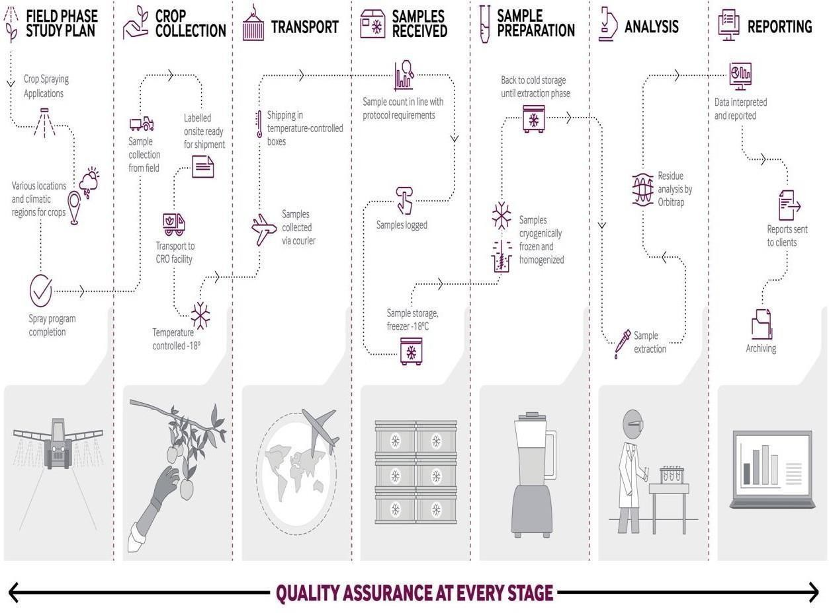

**Figure.1**

# OBJECTIVES OF GLP[7]

GLP makes sure that the data submitted are a true reflection of the results that are obtained during the study.

GLP also makes sure that data is traceable. Promotes international acceptance of tests. **MISSION OF GLP**

—Test systems

—Archiving of records and materials.

—Apparatus, material and reagent facilities.

—Quality assurance programs.

—Performance of the study.

—Reporting of study results.

—Standard operating procedures (SOP)

—Personnel and test facility organization

# STANDARD OPERATING PROCEDURES (SOP)[8]

* Written procedures for a laboratories program.
* They define how to carry out protocol-specified activities.
* Most often written in a chronological listing of action steps.
* They are written to explain how the procedures are suppose to work
* Routine inspection, cleaning, maintenance, testing and calibration.
* Actions to be taken in response to equipment failure.
* Analytical methods
* Definition of raw data
* Keeping records, reporting, storage, mixing, and retrieval of data

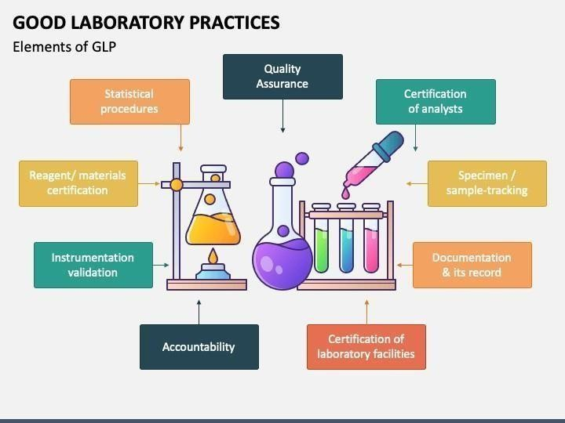

# Figure.2 Statistical Procedures for Data Evaluation

Statistical procedures are not simply chosen from a text book Practitioners in a particular field may adopt certain standards which are deemed acceptable within that field. Regulatory agencies often describe acceptable statistical procedures Scilife-logo-100 Search.

# GLP: GOOD LABORATORY PRACTICES[9]

GLP is the abbreviation of Good Laboratory Practices.

GLP guidelines are established by the FDA for non-clinical laboratory tests and studies conducted for assessing the safety and efficacy of the product. GLP layout to define the

framework for a non-clinical study and state how companies should be performed, evaluated, and reported. 21 CFR 58 Good laboratory practice for non-clinical laboratory studies.



# Figure.3

The guidelines of Good Laboratory Practices are the non-clinical counterpart of GCP. It comprises animal welfare as well during laboratory trials. As with any other form of GLP also requires extensive documentation of the details. It includes comprehensive documentation of lab samples and test animals.

If the tests are conducted on dead animals, they are rigidly regulated by GLP. It requires labs to handle specimens in perfectly humane ways under very definitive standards. Results are regularly reported and stored in order to enhance available data for future research.

If you need to read further about Good Laboratory Practices check Chapter 6 of the PCI Guide To Good Manufacturing Practice For Medicinal Products - Part I .“ Good quality control laboratory practices are explained in this chapter of PCI guideline which is mainly focused on areas as follows:

# Documentation

Laboratory documentation should follow the principles that are explained in this guideline. It’s important to have details that are required readily available in the documentation.

# Sampling

An SOP that describes the sampling steps should be in place. Such as sampling method, amount of sample, equipment to be used, identification of the containers, description of a representative sample, etc.

Thus, sampling should be done under this approved SOP.

# Testing

The test method should be validated in advance.

Test results should be recorded using Good Documentation Practices.

There should be SOP's that explain the stability, control, use of reagents, reference standards, culture media, as well as validated test methods.

Furthermore, SOP's should define the decontamination methods for used microbiological media and strains. And If any animals are used for testing, there should be a detailed SOP for it as well.

**Ongoing stability program:** After marketing the product, the stability of the product should be monitored according to a continuous program that will allow the detection of any stability issues associated with the formulation in the marketed package.

The ongoing stability program should be described in a written protocol. The stability protocol of an ongoing stability program should be maintained until the end of the shelf-life period.

# Technical transfer of testing method

There should be a detailed written protocol that explains the technical transfer of testing methods from one laboratory (transferring laboratory) to another.

Moreover, the term GLP is included in ISO 10993-1. ISO 10993 is an important standard for the medical device industry that explains the Biological evaluation of medical devices —Part 1: Evaluation and testing within a risk management process. The description of GLP term in ISO 10993-1.

# MANAGEMENT OF GOOD LABORATORY PRACTICES[10]

* 1. Without full commitment of management, GLP systems will not function as they includes.
  2. Should and will lack credibility. Managerial aspects are therefore critical for GLP implementation in a laboratory. Laboratory management responsibilities and organizational requirements take up about 15% of the GLP text, clearly demonstrating that the regulators .
  3. Also consider these points as important.
  4. Management has the overall responsibility for the implementation of both good science and good organization within their institution.

# Good Science

Careful definition of experimental design and study parameters. Science based on known scientific principle are control and documentation of experimental and environmental variables. Careful and complete evaluation and reporting of results. Results becoming part of accepted scientific knowledge.

# Good Organization

1. Proper planning of studies and allocation of resources.
2. Provision of adequate facilities, infrastructure and qualified staff.
3. Definition of staff responsibilities and provision of staff training.
4. Establishment of procedures to ensure proper conduct of studies.
5. Good record keeping and organized archives.
6. Implementation of verification procedures for study conduct and results.

# FACILITIES: BUILDINGS AND EQUIPMENT[11]

## BUILDINGS

. GLP requires that facilities be of appropriate size, construction and location to meet the equipment.

* 1. Requirements of the study and minimize disturbances that would interfere with the solution.
  2. Validity of the study. They should be designed to provide an adequate degree of separation between the various activities of the study.
  3. The purpose of these requirements is to ensure that the study is not compromised because of inadequate facilities. It is important to remember that fulfilling the requirements of the study does not necessarily mean providing “state of the art” constructions but carefully considering the objectives of the study and how to achieve them. It is up to it .
  4. The facility management to define what is adequate; this will depend on the kind of studies being performed.
  5. Separation ensures that different functions or activities do not interfere with each other or affect the study.
  6. Minimizing disturbance by separation can be achieved by Physical separation this can be achieved by walls, doors or filters, or by the use .
  7. Isolators in new buildings or those under transition or renovation,separation will be part of the design.
  8. Separation by organization, for example by the establishment of defined work areas within a laboratory carrying out different activities in the same area at different times allowing for cleaning and preparation between operations or maintaining separation staff, or by the establishment of defined work areas within a laboratory.
  9. As an illustration of the principles involved we have chosen two examples that are often found in laboratories. These are (A) The Dose Mixing Unit: the zone used for the preparation of the dosage form and (B) Animal House Facilities.

## Example A : Dose Mixing Unit

The Dose Mixing Unit is a laboratory area dealing with the work flow of test items vehicles and control items: receipt, storage, dispensing, weighing, mixing, dispatch to them animal house and waste disposal.

(Note: Most of the points which follow would equally apply to other laboratory areas such as analytical or histopathology areas.)

## - Size

The laboratory must be big enough to accommodate the number of staff working in it and allow them to carry on their own work without risk of interfering in each others work or mixing up different materials. Each operator should have a workstation sufficiently large to be able to carry out operation efficiently. There should be sufficient physical separation between the workstations to reduce the chance of mix up of materials or cross contamination. The dose mixing area is a sensitive zone and access to it should be restricted so as to limit the possibility people becoming vectors of pollution or contamination between studies or test items.

## - Construction

The laboratory should be built of materials that allow easy cleaning and do not allow any test items to accumulate in corners or cracks and cross contaminate others should be a proper ventilation system with filters that serve to protect personnel and prevent cross contamination. Many modern dose mixing areas are designed in a “box” fashion, each box having an independent air handling system.

## - Arrangement

Ideally there should be separate areas for:

* Storage of test items under different conditions
* Storage of control items
* Storage of vehicles
* Handling of volatile materials
* Weighing operations
* Mixing of different dose forms e.g. diet and liquid
* Storage of prepared doses
* Cleaning equipment
* Offices and refreshment rooms
* Changing rooms.

## Example B: Animal House Facility

In light in addition, the facility should be organized in a way that prevents the animals from coming into contact with disease, or with a test item other than the one under investigation.

**Equipment**[12]

## Suitability and Calibration

To perform a study properly, adequate equipment must be available. All equipment should be suitable for its intended use. The equipment that is suitable for a given study depends on the type of the study and the study objectives. Suitability can only be assessed by consideration of the performance of the equipment.

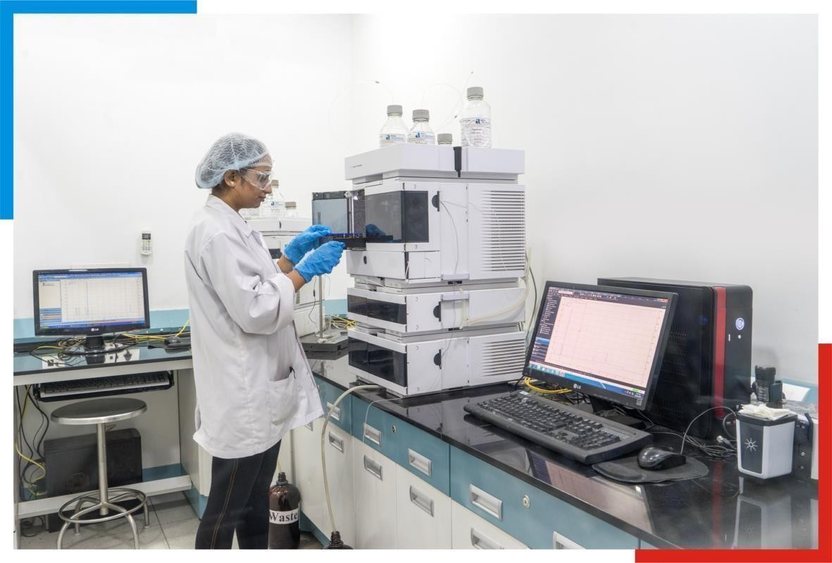

# Figure.4

For example,[13]

There is no need to have a balance capable of weighing to decimals of a milligram to obtain the weekly weight of a rat however a balance with this precision may be required in the analytical laboratory.

* + 1. Defining the suitability of equipment is a scientific problem to be judged by the study .
    2. There are analytical of directors in GLP.
    3. For some equipment it is necessary to conduct formal tests or even formal qualification .
    4. To demonstrate that it is fit for its intended use. This is often the case for analytical equipment.
    5. Whether formally qualified or not, all equipment must be calibrated and maintained .
    6. Ensure accurate performance. Most frequently, the calibration depends on the use of it .
    7. Standards used. For example, in the case of a balance, the standards are the weights that have been certified by a national or international standards authority as being occupied.
    8. Specified limits. Frequently the laboratory will have a set of certified weights. These “primary standards” are only used to qualify, “secondary standards”, which are then used on a routine basis.
    9. Another example is standard chemicals which are used to test/calibrate equipment, like pH meters, to ensure accurate performance. Standards may also be compound samples .
    10. Known concentration used to ensure that analytical equipment is functioning as expected .
    11. They are providing a basis for the calculation of the final result.
    12. The laboratory must decide the acceptable frequency for calibration this will depend on the type of equipment and its use. The calibration programme should be included the SOP's of the institution.
    13. Proof that equipment is performing to specifications is essential, whether generating data (e.g. analytical equipment or balances) or maintaining standard conditions (e.g. refrigerators or air conditioning equipment). This can be done by periodic checking at a sample.
    14. Frequency that allows action to be taken in time to prevent any adverse effect on the study .
    15. Should the equipment be faulty. Logbooks are often used to record these regular verification.
    16. Full documentation of all tests for suitability and for all calibration must be kept within etc .
    17. The laboratory to allow scientists to assess the accuracy of measurements taken during a solution.
    18. Studies, these data should be archived so that they are readily available should it become a formation.

## Maintenance

Facilities - Buildings and Equipment of GLP[14]

1. GLP requirements that equipment should be maintained are based on the assumption .
2. This reduces the likelihood of an unexpected breakdown and consequent loss of data.
3. Maintenance may be carried out in two distinct ways:

preventive or planned, whereby a regular check is made irrespective of the performance of the equipment

curative or repetitive, when the piece of equipment is not functioning according to practice.

1. Specification or when the equipment or system has broken down.
2. Planned, routine maintenance is a useful precaution for equipment that does not have a GLP suitable backup or alternative.
3. However, some pieces of equipment, such as modern computer-driven analyzed.
4. Electronic balances, do not lend themselves to routine maintenance. A better approach it .
5. May be to check them regularly and ensure that suitable contingencies are available if any from them problem occurs. The contingencies may include having duplicate equipment, or immediate access to an engineer or a contract laboratory with equivalent equipment.
6. Back-up for vital equipment as well as back-up for power failure should be available forms .
7. May need a stand-by generator capable of maintaining at least the animal room environment .
8. To prevent the loss of the animals that would irretrievably affect the study. Meanwhile, samples could be stored for a period until power is restored.
9. Early warning that equipment is malfunctioning is important. Periodic checks will help .
10. Detect malfunction, but this may also be achieved with alarms, particularly if the problem .
11. Occurs at a time when staff are not present in the laboratory.
12. Routine maintenance requires planning and this should be indicated in a service plan.
13. There are no specific rules concerning the format of the plan. Like all planned events the standard test.
14. Service plan should clearly indicate what is to be done and when. The related SOP should indicate tolerances for the targeted dates, how the actions are to be recorded and, of solution course, who is responsible for maintaining the plan.

# PATHOLOGY SUPPORT FOR GLP - COMPLAINT NONCLINICAL SAFETY STUDIES IN THE ACADEMIC SETTING[15]

Pathology is an integral component of all GLP - compliant nonclinical safety studies,48 and regulators view the contribution of pathologists as “key to the identification of potential target organs of toxicity and other toxicological significant risks”when such studies are performed.49 Pathologists are adept at examining cell, fluid, tissue, organ, and systemic changes during health and disease. The basis for this expertise is formal training (generally for a decade more)in anatomy, biochemistry, genetics, and physiology. Most pathologists who participate in GLP - compliant nonclinical studies also received formal instruction in clinical veterinary medicine, diagnostic pathology, and toxicology and have earned one or more professional certifications to highlight their pathology and/or toxicology credentials.50 The deep expertise in “whole organism” biology means that pathologists should be key members of all GLP compliant nonclinical research teams. Pathologists also should be involved in the study design process since their expertise is needed to assure that the appropriate tissue and fluid samples.(14)

They collected, preserved, and analyzed using suitable procedures.51,52 Importantly, the extensive educational and experiential requirements to acquire proficiency in this discipline mean that the pathology function, especially the microscopic evaluation of cells and tissue

sections, cannot be delegated to personnel with other scientific backgrounds. Pathologists are equipped to perform many roles in nonclinical safety studies within academia. Where institutional resources permit, pathologists usually should serve as contributing scientist (or principal investigator) rather than as study director so that they can concentrate their efforts in full- filling their unique roles in pathology data acquisition, analysis, and interpretation. The term for this function is study pathologist. Many studies have several study pathologists to address distinct tasks, typically a clinical study pathologist who evaluates cell numbers and morphology as well as biochemical components in blood and other fluids53 and an anatomic study pathologist who assesses macroscopic and microscopic findings in organs and tissues. This approach mimics the organizational structure of nonclinical safety facilities in most government and industrial institutions as well as CROs, where a given study is conducted by a multi- disciplinary team and the study pathologist produces a pathology sub report (or separate anatomic pathology and clinical pathology sub reports) that will be inserted into the final study report by the study director. However, some academic institutions possess limited staffing in their nonclinical laboratories, thus requiring pathologists in such settings to serve multiple functions: study pathologist, study director, and perhaps even clinical veterinarian for the laboratory animal facility. Pathologists employed as postdoctoral fellows or advanced graduate students may serve as the study pathologist or study director to gain practice in these roles while organizing their own studies, but in this case they should be assisted by an individual with prior experience as study director.

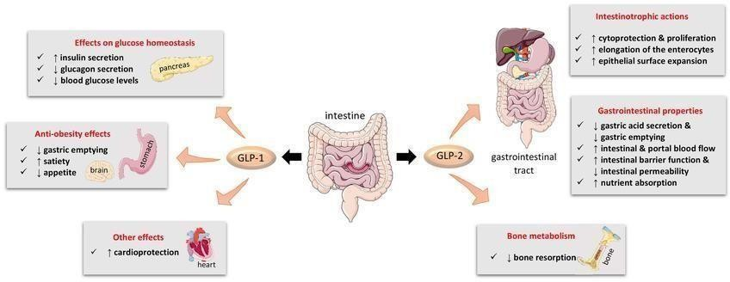

# Figure.5

**REFERENCES**

1. Pharmaceutical Research and Manufactures of America( PhRMA) (2018). GLP Guidelines.
2. Singh, S., & Kumar, V. (2020). Expanding the horizons of GLP beyond regulatory compliance. Journal of Environmental Science and Health, Part C, 38,1-11.
3. Morita & Morikawa (2011). GHS for Classification and Labeling of Chemicals. GLP of Regulation FDA (1978).
4. Nonclinical Safety Studies for the Conduct of Human Clinical Trials and Market Authorization for Pharmaceuticals. US FDA, 2020.
5. Vandivort, T., Pharmacokinetics and Toxicokinetic Studies in Fundamentals of Pharmaceutical and Biologics Regulations: A Global Perspective, Regulatory Affairs Professionals Soc. 2023, 53–62.
6. OECD Principles of Good Laboratory Practice, Environment Directorate Organization for Economic Cooperation and Development, 1998, DOI: [ENV/MC/CHEM(98)17](https://doi.org/ENV/MC/CHEM(98)17)
7. Tahl, K., Brown, J. G. Principles of Good Laboratory Practice and Nonclinical Development in Fundamentals of Pharmaceutical and Biologics Regulations: A Global Perspective. Regulatory Affairs Professionals Soc. 2023, 29–36.
8. OECD Principles of Good Laboratory Practice, Environment Directorate Organization for Economic Cooperation and Development, 1998, DOI: [ENV/MC/CHEM(98)1](https://doi.org/ENV/MC/CHEM(98)17)7 .WHO (2010) GLP Handbook FDA (1978)
9. Kolman, J.; Meng, P.; Scott, G. (Ed.), Good Clinical Practice: Standard Operating Procedures for Clinical Researchers, Wiley, 2021.
10. Code of Federal Regulations, Title 40, Part 160, Good Laboratory Practice Standards, Government Publishing Office, [https://www.ecfr.gov/current/title-40/chapter-](https://www.ecfr.gov/current/title-40/chapter-I/subchapter-E/part-160) [I/subchapter-E/part-160](https://www.ecfr.gov/current/title-40/chapter-I/subchapter-E/part-160)
11. TRS 966 - Annex 5: WHO Good Data and Record Management Practices. Annex 5, WHO Technical Report Series 966, World Health Organization, 2016
12. OECD Principles of Good Laboratory Practice, Environment Directorate Organization for Economic Cooperation and Development, 1998, DOI: [ENV/MC/CHEM(98)1](https://doi.org/ENV/MC/CHEM(98)17)7 .WHO (2010) GLP Handbook FDA (1978) OECD Principles of Good Laboratory Practice, Environment Directorate Organization for Economic Cooperation and Development, 1998, DOI: ENV/MC/CHEM(98)17 .WHO (2010) GLP Handbook FDA (1978)
13. NSF International (2019). Good Laboratory Practices (GLP) Equipment.
14. OECD Principles of Good Laboratory Practice, Environment Directorate Organization for Economic Cooperation and Development, 1998, DOI: [ENV/MC/CHEM(98)1](https://doi.org/ENV/MC/CHEM(98)17)7 .WHO (2010) GLP Handbook FDA (1978)
15. Dong M. W. Drug Development Process: Nonclinical Development of small Molecules Drugs LCGC North Am 2022, 40(10), 484-492.