# Title

**Parents’ perception of integrating AI literacy in Lebanese education: Shaping Future Young Minds**

# Abstract

The effective integration of AI-based technology into our daily lives has sparked an increase in interest in artificial intelligence education (AIED) across the social, and educational sectors. Educational systems must now prepare their students to live in a world where they will need to communicate with artificial intelligence (AI). AI literacy is therefore a cognitive and pedagogical issue. The purpose of this study was to comprehend the integration of AI literacy into Lebanese education system.

In response to the call of the Education 2030 agenda, that sets out a new vision for education which ensures inclusive and equitable quality of lifelong learning with insistence on leaving no one behind. This study’s aim is to implement artificial intelligence literacy into Lebanese curriculum, in accordance with e-learning; that may reveal higher understanding of AI literacy and encourage all students to access higher quality learning in digital world.

Older studies have always discussed artificial intelligence. A competency is about using the information in a useful way (confidence, how well); literacy is about knowing (knowledge, what skills). They have a close relationship. Beyond knowledge (AI literacy), this study aims to (i) to investigate parents’ perceptions about integrating AI into their kids’ education, and (ii) provide recommendations for families and schools about combining AI as a new curricular material into education in Lebanese schools.

The study highlights the impact of Implementing AI literacy and e-learning into Lebanese education. This study used a quantitative research method. A questionnaire was shared privately with Parents all over Mount Lebanon district in Lebanon. 87 parents filled the questionnaire out of 100. Whereas the analysis of the collected data was performed using chi-square test with the IBL SPSS software. Finally, this study will be important to validate that parents would like schools to integrate AI literacy into their kids’ education.

Keywords

Artificial Intelligence, AI literacy, parents’ perception, education

# Research objectives

The purpose of the study is to find out how parents feel about incorporating AI into their children's schooling. In order to give parents, schools, and curriculum designers useful insights and suggestions for making AI accessible and interesting for all Lebanese children in this digital age, we will be looking at how parents view integrating AI as a new curriculum element into their children's education.

# Purpose of the study

The purpose of the study is to investigate how parents see the inclusion of AI literacy in Lebanese education. In order to provide useful insights, identify possible issues, and provide recommendations for families and schools in general in this digital age. This study will examine the complex implications of artificial intelligence on kid's education.

# Introduction

In the current digital era, prior studies showed that the potential of implementing a curriculum that integrates technology as a tool to change the nature of a subject as stated by Koehler et al. (Spector, 2014) has raised recently and transforming knowledge into diverse and interesting learning experience is also increasing as claimed by (Rosayda, 2024). As a scientific- technological field AI is just a few decades old. In 1956, the name was coined and have contributed to its development from an interdisciplinary focus (Casal-Otero, 2023).

A variety of definitions focus on limited perspectives of AI’s definitions. In 1996, (Boden, 1996) claimed that Artificial Intelligence is the study of how to build or program computers to enable them to do what minds can do. But such definitions do not contribute to our aim in education. Thus a deep understanding of the terminology is suggested to help parents and kids develop their own perception of integrating AI into their kids’ education. A more relevant definition proposed by (Stefan A.D. Popenici, 2017) as computing systems that are able to engage in human-like processes such as learning, adapting, synthesizing, self-correction and use of data for complex processing tasks. Also, (Chiu, 2024) explained that AI literacy can be defined as: an individual's ability to clearly explain how AI technologies work and impact society, as well as to use them in an ethical and responsible manner and to effectively communicate and collaborate with them in any setting. It focuses on knowing (i.e. knowledge and skills).

The breadth of this topic is more significant than its depth which suggests that parents and kids should have a thorough understanding of AI and its literacy to attain the UNESCO recommendations about AI competency that states: The knowledge, skills, and attitudes students should acquire to understand and actively engage with AI in a safe and ethical manner in school and beyond. In the field of the future of our kids’ education, parents and educators recognized the increasing speed of the technological advancements and the emergence of the educational implications that requires the usage of AI where it turned to be a part of the fabric of our daily life.

# Method

1. Questionnaire for parents [online survey to a representative sample of parents]
2. Questionnaire directed to 6 parents of children whose children have AI integrated in their education, AI is not integrated in their education but receiving AI courses as an extracurricular course and not receiving any education related to AI literacy.

# Research questions

1. How do parents’ age influence their acceptance of AI into the education of their kids?
2. What is the impact of parents’ daily talk about AI on their kids’ future career?
3. To what extent do parents’ knowledge of AI influence their support to integrate AI literacy into their kids’ education.

# Hypotheses

1. Parents who have deeper knowledge of Al are more likely to support the integration of AI in their kids' education.
2. Parents who enroll their children in private schools support the integration of AI in their children’s kids more than parents who enroll their children in public schools.

# Methodology and background

## Background

In the part that follows, we go over pertinent earlier research on AI literacy for families, family involvement and parents scaffolding, and family learning and technology. Numerous perceptive findings regarding the impact of AI on academic performance have been presented in earlier research.

AI literacy for families is the article reviewed

The 1st reviewed article was: “Family as a Third Space for AI Literacies: How do children and parents learn about AI together?” (Stefania Druga, Fee Christoph, Amy J. Ko, 2022) explained: When studying AI literacies, take into account the benefits of parent-child collaborations and the most typical responsibilities parents play in helping their kids. Lastly, we offer design suggestions for upcoming family-centered AI literacy initiatives and talk about how our various activities complemented parents' duties.

Another article, “Parental cognitions and motivation to engage in psychological interventions: a systematic review” was reviewed. The author stated that according to an analysis of parents' engagement with psychological treatments for their kids, beliefs on the seriousness of the issue may have an impact on treatment compliance. (Pereira AI, Barros L., 2019)

The third reviewed article is: “Dimensions of artificial intelligence on family communication”. (Alfeir, 2024) The findings demonstrated a lack of awareness and openness regarding the privacy and data storage practices of AI-enabled communication tools.   
The effects of AI dimensions on family communication were generally favorable as well.

## Study design

To understand how parents, engage in AI literacies, the study followed a quantitative approach to answer the research questions. To explore relationships between variables a cross-sectional study design was adopted. This study design is efficient to assess the parents’ perceptions of AI literacy when integrated in their kids’ education. This approach explores how parents perceive AI across a range of demographics compared to a variation of factors including cultural background.

Surveys used in cross-sectional research are helpful for examining several phenomena, including illness prevalence, attitudes, and knowledge levels, as well as for validating comparisons (Kesmodel, 2018).

## Sampling technique

A sampling technique was adopted based on age groups, culture background, the quantity of AI tools and socioeconomic status. The recommended sample size was 170 parents. The study's participants were gathered via family-oriented forums, email newsletters, and social media. This sampling strategy helps to avoid a lot of the restrictions that come with conducting research.

## Study tool

Parents from Lebanon were invited to complete an electronic survey (google form) designed and validated by professors with interest in AIED. The online survey consisted of a part of closed-ended questions and another Likert-scale based-questions that reached participants through social media and family-based forums. The questionnaire investigated the demographics of parents, the parents’ and the kids’ education level and in particular: their past experiences with artificial intelligence in addition to their future expectations to their kids’ future career.

## Pilot test

Before distributing a questionnaire to a wider audience, it is imperative to conduct a pilot study to ensure its efficacy and dependability. A sample of 25 parents was considered a representative sample to ensure the relevance and clarity of the questionnaire. Some minor revisions were recommended to enhance clarity. The questionnaire was also assessed using Cronbach’s alpha with a value more than 0.7, which confirmed the reliability of the instrument.

## Data collection

A survey questionnaire was used to gather the data, and a spreadsheet was created using the participants' answers. The questionnaire consisted of 23 items in four sections,8 were multiple choice questions measuring demographic features and 15 were measured using a four-point Likert scale, encompassing Strongly Disagree, Disagree, Agree, and Strongly Agree, respectively. The moderate or neutral scale was removed to help parents accurately decide their opinion and don’t use the moderate or neutral scale and evade the question.

Email invitations that included a summary of the study, the estimated time needed to finish it, and the questionnaire link were used to distribute the survey questionnaire. To promote participation, two emails serving as reminders were issued. The first reminder was issued during the first week, and a second reminder was sent during the third week. The survey collected 156 responses which was expected to be higher but due to connection restrictions about 14 parents send incomplete answers or didn’t participate so their responses were discarded since the recommended sample was 170 participants.

## Data analysis

Descriptive statistics were employed for data analysis using the Statistical Package for the Social Sciences (SPSS) to determine if Lebanese Younger parents are more inclined to support the use of AI in their children's education. Private school parents are more supportive of AI integration in their children's education than public school parents are. Additionally, parents who are more knowledgeable about Al are more likely to support the integration of AI in their children's education, and daily conversations about AI can help their children use AI tools in their future careers.

# Ethical considerations

The investigation was conducted with ethical considerations in mind. Before the study began, the participants' informed consent was acquired in addition to the online survey form. Every participant received a briefing about the purpose of the study, the confidentiality of their identities, and the sole purpose for which the data will be used. By clearly outlining these procedures and guaranteeing compliance with ethical standards, the current study places a high priority on thorough data protection measures to ensure participant confidentiality and anonymity.

# Strengths and limitations

This study's contribution is to bring the communication literature regarding parents' attitudes of incorporating AI into their children's education up to date. In order to evaluate various aspects of AI separately and the parents' opinions about incorporating it, the article takes an innovative as well as more complicated method. It presented findings about the various facets of AI and how they impact children's education. Thus, this is a new effort to investigate how various aspects of AI affect children's education. By incorporating new ideas into their curricula, it offers developers, researchers, subject matter experts, and decision-makers fresh perspectives on how various facets of AI might be used to educate our children.

The focus on AI's importance in the real-world application of technological advancement emphasizes how it may improve productivity, accessibility, and personalization across a range of industries, including education. AI may provide useful tools that simplify work, provide accessibility for all students, and personalize interactions based on individual preferences by addressing particular requirements and obstacles within the dynamics of education. However, in order to build AI systems that properly integrate into children's education, it is imperative that ethical implications, privacy problems, and potential biases be carefully considered. By considering the advantages of AI against these factors, its use will be in line with the various educational needs and values and will enhance the learning experiences of the kids.

However, the study's weaknesses include that its empirical conclusions were derived from survey observations rather than interviews. Additionally, selection bias is introduced by convenience sampling through social media and family-oriented forums, which reduces the sample's variety and generalizability. The study's external validity may be impacted by this recruiting strategy as participants from these platforms could have different perspectives and experiences with AI than those who do not use them, leading to a biased sample.

# Future researches

Since researching the aspects of AI is a relatively new field of study, there is a great deal of room for researchers to investigate additional family communication phenomena. With a mixed-method study design, further research may be carried out with a larger sample size. Additionally, using a mixed-method approach—that is, surveys and interviews—can contribute more intriguing and practical insights to the body of knowledge on the educational experiences of kids when AI is integrated.

Furthermore, for more reliable insights, advanced analytic methods like Partial Least Squares (PLS) or Structural Equation Modeling (SEM) using AMOS are advised over SPSS. These techniques provide better path analysis, moderation, and mediation analysis skills, all of which are essential for comprehending complex connections between variables. Using these methods will improve the validity and reliability of conceptions with regard to AI use and offer more profound understanding of how AI affects the educational experiences of kids.

Additionally, to provide a more thorough knowledge of the long-term effects of AI on a kid's educational dynamics, future research should create a longitudinal study to evaluate changes in attitudes and behaviors over time.

# Results

Discussion

**Parents who have deeper knowledge of Al**

Table1 shows the results of the questionnaire, which give a summary about parents’ knowledge of AI. Regarding the understanding of the meaning of artificial intelligence, out of 87parents, 41 parents agree and 18 strongly agree that they are confident of their understanding of the meaning of artificial intelligence. 33 parents agree and 15 parents strongly agree that they know how to use AI applications. However, when it comes to comparing AI to deep learning and machine learning only 9 parents strongly agree and 37 parents agree that they can compare their differences. Moreover, the majority of the Lebanese parents, 35 agree and 24 strongly agree, that they understand how misuse of AI could result in substantial risk to humans. Whereas, 20 parents agree and 40strongly agree that AI systems should respect privacy.

Table 1 Parents who have deeper knowledge of AI

|  |  |  |  |  |  |
| --- | --- | --- | --- | --- | --- |
| **Descriptive Statistics** | | | | | |
| 1- Parents who have deeper knowledge of Al | | | | | |
|  | Strongly disagree | Disagree | Agree | Strongly agree | N |
| I am confident I can understand the meaning of artificial intelligence | 14 | 14 | 41 | 18 | 87 |
| I know how to use AI applications (e.g., Siri, chatbot, chat GPT, copilot) | 14 | 25 | 33 | 15 | 87 |
| I can compare the differences between AI concepts (e.g., deep learning, machine learning). | 14 | 27 | 37 | 9 | 87 |
| I understand how misuse of AI could result in substantial risk to humans. | 13 | 15 | 35 | 24 | 87 |
| I think that AI systems should respect privacy. | 15 | 12 | 20 | 40 | 87 |

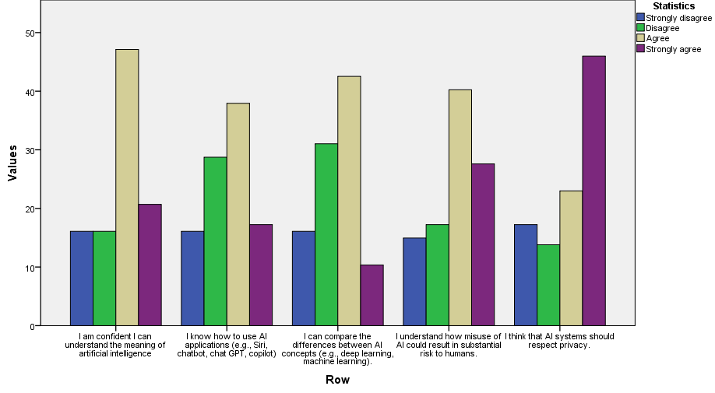

Figure 1 diagram representing parents’ knowledge of AI

Table 2 test of normality of parents’ knowledge of AI

|  |  |  |  |  |  |  |
| --- | --- | --- | --- | --- | --- | --- |
| **Tests of Normality** | | | | | | |
|  | Kolmogorov-Smirnova | | | Shapiro-Wilk | | |
| Statistic | df | Sig. | Statistic | df | Sig. |
| 1- Parents who have deeper knowledge of Al | ,168 | 87 | ,000 | ,930 | 87 | ,000 |

|  |  |  |  |  |
| --- | --- | --- | --- | --- |
| **Correlations** | | | | |
|  | | | T1 | T2 |
| Spearman's rho | T1 | Correlation Coefficient | 1,000 | ,630** |
| Sig. (2-tailed) | . | ,000 |
| N | 87 | 87 |
| T2 | Correlation Coefficient | ,630** | 1,000 |
| Sig. (2-tailed) | ,000 | . |
| N | 87 | 87 |
| **. Correlation is significant at the 0.01 level (2-tailed). | | | | |

Spearman’s rank correlation was computed to assess the relation between the variable Parents who have deeper knowledge of Aland parents support the integration of AI in their kids' education. There was a positive correlation between the 2 variables, r(85)=.630, p=.000. The results reflect strong relationship between the two variables.

**Result:**

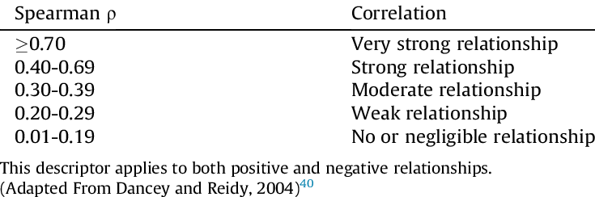

$$ρ=0.630 Then there is a strong relationship between the two variables$$

**When the first increases, the second increases.**

**Parents’ support the integration of AI into their kids' education**

Regarding parents who support the integration of AI literacy into their kids’ education, the majority of the parents believe that their kids can perform well on AI tasks, can master knowledge and skills related to AIED and can earn good grades in AI assessments. 29 parents agree and 31 strongly agree that AI literacy should be a main subject in their kids’ education.

|  |  |  |  |  |  |
| --- | --- | --- | --- | --- | --- |
| **Descriptive Statistics** | | | | | |
| 2- Support the integration of AI into their kids' education | | | | | |
|  | Strongly disagree | Disagree | Agree | Strongly agree | N |
| I am confident my kids will perform well on AI related tasks. | 13 | 22 | 38 | 14 | 87 |
| I believe AI should be a main school subject in my kids’ education | 13 | 14 | 29 | 31 | 87 |
| I believe my kids can master AI knowledge and skills | 10 | 17 | 35 | 25 | 87 |
| I believe my kids can earn good grades in AI related assessments. | 13 | 13 | 42 | 19 | 87 |

Table 3 Support the integration of AI into their kids' education

**Helping Kids benefit from AI tools in their future career**

Regarding kids’ future career, most parents who respond to the questionnaire, feel positive of the benefits of learning AI on their kids’ future job. Lebanese parents’ perceptions reflected their agreement of learning AI will help their kids get a good job in the future, understanding AI will benefit their kids in their future career and their kids can make good use of AI related tools.

Figure 2 Helping Kids benefit from AI tools in their future career

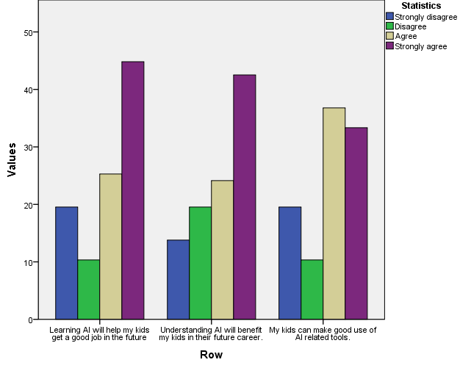

**Parents who enroll their children in private schools support the integration of AI in their children’s kids more than parents who enroll their children in public schools.**

The results show that parents whose kids are in private school and parents whose kids are public school P value 0.203 > 0.05 then no difference significant between the 2 variables. Therefore, we can say the type of school has not showed a great effect, and the majority of Lebanese parents support the integration of AI literacy into their kids’ education.

**Mann-Whitney Test**

|  |  |  |  |  |
| --- | --- | --- | --- | --- |
| **Ranks** | | | | |
|  | The school of my kids is: | N | Mean Rank | Sum of Ranks |
| 2- Support the integration of AI into their kids' education | Private school | 59 | 46,36 | 2735,00 |
| Public school | 28 | 39,04 | 1093,00 |
| Total | 87 |  |  |

|  |  |
| --- | --- |
| **Test Statisticsa** | |
|  | 2- Support the integration of AI into their kids' education |
| Mann-Whitney U | 687,000 |
| Wilcoxon W | 1093,000 |
| Z | -1,273 |
| Asymp. Sig. (2-tailed) | ,203 |
| a. Grouping Variable: The school of my kids is: | |

Result: P value 0.203 > 0.05 then no difference significant between the 2 variables

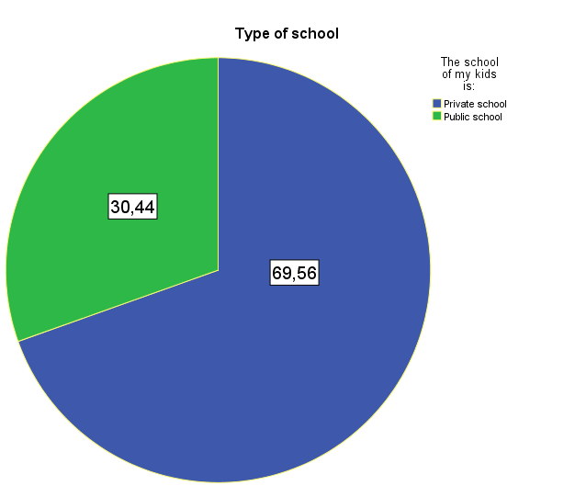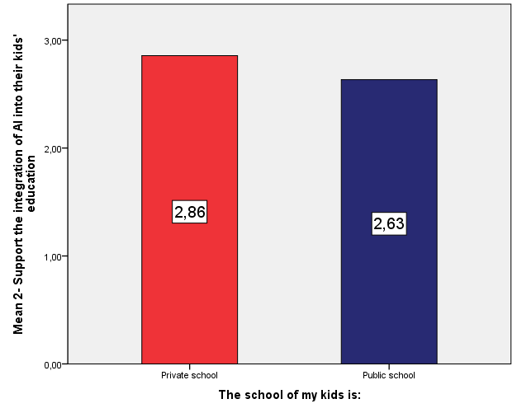

# Conclusion and recommendations

The study's findings advance our knowledge of the use and implementation of AIED by indicating that it can successfully support and improve kids in their learning and their future career. We also looked at the many moderator factors that could influence AI's effect sizes. Suggestions for further research on AI in education are made in light of the study's findings. According to the study, after being implemented, AI technologies have greatly improved parents’ interpersonal views and communication efficacy. But it also highlights important policy issues with relation to AI device data storage and privacy.

These issues are brought on by a lack of awareness regarding privacy regulations and the opaqueness of associated procedures. Additionally, the survey reveals that parents are becoming more and more dependent on AI gadgets due to their use of the self-learning features these tools provide.

Data Availability statement   
Without unnecessary hesitation, the authors will make the raw data that supports the results of this research public.

# Contributions from the authors

NA: Formal analysis, obtaining funding, managing projects, resources, Writing: first draft, review, and editing.

Funding   
The research, writing, and/or publishing of this paper were all done without any outside funding, according to the author(s).

Acknowledgments   
The author would like to express their gratitude to all of the reference staff that helped with this study.

Conflict of interest   
The author affirms that there were no financial or commercial relationships that may be interpreted as a potential conflict of interest during the research.

# References

# References

Alfeir, N. M. (2024). Dimensions of artificial intelligence on family communication.

Boden, M. A. (1996). *Artificial Intelligence* (2nd ed.). London: Academic Press Inc.

Casal-Otero. (2023, April 19). AI literacy in K-12: a systematic literature review. *International Journal of STEM Education*. doi:https://doi.org/10.1186/s40594-023-00418-7

Chiu, T. K. (2024, June). What are artificial intelligence literacy and competency? A comprehensive framework to support them. *Computers and Education open, 6*. doi:https://doi.org/10.1016/j.caeo.2024.100171

Kesmodel, U. (2018). Cross-sectional studies_what are they good for? *Acta Obstet. Gynecol. Scand.*, 388-393. doi:10.1111/aogs.13331

Pereira AI, Barros L. (2019). Pereira AI, Barros L. Parental cognitions and motivation to engage in psychological interventions: a systematic review. *Child Psychiatry Hum*, 347-361. doi:10.007/s10578-018-0852-2

Rosayda, S. (2024, sep 26). The influence of the TPACK approach in curriculum management and learning based kurikulum merdeka.

Spector, J. M. (2014). *Handbook of Research on Educational Communications and Technology.* springer.

Stefan A.D. Popenici, S. K. (2017, Nov 23). Exploring the impact of artificial intelligence on teaching and learning in higher education. *Research and Practice in Technology Enhanced Learning*. doi:https://doi.org/10.1186/s41039-017-0062-8

Stefania Druga, Fee Christoph, Amy J. Ko. (2022). Family as a Third Space for AI Literacies: How do children and parents learn about AI together?