**Improving Cloud Security: Defending Data and Upholding Privacy**

**Poornima Institute of Engineering and Technology, Jaipur, Rajasthan, India**

Ayush Maheshwari Prof. Girdhari Lal

Student Assistant Professor

B. Tech. Student Dept. of Computer Science, Computer Science and Engineering,

Poornima Institute of Engineering and Poornima Institute of Engineering and

Technology, Jaipur, Rajasthan, India Technology, Jaipur, Rajasthan, India

Email: [2021pietcaayush015@poornima.org](mailto:2021pietcspranay127@poornima.org) Email:girdhari.lal@poornima.org

**Abstract**

Cloud computing is characterised by outstanding flexibility and cost-saving possibilities, but it simultaneously generates significant security and privacy issues. This paper reviews some of the latest academic studies to highlight critical challenges, such as the risk of data breaches, insecure APIs, and virtual machine vulnerabilities. Researchers are demanding solutions that include high encryption, stronger APIs, and new security models especially tailored for cloud computing. However, much remains to be filled in this area, as a great deal of effort is put into cost-effective and scalable solutions that can accommodate different users. Conclusion In a nutshell, cloud Security has increased over the years, but there is still more to be done.

**1. Introduction**

**1.1 History of Cloud Computing**

Cloud computing has fundamentally transformed the methods by which we store, access, and manage data, enabling organisations—from startups to large corporations—to scale rapidly without the necessity of physical infrastructure. Nevertheless, this convenience is accompanied by significant concerns regarding data security and privacy. As an increasing amount of sensitive information transitions to the cloud, the risks of breaches and cyberattacks escalate, prompting essential questions: Is our data genuinely secure? What are the implications if something goes wrong?

**1.2 Importance of Security and Privacy in Cloud Computing**

Data protection in the cloud has never been more crucial. The recent cyberattacks have proven that even the most sophisticated systems are vulnerable, which makes security a concern not only for technology but also for business and society. For companies, a data breach may mean huge financial losses and reputation damage. For an individual, it may lead to personal and financial risks. With the growth of cloud usage, data protection is now the top priority.

**1.3 Scope and targets of the evaluate**

Based on five recent studies that address critical cloud security and privacy issues, such as insecure APIs and data protection during migrations, this assessment focuses on strategies related to encryption, risk management, and the use of privacy-preserving technologies toward these challenges.

**2. Methodology**

**2.1 Research Approach**

This review is based on five leading research articles in conjunction with other relevant literature on cloud security and privacy. The selected works illustrate various challenges and their solutions that cloud technology faces. They put emphasis on commonly vulnerable aspects and the available means to tackle them. An effort has been made to draw a lucid overview of recent progress, thus pointing out issues for further research.

**2.2 Data Sources and Selection Criteria**

All selected papers were obtained from reputable sources, such as IEEE Xplore, ScienceDirect, and the ACM Digital Library. Papers with a significant number of citations and relatively recent publication dates were used to ensure that the research is contemporary and influential in demonstrating credible contributions by well-respected authors.

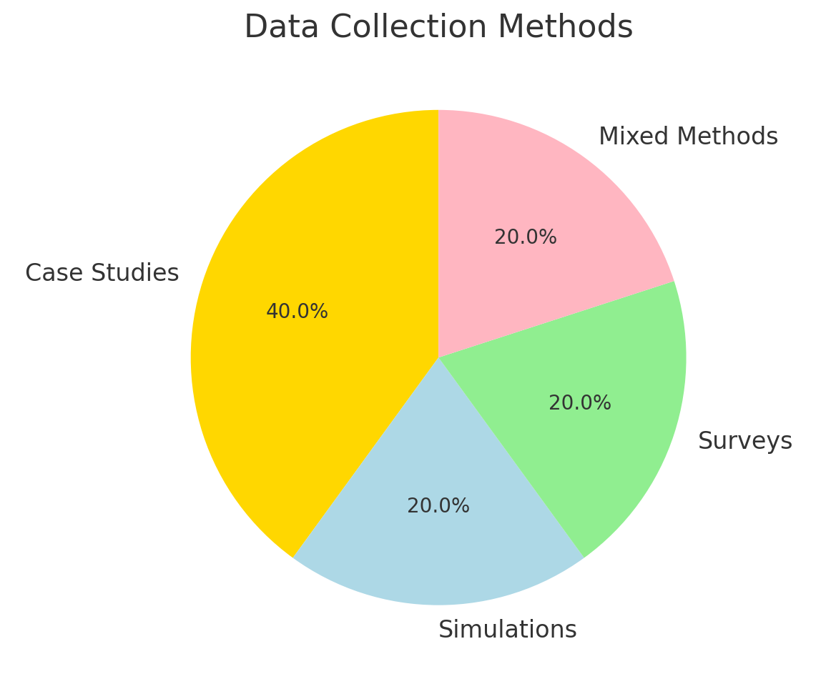

**3. Literature Review**

**3.1 Encryption strategies**

This encryption, in fact, acts like the cloud's secret key by locking information so tightly that an easily accessible key unlocks it. Techniques like ABE and homomorphic encryption make it possible for a record to relax without a virtually present look at the document by the cloud vendor. Now, here is a fact: encryption keeps things safe, which ironically also makes things slow and even allows access to a project just a bit shorter.

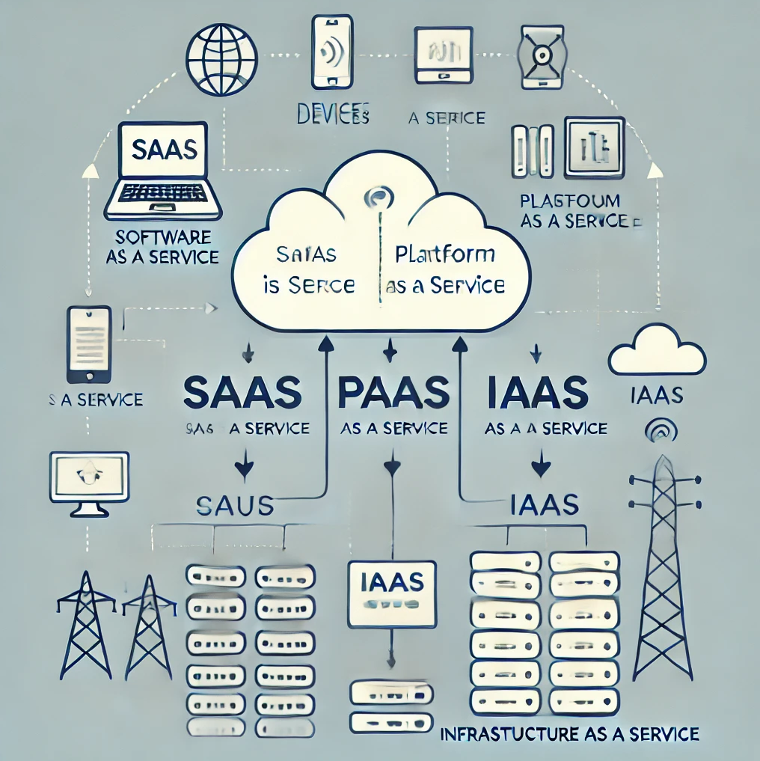

**3.2 API security**

APIs are a cloud offering connecting bridges. But it can easily become a weak point if not protected. Imagine these as restaurant waiters; sometimes you do not train them properly, and anybody will mess up your order. Strong security of APIs like authentication and encryption is highly important. But it leads to misconfigurations as well. The back door may not be locked, and so tracking is necessary for hackers to enter easily through it.

**3.3 Access Control**

Access Control grants just the right people access to the right data. These are some of the more popular models: RBAC (Role-Based Access Control) and ABAC (Attribute-Based Access Control). The problem is that is very hard to configure; one little mistake can create too much access for that person.

**3.4 secure Cloud garage**

Cloud storage is not just saving files; it keeps them. File splitting, also known as record sharding, splits up the file into pieces, keeping each part in a separate location so it's difficult to assemble by hackers. There's the encryption key system that becomes pretty complicated to handle when encryption keys are misplaced or lost—thereby, making information inaccessible to all of us.

**3.5 Other safety packages**

IDS act as protection cameras toward your cloud, on the lookout for suspicious hobbies. Protocols such as TLS and SSL defend files in the process of transfers, like using an armoured vehicle for valuables. Strategies like differential privateness ensure you are able to analyse facts without exposing non-public information.

**conclusion**

There's no one-size-fits-all approach to cloud safety. Each technique—whether it be encryption, API safety, or entry control access—has its pros and cons. The secret is finding the proper balance of technology and practice to build a safer, more trustworthy cloud.

**4. Comparative Study**

**4.1 Application areas**

**Statistics Encryption:** such as characteristic-based total encryption (ABE) and homomorphic encryption protect cloud statistics, but they can have an effect on efficiency. ABE controls achieve admission based on person attributes, even as homomorphic encryption enables computations without revealing files.

**API protection:** Strong authentication and encryption are important to protect you against attacks of APIs. According to papers, the keys should be managed economically and monitored constantly to keep APIs safe.

Access Control Models include Role-Based and Attribute-Based Access Control (RBAC/ABAC), which have become crucial in limiting access to data.

**4.2 Identified Challenges**

**Scalability & performance:** encryption can slow down real-time processing, making it tough for larger systems to scale.

**API Vulnerabilities:** Misconfigured APIs are a commonplace weak spot in cloud security.

**Statistics privateness:** making sure sensitive records, like fitness facts, stay non-public during storage and transmission is a first-rate challenge.

**cost:** imposing robust safety features may be costly, developing a barrier for smaller groups.

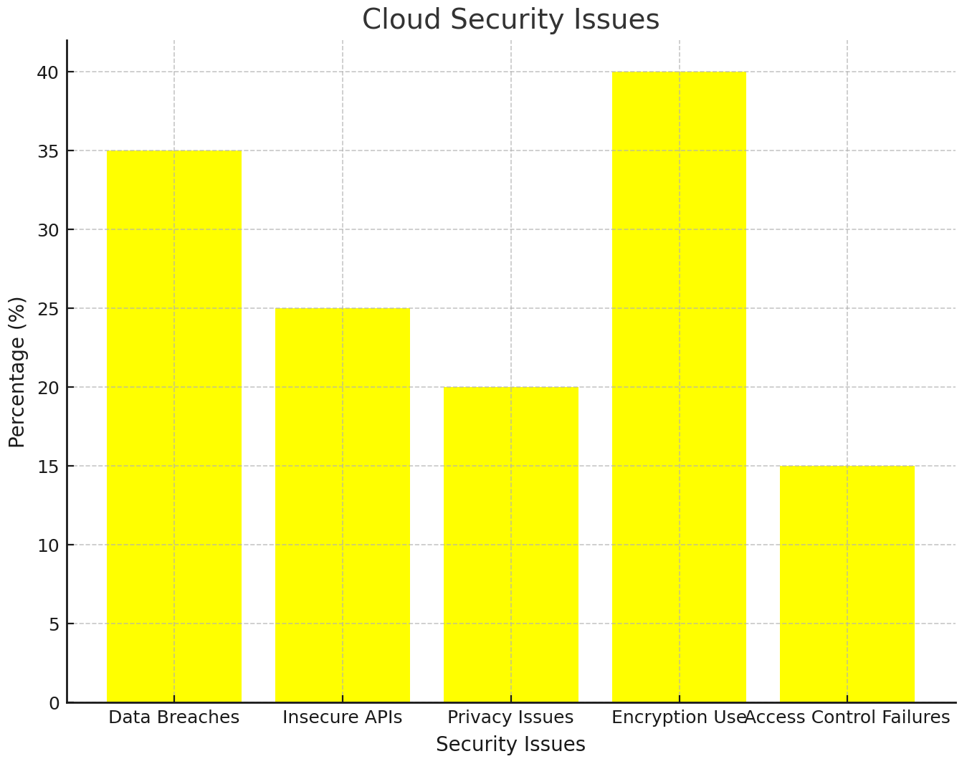

**4.3 suggested solutions**

**Hybrid encryption strategies:** combine different strategies to ensure stability, safety, and overall performance.

**more potent API management:** Use automatic equipment to come across and connect vulnerabilities in actual-time.

**Unified safety frameworks:** integrate a couple of safety practices to simplify management.

**privacy-maintaining Computation:** Use techniques like differential privateness to research records without exposing personal facts.

**Zero Trust Architecture:** Implement a zero trust approach where no entity, inside or outside the network, is trusted by default. Continuous verification and strict Access controls help prevent unauthorised access.

**AI-Driven Threat Detection:** artificial intelligence and machine learning to identify abnormal behaviour, detect threats in real-time, and respond faster to potential security breaches.

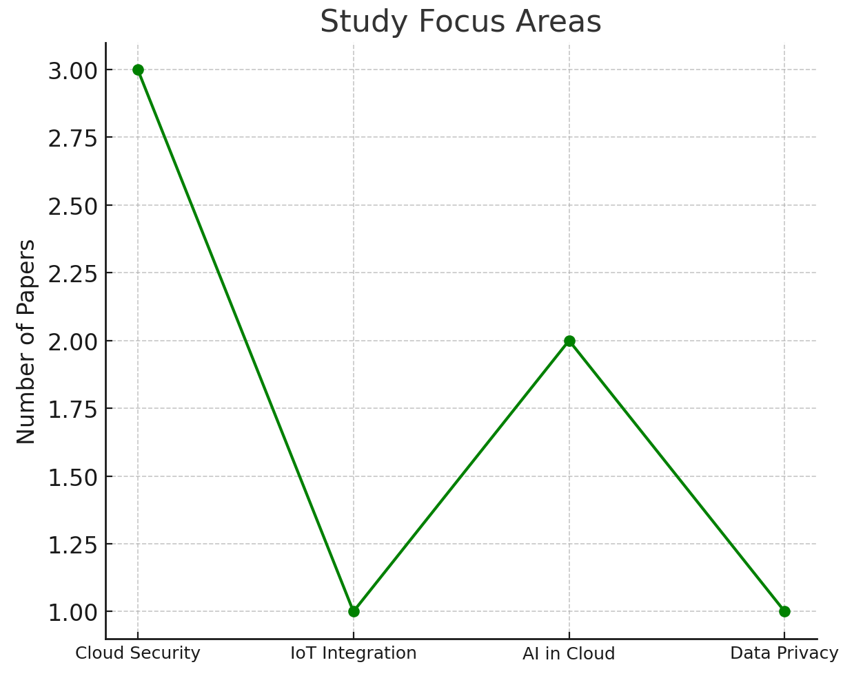

**4.4 Research Methodologies**

**Qualitative evaluation** critiques existing research to endorse new fashions and frameworks.

**Experimental studies:** tests new solutions in real-world eventualities to see what works.

**4.5 Contributions**

All papers stress that cloud safety and privacy are vital for enormous cloud adoption. At the same time as current answers like encryption and getting admission to manipulate are effective, demanding situations like scalability and fee nonetheless want greater interest.

**conclusion of Comparative analysis**

Despite the progress made in cloud protection, massive issues continue to be regarding affordability, scalability, and privacy. Future studies ought to recognise growing solutions that are not at best more fee-powerful but additionally scalable, ensuring that cloud generation stays and is available to everybody, from individuals to big enterprises.

**4.5 Comparative Table**

| **Comparison Point** | **Paper1** | **Paper2** | **Paper3** | **Paper4** | **Paper5** |
| --- | --- | --- | --- | --- | --- |
| Primary Focus | Data security challenges and encryption methods for protecting cloud data. | Using Attribute-Based Encryption (ABE) to provide more secure and flexible data access in the cloud. | Addressing API security vulnerabilities and proposing better management practices. | Strengthening API security, using better encryption methods, regular backups, and improved key management to protect data. | Exploring Role-Based and Attribute-Based Access Control (RBAC and ABAC) models to manage permissions. |
| Key Strengths | Proposes a hybrid encryption model to enhance security without major performance hits. | Offers fine-grained data access control using ABE, ideal for sensitive data environments like healthcare. | Comprehensive solution for API security, including monitoring tools and secure gateways. | Combines different access control models to make cloud security more flexible and adaptable. | Innovative techniques for maintaining privacy, even when handling sensitive data in real-time. |
| Major Challenge | Scalability issues—encryption can slow down systems when dealing with large data volumes | High complexity in setting up ABE and difficulty in practical implementation. | Misconfigured APIs can still create security gaps; continuous monitoring is required. | Managing and integrating different policies can become too complex, leading to potential gaps. | Balancing privacy with usability—some privacy techniques can reduce the effectiveness of data use. |
| Proposed Solutions | Hybrid encryption to balance security and performance. | ABE combined with other encryption methods to optimize security and ease of use. | Automated tools for continuous API monitoring and secure API gateways. | Combining RBAC and ABAC for flexible access control while minimizing human error. | Use of differential privacy and zero-knowledge proofs for better privacy without compromising data utility. |
| Approaches to Data Encryption and Message Authentication | Introduces a scalable, cost-effective hybrid encryption approach suitable for cloud applications. | Demonstrates how ABE can provide detailed control over data access, with real-world applications in mind. | Focuses on securing the "gateways" of cloud applications—APIs—to reduce vulnerabilities. | Proposes an innovative way to merge different access control models for improved security. | Pioneers new privacy-preserving techniques, making cloud data handling safer without compromising utility. |

**5. Review of Identified Problems and Suggested Solutions**

| **Sr. No.** | **Paper Title** | **Identified Problems** | **Review and Suggested Solutions** |
| --- | --- | --- | --- |
| 1 | Data Security and Privacy Issues in Cloud Computing | Issues like API security vulnerabilities, unintended data leaks, code injection attacks, and service disruptions like DoS attacks. | Strengthening API security, using better encryption methods, regular backups, and improved key management to protect data. |
| 2 | Cloud Delivery Models and Security Challenges | Risk of data breaches, weak encryption practices, insider attacks, and problems with shared multi-tenant environments. | Implementing strong encryption, better authentication practices, and backup solutions to safeguard sensitive data. |
| 3 | Privacy and Security in Multi-Tenant Cloud Environments | Unauthorized access due to shared resources, weak API security, and threats from internal users. | Using strict access controls, encrypting sensitive data, and enforcing regular backups to minimize risks. |
| 4 | Multi-Level Security Classification Models in the Cloud | Gaps in risk assessment, internal attacks, and other security weaknesses across cloud layers. | Adopting multi-layer encryption, dynamic security protocols, and robust authentication processes to enhance protection. |
| 5 | Approaches to Data Encryption and Message Authentication | Insufficient encryption and weak data integrity checks, making cloud communication vulnerable. | Introducing more advanced encryption techniques like attribute-based encryption, better key management, and stronger message authentication. |

**6. Limitations of the Current Research**

While important insights have been obtained, the present studies concerning cloud protection exhibit several notable shortcomings.

**6.1 Methodological limitations**

**slim focus:** Many research efforts delve into specific challenges like encryption or API security, but they often omit the critical aspect of how these solutions should work synergistically across the entire cloud ecosystem.

**short-term angle:** Most studies primarily focus on present-day protection challenges, overlooking the possible changes that may arise as we move deeper into the cloud era.

**Small Samples:** Some investigations adopt constrained case examples, resulting in uncertainty about whether their conclusions are relevant across a range of systems and industries.

**lack of quantitative facts:** While discussions are plentiful, there is a clear lack of robust data to confirm the effectiveness of the solutions that have been proposed.

**6.2 Contextual limitations**

**Geographic Bias:** most studies are focused on evolved regions, neglecting how those answers might work in regions with extraordinary infrastructure or fewer assets.

**Speedy Tech Evolution:** With cloud technology advancing fast, a few advised solutions can also come to be outdated earlier than they’re even applied.

**lack of prison insight:** Little interest is given to how global legal guidelines or rules affect cloud security.

**6.3 Theoretical obstacles**

**Overly Technical:** research regularly dives deep into technical solutions but misses the social, economic, and moral context of cloud protection.

**ethical Gaps:** statistics privateness is cited; however, broader ethical duties of cloud providers are not explored.

**No clear future roadmap:** Many papers don’t outline future research paths, lacking opportunities to construct on contemporary information.

**6.4 Gaps in research**

**Integration of answers:** There’s little study on a way to mixture extraordinary safety features into a cohesive, clean-to-put-in-effect framework.

**user interaction:** Few studies explore how customers sincerely interact with those safety tools, which is essential to ensuring proper adoption.

**effect of rising tech:** constrained studies on how AI, IoT, and different new technologies impact cloud security and what new dangers they bring.

End at the same time as the studies have superior our understanding of cloud security, there’s nonetheless a long way to go. Addressing these gaps with more complete, lengthy-time period research that encompasses ethical, social, and worldwide views may be key to developing more potent, extra adaptable cloud safety solutions.

**7. Conclusion**

In summary, even as these 5 papers offer strong insights into cloud protection, they fall quickly in addressing the total spectrum of challenges. The study has a tendency to focus closely on technical factors and lacks a broader, long-term view, lacking vital considerations like person behaviour, emerging technologies, and ethical concerns. Moving forward, integrating more comprehensive, real-world eventualities and growing adaptable, destiny-evidence answers will be key to retaining cloud environments comfortable as technology maintains to conform.

**8. References**

Mohamad, N.H., Saidin, N.B., & Zaidi, M.I.H. (2023). Data Security and Privacy Issues in Cloud Computing: Challenges and Solutions Review. Tec. <https://doi.org/10.36227/techrxiv.170327865.59737799>

Kumar, D., Rao, A.K., Kumar, S., & Varshney, N. (2024). A Study on the Security Models and Strategies of Cloud Computing. ICIPTM. <https://doi.org/10.1109/ICIPTM59628.2024.10563634>

Sun, P. (2020). Security and Privacy Protection in Cloud Computing: Discussions and Challenges. Journal of Network and Computer Applications, 160,102642. <https://doi.org/10.1016/j.jnca.2020.102642>

Parikh, S., Dave, D., Patel, R., & Doshi, N. (2021). Security and Privacy Issues in Cloud, Fog, and Edge Computing. Procedia Computer Science,160,734–739. <https://doi.org/10.1016/j.procs.2019.11.018>

Bokhari, M.U., Shallal, Q.M., & Tamandani, Y.K. (2020). Security and Privacy Issues in Cloud Computing. INDIACom,896-900. <https://doi.org/10.1109/INDIACOM.2016.7724374>