# Enhancing Cloud Security: Safeguarding Data and Privacy

**Institution: Poornima Institute of Engineering and Technology, Jaipur, Rajasthan, India**

Ramnarayan Sharma Prof. Priya Mathur

Student Assistant Professor

B. Tech. Student Dept. of Computer Science, Computer Science and Engineering,

Poornima Institute of Engineering and Poornima Institute of Engineering and

Technology, Jaipur, Rajasthan, India Technology, Jaipur, Rajasthan, India

Email: [2021pietcaramnarayan045@poornima.org](mailto:2021pietcspranay127@poornima.org) Email: <priya.mathur@poornima.org>

# Abstract

Cloud computing offers remarkable flexibility and cost efficiency; however, it also introduces considerable security and privacy issues. This paper examines recent studies to underscore critical challenges, including data breaches, insecure application programming interfaces (APIs), and weaknesses in virtual machines. Researchers propose solutions such as improved encryption methods, more secure APIs, and innovative security frameworks tailored for cloud environments. Although advancements have been achieved, significant gaps remain—particularly in the pursuit of affordable and scalable solutions that are universally applicable. In conclusion, while cloud security is advancing, further efforts are necessary to address existing vulnerabilities.

# Introduction

## History of Cloud Computing

Cloud computing has revolutionized the methods by which we store, access, and manage data, enabling organizations of all sizes—from emerging startups to established corporations—to expand swiftly without the necessity for physical infrastructure. Nevertheless, this convenience is accompanied by significant concerns regarding data security and privacy. As an increasing amount of sensitive information is transferred to the cloud, the potential for breaches and cyberattacks escalates, prompting essential inquiries: Is our data genuinely secure? What are the implications if a failure occurs?

## Significance of Security and Privacy in Cloud Computing

The protection of data in the cloud has become increasingly vital. Recent cyberattacks have shown that even advanced systems are susceptible to breaches, highlighting security as a critical issue for both technology and the broader business and societal landscape. For organizations, a data breach can incur substantial financial repercussions and damage their reputation. For individuals, it poses personal and financial threats. As the adoption of cloud services expands, safeguarding our data has emerged as a paramount concern. Scope and targets of the evaluate

This evaluation focuses on five recent studies that tackle significant issues related to cloud security and privacy, including vulnerabilities in APIs and data protection during migration processes. It emphasizes strategies such as encryption, risk management, and privacy-preserving technologies to address these concerns.

# Methodology

## Research Approach

This evaluation analyses five key studies papers along with other relevant literature on cloud safety and privacy. The chosen studies show diverse challenges and

answers in cloud technology, with a focus on not unusual vulnerabilities and strategies to address them. The goal is to give a clean image of the contemporary advancements and highlight areas that need more studies.

## Sources of Data and Criteria for Selection

The selected papers were sourced from reputable platforms such as IEEE Xplore, ScienceDirect, and the ACM Digital Library. Emphasis was placed on recent publications and those with significant citation counts to guarantee that the research is current and influential, highlighting credible contributions from esteemed authors..

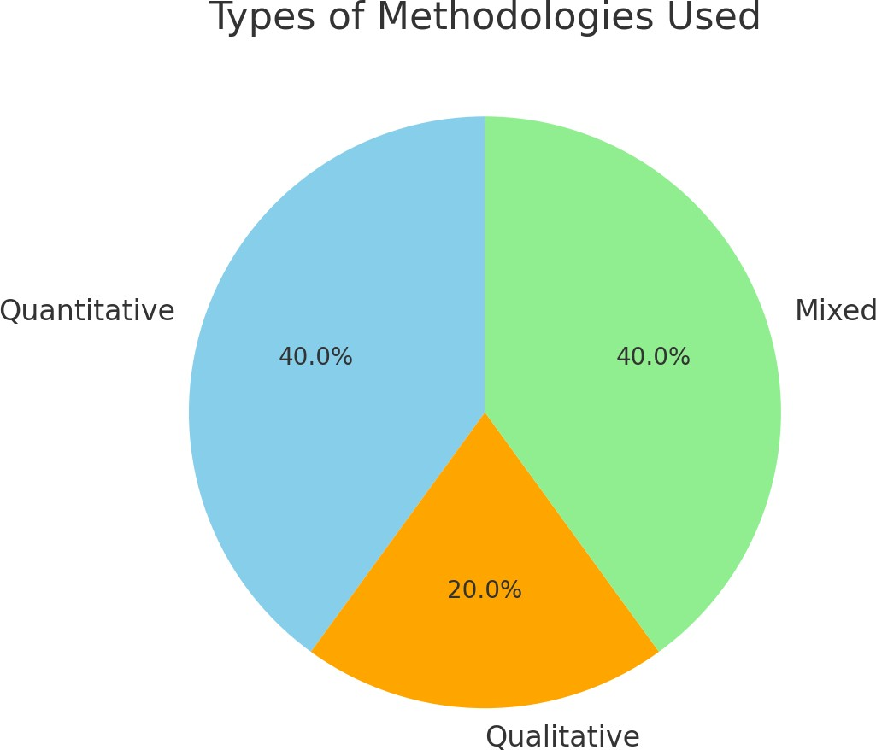

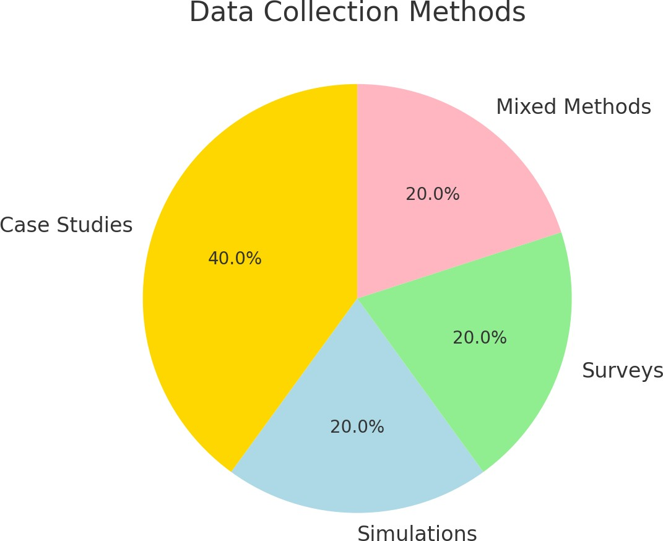 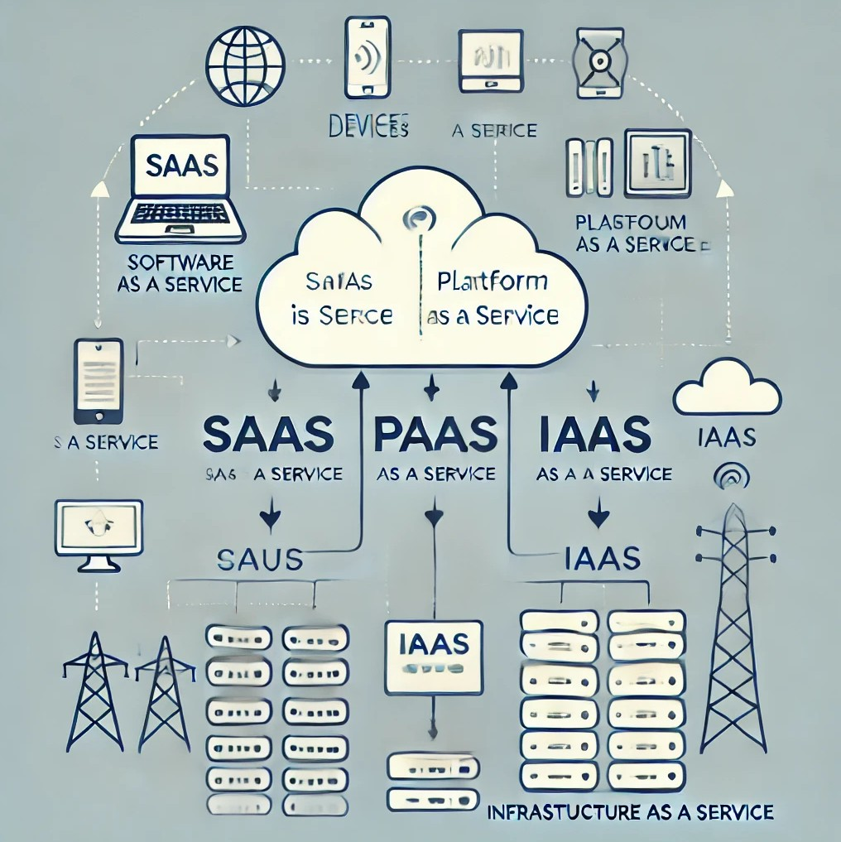

# Literature Review

## Encryption strategies

Encryption serves as a powerful tool for cloud security, safeguarding information with such rigor that only the appropriate key can unlock it. Advanced methods such as attribute-based encryption (ABE) and homomorphic encryption enable cloud service providers to manage data without directly accessing its content. However, this approach presents a challenge; while encryption effectively protects data, it may also introduce delays, hindering prompt access to projects..

## API security

APIs serve as the essential links between cloud services; however, they can also represent potential vulnerabilities if not properly secured. Consider them akin to waitstaff in a restaurant—if they are not adequately trained, there is a risk of errors in fulfilling your requests. Therefore, implementing strong API security measures, such as authentication and encryption, is crucial. Nevertheless, improper configurations may inadvertently create opportunities for cybercriminals, making continuous monitoring imperative..

## Access Control

Access Control grants only the right people access to the right data. Some of the most popular models include RBAC (Role-Based Access Control) and ABAC (Attribute-Based Access Control). The problem is that it is difficult to configure these settings, and one little mistake can grant too much access to someone.

## Secure Cloud Garage

Cloud storage isn’t pretty much saving files; it’s about securing them properly. Techniques like records sharding and dual encryption break down and defend files across more than one location, making it difficult for hackers to piece them together. But coping with encryption keys may be complicated—lose a key, and your facts’ locked away all the time!

## other safety packages

Intrusion detection systems (IDS) act like protection cameras to your cloud, watching for suspicious hobbies, while protocols like TLS and SSL defend records in the course of transfers, like the use of an armoured automobile for valuables. Privateness-preserving strategies like differential privateness ensure you can analyse facts without exposing non-public info.

## conclusion

There’s no person-size-fits-all approach to cloud protection. Each method—whether or not it’s encryption, API security, or getting admission to manage—has its pros and cons. The secret's locating the proper mix of technology and practices to create a safer, extra-reliable cloud environment.

# Comparative Study

## application areas

**statistics Encryption:** techniques like characteristic-based total Encryption (ABE) and homomorphic encryption guard cloud statistics, but they can impact performance. ABE controls get admission based on person attributes, even as homomorphic encryption allows computations without revealing records.

**API protection:** robust authentication and encryption are critical to save you API attacks. Papers recommend at ease key management and constant tracking to hold APIs safe.

Access Control Models: Role-Based and attribute-based Access Control (RBAC/ABAC) help limit who can access what, reducing the risk of data breaches.

## Identified Challenges

**Scalability & performance:** Encryption can slow down real-time processing, making it tough for larger systems to scale.

**API Vulnerabilities:** Misconfigured APIs are a commonplace weak spot in cloud security.

**Statistics privateness:** making sure sensitive records, like fitness facts, stay non-public during storage and transmission is a first-rate challenge.

**cost:** imposing robust safety features may be costly, developing a barrier for smaller groups.

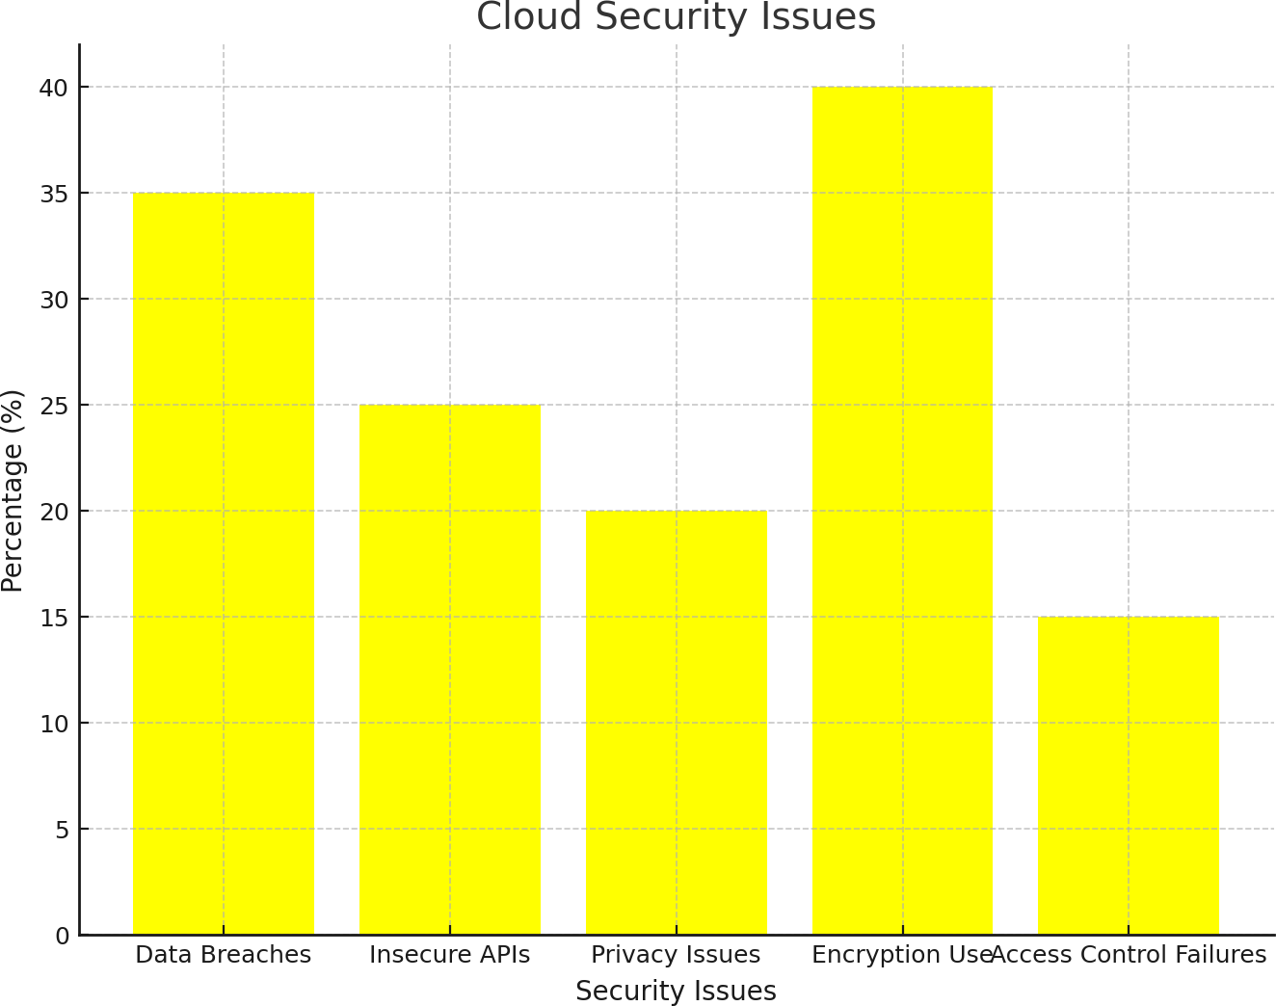

## suggested solutions

**Hybrid encryption strategies:** combine different strategies to ensure stability, safety, and overall performance.

**more potent API management:** Use automatic equipment to come across and connect vulnerabilities in actual-time.

**Unified safety frameworks:** integrate a couple of safety practices to simplify management.

**privacy-maintaining Computation:** Use techniques like differential privateness to research records without exposing personal facts.

**Zero Trust Architecture:** Implement a zero trust approach where no entity, inside or outside the network, is trusted by default. Continuous verification and strict

Access controls help prevent unauthorised access.

**AI-Driven Threat Detection:** artificial intelligence and machine learning to identify abnormal behaviour, detect threats in real-time, and respond faster to potential security breaches.

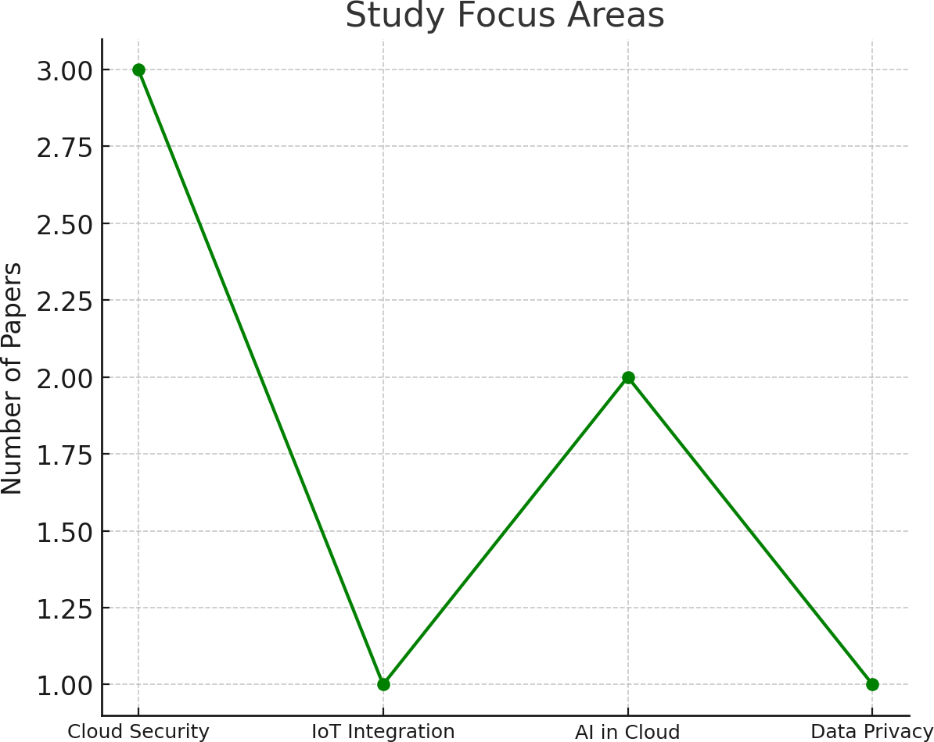

## Research Methodologies

**Qualitative evaluation** critiques existing research to endorse new fashions and frameworks.

**Experimental studies:** tests new solutions in real-world eventualities to see what works.

## Contributions

All papers stress that cloud safety and privacy are vital for enormous cloud adoption. At the same time as current answers like encryption and getting admission to manipulate are effective, demanding situations like scalability and fee nonetheless want greater interest.

## conclusion of Comparative analysis

Despite the progress made in cloud protection, massive issues continue to be regarding affordability, scalability, and privacy. Future studies ought to recognise growing solutions that are not at best more fee-powerful but additionally scalable, ensuring that cloud generation stays and is available to everybody, from individuals to big enterprises.

# 4.5 Comparative Table

|  |  |  |  |  |  |
| --- | --- | --- | --- | --- | --- |
| **Comparison**  **Point** | **Paper1** | **Paper2** | **Paper3** | **Paper4** | **Paper5** |
| Primary Focus | Data security challenges and encryption methods for protecting  cloud data. | Using  Attribute-Based Encryption (ABE) to  provide more secure and flexible data access in the cloud. | Addressing API security vulnerabilities  and proposing better management practices. | Strengthening API security, using better encryption methods, regular backups, and improved key management to protect data. | Exploring  Role-Based and Attribute-Based Access Control (RBAC and  ABAC) models to manage permissions. |
| Key Strengths | Proposes a  hybrid  encryption model to  enhance security  without major performance hits. | Offers  fine-grained data access  control using ABE, ideal for sensitive data environments like healthcare. | Comprehensive  solution for API security, including monitoring tools and secure gateways. | Combines different access control models to make  cloud security more flexible and adaptable. | Innovative  techniques for maintaining privacy, even when handling  sensitive data in real-time. |
|  | Scalability | High  complexity in  setting up ABE and difficulty in practical implementation. | Misconfigured  APIs can still create security  gaps; continuous monitoring is required. | Managing and integrating different policies can become too complex, leading to potential gaps. | Balancing  privacy with usability—some privacy techniques can reduce the  effectiveness of data use. |
|  | issues—encryp |
| Major  Challenge | tion can slow  down systems when dealing |
|  | with large data |
|  | volumes |
|  |  | ABE combined | Automated tools |  | Use of |
| Proposed Solutions | Hybrid  encryption to balance  security and performance. | with other encryption methods to optimize  security and ease of use. | for continuous API monitoring and secure API gateways. | Combining RBAC and ABAC for flexible access  control while minimizing human error. | differential privacy and  zero-knowledge proofs for better privacy without compromising data utility. |
|  | Introduces a | Demonstrates how ABE can provide detailed control over data access,  with real-world applications in mind. | Focuses on securing the  "gateways" of cloud  applications—A PIs—to reduce vulnerabilities. | Proposes an innovative way to merge different  access control models for improved security. | Pioneers new privacy-preservi ng techniques, making cloud data handling  safer without compromising utility. |
|  | scalable, |
| Approaches to | cost-effective |
| Data | hybrid |
| Encryption | encryption |
| and Message | approach |
| Authentication | suitable for |
|  | cloud |
|  | applications. |

1. **Review of Identified Problems and Suggested Solutions**

|  |  |  |  |
| --- | --- | --- | --- |
| **Sr. No.** | **Paper Title** | **Identified Problems** | **Review and Suggested Solutions** |
| 1 | Data Security and Privacy Issues in Cloud Computing | Issues like API security vulnerabilities, unintended data leaks, code injection attacks, and service disruptions like DoS  attacks. | Strengthening API security, using better encryption methods, regular backups, and improved key management to protect data. |
| 2 | Cloud Delivery  Models and Security Challenges | Risk of data breaches,  weak encryption practices, insider attacks, and problems with shared multi-tenant environments. | Implementing strong encryption, better authentication practices,  and backup solutions to safeguard sensitive data. |
| 3 | Privacy and Security in Multi-Tenant Cloud Environments | Unauthorized access due to shared resources, weak API security, and threats from internal users. | Using strict access controls,  encrypting sensitive data, and enforcing regular backups to minimize risks. |
| 4 | Multi-Level Security Classification Models in the Cloud | Gaps in risk assessment, internal attacks, and other security weaknesses across cloud layers. | Adopting multi-layer encryption, dynamic security protocols, and robust authentication processes to enhance protection. |
| 5 | Approaches to Data Encryption and  Message  Authentication | Insufficient encryption and weak data integrity checks, making cloud  communication vulnerable. | Introducing more advanced encryption techniques like  attribute-based encryption, better key management, and stronger message authentication. |

# Limitations of the Current Research

despite treasured insights, the current studies on cloud protection has a few terrific boundaries:

## Methodological limitations

**slim focus:** Many studies 0 in on unique issues like encryption or API safety, however leave out how those solutions ought to work together across the complete cloud ecosystem.

**short-term angle:** most research addresses present-day protection challenges without thinking about how these might evolve as cloud era advances.

**Small Samples:** some research use constrained case examples, making it uncertain if their findings are observed across distinctive systems and industries.

**lack of Quantitative facts:** whilst there’s loads of discussion, there’s a scarcity of tough numbers to prove the effectiveness of proposed solutions.

## Contextual limitations

**Geographic Bias:** most studies are focused on evolved regions, neglecting how those answers might work in regions with extraordinary infrastructure or fewer assets.

**Speedy Tech Evolution:** With cloud technology advancing fast, a few advised solutions can also come to be outdated earlier than they’re even applied.

**lack of prison insight:** Little interest is given to how global legal guidelines or rules affect cloud security.

## Theoretical obstacles

**Overly Technical:** research regularly dives deep into technical solutions but misses the social, economic, and moral context of cloud protection.

**ethical Gaps:** statistics privateness is cited, however broader ethical duties of cloud providers are not explored.

**No clear future Roadmap:** Many papers don’t outline future research paths, lacking opportunities to construct on contemporary information.

## Gaps in research

**Integration of answers:** There’s little studies on a way to mixture extraordinary safety features into a cohesive, clean-to-put into effect framework.

**user interaction:** Few studies explore how customers sincerely interact with those safety tools, that is essential to ensuring proper adoption.

**effect of rising Tech:** constrained studies on how AI, IoT, and different new

technology impact cloud security and what new dangers they bring.

End at the same time as the studies have superior our understanding of cloud security, there’s nonetheless a long manner to head. Addressing these gaps with more complete, lengthy-time period research that encompass ethical, social, and worldwide views may be key to developing more potent, extra adaptable cloud safety solutions.

# Conclusion

In summary, even as these 5 papers offer strong insights into cloud protection, they fall quickly in addressing the total spectrum of challenges. The study has a tendency to awareness closely on technical factors and lacks a broader, long-time period view, lacking vital considerations like person behaviour, emerging technologies, and ethical concerns. Moving forward, integrating more comprehensive, real-world eventualities and growing adaptable, destiny-evidence answers will be key to retaining cloud environments comfortable as technology maintains to conform.

# References

Mohamad, N.H., Saidin, N.B., & Zaidi, M.I.H. (2023). Data Security and Privacy Issues in Cloud

Computing: Challenges and Solutions Review. Tec.

[https://doi.org/10.36227/techrxiv.1703](https://doi.org/10.36227/techrxiv.170327865.59737799) [27865.59737799](https://doi.org/10.36227/techrxiv.170327865.59737799)

Kumar, D., Rao, A.K., Kumar, S., & Varshney, N. (2024). A Study on the Security Models and Strategies of Cloud Computing. ICIPTM. [https://doi.org/10.1109/ICIPTM59628.](https://doi.org/10.1109/ICIPTM59628.2024.10563634) [2024.10563634](https://doi.org/10.1109/ICIPTM59628.2024.10563634)

Sun, P. (2020). Security and Privacy Protection in Cloud Computing: Discussions and Challenges. Journal of Network and Computer Applications, 160,102642.

[https://doi.org/10.1016/j.jnca.2020.102](https://doi.org/10.1016/j.jnca.2020.102642) [642](https://doi.org/10.1016/j.jnca.2020.102642)

Parikh, S., Dave, D., Patel, R., & Doshi, N. (2021). Security and Privacy Issues in Cloud, Fog, and Edge Computing. Procedia Computer Science,160,734–739. [https://doi.org/10.1016/j.procs.2019.11](https://doi.org/10.1016/j.procs.2019.11.018)

[.018](https://doi.org/10.1016/j.procs.2019.11.018)

Bokhari, M.U., Shallal, Q.M., & Tamandani, Y.K. (2020). Security and Privacy Issues in Cloud Computing. INDIACom,896-900.

[https://doi.org/10.1109/INDIACOM.20](https://doi.org/10.1109/INDIACOM.2016.7724374) [16.7724374](https://doi.org/10.1109/INDIACOM.2016.7724374)