A Study On Recommended System Using Artificial Intelligence

Yash Dosaya1, Ms. Chanchal Tiwari2

Poornima Institute of Engineering and Technology, Jaipur

[2021pietadyash059@poornima.org](mailto:2021pietadyash059@poornima.org) , [chanchal.tiwari@poornima.org](mailto:chanchal.tiwari@poornima.org)

***Abstract:***

Modern information and e-commerce platforms cannot work without recommender systems, which tailor content recommendations to improve user   
encounters. This study offers a thorough examination of the planning, creation, and evaluation of an artificial intelligence  recommendation system. We start by looking at current recommender system approaches, addressing the drawbacks and restrictions of conventional methods. Next, we present a cutting-edge AI-driven recommendation system that combines sophisticated machine learning techniques like content-based filtering, collaborative filtering, and deep learning algorithms. This study adds to the current conversation around the development of recommendation systems in the AI era by pointing out the advantages and disadvantages of putting them into practice.

***Keywords:*** *Artificial Intelligence (AI), E-commerce, Methodologies, Deep learning algorithms, content-based filtering, collaborative filtering, Design, development, evaluation, Digital age.*

**Introduction**

In today’s digital landscape, you’ve probably noticed how websites and apps suggest movies, products, articles, and music that seem tailored just for you. These smart suggestions come from "recommender systems," which have become a key part of how we interact with the internet. This research paper explores how these systems can be improved by teaming up with another powerful tool: artificial intelligence (AI). AI acts as the brain behind these systems, helping them learn and make more accurate recommendations. Think of them as digital friends who know your likes and dislikes, much like a friend who know your favourite books and recommends new ones. In the digital world, these systems sift through vast amounts of data to suggest things that match your interests, making your online experience smoother and more enjoyable.

As the digital world continues to evolve, recommender systems serve as essential tools, guiding you through the flood of content to discover what truly resonates with you. Our research aims to show how AI can enhance these systems, providing a more enriching online experience that helps you make the most of the vast digital universe.

Recommender systems, or recommendation engines, are designed to understand and predict user preferences. Their goal is to create a more personalized online journey, much like a friend who instinctively knows what you like in books, music, movies, or products. These systems are versatile and cater to various needs, whether recommending your next favourite series, helping you find the perfect product, showing articles that match your interests, or curating music for your mood. What makes recommender systems remarkable is their ability to adapt to different domains and user preferences. Collaborative filtering, content-based filtering, and hybrid systems are the most popular varieties of recommender systems; each has a distinct function.

**2. How Recommendation System Works?**

Recommendation systems gather and evaluate user information to offer tailored suggestions.

These systems primarily rely on two types of data:

1. **Implicit Data**: This refers to information that is gathered without direct input from the user, such as browsing history, search patterns, and past purchase behaviour. It helps the system infer a user's preferences based on their actions.
2. **Explicit Data**: This includes information that users directly provide, such as ratings, reviews, and preferences. This data gives the system a clearer understanding of a user's likes and dislikes.

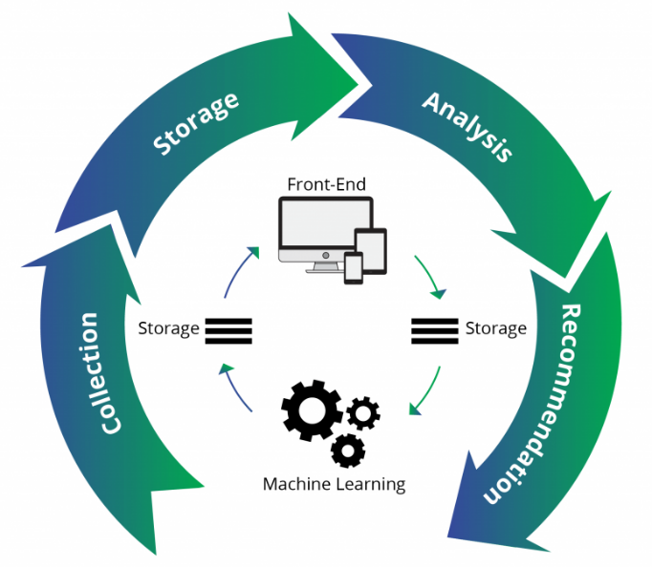

**Figure 1. Recommendation system**

**2.1 Data Collection**

Recommendation systems rely on collecting two main types of data: **explicit data**, which includes user ratings and feedback such as comments, and **implicit data**, which consists of actions like page views, search history, and purchase behaviour.

**2.2 Data Storage**

The choice of data storage should be aligned with the nature of the data being collected. Options include NoSQL databases, object storage systems, and traditional SQL databases, each offering different strengths based on the type and volume of data.

**2.3 Data Analysis**

In the analysis phase, the recommendation system examines the collected data to identify patterns in user behaviour. It looks for items that exhibit similar user engagement, helping to predict what the user may like next.

**2.4 Data Filtering**

The final phase involves filtering the data to extract the most relevant information needed for personalized recommendations. This step requires choosing the right algorithm that best matches the specific requirements of the recommendation system, ensuring effective and accurate suggestions.

1. **Types Of Recommendation System**

Recommendation systems come in various forms, tailored to different needs and scenarios. Here are some of the primary types:

* 1. **Collaborative Filtering :**

Recommendation systems use a technique called collaborative filtering, which analyzes user behavior and feedback to forecast a user's preferences. The fundamental idea is predicated on the idea that users who have previously shared preferences are likely to do so in the future. Collaborative filtering helps customize personalized suggestions by seeing trends in the interactions of users with similar interests. This improves the user experience by recommending products or content that suit the user's tastes.

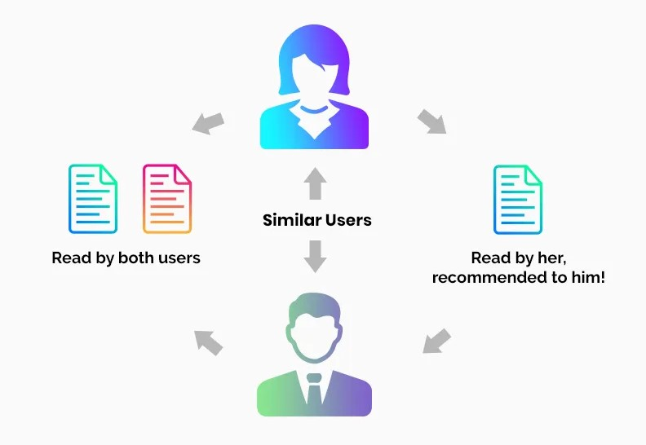

**Figure 2. Collaborative Filtering**

3.1.1 Collaborative Filtering consists of two

categories:

* **User-Based Collaborative Filtering (UBCF):**By finding users who exhibit similar interests and behaviors to the target user, User-Based Collaborative Filtering (UBCF) produces recommendations. The fundamental idea is that people are likely to have similar tastes in the future if they have previously interacted with or enjoyed similar things. The procedure entails determining a neighborhood—a collection of users who are similar to one another—and suggesting products that are well-liked by that neighborhood. By using the collective preferences of users with similar tastes, this method personalizes recommendations.
* **Item-Based Collaborative Filtering (IBCF):**The goal of item-based collaborative filtering, or IBCF, is to suggest products that are comparable to those that the target user has previously expressed interest in. The fundamental premise is that if a user likes a certain product, they will probably like related products as well. This technique computes similarity ratings between items and then suggests items that have traits in common with those the user has enjoyed or interacted with in the past. IBCF makes sure that the user gets recommendations based on their previously shown item preferences by analyzing item relationships.
  1. **Content-Based Filtering :**

Many online retailers now provide a wide range of goods to suit different user types. Customers have different tastes, therefore it's critical to present products that suit them when they visit the store.

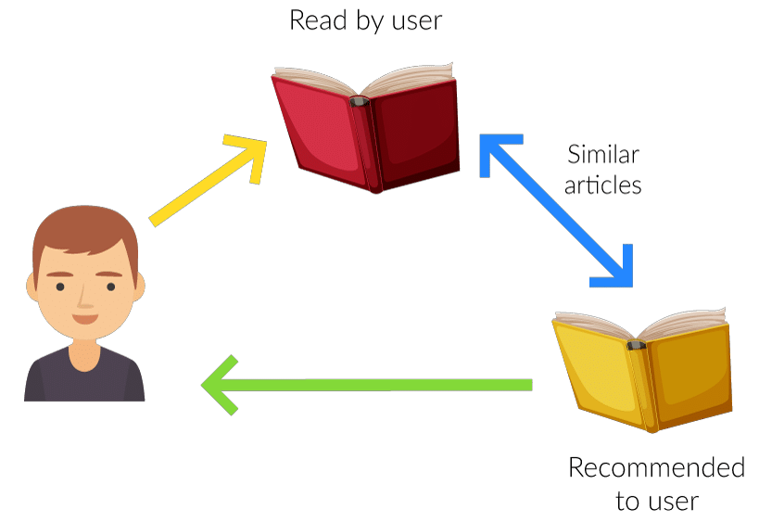

**Figure 3. Content Based Filtering**

**METHODOLOGY :**

"We introduce a content-based recommender system designed specifically to suggest pertinent content for online retailers. A visual representation of the suggested system's architecture is provided.

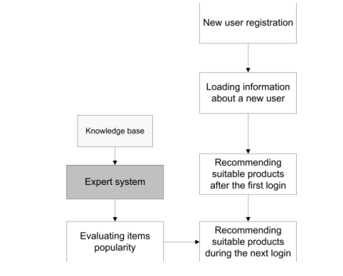 **Figure 4. Structure of the proposed system**

1. **Loading Information about a New User:**

* Important information is recorded when a new user is established, including birthdate, login credentials, favorite product categories, and personal information (first and last name).

**B. Recommending Suitable Products after the First Login:**

**C. Recommending Suitable Products (Collaborative Filtering):**

• The algorithm takes the following actions to take advantage of user similarity:   
o Finding users who have at least one documented item view and the same birth year.   
o Developing a vector of these users' favored categories.   
Finding the resemblance between users.   
Users with similarity scores of 0 or less are excluded.   
o Choosing products that have been viewed by comparable users and sorted by categories that are pertinent to the new user.   
o Making suggestions by classifying items according to how frequently they occur.

**D. Evaluating the Popularity of Items using an Expert System:**

The following criteria are used by the expert system assess item popularity:

* The objects' viewing time.   
  o How frequently items are seen.   
  o the quantity of things the user has viewed from the same category.   
  o the evaluation is guided by linguistic rules; for instance, a brief viewing duration, a restricted number of views, and a lesser number of items watched within the same category may indicate a lower item's popularity.

Based on user interactions, this expert system assesses item popularity using linguistic variables created with the Linguistic Fuzzy Logic Controller tool.

* 1. **Hybrid Based Filtering :**

According to recent studies, a hybrid strategy may work very well in several situations. Both content-based and collaborative filtering are used in information filtering systems, and each has unique benefits and drawbacks. A hybrid approach's primary goal is to enhance the precision and applicability of suggestions by combining the advantages of content-based and collaborative filtering strategies. By combining the two approaches, the hybrid strategy seeks to address the drawbacks of each method separately and give users more individualized and trustworthy recommendations.

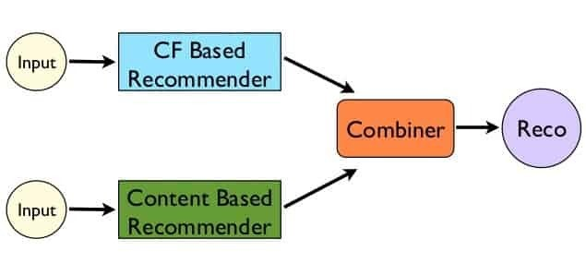

**Figure 5. Hybrid based Filtering**

• **Combining predictions**: For a more precise suggestion, content-based and collaborative approaches can be used independently and their predictions.   
•**Including content-based features in collaborative techniques:** To improve the suggestions, content attributes might be used in a collaborative filtering strategy.   
• **Including collaborative elements in content-based approaches:** A content-based strategy can be improved by adding collaborative.

• **Comprehensive models**: To capitalize on the advantages of both strategies, a single model that incorporates collaborative and content-based elements can be created.   
The cold start problem, which occurs when there is not enough data for new users or items, and data sparsity, which occurs when user-item interaction data is scarce, are two problems that hybrid approaches are very good at solving. Netflix is a great example of a hybrid recommender system since it mixes content-based filtering (by proposing movies with comparable features to highly-rated films) with collaborative filtering (by comparing the viewing patterns of similar users).   
Netflix challenged researchers to increase the accuracy of its recommendation algorithm, Cinematch, by releasing a dataset of about 100 million anonymous movie evaluations in 2006. The collection had dates and movie release years, along with ratings on a scale of 1 to 5, but it lacked user-specific data. Using a qualifying dataset with more than 281,000 unknown ratings, researchers were tasked with enhancing the system's accuracy as measured by the root mean squared error (RMSE). The winning team, which received a $1,000,000 prize, increased accuracy by 10% out of the 20,000 teams who registered and the 2,000 solutions that were submitted.   
Although it became harder to make further accuracy gains once RMSE exceeded a specific level, the competition's insights highlighted the value of ensemble approaches in enhancing prediction accuracy. Furthermore, the dataset offered insightful information.  
  
**4. Here are examples of companies that use recommendation engines to enhance user experiences:**

1.**Netflix:** Using a recommendation algorithm that examines customers' viewing interests and history, Netflix provides personalized content recommendations for films and TV series.   
2. **Spotify:** To guarantee that users get music that suits their tastes, Spotify uses a recommendation engine that generates customized playlists and song choices based on users' listening histories.   
3. **YouTube:** To keep people interested in content they are likely to appreciate, YouTube uses an algorithm that suggests videos based on their viewing interests and history.   
4.**Amazon:** Bymaking product recommendations based on users' past browsing and purchase activity, Amazon's recommendation system helps customers locate items that are relevant to them and improves their shopping experience.   
5. **Google:** Considering consumers' online activity, Google employs a recommendation system to provide tailored search results and recommendations.

6. **Facebook:** Facebook utilizes a recommendation system to suggest friends, groups, and content by analyzing users' interactions and interests, making the social platform more engaging.

7. **LinkedIn:** LinkedIn includes features like "You may also know" or "You may also like," recommending connections, job postings, and content based on users' professional activities.



**Fig 6. Machine Learning Model**

|  |  |  |
| --- | --- | --- |
| **Platform** | **Recommendation System** | **Focus Area** |
| **Netflix** | **By analysing users' viewing history and preferences.** | **Tailored content** |
| **Spotify** | **Provides personalized playlists and music suggestions** | **Music discovery** |
| **YouTube** | **By analysing users' watch history and preferences.** | **Viewer engagement** |
| **Amazon** | **Suggests products based on users' browsing and purchase history.** | **Shopping experience** |
| **Google** | **Personalized search results and suggestions based on users' online activities and preferences.** | **Search experience refinement** |
| **Facebook** | **Recommends friends, groups, and content by analysing users' interactions and interests.** | **Social platform engagement** |
| **LinkedIn** | **Suggests connections, job postings, and content based on users' professional activities and interests.** | **Professional networking** |

These companies leverage recommendation engines to offer users personalized and relevant content or products, enhancing engagement and improving overall user satisfaction.

1. **Conclusion:**

In the evolving field of recommendation systems, various approaches are crucial in shaping user experiences across diverse platforms. Collaborative filtering and content-based filtering, each with its own strengths and challenges, have long been foundational. Recent developments, however, demonstrate the power of hybrid approaches that combine both methods, leveraging their individual advantages to improve recommendation accuracy. Examining industry leaders like Amazon, Netflix, and LinkedIn shows that integrating recommendation engines plays a key role in driving user engagement and satisfaction.

Looking ahead, the focus of research in recommendation systems should be on enhancing hybrid models, particularly with emerging technologies like machine learning and artificial intelligence. Insights from competitions such as the Netflix challenge underscore the importance of accuracy, user satisfaction, and the ongoing pursuit of refinement. As we continue to navigate the delicate balance between personalization and user privacy, recommendation systems will remain at the heart of user-centric platform evolution.

In conclusion, the journey of recommendation systems reveals a compelling intersection of technology, user behavior, and business strategy. At the crossroads of collaborative and content-based filtering, the future holds immense potential for further innovation, pushing the boundaries of personalization in the digital landscape.

**6.References:**

**[1]** B. Walek and P. Spackova, "Content-Based Recommender System for Online Stores Using Expert System," 2018 IEEE First International Conference on Artificial Intelligence and Knowledge Engineering (AIKE), Laguna Hills, CA, USA, 2018, pp. 164-165, doi: 10.1109/AIKE.2018.00036.

**[2]** Thorat, Poonam B., Rajeshwari M. Goudar, and Sunita Barve. "Survey on collaborative filtering, content-based filtering and hybrid recommendation system." International Journal of Computer Applications 110.4 (2015): 31-36.

**[3]** Laseno, Fransiska Utami Dewi, and Bayu Hendradjaya. "Knowledge-based filtering recommender system to propose design elements of serious game." 2019 International Conference on Electrical Engineering and Informatics (ICEEI). IEEE, 2019.

**[4]** V. Mandalapu, L. Elluri, P. Vyas and N. Roy, "Crime Prediction Using Machine Learning and Deep Learning: A Systematic Review and Future Directions," in IEEE Access, vol. 11, pp. 60153-60170, 2023, doi: 10.1109/ACCESS.2023.3286344.

**[5]** Q. Umer, J. -W. Li, M. R. Ashraf, R. N. Bashir and H. Ghous, "Ensemble Deep Learning-Based Prediction of Fraudulent Cryptocurrency Transactions," in *IEEE Access*, vol. 11, pp. 95213-95224, 2023, doi: 10.1109/ACCESS.2023.3310576.