A Comparative Analysis of Algorithmic Defenses Against New Threats in Cloud Security

**Akshay Kumar Goyal1**

Student

Computer Science and Engineering (AI)

Poornima Institute of Engineering and Technology,

Jaipur, Rajasthan,

Email Id: 2021pietcaakshay008@poornima.org

**Ms. Bhawana Purohit2**

Assistant Professor

Artificial Intelligence and Data Science

Poornima Institute of Engineering and Technology,

Jaipur, Rajasthan, India

**Email Id:** bhawana.purohit@poornima.org

***Abstract:*** Cloud computing, which offers unparalleled scalability, flexibility, and cost-effectiveness, has radically changed the IT environment. However, this paradigm change has also created a number of new security issues since cloud-based systems are inherently more vulnerable to intrusions. To overcome these issues, researchers have created a variety of algorithmic solutions, each of which is especially made to thwart certain security threats. This study presents a thorough examination of the benefits, drawbacks, and applicability of these algorithmic techniques for thwarting emerging threats in the cloud computing domain.

The most frequent security issues in cloud computing, such as malware infections, denial-of-service attacks, insider threats, and unauthorized access, are covered first. Next, we offer a taxonomy of algorithmic solutions, classifying them based on the security issues they seek to address and their guiding principles. We next provide a detailed evaluation of these algorithms, evaluating their effectiveness, performance, and adaptability in addressing real-world cloud security problems.

Our research indicates that algorithmic methods offer a workable way to lower the risks related to cloud security. The effectiveness of these solutions, however, depends on the particular danger being addressed and the cloud context in which they are implemented. We emphasize that a thorough security approach that integrates several algorithmic solutions is essential to achieving a robust defense against the dynamic threat landscape..

This article is a great resource for cloud security practitioners, researchers, and specialists who wish to understand and apply algorithmic techniques to protect cloud-based systems. It provides insights into the benefits and drawbacks of various algorithms, enabling educated decision-making and the selection of appropriate defenses against specific security threats.

**Keywords**: Cloud-based software, comparative analysis, new threats, safety issues, and countermeasures

**I. INTRODUCTION**

Because cloud computing offers businesses previously unheard-of levels of scalability, flexibility, and affordability in their computing resources, it has fundamentally altered the IT environment. This paradigm change has enabled organizations to achieve unprecedented levels of efficiency and creativity by enabling them to operate with agility and a competitive edge [1]. Cloud-based systems are by definition more vulnerable to assaults, therefore this shift has resulted in a complex array of new security challenges. Because of the ever-evolving threat landscape, sensitive data handled and kept in cloud systems is extremely susceptible to availability, confidentiality, and integrity threats.

Scientists have set out to develop a variety of algorithmic solutions to address these problems, each meticulously crafted to mitigate specific security threats. These algorithmic solutions serve as digital sentinels, defending against cyberattacks on the crucial data that drives today's business environment. The complexity of cloud security is examined in this review paper, which provides a thorough assessment of these algorithmic solutions and analyzes their benefits and drawbacks as well as their applicability against emerging threats. Our goal was to investigate the intricacies of algorithmic countermeasures by evaluating their effectiveness, flexibility, and performance in the face of real-world cloud security threats.

We begin by examining the typical security issues that cloud computing systems encounter, including insider threats, malware infections, illegal access, and data breaches. We then provide a taxonomy of algorithmic solutions, classifying them based on the security concerns they seek to mitigate and their guiding principles. This taxonomy serves as a roadmap, helping us to navigate the complex world of algorithmic approaches and enabling a systematic evaluation of their potential..

We then evaluate the benefits, drawbacks, and adaptability of different algorithms by comparing and contrasting them. We look at how effectively they respond to real-world cloud security threats, how well they perform under pressure, and how well they adapt to the ever-evolving threat landscape. Our research indicates that algorithmic solutions are a good way to lower cloud security risks and provide a helpful tool for any cloud security specialist.

**II.Models for Cloud Deployment**

In the context of cloud computing, the cloud deployment model specifies who owns, where cloud resources are located, and how they may be accessed. It determines the type of cloud environment and level of control that a company will have. To select the appropriate approach for the particular needs and requirements of a company, it is crucial to understand the different cloud deployment models.

1. **Public Cloud:** In this arrangement, cloud resources like as servers, storage, and networking are owned, operated, and managed by a third-party cloud provider. Organizations offer pay-as-you-go access to these materials on the public internet [6]. The public cloud model is a popular option for businesses wishing to reduce IT infrastructure costs and quickly deploy apps because to its scalability, flexibility, and affordability.
2. **Private Cloud:** Because this strategy allocates cloud resources to a specific business, it provides greater control and customization. Companies can choose to manage their private cloud infrastructure internally or by contracting with a third party to do it at a designated off-site location. Because private clouds offer better security, privacy, and compliance, they are ideal for businesses that handle sensitive data or have stringent regulatory requirements.
3. **Hybrid Cloud:** This concept combines elements of private and public cloud infrastructures. Organizations can use public cloud resources for scalability and flexibility, while maintaining a private cloud for sensitive data or applications that require specialized resources [6]. The hybrid cloud approach offers a compromise between cost-effectiveness, control, and customisation.
4. **Community Cloud:** According to this approach, cloud infrastructure is shared by businesses with comparable goals or interests [7]. This strategy may limit control and personalization, but it also offers opportunities for cooperation and cost savings.

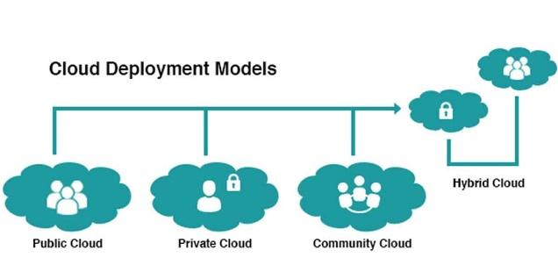

***Figure 1: Deployment Models***

**III. CLOUD SECURITY THREATS**

Data security is essential in the constantly evolving realm of cloud computing. Concern over potential security risks and breaches is rising as more and more sensitive data is entrusted to cloud-based services by enterprises. To safeguard data availability, confidentiality, and integrity, it is critical to understand the many forms of cloud security risks.

1. **Unauthorized Access:** People who obtain unlawful access to cloud-based resources, including data, systems, and apps, are said to have unauthorized access. It is a typical danger to cloud security. Phishing efforts, compromised credentials, and exploiting flaws in cloud platforms or setups are some of the ways that this might occur [3]. Serious consequences, including data theft and manipulation and the disruption of essential activities, can result from unauthorized access.
2. **Data Breaches**: One major cloud security concern is the intentional or unintentional release of private information stored in cloud settings. These breaches may result from system defects, insider threats, or inadequate security measures [2]. Once hacked, data can be utilized for illegal purposes such as identity theft, financial fraud, and damage to one's reputation.
3. **Malware Infections**: Malicious software designed to harm or disrupt computer systems is known as malware, and it poses a significant threat to cloud security [4]. Cloud-based systems are not immune to malware infestations, which can spread via compromised files, programs, or network connections. Malware may perform denial-of-service attacks, damage systems, and steal data.
4. **Denial-of-Services (DoS) Attacks:** They are intended to overwhelm cloud-based services, blocking access to them by authorized users. These attacks might cause networks to become overloaded with traffic, which would crash or disable responsive apps, websites, or services. [3]. DoS attacks have the potential to harm an organization's reputation, create losses, and interfere with business operations.[4]
5. **Insider Threats:** Insider threats occur when employees of a corporation have access to cloud-hosted resources but misuse that access for malicious purposes. Insider attacks can intentionally disrupt operations, compromise systems, and steal data [4]. Insider threats pose a particular risk due to their trusted access.
6. **Insecure Interfaces and APIs**: Attackers may be able to obtain unauthorized access or manipulate data by taking advantage of insecure interfaces and APIs, which are the entry points via which services and apps communicate with cloud resources [4]. Weak authentication processes, insufficient error handling, and injection flaws can all allow cyberattacks to obtain access.
7. **Account Hijacking:** In account hijacking, malicious actors take over authentic cloud user accounts, frequently via password leaks or phishing scams [3]. Hackers can conduct attacks, spread malware, and get private data once they have seized control of an account.
8. **Data Loss and Leakage:** DLLs occur when inadequate data handling practices, human mistake, or setup issues cause private data to be unintentionally lost or made public. Data loss can compromise the security and integrity of sensitive information, leading to financial losses, legal issues, and reputational damage.

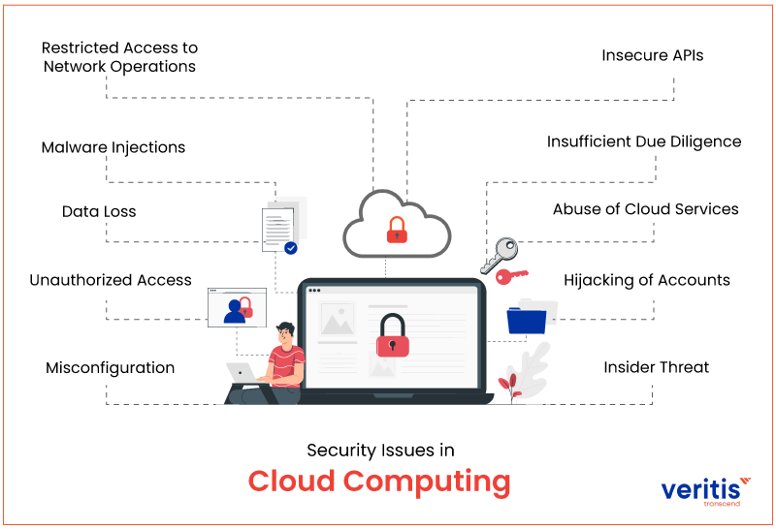

***Figure 2: Security Threats***

**IV. CLOUD SECURITY ALGORITHMS**

In the ever-evolving world of cloud computing, where data security is crucial, algorithmic solutions have emerged as indispensable instruments for fending against the ever-evolving variety of security threats. These technologies provide automatic and clever ways to safeguard private information and maintain a safe cloud environment. They are driven by sophisticated algorithms.

1. **Encryption Algorithms:** Encryption algorithms: These algorithms provide the basis of cloud security by transforming data into an incomprehensible format and preventing access by unwanted parties. Two popular algorithms that guarantee data integrity and secrecy during transmission and storage are Advanced Encryption Standard (AES) and Rivest-Shamir-Adleman (RSA).
2. **Digital Signatures:** Digital signatures ensure that digital data is valid and intact. Like electronic fingerprints, they function similarly. Algorithms like SHA-256 (Secure Hash Algorithm 2) and HMAC (Hash-based Message Authentication Code) generate unique cryptographic hashes that verify the source and undisturbed condition of data in order to avoid undesired manipulation or alterations.
3. **Access Control Mechanisms**: These systems serve as the gatekeepers of cloud resources, regulating user access and timing. Algorithms like Identity and Access Management (IAM) and Role-Based Access Control (RBAC), which dynamically allocate access rights based on user roles and permissions, ensure that only authorized users have access to critical data and systems.
4. **Intrusion Detection and Intrusion Prevention Systems (IDS/IPS):** These systems function as watchful sentinels, keeping an eye on system activity and network traffic for indications of potentially harmful or suspicious activity [4]. These systems can detect and possibly stop attacks in real time thanks to algorithms like anomaly detection and signature-based matching, protecting against malware infections, unauthorized access, and data breaches [5].
5. **Solutions for Data Loss Prevention (DLP):** Data Loss Prevention (DLP) solutions prevent undesired data exfiltration from cloud settings, protecting critical data. Thanks to techniques like content analysis and data fingerprinting, DLP systems can identify and prevent sensitive data from being transported outside of approved channels, preventing data breaches and leaks.
6. **latforms for Security Orchestration and Automation (SOAR):** SOAR systems, sometimes referred to as the cloud security conductors, automate and optimize security response processes. Thanks to algorithms like incident prioritization and automatic remediation, SOAR platforms may manage security issues more efficiently by limiting damage, enhancing overall security posture, and speeding up reaction times.
7. **Homomorphic Encryption:** Data processing is made possible by the novel cryptographic technique known as homomorphic encryption, even when the data is encrypted. Algorithms such as the BGN and Paillier cryptosystems allow for secure computations on encrypted data, protecting private information while facilitating data analysis and machine learning without revealing the underlying data.
8. **Cloud Security Management Platforms (CSMPs):** A collection of tools and technology known as cloud security management platforms (CSMPs) help businesses manage security in their cloud environments. CSMPs enable visibility into cloud resources, security posture, and potential threats. They also help businesses automate security tasks and respond to incidents. CSMPs are an essential component of any organization's cloud security plan.
9. **Multi-Factor Authentication (MFA)**: It increases the security of user authentication by employing several verification elements. This enhances security by making it more difficult for unauthorized individuals to access user accounts, even if they possess the essential credentials.

| **S.No.** | **Cloud Security Threat** | **Cloud Algorithmic Solutions** | **Analysis of Algorithms** | **Best Algorithmic Solution** |
| --- | --- | --- | --- | --- |
| 1. | Unauthorized Access | Role-Based Access Control (RBAC) | IAM handles user identities and access permissions, RBAC offers role-based access control.. | Identity and Access Management (IAM) |
| Identity and Access Management (IAM) |
| 2. | Data Breaches | Advanced Encryption Standard (AES) | AES is symmetric and efficient for data at rest, while RSA is asymmetric and computationally expensive for data in transit | Advanced Encryption Standard (AES) |
| Rivest-Shamir-Adleman (RSA) Algorithm |
| 3. | Malware Infections | Intrusion Detection System (IDS) | IPS actively blocks malicious traffic, while IDS monitors network traffic for suspicious activity. | Intrusion Prevention System (IPS) |
| Intrusion Prevention Systems (IPS) |
| 4. | Denial-of-Service (DoS) Attacks | Network Traffic Analysis | While resource monitoring tracks utilization for the purpose of detecting denial-of-service attacks, network traffic analysis looks for irregularities in traffic. | Network traffic analysis |
| Resource Monitoring |
| 5. | Insider Threats | User Activity Monitoring | User activity monitoring identifies anomalies in user behaviour, while Data Loss Prevention (DLP) proactively safeguards against unauthorized data and prevent insider threats | Data Loss Prevention (DLP) |
| Data Loss Prevention (DLP) |
| 6. | Account Hijacking | Multi-Factor Authentication (MFA) | MFA adds an extra layer of authentication, while risk-based authentication assesses user behaviour and device characteristics to determine risk. | Multi-Factor Authentication (MFA) |
| Risk-Based Authentication |
| 7. | Data Loss and Leakage . | Data Loss Prevention (DLP) | DLP prevents unauthorized data exfiltration, while data classification identifies sensitive data types | Data Loss Prevention (DLP) |
| Data Classification |
| 8. | Lack of Visibility and Control Security | Security Orchestration and Automation Platforms (SOAR) | SOAR centralizes security operations and automates incident response, while CSMP enhances visibility and control over cloud resources and security posture; | Security Orchestration Automation Response (SOAR) |
| Cloud Security Management Platforms (CSMP) |

***Table 1: Comparative Analysis of Security Threat and Algorithmic Solution***

**V. CONCLUSION**

In the ever evolving world of cloud computing, maintaining a secure cloud environment and safeguarding sensitive data are essential. As businesses rely more and more on cloud-based services, putting robust security measures in place has become crucial to their everyday operations. Algorithmic solutions driven by complex algorithms have developed into powerful tools to combat the ever-evolving threats to cloud security.

These solutions provide a thorough approach to cloud security and include data loss prevention strategies, encryption methods, intrusion detection systems, machine learning-powered security tools, and access control mechanisms. Each algorithm is tailored to address a specific danger and offers intelligent and automated defense against insider threats, denial-of-service assaults, malware infections, unauthorized access, unsecured interfaces, data loss, and misconfigurations.

Through a comparison analysis against specific cloud security risks, the effectiveness and applicability of each algorithmic approach were shown. While some algorithms concentrate more on proactive detection and prevention, others are particularly good at real-time mitigation and reaction.

In conclusion, algorithmic solutions have fundamentally altered the cloud security landscape by providing companies with a powerful toolset to safeguard their sensitive data and maintain the security of their cloud environment. By using these intelligent and automated solutions, organizations can protect against malware infections, illegal access, and data breaches, as well as ensure the availability, confidentiality, and integrity of their cloud-based assets.

**REFRENCES**

1. Coppolino, Letizia, Mazzeo, Giuseppe, and Romano, Luciano (2017). New threats to cloud security and existing remedies. Electrical Engineering & Computers, 59, 126–140.
2. T. S. Chou (2013). vulnerabilities in cloud computing security threats. International Journal of Information Technology & Computer Science, 5(3), 79.
3. Almaiah, M. A., and R. Al Nafea (2021, July). Review of the literature on cloud cyber security threats. pp. 779–786 in International Conference on Information Technology (ICIT) 2021. The IEEE.
4. Zhu, S. Y., & Kazim, M. (2015). a survey on the main risks to cloud computing security. 6(3), 109–113, International Journal of Advanced Computer Science and Applications.
5. Alosaimi, W., Alyami, H., Alharbi, A., Hasnain, M., Alouffi, B., & Ayaz, M. (2021). An organized review of the literature on cloud computing security, including methods for mitigating risks. Access IEEE, 9, 57792-57807.
6. Saha, P., Pal, M., Bose, M., Gupta, K., Bardhan, A., & Sarkar, P. (2018, January). Security challenges and solutions in cloud computing: a survey. Pages 347–356, IEEE 8th Annual Computing and Communication Workshop and Conference (CCWC), 2018. The IEEE.
7. Mayank Singh, Kanika Tyagi, S. K. Yadav, and Yadav. "Cloud data security and various security algorithms." IOP Publishing, 2021. Journal of Physics: Conference Series, Vol. 1998, No. 1.
8. In 2015, Pant and Saurabh published a book. Cloud security problems, obstacles, and best practices. International Journal of Management Technology & Engineering Research, 2(3), 41–50.