**AI in Farming**

Rahul Sharma 1st

Student AI &DS

Poornima Institute of Engineering and

Technology, Sitapura, Jaipur

Jaipur, India

[2021pietcarahul040@poornima.org](mailto:2021pietcakunal026@poornima.org)

Kamal saini 2nd

Asst Professor AI &DS

Poornima Institute of Engineering and

Technology, Sitapura, Jaipur

Jaipur, India

[kamal.saini@poornima.org](mailto:bharat.thathera@poornima.org)

## **Abstract*—****AI is revolutionizing the agricultural sector through precision farming practices enhanced by data-driven decision making. The paper shines light on how AI is going to transform the agricultural frontier in relation to optimizing resource and crop yields and encouraging sustainable farming practices. Evolving AI technologies will equip farmers with tools to apply site-specific interventions, in real time, based on data from a variety of inputting sources, such as drones, sensors, and satellite imagery. Some of the reasons that AI farming applications cannot be applied all things considered are problems of data ownership, algorithm transparency, and ethics. It will certainly go a long way toward enhancing trust among farmers if these concerns are addressed by determining model explainability and accountability, especially from the viewpoint of the AI system.*

## *Recommendations made in the study for boosting farmer involvement with AI technologies include improved transparency in algorithmic decision-making as well as fairer benefits from the exploitation of benefits derived from applications of AI. Cooperative environment between the developers of technology and farmers can help unlock the full potential of AI in driving innovation for agriculture but maintaining safety and soundness norms. Ultimately, it will result in having a sound framework regarding the responsible deployment of AI in farming to bring about a more sustainable agricultural future and increased productivity.*

**1. INTRODUCTION**

Witnessing the digital age, artificial intelligence is changing to a great extent within this agricultural landscape. This is called the term "smart farming" or "agriculture 4.0." This change is attributed primarily to the fact that there is more pressure to increase agricultural productivity as human populations increase in demand for food and with the accompanying problems in the environment. Artificial intelligence usually presents opportunities for the improvement of agriculture, which could lead to the use of resources with high efficiency, but at the same time, sustainability. Core technologies such as machine learning (ML), deep learning (DL), and robotics currently position themselves at the forefront of such a shift, easily integrating into different farm practices. They aim to improve crop management optimize the use of soil and water, and sharpen pest control strategies for enhanced yield quality.

The future, being precision agriculture, part of the touted fruits of artificial intelligence, makes farming more responsive to real-time data gathered by advanced sensors, high-resolution drones, and satellites; it then means data-driven significant interventions which boost crop yields significantly while greatly reducing the environmental impacts formerly associated with practices in traditional farming. There are many benefits of applying AI in agriculture, such as effective resource management, low costs of labor, and profitability. Powered by AI, predictive analytics can help predict the health of crops, detect diseases much before they start, and adjust the irrigation and nutrient distribution systems to prevent inputs wastage and optimize productivity.

**2. LITERATURE REVIEW**

There are, however a few impediments that stand in the way of mass penetration of AI into the agriculture sector. The data privacy, ownership, and security become increasingly important while operating with the sensitive information collected from the farmers for the AI application. Because of its complexity, the "black box" effect occurs, wherein the decision-making process behind the AI output confuses or cannot be traced by users. This also creates a gap between the trust of farmers and technology providers, which is increasing. When AI is able to enter the heart of agricultural operations to such an extent that it makes key decisions, accountability and openness are the two primary requirements.

## Integration of Artificial Intelligence in agriculture, which is mostly known as "smart farming" or "agriculture 4.0," revolutionizes traditional farming methods through data-driven insights to produce higher productivity and sustainability in agriculture. Pressures in the agricultural sector of rising global demand for food and environmental concerns portray AI technologies, including ML, DL, and robotics, as necessary tools for farmers. These technologies enable precision agriculture, that can introduce site-specific interventions based on real-time data coming in from sources that include sensors, drones, and satellite imagery. In a word, the effective application of AI into agriculture depends on so many critical factors such as the management of data processes that include obtaining clear data, thorough data checking, modeling of the suitable data, and translation of the data insights into suitable strategies.

## **2.1** The following literature review synthesizes key themes from studies on AI in agriculture lately, focusing on these important aspects of data management and the implications thereof to building trust with farmers.

**2.1.1 Obtain Clear Data**

Effective AI applications in agriculture depend primarily on the capability to obtain clear data. This involves high-quality, relevant information reflecting conditions in the agricultural environment. For example, using IoT sensors to monitor soil moisture can help farmers know when there is a need for irrigation at the right time. The quality of the data is really important because data that is noisy and not so accurate may cause poor decisions to be made. According to the study, using methods of strong data collection, remote sensing technologies, as well as ground truthing, can enhance more clarity and reliability in agricultural data (Gardezi et al., 2023).

**2.1.2 Data Verification**

After the collection of data, proper verification must be made to avoid any inaccuracies. Data verification ensures that the collected data is valid against the standard and benchmarks. For example, if images of crop health are captured by drones, then they need to be verified by cross references with historical yield data or expert assessment. The data validation process can be automated for easier implementations. Here is a simple piece of code in Python showing how one might go about checking for anomalies in a dataset:

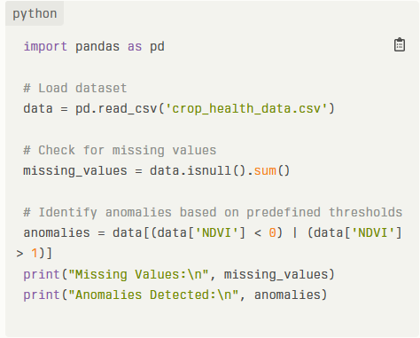

**2.1.3 Model Data**

Ensuring the Data Integrity After ascertaining that the data is clean, the second step is modeling the data effectively. It involves using correct machine learning algorithms to generate some predictive insights from that cleaned data set. Based on the specific application in agriculture, one might use different models, such as regression models for yielding predictions or classification models for detecting diseases. For example, decision trees and random forests are favorites because they are interpretable and suitable for any complex dataset (Ryan et al., 2023).

**2.1.4 Data Translation**

Data translation refers to the process whereby findings are conveyed in an interpretable and useful fashion for farmers. For example, an AI system can predict areas of a field that require more nitrogen through soil analysis; the result should be translated into language usable for farmers through informative dashboards or mobile applications. To achieve this translation, good visualization tools can be helpful by depicting crop health indices or irrigation schedules intuitively. Thence, AI can truly make a huge difference in the betterment of agriculture practice: most importantly, contributing to higher productivity and sustainability. Its success, however, depends on proper data management processes, though.

Indeed, if data are clean, well scrutinized, suitably modeled, and transformed into useful applications, stakeholders can come up with a stronger confidence that these technologies will amply benefit the farmers. Critical areas such as these should not only make AI solutions more believable but also project the right ethics within agriculture, thus leaving farming better positioned towards a sustainable future everywhere.

**3. APPLICATIONS**

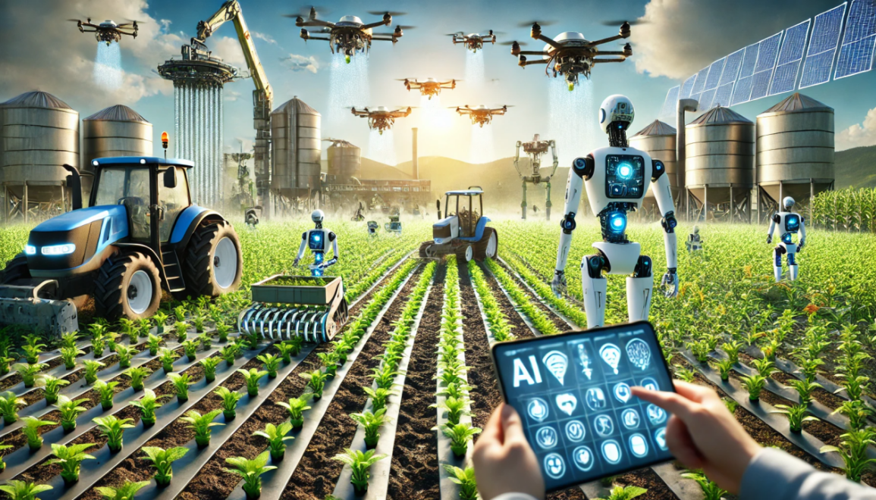

Application of AI to Farming The application of AI in farming is accelerating through innovative solutions to better enhance the productivity, sustainability, and efficiency of agricultural practices. Consequently, challenges such as increasing population, climate changes, and scarce resources in the agricultural sector result in AI tools for well-informed decision-making in agriculture through insights of data gathered. Applications of AI in farm activities range from precision agriculture and predictive analytics. This section will discuss several key applications of AI in agriculture, elaborating on their functionalities as well as benefits.

**3.1 Precision Agriculture**

Probably among the major applications of AI in agriculture is precision agriculture (PA). It employs AI technology for data gathering and processing from various sources, like satellite imagery, drones, and sensors, to maximise agricultural practices. Real-time data about the soil conditions, weather patterns, and health conditions of crops help farmers make efficiency-productive and wasteful processes. An example of how AI would be applied involves determining the amounts of water or fertilizer required in specific parts of a field by thereby lessening excess usage. It promotes sustainable farming practices through the conservation of resources due to increased yields.

**3.2 Crop Monitoring and Disease Detection**

Recently, systems based on artificial intelligence are widely being deployed for crop monitoring and disease detection. That is because algorithms in machine learning can analyze images captured by drones or cameras for early signs of plant stress and disease. For example, change in color or texture of leaves could be detected using computer vision techniques, indicating problems such as pest infestations or nutrient deficiency. Thus, they can correct them before the loss is more serious. In turn, this will protect their crops and enhance the overall quality of their yields.

**3.3 Autonomous Farming Equipment**

The development of autonomous farming equipment is another AI application in agriculture that brings innovation. Tractors and harvesters, for example, may be equipped with AI technology that can enable independent operation through planting, weeding, and harvesting with minimal human presence. Such machines may use GPS and onboard sensor information to determine their location within the fields as they adjust their operations according to real-time inputs fed into them. The automation reduces the labor costs and increases the overall efficiency of operation by having the farmer free to concentrate on strategic decision-making rather than on routine tasks.

**3.4 Predictive Analytics for Yield Forecasting**

AI-powered predictive analytics is changing the way farmers predict yields and the risks due to climate variability. In addition, AI models can predict future crop performance in different scenarios through the analysis of historical data and current environmental conditions. For instance, using machine learning algorithms, it would be possible to assess the underlying factors like temperature fluctuation patterns, rain fall patterns, and moisture retention capacity in the soil to predict an accurate yield. This information helps in planning the farmer's planting schedule and resource allocation, hence reducing risks attributed to both incongruent weather patterns**.**

**3.5 Smart Irrigation Systems**

## AI smart irrigation systems optimise water usage by monitoring data obtained from soil moisture sensors and weather forecasts. Such systems will determine the accurate amount of water to be administered to the crops at various stages of growth so that the plants are fully hydrated without overwatering. Such technologies make agriculture possible with low water consumption while maintaining the health of the crops. Furthermore, water conservation through these systems is important in any area that experiences water deficiency.

**3.6 Supply Chain Optimization**

AI applications go beyond the farm itself into optimizing the supply chains in the agricultural sector. Based on market trend analysis, consumer preferences, and logistical data, AI may help farmers make informed choices about the timing of harvests and strategies for distribution. For instance, demand for specific crops in different markets can be predicted using predictive analytics. This optimization not only increases the profitability but also reduces food waste by balancing supply with actual market needs.

1. **CONCLUSION**

AI in agriculture will provide tremendous opportunities for improving both productivity and sustainability along with efficiency in farming. Agriculture is constantly working to overcome climatic changes, resource scarcity, and feeding the global population. So, AI technology is a new wave in innovative options to change traditional ways of farming. AI empowers farmers through precision agriculture apps and crop monitoring, autonomous equipment, and predictive analytics. How real-time data and insights can be used to inform decision-making depends on critical issues of trust, transparency, and the ethical consideration of data usage. Conclusion: AI adoption in farming is more of a paradigm shift wherein agriculture should be run rather than just some technology to apply in farming. The benefits of AI abound; one is efficiency in use while minimizing environmental impacts and increasing decision-making capability. However, to realize all these benefits, trust must be created between the farmer and the technologies that are being used. It will be realized through increased model interpretability, showing the farmer where and how the system is coming to its conclusion. There's also going to have to be some rethink about data ownership and liability. All of this, of course, in an effort to build a joint relationship between the farmer and the technology provider. While agricultural landscape undergoes change with the integration of AI, stakeholders should ensure that these technologies come in handy and are developed and deployed responsibly enough as to enhance the interests of farmers while promoting sustainable practices.

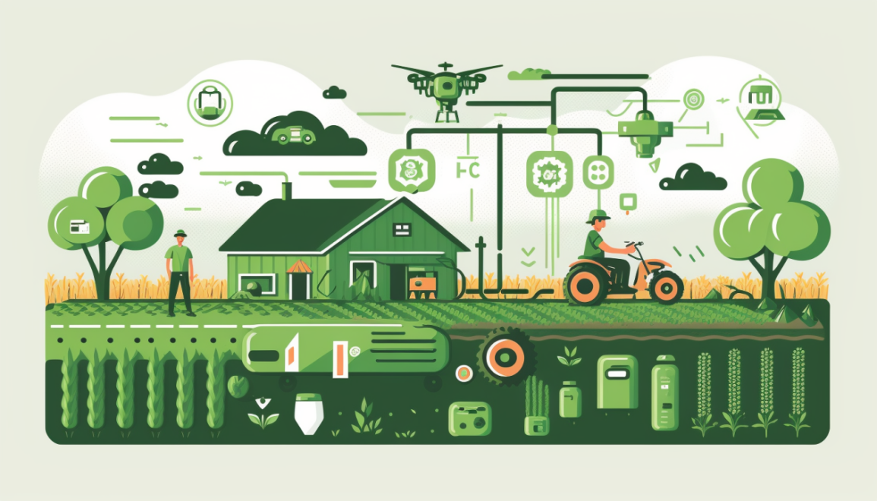

The future of AI in agriculture holds immense scope for more innovation and developments. With increasing work and advancement in machine learning and data analytics, we can expect more complex applications of AI. Such a future requires further research on improving the explainability of AI models so that farmers can read and interpret the outputs generated by these models. It will also be important to study how to democratize access to AI technologies, given that many smallholder farmers lack the resources or technical expertise in using this technology. Academia, industry, and agricultural communities will crucially collaborate in developing the most inclusive solution to the particular challenges faced by diverse farming systems around the world. Moreover, with the development of regulatory frameworks that incorporate not only the ethics of AI but also its impact on agriculture, standards in protecting farmers' rights while simultaneously fostering innovation will have to be put in place. In general, moving towards such an illuminating future relies on the responsible practice of AI technologies and its trust.

1. **REFERENCES**
2. Adal,H.,Promy,N.,Srabanti,S.andRahman,M.,2018,February.Androidbasedadvancedattendancevigilancesystemusingwirelessnetworkwithfusionofbio-metricfingerprintauthentication. In 2018 20th International Conference on AdvancedCommunication Technology (ICACT)(pp.217-222).IEEE.
3. .Sawant,V.andShah,K.,2014.Asurveyofdistributedassociation rule mining algorithms. Journal of Emerging Trends inComputingandInformationSciences, 5(5),pp.391-398.
4. .Kamsu-Foguem, B., Rigal, F. and Mauget, F., 2013. Miningassociationrules for the quality improvement of the productionprocess.Expertsystemswithapplications,40(4),pp.1034-1045.
5. . Berry, M.J. and Linoff, G.S., 2004. Data mining techniques: formarketing,sales,andcustomerrelationshipmanagement.JohnWiley&Sons.
6. .Linoff, G.S. and Berry, M.J., 2011. Data mining techniques: formarketing,sales,andcustomerrelationshipmanagement.JohnWiley&Sons.
7. Wu, S.Y. and Fan, H.H., 2009. Activity-based proactive datamanagementinmobileenvironments.IEEETransactionson MobileComputing,9(3),pp.390-404.
8. .Smita, P.S. and Sharma, P., 2014. Use of data mining in variousfield:Asurveypaper.IOSRJournalofComputerEngineering,16(3),pp.18-21.
9. Sharma, A., Sharma, R., Sharma, V.K. and Shrivatava, V., 2014.Application of data mining–a survey paper. International Journal ofComputer Science and Information Technologies, 5(2), pp.2023-2025.
10. Rain,C.,2013.Sentimentanalysisintwitterreviewsusingprobabilisticmachinelearning
11. Nandal, N., Tanwar, R. and Pruthi, J., 2020. Machine learningbased aspect level sentiment analysis for Amazon products. SpatialInformation Research, 28(5),pp.601-607