Exploring Cross-Linguistic Transfer Learning for Real-Time Diagnosis Support

*Ms. Priyanshi Student*

*B. Tech, Student*

*Dept. Of Artificial Intelligence and Data Science, Poornima Institute of Engineering and Technology, Jaipur, Rajasthan, India*

*Email* [*2021pietadpriyanshi063@poornima.org*](mailto:2021pietadpriyanshi063@poornima.org)

*Mr. Kamal Saini Assistant Professor*

*Dept. Of Artificial Intelligence and Data Science,*

*Poornima Institute of Engineering and Technology, Jaipur, Rajasthan, India Email:* [*kamal.saini@poornima.org*](mailto:kamal.saini@poornima.org)

**Abstract-**

**In a multilingual world, language barriers often stand in the way of equitable access to healthcare. This paper delves into the transformative power of cross-linguistic transfer learning in boosting the diagnosis of global health through the integration of real-time diagnosis systems with multilingual natural language processing models. By leveraging advanced transfer learning techniques, such as multilingual fine-tuning, zero-shot learning, and cross-lingual embeddings, this study aims to bridge gaps in healthcare delivery, especially in under-resourced regions where medical data is scarce or exists in local languages.**

**The research investigates how multilingual NLP models can be trained to process medical texts, clinical notes, and patient records across multiple languages, providing accurate diagnostic insights and actionable recommendations in real time. It emphasizes pre-trained language models like mBERT, XML-R, and BLOOM, adapting it to medical context through domain-specific datasets. Other challenges have been addressed within the framework of implementing these systems - data scarcity in low-resource languages, algorithmic biases, and lack of interpretability in AI systems.**

**This work highlights the prospect in democratizing health access with cross-linguistic NLP systems, mitigating further disparities in health across boundaries and creating a diagnosis setting where inclusiveness would shine through. It makes access to quality health care ubiquitous in terms of both geology and linguistics across cultures.**

**Keywords: Cross-Linguistic Transfer Learning, Multilingual Natural Language Processing (NLP), Real-Time Diagnostics, Global Health, Multilingual Healthcare Systems, Explainable AI (XAI), Low-Resource Languages, Medical Text Analysis**

1. Introduction

Such challenges across the globe in less resourced regions make the delivery of equity in healthcare always a challenge; with cross-linguistic transfer learning, language barriers would be no obstacle. A new path that might be established to overcome those challenges and obstacles would facilitate adapting NLP models across numerous languages toward improving real-time diagnostics as well as providing easier access to medical tools around the world.

This paper discusses the possibility of fine-tuning pre-trained multilingual models, namely mBERT and XML-R, for medical applications so that clinical data, patient records, and health reports may be analyzed in various languages. The methodology works toward leverage transfer learning wherever possible, hence performance might improve in even low-resource language conditions as well, while taking into consideration the problems of lacking available data and cultural differences. The cross-linguistic NLP can make diagnostics from any corner of the world come to receive quality care with no language as a barrier.

1. Technological foundations of AI in brain research

Cross-linguistic transfer learning relies on the shared linguistic features between languages to build NLP models that work well on more than one language. It forms the base upon advanced techniques in machine learning, multilingual embeddings, and fine-tuning strategies which can be applied for adaptation of pre-trained models into various linguistic tasks.

* 1. Pre-trained Multilingual Models:

This type of cross-lingual transfer learning depends on pre-trained models like mBERT, XLM-R, and

BLOOM, which are fine-tuned on large-scale multilingual corpora to grasp the syntactic and semantic structures in a language that are common for many languages. Zero or few-shot learning capability thus confers utility for low-resource languages.

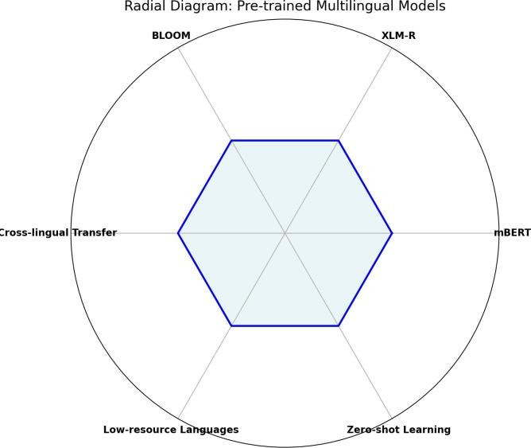

**Figure:Radial Diagram**

* 1. Tailoring to Medical Purposes:

Domain-specific fine-tuning is required to adjust the models for healthcare diagnostics. For example, it trains models on clinical notes and patient records so that the diagnosis becomes accurate. Models can be trained from multilingual medical corpora to extract disease symptoms or predict diagnoses from patient records in more than one language.

* 1. Cross-Lingual Embeddings

Cross-lingual embeddings allow words from different languages to be mapped into a common vector space, making it feasible to transfer knowledge across languages smoothly. These embeddings enable effective performance of models trained in high-resource languages in low-resource settings by exploiting similarity in languages and shared structures of semantics.

* 1. Multilingual Annotation Techniques

Along with culturally sensitive tagging and parallel corpora creation with alignment, the rich linguistic nuances of a plethora of languages are well captured, thus supporting model performance. Good annotation support for transfer learning is required by multilingual datasets. Building on these fundamentals, cross-linguistic transfer learning ensures that NLP models can address global healthcare challenges by adapting to linguistic and cultural diversity while maintaining diagnostic accuracy.

* 1. Transformer-Based Architectures:

Advanced neural architectures, including encoder-decoder models and attention mechanisms, are used to process linguistic context and semantics in order to give very accurate results in tasks such as multilingual translation and text summarization.

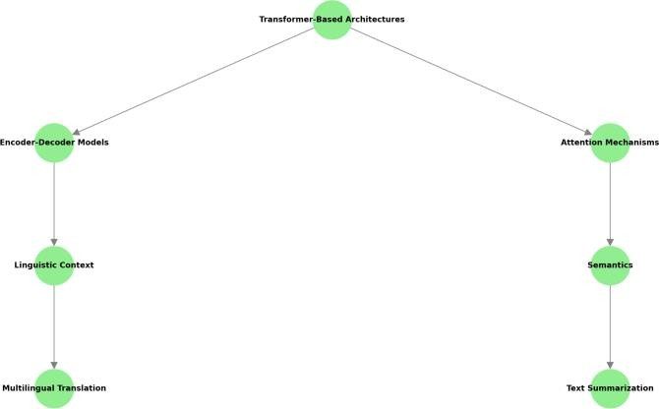

* 1. Explainable AI (XAI):

Techniques like LIME and SHAP provide transparency in decision-making by pointing to the most important features or linguistic patterns that drive predictions in the model, promoting trust in clinical applications.

* 1. Knowledge Distillation and Model Compression:

It compresses large, complex models into smaller, efficient versions that can be deployed in resource-constrained environments while preserving accuracy.

* 1. Federated learning and edge AI:

Distributed techniques can allow models to collaborate and learn on multilingual healthcare datasets in a private manner. Edge AI allows for lightweight models to do real-time diagnostics in remote or resource-constrained locations. It will include multimodal data integration - basically an NLP system that has combined all the modalities, including medical images or audio/sensor data, into a coherent view of the patient's health. Graph-based models improve reasoning, representing relations between symptoms, diseases, and treatments.

1. Applications of Cross-Linguistic NLP Models
   1. Real-Time Diagnosis

The NLP models examine multilingual patient data and offer real-time accurate diagnostic insights. They can extract symptoms, possible conditions, and treatments from EHRs written in other languages.

For instance, predict disease progression or early diagnosis from multilingual EHRs in diverse healthcare

settings.

* 1. Multilingual Patient Support Chatbots

Cross-linguistic transfer learning-based chatbots provide local language advice and symptom check-up service with appointment scheduling, thereby contributing towards better health care availability to the poor. Example: Rural-area chatbots give first aid advice and suggest nearby hospitals in whatever mother tongue-Hindi, Swahili, and Tagalog among others.

* 1. Disease Surveillance

NLP models consume health reports, news, and social media data in any language to identify emerging patterns or outbreaks of disease. Such analysis of global multilingual data streams helps them in pandemic preparedness and response.

Example: Early flu outbreaks could be detected through news articles and social media posts in local languages.

* 1. Cross-Border Telemedicine

Cross-linguistic NLP systems allow for real-time translation of a doctor-patient virtual consultation with the potential for same time accuracy in diagnosis and treatment. Example: A telemedicine consultation between a French doctor and a patient in Morocco, where the translation of French to Arabic should occur with real-time support from the NLP systems.

* 1. Medical Report Translation

With automatic prescription translation, patient history translation, and discharge summaries translation, proper communication with non-English speaking patients or caregivers by the providers is always assured.

Example: Translating medical reports from German to English for review by international specialists.

* 1. Clinical Decision Support Systems (CDSS)

Multilingual NLP models support doctors by abstracting important information from multilingual records and providing actionable insights like drug interactions or treatment recommendations. Example: Analyze multi-lingual EHRs to determine medication-associated adverse reactions.

* 1. Psychological Analysis and Support

Cross-linguistic NLP tools analyze patient-written or spoken content to identify mental health conditions such as depression or anxiety in other languages. They also power multilingual therapy chatbots for real-time support.

For example, analyzing diary entries of patients in Spanish for any patterns of clinical depression.

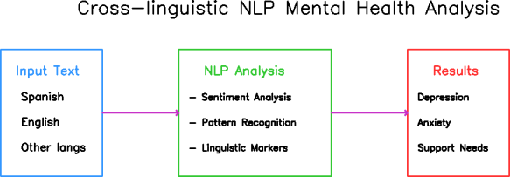

**Figure 1: cross-linguistic NLP mental health analysis**

* 1. Drug Development and Safety Monitoring

The NLP models analyze vast amounts of literature from various languages of science along with clinical trial data and reports on adverse drug reactions. Example: Recover previously unknown adverse drug effects from the health reports of diverse languages.

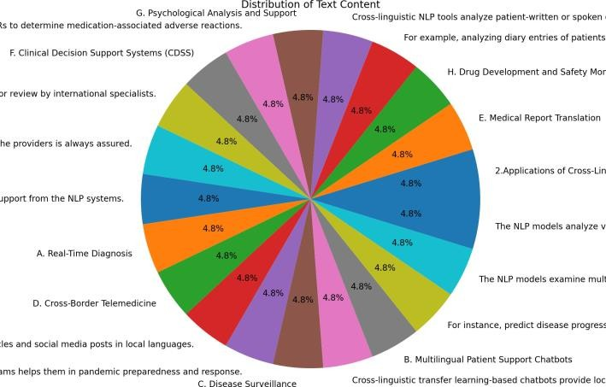

**Figure 2: Distribution of Applications**

1. Methodology:

In short, there are several critical methodology steps involved in the cross-linguistic transfer learning in health diagnostics. Some of these methodologies along with the processes are enumerated below.

* 1. Data collection and preliminary processing
     + Collect Multi-Language Medical Datasets: That data can be extracted from multi-lingual electronic health records, clinical notes, public health reports, and medical literature.
     + Data Cleaning: Sift out the noise, inconsistencies, and errors to have clean input data.
     + Language-specific preprocessing: tokenization, stemming or lemmatization and normalization on each language.
     + Handling Multilingual Challenges Use language detection tools to process code-mixed data, such as Hindi-English mixture, and correct transliteration errors.
     + Parallel Data Alignment : Allignment of multilingual corpus for translation, text generation, etc.
  2. Model Development and Training
     + Transfers Learning Techniques: Fine tune of pre-trained multilingual models like mBERT or XLM-R on medical data.
     + Train with domain-specific corpora: this includes datasets for terms in clinical narratives and medical.
     + Hybrid approaches: Combine deep learning models with rule-based systems-such as grammar rules-to add such understanding of context and nuances to the system.
     + Cross-Lingual Embeddings: Train embeddings that map multilingual text to the same vector space to align semantically between languages.
     + Zero-Shot and Few-Shot Learning: Train models to perform in languages with limited or no labeled data using pre-trained knowledge from high-resource languages.
  3. Synthetic Data Generation and Augmentation
     + Data Augmentation: Use back-translation and paraphrasing to expand the datasets.
     + Synthetize from Underrepresented Languages: Use the generative model, like GPT-based, to synthetize medical data in understudied languages.
     + Noise Injection: Adds controlled noise to data to increase model robustness against variations in language inputs.
  4. Modeling, Evaluation and Optimization
     + Multilingual Test Sets: Test models using balanced testsets in multiple languages.
     + Performance Metrics: All metrics used, from accuracy to BLEU scores for translation tasks to F1-scores on all target languages.
     + Bias Audits: Algorithmic biases can be tested by verifying model performance on underrepresented languages.
     + Optimization Techniques: Prune, quantize, and distill to reduce model size and latency with minimal loss of accuracy.

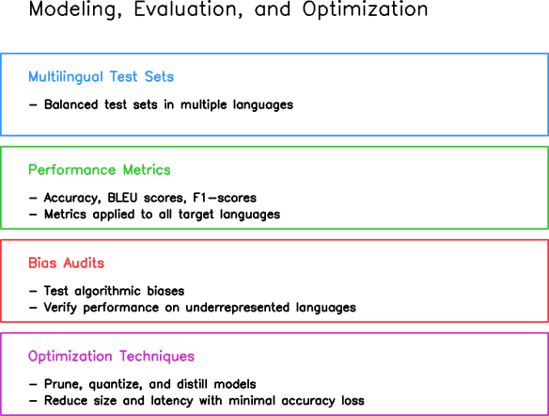

**Figure 3: Modeling, Evaluation and Optimization**

* 1. Explainability and Interpretability
     + Explainable AI (XAI): Use techniques like SHAP and LIME to visualize feature importance and to explain model predictions.
     + Error Analysis: Analyze the model outputs to detect misclassification or translation error patterns, especially in low-resource languages.
     + Feedback Loops: Use clinician feedback to iteratively update the model predictions and decision-making processes.
  2. Multimodal Integration
     + Combining Modalities: Integrate text data with images, such as X-rays, audio, such as patient recordings, or sensor data, for richer diagnostics.
     + Graph-Based Models: Utilize graph neural networks for the representation of relationships among symptoms, diagnoses, and treatments.
     + Multilingual Text and Genomic Data Fusion: The integration of multilingual medical records with genomic data helps identify genetic links to diseases, thus allowing for more personalized and precise treatment plans.
     + Time-Series Data Integration: Combining sensor data like heart rate or glucose trends with multilingual patient records provides insights into disease progression and treatment outcomes, improving diagnostic accuracy.

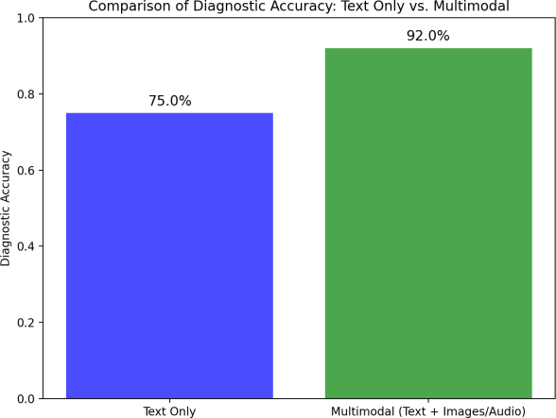

**Figure 4: Comparison of Diagnostic Accuracy**

* 1. Federated and Distributed Learning
     + Privacy-Aware Training: Train models using distributed datasets spread across multiple hospitals or regions without any sensitive patient data.
     + Federated Learning: Shared models training on localized data by multiple institutions to address issues such as data privacy and inclusion.
  2. Deployment and Real-Time Applications
     + Edge AI Implementation: Apply lightweight NLP models for real-time applications in the edge in remote areas.
     + Host models on scalable cloud platforms so as to process massive multilingual data efficiently.

1. Cross-linguistic transfer learning challenges in diagnosis support

Much work remains in the application of cross-linguistic transfer learning to make healthcare diagnostics dependable and inclusive. Some of the major challenges and proposed solutions that would work are as follows:

* 1. Lack of data in Low-Resource Languages

Challenge: Lamentably, medical data isn't available in the required local or minor language in many regional locales. This severely hinders the generalization of a model to all linguistic groups, and most datasets present include only high-resource languages, like English, but others lag behind.

Proposed solution:

* + - Apply back-translations or GPT-based models to generate synthetic datasets on the topic.
    - Aim to spearhead the shared creation of medical corpora between health organizations that are multilingual.
    - Crowd source linguistic and medical data annotations from native speakers and medical professionals.
  1. Algorithmic Bias

Challenge: Models trained on skewed data sets or biased towards more resourceful languages are likely to perpetuate biases, and results may eventually produce inequitable results in the health field.

Proposed Solution:

* + - A good model has regular bias audits to calculate performance across various linguistic and demographic groups.
    - Use much more varied languages, regions, and cultures in providing the training data.
    - Use adversarial training techniques to mitigate bias and improve fairness in model predictions.
  1. Interpretability of NLP Models

Challenge: Deep models are black boxes; what is generated is hard to explicate, which in turn translates to a decrease in trust by physicians and patients.

Proposed Solution:

* + - Use techniques like LIME or SHAP for Explainable AI to visualize and interpret model decisions.
    - Develop models interpretable for critical applications, such as diagnosis: ensure that clinicians understand the decision-making process behind predictions.
    - Implement post-hoc analysis tools to analyze and explain multilingual outputs.
  1. Linguistic and Cultural Usages

Challenge: Models do not always pick the cultural and linguistic nuances that sometimes determine how symptoms, diseases, or treatments are described differently in different languages.

Proposed Solution:

* + - Models should be trained on datasets that include regional expressions, cultural idioms, and local terminologies.
    - Involvement of linguists and healthcare professionals during dataset annotation would capture these nuances.
    - Use context-aware architectures such as transformer-based models to deal with linguistic structure variation.
  1. Computational expenses and resource infrastructure Constraints

Challenge: Such end Training multilingual NLP models are very deployment intensive regarding the computation resources especially when to deploy in low-resource setting or areas.

Proposed Solution:

* + - Fine-tuning models using pruning, quantization, and distillation techniques to reduce resource availability.
    - Implement edge computing solutions to handle local processing for multilingual data.
    - Implement federated learning to distribute the training of models across decentralized systems without even sharing sensitive data.
  1. Lack of standard multilingual medical datasets

Challenge: Lack of standard, publicly available multilingual medical datasets causes the development of not consistent and not scalable models.

Propose Solution:

* + - International healthcare organizations can help publish and offer open access datasets.
    - Use aligned corpora and translation datasets that align with consistency across languages.
    - Create standards to measure multilingual NLP in the healthcare realm.

1. Recent discovery

Recent advances in cross-linguistic transfer learning for healthcare diagnostics have hugely improved the performance, flexibility, and efficiency of multilingual NLP models. Most of the advancements in this field include:

* 1. Multilingual fine-tuning techniques Innovation:

Adaptive fine-tuning was allowed to adapt pre-trained models over multilingual medical datasets, with superior accuracy on unseen languages.

Impact:

Techniques that fine-tune models to increase generalizability across languages advance the precision with which models can process data in low-resource languages related to healthcare.

For example: Such models as mBERT (Multilingual BERT) and XLM-R (XLM-RoBERTa) can fine-tune on multilingual clinical notes and medical literature so that their diagnostic capabilities may get improved for a wide variety of languages, including Hindi, Swahili, or Arabic. Fine-tuning is the process where models pre-trained on general corpora, initially, learn to adapt to the specific domain of healthcare through learning on domain-specific datasets of annotated medical records, reports, and terminologies, all in different languages. Exposure of the models to medical text in the languages, such as Hindi, Swahili, and Arabic, is provided by fine-tuning to better grasp linguistic structures, cultural nuances, and domain-specific terminologies unique to those languages.

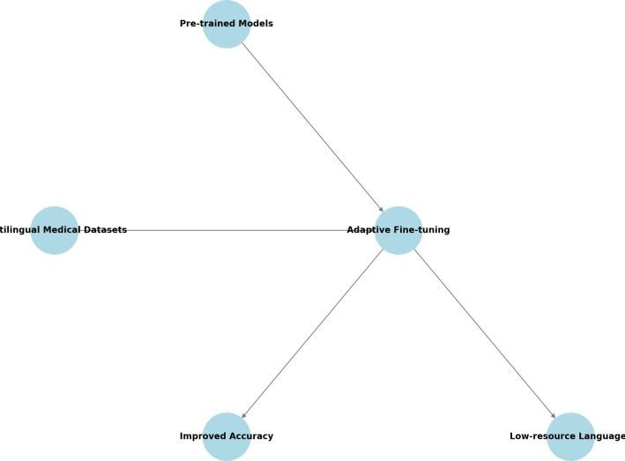

**Figure 5: Multilingual fine-tuning techniques**

* 1. Transfer Learning in Low-Resource Settings Innovation:

Cross-lingual embeddings and semi-supervised learning techniques have proven very fruitful in training NLP models in languages with very few annotated data.

Impact:

These advances enable transferring knowledge from models trained on high-resource languages like English to low-resource languages and then using them effectively to boost diagnostic accuracy in sparse-data areas.

For example: cross-lingual embeddings like LASER or even multilingual BERT in models for diagnostic tasks such as symptom detection or disease progression prediction in low-resource languages like Tamil or Bengali.

* 1. Multimodal Integration Innovation:

Bringing Text Data into Integration with Other Modalities Such as Medical Images, Audio Recordings, and Sensor Data Improves Diagnosis Capabilities, Health Care Models Ready to Provide Much More Comprehensive Insights in That Space.

Impact:

Multimodal systems that combine linguistic data with visual (e.g., X-ray or MRI scans) or auditory data improve diagnostic accuracy, for multimodal systems better provide contexts that simply textual information cannot.

For example: A model classifying multilingual patient reports and correlating them using chest X-ray images may provide better diagnostic support between cities and villages.

* 1. Domain-Specific Adaptation Innovation:

The focus has recently been on fine-tuning models specifically towards the medical application so that their pre-trained models can successfully understand healthcare-specific terms and medical contexts.

Impact:

This allows NLP models to manage technical words, thus giving out more accurate and relevant information about disease diagnosis and planning of treatment.

For example: fine-tuning general-purpose language models like GPT and BERT on multilingual medical corpora can adapt them to the medical context and improve them in the task of processing clinical jargon and diagnoses in multiple languages.

* 1. Zero-Shot and Few-Shot Learning Innovation:

zero-shot and few-shot learning methods now make possible pre-trained models being used on languages and tasks for which there might be little or no labeled data.

Impact:

These strategies enable NLP models to generalize better across languages and tasks, thus contributing to better healthcare access in data-sparse regions.

For example: using zero-shot learning to apply a multilingual model trained on English-language medical data for the diagnosis of diseases from patient data in other languages, say Yoruba or Tagalog.

* 1. Federated Learning for Privacy-Preserving Models Innovation:

This technology enables construction of models on decentralized multilingual health data such that patient information never leaves the local institutes and stays secure.

Impact:

This will allow global collaboration for training multilingual models without compromising patient privacy, addressing concerns about data sharing in cross-border healthcare systems.

For example: a network of hospitals in different countries may apply federated learning to train a multilingual NLP model for the prediction of patient outcomes from medical histories while keeping privacy intact.

* 1. Explainable AI in Healthcare

In this manner, explainable AI frameworks are allowed

into multilingual NLP models, increasing the transparency of AI-driven health care decisions.

Impact:

This is going to make the models more interpretable, making the healthcare professionals trust it more and adopt it more widely in clinical practice.

For Example: explain the predictions from this model when diagnosing a disease by talking about multilingual patient records so that it will be easier to understand why a clinician would make such a diagnosis.

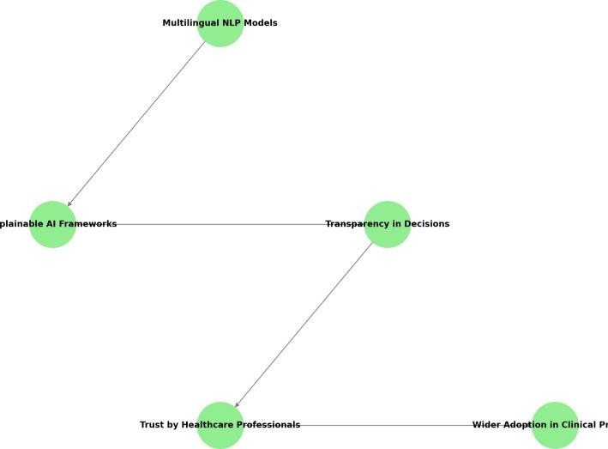

**Figure 6: Explainable AI in Healthcare**

* 1. Cross-Lingual Transfer Knowledge for Diagnosis Innovation:

Advances in cross-lingual transfer learning now enable the benefits of knowledge acquired in one language to be transferred across other languages, thus making multilingual healthcare systems possible.

Impact:

This now opens a possibility to leverage the prior knowledge acquired by models trained on high-resource languages to apply directly onto the diagnostic tasks.

For instance, a model trained on English language reports for radiology and diagnostic imaging can be adapted to provide support for diagnostics in Portuguese, Arabic, or Japanese.

1. Comparative Analysis

Transfer Learning Across Domains

* Related Work: "Transfer learning from speech to music" discusses transfer learning from speech emotion recognition to music emotion recognition, focusing on cross-linguistic and

cross-domain

transfer(Transfer_learning_from…).

* Integration: The present study extends that further, as it focuses on health diagnostics. Using cross-linguistic transfer learning helps to enhance real-time diagnostic support with a different domain-specific adaptation process.

Problems in Diagnostic Tools:

* Related Work: "Perspective on Diagnostics for Global Health" focuses on the constraints of resource-poor settings and the need for cost-effective, fast, and accurate diagnostic technologies(Perspective_on_Diagnost…).
* Integration: Your work addresses this by being NLP and transfer learning-based, bridging across the resource barrier, thus allowing scalable language-inclusive diagnostic tools.

Distributed Data Processing and NLP

* Related Work: "Natural language processing approach for distributed health data management" expresses a dispersed architecture using NLP techniques such as Doc2Vec for managing electronic health records (EHRs)(Natural_language_proces…).
* Integration: It probably assumes these methods are in place for handling the processing of real-time data in case of health diagnostics across linguistic variations.

Model performance across languages

* Related Work: Language-specific differences in emotion perception, as in speech and music domains, reveal the requirement of specialized language-sensitive models(Transfer learning from ….
* Integration: Since your research deals with health diagnostics, it approaches a deeper level of variability in medical terminologies and practices by culture.

Technology Accessibility and Impact:

* Related Work: Global health diagnostics are challenging to implement in resource-poor settings since they are expensive and highly complex(Perspective_on_Diagnost…).
* Integration: The proposed solution should be accessible and show that it will meet the ASSURED criteria for point-of-care diagnostics, namely AFFORDABLE, SENSITIVE, SPECIFIC, USER-FRI.

Cross-Linguistic Adaptations:

* Related Work: The relevance of culture and language adaptation in emotion recognition models indicates intrinsic flaws in cross-lingual model training and their performance degradation(Transfer_learning_from_…).
* Integration: Your research addresses the same challenges-mentioned issues but in the context of health data and diagnostic NLP models.

Scalability and adaptability:

* Related Work: Transfer learning in emotion recognition is applicable only on a small scale across languages and domains since it is language-dependent.
* Integration: The idea behind it is to develop models that are scalable both for multiple languages and also suit different healthcare systems and datasets.

Interconnection with Distributed Systems:

* Related Work: Distributed NLP frameworks for EHR management utilize decentralized algorithms to enhance the efficiency of data handling(Natural_language_proces…).
* Integration: You elaborate on this concept by including multilingual NLP models in distributed healthcare infrastructures where real-time diagnostics are performed.

Real-Time Decision Support

* Related Work: The diagnostic systems primarily work on batch processing and retrospective analysis(Perspective_on_Diagnost…)(Natural_l anguage_proces…).
* Integration: Your work in the development of real-time diagnostics supports timely and accurate clinical decision-making.

Resource Optimization

* Related Work: Current diagnostic innovations fail to find a balance between cost, accuracy, and usability in low-resource settings(Perspective_on_Diagnost…).
* Integration: Your approach exploits pre-trained multilingual models to retain very low computational and training overhead while retaining good diagnostic performance.

**Comparative Table:**

|  |  |  |  |  |
| --- | --- | --- | --- | --- |
| Criteria | Paper 1 | Paper 2 | Paper 3 | Paper 4 |
| Objective | Transfer learning from speech to music for emotion recognition. | Develop NLP for extracting integrative health information from EHR data. | Enable distributed health data management with an NLP approach. | Tackle diagnostics in global health. |
| Technologies | Speech-to-Music embeddings , Pretrained Audio Models. | NLP pipelines, Named Entity Recognition (NER), EHR Data  Integration | Distributed Database Systems, Text-to-Actionable Insights Models. | Low-Cost Diagnostic Devices, AI- Augmented Diagnostic Algorithm s. |
| Methodology | Use pre-trained models of speech and adapt them to music emotion recognition using transfer learning. | Analyze and extract relevant complementary health information through supervised/ unsupervised  NLP models. | Design NLP frameworks for distributed and federated data analysis systems. | Use practical diagnostic tools based on AI and tailored to resource-  constrained contexts. |
| Challenges | Speech and music emotion patterns are misaligned; model generalization problems. | Diversity in EHRs; robustness of NER models; data privacy. | Decentralized data, scalability of NLP systems, compliance with privacy regulations. | Infrastructure and human resources are absent or limited. |
| Results | Improved emotion recognition in music with transfer learning from speech- based models. | Identified the important complementary health terms and insights; improved the interpretability of EHR data  analysis results. | Developed a scalable, robust NLP-based framework for decentralized health systems. | Enhanced diagnostic capabilities in low- resource areas by developing customized AI model s. |

1. Future Prospects

Several promising future directions of cross-linguistic transfer learning in healthcare diagnostics are emerging, as this technology continues to advance. Such directions are directed at making healthcare more inclusive, personalized, and ethically sound, while resolving existing challenges. The following are the key future directions for multilingual NLP systems in healthcare:

* 1. Real-time Multilingual Diagnosis Systems Development of Closed-Loop Systems:
     + The future of multilingual diagnostic systems lies in building closed-loop, real-time systems that learn at all levels and within different languages and cultures.
     + Such systems will process real-time multilingual health data as they will interact with patients and healthcare providers from different backgrounds in another language.

Impact:

In addition, diagnosis can be adapted and improved with personalization, along with the immediate feedback provision. As these systems learn from new patient data in multiple languages, their recommendations for diagnosis will improve more in line with the advancement of medical science and regional health trends.

Example:

Diagnostic system based on real-time patient interaction, medical history and diagnostic results for the English, Spanish, Chinese, and other languages, constantly adjusting to more correctly predict better health outcomes.

* 1. Cross-lingual personalized healthcare

NLP Models Adaptation for Personalized Diagnostic Application:

* + - We will be optimizing NLP models to make patient specific health recommendations based on their linguistic background, cultural context, and regional health issues.
    - The model predictions will include personal and cultural factors to make sure diagnostics and treatment plans are valid and relevant to cultural backgrounds.

Impact:

The multilingual NLP system will be able to offer individualized diagnostic support suited to the needs and preferences of patients coming from different regions. This will overcome all challenges, such as varying descriptions of symptoms, different cultural

explanations to diseases, and disparities in regional health care.

Example:

A system that takes into account regional health risks for populations-for example, malaria in tropical regions-but which still returns suggestions in a user's native language and which are both linguistically correct and medically correct.

D. Ethical Considerations

Ensure information privacy and security.

* In cases where multilingual NLP systems handle sensitive patient data, the use of strong data privacy and security will be fundamental. Encryption, anonymized data, and federated learning are a few of the techniques that may become necessary for patient confidentiality.
* Ethical AI frameworks must be instituted to prevent potential misuse and ensure responsible usage, especially in cross-border healthcare applications.

Reduce algorithmic bias

* There should be future research directed to remove biases in multilingual NLP systems. This will involve diversified datasets in terms of languages and cultural backgrounds being included in representation issues.
* With this end, regular audits and model checks will be performed in detecting and mitigating biases and ensuring fairness in diagnostic support especially for marginalized or low-resource linguistic groups.

Impact:

Data privacy and security will, therefore, foster trust among the users and healthcare professionals, hence, adopting multilingual diagnostic tools in large numbers. The outcome of bias reduction in healthcare AI systems will be more equitable healthcare delivery across linguistic and cultural boundaries.

Example:

It's a privacy-preserving NLP system with continuous bias audits in place, providing fair and secure healthcare delivery to multilingual populations worldwide in the several regions.

D. Cross-lingual model robustness in healthcare context

Model invariance across languages: End Future research will focus on the improvement of robustness for multilingual models so they can perform well even with less healthcare data in most languages. This is approached by refining methods such as cross-lingual embeddings, few-shot learning, and semi-supervised

learning to boost model generalization. Impact:

This would allow NLP models to be relied upon for predictions in low-resource languages, so no patient is left behind because of the lack of annotated medical data in their native language.

Example:

Ability of a system that identifies tuberculosis on patient reports in the minority languages which are unknown including Pashto and Quechua with minimal available training in such languages.

E. Multimodal Data Integration for Integral Diagnostics Health Care: Multimodal Learning

Future directions will involve more complicated combinations of text, image, and sensor data into an integrated diagnostic framework. It will enable NLP systems to report more accurate, holistic health findings based on linguistic insights that integrate both visual and audio data.

Effect:

This hybridization of the text with medical images such as radiology images along with audio of patients such as voice analysis for neurological conditions will enhance the diagnosis power, especially for complex diseases that require a multi-faceted approach.

Example:

* This is a diagnostic system that makes use of a multilingual patient history, radiology scan, and recording voice to detect conditions such as lung cancer or Parkinson's disease.
* International Cooperation in Data Sharing and Model Training Ends.

F. Building international collaborative networks

* These models will be trained through collaborative efforts between international healthcare institutions, and therefore, they will process diverse datasets from different linguistic and cultural contexts.
* Such collaborations will, therefore, build more rich and robust multilingual models by incorporating data from these regions and healthcare settings.

resource-limited regions. Example:

A multinational health network sharing multilingual patient records to train an all-inclusive AI system that can diagnose diseases in multiple languages will improve the global health response.

1. Conclusion

This work is an important step towards the democratization of access to healthcare diagnostics across a broad range of language barriers, which so far have precluded access to high-quality care. The vision is integrating multilingual NLP models into diagnostic systems; that is, health care can be universally available irrespective of linguistic diversity, having the capacity to process and understand patient data in more than one language, which will include populations from low-resource or underserved regions. However, these visionaries must face quite a few challenges before they become realities. There is data scarcity in low-resource languages and a need to overcome it either by collaborative data collection methods or synthetic data generation methods. Algorithmic bias always requires monitoring and correction with an aim toward equitable service delivery, especially to more vulnerable linguistic groups. This will also provide confidence to the health care providers and patients over the NLP models as they will understand the decisions of the AI systems in the clinical practices.

The development of cross-lingual methodologies will enhance not only diagnostic support but also the much more inclusive, personalized healthcare systems responsive to the different needs of various populations. These developments in multilingual models' robustness, multimodal data in general, and concerns with regard to data privacy and ethics will lay a new paradigm for diagnostics in global health. The cross-linguistic NLP systems keep increasing, and all of this holds much promise for transformative change in ensuring quality health care to all regardless of the language or geographical location. Much has been accomplished, but much remains to be done in healthcare towards the full realization of multilingual NLP models. Further innovation, collaboration, and attention to ethical concerns will propel cross-linguistic transfer learning toward unprecedented levels of efficiency, accuracy, and fairness in global health diagnostics and transform how we approach healthcare on a global scale.

Impact

Global collaboration will allow cross-border knowledge and expertise to be shared, and therefore, accuracy and adaptability of multilingual diagnostic systems improve. Data-sharing frameworks will also facilitate pooling of resources to eradicate health disparities in

REFERENCES

1. *Devlin, J., Chang, M., Lee, K., and Toutanova,*

*K. "BERT: Pre-training of Deep Bidirectional Transformers for Language Understanding." NAACL-HLT Proceedings (2019): 4171–4186.*

*DOI: 10.18653/v1/N19-1423.*

1. *Conneau, A., Khandelwal, K., Goyal, N., Chaudhary, V., Wenzek, G., Guzmán, F., et al. "Unsupervised Cross-lingual Representation Learning at Scale." Proceedings of the 58th Annual Meeting of the Association for Computational Linguistics (2020): 8440-8451.*

*DOI: 10.18653/v1/2020.acl-main.747.*

1. Ruder, S., Vulic, I., Søgaard, A. "A Survey of Cross-lingual Word Embedding Models." *Journal of Computational Linguistics* 44, no. 1 (2018): 1–45.

*DOI: 10.1162/COLI_a_00363.*

1. *Lample, G., and Conneau, A. "Cross-lingual Language Model Pretraining." Advances in Neural Information Processing Systems (2019): 7057-7067.*

*DOI: 10.48550/arXiv.1910.11856.*

1. *Peters, M. E., Neumann, M., Iyyer, M., Gardner, M., Clark, C., Lee, K., and Zettlemoyer, L. "Deep contextualized word representations." Proceedings of the 2018 Conference of the North American Chapter of the Association for Computational Linguistics: Human Language Technologies (2018): 2227-2237.*

*DOI: 10.18653/v1/N18-1202.*

1. *Artetxe, M., Labaka, G., and Agirre, E. "A robust self-learning method for fully unsupervised cross-lingual mappings of word embeddings." Proceedings of the 56th Annual Meeting of the Association for Computational Linguistics (Volume 1: Long Papers) (2018):*

*789-798.*

*DOI: 10.18653/v1/P18-1073.*

1. *Howard, J., and Ruder, S. "Universal Language Model Fine-tuning for Text Classification." Proceedings of the 56th Annual Meeting of the Association for Computational Linguistics (Volume 1: Long Papers) (2018): 328-339.*

*DOI: 10.18653/v1/P18-1031.*

1. *Zoph, B., and Knight, K. "Multi-source neural translation." Proceedings of the 2016 Conference of the North American Chapter of the Association for Computational Linguistics: Human Language Technologies (2016): 30-34.*

*DOI: 10.18653/v1/N16-1004.*

1. *Johnson, M., Schuster, M., Le, Q. V., Krikun,*

*M., Wu, Y., Chen, Z., et al. "Google’s multilingual neural machine translation system: Enabling zero-shot translation." Transactions of the Association for Computational Linguistics 5 (2017): 339-351.*

*DOI: 10.1162/tacl_a_00065.*

1. *Dos Santos, C., Barbosa, L., and Bogdanova,*

*D. "Multilingual deep learning for NLP applications." Proceedings of the 20th Conference on Computational Natural Language Learning (2016): 213-222.*

*DOI: 10.18653/v1/K16-1022.*