**MAPPING BEHAVIORAL BIASES IN INVESTMENT DECISIONS: A BIBLIOMETRIC ANALYSIS (2014 – 2024)**

**Dr. Irudhayamary Premkumar, Assistant Professor, MEASI Institute of Management**

**Ms. Muskan M. Parmar, I yr MBA, MEASI Institute of Management**

**Abstract**

Behavioral finance has emerged as a pivotal area of research in understanding the irrational financial behaviors of investors. Traditional finance theories assume that individuals make rational decisions aimed at maximizing their utility. However, behavioral finance challenges this notion by exploring how psychological factors and biases influence decision-making, often leading investors to act irrationally. These biases, which can be categorized into cognitive and emotional, affect how individuals perceive information, assess risks, and ultimately make financial choices. Cognitive biases stem from flawed reasoning and information processing, while emotional biases are driven by feelings and instinct, making them more difficult to overcome.

Over the last decade, research on behavioral biases and their effects on investment decisions has seen significant growth. This surge in interest reflects the increasing recognition that understanding investor psychology is crucial for explaining financial market anomalies. Behavioral biases such as overconfidence, herding, the disposition effect, and anchoring are frequently cited as major influences that deviate investors from rational decision-making.

The current study aims to conduct a comprehensive bibliometric analysis of publications on behavioral biases in investment decisions between 2014 and 2024. This analysis provides a quantitative and qualitative assessment of research trends, geographical distribution, author collaborations, and the gender dynamics in sole authorship. It offers insights into the evolution of the field over the past decade and highlights key contributors, both in terms of countries and publishers, as well as influential researchers.

One of the primary objectives of this analysis is to map the growth of academic publications in this domain and to identify which countries have contributed most significantly to the body of research. Early findings suggest a strong concentration of research output from the United States, which leads in terms of both the number of publications and citations. Other countries such as the UK and India are also emerging as important contributors, though the research output from these regions is much lower compared to the USA. The analysis also seeks to understand the performance of major academic publishers in this field, with Elsevier standing out as the leading publisher.

In addition to country-wise and publisher-wise distribution, the analysis delves into authorship patterns, identifying trends in single-authored versus multi-authored publications. This is complemented by a gender analysis, which shows significant disparities in publication contributions by male and female authors, particularly in countries like the USA, UK, and India. However, interestingly, Russia shows a near-equal distribution of publications between male and female authors.

Overall, this bibliometric study serves to provide a holistic view of the research landscape on behavioral biases in investment decisions. By analyzing trends across time, regions, and contributors, it sheds light on the growing academic interest in behavioral finance and offers a roadmap for future research in the field. The study also underscores the importance of addressing geographical and gender disparities in academic contributions to foster a more inclusive and diverse body of knowledge in this rapidly evolving domain.

**NEED FOR THE STUDY**

Behavioral biases significantly influence investment decisions, impacting investor behavior and market dynamics. Understanding these biases is crucial for developing strategies to mitigate their effects, thereby enhancing investment performance. This study aims to provide a comprehensive bibliometric analysis of research on behavioral biases in investment decision-making from 2014 to 2024. By examining publication trends, geographical distributions, and authorship patterns, this research seeks to highlight gaps in the existing literature and promote further exploration of this critical field. The insights gained will not only contribute to academic discourse but also inform practitioners and policymakers about the importance of addressing behavioral factors in investment strategies.

**SCOPE OF THE STUDY**

This study focuses on publications related to behavioral biases in investment decision-making from 2014 to 2024. The analysis encompasses:

* **Geographical Focus:** Examination of publication contributions from key countries, including the USA, UK, and India, providing insights into the global landscape of research in this area.
* **Key Metrics:** The analysis covers various aspects such as publication distribution by country and publisher, growth trends in the number of publications, authorship patterns (including co-authorship and gender representation), and citation impact across different regions.
* **Research Emphasis:** The study specifically targets behavioral biases that influence investment decisions, thereby contributing to a better understanding of investor behavior and the potential implications for financial markets.

**LIMITATIONS OF THE STUDY**

While this study offers valuable insights into the field of behavioral biases in investment decision-making, several limitations must be acknowledged:

* **Data Availability:** The analysis is constrained by the publications indexed in the selected databases (e.g., Scopus, Web of Science), which may exclude relevant studies not captured within these platforms.
* **Language Bias:** This study primarily focuses on English-language publications, which may overlook significant contributions from non-English-speaking researchers or regions.
* **Geographical Concentration:** The research reveals a strong concentration of publications from a limited number of countries, particularly the USA, which may not fully represent the global research landscape and could omit valuable insights from emerging markets.
* **Gender Representation:** The findings indicate substantial gender disparities in authorship, suggesting broader systemic issues in academia. However, the study may not fully capture the experiences or contributions of underrepresented genders in different contexts.
* **Citation Bias:** The analysis highlights a concentration of citations among the leading countries, which may not reflect the overall impact or quality of research from countries with fewer publications.

**REVIEW OF LITERATURE**

**2.1 PERTIWI, T. K., YUNININGSIH, Y., & ANWAR, M. (2019).**

The Indonesian stock exchange serves as a vital platform for the community to access financial resources for business and investment purposes. Investors typically seek to generate profits from their investments; however, many do not always make rational decisions when formulating their strategies. Furthermore, the high level of uncertainty in stock trading can lead to irrational behaviors and investment choices. This study aims to examine biased investor behavior, specifically focusing on overconfidence, the disposition effect, and risk tolerance in relation to trading activities on the Indonesian Stock Exchange. To analyze the qualitative response variable, a Multi-nominal Logistic Regression Model was employed, given that the research considered multiple categories. The participants in this study included customers of various securities firms, with a total of 170 questionnaires distributed and 141 completed responses collected for analysis. The results of the simultaneous multi-nominal logistic regression indicated that the overall model was quite significant. However, the partial testing revealed that only overconfident investors influenced trading activities, with a moderate likelihood of trading for overconfident individuals estimated at 0.177 when considering the “infrequent” trading category.

**2.2 AHMAD, M., & MAOCHUN, Z. (2019).**

The conventional view of investors as rational decision-makers is increasingly challenged by research highlighting significant behavioral variability linked to individual personality traits and psychological biases. The Big Five personality traits—Extraversion, Agreeableness, Conscientiousness, Neuroticism, and Openness to Experience—play a critical role in shaping investor behavior. Specifically, Conscientiousness is associated with higher financial risk tolerance due to structured decision-making, while Neuroticism often leads to lower risk tolerance due to heightened anxiety over losses. Individuals high in Openness to Experience are more likely to embrace risks, influenced by their attraction to new ideas. Furthermore, psychological biases such as overconfidence and loss aversion complicate rational decision-making, making the interplay between these factors crucial for understanding investor behavior. This study examines the relationship between financial risk tolerance and the Big Five traits among investors at the Pakistan Stock Exchange, finding positive correlations between Conscientiousness, Neuroticism, and Openness. These results underscore the significant impact of personality traits on investment decisions, contributing valuable insights to the behavioral finance literature.

**2.3 RZESZUTEK, M., SZYSZKA, A., & CZERWONKA, M. (2015)**

This paper explores the interplay between behavioral biases—specifically the certainty effect, sunk cost fallacy, and mental accounting—and individual differences in investment expertise and personality traits. Prior research has established that behavioral biases can significantly impact decision-making processes in financial markets, leading to suboptimal investment choices. The study contributes to this body of literature by examining how susceptibility to these biases varies among different groups, particularly retail investors and students involved in investing. By utilizing a survey methodology that includes situational exercises and the Impulsivity, Venturesomeness, Empathy (IVE) Questionnaire, the authors effectively isolate and measure the influence of expertise and personality traits on behavioral bias susceptibility. The findings suggest that greater expertise correlates with an increased likelihood of exhibiting these biases, challenging the notion that more experienced investors are less prone to irrational behaviors. Additionally, certain personality traits, including impulsivity, venturesomeness, and empathy, are shown to influence the propensity to display biases, further underscoring the complex interplay between individual characteristics and decision-making in investment contexts. This study enhances our understanding of how psychological factors shape investor behavior, highlighting the need for comprehensive strategies that address both expertise and personality in financial decision-making.

**2.4 RAUT, R. K., & KUMAR, R. (2018).**

This study examines the differences in susceptibility to seven key behavioral biases—availability bias, representativeness, emotional contagion, herding, informational cascades, anchoring, and overconfidence—between experienced and novice investors in India. Prior research has established that behavioral biases can significantly influence investment decisions, often leading to irrational market behavior. The study contributes to this literature by analyzing data from individual stock market participants across four Indian states: Jharkhand, Bihar, Odisha, and West Bengal. Findings reveal that while both experienced and new investors share similar perceptions of availability bias, representativeness, and emotional contagion, significant differences emerge in their responses to herding, informational cascades, anchoring, and overconfidence. Notably, herding is identified as the most influential factor in differentiating investment decision-making between the two groups. This research highlights the importance of understanding how investor experience impacts susceptibility to behavioral biases, offering insights for improving decision-making strategies in the stock market.

**2.5 JAIN, J., WALIA, N., & GUPTA, S. (2020)**

This study focuses on identifying and ranking the behavioral biases that impact the investment decisions of individual equity investors in Punjab, India, contributing to the broader field of behavioral finance. Previous research has shown that investor behavior often deviates from rationality, leading to suboptimal investment decisions influenced by various psychological biases. Using the fuzzy analytic hierarchy process (FAHP), the authors rank eight key biases: overconfidence, representativeness, anchoring, availability, regret aversion, loss aversion, mental accounting, and herding. The findings reveal that herding bias, loss aversion, and overconfidence bias are the most influential factors affecting investors' decisions. Specific sub-criteria such as selling stocks that have appreciated in value, the influence of media on decisions, and holding onto losing stocks in anticipation of a trend reversal are highlighted as key behavioral patterns. The study's insights help investors and market participants recognize these biases and improve their decision-making processes. However, the research is limited by its focus on a specific geographic area, which may affect the generalizability of the results.

**2.6 RASHEED, M. H., RAFIQUE, A., ZAHID, T., & AKHTAR, M. W. (2018)**

This study investigates how two common heuristics—representative bias and availability bias—impact investment decision-making, with a focus on the role of locus of control as a potential moderator. Building on behavioral finance literature, the research uses a quantitative approach, collecting data through surveys from 227 investors across Islamabad, Lahore, and Sargodha in Pakistan. The data are analyzed through structural equation modeling and regression techniques. The findings reveal that both heuristics lead investors to deviate from rational decision-making, while the locus of control does not have a significant moderating effect. This research is the first to quantify the extent of irrationality caused by these biases, providing valuable insights for individual investors, investment managers, and policymakers to improve decision-making strategies in financial markets.

**2.7 ZAHERA, S. A., & BANSAL, R. (2018).**

This study aims to review various behavioral biases influencing investment decision-making, highlighting how behavioral finance has evolved as a distinct area of study. Through an analysis of research papers published from 1979 to 2016, the authors explore the behavioral patterns of individual investors, institutional investors, and financial advisors. The paper identifies 17 types of biases categorizes the research by bias type, year, country, and author. The findings indicate that behavioral finance, once a niche focus, has grown in importance, attracting attention from academics, corporate entities, and financial intermediaries. The study emphasizes the need for further exploration of intermediary behavior and investor psychology, particularly in emerging markets. The paper also offers practical insights for companies, policymakers, and investors on how to address these biases in decision-making, promoting better financial practices and reducing risk.

**2.8 OMORUYI, A., & ILABOYA, O. (2019).**

This study examines the impact of behavioral biases on the investment decisions of individual investors in Nigeria, as opposed to the rational decision-making models suggested by traditional finance theories. Using a survey design, the researchers targeted a sample of 70 respondents, including students and staff from the University of Benin, using a snowball sampling technique. Data were collected through a structured questionnaire. The findings revealed that biases like representativeness, overconfidence, loss aversion, and regret aversion did not significantly affect investment decisions. However, hindsight bias played a significant role, suggesting that behavioral factors, rather than rational ones, influence individual investors' decisions. The study recommends that investors should be educated on recognizing and overcoming behavioral biases, and training programs should be implemented to raise awareness about these biases. Additionally, the paper suggests that investors should seek advice from stockbrokers or fund managers who have a deeper understanding of market dynamics to make informed investment decisions.

**2.9 KUMAR, S., & GOYAL, N. (2015).**

This paper presents a comprehensive systematic review of the literature on behavioral biases in investment decision-making over the past 33 years, focusing on articles published between 1980 and 2013. Utilizing a systematic literature review (SLR) method, the study examines 117 selected articles from peer-reviewed journals, assessing various aspects such as the year of publication, journal of publication, country of study, and types of statistical methods employed. The findings reveal significant gaps in the existing research, notably a lack of studies conducted in emerging economies, a predominance of secondary data-based empirical research, and insufficient empirical work addressing individuals exhibiting herd behavior. Additionally, the paper points to a focus on equity in home bias and mixed empirical findings concerning herding bias. The research highlights the need for more targeted investigations into how cognitive biases impact trading behavior, market volatility, market returns, and portfolio selection. By shedding light on these gaps, the study raises pertinent questions for future research endeavours in the field of behavioral finance. This paper is valuable for researchers, academicians, and practitioners, offering insights into the implications of behavioral biases on investment decision-making and encouraging a deeper exploration of this critical area.

**2.10 DHAR, S., SALEMA, S. M. K., & SAHA, A. (2017).**

This empirical study investigates the factors influencing mutual fund buying behavior among individual investors in Dhaka city, where the mutual fund industry is experiencing growth and increasing investor awareness. Based on a sample of 103 respondents selected through random sampling, primary data were collected via a structured questionnaire using a 5-point Likert scale between October and December 2017. Employing exploratory factor analysis, the study identified two key factors that significantly affect investors' decisions: intrinsic features of the fund and income features of the fund. Intrinsic features include the reputation of the fund manager, scheme diversification, investment simplicity, growth potential, brand recognition, entry and exit loads, scheme risk, and asset quality. Income features focus on return performance and tax benefits for investors. The findings enhance the existing literature on mutual fund buying behavior in Bangladesh and offer valuable insights for mutual fund companies and fund managers, allowing them to design better schemes that align with investor preferences.

**2.11 BAKER, H. K., & PUTTONEN, V. (2017).**

The passage discusses the pervasive nature of behavioral biases in investing, emphasizing that these biases can lead to poor decision-making and ultimately undermine success. It highlights that effective investors recognize these biases and actively work to mitigate their effects. Key strategies include being self-aware, avoiding emotional decision-making, and adhering to a well-defined investment plan. The importance of seeking expert advice and maintaining a disciplined approach is also emphasized. By following these principles, investors can make more rational choices and improve their overall investment outcomes.

**2.12 ZHANG, Y., & ZHENG, X. (2015).**

This paper explores the intersection of behavioral finance and investment behavior, emphasizing how psychological and sociological factors influence investor decisions. It critiques traditional finance theories by demonstrating that both individual and institutional investors often engage in irrational behaviors influenced by cognitive biases and prejudices. By utilizing data from a questionnaire targeting Chinese security investors, the study provides insights into the psychological characteristics that explain market anomalies, advocating for a more realistic approach to developing investment strategies informed by behavioral finance principles.

**DATA ANALYSIS AND INTERPRETATION**

**3.1 PUBLICATION BY THE COUNTRY**

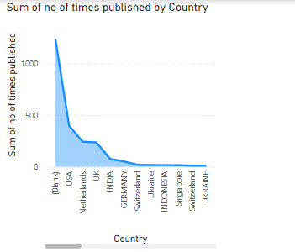

**Fig.3.1**

The key inferences from the chart are:

1. **Dominance of Top Countries**: USA has a significantly higher number of publications compared to the others, with over 1,000 publications between 2014 and 2024. This country leads by a substantial margin.
2. **Sharp Decline**: After the USA, there is a steep decline in the number of publications for other countries like the Netherlands, UK, and India.
3. **Minor Contributions**: Countries like Indonesia, Ukraine, Singapore, and Switzerland appear multiple times but contribute a relatively low number of publications.

This chart suggests a strong concentration of publications from a small set of countries, with one country dominating the output, followed by a steep drop for the others

**3.2 PUBLISHERS’ PERFORMANCE METRICS**

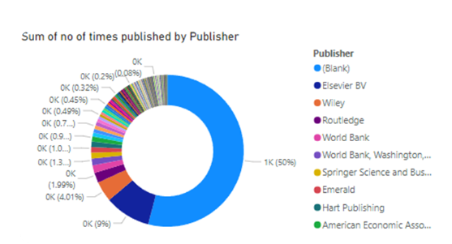

**Fig.3.2**

The key inferences from the chart are:

1. **Elsevier BV**: Elsevier BV is the largest contributor, accounting for 9% of the total publications. It stands out as the most prominent identified publisher.
2. **Other Publishers**: Other publishers like **Wiley**, **Routledge**, and **Springer Science and Business Media** contribute smaller percentages, typically below 5%.
3. **Minor Contributions**: The remaining publishers, such as **World Bank**, **Hart Publishing**, and **American Economic Association**, show relatively minimal contributions, with percentages ranging from 0.1% to 2%.
4. **Fragmentation**: Beyond the dominant categories, the chart demonstrates a long tail of publishers contributing less than 1% each, reflecting a highly fragmented publishing landscape for the remainder.

This chart suggests that a significant portion of publication data is made by Elsevier BV, , with a few major publishers accounting for most of the identified contributions.

**3.3 NO OF PUBLICATIONS BETWEEN 2014 TO 2024**

**Fig.3.3**

The graph shows a steady increase in the number of publications from 2014 to 2024. Here are some key observations and inferences:

1. **Growth Trend**: From 2014 to 2022, the number of publications has consistently increased, showing a positive trend. This could indicate increased research output or the expansion of the publishing scope during these years.
2. **Peak in 2022**: The highest number of publications is observed around 2022, peaking at approximately 120 publications. This year likely marks a significant increase in research activity.
3. **Stabilization or Slight Decline**: After 2022, there is a slight decrease or stabilization in the number of publications by 2023 and 2024. This might imply a plateau in publishing activity or a slight reduction after a peak.
4. **Overall Positive Growth**: Despite the slight decline post-2022, the overall trend from 2014 to 2024 is strongly upward, indicating a general growth in the number of publications over the decade.

**3.4 AUTHOR SPECIFICATIONS**

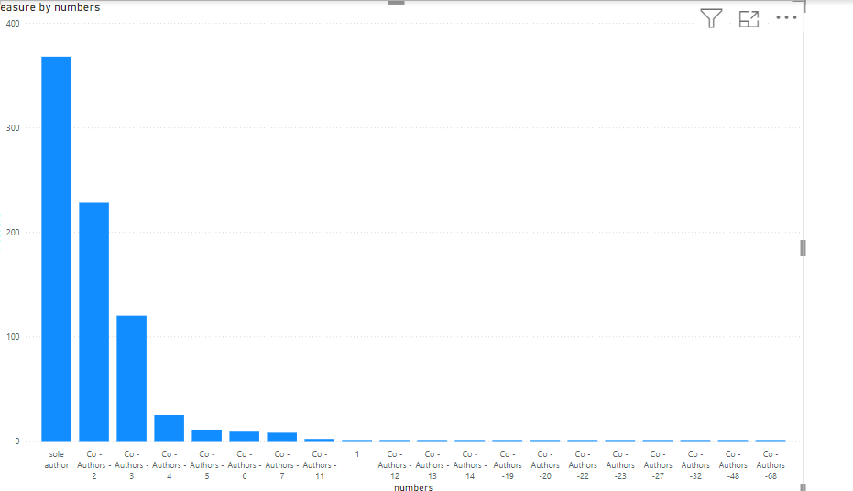

**Fig.3.4**

The key inferences from the chart are:

1. The chart represents a measure by numbers, likely indicating frequency or count of author contributions.
2. There's a strong negative correlation between the number and the measure - as the number increases, the measure decreases significantly.
3. The highest measure is associated with the "sole author" category, suggesting individual authorship is most common.
4. Co-authorship decreases rapidly as the number of authors increases, with a sharp drop after 4-5 authors.
5. There's a long tail of co-authorship, with very low measures for high numbers of co-authors (20+).
6. The data likely represents publication patterns, showing that single-authored works are most frequent, followed by works with 2-3 authors, while large collaborations are rare.
7. This pattern might reflect the nature of the field or discipline, suggesting it's an area where individual or small-team research is more common than large collaborations.

**3.5 ACTIVE YEARS**

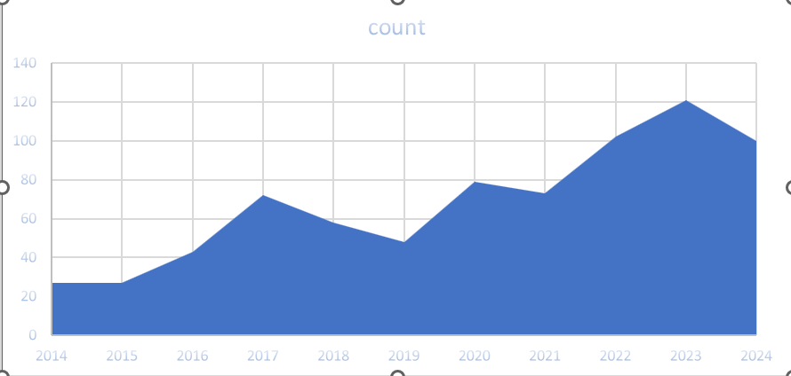

**Fig.3.5**

The key inferences from the chart are:

1. The chart displays a count metric over time, from 2014 to 2024.
2. There's a clear upward trend in the count over the years, indicating overall growth.
3. The growth is not linear; there are fluctuations and periods of faster growth.
4. Notable points:

* A significant jump occurred between 2016 and 2017
* A dip in 2019, followed by recovery and accelerated growth
* The steepest increase appears to be from 2022 to 2023

1. The count in 2024 is lower than in 2023, suggesting a recent decline for the current year
2. Further analysis would be needed to understand the factors driving these changes and to make predictions about future trends

**3.6 PUBLICATION COUNTRYWIDE**

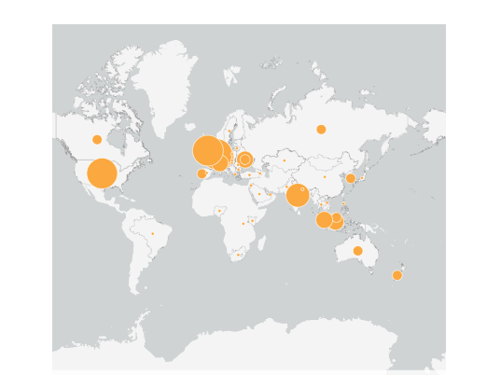

**Fig.3.6**

This chart represents the **number of publications** by region on the **behavioral biases in investment decisions**. The interpretations are

1. **Europe**: Europe has the largest concentration of publications, which could indicate strong academic interest and research focus on understanding how behavioral biases influence investment decisions in this region.
2. **North America**: The United States shows a significant number of publications as well. This suggests that behavioral finance is a well-explored topic, potentially driven by large financial markets and investor behavior studies.
3. **Asia**: Key regions like China and India show moderate to significant interest in this field, reflecting growing attention toward behavioral finance as their financial markets expand.
4. **Other Regions**: Australia and parts of South America show smaller circles, indicating a more limited but still present research focus on the topic. Africa and the Middle East have minimal publications, possibly due to less established research or smaller markets.

Overall, regions with major financial hubs or growing markets tend to have higher numbers of publications, showing greater academic attention to how behavioral biases affect investment decisions globally.

**3.7 PUBLICATION COUNTRYWIDE- HIGHEST PUBLICATION**

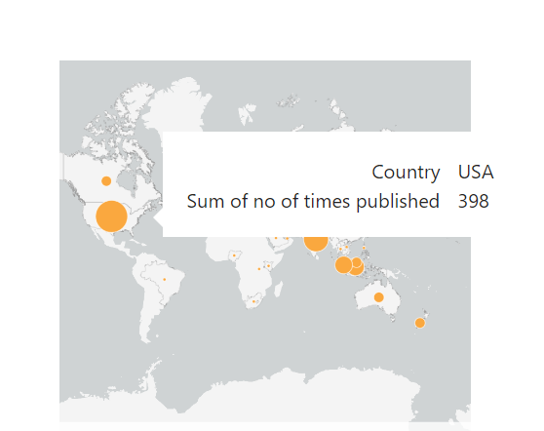

**Fig.3.7**

The map and chart show the regional distribution of publications on **behavioral biases in investment decisions**. Here are the inferences:

**USA** has the highest number of publications, with **398** times.

* + This indicates a significant research interest in behavioral biases in investment decisions within the United States.

This geographical visualization highlights the global spread of interest in the topic, but it underscores a much stronger concentration of research in the United States compared to other regions.

**3.8 PUBLICATION COUNTRYWIDE- SECOND - HIGHEST PUBLICATION**

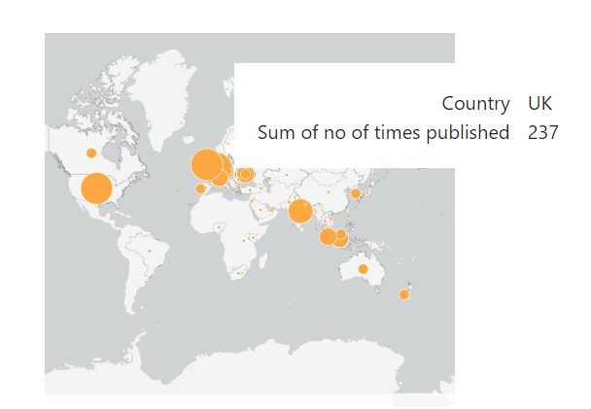

**Fig.3.8**

This image represents a map visualization of the number of times research publications have originated from various countries. The UK has taken the position as the second largest country by publication, with a total of 237 publications. This is indicated by the relative size of the orange circle over the UK, showing its prominence in global research activity.

When compared to other countries on the map, the size of the bubble indicates the UK's strong academic output. Although not as large as the USA (which is leading), the UK stands out, especially within Europe, as a major contributor to global research publications.

**3.9 PUBLICATION COUNTRYWIDE- THIRD HIGHEST PUBLICATION**

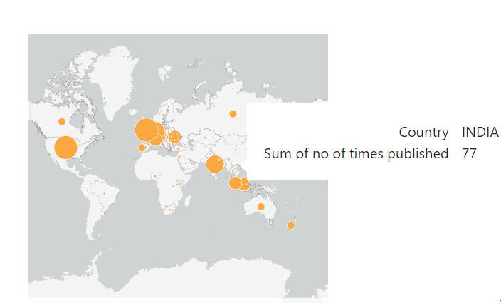

**Fig.3.9**

This image represents a map visualization of the number of times research publications have originated from various countries. India has taken the position as the third largest country by publication, with a total of 77 publications. This is indicated by the relative size of the orange circle over India, showing its prominence in global research activity.

**3.10 PUBLICATION COUNTRYWIDE- FOURTH HIGHEST PUBLICATION**

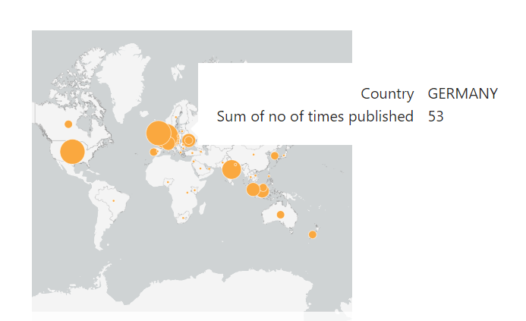

**Fig.3.10**

This image represents a map visualization of the number of times research publications have originated from various countries. Germany has taken the position as the fourth largest country by publication, with a total of 53 publications. This is indicated by the relative size of the orange circle over Germany, showing its prominence in global research activity.

**3.11 GENDER ANALYSIS – SOLE AUTHORSHIP -USA**

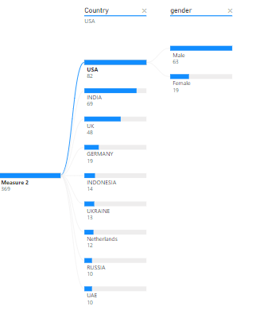

**Fig.3.11**

Based on the image data shown, there are clear gender disparities in authorship:

1. The data is broken down by country, with the highest number of authors coming from:
   * USA (82)
   * India (69)
   * UK (48)
   * Germany (19)
2. In the USA, male authors significantly outnumber female authors with 63 male authors compared to 19 female authors, showing a substantial gender gap

This pattern aligns with broader research findings that show persistent gender disparities in academic authorship, where women generally have lower representation. Studies have shown that women particularly face challenges in securing invited commentary authorships, especially at senior research levels

**3.12 GENDER ANALYSIS – SOLE AUTHORSHIP -INDIA**

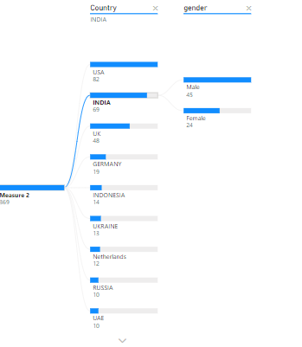

**Fig.3.12**

Based on the image data shown, in India, male authors significantly outnumber female authors with 45 male authors compared to 19 female authors, showing a substantial gender gap.

**3.13 GENDER ANALYSIS – SOLE AUTHORSHIP -UK**

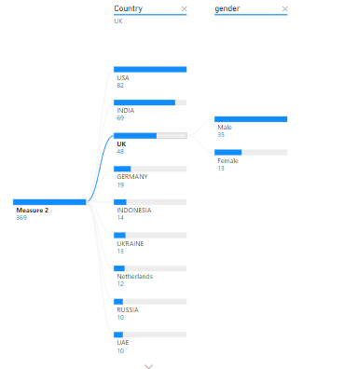

**Fig.3.13**

Based on the image data shown, in UK, male authors significantly outnumber female authors with 35 male authors compared to 13 female authors, showing a substantial gender gap.

**3.14 GENDER ANALYSIS – SOLE AUTHORSHIP - RUSSIA**

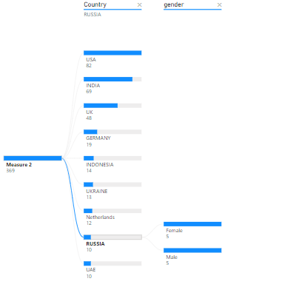

**Fig.3.14**

Based on the image data shown, in Russia, is the only country where the gender gap is null, both male and female authors have contributed equally with 5 publications applicable for each gender.

**3.15 CITATION DISTRIBUTION**

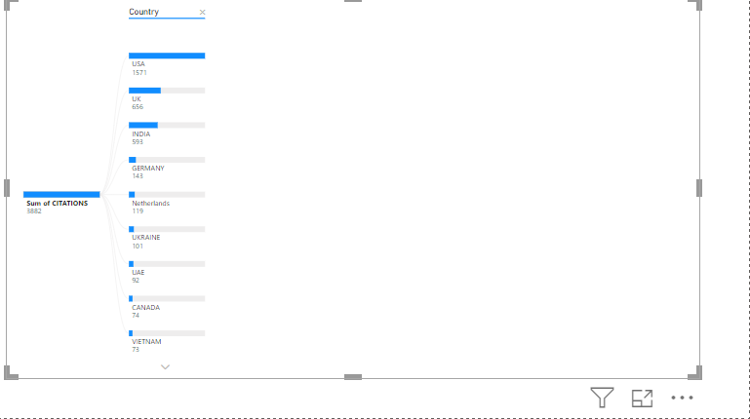

**Fig.3.15**

Based on the image data showing citation distribution by country:

1. Total citations shown are 3882, with clear geographical concentration:
   * USA leads significantly with 1571 citations (40.5% of total)
   * UK follows with 656 citations (16.9%)
   * India ranks third with 593 citations (15.3%)
2. This pattern aligns with research showing significant geographic disparities in academic influence. Studies indicate that citation patterns can be influenced by various factors:
   * Gender plays a role in citation impact, with female-authored papers showing different patterns of recognition.
   * Female last authors tend to have more female co-authors (31%) compared to male last authors.
3. The substantial gap between the top three countries (USA, UK, India) and others suggests a concentration of academic influence in these regions, with the remaining countries showing significantly fewer citations (all under 150 citations).

**FINDINGS, SUGGESTIONS & CONCLUSION**

1. **Publication Distribution:**

* **USA’s Dominance:** The bibliometric analysis indicates a clear dominance of the United States in behavioral bias research, contributing over 1,000 publications from 2014 to 2024. This signifies a strong academic and institutional interest in the study of behavioral biases in the largest financial market globally. The U.S. consistently remains a leader in the production of research output, suggesting that it has the most established infrastructure and resources for studying investor behavior and financial decision-making.
* **Other Major Contributors:** Following the U.S., the UK emerges as a distant second, contributing 237 publications, and India ranks third with 77 publications. The steep drop between the top three countries highlights the uneven global distribution of research on behavioral biases. Developed countries with larger financial markets tend to lead in behavioral finance research.
* **Elsevier’s Prominence:** Among the publishers, Elsevier BV stands out, contributing 9% of total publications, making it the largest publisher in this field. The presence of other academic publishers like Wiley, Routledge, and Springer reflects a diversity of platforms for disseminating research, though none come close to Elsevier’s dominance. The fragmentation of other publishers suggests that research is scattered across multiple sources, with no single entity holding substantial influence beyond the top few.
* **Growth and Peak:** The number of publications grew steadily between 2014 and 2022, with the highest number of publications occurring in 2022. This growth likely reflects increased interest in behavioral finance, possibly fueled by new market dynamics and global financial crises that drew attention to irrational investor behavior. However, after peaking in 2022, the publication rate appears to have stabilized or slightly declined.

1. **Author Analysis:**

* **Prevalence of Sole Authorship:** The findings indicate that single authorship remains the most common form of publication. This pattern may suggest that behavioral finance research is often conducted by individual scholars or within small academic groups, rather than large, collaborative research teams.
* **Gender Disparities:** A significant gender gap is observed in the sole authorship analysis. Male authors dominate the field, particularly in the USA, India, and the UK, where male authors outnumber their female counterparts by a wide margin. However, Russia stands out as anexception, showing equal representation between male and female authors. This gender disparity reflects broader systemic issues in academia, where women often face barriers to equal participation and recognition in research.

1. **Citation Impact:**

* **Geographical Concentration:** The U.S. also leads in terms of citation impact, contributing to 40.5% of the total citations (1,571), followed by the UK with 656 citations (16.9%), and India with 593 citations (15.3%). This concentration of citations indicates that research from these countries holds the most academic influence, likely due to higher-quality output, a stronger academic network, or greater visibility in prominent journals. The large disparity between these leading countries and others further underscores the concentration of academic influence in specific regions.

**SUGGESTIONS**

1. **Encourage More Collaborative Research Across Regions:**

The current findings reveal that research is concentrated in a few countries, particularly in the U.S., the UK, and India. To bridge the gap in research output across regions, it is essential to foster cross-country collaborations. Joint studies and partnerships between institutions from developing countries and established research centers can help promote a more diverse and comprehensive understanding of behavioral biases in different financial contexts. These collaborations can also aid in the transfer of knowledge and research techniques to regions with lower academic output.

1. **Address Gender Disparities in Academic Publishing:**

The gender imbalance in authorship, particularly in countries like the USA, India, and the UK, suggests the need for concerted efforts to support female scholars in the field of behavioral finance. Institutions and journals should prioritize diversity and inclusion, providing mentorship, networking opportunities, and equitable access to research funding for women. Encouraging female participation and recognizing their contributions can help create a more balanced research environment and enrich the field with diverse perspectives.

1. **Focus on Quality Research Output from Underrepresented Regions:**

The uneven distribution of research and citations indicates that regions like Africa, South America, and parts of Asia are underrepresented in the study of behavioral biases. Researchers, academic institutions, and funding agencies should focus on promoting high-quality research from these underrepresented regions. By incentivizing localized studies and encouraging participation in global academic conferences, it is possible to enhance the visibility and impact of research from these areas. Addressing regional gaps can lead to a more holistic understanding of behavioral biases and their implications across different financial markets.

**CONCLUSION**

The bibliometric analysis of research on behavioral biases in investment decision-making from 2014 to 2024 reveals clear geographical and gender disparities in the academic output. The United States emerges as the dominant contributor, followed by the UK and India, with Elsevier BV leading as the largest publisher in the field. Despite a significant growth trend in publications, the data shows that behavioral finance research remains concentrated in a few countries, with a sharp drop in contributions from other regions.

Single authorship is the most common form of publication, and a persistent gender gap is evident in key countries, with male authors vastly outnumbering female authors. However, Russia demonstrates equal gender representation, offering a glimpse of progress in bridging this gap. The citation impact further reinforces the geographical concentration of academic influence, with the U.S., UK, and India leading the charge in research recognition.

Moving forward, collaborative research efforts across regions, addressing gender disparities, and promoting quality research from underrepresented regions will be crucial steps in ensuring that the field of behavioral finance continues to evolve inclusively. The findings highlight the need for a more global and diverse approach to understanding how behavioral biases shape investment decisions across different financial markets.

**BIBLIOGRAPHY**

* Fama, E. F. (1970). Efficient capital markets: A review of theory and empirical work. *Journal of Finance, 25*(2), 383–417.
* Kahneman, D., & Tversky, A. (1979). Prospect theory: An analysis of decision under risk. *Econometrica, 47*(2), 263–292.
* Thaler, R. H. (1999). Mental accounting matters. *Journal of Behavioral Decision Making, 12*(3), 183–206.
* Barberis, N., & Thaler, R. H. (2003). A survey of behavioral finance. In *Handbook of the economics of finance* (pp. 1053–1128). Elsevier.
* Shefrin, H. (2002). *Beyond greed and fear: Understanding behavioral finance and the psychology of investing.* Harvard Business Review Press.
* Tversky, A., & Kahneman, D. (1974). Judgment under uncertainty: Heuristics and biases. *Science, 185*(4157), 1124–1131.
* Kahneman, D., & Tversky, A. (1982). The law of small numbers. *Psychological Bulletin, 91*(3), 493–508.
* Bell, D. E. (1982). Regret in decision making under uncertainty. *Operations Research, 30*(5), 961–981.
* Bali, T. G., Cakici, N., & Whitelaw, R. F. (2011). Maxing out: Stocks as lotteries and the cross-section of expected returns. *Journal of Financial Economics, 99*(2), 427–446.
* Durand, R. B., Newby, R. L., & Sanghani, M. (2008). Investor characteristics and trading behavior: Evidence from India. *Journal of Behavioral Finance, 9*(2), 102–115.
* Shiller, R. J. (2000). *Irrational exuberance.* Princeton University Press.
* Lo, A. W. (2004). The adaptive markets hypothesis: Market efficiency from an evolutionary perspective. *Journal of Portfolio Management, 30*(5), 15–29.
* Pertiwi, T. K., Yuniningsih, Y., & Anwar, M. (2019). The biased factors of investor’s behavior in stock exchange trading. *Management Science Letters*, 9(6), 835–842. DOI: <https://doi.org/10.5267/j.msl.2019.3.005>.
* Ahmad, M., & Maochun, Z. (2019). Personality Traits and Investor Decisions. *Asian Journal of Economics, Finance and Management*, *1*(1), 19–34.
* Rzeszutek, M., Szyszka, A., & Czerwonka, M. (2015). Investors’ expertise, personality traits and susceptibility to behavioral biases in the decision-making process. *Contemporary Economics, 9*(3), 237–352. <https://ssrn.com/abstract=2694193>
* Raut, R. K., & Kumar, R. (2018). Investment decision-making process between different groups of investors: A study of the Indian stock market. Asia-Pacific Journal of Management Research and Innovation, 14(1-2), 39–49. <https://doi.org/10.1177/2319510X18813770>
* Jain, J., Walia, N., & Gupta, S. (2020). Evaluation of behavioral biases affecting investment decision making of individual equity investors by fuzzy analytic hierarchy process. *Review of Behavioral Finance, 12*(3), 297-314. <https://doi.org/10.1108/RBF-03-2019-0044>
* Rasheed, M. H., Rafique, A., Zahid, T., & Akhtar, M. W. (2018). Factors influencing investor’s decision making in Pakistan: Moderating the role of locus of control. *Review of Behavioral Finance, 10*(1), 70-87. <https://doi.org/10.1108/RBF-05-2016-0028>
* Zahera, S. A., & Bansal, R. (2018). Do investors exhibit behavioral biases in investment decision making? A systematic review. Qualitative Research in Financial Markets, 10(2), 210-251. <https://doi.org/10.1108/QRFM-04-2017-0028>
* Omoruyi, A., & Ilaboya, O. (2019). Does behavioral biases influence individual investment decisions? Journal of Finance and Investment Analysis, 8(1), 23-45. <https://www.researchgate.net/publication/335455695>
* Kumar, S., & Goyal, N. (2015). Behavioral biases in investment decision making – A systematic literature review. Qualitative Research in Financial Markets, 7(1), 88-108. <https://doi.org/10.1108/QRFM-07-2014-0022>
* Dhar, S., Salema, S. M. K., & Saha, A. (2017). Factors affecting individual investor behavior: Empirical evidence from mutual fund investors in Dhaka City. *Management Development*, 31(3&4), 79-101. <https://www.researchgate.net/publication/329590486>
* Baker, H. K., & Puttonen, V. (2017). How behavioral biases can hurt your investing. In *Investment Traps Exposed* (pp. 107-145). Emerald Publishing Limited. <https://doi.org/10.1108/978-1-78714-252-720171004>
* Zhang, Y., & Zheng, X. (2015). A study of the investment behavior based on behavioral finance. *International Journal of Economics and Financial Issues*, 10(1), 1-5.
* Shukla, A., Rushdi, N. J., & Katiyar, R. C. (2020). Impact of behavioral biases on investment decisions: A systematic review. *International Journal of Management, 11*(4), 68-76. <https://ssrn.com/abstract=3600023>
* Santhanam, S., & Balamurugan, H. (2024). A study on the impact of behavioral factors on investment decision in Chennai. *Humanity and Social Science Studies*, 13(1), 179-184. <https://www.researchgate.net/publication/383870228>
* Gupta, Y., & Ahmed, S. (2017). The impact of behavioral biases on investor’s behavior in the Indian stock market. *International Journal of Management and Social Science Research Review*, 1(37), 175-183. <https://ssrn.com/abstract=3045280>
* Sharma, A., & Kumar, A. (2020). A review paper on behavioral finance: Study of emerging trends. *Qualitative Research in Financial Markets, 12*(2), 137-157. <https://doi.org/10.1108/QRFM-06-2017-0050>
* Talwar, M., Talwar, S., Kaur, P., Tripathy, N., & Dhir, A. (2021). Has financial attitude impacted the trading activity of retail investors during the COVID-19 pandemic? *Journal of Retailing and Consumer Services, 58*, 102341. <https://doi.org/10.1016/j.jretconser.2020.102341>