Abstract

One non-invasive way to administer medication is with transdermal patches. It is an adhesive patch that is intended to penetrate the skin and enter the bloodstream throughout the body to provide a certain dosage of medication. Compared to other methods of administration, transdermal drug delivery has a number of benefits, including being less intrusive, patient-friendly, and avoiding first-pass metabolism and the harmful acidic environment of the stomach that arises when medications are taken orally. providing a longer duration of controlled drug release as well. This review article discusses the preparation methods for many kinds of transdermal patches, such as membrane matrix, drug-in-adhesive, and micro reservoir patches. Studies have also been conducted on the different methods for evaluating transdermal dose forms.

**Keywords:** Transdermal patch, matrix patches, reservoir type, membrane matrix, drug-in-adhesive patches.

# INTRODUCTION:

## Novel drug delivery system (NDDS):

Drugs administered in the conventional dosage forms usually produce large range in fluctuations plasma drug concentrations leading to undesirable toxicity or poor effectiveness. These factors as well as other. factors the concept of the controlled drug delivery system or super repetitive dosing and unpredictable absorption, led to therapeuticsystem. A dosage form that releases one or more drugs continuously in a predetermined pattern for a fixed period of time, either systemically or to a specified target organ is a controlled drug delivery system. The primary objectives of controlled drug delivery are toensure safety and to improve efficacy of drugs as well as patient compliance. This is achieved by better control of plasma drug levels and less frequent dosing. Transdermal therapeutic systems are defined as self-contained discrete dosage forms which, when applied to the intact skin, deliver the drug(s), through the skin, at controlled rate to the systemic circulation 1, 2.

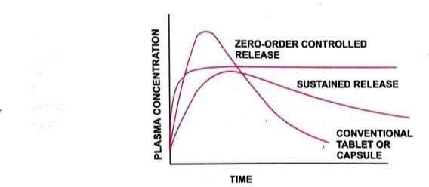

### Fig.1 Different drug release pattern

**SUSTAINED RELEASE (SR)**

* Dosage form that provides medication over extended period of time
* Follow first order release kinetics
* Usually do not promote localization of the drag at active site
* Drug release at programmed rate, dependent on external environmental.

### CONTROLLED RELEASE (CR)

* Dosage form that maintains constant drug levels in the blood tissue
* Follow zero order release kinetics
* Usually, pruinose localization of the drug at active site.
* Drug release at predetermined rate, independent of external environmental

Every drug molecule needs a delivery system to carry the drug to the site of action upon administration to the patient. Delivery of the drugs can be achieved using various type of dosage forms like tablets, capsules, creams, liquids, ointments etc. Most of these conventional drug delivery systems are known to provide immediate release of the drug with little or no control over delivery rate .To achieve & maintain therapeutically effective plasma Several doses are needed daily which may cause significant fluctuations in plasma. Because of these fluctuations in plasma levels the drug level could fall below the MEC. Such fluctuations result in unwanted side effects lack of intended therapeutic benefit. Sustained-release & controlled release drug delivery systems can reduce the undesired fluctuations of drug levels, reduce side effects, while improving the therapeutic outcome of the drug. Controlled drug delivery systems can include the maintenance of drug levels within a desired range, the need for fewer administrations, optimal use of the drug in question, and increased patient compliance 4,5.

# Mechanism of drug penetration through skin:

Three potential entry MACRO ROUTES to the viable tissue:

1. Via the sweat ducts
2. Across the continuous stratum corneum
3. Through the hair follicles with their associated sebaceous glands. Routes of penetration.

➤Low molecular weight molecules penetrate through stratum conium to some extent.

➤Skin appendages are main route for Electrolytes, polar steroids, antibiotics and colloidal particles.

➤Particles of 3-10 μ penetrate through hair follicle and particles less than 3u penetrate through stratum conium.

➤Hair follicle route may be important for ions and large polar molecules.

➤Topically applied agents such as steroids, hexa-chlorophane, griseofulvin, sodium fusidate and fusidic acid may form a depot or reservoir by binding within the stratum corneum. Once drug permeates through horny layer it readily enters living tissue and systemic circulation.

➤The average residence time of drug in dermis may be 1 min before it is washed away by blood.

➤NSAIDS reach far down to muscles to form depots.

# Transdermal patches;

The first Transdermal drug delivery (TDD) system, Transdermal -Scop developed in 1980, contained the drug Scopolamine for treatment of motion sickness. The Transdermal device is a membrane-moderated system. The membrane in this system is a microporous polypropylene film. The drug reservoir is a solution of the drug in a mixture of mineral oil and polyisobutylene. This study release is maintained over a three-day period8

## Advantages:

First pass metabolisms of drug get avoided. Gastrointestinal incompatibilities get avoided. Self-medication is possible.

Duration of action gets extended & predictable. Unwanted side effects get minimized.

Drug plasma concentration gets maintained.

Number of doses get reduces which improve patient compliance.

Therapeutic value of many drugs gets increased by avoiding problems associated with

drug like-lower absorption, GI irritation, decomposition due to hepatic first pass metabolism

## Disadvantages:

Chances of allergic reactions at the site of application like- itching, rashes, local etc. Larger molecular size of drug (above 1000) creates difficulty in absorption.

Barrier function of skin varies from site to site on the same or different person

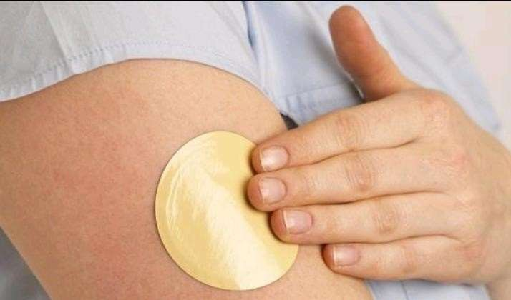

# Fig.5 Transdermal patches

Factors influencing dermal penetration of drugs:

### Biological factors: II. Physicochemical factors:

* 1. Skin condition 1. Skin hydration
  2. Skin age. 2.Temperature and PH
  3. Blood flow. 3.Diffusion coefficient
  4. Regional skin site. 4.Drug concentration
  5. Skin metabolism 5. Partition Coefficient
  6. Species difference. 6. Molecular size and Shape

# Ideal Product Requirements:

Up to two years of shelf life.

Small patch (less than 40 cm2) and practical dosage frequency (i.e., once a day to once a week). Appearance-wise acceptable (i.e., clear, white color).

Simple packaging (i.e., fewer stages and pouches needed to apply the solution) simple release liner removal (i.e. for children and elderly patients)

# Components of TDDS;

1. Polymer matrix/ Drug reservoir
2. Drug
3. Permeation enhancers.
4. Pressure sensitive adhesive (PSA).
5. Backing laminate.
6. Release liner.
7. Other excipients like plasticizers and solvents.

## Types of TDDS / Approaches in development of TDDS:

1. Membrane permeation-controlled systems / Reservoir type systems.
2. Adhesive- dispersion type systems.
3. Matrix diffusion- controlled systems.
4. Micro-reservoir type/ micro-sealed dissolution-controlled systems.

### Membrane-moderated or Permeation controlled TDDS (Reservoir type);

Drug reservoir (homogenous dispersion of drug with polymeric matrix or suspension of drug in un leachable viscous liquid medium such as silicone fluid) is encapsulated within drug impermeable metallic plastic laminate and a rate controlling polymeric membrane (ethylene vinyl acetate co polymer).

The rate of drug release is determined by the permeability of the rate controlling membrane. A layer of

adhesive polymer is applied on membrane to secure the device on skin. The rate of releaseof drug is always maintained at constant rate & the type of release is zero order.

Release rate of this TDDS depends upon the polymer composition, permeability co efficient and thickness of the rate controlling membrane and adhesive. The intrinsic rate of drug release from this TDDS is calculated by the following formula.

dQ/dt =1/Pm + 1/Pa

Whereas; Cr- Conc. of drug in the reservoir compartment

Pm- Permeability co efficient of rate controlling polymeric membrane Pa- Permeability co efficient of adhesive

### Adhesive dispersion type systems:

Drug reservoir is formulated by homogenous dispersion of drug with adhesive polymer poly(isobutylene) or poly acrylate. Then spreading of this medicated adhesive by solvent casting/ hot melt on flat sheet of drug impermeable metallic plastic backing to form thin drug reservoir layer.

On top of the drug reservoir layer, thin layers of rate controlling adhesive polymer of specific permeability and constant thickness are applied to produce an adhesive dispersion- diffusion controlled TDDS

The rate of drug release in this system is defined by a

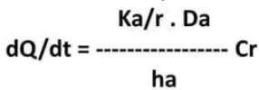

Where

Ka/r- Partition co-efficient of drug b/t adhesive layer and reservoir layer Da- Diffusion co-efficient of drug in the adhesive layer

Ha- Thickness of adhesive layer

## Matrix diffusion - controlled systems:

Drug reservoir of homogenous dispersion of drug with hydrophilic or lipophilic polymer is prepared with one of the following methods

* 1. Homogenous dispersion of finely ground drug particles with liquid polymer or highly viscous base polymer followed by cross linking of polymer chains
  2. Homogenous mixing of drug solid with rubbery polymer at an elevated temperature
  3. Dissolving the drug and polymer in a common solvent followed by solvent evaporation in a mold at an elevated temperature or under vacuum

### Micro reservoir type/ micro sealed dissolution-controlled systems.

This is combination of the reservoir and matrix diffusion systems.

### Drug reservoir:

* + 1. Suspension of drug in aqueous solution of water-soluble Drug reservoir
    2. Homogenously dispersing of drug suspension in a lipophilic polymer (silicone elastomer).
    3. As a result, discrete unleachable microscopic spheres of drug reservoir is formed which is stabilized by cross linking.
    4. Medicated polymer is moulded in to medicated polymer discs of desired surface area and controlled thickness. Depending on property of drug and desired rate of drug release disc is coated with a layer of bio compatible polymer. This medicated polymer disc is pasted on to an occlusive base plate with impermeable plastic backing. Then the adhesive polymer is spread along the circumference to form a strip of adhesive rim around the medicated disc.

### Table 1: Properties of reservoir type dissolution-controlled systems

|  |  |
| --- | --- |
| Parameters | Properties |
| Dose | Should be low in weight |
| Half life | 10/less (hrs.) |
| Molecular weight | Greater than 400 Daltons |
| Skin permeability  coefficient | Less than 0.5*10-3 cm/h |

|  |  |
| --- | --- |
| Skin reaction | Non irritating, non sensitizing |
| Oral bioavailability | Low |

**Methods of Preparation of TDDS:**

* + - 1. Asymmetric TPX membrane method.
      2. Circular Teflon mold method.
      3. Mercury substrate method.
      4. By using “IPM membranes” method.
      5. By using “EVAC membranes” method.
      6. By using free film method.

### EVALUATION PARAMETERS:

The evaluation methods for transdermal dosage form can be classified into following type

* Physicochemical evaluation
* In vitro evaluation
* In vivo evaluation
* Stability studies

### Physicochemical evaluation:

* Interaction Studies
  + Thickness of the Patch
  + Weight Uniformity
  + Folding Endurance
  + Percentage Moisture Content
  + Percentage Moisture Uptake
  + Water Vapour Permeability (WVP) Evaluation
  + Drug Content
  + Content Uniformity Test
  + Uniformity of Dosage Unit Test
  + Polariscope Examination
  + Shear Adhesion Test
  + Adhesive Studies
* Tack Properties
* Thumb Tack Test
* Peel Adhesion Test

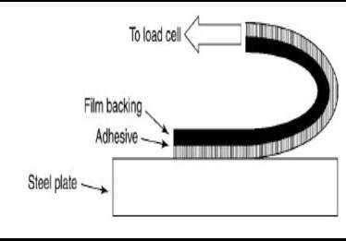

### Fig.2 Peel Adhesion

* Flatness Test
* Rolling Ball Tack Test
* 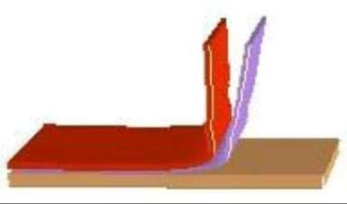Quick stick (peel-tack) Test

### Fig. 13 Quick stick (peel-tack) tests.

* Percentage Elongation Break Test
* Shear strength properties or creep resistance.

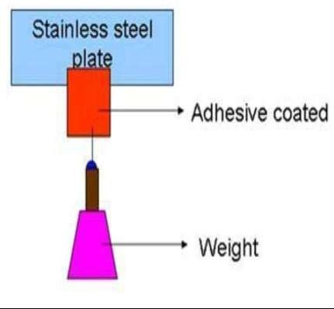

### Fig 15. Shear strength properties or creep resistance.

***In Vitro* Evaluation:**

* + ✓ ***In vitro* drug release studies:**

The paddle over disc method (USP apparatus V) can be employed for assessment of the release of the drug from the prepared patches. Dry films of known thickness are to be cut into definite shape, weighed, and fixed over a glass plate with an adhesive. The glass plate was then placed in a 500-mL of the dissolution medium or phosphate buffer (pH 7.4), and the apparatus was equilibrated to 32± 0.5°C. The paddle was then set at a distance of 2.5 cm from the glass plate and operated at a speed of 50 rpm. Samples (5 ml aliquots) can be withdrawn at appropriate time intervals up to 24 h and analyzed by UV spectrophotometer or HPLC. The experiment is to be performed in triplicate and the mean value can be calculated.

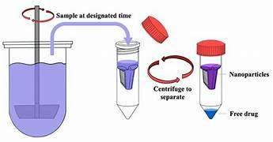

**FIG 16: *In vitro* drug release studies**

* + - ***In vitro* skin permeation studies:**

An *in vitro* permeation study can be carried out by using diffusion cell. Full thickness abdominal skin of male Wistar rats weighing 200 to 250g. Hair from the abdominal region

is to be removed carefully by using a electric clipper; the dermal side of the skin was thoroughly cleaned with distilled water to remove any adhering tissues or blood vessels, equilibrated for an hour in dissolution medium or phosphate buffer pH 7.4 before starting the experiment and was placed on a magnetic stirrer with a small magnetic needle for uniform distribution of the diffusant. The temperature of the cell was maintained at 32 ± 0.5°C using a thermostatically controlled heater. The isolated rat skin piece is to be mounted between the compartments of the diffusion cell, with the epidermis facing upward into the donor compartment. Sample volume of definite volume is to be removed from the receptor compartment at regular intervals, and an equal volume of fresh medium is to be replaced. Samples are to be filtered through filtering medium and can be analyzed spectrophotometrically or HPLC. Flux can be determined directly as the slope of the curve between the steady-state values of the amount of drug permeated mg/min vs. time in hours and permeability coefficients were deduced by dividing the flux by the initial drug load mg

/min.

* + - * Horizontal-type skin permeation system
      * Franz diffusion cell
      * Flow-through diffusion cell

***In Vivo* Evaluation Studies:**

* + ***In vivo* Evaluation:**

*In vivo* evaluations are the true depiction of the drug performance. The variables which cannot be taken into account during in vitro studies can be fully explored during *in vivo* studies. *In vivo* **evaluation of TDDS can be carried out using:**

* + Animal models
  + Human volunteers
  + Biophysical models
* **Animal models:** Considerable time and resources are required to carry out human studies, so animal studies are preferred at small scale. The most common animal species used for evaluating

transdermal drug delivery system is mouse, hairless rat, hairless dog, hairless rhesus monkey, rabbit, guinea pig etc. Various experiments conducted lead us to a conclusion that hairless animals are preferred over hairy animals in both in vitro and in vivo experiments. Rhesus monkey is one of the most reliable models for in vivo evaluation of transdermal drug delivery in man.

### Skin Irritation study:

Skin irritation and sensitization testing can be performed on healthy rabbits (average weight 1.2 to

* 1. kg). The dorsal surface (50cm2) of the rabbit is to be cleaned and remove the hair from the clean dorsal surface by shaving and clean the surface by using rectified spirit and the representative formulations can be applied over the skin. The patch is to be removed after 24 hr. and the skin is to be observed and classified into 5 grades on the basis of the severity of skin injury

Accelerated **Stability studies:**

Stability studies are to be conducted according to the ICH guidelines by storing the TDDS samples at 40±0.5°c and 75±5% RH for 6 months. The samples were withdrawn at 0, 30, 60, 90 and 180 days and analyze suitably for the drug content 22,23,24,25.

### APPLICATIONS OF TDDS:

* + - Hisetal, used in the treatment of multiple sclerosis may be formulated in TDDS using oleic acid as permeation enhancer to achieve sufficient drug delivery
    - Diclofenac sodium, celecoxib used as Non- Steroidal Anti-Inflammatory Drugs (NSAIDs),

formulated in TDDS may overcome the gastric lesions associated with oral dosing

* + - Drugs used for long term dosing in the chronic diseases like captopril, verapamil, terbutaline sulphate, pinacidil, propranolol which have a short biological half-life, considerable first pass metabolism may be formulated as TDDS to achieve prolonged steady state plasma concentration
    - Hydrophilic polymers like polyvinylpyrrolidone may provide faster drug release whereas hydrophobic polymers like ethyl cellulose can provide prolonged drug delivery
    - Gel formulation with lipid disperse system of betahis-tine has potential for the development of an efficient controlled release transdermal system
    - Enhancer and co-solvent may synergistically enhance the delivery of peptides like thyrotropin releasing hormone across the human skin
    - Prazosin Hydrochloride in membrane controlled TDDS may deliver the drug enough to maintain the minimum effective concentration and can avoid hypotension associated with high initial oral dosing
    - TDDS of indomethacin in polyvinylpyrrolidone polymer (acting as antinucleating agent) may provide better anti-inflammatory activity and lower ulcer indices compared to oral administration
    - Diclofenac sodium, existing in anionic form at skin pH may be formulated as ion-pairs with oppositely charged enhancers to enhance the transdermal deli-very compared to non- ion paired forms
    - Iontophoresis may increase the permeation rate of hydrophilic atenolol to a greater extent than permeation enhancer and overcome incomplete absorption in the gastrointestinal (GI) tract 27

## CONCLUSION

Transdermal patch technology, with its immense potential to change healthcare, has evolved into a versatile and patient-friendly medication delivery technique. Transdermal patches have the potential to revolutionize drug delivery and improve patient outcomes in the future, thanks to personalized medical procedures, targeted drug delivery, and digital health integration. Personalization, combination therapy, and bio responsive patches are examples of cutting-edge trends that researchers and doctors can use to increase therapeutic efficacy, reduce adverse effects, and enhance patient adherence. To realize its full potential and successfully address unmet medical needs,

transdermal patch technology requires continuous innovation, collaboration, and investment in research and development. Transdermal patches have the potential to greatly contribute to the advancement of precision medicine, improve disease management, and alter how healthcare is delivered.

### REFERENCES;

1. Arti Kesarwani, Ajit Kumar Yadav, Sunil Singh, Hemendra Gautam, Haribansh N Singh, et al. A review-Theoretical aspects of Transdermal Drug Delivery System. Bulletin of Pharmaceutical Research, 2013; 3(2): 78-89.
2. Sampath Sampath Kumar KP, Debjit Bhowmik, Chiranjib B, RM Chandira A review Transdermal Drug Delivery System- A Novel Drug Delivery System and its market scope and opportunities. International Journal of Pharma and Bio Sciences, 2010; 1(2).
3. Dipen Patel 1, S.A.C. Bhavesh Parmar 1, Nikunj Bhura 1, Transdermal Drug Delivery System: A Review. The pharma innovation, 2012; 1(4): 67.
4. Saurabh Pandey, Ashutosh Badola, Ganesh Kumar Bhatt, Preeti Kothiyal An Overview on Transdermal Drug Delivery System. International Journal of Pharmaceutical and Chemical sciences, 2013; 2(3).
5. P K Gaur, S Mishra, S Purohit, K Dave Transdermal Drug Delivery System: A Review. Asian Journal of Pharmaceutical and Clinical Research, 2009; 2(1): 14-20.