**ROLE OF KINESICS IN COMMUNICATION**

**SNEHA ROY**

School of Computer Science and Engineering

Vellore Institute of Technology, Vellore – 632014, Tamil Nadu, India

**Prof G. Anburaj**

Assistant Professor of English

Vellore Institute of Technology, Vellore – 632014, Tamil Nadu, India, anburaj,g@vit.ac.in

**Abstract**

The study delves into the importance of body language in communication and its impact on how we understand and interpret interactions is the focus of this research project on "The Role of Kinesics in Communication." It raises the question of how gestures and facial expressions either align with or diverge from communication and examines how this dynamic influences a listener's perception and comprehension of a speaker's message. After watching live and recorded communication instances and using a mix of methods that involved structured observations and surveys from participants both online and offline, we discovered that consistent body language signals greatly improve understanding and trustworthiness, but conflicting cues can weaken intentions, especially during conflicts or in virtual environments. This study fills a void by investigating the interaction between spoken and unspoken communication cues, which lays the groundwork for delving deeper into cultural distinctions and the significance of body language in digital interactions.

**Keywords**

*Kinesics, Body language, Non–verbal Communication, Posture, Gesture, Conversations*

**Introduction**

Body language, or kinesics, is crucial in communication as it can either reinforce or challenge spoken words using gestures and posture expressions, shaping how honest and genuine a person appears to be. It influences comprehension, trust levels, and the level of engagement in an interaction. This study delves into how body language complements or contradicts verbal communication, impacting how a message is perceived by the listener and the overall message. Clarity in today's communication environment: having a grasp of kinesics is vital for promoting transparent and authentic interactions both in personal and professional settings. Understanding communication cues, like body language, can be different depending on the context, but this research recognizes these differences and seeks to offer practical tips for better communication strategies.

**Problem Statement**

This paper looks into its main problem statement: *"To what extent does kinesics complement or even contradict the verbal message of the speaker, and in what way does this affect the audience’s perception as well as comprehension of the communicator’s intentions?"* As the core inquiry driving the study, how body language relates to or even opposes spoken words and contributes towards his overall communication is further investigated. In order to achieve this goal, the paper emphasizes the importance of the question in order to analyze how congruent and incongruent kinesic cues operate and influence the interpretation of the listeners. Although the principal analysis focuses around the significance of this correlation, a number of other factors—cultural dimensions, the relationship between kinesics and emotional intelligence, the difficulties of communicating in a virtual space, or kinesic aspects of leadership—expand our understanding of how kinesics works in different settings. These supplementary factors, treated as minor problem statements, will be discussed in the *"Scope for Further Research"* section outlining how these studies can be used to improve our understanding of kinesics in communication.

**Research Gap**

Studies on communication, in the past, have mostly dealt with the verbal part of communication, while the role of nonverbal communication, such as body language or kinesics, has been left untouched as far as the communication process is concerned. The early theories of communication put much weight on speaking and writing, relegating communication signals to the secondary or supportive level. In the mid-20th century, the same time when kinesics became recognized with representatives such as Ray Birdwhistell, some research began to assert that nonverbal behaviors such as faces, gestures, and postures are of great importance in the expression of intention and emotion. Nonetheless, during this early period of study, such works placed emphasis on kinesics alone and did not seek to proceed from kinesis to oral language.

Although much advancement has been achieved in understanding of the role of the nonverbal cues, there still exists a problem of a systematic approach to the ways how kinesics contributes to or infringes the verbal communication in the first place. The limited studies include the nuanced discrepancies, where the body moves in a different direction from the speech, and what the body speech does to listeners’ impressions of the speaker's authority and trust, as well as the intentions. This deficiency is particularly important in the contemporary globalized environment and the world, which is today, more often than not an online one where communication has to be precise more than ever. By emphasizing kinesics that either coincide with or contradict the verbal messages, more focus is placed on consequences and investigating how kinesics relates to verbal messages, more so the consequences.

**Methodology**

The observational study investigated a live or recorded communication episode situated in varied settings such as interviews, public speeches, and interpersonal conversations, emphasizing instances in which body language either supported or contradicted verbal messages. Observers identified and categorized the behaviors on the basis of kinesic cues such as gestures, facial expressions, posture, and eye contact. The structured questionnaire was administered online and offline to a variety of participants by undergraduate and postgraduate students in the fields of social sciences and computer science. The subjects were presented with scenarios amidst congruent and incongruent kinesic cues along with verbal messages and were required to rate the intent, trustworthiness, and clarity of the advisor's message according to their perception. Statistical analysis of the survey responses was performed using SPSS and R to identify patterns in listener interpretation of congruent versus incongruent kinesics. Descriptive statistics and correlation analyses were used to quantify the relationship between congruence between kinesic cues and verbal messages and the listeners' perception of intent and clarity. The results of both qualitative and quantitative analyses were then fused to generate a well-rounded perspective on how kinesics can either enhance or detract from verbal communication. Here, the patterns of congruence and incongruence and their perceived effects were appraised in the context of existing communication theories to yield a more elaborate picture of how body language contributed to communication effectiveness.

**Result Analysis**

The survey conducted on the role of kinesics finds a variety of interesting aspects related to communication through physique and kinesics in various contexts of interpersonal communication. The foremost thing noticed is to relax body posture and introduce a friendlier taste in the environment, which subsequently comforts the other person as well. And this would mean that non-verbal communication so often establishes an area conducive to socialization on the one hand but also aids in creating a space where honest conversation can blossom. That people who are relaxed in their postures are more 'open' to receiving messages from your end with more ease, therefore increasing the quality of communication.

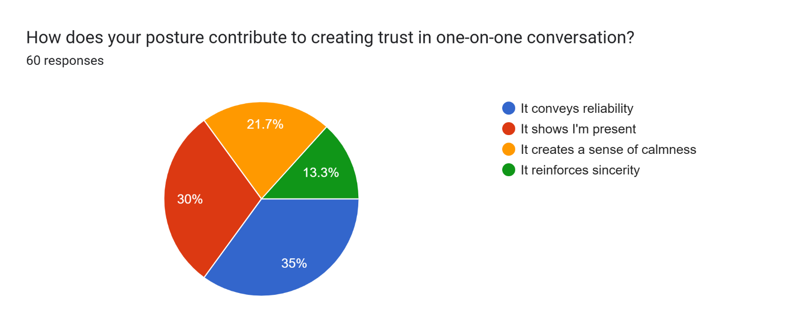

The data proves the importance of posture signaling trustworthiness and being present, both of which relate to credibility in a personal context. By using open and engaged body language, the displayer notifies his or her interlocutor that he or she is interested and honest. This serves to reaffirm the importance of nonverbal behavior in general and of posture in particular in building interpersonal role-based trust as it moderates the extent of the subsequent communication schema or intimacy level between two individuals.

With regards to demanding dialogue or clashes, discoveries indicate that a relaxed posture shapes the groundwork for passionate control and readiness to find a goal. Respondents felt that their own posture influenced the quality of the exchange; physical calmness and openness appeared to help steer what might otherwise be a tense interaction into more positive territory. It indicates that this study highlights that you will be able to manage the conflict in a more fruitful way if you are more conscious of your kinesics, which means that this will help a more ypouradorba show respect and compassion in the communication.

When the change in posture and engagement happens (which is something one does not always do consciously) is something that one can observe obsessively based on the flow and tone one uses during these kinds of conversations to sufficiently increase the performance and response that one gets. This kind of flexibility indicates a knowledge of kinesics at a micro level; someone who knows of body stances can automatically begin to syncronise with their counterpart, and so that the exchange effectively becomes a conversation, with ideas ping-ponging between them. This immediacy is/has a vital importance both in personal and professional level, so adding a bit of kinesics to the communicative fluidity as such. 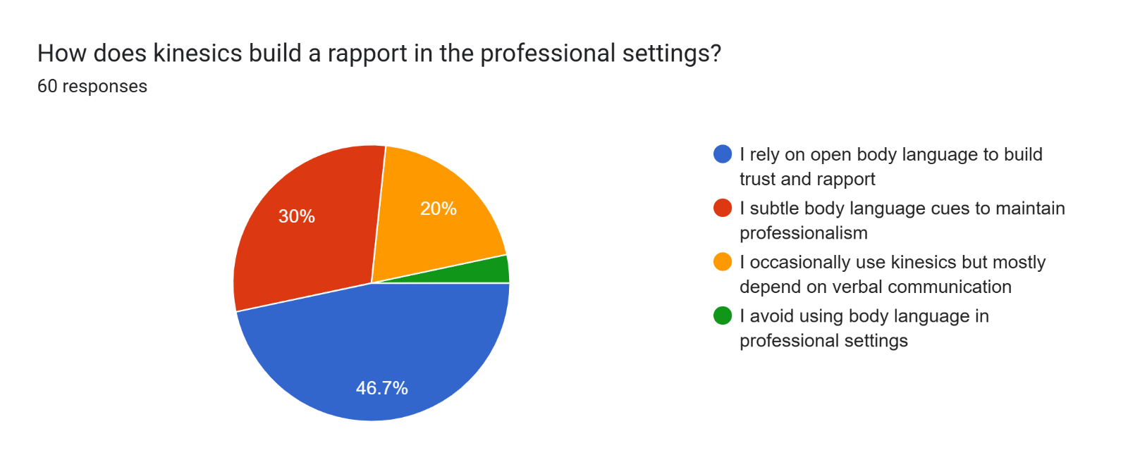

Professional setting differs quite a bit when it comes the getting trust and rapport using open body languageJenga. Results suggest that large gestures coupled with eye contact during a conversation invoke a person to create an environment in which to collaborate. On the other hand, in professional environments participants reduced body language, which contradicts research on professionalism and the role of non-verbal communication in its development. This opposition demonstrates relatively constricted body language as somehow being regarded as more professional-even though on the flip side it is a role which will stifle connection.

I was also intrigued and enthused by the insights on mirroring body language as this helps in making the quality of communication through understanding the concept of connection, richer; of course, there are some concerns related to its disingenuousness. The interplay of these factors is a subtle reminder that people should be cautious in how they present themselves to others since misinterpretation could easily occur.

The absence of kinesics in digital communication is the main drawback. These results show that a lot of misinterpretations have occurred due to the absence of kinesics which is an integral part of message therefore there is lack of fulfilment in a very essential area – receipt of emotions of the sender. It implies that one relies on text to flesh out tone instead of kinesics, which is supported by audio and visual proof, otherwise one suffers misunderstandings and confusion as a result.

Lastly, posture in team play puts value on working environments. Appropriate body language helps create a sense of common purpose and generate open participation leading to an improved group dynamic. On the flip side, other results indicate that not all such individuals feel confident in their ability to use body language effectively in group situations, and therefore identify a potential further area for development and training — and perhaps trioing the use of body language as well.

Clearly, kinesics, does make a difference in dynamics of communication as evident from the survey data-it leads to affecting confidence level, level of interest or even showing emotions of a communicating party. Although most of the findings cooperate with earlier theories on kinesics, some variations reaffirm that body language and its interpretation may be more complex than it seems. In this context, the researches highlighted that awareness and adjustment in body movement as key for effective improvement of communication abilities and development of improved inter human relations in all areas of life.

**Discussion on the Result**

The survey results present evidence that relaxed body positions have a significant influence on such dimensions as friendliness, comfort, and open communication. This corroborates the work of the kinesics literature, emphasizing the importance of body language in interpersonal similarities. Interestedly, the relaxed body posture can facilitate positive communication in a situation where the verbal and nonverbal cues are not fully congruent, despite previous research focusing on the establishment of trust through alignment between verbal and nonverbal signals. This further suggests that at times context and overall attitude might be more paramount. The implications are considerable; by developing an awareness of body language, one improves his/her communication skills, thereby making them more approachable in both personal and professional situations. Reading body language in the context of such trying situations becomes nothing short of using it as some masterstroke to recalibrate conversations in pursuit of engagement or collaboration.

**Unexpected Findings**

Several unexpected findings emerged from the survey, one of which was the emphasis on relaxed body posture as a significant factor in creating a friendly environment, increasing to above the anticipated importance of consistency between verbal and nonverbal cues. Also notable were the wide variations in perceptions of kinesics in professional settings; whereas many favor open body language to build trust, a significant minority still wish to reinforce their messages almost solely verbally. Responses regarding mirroring body language were also astonished, many considering this potentially disingenuous. Lastly, the low percentage of people who have trouble with aligning their facial expressions to show what they really feel very much indicates a problem in using nonverbal communication. These findings indicate that kinesic communication is very complicated and therefore require further deliberations toward understanding the various perceptions and interpretations of nonverbal behavior in different contexts.   
**Scope for Furthur Studies**

The field of kinesics and communication has a wide array of opportunities for future studies in several dimensions of nonverbal communication. Future investigations could study the effectiveness of different cultural forms in kinesics for communication in that different lays of nonverbal cues may differ in perception in accordance with the culture. Examining the relationship between kinesics and emotional intelligence could provide insight into how nonverbal behaviors communicate trust and other rapport-building qualities in personal and professional relationships. The effect of virtual communication forms on nonverbal cues is another area due for study, especially since remote interactions have been gaining a higher frequency. Studies could also focus on how body language affects persuasion and leadership, reflecting on the subtleties of nonverbal communication guiding the decision-making process. Overall, all the above-mentioned ideas promise to add to our understanding of kinesics and its invaluable role in shaping effective communication across an array of contexts.

**Conclusion**

This study underscores the critical role kinesics plays in communication, revealing how nonverbal cues like gestures, posture, and facial expressions can either reinforce or contradict verbal messages, shaping the listener’s perception of clarity, trustworthiness, and intent. The findings indicate that congruent body language enhances trust and engagement, creating an environment conducive to positive communication. Relaxed postures and open gestures emerged as key contributors to fostering openness and collaboration, even in challenging situations. However, incongruent kinesics, particularly during conflicts or in virtual settings, often led to misinterpretations and reduced communication effectiveness. The research also highlights the challenges posed by digital communication, where the absence of kinesic cues can confuse, emphasizing the need for strategies to overcome these limitations. Intriguing insights, such as the unexpected significance of relaxed body posture and the mixed perceptions of mirroring body language, suggest that verbal and nonverbal communication is more nuanced than traditionally understood.

By addressing these dynamics, this study establishes kinesics as essential to effective communication and calls for greater awareness of nonverbal behaviors. It lays the groundwork for future research into cultural influences, emotional intelligence, and the role of kinesics in digital and professional interactions.

**Reference**

1. Key, Mary Ritchie. "Paralanguage and Kinesics (Nonverbal Communication)." (1975).
2. Sundaram, Dilip S., and Cynthia Webster. "The role of nonverbal communication in service encounters." *Journal of Services Marketing* 14.5 (2000): 378-391.
3. Afifi, Walid A. "Nonverbal communication." *Explaining Communication*. Routledge, 2013. 39-62.
4. von Raffler-Engel, Walburga. "Developmental kinesics: cultural differences in the acquisition of nonverbal behavior." *Word* 27.1-3 (1971): 195-204.
5. Bunglowala, Arifa, and Aaquil Bunglowala. "Nonverbal communication: An integral part of teaching learning process." *International Journal of Research in Advent Technology* 1.1 (2015): 371-375.
6. Gunawan, Gunawan, Syarifuddin Dollah, and Geminastiti Sakkir. "The Use of Kinesics as Nonverbal Communication in the Classroom at University of Muhammadiyah Bone." *EduLine: Journal of Education and Learning Innovation* 4.2 (2024): 209-215.
7. Poyatos, Fernando. "Language and nonverbal systems in the structure of face-to-face interaction." *Language & Communication* 3.2 (1983): 129-140.
8. Najarzadegan, Sahar, and Azizollah Dabaghi. "Effective nonverbal communications and English language classrooms." *Research in English language pedagogy* 2.2 (2014): 109-118.
9. Müller, Cornelia, et al. "Body-language-communication." *An international handbook on multimodality in human interaction* 1.1 (2013): 131-232.
10. Gregersen, Tammy S. "Language learning beyond words: Incorporating body language into classroom activities." *Reflections on English language teaching* 6.1 (2007): 51-64.
11. Dittmann, Allen T. "The role of body movement in communication." *Nonverbal behavior and communication*. Psychology Press, 2014. 37-64.
12. Imai, Gary. "Gestures: Body language and nonverbal communication." 2002,
13. Goman, Carol Kinsey. *The nonverbal advantage: Secrets and science of body language at work*. ReadHowYouWant. com, 2009.
14. Fast, Julius. *Body language*. Vol. 82348. Simon and Schuster, 1970.
15. Schouten, Barbara C., and Ludwien Meeuwesen. "Cultural differences in medical communication: a review of the literature." *Patient education and counseling* 64.1-3 (2006): 21-34.
16. Hooker, John. "Cultural differences in business communication." *The handbook of intercultural discourse and communication* (2012): 389-407.
17. Tannen, Deborah. "Cross-Cultural Communication." (1983).
18. Philipsen, Gerry. "Cultural communication." *Handbook of international and intercultural communication* 2 (2002): 51-67.
19. Jang, Ha-Yong, and George A. Barnett. "Cultural differences in organizational communication: a semantic network analysis 1." *Bulletin of Sociological Methodology/Bulletin de Méthodologie Sociologique* 44.1 (1994): 31-59.
20. Tili, Tiffany R., and Gina G. Barker. "Communication in intercultural marriages: Managing cultural differences and conflicts." *Southern Communication Journal* 80.3 (2015): 189-210.
21. Carbaugh, Donal. "Communication and cultural interpretation." (1991): 336-342.
22. Scheflen, Albert E. "The significance of posture in communication systems." *Psychiatry* 27.4 (1964): 316-331.
23. Mehrabian, Albert. "Significance of posture and position in the communication of attitude and status relationships." *Psychological bulletin* 71.5 (1969): 359.
24. Bull, Peter E. *Posture & Gesture: Posture & Gesture*. Vol. 16. Elsevier, 2016.
25. Vinayagamoorthy, Vinoba, et al. "The role of posture in the communication of affect in an immersive virtual environment." *Proceedings of the 2006 ACM international conference on Virtual reality continuum and its applications*. 2006.
26. LaFrance, Marianne, and Maida Broadbent. "Group rapport: Posture sharing as a nonverbal indicator." *Group & Organization Studies* 1.3 (1976): 328-333.
27. Givens, David B. "Posture is Power." *Barrister* 8 (1981): 15.
28. De Gelder, Beatrice, and Marta Poyo Solanas. "What postures communicate." *Enfance* 3.3 (2022): 353-365.
29. Goldin-Meadow, Susan. "The role of gesture in communication and thinking." *Trends in cognitive sciences* 3.11 (1999): 419-429.
30. Hostetter, Autumn B. "When do gestures communicate? A meta-analysis." *Psychological bulletin* 137.2 (2011): 297.
31. Kendon, Adam. "Do gestures communicate? A review." *Research on language and social interaction* 27.3 (1994): 175-200.
32. Kelmaganbetova, Aiman, et al. "The Role of Gestures in Communication." *Theory and Practice in Language Studies* 13.10 (2023): 2506-2513.
33. Siger, Leonard. "Gestures, the language of signs, and human communication." *American Annals of the Deaf* (1968): 11-28.
34. Roth, Wolff-Michael. "Gestures: Their role in teaching and learning." *Review of educational research* 71.3 (2001): 365-392.
35. Bohannon, Leanne S., et al. "Eye contact and video-mediated communication: A review." *Displays* 34.2 (2013): 177-185.
36. Davidhizar, Ruth. "Interpersonal communication: a review of eye contact." *Infection Control & Hospital Epidemiology* 13.4 (1992): 222-225.
37. Senju, Atsushi, and Mark H. Johnson. "The eye contact effect: mechanisms and development." *Trends in cognitive sciences* 13.3 (2009): 127-134.
38. Lee, Edward A., and David G. Messerschmitt. *Digital communication*. Springer Science & Business Media, 2012.
39. Lapidoth, Amos. *A foundation in digital communication*. Cambridge University Press, 2017.
40. Madhow, Upamanyu. *Fundamentals of digital communication*. Cambridge university press, 2008.
41. Gallager, Robert G. *Principles of digital communication*. Vol. 1. Cambridge, UK: Cambridge University Press, 2008.
42. Krauss, Robert M. "The psychology of verbal communication." *International Encyclopaedia of the Social and Behavioral Sciences. London: Elsevier* (2002): 16161-16165.
43. Liu, Meina. "Verbal communication styles and culture." *Oxford research encyclopedia of communication*. 2016.
44. Rocci, Andrea, and Louis de Saussure, eds. *Verbal communication*. Vol. 3. Walter de Gruyter GmbH & Co KG, 2016.
45. De Saussure, Louis, and Andrea Rocci. "Verbal communication: An introduction." *Verbal communication (Handbook of Communication Sciences, vol. 3)* (2016): 3-20.
46. Bambaeeroo, Fatemeh, and Nasrin Shokrpour. "The impact of the teachers’ non-verbal communication on success in teaching." *Journal of advances in medical education & professionalism* 5.2 (2017): 51.
47. Siegman, Aron W. "The telltale voice: Nonverbal messages of verbal communication." *Nonverbal behavior and communication*. Psychology Press, 2014. 351-434.
48. Bateson, Mary Catherine. "Kinesics and paralanguage." *Science* 139.3551 (1963): 200-200.
49. Birdwhistell, Ray L. "Background to kinesics." *ETC: A Review of General Semantics* (1983): 352-361.
50. von Raffler-Engel, Walburga. "Developmental kinesics: cultural differences in the acquisition of nonverbal behavior." *Word* 27.1-3 (1971): 195-204.
51. Kleshchukov, Volodymyr Petrovych. "About the interaction of intonation and kinesics in music." (2023).
52. Aziz, Anbreen, et al. "Actions Speak Louder Than Words: Impact Of Kinesics On Undergraduate Medical Education." *Journal of Ayub Medical College Abbottabad-Pakistan* 33.4 (2021).
53. Nuessel, Frank. "Teaching kinesics through literature." *Canadian Modern Language Review* 41.6 (1985): 1014-1019.
54. Raffler-Engel, Walburga von. "Kinesics and paralinguistics: A neglected factor in second-language research and teaching." *Canadian Modern Language Review* 36.2 (1980): 225-237.
55. Prozesky, Detlef R. "Communication and effective teaching." *Community Eye Health* 13.35 (2000): 44.
56. Martinez, Laura, et al. "Contributions of facial expressions and body language to the rapid perception of dynamic emotions." *Cognition and Emotion* 30.5 (2016): 939-952.
57. Afifi, Walid A. "Nonverbal communication." *Explaining Communication*. Routledge, 2013. 39-62.
58. Poggi, Isabella. "Mind, hands, face and body." *A goal and belief view of multimodal communication. Weidler, Berlin* (2007).
59. Buck, Ross. "Social and emotional functions in facial expression and communication: The readout hypothesis." *Biological psychology* 38.2-3 (1994): 95-115.
60. Thompson, Diana Frumkes, and Leo Meltzer. "Communication of emotional intent by facial expression." *The Journal of Abnormal and Social Psychology* 68.2 (1964): 129.
61. Motley, Michael T., and Carl T. Camden. "Facial expression of emotion: A comparison of posed expressions versus spontaneous expressions in an interpersonal communication setting." *Western Journal of Communication (includes Communication Reports)* 52.1 (1988): 1-22.
62. Mandal, Manas K., and Avinash Awasthi, eds. *Understanding facial expressions in communication: Cross-cultural and multidisciplinary perspectives*. Springer, 2014.
63. Hennenlotter, Andreas, et al. "A common neural basis for receptive and expressive communication of pleasant facial affect." *Neuroimage* 26.2 (2005): 581-591.
64. Yang, Chi-Lan, et al. "Affective Profile Pictures: Exploring the Effects of Changing Facial Expressions in Profile Pictures on Text-Based Communication." *Proceedings of the 2023 CHI Conference on Human Factors in Computing Systems*. 2023.
65. Bogart, Kathleen R., Jonathan Cole, and Wolfgang Briegel. "On the Consequences of living without facial expression." (2014).
66. Sathik, Mohamed, and Sofia G. Jonathan. "Effect of facial expressions on student’s comprehension recognition in virtual educational environments." *SpringerPlus* 2 (2013): 1-9.