CONVENTIONAL STREAMER DATA DEGHOSTING USING FREQUENCY-VARYING REFLECTION COEFFICIENT FOR AN IMPROVED DECONVOLUTION
Paula Ukerun¹, Dr. Sylvester Ugwu², Rasaki Salami³
Department of Geology, University of Port Harcourt², Total Energies^{1 & 3}

Email: paulaukerun@gmail.com

Abstract
In this study, we present the benefits of applying source and receiver sides ghost removal within optimized frequency bands. The occurrence of multiples in the seismic signal limits the resolution of seismic events. In most conventional seismic surveys, short-period multiples are generated from downward reflections of seismic waves by the sea surface on the source and receiver sides; with a reflection coefficient close to -1, which varies with the angle of incidence. Using data-derived deghosting operators can improve signal resolution and seismic bandwidth for more accurate subsurface imaging. The data used in this research had a nominal source depth of 5m and receiver depth of 8m, giving a source and receiver notch frequencies of 150Hz and 94Hz respectively. Deconvolution in the F-K (Stolt) migration domain showed an improvement in signal resolution with the removal of the source and receiver sides generated short-period multiples. Higher reflection coefficient estimation for the ghosts improved the low-frequency signal recovery with potential loss in high-frequency signal quality. To optimize the signal-to-noise ratio over the frequency range, frequency-varying reflection coefficients were used in data deghosting in a novel approach; the improved quality of the deghosted data indicates a dependence between the reflection coefficient of the ghost operation and the frequencies.
Keywords: Streamer, deghosting, subsurface imaging, notch frequencies, deconvolution, reflection coefficient, signal-to-noise ratio.
Introduction
Source and receiver side ghosts are short-period seismic multiples of primary reflections rebounded off the free surface at the source and receiver side during marine seismic acquisition (Figure 1). Up-going seismic waves are reflected downward by the sea surface with a near -1 reflection coefficient. (Zhou et. al, 2012, O’Driscoll et. al, 2013). This would indicate that the ghost energy is predicted to have the same (inverse) amplitude as the primary signal. However, the reflection coefficient changes with angle of incidence (Yilmaz, 2001). Many conventional streamer data are acquired with source- and receiver-side ghosts reflecting off the free surface, reducing signal resolution and processing bandwidth through constructive and destructive interferences with the desired primary signals.
Deghosting processes (used in this study refer to the removal of both receiver and source side ghost reflections from the sea surface) can be applied to conventional streamer data acquired with single component streamers (Zhou et. al, 2013). In this study, a data-driven approach was used to derive the de-ghosting operators for deconvolving the recorded reflections off the water layer at the source and receiver sides. The applied deghosting method uses a non-linear optimization to derive a stable operator which, when applied to conventional marine streamer seismic data, recovers much of the signal present in the recorded data, but weakened by the presence of the ghosts at the notch frequencies (O’Driscoll et. al, 2013).
As the P-wave travels through rock, its amplitude decays due to effective Q as a function of frequency and travel time. As it travels through a rock/medium, the higher frequencies have more cycles than the lower frequencies and are more attenuated (Flutterman, 1962). This may indicate that a lower Reflection Coefficient (RC) is required to improve deghosting results at higher frequencies by the use of varying Reflection Coefficient across the frequency range as demonstrated in this study.
The bandwidth of recorded seismic data is typically between 2-250Hz and is limited in conventional streamer data by the presence of both source and receiver ghost notches. The source and receiver ghost reflections can be predicted using the depths and the near-surface water velocity; and their cycles can be identified as notches in the amplitude spectrum. Absorption (Q) is another wavelet distortion factor that can be compensated for to recover the spectrum of conventional streamer data during seismic data processing.
In this paper we present the benefit of applying deghosting at targeted frequency intervals versus the application of deghosting across all frequencies.
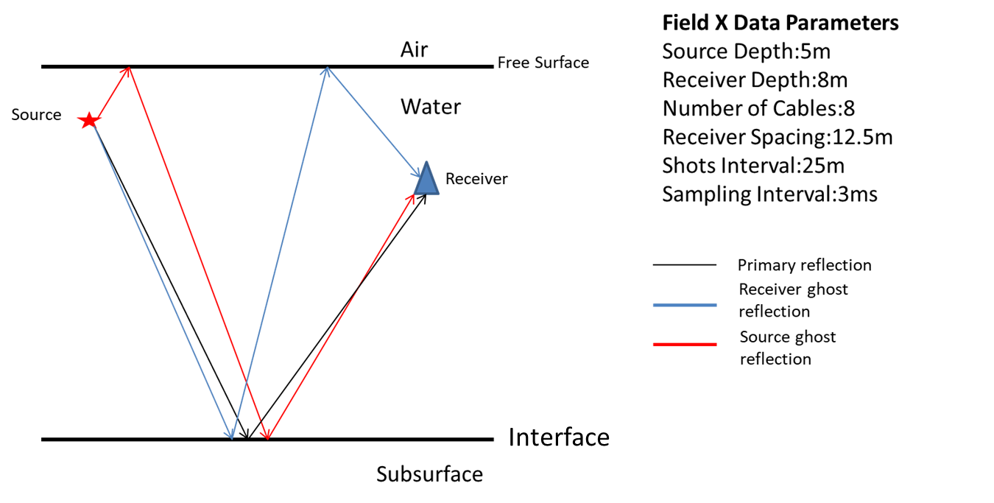
Figure 1 Cartoon illustration of receiver and source ghosts generation

Methodology
The seismic data used in this study was acquired using a single component streamer on a producing field in deep-offshore Nigeria, the streamer configuration is shown in (Figure 2). The nominal source and receiver depths of the acquisition are 5m and 8m respectively. The expected ghost notches from these depths are 150Hz and 94Hz for the source and receiver side ghosts at a water velocity of 1500m/s. However due to resampling to 3ms and applying a high-cut filter (HC) (120Hz, 72dB / OCT) to the data; the districting source notch is not very apparent. Also, variation of receiver depth between 6-10m from the nominal receiver depth of 8m, with most values between +/- 0.5m of nominal depth, caused a variation of the receiver notch in the frequency-amplitude spectrum ranging between 88Hz and 100Hz (Figure 2). The value of the source depth header was constant at 5m.
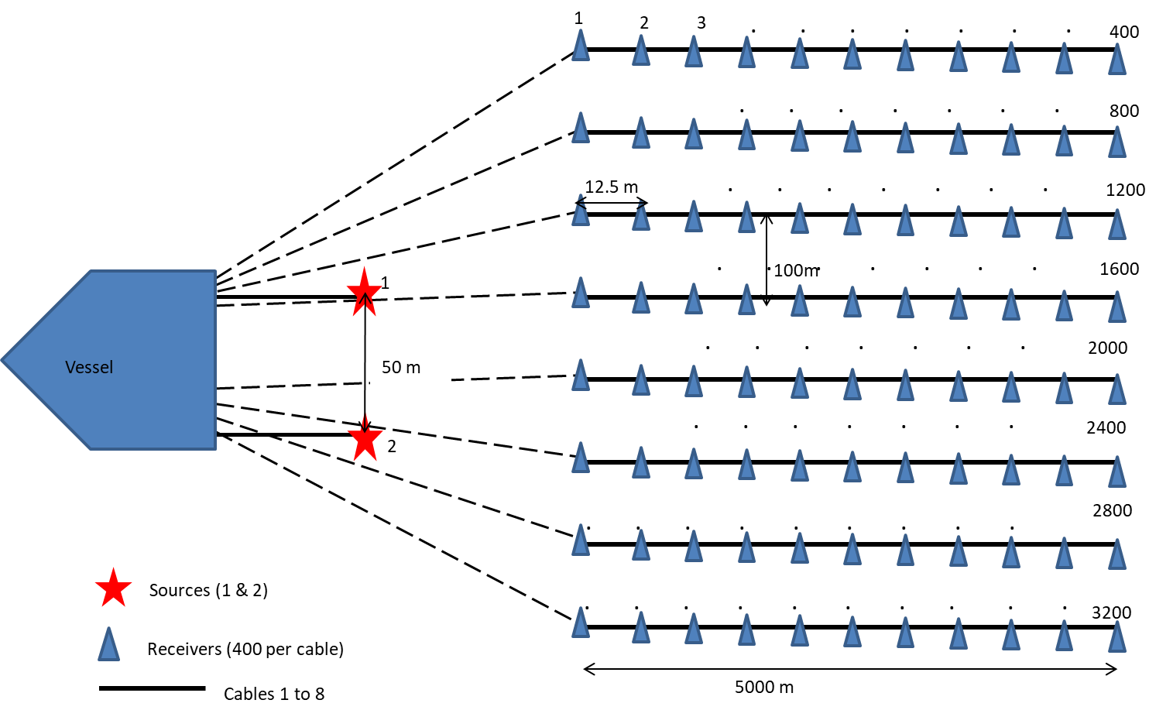
Figure 2 Cartoon representation of acquisition spread of research data based on SEGY header information
It is important that the data is sufficiently free of random and coherent noise bursts prior to deghosting to avoid boosting of noise during the deconvolution process. The success of data-driven de-ghosting has enabled many conventional streamer data to be reprocessed for better reservoir imaging and velocity model building (Agnisola et. al, 2019; Chigbo, et. al, 2021). The data used in this study has undergone couple of preprocessing steps as well as various noise attenuation processes (Table 1) and has been resampled from 2ms to 3ms, giving a Nyquist frequency of about 167Hz with a HC filter applied (Figure 3).
Table 1 Key steps of preprocessing applied to input data
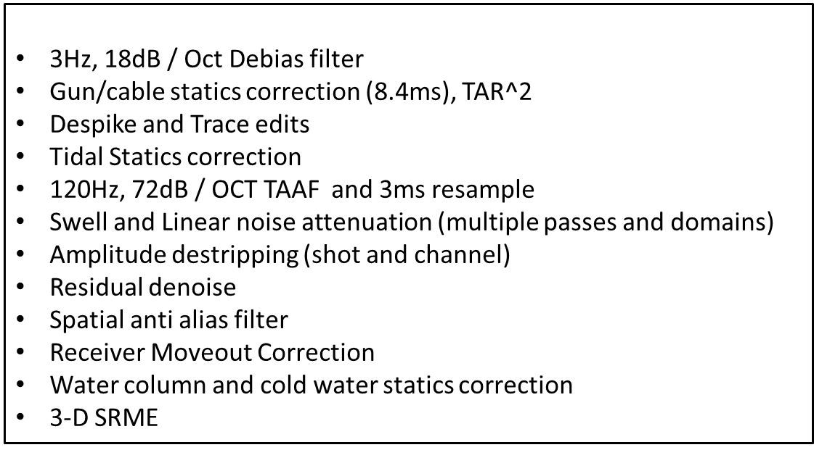
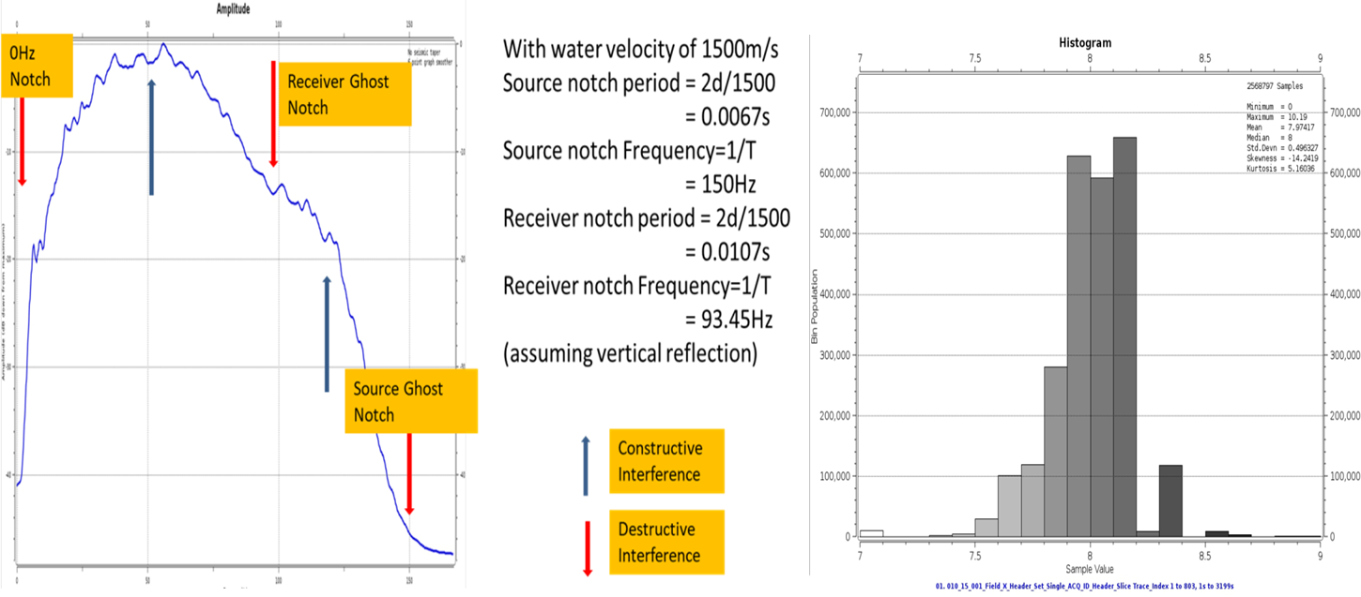
Figure 3 Amplitude spectrum of input data with constructive peaks and destructive notches caused by source and receiver side ghosts interferences (Left). Right is histogram of receiver depths.
Deghosting was applied to shot gathers using wave equation (Stolt) migration in the frequency domain which helps to remove the angular dependency of the ghost period as the convolutional model is based on 1D assumption (Yilmaz, 2001) (Figure 4). The migration scheme uses a 2D Fourier transform in both the temporal and spatial domain; by using the full scalar wave equation in the conjugate space, the method eliminates (up to aliasing frequency) dispersion altogether (Stolt, 1978). The measured energy of the data-derived ghost is determined by the estimated reflection coefficient of the ghost used in the deconvolution. The gun and cable statics were backed off before the deghosting process.
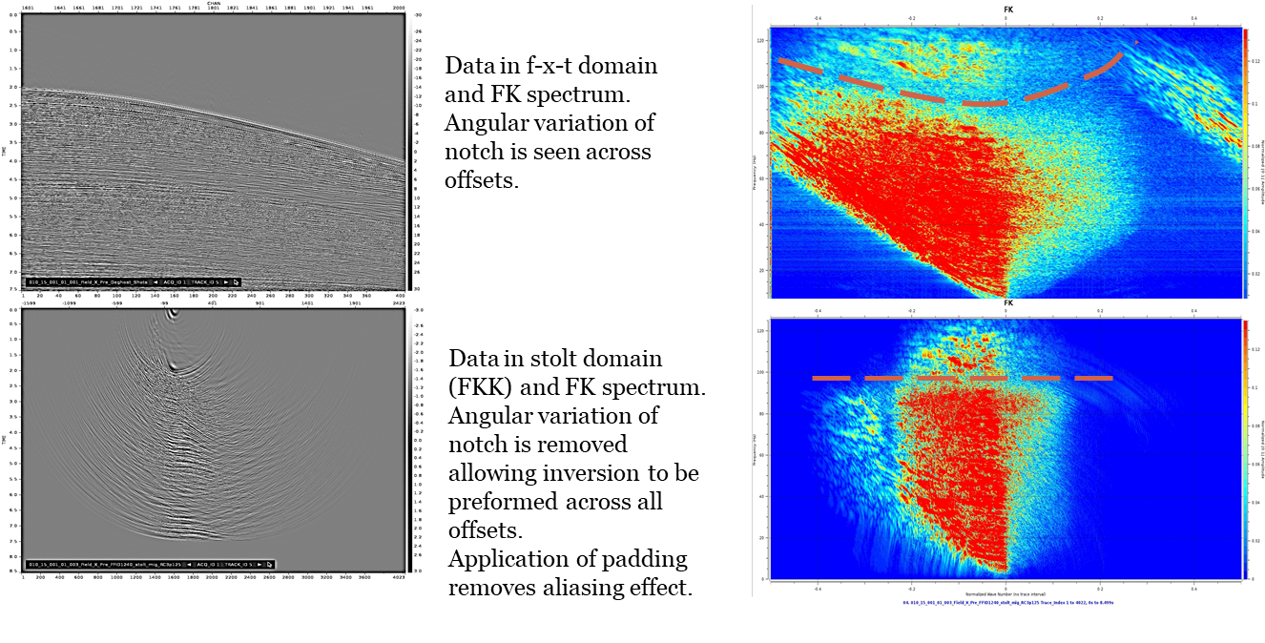
Figure 4 Data in f-x-t domain (above) and FKK domain (below). Deghosting is done in the FKK domain where the near to far offset is better aligned for improve deconvolution of ghost energy

Using a procedure not known to have been previously used in any documentation of data deghosting, tests were performed to optimize the estimate of the RC of the spirit energy to ensure an optimal subtraction of the ghost energy without overestimation that would cause artifacts to develop. Seven initial tests results using different ranges of Reflection coefficient (RC) estimate for the source and receiver ghost were compared (Figure 5, Table 2 left). From the shot and channel gathers analysis, the low-frequency content of the data appeared to be improved with increasing RC, while the higher-frequency content appeared more stable with lower RC. It was observed that Tests 3, 4, and 5 gave the best results; with improved low-frequency content in test 5 and evidence of data stability at higher frequency in test 3 and 4 (Figure 6 and 7). To optimize the observed improvement in the deghosting across Test 3 through 5, varying bandwidth deghosting was tested using parameters shown in Table 2 right.

Table 2 Reflection Coefficient test range for single RC in Tests 1 – 7 (left) and using varying Reflection Coefficient at varying frequency bands (right).

Test # | Receiver Ghost RC | Source Ghost RC
1 | 3-4 | 4-5
2 | 4-5 | 5-6
3 | 4-5 | 6-7
4 | 5-6 | 6-7
5 | 6-7 | 7-8
6 | 7-8 | 8-9
7 | 8-9 | 9-1

Frequency (Hz) | Rec. Ghost RC | Source Ghost RC
0-0-10-15 | 0.7 – 0.8 | 0.7 – 0.8
10-15-70-80 | 0.4 – 0.5 | 0.5 – 0.6
70-80-160-180 | 0.5 – 0.6 | 0.6 – 0.7

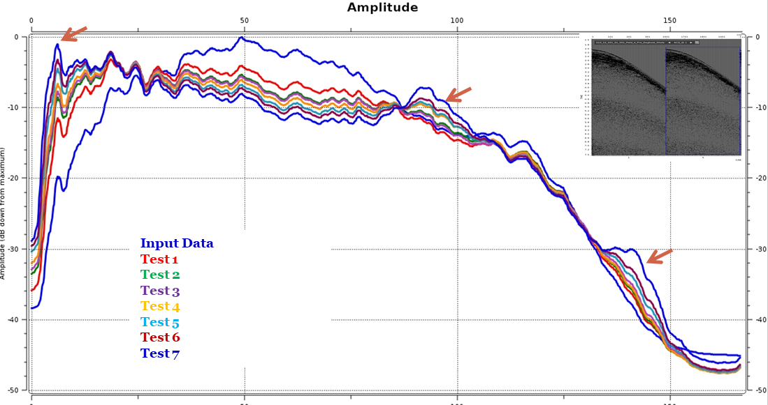
Figure 5: Amplitude spectra of shot gathers from Tests 1 -7. Spectrum at lower frequency appears boosted with increasing RC while the amplitude spectrum appears more distorted with increasing RC estimation (arrow indication Test 7 spectrum).

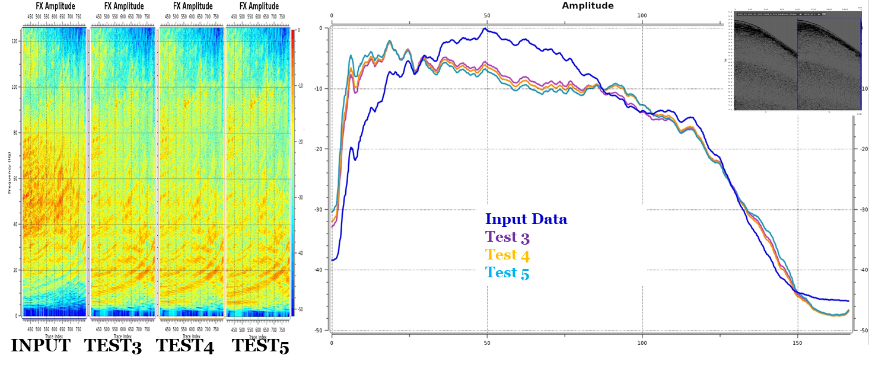
Figure 6 FX and amplitude spectra of Test 3, 4 and 5 shot gathers.

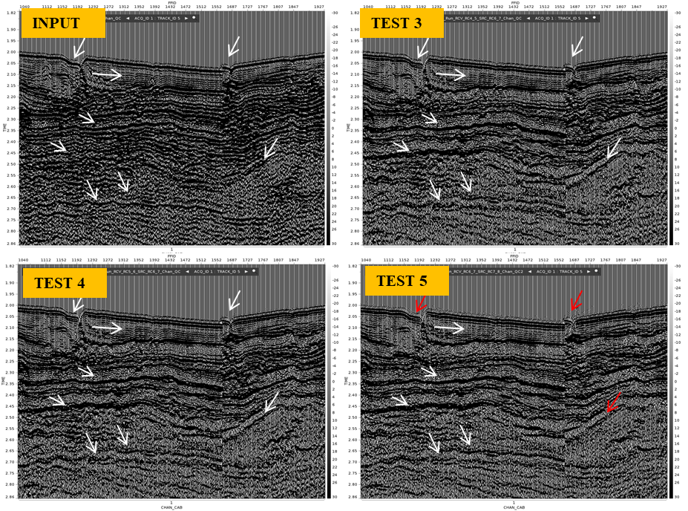
Figure 7: Near Channel Gathers of Tests 3 – 5. Low frequency seen to improve with higher RC estimation but higher frequencies signals appear less optimal (red arrows) with increasing RC estimation

Result
The results from Test 4 and 5 were compared to results from using varying RC across the frequency range (Test 8). Shot gathers QC of Test 4, Test 5 and Test 8 (Figure 8) showed improvement in the data from low to high frequency. Using Test 8 with varying RC across frequency range appears to show best improvement in the low to high frequency signal.
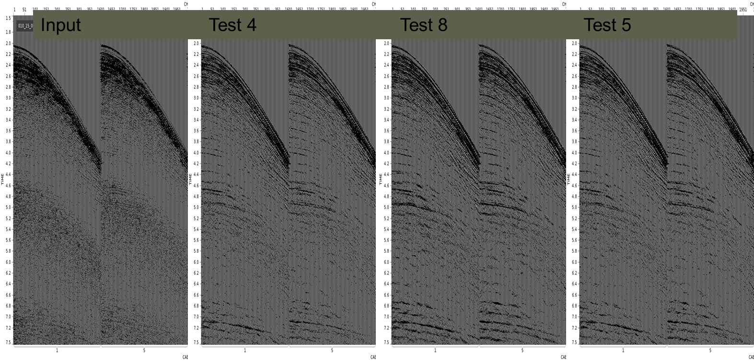
Figure 8: Shot gathers of data before and after deghosting. Signal appears more enhance with use of Test 8 varying RC across the frequency range
Analysis of near-channel gathers show correction of possible high frequencies near-surface phase distortion (observed in Test 5) using the frequency variable RC of Test 8 (Figure 9). The near channel gathers FK spectra showed the absence of aliased energy observed in Test 5 due to high RC indicating that frequency varying RC is better able to handle ghost removal properly across all the observed frequencies (Figure 10).

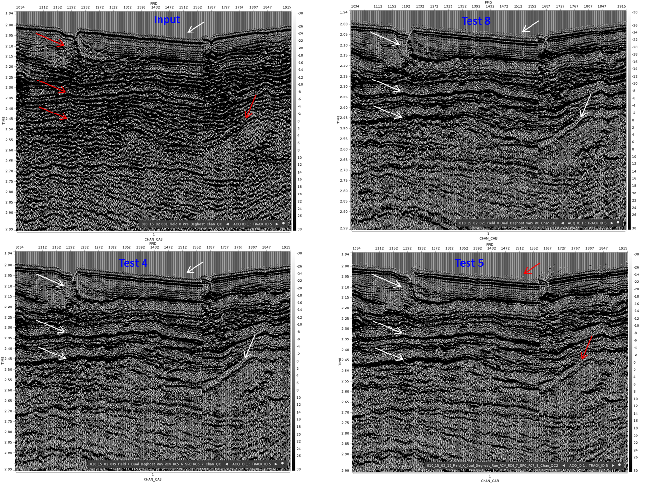
Figure 9: Near Channel gathers displays appears to show correction of phase distortion of higher frequencies observed in Test 5 near the water bottom with the use of Test 8 deghosting
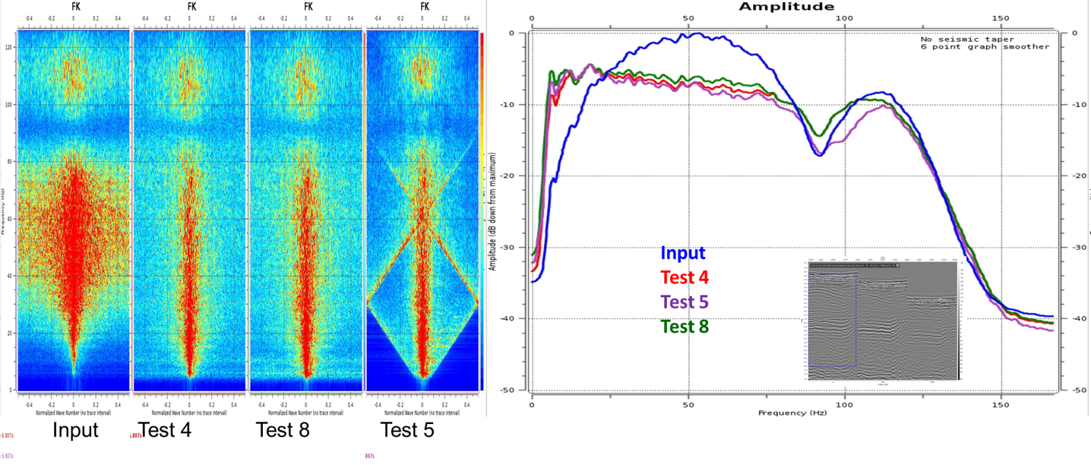
Figure 10: Near channel gather FK spectra show aliasing with RC increment in Test 5. This aliasing effect is not observed in Test 8 (variation of the RC)
Increasing low-frequency content from deghosting dominate the amplitude spectrum due to the absorption (Q) effect, the high frequencies are recovered with the application of Q compensation. Comparison of pre-migration stacks using a test Q of 35Hz at reference frequency of 100Hz and maximum gain of 3 showed that the resolution of the data using Test 8 appeared slightly better than using a constant high RC in Test 5 (Figure 10).
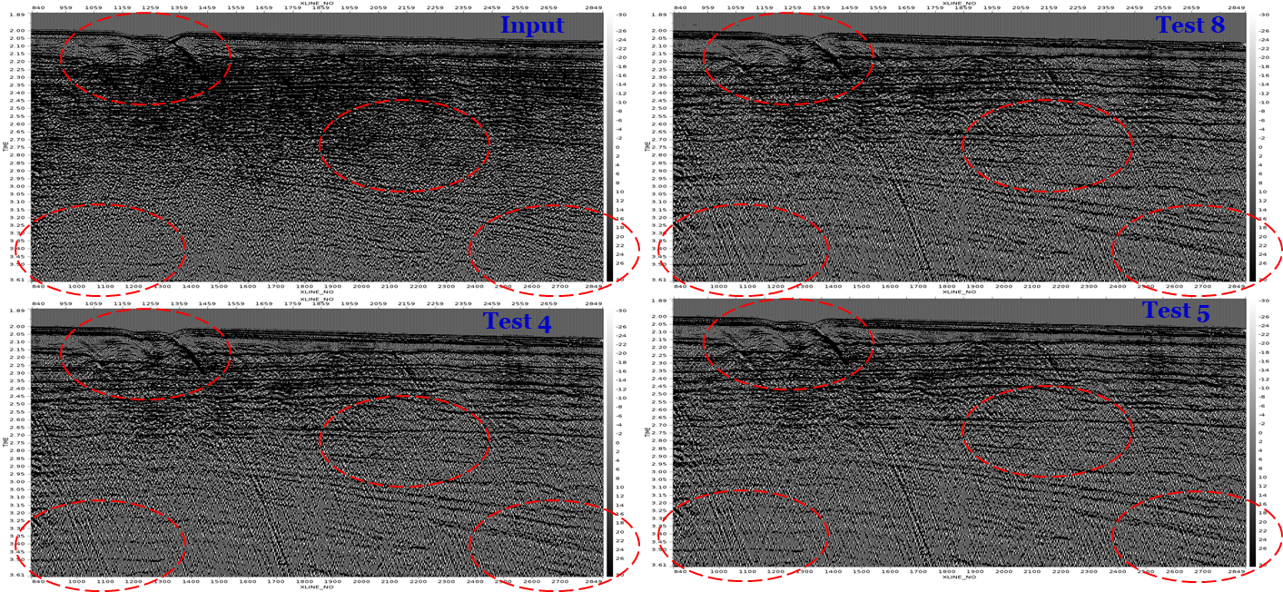
Figure 11: Pre-migration 3D Qstacks show some improved signal resolution of continuity and dips with the use of Test 8

Final pre-migration 3D stacks result showed improvement of the data bandwidth with the application of deghosting to the conventional acquired data; with most improvement from the low to high frequency range observed with the use of Test 8.
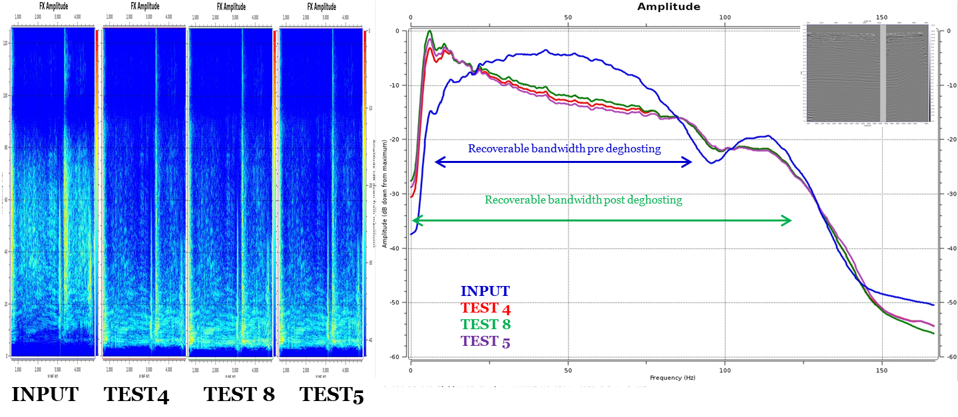
Figure 12: Pre-migration 3D stacks spectra FX and amplitude spectra without Q compensation show broadband enhancement of the data with deghosting
Conclusion
This study aims to develop an improved methodology to improve the signal-to-noise ratio by optimizing the source and receiver ghost removal using frequency-varying reflection coefficient. This can help improve the resolution of deeper reservoirs and shallow anomalies and reduce the turnaround time of either a fast-track processing or a full reprocessing project of a conventional streamer data.
Increasing the estimation of the RC during deghosting appears to cause less optimal ghost removal in the high-frequency signals (and introduce artifacts) while enhancing the low-frequency signals. By using varying RC at various frequency bands in a method not known from any past research reports, optimal ghost removal was achieved in the source and receiver-side deghosting.
The bandwidth of the seismic data analysis is improved by applying source and receiver sides deghosting techniques. The linear curve of the amplitude spectrum post-deghosting shows the expected natural decay caused by absorption (Q).
Acknowledgments
The authors would like to thank NUPRC (former DPR) and Total Energies for permission to show this data, and Bulwark-ION (ION now acquired by TGS) for providing technical assistance to complete this research work for my 2023 MS thesis on ‘Signal Enhancement from De-Ghosting of Offshore Streamer Data in X-Field of Niger Delta’.
.

References
Agnisola, P., O’Driscoll, R., Smith, P., Chu, D., Assiak, E., Ugwueze, C. and Ukerun P. (2019). The Effect of Deghosting On the 4D Response: Usan Field, Nigeria. SEG Technical Program Expanded Abstract, pp 5214 - 5218. DOI: https://doi.org/ 10.1190/segam2019-3201739.1
Chigbo. J., Smith, M., Onojete, A., Ukerun, P., Mascomere, J., Ekut, E., Esotu, M. and Pou-Palome, S. (2021). Multi Azimuth Imaging of an Oil Bearing Faulted Sandstone Reservoir: A Nigeria Deep Offshore Case Study. 82nd EAGE Annual Conference and Exhibition. pp 1 – 5. DOI: https://doi.org/10.3997/2214-4609.202112756
Futterman, W. I. (1962). Dispersive Body Waves: Journal of Geophysical Research, Vol. 67, pp 5279 – 5291
O’Driscoll, R., King, D. and Tatarata A. (2013). Broad-Bandwidth Data Processing of Conventional Marine Streamer Data: An Offshore West Africa Field Case Study. SEG Houston Annual Meeting. pp 4231-4235 DOI: https://dx.doi.org/10.1190/segam2013-1019.1
Stolt. R. H. (1978). Migration By Fourier Transform. Geophysics. Vol. 43, pp 23 – 48
Yilmaz, O. (2001). Seismic Data Analysis: Processing, Inversion, And Interpretation Of Seismic Data. Society of Exploration Geophysicists (Tulsa: USA)
Zhou, Z. Z., Cvetkovic, M., Xu, B. and Fontana, P. (2012). Analysis of A Broadband Processing Technology Applicable to Conventional Streamer Data: First Break. Vol. 30, pp 77 – 82.
Zhou, Z. J., Xu, B. and Naval, D. (2013). Broadband Processing of Conventional and Deep Tow Marine Streamer Seismic Data, ASEG Extended Abstracts. pp 1 – 4 DOI: https://doi.org/ 10.1071/ASEG2013ab383

