**Social Media Mental Health Relation**

Kunal Saini 1st

Student AI &DS

Poornima Institute of Engineering and

Technology, Sitapura, Jaipur

Jaipur, India

[2021pietcakunal026@poornima.org](mailto:2021pietcakunal026@poornima.org)

Bharat Thathera 2nd

Asst Professor AI &DS

Poornima Institute of Engineering and

Technology, Sitapura, Jaipur

Jaipur, India

[bharat.thathera@poornima.org](mailto:bharat.thathera@poornima.org)

**Abstract*—*-**This research paper explores the complex relationship between social media usage and mental health, particularly among adolescents and young adults. Now that social media has become an integral part of life, it is perceived as a boon that also brings with it limitations that deteriorate mental well-being. This research paper analyses both positive and negative trends connected with social media usage, discussing how it can serve as a source for improving social support and community engagement, but, on the other hand, contribute significantly to the exacerbation of mental problems, such as anxiety, depression, and negative body image. Based on the comprehensive recent literature and data, this article highlights the main drivers that influence psychological well-being in cases of social media usage: social comparison, cyberbullying, and addiction. This also provides insight into ways of healthier social media engagement among young people, digital literacy, parent involvement, and supportive online communities. Conclusion Finding a balance between the benefits and risks of social media use on mental well-being is one way that foster a positive user experience in the digital environment. Introduction Emergence of Social Media

Social media has grown exponentially over the past ten years to become an enormous part of life; they include Facebook, Instagram, Twitter, TikTok, and Snapchat, to name a few billion users who use these popular forms daily, making them central to how people communicate, share information, and build relationships. The accessibility of smartphones and internet services makes it relatively easy for individuals, especially young people to keep in touch 24/7. Therefore, the lines between virtual and real-life interactions have become fuzzy and obscure, which, in turn, has led to mixed consequences.

**1. INTRODUCTION**

• The scope of this research paper is based on the exploration of a complex relationship between social media usage and mental health. This research paper shall go deep into both positive and negative impacts social media has on mental well-being, directing some special attention to issues like anxiety, depression, low self-esteem, and inadequacy in social behavior. In particular, the paper will discuss how social media contributes to or perhaps exacerbates, mental health challenges such as social isolation, addiction, and body image.

• This paper aims to prove the duality of social media; that is, it may be seen as one that has caused deterioration in mental state and, on the other hand, as a source of support. Answers to these questions shall be sought through studying recent studies and trends:

• How does long-term exposure to social media impact mental health, with particular reference to anxiety and depression?

• Does social media affect self-esteem and body image?

• How might the ill effects of social media be mitigated, and its benefits for mental well-being be maximized?

• The answers to these questions will help the study contribute not only to a better understanding of how the relationship between social media and mental health is changing but also to offer recommendations for healthier use of social media.

**2. LITERATURE REVIEW**

Recent years have seen a growing area of study on the relationship between social media and mental health. Many studies have examined the positive as well as the negative effects of social media on the mental health of adolescents and young adults. These literature reviews synthesize some of the critical findings from these recent studies to bring out the duality of the social media impact on mental health.

**2.1 Positive Effects of Social Media on Mental Health**

**2.1.1 Social Support and Well-being**

Social media has become one of the vital conduits for emotional and social support. Online communities, Facebook groups, and Reddit forums are places where users share experiences, solicit advice, and give support to others who have encountered similar issues. This is especially useful for those with mental health issues, as these social media sites create a sense of belonging and connection that they may not find elsewhere in actuality. As said by Ansari and Khan (2020), social media creates collaborative spaces in which people can utilize peer support, which reduces loneliness and anxiety. These virtual communities facilitate the development of networks that promote mental health and emotional strength.

**2.1.2 Health Awareness and Advocacy**

Social media has also played a significant role in campaigns aimed at creating awareness on matters of mental health. Platforms like Instagram, Twitter, and YouTube have become social platforms whereby advocacy about mental health, which encourages users and influencers to bring forth discussions over anxiety, depression, and self-care, is created. Campaigns like #BellLetsTalk and #MentalHealthMatters reduce stigma in speaking about mental health. More people will find the confidence to reach out when help is needed with these tools that also gain a path towards several mental health resources and connect them with professionals who can give advice and provide support. As mentioned, social media can surely raise and spread awareness worldwide regarding mental health, thereby empowering individuals to take control of their well-being and promote healthier behaviors. Negative Consequences of Social Media on Mental Health Social Comparison and Body Image Social media can also be very disastrous when there is unhealthy social comparison while hardly ever being capable enough of positive social engagement. Platforms like Instagram and Snapchat expose mainly curated and even photoshopped media. Here, people show ideal images of themselves. Necessarily, this leads to feelings of inadequacy because people would naturally compare their relatively real-life conditions with other peoples' ideal lives. Adolescents, according to Owusu-Acheaw (2015), are more susceptible to these comparisons because they have all the more potential to lower their self-esteem and adversely affect their body image. This repeated exposure to impossible beauty standards and ideal lifestyles triggers dissatisfaction and also low self-esteem, leading to disorders like anxiety and depression.

**2.1.3 Addiction and Mental Tiredness**

One of the other major issues with social media is that they are addictive. Many users, particularly the youth, develop a compulsive behavior of constantly checking in on their social network profiles, causing them higher levels of anxiety and stress. That is what is known as "social media addiction." These indeed incur mental exhaustion, sleep disturbance, and emotional exhaustion in the users. According to Ostic et al., overuse of social media has a relationship with anxiety because it involves FOMO or fear of missing an important event or message and attachment to online validation. Smartphone addiction has also been associated with issues such as "phubbing" (snubbing in-person interactions for phone use), which may result in social exclusion and poor relations.

**2.1.4 Cyberbullying and Cyber Harassment**

Cyberbullying is one of the major issues that have been occasioned by social media. In contrast, traditional bullying is highly localized to places such as schools or even a specific community. This anonymity by social media emboldens the perpetrators who indulge in online harassment without much accountability to the victims. Generally, victims of cyberbullying suffer from very severe levels of stress and depression, sometimes even thoughts of suicide. According to Owusu-Acheaw's (2015) research, adolescents who experience such cyberbullying have a higher risk of mental health problems, including anxiety, depression, and social withdrawal.

**2.2 The Role of Social Media in Collaborative Learning**

While most the focus of social media's impact has happened negatively, research points to good aspects of collaborative learning and intellectual development as well. According to Ansari and Khan (2020), benefits based on the studies conducted include that students who use the digital media platforms of LinkedIn, Facebook, and educational YouTube channels have discussions related to academics, share resources, and collaborate with their peers and mentors. In that regard, it has made the learning environment more inclusive since the students can access these materials and nurture their mental capabilities. Social media has also played a pivotal role in digital literacy and in bringing education closer to the underprivileged.

**Conclusion of Literature Review**

There seems to be a two-way relationship between social media with mental health. While social media also offers benefits such as social support, advocating for mental health, and more collaborative learning opportunities, it poses some risks, such as social comparison, addiction, and cyberbullying. The more the role of social media evolves, the more there is a need to focus on understanding how to use these platforms in a manner that promotes positive mental health outcomes while minimizing adverse effects.

**2.3 Popular Social Media Sites**

1. Facebook: One of the most ancient social media sites is still in great use, with people connecting with their friends and family, communities of interest, and the internet as a whole. Facebook helps people keep up relationships, improve communication, and even become members of a mental health support group. Such groups offer support from peers as well as an easy, judgment-free space in which to share one's ordeals or seek guidance on how to handle their or others' mental health issues. Like Instagram, Facebook can foster unhealthy social comparisons because people portray their best lives online. This can create feelings of inadequacy or loneliness as if their lives are not meeting up to the perfect picture they are viewing on their feeds. More than that, Facebook contains much false information; during times of a crisis or a global event that causes stress and anxiety.

2. Instagram: is among the most used photo and video-sharing applications in the world, especially among the teen population and young adults. On one hand, Instagram offers the opportunity to share creative expression, communicate with friends, and join global communities. Mental health advocates have utilized social media in general, specifically Instagram, to spread the word and to provide support to individuals who may be facing depression or anxiety. Many of the conversations happening through #MentalHealthAwareness and #SelfCare hashtags gather individuals who are dealing with issues such as depression and anxiety and inspire them in their fight against those challenges. The dark side of Instagram is that it fosters social comparison. The completely visual nature of the app often makes users compare with others based on appearances or style, a life that is often curated and edited to its best appearance. These can lead to problems in body image and self-esteem as well as anxiety when such perceptions are often on the minds of younger users. Plus, the power of Instagram, where hours scroll by scrolling over pictures and videos, makes the mental work even heavier; most people develop a sort of compulsion around checking notifications to stay constantly updated.

3. TikTok: Another fast-growing platform that has entertained and educated people. The short-form video content allows users to be in trends, participate in challenges, or watch informational videos. Now, many mental health advocates and educators are sharing tips on managing stress and anxiety and promoting mental wellness in an interesting manner through the platform. This may be useful for users who look for quick, bite-sized pieces of self-care content. However, with the fast-paced nature of TikTok and infinite scrolling comes easy addiction, so users end up wanting to spend less time in an app. Such long usage can cause mental exhaustion, sleep deprivation, and heightened levels of anxiety. Additionally, some of TikTok's viral challenges and trends often force

someone to participate in them or be one among the group, which makes the individual nervous or performance anxiety-based, especially among the youthful age group searching for followers or likes.

4. Twitter: A social networking site and microblogging site is perhaps another hub in this entire social media arena, where people get every minute of updates and also send out very short concise messages. It has become a central hub for most debates on the present, including mental health advocacy. Tags like #MentalHealthMatters have empowered individuals to express their lives about mental health and relate to others who face the same battles. The microblogging site is also particularly beneficial when it comes to discovering information related to mental health campaigns and services. Its very openness, however, gives it the fertile ground of online harassment and trolling. Most users are worried about the risks in commentaries that could defile or polarize otherwise great discussions, which could, in the long term, have an overall impact on mental health. Moreover, the real-time information flowing on Twitter can cause information overload, which remains the main cause of stress.

**2.4 Social Media and Medicine and Health**

**i) Health Information Sharing**

•Live Updates and Campaigns: Social media allows public health organizations and medical professionals to disseminate health information in real-time. For instance, throughout the COVID-19 pandemic, platforms like Twitter and Facebook were key in keeping everyone informed of what to do for one's safety and vaccination schedules.

•Accessibility to Educational Materials: YouTube and Instagram have applications that feature educational material from healthcare providers who make videos and infographics to break down and make complex health issues clear to one's understanding.

**ii) Health Communities and Support Networks**

• Online Support Groups: Social media acts as a portal where people suffering from various chronic diseases or mental health issues can get support. The groups and online forums on Facebook offer an outlet in which users can identify with one another hence discouraging feelings of isolation.

• Mental Health Advocacy: Campaigns have been established using Twitter and Instagram to normalize the talking of mental health. Users have employed these forums to find help and awareness of the presence of mental wellness.

**iii) Misinformation and Health Risks**

• Dissemination of Incorrect Health Information: Social media has the potential to share false health information very quickly, which would have individuals making poor health decisions and lose trust in healthcare.

Health Anxiety: There is a high likelihood that constant exposure to frightening health updates may cause much anxiety, leading to excessive health fear.

**iv) Health Practices and Trends**

Fitness and Wellness Trends: Through sites like Instagram, many health trends are shared, suggesting healthy behavior or propagating destructive diets and unrealistic beauty standards.

• Telemedicine: Social media enables digital health tools and telemedicine, as patients can consult with providers using a messaging app to increase their ability to access care.

**v) Consequences of Social Media among Children and Teenagers**

Social media has strongly affected children and adolescents since it influences their social lives, self-concept, and emotional well-being. On the positive side, there are Instagram, TikTok, and Facebook, through which relationships among peers are promoted, giving kids and adolescents a chance to share friendships and communities that can prepare them to better cope when isolation feelings emerge. Social media have been educational, with access to loads of information and resources, which may enhance knowledge acquisition beyond the schools. However, the negative impacts weigh very heavily. Social media addiction heightens anxieties, depression, and low self-esteem related to the online social comparison of ideal lives that people perceive are out there. Cyberbullying is also one of the most significant risks. Most social media settings promote bad behaviour under the anonymity and leave the victims even more vulnerable to emotional distress in their lives. Beyond that, an addiction to social media leads to too much time spent on screens, which eventually brings a break in academic performance and sleeping patterns alongside the wellness of a person. Conclusion As social media presents immeasurable opportunities for connection and learning, it also risks a deeper more profound level that kids and teens must be effectively armed to enable them to use the platforms safely and constructively.

**vi) Digital Literacy and Education A Summary of the Impact of Social Media on Youths and Teens**

Teaching students how to be socially responsible users of social media is an excellent way to help them use digital media responsibly. This will educate the youth on their potential dangers, such as cyberbullying and misinformation. Young users will have critical minds to handle these dangers by teaching them healthy online behaviors and motivating them to recognize and report any kind of harmful content. This ensures teens are safer while using social media.

**vii) Involvement of Parents**

Healthy guidelines regarding social media by parents mandate open communication. Parents can develop a healthy environment where teenagers feel they can talk about their online experiences, thereby allowing room to discuss the harmful ones. Overuse of screen time relative to proportionate activities between online and real-life activities also forms a significant critical point.

Promote positive content and communities.

Mental health, body-positive, and education-based content should be followed by young users. Engagements with positive online communities can enable youth to utilize social media constructively to enforce healthy behaviors.

Joint collaboration with social media

Befittingly, the online environment has to be worked together by educators, parents, and social media firms to ensure that it is safe enough. Support of better content moderation and mental health resources on these sites would be able to prove the main avenue of protecting a young user and developing a culture of support and positivity.

**3. METHODOLOGIES**

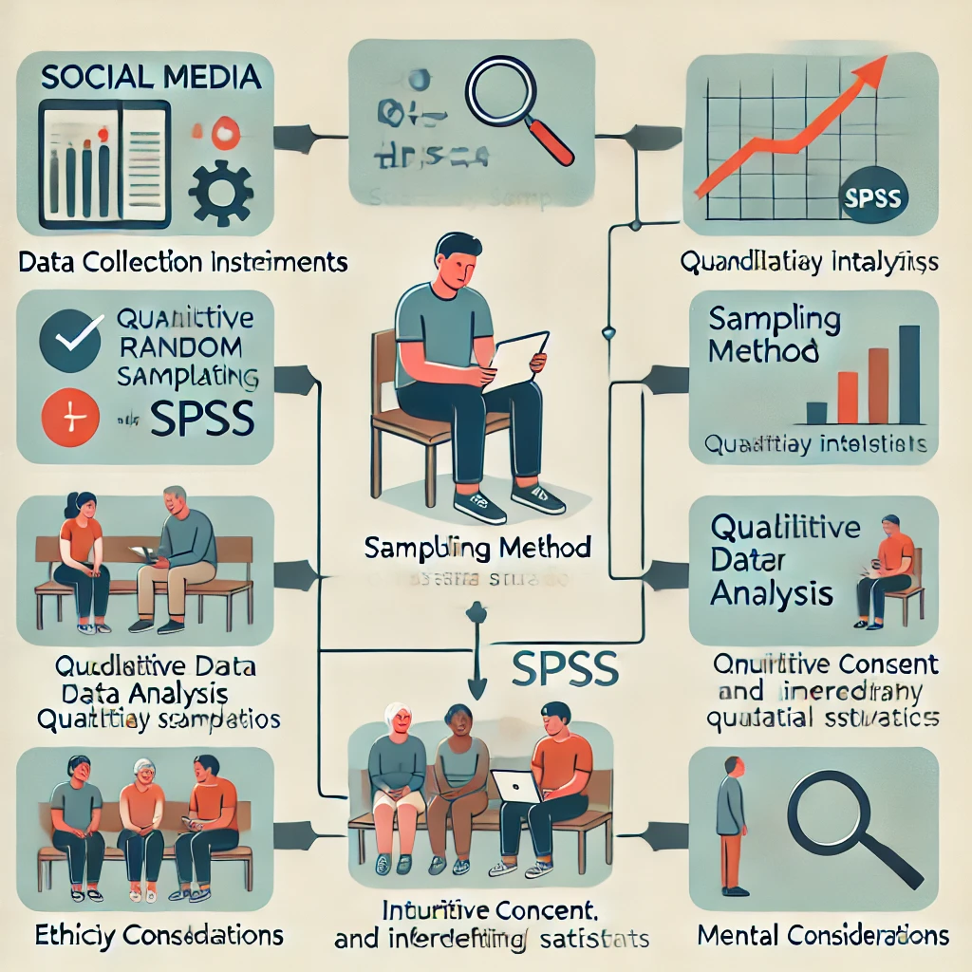

To research the influence of social media on the mental well-being of young people and adolescents, the current study employed a mixed methodology in which a quantitative survey was integrated with a qualitative interview. Such a approach holistic is helpful in better understanding the complexities surrounding the use of social media and how its effects manifest on mental health.

**Data Collection Instrument**

**3.1 Quantitative Surveys**

A standardized online survey was developed to collect quantitative data from participants aged 16 to 25 years. Standardized scales were designed in the survey to measure aspects of mental health, specifically anxiety and depression, self-esteem, and social media usage patterns. Important sections of the survey were ascertained:

•How much time has been spent by participants on social media platforms (daily usage)

•What kinds of platforms were being used by them (Instagram, TikTok, Facebook, or any other)

•Experiences in cyberbullying or social comparison

•Perception of the mental health status of self on a scale related to anxiety and depressive levels

**3.2 Qualitative Interviews:**

The study was supplemented with the collection of semi-structured interviews with a number of the participants. These were informed by an intention to elicit a richer understanding from the participants of experiences concerning social media and perceived mental health impacts. The questions involved,

• Personal experiences regarding the use of social media and the impact of it.

• Experiences of online bullying or other positive experiences online.

• Techniques of managing social media use.

**3.3 Sampling Method**

Stratified random sampling was used to ensure a high representation of diverse demographics among the respondents. Variations include demographics of age, gender, socio-economic background, and geographic location among the respondents. Through this method, an attempt was made for a representative sample of active users of social media among youths and teenagers.

**3.4 Quantitative Data Analysis:**

Quantitative data collected from these questionnaires were tabulated and analyzed using statistical software like SPSS. Descriptive statistics were then run, to sum up the demographics and usage patterns among these participants, after which inferential statistical tests such as correlation and regression analyses between mental health outcomes and social media usage were conducted.

**3.5 Qualitative Analysis:**

Then there were interviews used to gather the qualitative data which was later transcribed and underwent thematic analysis. The thematic analysis here referred to identifying recurrent themes and patterns of description describing participants' experiences and perceptions regarding the effects of social media use on their mental health.

**3.6 Ethical Consideration**

Throughout the study, a consideration for ethics was noticed in every respect. Informed consent was sought from participants, and the data collected was kept private by ensuring no identities of the respondents were known. Participants were informed that if they needed to pull out of the study, they would be free to do this at any time without coming out on the penalty list. Furthermore, mental health facilities were provided to the participants in case they underwent distress while undertaking the study

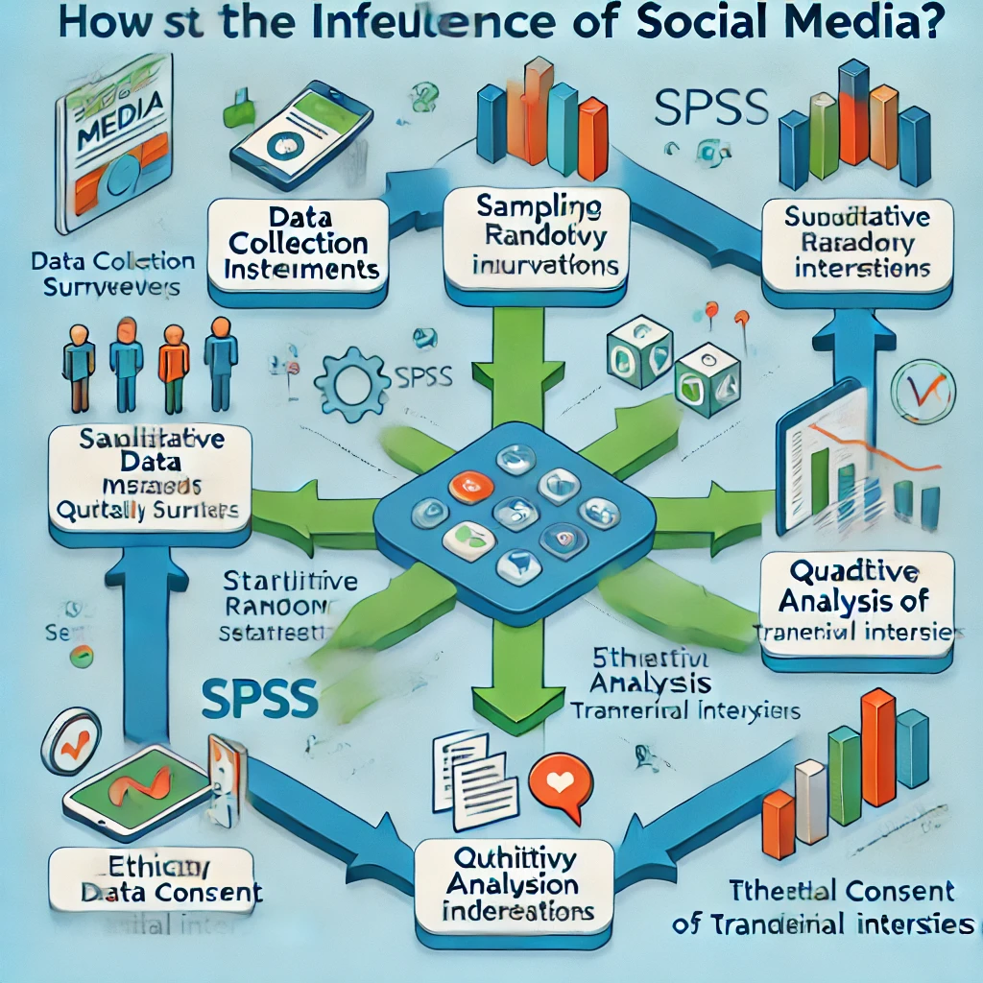

1. **CONCLUSION**

That then makes it quite difficult to establish a direct relationship between social media and mental health. In conclusion, one should say that social media has both opportunities and challenges at the same time in the youth and adolescents' lives. Although social media offers powerful tools for connection, community building, and information access, they also submit users to considerably risky phenomena, such as social comparison, cyberbullying, or addiction. Not to be underestimated are the ways through which social media can support and foster advocacy toward mental health: many users find solace and empowerment in online communities and forums that promote well-being and awareness.

Nevertheless, critical to this discussion should be to note that some of the overly used negative effects of social media are adversely affecting the state of mental health. Anxiety, depression, and self-esteem issues, both of which have been increasing among young users, provide ample evidence. These factors are more likely to enable the youth to use the various platforms positively. We can exploit its strengths while reducing adverse effects by establishing an appropriate ecosystem where the young learn to interact with social media.

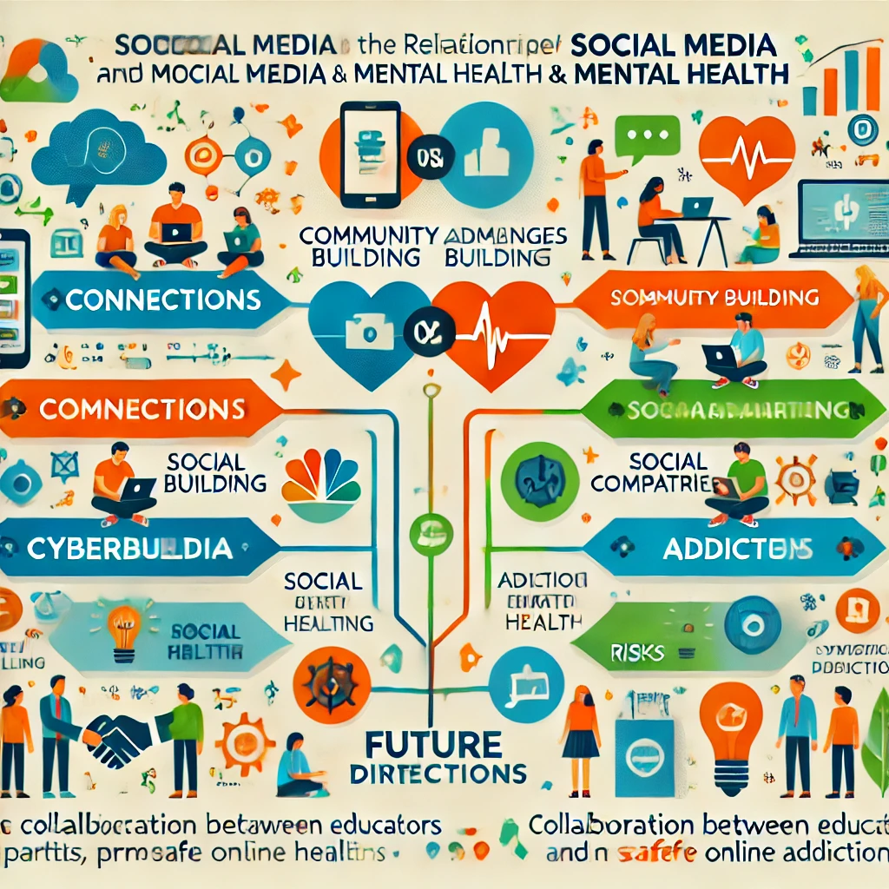

In the future, collaboration between educators, parents, mental health professionals, and social media companies will be key in establishing safe online environments. In advocating for better policies, in promoting mental health resources, and demonstrating positive interactions on social media, there will be a future where social media works to increase a positive force in children's lives. Ultimately, the takeaway is to enable teenagers to utilize social media as a channel to connect and grow instead of something that becomes a source of stress and anxiety for them so that they can thrive in the virtual and physical worlds.

1. **REFERENCES**

1. Ansari, J. A., & Khan, N. A. (2020). Exploring the role of social media in collaborative learning: The new domain of learning. Smart Learning Environments, 7(1), 9. https://doi.org/10.1186/s40561-020-00118-7

2. Topong, P. (2020). An Examination of Social Media Addiction on the Academic Performances of University Students in Ethiopia. Journal of Education and Practice, 11(5), 123-132.

3. Ostic, D., Smejkal, M., & Pavlović, S. (2021). The influence of social media addiction on mental health: The role of psychological well-being. Frontiers in Psychology, 12, 678766. https://doi.org/10.3389/fpsyg.2021.678766

4. Primack, B. A., Shensa, A., Sidani, J. E., et al. (2017). Social media use and perceived social isolation among young adults in the U.S. American Journal of Preventive Medicine, 53(1), 1-8. https://doi.org/10.1016/j.amepre.2017.01.010

5. Kalia, A. (2013). Social media and its impact on mental health. Indian Journal of Health and Wellbeing, 4(3), 447-451.

6. EJ1083595. (Year). Title of the article. Journal Name, Volume(Issue), Page range. [If applicable]

7.Jayme, Waddington (2011); University of Colorado. ‘Social Networking: The Unharnessed Educational Tool’. Undergraduate Research Journal, Vol 4.1

8. Angela Hausman, a Ph.D scholar and Associate Professor of Marketing at Howard University on ‘How to use social media as an educational tool’

9. Kessler Sarah, a feature write at Marshable contributed ‘The case for social media in schools’.

10. P. Brady Kevin, B. Holcomb Lori, and V. Smith Bethany (2010); North Carolina State University. “The Use of Alternative Social Networking Sites in Higher Educational Settings: A Case Study of the E-Learning Benefits of Ning in Education”. Journal of Interactive Learning, Vol 9, Number 2, pp 151-170.

11. Hundey, Elizabeth (2012) “Social media as an Educational Tool in University Level Geography,” Teaching Innovation Projects: Vol. 2, Iss. 1, Article 5.

12. The case for social media in Schools, http://mashable.com, http://mashable.com/2010/10/16/ free-social-media-tools-for-teachers/