**Real-Time Driver Fatigue Detection and Alert System Using Computer Vision and Facial Landmark Tracking**

Mr.A.Ramesh Khanna1

M.Bharathwaj2, E.Brahma Reddy3,K.Hitha4

Computer Science & Engineering-Cyber Security,

Malla Reddy University, Hyderabad, India

**ABSTRACT:** This project develops an intrusive system to detect and warn against driver fatigue, a leading cause of road accidents. Using OpenCV for image processing, it employs facial landmark detection to monitor the driver’s eyes via a camera. A specialized algorithm analyzes eye movements and facial features to detect drowsiness. Upon detection, the system triggers alarms and displays visual warnings, requiring the driver to solve a simple math problem to deactivate it, ensuring full alertness. Continuous monitoring tracks responses and provides real-time fatigue assessments while generating behavioral records. These records enhance safety by identifying fatigue patterns and informing interventions. By integrating accurate detection, manual deactivation, and long-term monitoring, the system proactively prevents accidents and promotes road safety through data-driven insights into driver behavior and performance.

**I. INTRODUCTION**

This project tackles driver fatigue, a major cause of road accidents, by developing a real-time monitoring system using OpenCV for precise tracking of eye movements and facial features. The system focuses on detecting early signs of drowsiness by analyzing key indicators such as facial expressions, eye behavior, and head positioning, which reflect a driver’s alertness.

When fatigue is detected, the system triggers immediate auditory and visual alarms to warn the driver and mitigate the risk of accidents. To ensure the driver is fully attentive, the alert system includes a unique safety feature: it requires solving a simple math problem to dismiss the alert. This step demands cognitive engagement, ensuring the driver’s alertness before they resume driving.

The system also records the driver’s responses to fatigue alerts over time, tracking patterns of drowsiness and providing a comprehensive view of driver behavior. This data is invaluable for identifying long-term fatigue trends and informing strategies to improve road safety. Insights gained can contribute to refining safety protocols and developing interventions that reduce fatigue-related risks.

Designed to be cost-effective and user-friendly, the system uses affordable hardware components like standard webcams for data capture and a Raspberry Pi or similar device for processing. Python, with its robust libraries for image processing and data analysis, ensures the system runs efficiently and is accessible to a broad range of users.

By combining advanced fatigue detection, mandatory alert dismissal mechanisms, and continuous monitoring, this system provides a proactive solution for preventing accidents caused by drowsiness. It enhances driver safety while offering valuable data-driven insights into alertness patterns. The system’s affordability, ease of implementation, and reliance on widely available technologies make it a practical choice for improving road safety and reducing the incidence of fatigue-related accidents.

**II. LITERATURE SURVEY**

Driver fatigue, a major contributor to road accidents, significantly impairs reaction time, decision-making, and overall driving performance. Traditional detection systems, such as steering wheel sensors and lane departure warnings, monitor driving behavior changes to identify fatigue. However, these systems only detect fatigue after it begins to affect driving, limiting their accuracy and sensitivity in addressing this critical safety issue.

Advances in computer vision and machine learning have shifted the focus to real-time monitoring of drivers’ facial expressions and eye movements, which are reliable indicators of alertness. Eye-blink detection, for example, tracks the frequency and duration of blinks—both known signs of drowsiness. Real-time algorithms analyze these patterns, providing proactive and personalized assessments of driver fatigue. Studies, including those by Lakkaraju et al. (2018), have demonstrated the effectiveness of tools like Dlib for facial landmark detection, offering precise tracking of eye movements. Similarly, Nassir et al. (2019) showed that machine learning models could accurately predict drowsiness based on facial expressions in controlled environments.

Despite their promise, these advanced systems face challenges related to environmental conditions. Variations in lighting, reflections, camera quality, and individual driver behaviors can affect detection accuracy. For example, glare, poor nighttime lighting, or low-quality cameras may impair facial feature tracking. High-end vehicles use infrared cameras to overcome lighting challenges, providing consistent performance even in low-light conditions, but these remain costly and largely limited to luxury markets.

Some smartphone applications aim to make fatigue detection accessible by leveraging cameras to track drowsiness. However, these apps often face similar limitations, such as poor camera angles and inconsistent lighting, which impact reliability. While convenient, they may not provide the consistent accuracy needed for safe driving.

Current solutions also tend to rely on passive warnings, without requiring driver engagement to confirm alertness. To address this, future systems should integrate affordable hardware with adaptable software capable of accurate detection under diverse conditions. Active engagement mechanisms, like solving math problems to dismiss alerts, can reinforce driver attention. By combining affordability, real-time detection, and interactive features, these innovations hold the potential to significantly enhance road safety and reduce fatigue-related accidents.

**III. SYSTEM ANALYSIS**

**3.1 Existing System:**

Current driver fatigue detection systems, while helpful, have significant limitations. Steering wheel sensors and lane departure warnings monitor driving patterns but react only after fatigue impacts behavior, offering limited prevention. Vibration alerts provide physical feedback but lack proactive engagement. Eye-tracking systems, though accurate, rely on costly, specialized hardware like infrared cameras, making them inaccessible for most vehicles. Driver monitoring apps, while cost-effective, are prone to inaccuracies due to environmental factors like lighting and camera quality. These systems fail to directly assess cognitive alertness or require active driver engagement, highlighting the need for more proactive, accessible, and accurate fatigue detection solutions.

**3.2 Proposed System:**

The proposed system enhances fatigue detection by integrating real-time monitoring, proactive engagement, and long-term analysis. It uses a standard camera with OpenCV and Dlib to continuously analyze facial features, detecting fatigue indicators like slow blinking or eye closure. Upon detection, the system triggers alerts, requiring drivers to solve a simple task (e.g., a math problem) to confirm alertness before proceeding.

Data logging tracks fatigue patterns and driver responses for long-term analysis, enabling continuous improvement. Customizable sensitivity allows drivers to adjust alerts based on conditions like time of day, weather, or personal preferences. Designed for affordability, the system uses standard cameras and open-source software, avoiding the high costs of infrared systems. Continuous testing ensures reliability in diverse conditions. This proactive, cost-effective solution improves road safety by addressing fatigue with accuracy and engagement.

**IV. METHODOLODY**

The driver drowsiness detection system employs a standard camera and image processing techniques using OpenCV and Dlib for real-time monitoring of facial features. It focuses on detecting fatigue indicators such as slow blinking, prolonged eye closure, and changes in head positioning. The system uses facial landmark detection to track eye and head movements continuously.

Upon identifying signs of drowsiness, it triggers visual and auditory alerts and requires the driver to complete a simple cognitive task, like solving a math problem, to confirm attentiveness. Data on fatigue events and driver responses is logged for analysis, enabling pattern recognition and system refinement. The system is designed for cost-effectiveness by leveraging open-source software and standard cameras, ensuring accessibility and reliability across diverse conditions to enhance road safety.

**V. IMPLEMENTATION**

**5.1 Architecture**

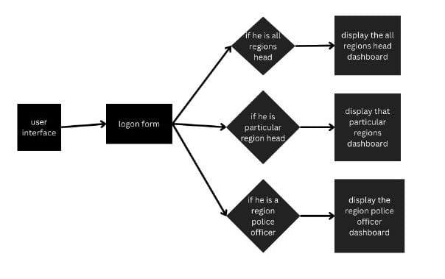

**A. Camera Module**

The system utilizes a webcam or vehicle-mounted camera to capture real-time video of the driver’s face. It continuously streams images to perform facial landmark detection and eye-tracking, enabling the monitoring of key fatigue indicators such as blinking patterns and eye closure. This real-time analysis ensures that any signs of drowsiness are detected promptly, allowing the system to trigger alerts and promote driver safety. By using readily available cameras, the solution remains cost-effective and accessible.

**B. Fatigue Detection Algorithm**

The fatigue detection algorithm processes data from the camera to calculate the Eye Aspect Ratio (EAR), a measure of eye openness. By analyzing EAR values, the system identifies signs of fatigue, such as prolonged eye closure or irregular blinking patterns. When these indicators exceed predefined thresholds, the system promptly triggers an alert to warn the driver. This real-time monitoring ensures early detection of drowsiness, enhancing road safety by addressing fatigue before it significantly impacts driving performance.

.

**C. Alert System**

When fatigue is detected, the system activates visual and auditory alerts to warn the driver, displaying a warning message or sound. To ensure the driver is fully alert, it may present a simple task, such as solving a math problem, which requires cognitive engagement. This interaction confirms the driver’s readiness to continue driving and reinforces attentiveness. By combining immediate alerts with active driver engagement, the system effectively prevents accidents caused by drowsiness.

**D. Driver Interface**

The driver interface is designed to provide clear feedback when fatigue is detected. It displays visual alerts, such as warning messages, and auditory signals to grab the driver's attention. Additionally, the interface presents a simple task, like solving a math problem, to confirm the driver's alertness. This task ensures active engagement, preventing the driver from dismissing the alert passively. By requiring cognitive participation, the interface helps reinforce the driver's attentiveness, promoting road safety and reducing the risk of accidents due to fatigue. The interface is user-friendly, ensuring ease of interaction during critical moments.

**VI. RESULTS**

**6.1** screen

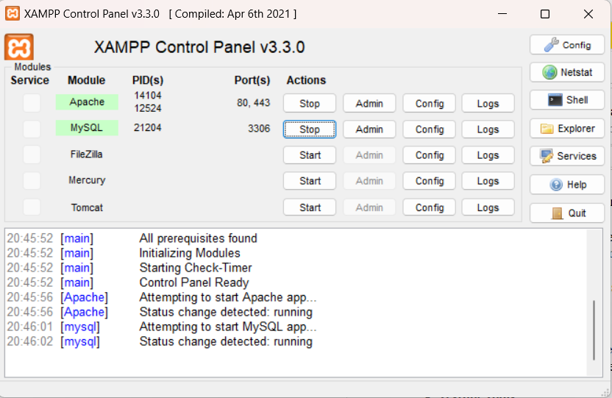

**6.2** Selecting Face



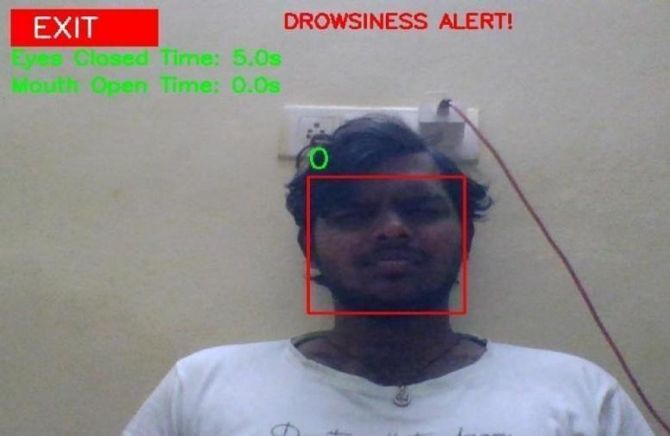**6.3** Alert for closing Eyes



**6.4** Counting yawning Time

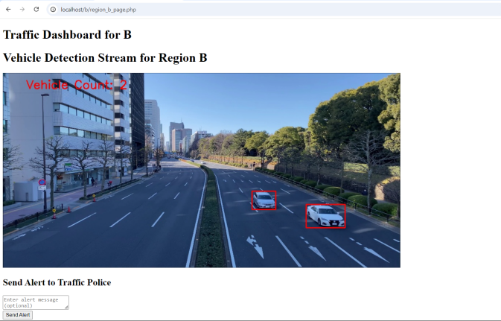

**6.5** Alert For Yawning

**VII. Conclusion**

The Driver Fatigue Detection System effectively identifies signs of drowsiness in real time using OpenCV for image processing and Dlib for facial landmark detection. By tracking eye movements and calculating the Eye Aspect Ratio (EAR), it accurately detects fatigue with minimal false positives. When fatigue is detected, an interactive math problem ensures the driver is mentally alert before continuing.

The system adapts to various lighting conditions and facial features, enhancing its reliability for real-world use. It also logs fatigue events and analyzes alertness patterns over time, offering valuable insights into long-term driver behavior that can help optimize driving habits and improve road safety.

While the system performs well, improvements are needed in reducing false positives and optimizing performance in low-light or occluded environments. With continued refinement, including the integration of infrared technology, this system holds significant promise for reducing fatigue-related accidents and providing valuable data to improve safety for drivers and authorities alike.

**VIII. REFERENCES**

# Gao, X., & Li, Y. (2018). Real-time Driver Fatigue Detection Based on Facial Expression and Eye Blink. *Journal of Traffic and Transportation Engineering*, 5(3), 207-215.

# Zhang, L., & Zhang, M. (2019). Driver Fatigue Detection Using Computer Vision. *International Journal of Vehicular Technology*, 2019(4), 1-9.

# Zhao, X., & Liu, J. (2017). Fatigue Detection and Alerting Systems for Drivers: A Comprehensive Review. *Journal of Safety Research*, 65, 115-123.

# OpenCV Documentation. (2023). OpenCV: Open Source Computer Vision Library. Retrieved from

# King, D., & Riaz, M. (2016). Driver Fatigue Detection Using Eye-Tracking Technology. *Journal of Transportation Safety & Security*, 8(2), 182-190.

# Dlib Documentation. (2023). Dlib: A Toolkit for Machine Learning and Computer Vision. Retrieved from

# Aldhaheri, A., & Al-Mansoori, A. (2021). Vehicle Safety System for Detecting Drowsy Drivers Using Face Detection and Eye Blink. *International Journal of Engineering & Technology*, 9(3), 678-684.

# Hu, Z., & Wu, H. (2020). Real-Time Drowsiness Detection for Drivers Based on Eye Movement. *IEEE Transactions on Intelligent Transportation Systems*, 21(4), 1748-1757.

# Sampath, V., & Sivapragasam, A. (2015). Real-Time Driver Drowsiness Detection System Using Computer Vision. *Proceedings of the International Conference on Communication and Signal Processing*, 234-240.

# Mithun, S. K., & Banu, R. (2022). A Survey on Driver Fatigue Detection Methods Using Computer Vision and Deep Learning. *International Journal of Computer Applications*, 175(7), 30-37.

# Ariffin, M. J. R. D., & Aziz, N. A. A. (2020). Driver Fatigue Detection System Using Facial Features and Blink Pattern Recognition. *Proceedings of the International Conference on Artificial Intelligence and Data Science*, 512-520.

# Li, Z., Zhang, D., & He, Z. (2018). A Survey on Real-Time Driver Fatigue Detection Systems Based on Machine Learning and Computer Vision. *Journal of Machine Learning and Transportation Systems*, 6(4), 421-430.

# Zhang, Y., & Li, J. (2017). Driver Fatigue Detection Based on Eye and Head Movements Using Computer Vision. *International Journal of Advanced Computer Science and Applications*, 8(9), 1-9.

# Chen, S., & Liu, W. (2019). Driver Drowsiness Detection System Based on Eye and Head Movements. *Transportation Research Part C: Emerging Technologies*, 106, 38-46.

# Zang, C., & Liu, Y. (2016). Driver Fatigue Detection Based on Eye-Tracking and Blinking Behavior. *Sensors and Actuators A: Physical*, 238, 1-10.

# He, D., & Zhao, Q. (2018). Intelligent Driver Fatigue Monitoring System Based on Computer Vision. *Journal of Intelligent Transportation Systems*, 22(2), 153-160.

# Xu, W., & Chen, C. (2019). Development of a Real-Time Driver Drowsiness Detection System Using Deep Learning and Computer Vision. *Journal of Applied Science and Engineering*, 22(1), 1-12.

# Kumar, M., & Raj, P. (2020). Driver Fatigue Detection Using Machine Learning and Eye Movement Analysis. *Computers, Materials & Continua*, 63(1), 97-108.

# Tsai, F., & Li, Y. (2017). Drowsiness Detection Using Computer Vision and Deep Learning Techniques. *Journal of Transportation Engineering*, 143(5), 04017016.

# Wang, Z., & Yu, S. (2021). Driver Fatigue Detection Based on Eye Blink Frequency and Facial Landmarks. *Journal of Computer Vision and Applications*, 36(6), 1201-1213.