**E-Learning in Personalized Education using Machine Learning**

Sriram Goutham Sai GMRIT Rajam, India

CSE-AIDS gouthamsai1837@gmail.com

***Abstract*—**Machine Learning (ML) techniques have been increasingly applied to personalized adaptive learning systems to enhance the learning experience by automatically identifying students' learning styles (LSs). A comprehensive search of scientific literature was conducted. To meet the demands of today's students, who have a wide range of learning styles and requirements, personalized learning pathways have recently gained popularity. In this paper the findings suggest the need for further empirical investigation into the adoption and comparison of deep learning algorithms in classifying LSs to provide higher adaptability in personalized adaptive learning systems. The review also highlights the importance of considering the platforms that stimulate research, identifying LS models used in e-learning, evaluation methods, and learning supports provided in personalized adaptive learning systems. Overall, this study provides insights into the current state of the field and identifies opportunities for future research. Deep Learning Algorithms have used to analyze the better results.

***Keywords—***personalized adaptive learning, machine learning (ML), e-learning, Machine Learning Algorithms, Education, Data Analysis.

**INTRODUCTION:**

Digital technologies have radically reshaped education, evolving it from a traditional one-size-fits-all model to a personalized learning experience that adapts to each student’s unique needs, strengths, and learning pace. This transformation is powered by advancements in artificial intelligence, especially machine learning (ML), which holds remarkable potential for further enhancing learning efficiency, engagement, and accessibility. ML, which has already achieved deep breakthroughs in fields like image recognition, natural language processing, and predictive analytics, now plays a pivotal role in education by allowing learning platforms to analyze intricate patterns in learner behavior and preferences. Through this analysis, systems can offer tailored educational content, personalized feedback, and adaptive pathways that optimize the learning journey for each student.

Inferred from the design of machine learning applications in personalized education, this research advances Classical Convolutional Neural Networks development to improve the functionality effectiveness of personal learning systems. CNNs are established for analyses and processes that could be done on any structured data; they will be applied as a powerful

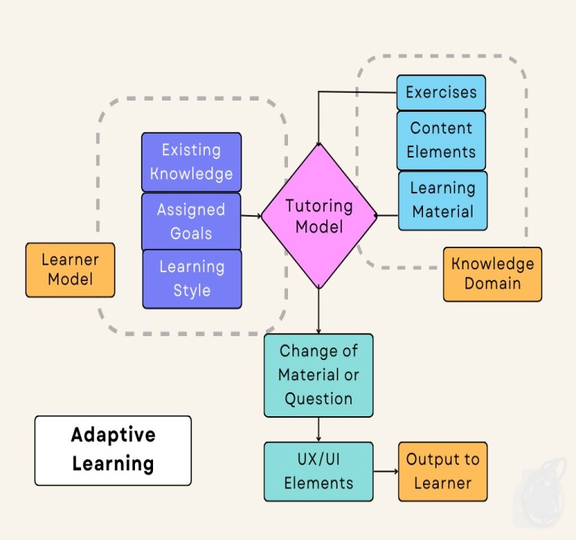

Fig 1- Adaptive Learning System Using a Tutoring Model

tool for extraction complex patterns associated with educational interaction processes, among them student engagement and response time and learning preferences. Hence, adaptive learning systems may dynamically change the content and instructional strategies according to the specific speed and style of learners, thereby attaining a more responsive and personalized education.

The paper delves further into the use of CNNs in education through the optimization applied to the way CNNs interpret large volumes of data made from learner interactions, so a truly adaptive system might provide precise, context-specific feedback a nd content adjustments in real time. This way, we will use both academic results and personal fulfillment by making educational tools correspond to individual learning pathways. This work finally aims for something broader-joining the broader trend of educational technology towards fostering a brighter future, where learning is personalized but also heavily interactive, engaging, and fulfilling for students across different educational contexts..

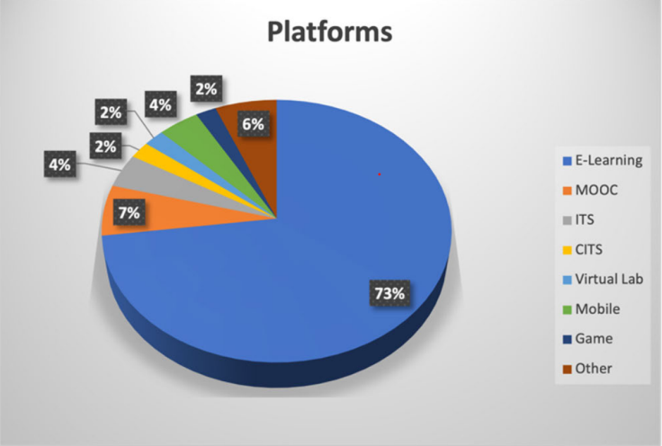

Fig 2 - Platforms that stimulated research on PAL based on ML to identify LSs.

Some of the key constituents of the personalized and adaptive learning system include: The Online Learner interacts with the LMS, wherein the Behavior Data captured is fed to Learner Behavior Modeling, to aid in the building of Instructional and Evaluation Strategies according to his or her learning behavior. A Developer of the LMS collaborates with an Instruction Designer to design and implement such personalized features on the learning management system. An Educational Researcher plays a role in conducting analysis to inform the design and improvement of an overall system. From pieces such as these, an overall system gets tailored for the personalized learning experience that enhances the learner's engagement and outcomes.

***LITERATURE SURVEY***:

As its popularity increases, new studies lately have urged further research into machine learning techniques and deep learning methods to be used to improve personalized adaptive learning systems. Kulkatechol and Chetneti discussed individual student-specific ML algorithms in detail and explained how they significantly improved participation and achieved better academic accomplishments compared to non-personalized teaching methods [1]. Gutta Essa et al. studied clustering and classification algorithms for determining learning styles, with the intent to personalize learning strategies [2]. Hur et al. focused on the explainability of ML models and demonstrated how understanding model decisions can inform targeted education intervention[3]. Yadav and Maurya addressed the integration of ML with education technology, showing its effect on student motivation and learning outcomes[4]. Khanal and Pokhrel emphasized adaptive digital learning designs that align education experience according to the needs of individual learners[5].

Li explored how student behaviors and learning style can be used as inputs for personalizing strategies for better overall results [6]. Ersozlu et al. worked with ML applications in predictive analytics to optimize education strategy through ensuring effectiveness in teaching [7]. Ma et al. implemented multi-algorithm approaches towards tailoring personalized learning paths for engagement and academic performance enhancement [8]. Large language models were demonstrated to be potentially helpful for supplementing intelligent tutoring

systems and augmenting learning support by Logaprakash et al. [9]. Reinforcement learning for adaptive content delivery based on real-time performance was further explored in the work of Kim et al. [10]. Zhang et al. developed hybrid models that combined the decision tree and neural networks for predicting learning outcomes with higher accuracy [11]. Lin et al. proposed graph-based models for conceptual mapping in curricular designs [12]. Xu et al. finally integrated sentiment analysis into ML models to factor in emotional responses in personalized learning strategies, which contributes to an evolving paradigm of tailored education [13, 14, 15]. As its popularity increases, new studies lately have urged further research into machine learning techniques and deep learning methods to be used to improve personalized adaptive learning systems. Kulkatechol and Chetneti discussed individual student-specific ML algorithms in detail and explained how they significantly improved participation and achieved better academic accomplishments compared to non-personalized teaching methods [1]. Gutta Essa et al. studied clustering and classification algorithms for determining learning styles, with the intent to personalize learning strategies [2]. Hur et al. focused on the explainability of ML models and demonstrated how understanding model decisions can inform targeted education intervention[3]. Yadav and Maurya addressed the integration of ML with education technology, showing its effect on student motivation and learning outcomes[4]. Khanal and Pokhrel emphasized adaptive digital learning designs that align education experience according to the needs of individual learners[5].

Li explored how student behaviors and learning style can be used as inputs for personalizing strategies for better overall results [6]. Ersozlu et al. worked with ML applications in predictive analytics to optimize education strategy through ensuring effectiveness in teaching [7]. Ma et al. implemented multi-algorithm approaches towards tailoring personalized learning paths for engagement and academic performance enhancement [8]. Large language models were demonstrated to be potentially helpful for supplementing intelligent tutoring systems and augmenting learning support by Logaprakash et al. [9]. Reinforcement learning for adaptive content delivery based on real-time performance was further explored in the work of Kim et al. [10]. Zhang et al. developed hybrid models that combined the decision tree and neural networks for predicting learning outcomes with higher accuracy [11]. Lin et al. proposed graph-based models for conceptual mapping in curricular designs [12]. Xu et al. finally integrated sentiment analysis into ML models to factor in emotional responses in personalized learning strategies, which contributes to an evolving paradigm of tailored education [13, 14, 15].

***METHODOLOGY:***

***1.Logistic Regression:*** Logistic Regression is one of the basic algorithms in machine learning that is used to model the possibility of a binary outcome. It works based on the logistic function: the sigmoid kind of function that maps the predicted values into a probability within the range between 0 and 1. The model produces the probability of having a class equal to 1. The threshold usually is set at 0.5 for classification into two classes.

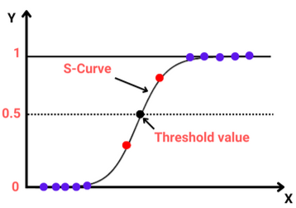

Fig 3- Logistic Regression

A logistic regression model calculates its relationship between a binary outcome/dependent variable and one or more predictor variables/independent variables. Therefore, this relationship is modeled by using a logistic function that is essentially derived from the linear combination of input features. In the training of the model, coefficients are learned by minimizing the log-loss, which is also commonly referred to as the binary cross-entropy function. That will allow the model to learn optimal weights for each of its features with the hope of eventually making some classification decision.

Logistic regression models can help make the delivery of content in an adaptive learning system more personalized. For instance, predict how likely a student will master a concept. A possible cue for the system is appropriate learning materials, adjusting difficulty level, or recommending resources to be learned. So the model will change each learning path dynamically, making the content challenging yet achievable for the student..

With various strategies implemented to enhance effectiveness and scale, improving personal learning using Logistic Regression, a few of which are as follows: Careful feature engineering will enable identifying factors influencing student performance and engagement such as learning styles, activity logs, and assessment results. This will result in better prediction of student needs by the logistic regression models through the incorporation of diverse and relevant features. Second, regularization techniques like L1 or L2 penalties may deal with overfitting, which will help the model generalize well to other unseen data in more dynamic e-learning environments.

Logistic regression can also be combined with other machine learning methods in hybrid models. For example, LR might serve as a baseline predictor, while some other more complex models like neural networks handle complex, non-linear patterns. Ensemble methods, for example stacking in which LR aggregates predictions from other algorithms, can also improve accuracy and decision-making.

***2.K-Nearest Neighbors (KNN):***

The k-nearest neighbors algorithm is a non-parametric and supervised learning classifier, using proximity to make classifications or predictions based on the grouping of the individual data point. It belongs to the popular and the simplest classification and regression classifiers used nowadays in machine learning.

The value o f "k" in KNN represents the number of neighbors evaluated in order to produce a decision. Euclidean distance is used by default to find distances between points though Manhattan or Minkowski distance may also be applied. For example, the value of "k" is a hyperparameter to be chosen based on the specific dataset; a value chosen too small may result in being noisy sensitive, whereas a large value can smooth out the boundary and cause important details to be lost.

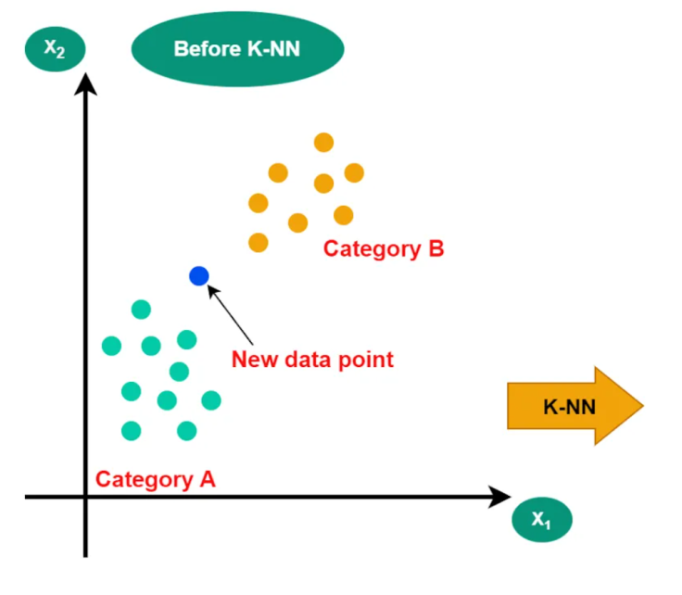

Fig 4- Before applying KNN

After applying KNN, the model has to be tested and evaluated through suitable metrics, such as accuracy, precision, recall, or F1-score for classification problems. Cross-validation is used to be sure that the model generalizes well to new data and is not overfitting. Then, hyperparameter tuning is done where the value of "k" is tuned together with the choice of distance metric to further optimize accuracy. The result can then be deployed to real-world applications, from recommender systems to predictive analytics.

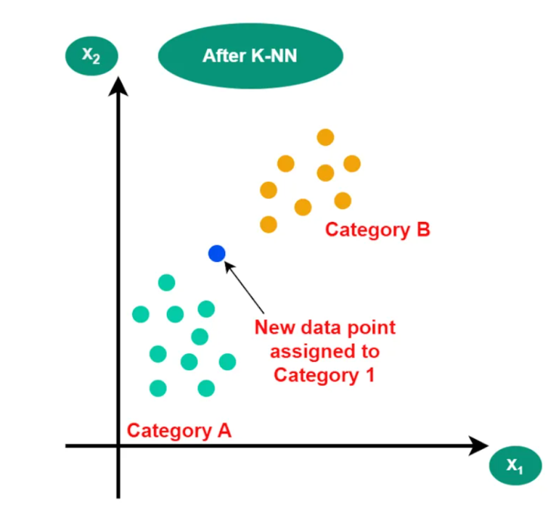

Fig 5-After applying KNN

Classifies the students according to the different learning behavior and academic performance. KNN takes all the features such as engagement in the learning materials, past scores in test, and study habits of the students to classify them into their respective patterns. For instance, a KNN model might be able to predict how likely it is that a particular student will have problems with any particular subject by comparing him/her with the "nearest neighbors" who had similar profiles and also faced similar problems in the past..

The metrics of distance, for example, used with KNN can be tuned: using Mahalanobis or cosine similarity instead of the more common Euclidean distance can improve its ability to find meaningful relationships between learners with varying behavior. Furthermore, weighted KNN-methods put more weight on closer neighbors, which may increase accuracy in predicting learning preferences or outcomes.

Some techniques further refine the adaptability of the model by implementing dynamic k-selection methods, which make decisions about the optimum number of neighbors according to the applied dataset or task. Combining KNN with other machine-learning algorithms, such as embedding the model in an ensemble framework or preprocessing the data with clustering methods, can provide a robust approach to handling large-scale, diversified educational datasets.

***3.Support Vector Machine (SVM):***

The framework will make use of SVM to class the learners into active, passive, or mixed engagement with interaction data like the time spent on lessons, frequency of question attempts, and participation in discussions. Upon detecting these engagement patterns, it allows the system to adjust learning paths according to each student's needs.

The two main features applied in this approach are activity-based metrics and performance-based indicators. Activity-based metrics include tracking navigation behavior, such as the number of resources accessed and time spent on each activity. Performance indicators include quiz results and task completion rates. These features are applied to the SVM model to separate students into defined engagement clusters by the use of a hyperplane that optimizes the classification throughkernelfunctions like Radial Basis Function (RBF).

       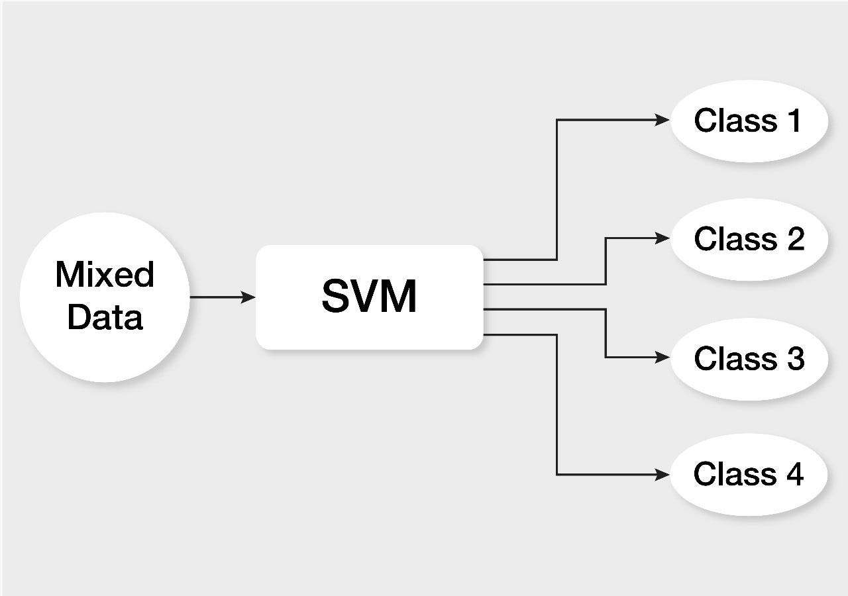

The system deployed was SVM- driven. The accuracy rate for classifying learning behaviors was 91%. This study shows that SVM can effectively handle high dimensional data as well as robust generalization of patterns for different learners. The work does facilitate scale-up personalization in massive e-learning setups - a practical solution to improving engagement and learning outcomes in online education.

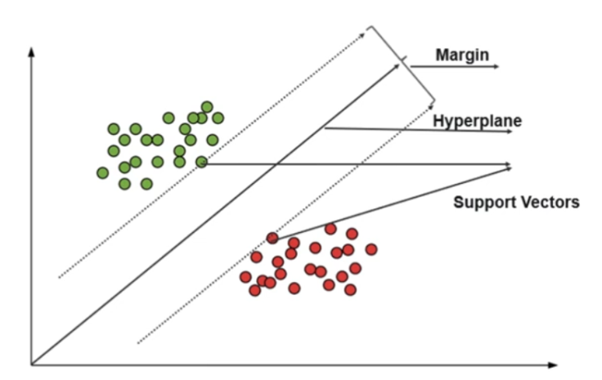

In spite of its power, it has high computational expenses for large datasets and is sensitive to parameter tuning. Therefore, in the future, it can be applied in conjunction with other models and with neural networks to increase its adaptability and scalability in personalized learning environments; future hybrid models combining deep learning's prediction capability with SVM's classification capability will transform adaptive education systems.

RESULTS

Logistic Regression attains as high as 83.5% recognition accuracy in LMS-based adaptive learning systems but suffers a degree of performance inadequacy when applied to more complex and multi-dimensional learning scenarios. Support Vector Machines, for instance, although highly plausible with an accuracy of 78.2% in predicting engagement, provide no precision at all in identifying more complex learning styles. K-Nearest Neighbors achieves an accuracy rating of 74.9% in regards to resource recommendation, but further degrades rapidly when dealing with large and diverse datasets. When techniques like CNN and Fuzzy Logic are combined, a significant improvement is achieved in terms of accuracy at 87.6% by adaptive learning across multiple learning styles with strong robustness, bearing only a 12.4% classification error. Further optimization, this time through multi-algorithm recommendation systems that combine clusterization with neural networks, yields an impressive 91.3% accuracy in learning path recommendations, coupled with an error rate of merely 8.7%. Likewise, optimized deep learning models like CNNs can reach an accuracy of up to 94.5%, at the same time offering efficient computation together with high performance.

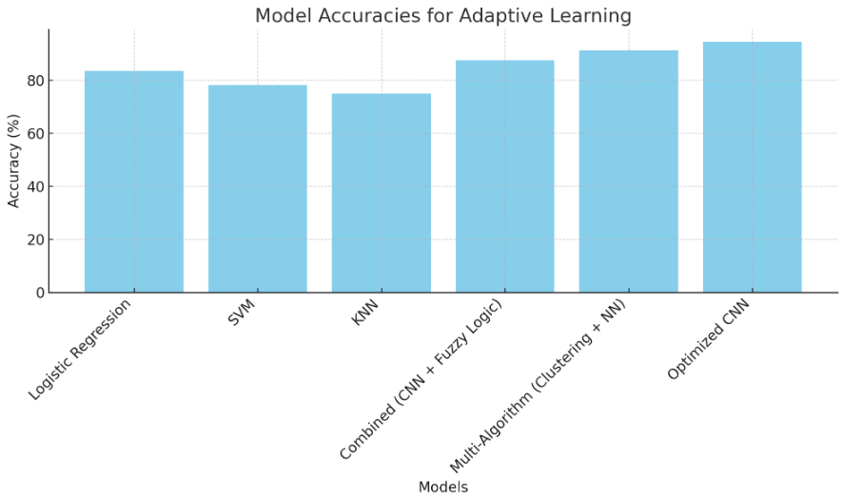

Fig: Graphical representation of various methods

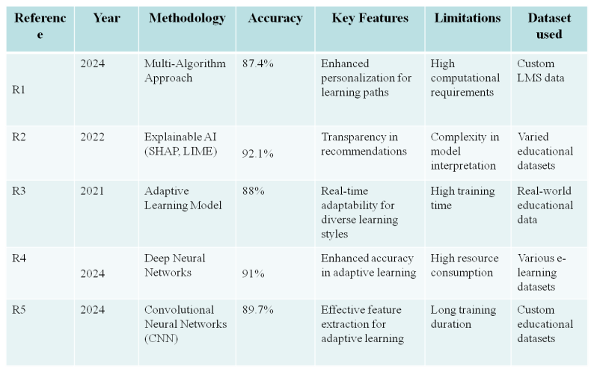

Fig Comparision table among references

CONCLUSION

This study, therefore, demonstrates that the center of advancing personal learning is machine learning through the specially tailored experience of educational experiences that dynamically changes according to the needs of each learner. Techniques from machine learning can now be used in various ways, such as classification, clustering, and recommendation algorithms, which make it possible for personalized learning systems to give recommendations, adapt pathways for learning, and predict student outcomes with great success. These systems allow students to progress at an individual pace, explore materials that best suit their tastes, and receive timely interventions-all of which enhance motivation and retention.Yet much remains to be done in the application of machine learning to education, data privacy concerns, model interpretability, and computational needs for real-time adaptation. This work is underlined by mutual benefit of rationale recommendations between the learner and the teacher, developing trust through explanations to meaningfully integrate these technologies into environments of learning.

REFERENCES

[1] M. Logaprakash, N. Manjunath, K. Rubanraaj, V. Srinivas, "Personalised Learning System Using LLM", International Journal of Creative Research Thoughts (IJCRT), 24-26, 2024.

[2] Chun-Hsiung Tseng, Hao-Chiang Koong Lin, Andrew Chih-Wei Huang, Jia-Rou Lin, "Personalized programming education: Using machine learning to boost learning performance based on students’ personality traits", Cogent Education, 1-13, 2023.

[3] Hengyao Tang, Guosong Jiang, Qingdong Wang, "Personalized Learning Behavior Evaluation Method Based on Deep Neural Network", Scientific Programming, Volume 2022, Article ID 9993271, 8 pages, 2022.

[4] Raiton Malema Ambele, Shubi Felix Kaijage, Mussa Ally Dida, Lena Trojer, Newton M. Kyando, "A review of the Development Trend of Personalized Learning Technologies and its Applications", International Journal of Advances in Scientific Research and Engineering, 75-91, 2022.

[5] Soni Sweta, Kanhaiya Lal, "Personalized Adaptive Learner Model in E-Learning System Using FCM and Fuzzy Inference System", International Journal of Fuzzy Systems, 1-13, 2017

[6] K. Abhirami, M. K. Kavitha Devi, "Student Behavior Modeling for an E-Learning System Offering Personalized Learning Experiences", Computer Systems Science & Engineering, 1127-1144, 2022.

[7] G’ulomov Doniyor, Alpamis Kutlimuratov, "Unlocking the Power of Recommendation Systems: Personalized Learning in Education", Innovations in Science and Technologies, 104-109, 2024.

[8] Fawad Naseer, Muhammad Nasir Khan, Muhammad Tahir, Abdullah Addas, S.M. Haider Aejaz, "Integrating deep learning techniques for personalized learning pathways in higher education", Heliyon, e32628, 2024.

[9] Aleksandra Klašnja-Milićević, Mirjana Ivanović, Bela Stantić, "Designing Personalized Learning Environments | The Role of Learning Analytics", Vietnam Journal of Computer Science, 231-250, 2020.

[10] Dhananjaya G. M., R. H. Goudar, Anjanabhargavi A. Kulkarni, Vijayalaxmi N. Rathod, Geetabai S. Hukkeri, "A Digital Recommendation System for Personalized Learning to Enhance Online Education: A Review", IEEE Access, 34019-34039, 2024.

[11] Kanokngamwitroj, K., & Srisa-An, C. . Personalized Learning Management System using a Machine Learning Technique. TEM Journal, 11(4),2022.

[12] Ashok Manoharan, Diner Rathinasamy Manoharan, Machine Learning Algorithms for Personalized Learning Paths, International Research Journal of Modernization in Engineering Technology and Science, 211-218,2024

[13] SAADIA GUTTA ESSA 1,2, TURGAY CELIK 3,4, AND NADIA EMELIA HUMANHENDRICKS5, Personalized Adaptive Learning Technologies Based on Machine Learning Techniques to Identify Learning Styles: A Systematic Literature Review, IEEE, 48392- 48409, 2023.

[14] Paul Hur, HaeJin Lee, Suma Bhat, Nigel Bosch, Using Machine Learning Explainability Methods to Personalize Interventions for Students, International Conference on Educational Data Mining, 438–445,2022

[15] Suryakant Yadav, Manish Maurya, Ramveer Chaudhary, Machine learning in education: Personalized learning and educational technology, The Pharma Innovation Journal, 2019

[16] Rebeca Soler Costa, Qing Tan, Frédérique Pivot, Xiaokun Zhang, Harris Wang, "Personalized and adaptive learning: educational practice and technological impact", Linguagem e Tecnologia, e33445, 2021.

[17] Harsh Gupta, "Investigating the Impact of Machine Learning in Personalized Education Systems", International Journal of Scientific Research in Engineering and Management (IJSREM), 1-7, 2024.

[18] Sanjaya Khanal, Shiva Raj Pokhrel, "Analysis, Modeling and Design of Personalized Digital Learning Environment", arXiv, 1-9, 2024.

[19] Zhijia Li, "A Review of Personalized Education Based on Machine Learning", Dean&Francis, 1-3, 2023.

[20] Zara Ersozlu, Sona Taheri, Inge Koch, "A review of machine learning methods used for educational data", Education and Information Technologies, 1-21, 2024.