**Green buildings: Understanding and Incorporating the Sustainable Housing Infrastructure in Accordance with SDG-11**

Vasudha(1) and Dr. Ashit Dutta(2)

Department of Environmental Science, Bhagwant University, Ajmer. (1&2)

*Corresponding author: v.vasudha4664@gmail.com*

# Abstract: This paper will provide some background on green buildings and a historical perspective on the international green building movement in general. GRIHA (Green Rating for Integrated Habitat Assessment) is India’s rating system to assess the performance of buildings against certain nationally accepted standards are discussed in the paper. The idea of a green building management system can go some way to solving the various problems before and after construction and ensuring the viability and practicality of green buildings, but it still needs to be supported by policy and a green building construction system. The Certification Processes for Green Buildings in India is also mentioned. The idea of a green building management system can go some way to solving the various problems before and after construction and ensuring the viability and practicality of green buildings, but it still needs to be supported by policy and a green building construction system. This study provides a macro view of the whole process of green building.

**Key words:** Green buildings, Sustainable Housing, GRIHA, Certification Processes, Green building management system.

**INTRODUCTION:**

Climate change led to the disastrous consequences in the recent history and are stimulating the technological metamorphosis towards a sustainable development, with its adding effectiveness, protection and restoration of ecological systems and enhancement of mortal well- being. The conservation of natural coffers is a concern that frequently appears when sustainable development is considered. In addition, numerous countries around the world, is growing at an explosive rate and arising on the radar defenses of a wide range of actors, from inventors to politicians, from contrivers to builders to policy. This paper will give some background on green structures and a literal perspective on the transnational green structure movement in general. As is the case with any other truly serious trouble, the roots of its actuality are important to appreciate its elaboration and current status. Encyclopedically, structure and structure construction consumes 60 of the raw accoutrements uprooted from the Earth( Bribian et al., 2011, MMSD, 2002). From this volume, erecting accounts for 40 of global lines. In the US, with 4 of world’s population, the consumption of coffers is at a stunning 25 of total coffers available in the world( Teller and Bergman 2010). A maturity of these coffers( 60 according to USGBC) are consumed in the structure assiduity. Carbon dioxide( CO2) emigrations from the erected terrain contributes for roughly 35- 40 of total emigrations in the US( Environmental Information Administration 2008, Nelson 2002). Not only do structures correspond of a multitude of products, and thus specialized and natural nutrients, they also have an important and wide- ranging impact on water and energy cycles, air quality( inner and out-of-door ), and fauna and foliage, as well as on social and profitable factors. One of the crucial aspects in sustainability is sustainable construction. The conception of green structures is the measure of our sweats in attaining that romantic sustainable construction practices. According to Environmental Protection Agency( EPA) in the US, Green Building is the “ practice of creating structures and using processes that are environmentally responsible and resourceeffective throughout a structure life- cycle from siting to design, construction, operation, conservation, addition, and deconstruction. ” Green Building is the status of our sweats in attaining sustainability in construction practices. The end of this paper is to bandy sustainability with respect to green structures, its significance in one of the world’s leading Green Building program Leadership in Energy and Environmental Design( LEED) instrument from the perspective of sustainable material selection, and governing programs in LEED. likewise, the part of life cycle assessment( LCA) in assessing the sustainability claims of green structures and structure accoutrements is introduced. also, the eventuality for including LCA in the scheme of Green Building standing system is critically estimated

Climate change led to the disastrous consequences in the recent past and are stimulating the technological transformation towards a sustainable development, with its increasing efficiency, protection and restoration of ecological systems and improvement of human well-being. The maintenance of natural resources is a concern that often appears when sustainable development is considered. In addition, many countries around the world, is growing at an explosive rate and emerging on the radar screens of a wide range of actors, from developers to politicians, from designers to builders to policy. This paper will provide some background on green buildings and a historical perspective on the international green building movement in general. As is the case with any other truly serious effort, the roots of its existence are important to appreciate its evolution and current status. Globally, infrastructure and building construction consumes 60 % of the raw materials extracted from the Earth (Bribian et al., 2011, MMSD, 2002). From this

volume, building accounts for 40 % of global extractions. In the US, with 4 % of world’s population, the consumption of resources is at a staggering 25 % of total resources available in the world (Teller and Bergman 2010). A majority of these resources (60 % according to USGBC) are consumed in the building industry.

Carbon dioxide (CO2 ) emissions from the built environment contributes for roughly 35-40 % of total emissions in the US (Environmental Information Administration 2008, Nelson 2002). Not only do buildings consist of a multitude of products, and therefore technical and biological nutrients, they also have an important and wide-ranging impact on water and energy cycles, air quality (indoor and outdoor), and fauna and flora, as well as on social and economic factors. One of the key aspects in sustainability is sustainable construction.

The concept of green buildings is the measure of our efforts in attaining that idealistic sustainable construction practices. According to Environmental Protection Agency (EPA) in the US, Green Building is the “practice of creating structures and using processes that are environmentally responsible and resource-efficient throughout a building life-cycle from siting to design, construction, operation, maintenance, renovation, and deconstruction.” Green Building is the status of our efforts in attaining sustainability in construction practices. The aim of this paper is to discuss sustainability with respect to green buildings, its importance in one of the world’s leading Green Building program - Leadership in Energy and Environmental Design (LEED) certification from the perspective of sustainable material selection, and governing policies in LEED. Furthermore, the role of life cycle assessment (LCA) in assessing the sustainability claims of green buildings and building materials is introduced. Moreover, the potential for including LCA in the scheme of Green Building rating system is critically evaluated.

**Sustainability** is increasingly becoming a key term of building practitioners with the goal of increasing protection, and restoring ecological systems and improving human well-being. The following objectives should be met to achieve sustainability:

1. Minimize the consumption of matter and energy
2. Reusability and recycling of the materials
3. Human satisfaction and enhanced quality of life
4. Minimizing the environmental impacts.

It is important to minimize the consumption, as the chances for future use are diminishing and hence, its potential to be used by future generation is lost (Roberts, 1994). Another aspect of minimizing the consumption is either reusing the same material or recycling the material to mold into a different or similar building product. This also helps in meeting a certain level of end -user satisfaction (Pearce at al., 1995).

Human satisfaction level is also accelerated by the sustainability goal that in turn paves the way for right material selection process. The increased use of renewable materials such as wood, waste paper and fibre insulation in construction not only reduces the investment in construction, but also alleviates the ecological problems caused by the overexploitation of natural resources by humans. In the past, the traditional construction industry was often very vague about the use of materials, but with the development of technology, people's concepts are gradually updated. The concept of renewable is gradually gaining ground. Renewable means multi-level use of materials, inexhaustible, which can not only reduce the cost of materials, but also maximize the advantages and save materials while causing less damage to the environment. But it cannot be claimed indefinitely, and renewable materials need to be used while the environmental carrying capacity is acceptable.

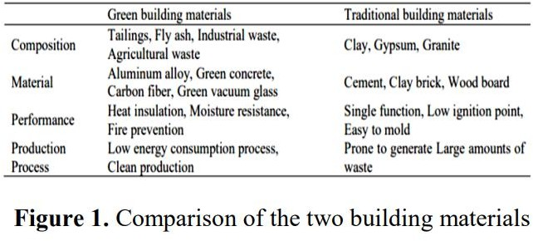As shown in figure 1, the materials used in green buildings have very clear advantages over traditional ones. Producers use industrial waste and other wastes as raw materials and use clean production techniques to produce green building materials, reducing natural energy consumption and environmental pollution while increasing the utilization of resources.

**Sustainable housing:** The term housing mean any type of building that provides shelter or lodging for one or more people. Housing provides people with a place to sleep, eat, relax, be safe, and conduct their daily lives. Sustainable housingas housing with a zero carbon impact that, where possible, contributes to regenerate initiatives that support wider sustainable elements. Sustainable housing is housing that significantly reduces and curtails its life cycle impacts and engages with concepts of the circular economy. Our focus on zero and low carbon performance outcomes aligns with the wider international research that argues for significant greenhouse gas emission reductions of 80% or more from key sectors (IPCC,2021; IEA,2021). However, sustainable housing is more than just physical elements; sustainable housing improves health and well-being, reduces living costs and connects to other sectors such as transport, food, and energy networks. Sustainable housing draws on a variety of design, material, technology, and construction innovations to build housing that will perform well now and into the future. This is not merely performance from a technical perspective but also in terms of resiliency against the changing climate.

**The 2030 Agenda for Sustainable Development**: with its 17 Sustainable Development Goals (SDGs) is a global call for action toward a more sustainable future. Within the 17 SDGs, SDG 11: “Make cities and human settlements inclusive, safe, resilient and sustainable”, contains several targets and related indicators (including unit of measurement or analysis) for development at an urban or city scale (United Nations Department of Economic and Social Affairs, 2022). Smart City initiatives, with popular discourse suggesting the use of Information and Communication Technology (ICT) and related technological developments can lead to social, economic and environmental benefits (Ismagilova et al., 2019; Raharjana, 2019), initially appear to be in a strong position to engage with sustainable development actions directly related to the SDGs. There are multiple areas of social and environmental justice that are pointed to as concerns in existing models and manifestations of Smart Cities (Asteria et al., 2020; Loos et al., 2020; Curran and Smart, 2021). The dominant public discourse on SDG 11 typically focuses on physical infrastructure projects in cities, including environmental benefits and risks (Hölscher et al., 2019). Simultaneously, there is a growing literature related to SDG 11 that involves an ICT component, often under the theme of Smart Cities (Bibri and Krogstie, 2017b; Ismagilova et al., 2019). Smart city initiatives in this paper refer to city government-supported projects involving substantial investments in ICT infrastructure and ubiquitous computing projects for real-time monitoring, management and regulation (Kitchin, 2015)

# Certification Processes for Green Buildings in India:

Worldwide, green buildings are certified through an independent body, the US Green Building Council (USGBC), through its LEED (Leadership in Energy and Environmental Design) certification program. This focuses on five aspects - sustainable sites, water efficiency, energy performance, use of recyclable materials and indoor environmental quality. In India, there are two mechanisms for evaluating the energy efficiency of a building. The Indian Green Building Council, which was formed in 2001, set up the Leadership in Energy and Environment Design (LEED) India committee. IGBC rated green building is a combination of India’s rich architectural heritage with a blend of modern technological innovations. The second system is The Green Rating for Integrated Habitat Assessment (GRIHA) devised by TERI. The majority of the buildings are approaching the IGBC and taking the green pathway and those include IT parks, malls, residential buildings, educational institutions, airports, factories, government buildings, hospitals, hotels and other institutions. Old and heritage buildings are also being rated. Tata Group Headquarters, Bombay House, a heritage building is the first certified Green Existing Building Rating under the IGBC .

# The India Green Building Council: The India Green Building Council (IGBC) was established in 2001 by the Confederation of Indian Industry. IGBC is mainly responsible for administering the Leadership in Energy and Environment Design (LEED) certification in India and supposedly the first green building certification systems in India. Credits earned through LEED can be traded in the carbon market. Green Certification began in 2004 and so far there have been more than 1,600 LEED-certified registered buildings. Since July 2014, the process of LEED certification is taken over by Green Building Certification Institute (GBCI). Currently, the IGBC has more than 1,700 members, 1,200 accredited professionals, 15 vibrant chapters in all major metros and 3,000 registered projects covering 3.13 billion sq feet of the green building footprint. IGBC rating systems include new buildings, existing buildings, residential homes, schools, factory buildings, townships, special economic zones, green landscape and MRTS to Metro Rail and MonoRail systems. IGBC rating credits are graded as certified, silver, gold and platinum categories.

# Green Rating for Integrated Habitat Assessment (GRIHA):

GRIHA (Green Rating for Integrated Habitat Assessment) is India’s rating system to assess the performance of buildings against certain nationally accepted standards. It was developed by the Tata Energy Resource Institute (TERI) in 2005 and the Ministry of New and Renewable Energy and has been adopted as the national rating system for green buildings in India by the Government of India in 2007. The GRIHA rating system evaluates the performance of green buildings through operating in a three-tier process (pre-construction, building planning and construction and building operation and maintenance stage). GRIHA rating system consists of 34 criteria that are categorized under various sections - Site Selection and Site Planning, Conservation and Efficient Utilization of Resources, Building Operation and Maintenance, and Innovation.

Under GRIHA, there are various categories of rating system for different buildings:

* SVAGRIHA (Small Versatile Afford able GRIHA) – developed for smaller buildings/projects with builtup areas < 2,500 sq. Meter. The rating comprises only 14 criteria.
* GRIHA LD (GRIHA Larger Developments) – developed to assess the environmental performance of larger developments. It applies to the greater than or equal to 1,50,000 sq. Meter.
* GRIHA Prakriti – Rating systems developed for sustainable schools. The rating system has categorised into six broad categories – energy, comfort, water, trees, solid waste management and social.

Some of the GRIHA-rated buildings in India are:

* Commonwealth Games Village, New Delhi,
* Fortis Hospital, New Delhi,
* CESE (Centre for Environmental Sciences & Engineering), IIT Kanpur,
* Suzlon One Earth, Pune etc.

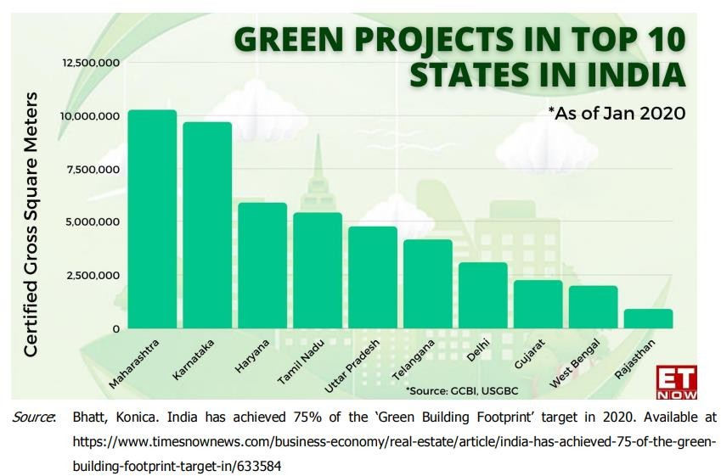

The US Green Building Council (USGBC) announced the recipients of its 2023 LEED Homes Awards, where it recognizes the best projects, and developers in the sustainability domain. This year, **DLF's The Crest** was awarded Project of the Year, making it the most sustainable

residential project across the globe. Last year, The Crest was recognized as the world’s largest LEED Platinum-certified residential project.

**CONCLUSION:**

Sustainable green development is the theme of our time and green building is the embodiment of this concept in the field of architecture. The ultimate goal of green architecture is to provide a harmonious and green living environment that can effectively reduce global carbon emissions and work tirelessly to combat global warming. In recent years, the state has attached more importance to the development of green architecture, and the rapid development of green architecture requires contemporary designers to carry out in-depth analysis and research.

However, in this development process, the problem of difficulty in harmonizing design with reality has arisen, and the supervision of the whole process of green buildings is still inadequate. Therefore, for the long-term development of green buildings, the focus needs to be on the aspect of city-wide management and subsequent maintenance. The idea of a green building management system can go some way to solving the various problems before and after construction and ensuring the viability and practicality of green buildings, but it still needs to be supported by policy and a green building construction system. This study provides a macro view of the whole process of green building.

**BIBLIOGRAPHY:**

**Asteria, D., Jap, J. J. K., and Utari, D. (2020).** A gender-responsive approach: social innovation for the sustainable smart city in Indonesia and beyond. *J. Int. Womens Stud.***21, 196–210.**

**Bhatt, Konica.** India has achieved 75% of the ‘Green Building Footprint’ target in 2020. Available at https://[www.timesnownews.com/business-economy/real-estate/article/india-has-](http://www.timesnownews.com/business-economy/real-estate/article/india-has-) achieved-75- of-the-green-building-footprint-target-in/633584

**Bibri, S. E., and Krogstie, J. (2017a).** On the social shaping dimensions of smart sustainable cities: a study in science, technology, and society. *Sustain. Cities Soc.* 29, 219–246. doi: 10.1016/j.scs.**2016.11.004**

**Bribian, I.Z.; Uson, A.A.; Scarpellini, S., 2009**: Life cycle assessment in buildings: State-of-the- art and simplifi ed LCA methodology as a complement for building certifi cation Ignacio. Build. Environ. 44: 2510-2520 [http://dx.doi.org/10.1016/j.buildenv.**2009.05.001.**](http://dx.doi.org/10.1016/j.buildenv.2009.05.001)

**Bribian, I.Z.; Capilla, A.V.; Uson, A.A., 2011**: Life cycle assessment of building materials: Comparative analysis of energy and environmental impacts and evaluation of the eco-effi ciency improvement potential. Build Environ **46: 1133-1140**

**Ensmenger, N. (2018).** The environmental history of computing. *Technol. Cult*. 59, S7–33. doi:10.1353/tech.**2018.0148**

**Ismagilova, E., Hughes, L., Dwivedi, Y. K., and Raman, K. R. (2019).** Smart cities: advances in research—An information systems perspective. *Int. J. Inf. Manage.* 47, 88–100. doi: 10.1016/j.ijinfomgt.**2019.01.004**

**IPCC**, *Summary for Policymakers. Climate Change 2021: The Physical Science Basis. Contribution of Working Group I to the Sixth Assessment Report of the Intergovernmental Panel on Climate Change.*, V. MassonDelmotte, et al., **Editors. 2021.**

**IEA, *Net Zero by 2050.*** *A Roadmap for the Global Energy Sector.* **2021, International Energy Agency,: Paris.**

**Mining, Minerals and Sustainable Development (MMSD), 2002**: “Breaking new ground: The report of the Mining, Minerals, and Sustainable Development Project.” Mining, Minerals, and Sustainable Development. (MMSD), Earthscan for International Institute for Environment Development (IIED) and World Business Council for Sustainable Development (WBCSD).

**United States Green Building Council (USGBC), 2009**: New Construction and Major Renovation Reference Guide. USGBC, Washington D.C.

**Nelson, W., 2002:** Compressed Earth Blocks. In J. F. Kennedy, M. G. Smith & C. Wanek (Eds.), The Art of Natural Building (pp. 138-142). Gabriola Island BC: New Society Publisher

**Pearce, A., Makarand, H.; Vanegas, J., 1995:** “A Decision Support System for Construction Materials Selection Using Sustainability as a Criterion.” In: Proceedings of the 28th Annual Conference, National Conference of States on Building Codes and Standards. Albuquerque, New Mexico, November 1-4.

**Raharjana, I. K. (2019).** A systematic literature review of environmental concerns in smart-cities. IOP Conf. Series Earth Environ. Sci. 245, 012031. doi: 10.1088/1755-1315/245/1/012031

**Roberts, D.V., 1994:** Sustainable development – A challenge for the engineering profession. In Ellis, MD ed. The role of engineering in sustainable development. American Association of Engineering Societies, Washington DC: 44-61.