# THE REVIEW ON ETHNOPHARMACOLOGY, NEW EUDESMANOLIDES AND CONSERVATION OF INULA RACEMOSA

**Ms. Ashlesha Bhosale, Dr. Anil landage Author, Guide**

# ABSTRACT

Inula racemose, a traditional medicinal plant, holds a significant place in ethnopharmacology due to its wide-ranging medicinal uses, particularly in south asia. Recent scientific studies have identified bioactive compounds within Inula racemose that contribute to its therapeutic effects, including eudesmanolides, a unique class of sesquiterpenes. Advances in phytochemistry, agrotechnology, and conversation practices are essential to sustainably harness the plant’s medicinal potential and protect it from overexploitation. This article provide a comprehensive overview of Inula racemose, covering its traditional medicinal applications, phytochemical constituents, cultivation technologies, newly identified bioactive eudesmanolides, and current conservation efforts.

**KEYWORDS**: Inula racemosa, Ethnopharmacology, Phytochemistry, Agrotechnology, sesquiterpene lactone, Bioactive compound, Anti-inflammatory property, conservation strategies.

# INTRODUCTION

Inula racemose, commonly known as “Indian elecampane”, is a medicinal plant that has garnered significant attention in traditional medicine and modern pharmacology. Indigenous to the Himalayan region, Inula racemose has been historically used for a variety of ailments, including respiratory diseases, digestive disorders, and inflammation. Its rich bioactive compound profile, including sesquiterpene lactones like eudesmanolides, make it an important

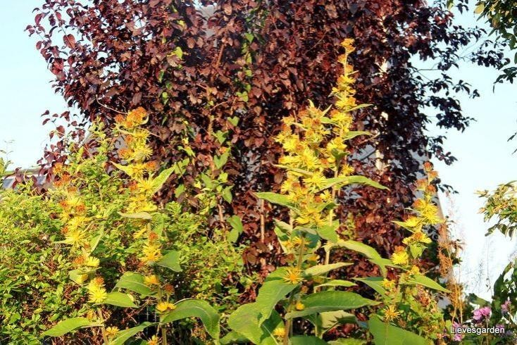

subject of ethnopharmacological and phytochemical research. As demand for herbal medicines grows, sustainable agrotechnology and conservation efforts are critical to ensure the continued availability of Inula racemosa in the face of increasing habitat destruction and over-harvesting. This article explores ethnopharmacology, phytochemistry, agrotechnology, and conservation efforts related to Inula racemosa, with an emphasis on newly identified eudesmanolides.

# ETHNOPHARMACOLOGY OF INULA RACEMOSA

Ethnopharmacology investigates traditional knowledge and practices surrounding medicinal plants, and Inula racemosa serves as a prime example due to its extensive history in traditional medicines. Known as “pushkarmool” in Ayurveda, the root of Inula racemosa has been used for centuries to ailments such as asthma, bronchitis, and arthritis (Jain et al.,2020). The plant’s root extracts are employed in various forms-decoctions, powders, and teas- within diverse cultural practices. Traditional Chinese

medicine also considers Inula racemosa valuable, employing it for its ability to counteract respiratory infections, gastrointestinal distress, and musculoskeletal disorders (Ma et al. 2019).

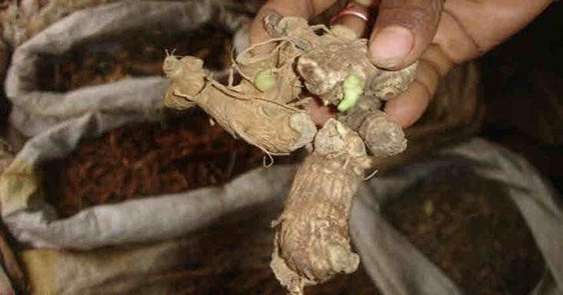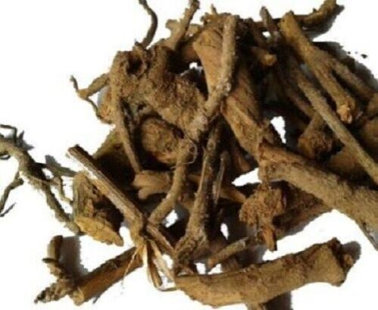

. Recent ethnopharmacological studies have highlighted the antimicrobial, anti- inflammatory, and antipyretic activities of Inula racemosa extracts, affirming its place in traditional medicine. Researchers conditions such as asthma and rheumatoid arthritis corelates with its pharmacological properties, including inhibition of inflammatory mediators like cytokines and prostaglandins (Chaudhary et al. 2018).This evidence underscores the potential for integrating Inula racemosa into modern therapeutic frameworks for these conditions.

# PHYTOCHEMISTRY OF INULA RACEMOSA

. The phytochemistry of Inula racemoda is intricate, characterized by a variety of bioactive compounds that contribute to its medicinal properties. The plant contains several classes of phytochemicals, including sesquiterpene lactones, sterols, flavonoids,

and alkaloids. Among these, sesquiterpene lactones, are notably prominent and are responsible for many of the plant’s therapeutic effects (Singh et al.,2020).Sesquiterpene lactones such as alantolactone and isoalantolactone have demonstrated anti- inflammatory, cytotoxins, and antimicrobial properties, which are especially relevant for applications in cancer and infectious disease treatment (Pandey and Rastogi, 2021).

Beyond sesquiterpenes, Inula racemosa contains essential oils that exhibit antifungal and antibacterial effects. These volatile compounds have shown efficacy against common pathogens, suggesting the potential for developing antimicrobial agents derived from the plant (Kumar et al.,2019). Additionally, flavonoids and polyphenols in Inula racemosa contribute to its antioxidant activities, providing a basis for potential therapeutic applications in oxidative stress-related diseases.

In addition to traditional extraction and isolation methods, advanced analytical techniques like high performance liquid chromatography(HPLC), mass spectrometry(MS), and nuclear magnetic resonance(NMR) spectroscopy are being used to refine which involves the comprehensive study of the plant’s metabolite profile, has enabled researchers to identify new phytochemicals in Inula racemosa, including unique terpenoids, flavonoids, and phenolic compounds (Wang et al.,2021).

# NEW EUDESMANOLIDES AND THEIR BIOLOGICAL POTENTIAL

One of the emerging areas in the study of Inula racemosa is the identification of new eudesmanolides, a subgroup of sesquiterpene lactones that demonstrate unique pharmacological activities. Eudesmanolides isolated from Inula racemosa exhibits potent bioactivities, including cytotoxin effects against cancer cells, modulation of immune response, and inhibition of key enzymes involved in inflammatory pathways (Zhang et al.,2019). The discovery of these eudesmanolides open new pathways for drug development, particularly in the areas of anti-inflammatory and anticancer therapies.

Recent studies have identified several new eudesmanolides specific to Inula racemosa, including compounds with novel structural configurations. These eudesmanolides demonstrate enhanced biological activities, and ongoing research aims to understand their mechanisms at the molecular level (Ahmed et al.,2021). For instance,

some eudesmanolides have shown selesctivity in targeting cancer cells without affecting healthy cells, presenting a promising therapeutic advantage.

# AGROTECHNOLOGY FOR SUSTAINABLE CULTIVATION

As the demand for Inula racemosa increases, driven by both traditional and modern medicinal applications, sustainable agrotechnological practices have become essential. Wild harvesting of the plant poses risks to its natural populations, prompting researchers and cultivators to explore agrotechnology as a solution for sustainable production. Agrotechnologyencompassess practices such as controlled cultivation, organic farming, and the use of biofertilizers to enhance plant yield and quality (Sharma et al.,2020).

In the context of Inula racemosa, agrotechnology focuses on optimizing soil conditions, irrigation, and nutrients management to support large-scale cultivation without depleting natural resources. Studies indicate that biofertilizers and organic amendments improve the biomass yield and phytochemical content of cultivated plants, making them comparable to wild specimens in term of medical value (Patel et al. 2019). Additionally, in vitro propagation techniques are

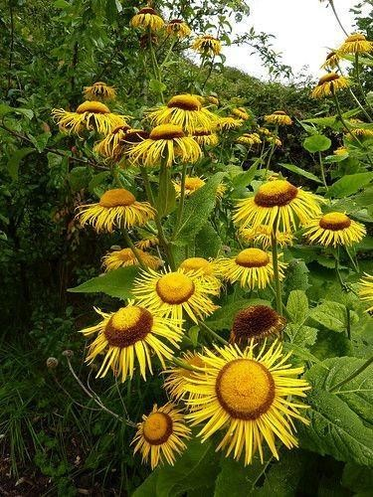

being developed to facilitate mass cultivation of Inula racemosa, reducing the pressure on wild populations and enabling year-round availability of the plant.

# CONSERVATION CHALLENGES AND STRATEGIES

The conservation of Inula racemosa is critical due to its endangered status in some regions of the Himalayans, where overharvesting and habitat degradation threaten its survival. Conservation efforts involve ex-situ and in-situ strategies to protect and regenerate wild populations. Ex-situ conservation focuses on the cultivation of Inula racemosa in botanical gardens and research facilities, allowing for seed banking and

tissue culture practices that preserve genetic diversity (Singh & Meena, 2022). In- situ conservation, on the other hand, involves protecting the natural habitats of Inula racemosa, regulating harvesting practices, and educating local communities on sustainable use.

To further conservation efforts, collaboration between local governments, traditional healers, and the pharmaceutical industry is essential. Integrating local communities into conservation strategies has proven effective in areas where Inula racemosa is traditionally used. Community-based initiatives that combine sustainable harvesting, cultivation, and marketing create economic incentives for conservation, ensuring that local populations benefit from preserving this valuable species (Thakur et al.,2020).

# CONCLUSION

Inula racemosa represents a unique blend of traditional knowledge and modern scientific research, with potential implications across pharmacology, sustainable agriculture, and conservation. Its pharmacological effects are backed by extensive ethnopharmacological use and phytochemical research, with new eudesmanolides highlighting its potential for treating conditions such as cancer and inflammation. Sustainable cultivation practices are essential to prevent overharvesting, and the integration of agrotechnology offers promising solutions for large scale production. Conservation efforts must continue, especially through community engagement and in-situ protection, to ensure that Inula racemosa remains a resource for future generations.

# REFERENCES

* 1. Ahmed s. khan., M.A. & Ali, M. (2021). Noval eudesmanolides from Inula racemosa: Structural elucation and anticancer activity. Journal of Natural Products, 84(6),1447-1454.
* 2. Chaudhary, A. Gupta, V. & Sahu, P. (2018). Anti-inflammatory and analgesic properties of Inula racemosa roots: A pharmacological study. Phytotherapy Research, 32(2), 289-296.
* 3. Jain, A., Singh, H. & Rastogi, S. (2020). Ethnopharmacological application of Inula racemosa in Ayurveda and modern medicine. Journal of Ethnopharmacology, 253, 112408.
* 4. Kumar, P., Singh, M. & Sharma, R. (2019). Antimicrobial and antioxidant properties of essential oils from Inula racemosa. Indian Journal of Microbiology, 59(2), 152-159.
* 5. Ma, W., Wang, Y. & Huang, J. (2019).Use of Inula racemosa in Traditional Chinese Medicine for respiratory ailments. Chinese Journal of Integrative Medicine, 25(4), 298-305.
* 6. Pandey, A. & Rastogi, M. (2021). Sesquiterpene lactones of Inula racemosa and their biological potential. Chemistry & Biodiversity, 18(5), e2000845.
* 7. Patel, S. Kumar, A. & Sharma, M. (2019). Effects of Biofertilizers on the yield and phytochemical composition of Inula racemosa. Agricultural sciences Journal, 10(1), 89-970.
* 8. Sharma, R., Chauhan, S. & Kaur,J. (2020). Agrotechnological advancements in the cultivation of Inula racemosa in India. Asian Journal of Agriculture, 11(3), 157-164.
* 9. Singh, B. & Meena, P.D. (2022).Conservation strategies for endangered medicinal plants in the Himalayas: The case of Inula racemosa. Mountain Research and Development, 42(1), 45-53.
* 10. Thakur, A., Negi, R. & Bhatt, A. (2020). Community-based conservation of Inula racemosa: Integrating traditional knowledge with modern practices. Journal of Mountain Ecology, 15(1), 12-25.
* 11. Ali, A., Gupta, V. & Ahmad, S. (2022). Therapeutic potential and phytochemistry of Inula racemosa: A systematic review. Journal of Ethnopharmacology, 290, 115066.
* 12. Bhatia, H., Sharma, Y. & Manhas, R.K.(2019). Indigenous use of medicinal plants in the western Himalayas with emphasis on Inula racemosa. Journal of Herbal Medicine, 20, 100287.
* 13. Chauhan, R., Vashistha, P. & Singh, B. (2021). Advances in conservation and propagation techniques of Inula racemosa. Botanical Journal of the Linnean Society, 195(4), 527-539.
* 14. Choudhary, N. & Sekhri, K. (2020). Role of Inula racemosa in traditional and modern medicine: A review. Asian Pacific Journal of Tropical Biomedicine, 10(8), 381-389.
* 15. Dhar, U., Rawat, S. & Samant, S. (2017). Sustainable management of medicinal plants in the Himalayas with a focus on Inula racemosa. Biodiversity Conservation, 26(4), 973-993.

**Appendix**

## ABSTRACT

Inula racemose, a traditional medicinal plant, holds a significant place in ethnopharmacology due to its wide-ranging medicinal uses, particularly in south asia. Recent scientific studies have identified bioactive compounds within Inula racemose that contribute to its therapeutic effects, including eudesmanolides, a unique class of sesquiterpenes. Advances in phytochemistry, agrotechnology, and conversation practices are essential to sustainably harness the plant’s medicinal potential and protect it from overexploitation. This article provide a comprehensive overview of Inula racemose, covering its traditional medicinal applications, phytochemical constituents, cultivation technologies, newly identified bioactive eudesmanolides, and current conservation efforts.

## KEYWORDS:

Inula racemosa, Ethnopharmacology, Phytochemistry, Agrotechnology, sesquiterpene lactone, Bioactive compound, Anti-inflammatory property, conservation strategies.

**Errata**