**Smart Agriculture System Using IOT For Efficient and Sustainble Farming**

Varada Eswar Prasad, S. Prassana2 (Assistant Professor)

Department of CSE-AIML, GMRIT, Rajam, Andhra Pradesh, India.

**ABSTRACT**

Smart Agriculture System using IoT (Internet of Things) is the name that would suffice to explain how it integrates technology with traditional agriculture. The system uses sensors, automation and data analytics that provide up-to-the-minute monitoring with cloud-based control of soil moisture as well as the temperature and humidity conditions. Watering of crops is optimized by smart irrigation systems, and the use of automated machinery or even drones different control strategies used to automate agriculture such as IoT, aerial imagery, multispectral, hyperspectral, NIR, thermal camera, RGB camera, machine learning, and artificial intelligence techniques. Problems in agriculture like plant diseases, pesticide control, weed management, irrigation and water management can easily be solved by different automated and control techniques mentioned above for crop management and monitoring. Using the power of AI and big data, one can predict better yield results as well as identify diseases in plants early. This technology is also great for technicians who have to drive out to multiple sites only to find that it was a minor problem, now with these mobile apps the techs can see if no readings came through and just need a reboot. This IoT-driven approach overcomes major constraints in agriculture, driving precision farming and helping sustain the growing world food demand with minimal environmental degradation.

**Keywords**: Smart Agriculture, Internet Of Things, Sensors, Automation, Smart Irrigation, Crop Monitoring.

**INTRODUCTION**

The use of Internet of Things (IoT) technology in farming, the integration of advanced IoT agriculture implements is bringing about a wave of change and inducing upgrades. With the growth of the world population, food production needs to be stepped up even more as it far outspaces possibility and therefore innovation is required to address these growing challenges. Agriculture IoT uses a solution that incorporates a network of sensors, tools and data analytics apparatus, to monitor and manage through real time status update available in crops, livestock, dairy production or natural resource consumption. This innovation equips farmers with important insights about soil quality, weather conditions and the health of plants which enables to make more effective decisions that improve yields.Optimized resource usage One of the major advantage IoT in agriculture helps in is to reduce the waste and cost. The precision irrigation system is such that it will just drop water, exactly when and where designed which makes the ideal strategy to combat with dry seasons.

**LITERATURE SURVEY**

The architecture integrates sensors (for environmental data collection), microcontrollers (to process data), and wireless communication (for transmitting data to a central platform).Remote monitoring of agricultural fields, reducing the need for manual field inspections.The paper highlights the use of Raspberry Pi, Arduino, and various IoT protocols for system implementation.Promotes precision agriculture, leading to efficient water usage and resource management[1].

The primary aim is to create a reliable and cost-effective water level measurement system that informs users about water levels through SMS notifications.A microcontroller processes the sensor data and determines the water level,ultrasonic sensorsA GSM module is used to send water level updates to a predefined mobile number. [2].

The document titled **"World Population Projected to Reach 9.8 Billion in 2050, and 11.2 Billion in 2100**. These demographic changes pose substantial challenges, including increased pressure on natural resources, food security [3].

the critical role of the AFOLU sector in mitigating climate change. This sector contributes significantly to global greenhouse gas (GHG) emissions, primarily through activities like deforestation, soil degradation, livestock farming, and agricultural practices. [4].

The paper concludes by outlining future directions for improving microcomputer-based applications, focusing on sustainability, foodsecurity, and the integration of advanced analytics for smarter decision-making. This study highlights the importance of information systems in the distribution of agricultural data. The paper focuses on the role of microcomputers and sensors in disseminating critical farming information to improve agricultural productivity. [5].

The paper emphasizes the importance of precision agriculture in addressing water scarcity and improving crop yields while reducing environmental impact. The paper concludes by advocating for further research and collaboration to optimize WSN technologies for sustainable farming practices.[6].

The paper **"An Internet of Things Solution for Smart Agriculture"** by **Gagliardi, G. et al.**, published in **Agronomy** in **2021**. explores the application of **Internet of Things (IoT)** technologies in transforming traditional agricultural practices into more efficient, sustainable, and data-driven systems [7].

The authors highlight the potential of IoT to contribute to sustainable farming practices and address challenges such as water scarcity, soil degradation, and climate change. The paper concludes by suggesting future research directions to improve the scalability, affordability, and effectiveness of IoT solutions in agriculture [8].

The authors present a comprehensive IoT-based solution designed to monitor and manage critical farming conditions such as soil moisture, temperature, humidity, and crop health [9].

**Global Information System on Water and Agriculture"** provides a comprehensive database and analysis tool designed to monitor and assess water use in agricultural practices worldwide The online resource is regularly updated, providing a reliable and accessible tool for global water and agricultural analysis.[10].

The authors discuss how cloud storage enables the seamless management and storage of vast amounts of data, which is essential for cloud computing services. [11].

the concept of **Agriculture 4.0**, which represents the integration of advanced technologies such as **IoT**, **artificial intelligence (AI)**, **big data**, and **robotics** into farming practices. [12].

**Computers and Electronics in Agriculture** provides an in-depth review of **Internet of Things (IoT)** communication technologies used in smart agriculture and discusses the challenges associated with their implementation explore various IoT communication protocols, such as **LoRa**, **ZigBee**, **NB-IoT**, and **5G**, evaluating their suitability for agricultural applications based on factors [13].

provides a comprehensive review of **IoT-enabled smart agriculture**, focusing on its architecture, key applications, and the challenges that must be addressed for successful implementation. The authors describe the architecture of IoT systems in agriculture, which integrates **sensors**, **actuators**, **communication networks**, and **data analytics platforms** to enable real-time monitoring and management of agricultural processes such as soil health, irrigation, pest control, and climate conditions. [14].

explores the transformative potential of **Internet of Things (IoT)** technologies in revolutionizing agricultural practices. The authors discuss the integration of IoT devices such as **sensors**, **drones**, and **smart irrigation systems** to optimize farm operations. [15].

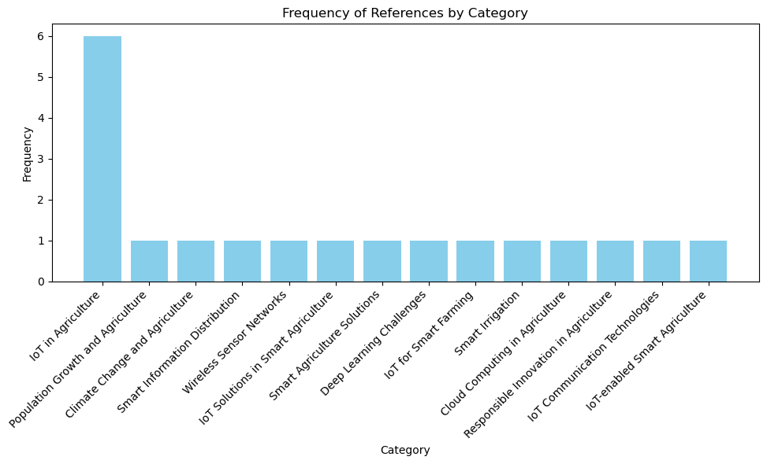

Fig-1: This Figure shows Number of Papers published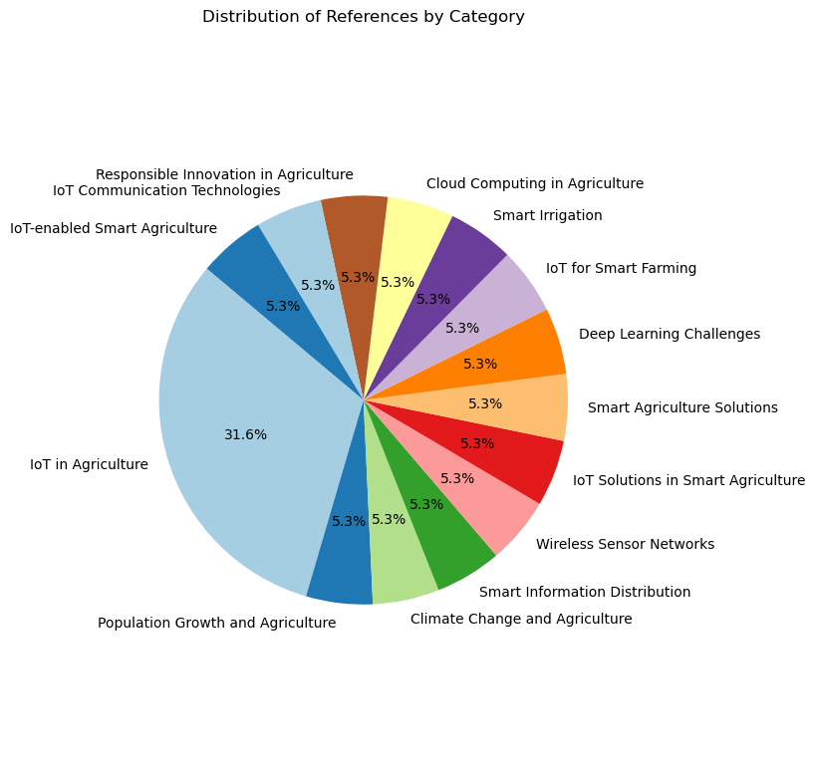

Fig-2: This Figure shows the Distribution of papers by year.

**METHODOLOGY**

**Research Design:**

Objective: To develop an IoT-based smart application that enhances agricultural practices through real-time monitoring and data analysis.

**System Architecture Components:**

Sensors: Soil moisture, temperature, humidity, and light sensors.

Microcontroller: Use of a Raspberry Pi for data processing.

**Data Collection:**

Field Trials:Selection of a representative agricultural site.

**Data Analysis:**

Data Preprocessing: process the raw data into clean and normalinging data. Algorithm Development:Development of algorithms for data interpretation (e.g., moisture level thresholds for irrigation).

**Precision Agriculture:**

Precision agriculture, also known as precision farming, is an innovative approach that utilizes advanced technologies to optimize crop production and resource management.

By integrating tools such as GPS, IoT sensors, drones, and data analytics, farmers can monitor and manage field variability in crops, soil, and climate conditions

**Objective:**Maximize crop yield while minimizing resource use (water, fertilizers, pesticides).

**IoT Implementation:**

**Soil Sensors:** Monitor soil moisture, pH, temperature, and nutrient levels in real time.

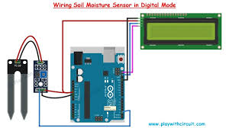

**Weather Stations:** Gather localized weather data to predict irrigation needs and disease risks.

**GPS-Enabled Devices:** Ensure precise planting, watering, and fertilization using automated machinery.

**Energy-Efficient Farming:**

Energy-efficient farming focuses on reducing energy consumption in agricultural operations while maintaining or enhancing productivity.

**Solar-Powered Sensors and Devices:**Power IoT devices with renewable energy.

**Smart Energy Meters**: Monitor and optimize energy use in irrigation pumps, machinery, and storage facilities**.**

**Energy-Efficient Lighting**: Use IoT to manage LED lighting in controlled environments.

**CONCLUSION**

The **"Smart Agriculture: IoT-Based Smart Application for Agriculture"** paper presents a transformative approach to modern farming through IoT technology. The research highlights the integration of smart sensors, microcontrollers, and communication technologies to optimize agricultural practices, addressing critical challenges such as resource inefficiency, high operational costs, and environmental impact.By utilizing components like soil moisture, temperature, pH sensors, and ESP32 microcontrollers, the system enables precise monitoring and control of key agricultural parameters. Features such as real-time data collection, remote monitoring, and automation allow for better irrigation, pest control, and nutrient management. The inclusion of user-friendly interfaces enhances accessibility for farmers, promoting informed decision-making and sustainable resource usage.The research's impact lies in its potential to revolutionize agriculture, boosting productivity while minimizing environmental footprints. Future developments suggested include adaptive algorithms for automation, integration of edge computing to enhance real-time responsiveness, and blockchain technology for secure and transparent data management. The paper concludes with a promising vision for IoT-based smart agriculture, ensuring global food security and sustainability while adapting to the growing challenges of climate change and population growth.

**References:**

1. 1) Prathibha, S. R., Hongal, A., & Jyothi, M. P. (2017, March). IoT based monitoring system in smart agriculture. In 2017 international conference on recent advances in electronics and communication technology (ICRAECT) (pp. 81-84). IEEE.
2. Design and Construction of Water Level Measurement System Accessible through SMS, Made Saraswati Dept. of Electr. Eng., Univ. PelitaHarapan, Tangerang, Indonesia Endrowednes Kuantama , PonoMardjoko.
3. World Population Projected to Reach 9.8 Billion in 2050, and 11.2 Billionin 2100. Accessed: Apr.18, 2019. [Online]. Available:
4. P. Smith, H. Clark, H. Dong, E. Elsiddig, and H. Haberl, ‘‘Agriculture,forestry and other land use(AFOLU),’’in Proc. Clim. Chang. Mitig. Clim.Chang., 2015, pp. 811–922, doi:10.1017/cbo9781107415416.017.
5. k.lakshmisudha, swathi hegde, neha cole, shruti iyer, "good information used for very widespread distribution", weekly status from microcomputer applications (0975-8887), number 146-no.11, july 2011.
6. Morais, Raul, A. Valente and C. Serôdio. "A wireless sensor network for smart irrigation and environmental monitoring: A position article." In 5th European federation for information technology in agriculture, food and environment and 3rd world congress on computers in agriculture and natural resources (EFITA/WCCA), pp.45-850.
7. Gagliardi, G. et al., An Internet of Things Solution for Smart Agriculture, Agronomy, 11(11), 2140, Oct, doi: https://doi.org/10.3390/agronomy11112140 (2021).
8. Dhar, T., Dey, N., Borra, S., & Sherratt, R. S. (2023). Challenges of deep learning in medical image M.K.Gayatri, J.Jayasakthi, Dr. G.S. Anandha Mala, (2015). Providing Smart Agricultural Solutions to Farmers for better yielding using IoT. IEEE International Conference on Technological Innovations in ICT for Agriculture and Rural Development (TIAR 2015) .
9. Doshi, J, Patel, T, and Kumar Bharti, S. (2019) “Smart farming using IoT, a solution for optimally monitoring farming conditions.”Procedia Computer Science 160: 746-751
10. Food and Agricultural Organization of the United Nations organization. AQUASTAT—FAO’s Global Information System on Water and Agri-culture. Accessed: Nov. 13, 2020. [Online]. Available:
11. J. Wu, L. Ping, X. Ge, Y. Wang, and J. Fu, ‘‘Cloud storage as the infrastructure of cloud computing,’’in Proc. Int. Conf. Intell. Comput. Cogn. Inform.(ICICCI), Kuala Lumpur, Malaysia, Jun. 2010.
12. D.C. Rose, J. Chilvers, Agriculture 4.0: broadening responsible innovation in an era of smart farming, Front. Sustain. Food Syst. 2 (2018) 87.
13. Tao, W., Zhao, L., Wang, G., & Liang, R. (2021). Review of the internet of things communication technologies in smart agriculture and challenges. Computers and Electronics in Agriculture, 189, 106352.
14. Quy, V. K., Hau, N. V., Anh, D. V., Quy, N. M., Ban, N. T., Lanza, S., ... & Muzirafuti, A. (2022). IoT-enabled smart agriculture: architecture, applications, and challenges. Applied Sciences, 12(7), 3396
15. Gowda, V. D., Prabhu, M. S., Ramesha, M., Kudari, J. M., & Samal, A. (2021, November). Smart agriculture and smart farming using IoT technology. In Journal of Physics: Conference Series IOP Publishing