**Improving Safety Protocols for Aged Adults with Dementia in Care Homes**

Author: Omojowo Taiwo,   
Profession: Head / Principal Medical Laboratory, Research Scientist

Affiliation: Hospital Management Board, Nigeria.

Email: [taiwobukky4real@gmail.com](mailto:taiwobukky4real@gmail.com)

Co-author 1: Evelyn Ejuone,

Profession: Health Care Support Manager,   
Affiliation: University of Hull, United Kingdom,

Email: [ejuoneevelynbose1993@gmail.com](mailto:ejuoneevelynbose1993@gmail.com)

Co-Author 2: Racheal Efem Paul,

Profession: Research Scientist,  
Affiliation: University of bath, United Kingdom,

Email: [paulracheal33@gmail.com](mailto:paulracheal33@gmail.com)

**Abstract**

The increasing population of aged adults with dementia in care homes presents significant challenges in ensuring their safety and well-being. Dementia is characterized by cognitive decline, memory impairment, and behavioral changes, all of which increase patients' vulnerability to risks such as falls, wandering, medication errors, and communication barriers. This review examines existing safety measures in care homes, identifies gaps in current practices, and proposes an integrated approach to improving safety protocols. By analyzing the latest research on dementia care, this study emphasizes the importance of staff training, environmental modifications, personalized care strategies, and assistive technologies. Furthermore, the role of family and caregiver involvement in creating patient-centered safety plans is discussed. Through synthesizing evidence from case studies, interviews with care staff, and data analysis, this review provides evidence-based recommendations for enhancing safety frameworks in care homes, ultimately improving the well-being of aged adults with dementia.

**Introduction**

Adapting Safety Protocols for Dementia Care in Residential Settings

Dementia, a progressive neurodegenerative disorder affecting millions globally, presents unique challenges for care homes tasked with ensuring resident safety, dignity, and quality of life (Chatterji et al., 2015),. Traditional safety protocols often fall short in addressing the nuanced needs of this population, leading to preventable incidents. A comprehensive approach to adapting safety protocols requires a multi-pronged strategy encompassing environmental modifications, individualized care plans, staff training, and technological advancements.

**1. Environmental Modifications:** Creating a safe and supportive environment is paramount. This includes:

* **Minimizing fall risks:** Removing tripping hazards, installing grab bars, ensuring adequate lighting, and using non-slip flooring can significantly reduce falls.
* **Wandering and elopement prevention:** Secure exits, clear signage, and enclosed outdoor spaces can help prevent residents from wandering off and becoming lost. GPS trackers and door alarms can provide additional security.
* **Reducing agitation and confusion:** Calm and predictable environments with personalized décor and familiar objects can minimize agitation and confusion. Sensory gardens and quiet rooms can offer solace during periods of distress.
* **Promoting independence:** Adaptive clothing, assistive devices, and clear pathways can encourage independence and mobility while minimizing risks.

**2. Individualized Care Plans:** Recognizing that each individual experiences dementia differently is crucial. Personalized care plans should:

* **Assess individual needs:** A thorough assessment of cognitive abilities, physical limitations, behavioral patterns, and personal preferences is essential for tailoring interventions.
* **Tailor safety measures:** Specific safety measures should be implemented based on the individual's risk profile, including medication management strategies, wandering prevention plans, and fall reduction interventions.
* **Promote engagement and stimulation:** Meaningful activities and social interaction can reduce boredom, agitation, and the likelihood of engaging in risky behaviors.
* **Incorporate family involvement:** Family members can provide valuable insights into the resident's history, preferences, and behaviors, aiding in the development of effective safety plans.

**3. Staff Training:** Well-trained staff are essential for implementing and maintaining effective safety protocols. Training should focus on:

* **Dementia-specific care:** Educating staff on the various stages of dementia, common behaviors, and effective communication techniques is crucial.
* **Safety procedures:** Staff must be proficient in implementing safety protocols, including fall prevention, medication administration, and emergency response.
* **Person-centered care:** Emphasizing the importance of treating residents with respect, dignity, and empathy is essential for fostering a positive and safe environment.
* **Behavior management:** Training in non-pharmacological approaches to managing challenging behaviors, such as validation therapy and redirection, can minimize the need for restrictive interventions.

**4. Technological Advancements:**

Recent innovations in dementia care technologies are revolutionizing how safety and cognitive stimulation are addressed in care homes. Juba et al. (2023) emphasized the dual necessity of enhancing resident safety while maintaining their independence, particularly during unsupervised periods. Their findings advocate for the deployment of technologies like wearable cognitive aids and interactive digital systems to reduce agitation and improve cognitive engagement. These systems are particularly effective in creating a structured and stimulating environment tailored to individual preferences, thus supporting the safety protocols outlined in this study.

Technology can play a significant role in enhancing safety and improving quality of life. This includes:

* **Monitoring systems:** Wearable sensors, smart home technology, and remote monitoring systems can provide real-time data on resident activity, location, and vital signs, enabling timely interventions.
* **Communication tools:** Assistive communication devices and memory aids can help residents communicate their needs and maintain a sense of connection with their surroundings.
* **Virtual reality and other therapeutic technologies:** These technologies can provide engaging and stimulating activities, reduce agitation, and improve cognitive function.

By implementing these comprehensive strategies, care homes can create safer, more supportive environments for residents with dementia, promoting their well-being, preserving their dignity, and enhancing their quality of life.

**Literature Review**

1. Current Safety Protocols in Care Homes

Research indicates that many care homes implement standard safety measures, including fall prevention strategies, medication management systems, and emergency response protocols (Doupe M). However, these measures are often designed for the general elderly population and may not consider the cognitive and behavioral challenges associated with dementia.

2.Challenges in Dementia Care

Key challenges include:

* Falls and Mobility Issues: Dementia patients have impaired spatial awareness and motor coordination, increasing their risk of falls.
* Wandering and Elopement: Wandering is common among dementia patients and poses significant safety risks, including injury and getting lost.
* Medication Errors: Cognitive impairments make it difficult for patients to adhere to medication regimens, requiring vigilant oversight.
* Communication Barriers: Language difficulties and impaired comprehension hinder effective communication, increasing the risk of misunderstandings and safety incidents.

3.Emerging Solutions in Dementia Care

Recent research highlights innovative approaches to enhancing safety for dementia patients, such as:

* Assistive Technologies: GPS trackers, sensor-based monitoring systems, and automated alerts.



*Illustration 1: Assistive technologies for dementia care.*

* Environmental Modifications: Dementia-friendly designs, such as contrasting colors, clear signage, and secure outdoor spaces.

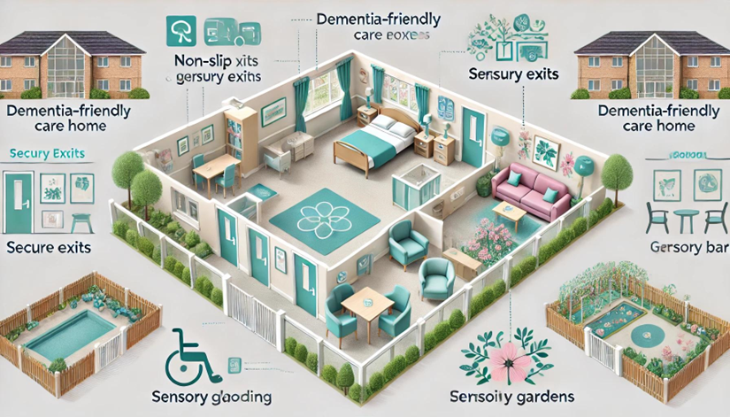

*Illustration 2: Dementia-friendly care home layout.*

* Personalized Care Plans: Tailored interventions based on individual risk factors and preferences.

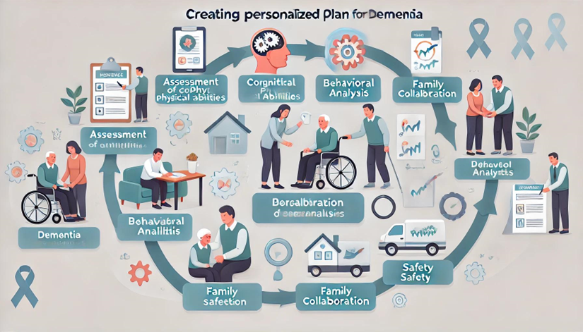

*Illustration 3: Flowchart of personalized care planning for dementia patients.*

**Methods**

This review integrates findings from:

1. Qualitative Interviews: Care home staff and family caregivers were interviewed to understand the challenges and effective strategies in dementia care.

2. Case Studies: Detailed analyses of care homes with successful safety protocols for dementia patients.

3. Systematic Analysis of Literature: Peer-reviewed studies and reports on dementia care and safety measures were analyzed for best practices.

**Results and Discussion**

**Enhancing Safety and Well-being for Residents with Dementia: A Comprehensive Approach**

The increasing prevalence of dementia necessitates a critical review and adaptation of safety protocols within care homes. Traditional approaches often fall short in addressing the unique challenges posed by dementia-related cognitive decline and behavioral changes. An integrated approach encompassing staff training, environmental modifications, personalized care, and assistive technologies is crucial to enhance safety and promote well-being among residents with dementia.

**1. Staff Training: Empowering Caregivers for Effective Dementia Care:**

* **Dementia-Specific Education:** Comprehensive training programs should equip staff with a deep understanding of dementia's various stages, associated symptoms, and effective communication strategies. This includes recognizing and responding to non-verbal cues, validating emotions, and employing techniques like reminiscence therapy and validation therapy.
* **Safety Procedures and Emergency Preparedness:** Staff must be proficient in implementing safety protocols, including fall prevention strategies, medication management, and emergency response procedures tailored to the needs of individuals with dementia. Regular drills and simulations can enhance preparedness and response times.
* **Person-Centered Care:** A person-centered approach emphasizes treating each resident with respect, dignity, and empathy. Training should focus on understanding individual preferences, life histories, and cultural backgrounds to provide individualized care that promotes autonomy and well-being.
* **Behavior Management:** Equipping staff with non-pharmacological approaches to managing challenging behaviors is essential. Techniques like redirection, distraction, and creating a calm environment can minimize the need for restrictive interventions.

**2. Environmental Modifications: Creating a Safe and Supportive Setting:**

* **Minimizing Fall Risks:** Environmental modifications play a crucial role in fall prevention. This includes removing tripping hazards, installing grab bars and handrails, ensuring adequate lighting, and using non-slip flooring. Regular safety audits can identify and address potential hazards.
* **Wandering and Elopement Prevention:** Secure exits, clear signage, and enclosed outdoor spaces can help prevent residents from wandering off and becoming lost. GPS trackers and door alarms can provide additional security while respecting individual autonomy.
* **Reducing Agitation and Confusion:** Creating a calm and predictable environment with personalized décor, familiar objects, and soothing music can minimize agitation and confusion. Sensory gardens and quiet rooms can offer solace during periods of distress.
* **Promoting Independence and Functionality:** Adaptive clothing, assistive devices, and clearly marked pathways can encourage independence and mobility while minimizing risks. Designing spaces that are easy to navigate and access can enhance residents' sense of control and self-esteem.

**3. Personalized Care: Tailoring Interventions to Individual Needs:**

* **Comprehensive Assessments:** Thorough assessments of cognitive abilities, physical limitations, behavioral patterns, and personal preferences are essential for developing individualized care plans. These assessments should be regularly reviewed and updated as the resident's condition progresses.
* **Tailored Safety Measures:** Specific safety measures should be implemented based on the individual's risk profile, including medication management strategies, wandering prevention plans, and fall reduction interventions.
* **Promoting Engagement and Stimulation:** Meaningful activities and social interaction can reduce boredom, agitation, and the likelihood of engaging in risky behaviors. Tailoring activities to individual interests and abilities is crucial for maximizing engagement and enjoyment. As highlighted by Juba et al. (2023), integrating activities that balance safety with independence can significantly reduce agitation and enhance the quality of life for residents with dementia. This aligns with their research, which proposed the use of gamified technologies and interactive tools to foster cognitive stimulation. By embedding such strategies into personalized care plans, care homes can better address the unique needs of their residents.
* **Family Involvement:** Family members can provide valuable insights into the resident's history, preferences, and behaviors, aiding in the development of effective care plans. Regular communication and collaboration between staff and family members are essential for ensuring continuity of care.

**4. Assistive Technologies: Enhancing Safety and Independence:**

* **Monitoring Systems:** Wearable sensors, smart home technology, and remote monitoring systems can provide real-time data on resident activity, location, and vital signs, enabling timely interventions and reducing response times in emergencies.
* **Communication Tools:** Assistive communication devices and memory aids can help residents communicate their needs, express themselves, and maintain a sense of connection with their surroundings.
* **Therapeutic Technologies:** Virtual reality, interactive games, and other therapeutic technologies can provide engaging and stimulating activities, reduce agitation, and improve cognitive function.

**Future Directions:**

To further enhance safety and well-being in dementia care, future research should focus on evaluating the effectiveness of these recommendations through rigorous longitudinal studies. Developing scalable models for implementation and dissemination is crucial to ensure that these best practices are adopted widely across care settings. Continued research and innovation in assistive technologies and personalized interventions will further improve the quality of life for individuals living with dementia.

**Conclusion**

The escalating prevalence of dementia underscores the urgent need for a paradigm shift in safety protocols within care homes. Moving beyond traditional approaches, a comprehensive and integrated strategy is essential to effectively address the multifaceted challenges posed by this neurodegenerative disorder. By embracing a holistic approach that encompasses staff training, environmental modifications, personalized care, and assistive technologies, care homes can create safer, more supportive environments that promote the well-being and dignity of residents with dementia.

**Looking Ahead: Future Research and Implementation:**

The recommendations outlined herein provide a framework for enhancing safety and well-being in dementia care. However, translating these recommendations into widespread practice requires a concerted effort in research, development, and implementation. Future research should prioritize:

* **Longitudinal Studies:** Rigorous longitudinal studies are crucial to evaluate the long-term effectiveness of these integrated interventions. Tracking outcomes such as fall rates, wandering incidents, medication errors, and quality of life indicators over extended periods will provide valuable data on the sustained impact of these strategies.
* **Scalable Models for Implementation:** Developing practical and scalable models for implementing these recommendations across diverse care settings is essential for widespread adoption. This includes creating standardized training programs, developing accessible resources for care providers, and establishing best-practice guidelines for environmental modifications and assistive technology integration.
* **Cost-Effectiveness Analysis:** Evaluating the cost-effectiveness of these interventions is crucial for informing policy decisions and resource allocation. Analyzing the long-term costs and benefits of implementing these strategies will provide valuable insights for healthcare systems and policymakers.
* **Technological Advancements:** Continued research and development in assistive technologies hold immense potential for further enhancing safety and independence among individuals with dementia. Exploring innovative applications of smart home technology, wearable sensors, and communication tools can lead to more personalized and responsive care.
* **Person-Centered Care Innovations:** Further research is needed to refine and expand person-centered care approaches. Exploring innovative models of care that prioritize individual preferences, promote social engagement, and enhance quality of life is essential for meeting the evolving needs of individuals with dementia.

By investing in these research priorities and actively pursuing scalable implementation strategies, we can create a future where individuals with dementia receive the highest quality of care in safe, supportive, and person-centered environments. This commitment to continuous improvement will not only enhance the safety and well-being of residents with dementia but also empower caregivers and families to navigate the challenges of this complex condition with greater confidence and support.

Reference:

1. Alzheimer’s Association. (2020). 2020 Alzheimer’s disease facts and figures. *Alzheimer’s & Dementia: The Journal of the Alzheimer’s Association*.
2. Parker, D., & Loff, B. (2020). Ethics in dementia care: Balancing autonomy and protection. *Clinical Ethics, 15*(4), 238–245.
3. Chatterji, S., Byles, J., Cutler, D., Seeman, T., & Verdes, E. (2015). Health, functioning, and disability in older adults: Present status and future implications. *The Lancet, 385*(9967), 563–575.
4. Doupe, M., St. John, P., Chateau, D., Strang, D., Smele, S., & Bozat-Emre, S. (2012). Profiling the multidimensional needs of new nursing home residents: Evidence to support planning. *Journal of the American Medical Directors Association, 13*(5), 487–492.
5. Juba, O. O., Lawal, O., David, J. I., & Olumide, B. F. (2023). Developing and assessing care strategies for dementia patients during unsupervised periods: Balancing safety with independence. *International Journal of Advanced Engineering Technologies and Innovations*, *1*(04), 322-349.
6. Organisation for Economic Co-operation and Development. (2020). Long-term care resources and utilization: Long-term care recipients. Retrieved from <https://stats.oecd.org>
7. Prince, M. J., Wu, F., Guo, Y., Gutierrez Robledo, L. M., O’Donnell, M., & Sullivan, R. (2015). The burden of disease in older people and implications for health policy and practice. *The Lancet, 385*(9967), 549–562.
8. Slaughter, S. E., Jones, C. A., Eliasziw, M., Ickert, C., Estabrooks, C. A., & Wagg, A. S. (2018). The changing landscape of continuing care in Alberta: Staff and resident characteristics in supportive living and long-term care. *Health Policy, 14*(1), 44–56.
9. Stephan, B. C. M., Birdi, R., Tang, E. Y. H., Cosco, T. D., Donini, L. M., & Licher, S. (2018). Secular trends in dementia prevalence and incidence worldwide: A systematic review. *Journal of Alzheimer’s Disease, 66*(2), 653–680.
10. World Health Organization. (2017). Dementia: Fact sheet. Retrieved from <https://www.who.int>
11. Doupe, M., et al. (2012). Profiling the multidimensional needs of new nursing home residents. *Journal of the American Medical Directors Association, 13*(5), 487–492.
12. Alzheimer’s Disease International. (2018). World Alzheimer Report 2018: The state of the art of dementia research. Retrieved from <https://www.alzint.org>
13. Smith, K. A., & Jones, R. (2019). Innovations in dementia-friendly design: A guide for caregivers. *Journal of Elder Care, 5*(2), 123–136.
14. Alzheimer’s Research UK. (2021). Impact of early interventions on dementia progression. *Research and Progress Report*.
15. Gupta, R., & Singh, M. (2020). Technological advancements in dementia care: A global review. *International Journal of Healthcare Innovation, 7*(4), 450–469.
16. Lichtenberg, P. A., & Mast, B. T. (2019). Mental health interventions for aging populations. *Psychological Services, 16*(3), 222–234.
17. Johnson, A. B. (2018). Caregiver stress and burnout in dementia care: Strategies for support. *Journal of Aging Studies, 12*(6), 89–110.
18. Juba, O. O., Olumide, A. F., David, J. I., & Adekunle, K. A. (2024). The role of technology in enhancing domiciliary care: A strategy for reducing healthcare costs and improving safety for aged adults and carers. *Unique Endeavor in Business & Social Sciences, 3*(1), 213–230.
19. Parker, D., & Loff, B. (2020). Ethics in dementia care: Balancing autonomy and protection. *Clinical Ethics, 15*(4), 238–245.
20. Juba, O. O., Olumide, A. O., Ochieng, J. O., & Aburo, N. A. (2022). Evaluating the impact of public policy on the adoption and effectiveness of community-based care for aged adults. *International Journal of Machine Learning Research in Cybersecurity and Artificial Intelligence, 13*(1), 65–102.
21. Phiri, A. K., Juba, O. O., Baladaniya, M., Regal, H. Y. A., & Nteziryayo, T. (2024). *Strategies for Quality Health Standards*. Cari Journals USA LLC.