**AI-Driven Innovations for Efficient Waste Management**

*Marna Vinay Kumar, Mr.D.Ganesh*

**Abstract**

The integration of artificial intelligence (AI) into waste management has sparked significant advancements, particularly through the deployment of specific technologies aimed at optimizing waste handling processes. This paper explores the impact of key AI-driven technologies, such as machine learning algorithms, robotic sorting systems, and sensor-equipped smart bins, on the efficiency and sustainability of waste management practices. Machine learning algorithms play a pivotal role by analyzing historical and real-time data to predict waste generation patterns, enabling more effective resource allocation and route optimization for waste collection. Robotic sorting systems, equipped with advanced computer vision, automate the segregation of recyclables, enhancing the accuracy and speed of sorting processes while reducing contamination levels and labor costs. Additionally, smart bins with integrated sensors provide real-time data on waste levels, facilitating dynamic route planning that reduces fuel consumption and operational expenses. The paper delves into the technical mechanisms behind these technologies, assessing their performance, scalability, and adaptability in varied contexts, from developed regions with advanced waste infrastructures to emerging markets facing infrastructural constraints. It also examines the challenges associated with implementing these technologies, including technical, financial, and regulatory barriers, and proposes strategies to overcome them. By conducting a detailed analysis of these AI-driven innovations, the paper aims to highlight their transformative potential in creating smarter, more sustainable waste management systems. Ultimately, this study underscores the critical need for continued technological advancements and collaborative efforts to maximize the benefits of AI in waste management globally.**Keywords:** *Artificial Intelligence (AI) , Waste Management ,Machine Learning Algorithms, Robotic Sorting Systems, Smart Bins*

**Introduction**

The escalating global waste management crisis, driven by rapid urbanization and industrialization, has created an urgent need for innovative solutions. Traditional waste management practices are increasingly proving insufficient, leading to environmental degradation, health risks, and resource depletion. In this context, artificial intelligence (AI) has emerged as a promising tool, offering advanced techniques for optimizing waste collection, sorting, recycling, and disposal. AI-driven systems are enabling real-time monitoring, predictive waste generation models, and enhanced recycling efforts, particularly in smart cities.Various studies have explored the applications of AI and machine learning in waste management across different regions, including developed and developing nations. For instance, AI-driven innovations in the USA focus on advanced waste collection optimization, automated sorting systems using computer vision, and leveraging machine learning algorithms to predict waste patterns​. Conversely, in regions like Africa, AI solutions prioritize adaptability and scalability, utilizing mobile applications and sensor-equipped smart bins to address infrastructural limitations​. This comparative analysis of innovations provides insights into the socio-economic and infrastructural differences that shape the implementation and success of AI-driven waste management systems globally.

**Literature Review**:

[1]Nwoke diegwu, Z. Q. S., Uguanyi, E. D., Dada, M. A., Majemite, M. T., & Obaigbena, A. (2024). AI-driven waste management systems: a comparative review of innovations in the USA and Africa. Engineering Science & Technology Journal, 5(2), 507-516.[2] Dodampegama, S., Hou, L., Asadi, E., Zhang, G., & Setunge, S. (2024). Revolutionizing construction and demolition waste sorting: Insights from artificial intelligence and robotic applications. Resources, Conservation and Recycling, 202, 107375.[3] Kothamali, P. R., Mandaloju, N., & Dandyala, S. S. M. (2022). Optimizing Resource Management in Smart Cities with AI. Unique Endeavor in Business & Social Sciences, 1(1), 174-191.[4] Wilts, H., Garcia, B. R., Garlito, R. G., Gómez, L. S., & Prieto, E. G. (2021). Artificial intelligence in the sorting of municipal waste as an enabler of the circular economy. Resources, 10(4), 28.[5] Xia, W., Jiang, Y., Chen, X., & Zhao, R. (2022). Application of machine learning algorithms in municipal solid waste management: A mini review. Waste Management & Research, 40(6), 609-624.[6]Namoun, A., Tufail, A., Khan, M. Y., Alrehaili, A., Syed, T. A., & BenRhouma, O. (2022). Solid waste generation and disposal using machine learning approaches: a survey of solutions and challenges. Sustainability, 14(20), 13578[7] Pallathadka, H., Mustafa, M., Sanchez, D. T., Sajja, G. S., Gour, S., & Naved, M. (2023). Impact of machine learning on management, healthcare and agriculture. Materials Today: Proceedings, 80, 2803-2806.[8] Water pollution control and revitalization using advanced technologies: Uncovering artificial intelligence options towards environmental health protection, sustainability and water security [9] Younas, F., Mustafa, A., Farooqi, Z. U. R., Wang, X., Younas, S., Mohy-Ud-Din, W., ... & Hussain, M. M. (2021). Current and emerging adsorbent technologies for wastewater treatment: trends, limitations, and environmental implications. Water, 13(2), 215. [10]Huseien, G. F., & Shah, K. W. (2022). A review on 5G technology for smart energy management and smart buildings in Singapore. Energy and AI, 7, 100116.[11] Yigitcanlar, T., & Cugurullo, F. (2020). The sustainability of artificial intelligence: An urbanistic viewpoint from the lens of smart and sustainable cities. Sustainability, 12(20), 8548. [12] avaid, M., Haleem, A., Khan, I. H., & Suman, R. (2023). Understanding the potential applications of Artificial Intelligence in Agriculture Sector. Advanced Agrochem, 2(1), 15-30. [13] Schwarz, A. E., Ligthart, T. N., Bizarro, D. G., De Wild, P., Vreugdenhil, B., & Van Harmelen, T. (2021). Plastic recycling in a circular economy; determining environmental performance through an LCA matrix model approach. Waste Management, 121, 331-342.[14]Chauhan, C., Parida, V., & Dhir, A. (2022). Linking circular economy and digitalisation technologies: A systematic literature review of past achievements and future promises. Technological Forecasting and Social Change, 177, 121508. [15] Nti, E. K., Cobbina, S. J., Attafuah, E. E., Senanu, L. D., Amenyeku, G., Gyan, M. A., ... & Safo, A. R. (2023). Water pollution control and revitalization using advanced technologies: Uncovering artificial intelligence options towards environmental health protectioony. Heliyon, 9(7).

**Methodology:**

* Existing Methodologies Artificial Neural Networks (ANN) are suitable for any nonlinear relationship and have strong robustness and fault tolerance, but they need many parameters and lack interpretability.Support Vector Machine/Support Vector Regression (SVM/SVR) are suitable for small sample problems and can avoid local minima, but they are sensitive to missing data and kernel selection.Decision Trees (DT) have high interpretability and efficiency, but they are prone to overfitting and ignore feature correlation.K-Nearest Neighbor (KNN) makes no assumption for input data and is not sensitive to outliers, but it needs a large amount of calculation and has low accuracy.Adaptive Network Fuzzy Inference System (ANFIS) combines the advantages of neural networks and fuzzy reasoning, but it is not suitable for higher dimensional features.K-means is easy to implement, has fast convergence, and uses few parameters, but it is sensitive to noise and depends on the initialization of the cluster center.Fraud Detection: Algorithms like Random Forest, SVM, and MLP effectively classify transactions as legitimate, suspicious, or fraudulent. Fraud detection benefits from using models with high accuracy and the ability to handle imbalanced data.Route Optimization for Waste Collection: Clustering techniques (e.g., K-means) and predictive models optimize waste collection routes, reducing fuel costs and carbon emissions by ensuring bins are serviced only when necessaryWaste Classification and Recycling: Convolutional Neural Networks (CNN) are used for identifying recyclable materials through image classification, streamlining sorting processes and improving recycling efficiency.

.

**Work flow:** 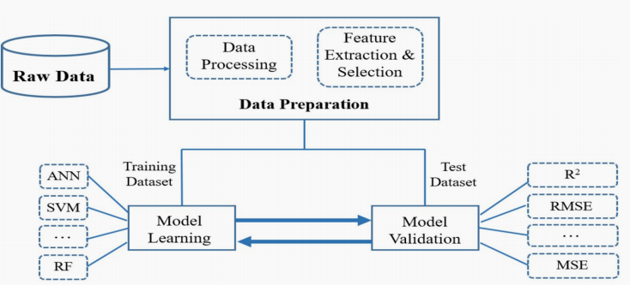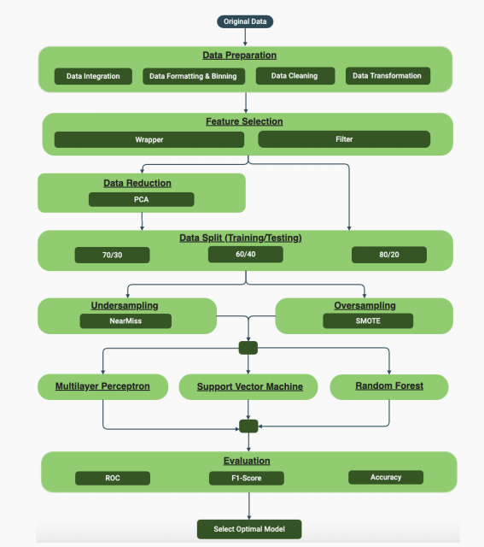

**Result:**

|  |  |  |  |  |  |
| --- | --- | --- | --- | --- | --- |
| **No** | **DATESET** | **MODEL** | **ACCURACY** | **PRECISION** | **F1-SCORE** |
| **1** | I CYCLE Malaysia Private Dataset | Multi-layer perception | 91.72 | 91.66 | 93.23 |
| **2** | Trash Net | Multi layer perception | 91.38 | 92.13 | 88.27 |
| **3** | Kunal RCHS Waste Data | Multi layer perception | 89.43 | 88.32 | 86.38 |
| **4** | GAIA Waste Audit Data | Multi layer perception | 96.3 | 88.54 | 78.62 |
| **5** | ANOFIELD project | Random Forest | 96.21 | 98.92 | 95.20 |
| **6** | GAIA Waste Audit Data | Random Forest | 95.98 | 98.76 | 94.63 |
| **7** | Web of Science | Random Forest | 93.84 | 96.79 | 94.20 |
| **8** | Waste Classification | Random Forest | 77.64 | 73.48 | 94.63 |
| **9** | C&D Waste Image | Random  Forest | 79.93 | 79.29 | 94.20 |
| **10** | ICYCLE Malaysia | SVM | 72.10 | 72.93 | 93.68 |
| **11** | Landfill Gas Modeling | SVM | 85.73 | 72.10 | 73.48 |
| **12** | IoT Sensors | SVM | 86.01 | 85.73 | 71.56 |
| **13** | Scopus database | SVM | 86.29 | 86.01 | 70.81 |
| **14** | 2836 C&D waste images | SVM | 72.93 | 86.29 | 67.72 |
| **15** | Energy Recovery Potential Prediction | SVM | 74.08 | 74.08 | 86.38 |

**Conclusion**

The integration of Artificial Intelligence (AI) and Machine Learning (ML) in waste management has demonstrated promising potential across several critical areas, from optimizing municipal solid waste processes to promoting circular economy initiatives. Recent studies and frameworks indicate that ML algorithms can enhance waste classification, improve predictions of waste generation, and optimize collection routes, resulting in cost savings and efficiency gains for urban waste management systems (Xia et al., 2022; Namoun et al., 2022). Furthermore, the application of ML to fraud detection in waste systems helps to minimize financial losses and improve regulatory compliance (Hewiagh et al., 2021).A significant advancement highlighted is the use of Industry 4.0 technologies, including IoT and AI, which enable real-time data analysis for smart waste management in urban settings. This is particularly relevant in smart city transformations, where dynamic and adaptive systems can respond to changing waste management needs (Kumar, 2024). Case studies in emerging economies have also shown that ML-based circular economy practices, particularly in managing packaging waste, are crucial for achieving environmental sustainability goals (Ajwani-Ramchandani et al., 2021).However, several challenges persist. Many ML models require extensive data for training and are sensitive to quality, making data acquisition and preprocessing significant hurdles. Furthermore, the ethical and environmental implications of AI use in waste management are still under debate, as AI's energy consumption and potential biases may counteract sustainability goals (Yigitcanlar & Cugurullo, 2020).

**References**

[1]Nwoke diegwu, Z. Q. S., Uguanyi, E. D., Dada, M. A., Majemite, M. T., & Obaigbena, A. (2024). AI-driven waste management systems: a comparative review of innovations in the USA and Africa. Engineering Science & Technology Journal, 5(2), 507-516.[2] Dodampegama, S., Hou, L., Asadi, E., Zhang, G., & Setunge, S. (2024). Revolutionizing construction and demolition waste sorting: Insights from artificial intelligence and robotic applications. Resources, Conservation and Recycling, 202, 107375.[3] Kothamali, P. R., Mandaloju, N., & Dandyala, S. S. M. (2022). Optimizing Resource Management in Smart Cities with AI. Unique Endeavor in Business & Social Sciences, 1(1), 174-191.[4] Wilts, H., Garcia, B. R., Garlito, R. G., Gómez, L. S., & Prieto, E. G. (2021). Artificial intelligence in the sorting of municipal waste as an enabler of the circular economy. Resources, 10(4), 28.[5] Xia, W., Jiang, Y., Chen, X., & Zhao, R. (2022). Application of machine learning algorithms in municipal solid waste management: A mini review. Waste Management & Research, 40(6), 609-624.[6]Namoun, A., Tufail, A., Khan, M. Y., Alrehaili, A., Syed, T. A., & BenRhouma, O. (2022). Solid waste generation and disposal using machine learning approaches: a survey of solutions and challenges. Sustainability, 14(20), 13578[7] Pallathadka, H., Mustafa, M., Sanchez, D. T., Sajja, G. S., Gour, S., & Naved, M. (2023). Impact of machine learning on management, healthcare and agriculture. Materials Today: Proceedings, 80, 2803-2806.[8] Water pollution control and revitalization using advanced technologies: Uncovering artificial intelligence options towards environmental health protection, sustainability and water security [9] Younas, F., Mustafa, A., Farooqi, Z. U. R., Wang, X., Younas, S., Mohy-Ud-Din, W., ... & Hussain, M. M. (2021). Current and emerging adsorbent technologies for wastewater treatment: trends, limitations, and environmental implications. Water, 13(2), 215. [10]Huseien, G. F., & Shah, K. W. (2022). A review on 5G technology for smart energy management and smart buildings in Singapore. Energy and AI, 7, 100116.[11] Yigitcanlar, T., & Cugurullo, F. (2020). The sustainability of artificial intelligence: An urbanistic viewpoint from the lens of smart and sustainable cities. Sustainability, 12(20), 8548. [12] avaid, M., Haleem, A., Khan, I. H., & Suman, R. (2023). Understanding the potential applications of Artificial Intelligence in Agriculture Sector. Advanced Agrochem, 2(1), 15-30. [13] Schwarz, A. E., Ligthart, T. N., Bizarro, D. G., De Wild, P., Vreugdenhil, B., & Van Harmelen, T. (2021). Plastic recycling in a circular economy; determining environmental performance through an LCA matrix model approach. Waste Management, 121, 331-342.[14]Chauhan, C., Parida, V., & Dhir, A. (2022). Linking circular economy and digitalisation technologies: A systematic literature review of past achievements and future promises. Technological Forecasting and Social Change, 177, 121508. [15] Nti, E. K., Cobbina, S. J., Attafuah, E. E., Senanu, L. D., Amenyeku, G., Gyan, M. A., ... & Safo, A. R. (2023). Water pollution control and revitalization using advanced technologies: Uncovering artificial intelligence options towards environmental health protectioony. Heliyon, 9(7).