ENHANCING ELECTRIC VEHICLE PERFORMANCE AND SAFETY THROUGH ADVANCED THERMAL MANAGEMENT
P.Sujidha¹, Dr.S.Lakshmi kanthan Bharathi², N.Ahamed Hussain Asif³, Dr.G.Vijayasri⁴, A.Usha⁵
^{1,3,5}Assistant Professor, Department of Electrical and Electronics Engineering, Mohamed Sathak Engineering College, Kilakarai, Tamilnadu, India
²Associate Professor, Department of Electrical and Electronics Engineering, Mohamed Sathak Engineering College, Kilakarai, Tamilnadu, India
⁴Associate Professor, Department of Physics, Mohamed Sathak Engineering College, Kilakarai, Tamilnadu, India

ABSTRACT
Electric vehicles (EVs) are poised to revolutionize the automotive industry, but their widespread adoption hinges on addressing critical thermal management challenges. This research delves into innovative strategies to optimize EV thermal performance and safety. By effectively managing heat dissipation and temperature control, we aim to extend battery life, enhance charging efficiency, and mitigate the risk of thermal runaway. This paper explores advanced thermal management techniques, including liquid cooling systems, phase change materials, and intelligent control algorithms. Through rigorous simulations and experimental validation, we demonstrate the significant impact of these technologies on EV performance and safety. By optimizing thermal management, we pave the way for a sustainable and efficient future of electric mobility.
Keywords: Electric Vehicle (EV),Thermal Management,Battery Thermal Management,EV Performance,EV Safety.
- INTRODUCTION
The burgeoning era of electric vehicles (EVs) promises a sustainable future for transportation. However, their widespread adoption hinges on overcoming significant thermal management challenges. Lithium-ion batteries, the cornerstone of EV power systems, possess a delicate thermal equilibrium. Operating outside their optimal temperature range can lead to severe consequences, including reduced capacity, accelerated aging, and, in extreme cases, thermal runaway, which can result in catastrophic fires.Furthermore, the high power densities associated with EV components, such as electric motors, power electronics, and charging infrastructure, generate substantial heat. This heat, if not effectively dissipated, can compromise the performance, durability, and safety of the entire vehicle.To address these thermal challenges, advanced thermal management systems are imperative. These systems employ a combination of techniques, including liquid cooling, air cooling, phase change materials, and intelligent control algorithms, to regulate temperatures within optimal limits. By precisely controlling the thermal environment, we can unlock the full potential of EVs, enhancing their performance, range, and safety.This research delves into the intricacies of EV thermal management, exploring innovative strategies to optimize heat dissipation and temperature control. Through rigorous simulations and experimental validation, we aim to identify the most effective techniques for mitigating thermal stress and maximizing EV performance. By addressing the thermal challenges, we can pave the way for a sustainable and efficient future of electric mobility.

- EXISTING THERMAL MANAGEMENT TECHNIQUES
Effective thermal management is paramount for the performance, safety, and longevity of electric vehicles (EVs). Various techniques have been developed to dissipate heat generated by battery cells, electric motors, and power electronics.

2.1. Air Cooling
Air cooling systems utilize fans to circulate air around the battery module. While simple and cost-effective, this method is limited in its ability to dissipate high heat loads, particularly in demanding driving conditions and extreme ambient temperatures.

2.2. Liquid Cooling
Liquid cooling systems employ a coolant fluid, often water or a specialized coolant, to transfer heat away from the battery cells. This method offers superior heat dissipation compared to air cooling and is suitable for high-power applications.

Direct Liquid Cooling: The coolant directly contacts the battery cells, providing efficient heat transfer.
Indirect Liquid Cooling: The coolant circulates in channels or jackets near the battery cells, offering a balance between efficiency and complexity.
2.3. Phase Change Materials (PCMs)
PCMs absorb and release latent heat during phase transitions, effectively buffering temperature fluctuations. By integrating PCMs into battery modules or using them as thermal interface materials, engineers can mitigate thermal stress and improve battery performance.

2.4. Thermal Interface Materials (TIMs)
TIMs, such as thermal grease, thermal pads, and phase-change interface materials, enhance thermal conductivity between components, ensuring efficient heat transfer from the heat source to the cooling system.

- ADVANCED THERMAL MANAGEMENT STRATEGIES
To propel the electric vehicle (EV) revolution forward, advanced thermal management systems are indispensable. These cutting-edge strategies are designed to optimize heat dissipation, temperature control, and energy efficiency, thereby enhancing the performance, safety, and longevity of EVs.

3.1.Intelligent Thermal Management Systems
Predictive Modeling and Control
By harnessing the power of advanced algorithms and real-time sensor data, intelligent thermal management systems can anticipate thermal loads and proactively adjust cooling or heating strategies. This predictive approach ensures optimal thermal performance across diverse operating conditions, from scorching summers to frigid winters.

Machine Learning and AI
Machine learning techniques can analyze vast datasets to identify optimal thermal management strategies. AI-powered systems can continuously learn and adapt to changing conditions, further enhancing the efficiency and reliability of thermal management.

3.2.Innovative Cooling Techniques
Immersion Cooling
This technique involves submerging battery modules in dielectric fluids, providing highly efficient heat transfer and uniform temperature distribution. By eliminating thermal gradients, immersion cooling can significantly improve battery performance and lifespan.

Spray Cooling
By directly spraying coolant onto the battery surface, spray cooling offers precise temperature control and rapid heat removal, particularly in localized hot spots. This technique is especially effective for high-power applications where rapid heat dissipation is crucial.

Jet Impingement Cooling
High-velocity jets of coolant are directed at the battery surface, enhancing heat transfer and reducing thermal gradients. This technique is well-suited for high-power density batteries and can improve overall system efficiency.

3.3.Advanced Materials and Phase Change Materials (PCMs)
High-Thermal-Conductivity Materials: Utilizing materials with superior thermal conductivity, such as copper or diamond, can significantly improve heat dissipation within the battery module. By reducing thermal resistance, these materials can accelerate heat transfer and enhance cooling efficiency.

Advanced PCMs: Developing PCMs with tailored phase change temperatures and high latent heat storage capacity can enhance thermal buffering and temperature stability. These materials can absorb excess heat during charging or high-power operation and release it gradually, mitigating temperature fluctuations and preventing thermal runaway.

3.4.Integrated Thermal Management

Multi-Domain Thermal Management
By considering the thermal interactions between the battery, electric motor, power electronics, and cabin, integrated thermal management systems can optimize the overall energy efficiency and performance of the vehicle. By coordinating the thermal management of various components, energy can be recovered and utilized to improve system efficiency.

Waste Heat Recovery
Capturing and utilizing waste heat from the powertrain and other components can reduce energy consumption and improve system efficiency. By recovering and reusing waste heat, EVs can operate more efficiently and reduce their environmental impact.

- PROPOSED SYSTEM DESIGN 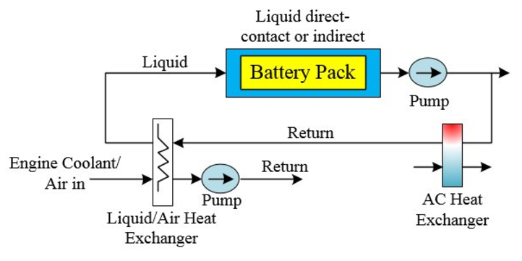
Figure 1. lithium-ion battery thermal management system using phase change material assisted by liquid cooling method
A Lithium-ion battery thermal management system (TMS) using Phase Change Material (PCM) assisted by a liquid cooling method is a promising hybrid approach for addressing the thermal challenges faced in energy storage systems. Here's a detailed framework for this concept

4.1. System Overview

Lithium-ion Battery Pack
The core component requiring thermal regulation to maintain optimal operating temperatures (20–40°C) and prevent issues like overheating or thermal runaway.
Phase Change Material (PCM)
Absorbs heat during phase transition (solid to liquid) without a significant rise in temperature, providing passive thermal regulation.
Liquid Cooling System
Actively removes excess heat from the PCM or directly from the battery when the heat load exceeds passive control.

4.2. Components and Design

Phase Change Material (PCM):

PCMs absorb or release latent heat during phase transitions (e.g., solid to liquid), acting as thermal buffers.By absorbing excess heat during peak loads and releasing it during low-demand periods, PCMs help maintain a stable operating temperature.PCMs can mitigate the risk of thermal runaway by absorbing heat and preventing excessive temperature rise.

Liquid Cooling System:
Use water-glycol mixtures or other high-thermal-conductivity liquids.Employ microchannel heat sinks or serpentine cooling channels around or near PCM and battery modules.Use pumps and valves to control flow rates based on real-time thermal demands.

Thermal Interface Material (TIM):
Ensures efficient heat transfer between battery cells, PCM, and liquid cooling channels.

Sensors and Control System:
Temperature sensors monitor the battery and PCM temperatures. A control unit dynamically manages liquid cooling activation based on PCM saturation or battery load.

3. Working Mechanism

Electrochemical reactions within the battery generate heat. The PCM layer absorbs excess heat, preventing a rapid temperature increase. If the battery temperature exceeds a predefined threshold, the control unit activates the liquid cooling system. The liquid coolant removes heat from the battery pack and transfers it to the environment. As the battery cools down, the PCM releases stored heat back to the battery, maintaining a stable temperature.

5.MODELLING OF PROPOSED SYSTEM

MATLAB, with its powerful numerical computing capabilities and extensive toolboxes, is an excellent tool for modeling and simulating thermal systems. Here's a general approach to modeling thermal systems in MATLAB.

5.1. Identify the System and its Components
Identify the key components of the system, such as heat sources, heat sinks, thermal resistances, and thermal capacitances.
Write down the energy balance equations for each component. These equations will typically involve heat conduction, convection, and radiation.

5.2. Formulate the Mathematical Model
Convert the energy balance equations into a system of differential equation.Express the system of differential equations in matrix form, which is suitable for numerical solution.

5.3. Implement the Model in MATLAB
Define the system parameters, such as thermal conductivities, specific heat capacities, and heat transfer coefficients.Write MATLAB code to implement the numerical method and solve the system of differential equations.
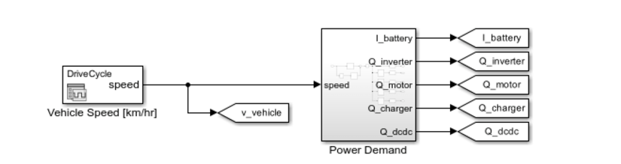
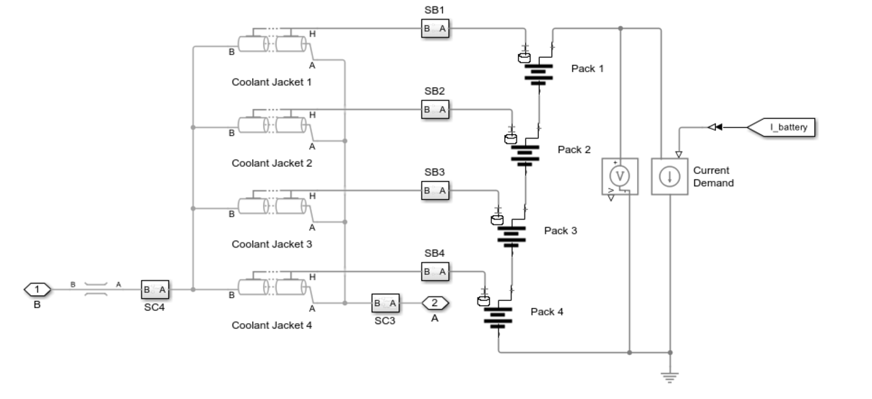
Figure 2. Modeling of lithium-ion battery thermal management system using phase change material assisted by liquid cooling method

6.SIMULATION RESULTS
Execute the MATLAB code to simulate the thermal system's behavior over time.Plot the temperature profiles, heat fluxes, and other relevant variables.Analyze the simulation results to gain insights into the system's performance and identify potential optimization opportunities.

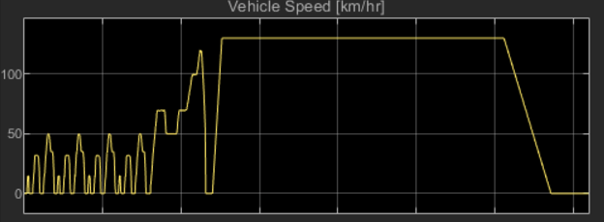
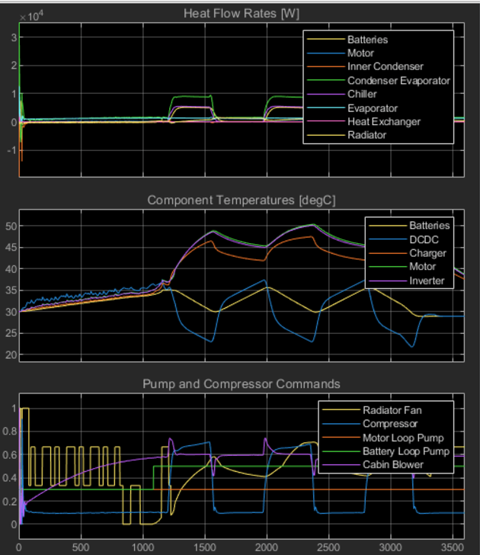
Figure 3. Simulation Results of lithium-ion battery thermal management system using phase change material assisted by liquid cooling method

7.CONCLUSION
Lithium-ion batteries are essential for modern technology, but their performance and lifespan are significantly impacted by temperature fluctuations. High temperatures can accelerate degradation, reduce capacity, and even lead to thermal runaway, while low temperatures can hinder ion mobility, reducing power output and charging efficiency. To address these challenges, thermal management systems have emerged as a critical component in optimizing battery performance and safety.A promising approach involves combining phase change materials (PCMs) and liquid cooling. PCMs are substances that absorb or release latent heat during phase transitions, acting as thermal buffers. When the battery temperature rises, the PCM absorbs excess heat, preventing it from reaching critical levels. As the battery cools down, the PCM releases the stored heat, maintaining a stable temperature.Liquid cooling systems actively remove heat from the battery by circulating a coolant through channels or plates in contact with the battery cells. This allows for precise temperature control, ensuring efficient heat dissipation and preventing overheating.By combining these two techniques, hybrid thermal management systems offer several advantages such us Enhanced Thermal Performance,Improved Safety,Extended Battery Life,Efficient Energy UtilizationOngoing research aims to further enhance the performance and reliability of these systems. Advanced PCMs with improved thermal properties, innovative cooling techniques like microchannel cooling and spray cooling, and intelligent control systems are being explored to optimize thermal management.By effectively managing temperature, these systems contribute to the development of safer, more efficient, and longer-lasting lithium-ion batteries, powering a sustainable future.
REFERENCES
- M. Amir, A. Sadar, N. Mohammad and A. Iqbal, "Optimal Design and Feasibility Study of Electric Vehicle Battery Thermal Management System," 2023 IEEE International Transportation Electrification Conference (ITEC-India), Chennai, India, 2023, pp. 1-6, doi: 10.1109/ITEC-India59098.2023.10471511.
- R. R. Kumar, C. Bharatiraja, K. Udhayakumar, S. Devakirubakaran, K. S. Sekar and L. Mihet-Popa, "Advances in Batteries, Battery Modeling, Battery Management System, Battery Thermal Management, SOC, SOH, and Charge/Discharge Characteristics in EV Applications," in IEEE Access, vol. 11, pp. 105761-105809, 2023, doi: 10.1109/ACCESS.2023.3318121.
- N. Nieto, J. Gastelurrutia, L. Díaz and F. Blanco, "Thermal management systems' design methodology for transport applications," 2013 World Electric Vehicle Symposium and Exhibition (EVS27), Barcelona, Spain, 2013, pp. 1-9, doi: 10.1109/EVS.2013.6914738.
- Tan Gangfeng, Guo Xuexun, Liu Ranran, Hu Ping and Yin Huajun, "EREV driveline thermal management system design," 2011 International Conference on Electric Information and Control Engineering, Wuhan, China, 2011, pp. 2158-2161, doi: 10.1109/ICEICE.2011.5777134
- W. Choi, J. W. Kim, C. Ahn and J. Gim, "Reinforcement Learning-based Controller for Thermal Management System of Electric Vehicles," 2022 IEEE Vehicle Power and Propulsion Conference (VPPC), Merced, CA, USA, 2022, pp. 1-5, doi: 10.1109/VPPC55846.2022.10003470.
- L. H. Saw, A. A. O. Tay and L. W. Zhang, "Thermal management of lithium-ion battery pack with liquid cooling," 2015 31st Thermal Measurement, Modeling & Management Symposium (SEMI-THERM), San Jose, CA, USA, 2015, pp. 298-302, doi: 10.1109/SEMI-THERM.2015.7100176.
- K. P. Senthilkumar and E. Anbalagan, "Comparative Analysis of Traditional And AI Based Fault Detection for Battery Thermal Management System," 2024 2nd World Conference on Communication & Computing (WCONF), RAIPUR, India, 2024, pp. 1-8, doi: 10.1109/WCONF61366.2024.10692283.
- T. Golubev, L. Canull and Z. Edel, "Modeling the Impact of Thermal Management on Electric Vehicle Energy Consumption and Driving Range," 2024 40th Semiconductor Thermal Measurement, Modeling & Management Symposium (SEMI-THERM), San Jose, CA, USA, 2024, pp. 1-7.
- T. Roy, R. L. Miguel, D. Taylor and D. Poulikakos, "Flow Optimization for the Thermal Management of Heavy-Duty Batteries Using Viscoelastic Coolants," 2022 21st IEEE Intersociety Conference on Thermal and Thermomechanical Phenomena in Electronic Systems (iTherm), San Diego, CA, USA, 2022, pp. 1-5, doi: 10.1109/iTherm54085.2022.9899543.
- S. Rajalingam, S. Kanagamalliga, M. Lohitha Lakshmi and A. Swathi, "Optimizing Battery Thermal Management for Electric Vehicles," 2024 10th International Conference on Communication and Signal Processing (ICCSP), Melmaruvathur, India, 2024, pp. 200-204, doi: 10.1109/ICCSP60870.2024.10543318.
- N. Napa, M. K. Agrawal and B. Tamma, "Design of an Air-Based Thermal Management and Predictions of Thermal Characteristics of Lithium-Ion Cell Using 1D Numerical Model," 2023 IEEE 3rd International Conference on Sustainable Energy and Future Electric Transportation (SEFET), Bhubaneswar, India, 2023, pp. 1-6, doi: 10.1109/SeFeT57834.2023.10244838.
- S. Al-Hallaj, R. Kizilel, A. Lateef, R. Sabbah, M. Farid and J. R. Selman, "Passive thermal management using phase change material (PCM) for EV and HEV Li- ion batteries," 2005 IEEE Vehicle Power and Propulsion Conference, Chicago, IL, USA, 2005, pp. 5 pp.-, doi: 10.1109/VPPC.2005.1554585
- H. Guan, Y. Wu, Z. Qin and P. Bauer, "Submodeling Method-Based Thermal Investigation of the Battery Energy Storage System Integrated in a 450 kW EV Charger," 2023 IEEE 14th International Symposium on Power Electronics for Distributed Generation Systems (PEDG), Shanghai, China, 2023, pp. 434-438, doi: 10.1109/PEDG56097.2023.10215247.
- Cao Jianhua, Gao Dawei, Liu Jiexun, Wei Jieyuan and Lu Qingchun, "Thermal modeling of passive thermal management system with phase change material for LiFePO4 battery," 2012 IEEE Vehicle Power and Propulsion Conference, Seoul, Korea (South), 2012, pp. 436-440, doi: 10.1109/VPPC.2012.6422582.
- G. Wang and Y. Zhou, "Thermal Management Modeling for β-Ga2O3-Highly Thermal Conductive Substrates Heterostructures," in IEEE Transactions on Components, Packaging and Manufacturing Technology, vol. 12, no. 4, pp. 638-646, April 2022, doi: 10.1109/TCPMT.2022.3157672.
- G. Huang, P. Zhao and G. Zhang, "Real-Time Battery Thermal Management for Electric Vehicles Based on Deep Reinforcement Learning," in IEEE Internet of Things Journal, vol. 9, no. 15, pp. 14060-14072, 1 Aug.1, 2022, doi: 10.1109/JIOT.2022.3145849.
- D. Dwivedi, P. Kumar Yemula, P. Sai Ram Aditya, P. Kumar Panigrahi, D. Kronman and M. Pal, "Efficient EV Fleet Management using Automated Thermal Stress Computation for Transformer in Electrical Distribution System," 2023 First International Conference on Cyber Physical Systems, Power Electronics and Electric Vehicles (ICPEEV), Hyderabad, India, 2023, pp. 1-6, doi: 10.1109/ICPEEV58650.2023.10391876.
- Z. M. Salameh and C. Alaoui, "Modeling and simulation of a Thermal Management System for Electric Vehicles," IECON'03. 29th Annual Conference of the IEEE Industrial Electronics Society (IEEE Cat. No.03CH37468), Roanoke, VA, USA, 2003, pp. 887-890 vol.1, doi: 10.1109/IECON.2003.1280100.
- S. Jones-Jackson, R. Rodriguez, Y. Yang, L. Lopera and A. Emadi, "Overview of Current Thermal Management of Automotive Power Electronics for Traction Purposes and Future Directions," in IEEE Transactions on Transportation Electrification, vol. 8, no. 2, pp. 2412-2428, June 2022, doi: 10.1109/TTE.2022.3147976.

