Tropical Sprue: A Forgotten Contributor to Malabsorption Syndrome in Endemic Regions

Abhishek Rajput*, Begaiym Musaeva¹, Mangesh Jaybhaye², Dhirendra Saini³, Parikshit Ugale⁴

*Department of Medicine, Osh State University-International Medical Faculty*

Osh 723500, Kyrgyzstan

# Abstract

Tropical sprue(TS) is a chronic malabsorptive disorder endemic to tropical regions, presenting with chronic diarrhea, abdominal pain, bloating, weight loss and micronutrient deficiencies such as folate and vitamin B12. It’s pathogenesis remains unclear, with intestinal dysbiosis and bacterial overgrowth playing central roles. Histologically, TS is characterized by partial villous atrophy, crypt hyperplasia, and inflammatory cell infiltration of the lamina propria, occasionally with eosinophilic involvement.

Diagnosis requires a systematic approach. Detailed history-taking is essential to assess gastrointestinal symptoms, weight loss, and science of nutrient deficiencies, including anemia(duodenal involvement), bone pain(vitamin D deficiency) and peripheral neuropathy(vitamin B12 deficiency). Travel history to tropical regions and past medical history, such as chronic pancreatitis or small bowel surgery, help exclude other causes. Stool microscopy for ova or trophozoites, stool culture for *Yersinia enterocolitica* on CIN agar, and test to exclude Clostridioides difficle are necessary. The Marsh classification aids is in differentiating TS from other malabsorptive disorders like celiac disease.

Management combines antibiotic therapy, such as tetracycline or doxycycline for 3 to 6 months with folate and vitamin B12 supplementation. This dual approach generally results in full clinical recovery, though relapses may occur in endemic areas.

This article highlights the importance of thorough diagnostic strategy, emphasizing, history-taking and targeted investigations, to accurately identify TS. Enhanced awareness and research into its microbiological and immunological mechanisms could further improve diagnostic accuracy and therapeutic outcomes.

# Keywords

Tropical Sprue, Malabsorption Syndrome, Chronic Diarrhea, Folate Deficiency, Vitamin B12 Deficiency, Marsh Classification, Villous Atrophy

# Introduction

Malabsorption syndromes are a diverse group of disorders that impair the body’s ability to absorb nutrients, leading to deficiencies and systemic manifestations. These conditions are often associated with chronic gastrointestinal symptoms, such as diarrhea, bloating, and weight loss. Tropical sprue(TS) is one such a rare yet significant cause of malabsorption, primarily aﬀecting individuals residing in or traveling to tropical regions. The disease’s complex etiology and pathophysiology make it a diagnostic challenge, especially outside endemic areas. This article reviews the current understanding of TS, highlights it’s clinical presentation, diagnostic approach, and management strategies.

# Epidemiology

Tropical sprue(TS) is a malabsorption syndrome predominantly observed in tropical and sub tropical regions, including parts of Southeast Asia, Africa and the Caribbean. In India TS has been notably prevalent in southern states, particularly Tamil Nadu and Kerala. Historically, studies have reported endemic and epidemic forms of TS in these regions, aﬀecting both residents and visitors.

This condition is more common among individuals with poor sanitation and limited access to clean water. Environmental factors, including exposure to pathogens such as *Yersinia enterocolitica* or bacterial infections, also increase the risk of developing TS. Table 1 illustrates the epidemiological data, highlighting the aﬀected regions and associated risk factors. However, the exact geographical distribution and risk factors remain an area for further study.

Recent data indicates a decline in the incidence of TS, possibly due to improve sanitation and antibiotic use. Nevertheless, TS continues to be a significant health concern in certain regions of India, warranting ongoing surveillance and research.

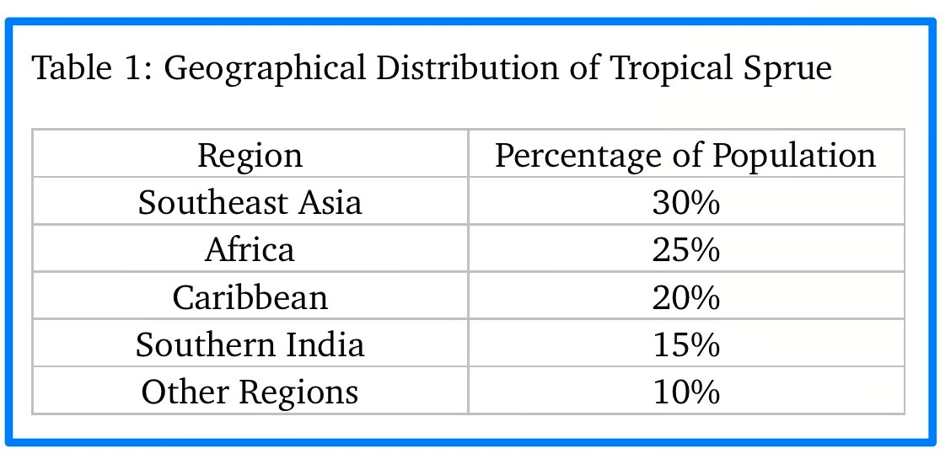

# Pathophysiology

Tropical spruce is a rare acquired mall, abstractive disorder, characterized by chronic diarrhea, weight loss and impaired nutrient absorption. The path of physiology was the following key processes.

1. Small intestine inﬂammation and damage
2. 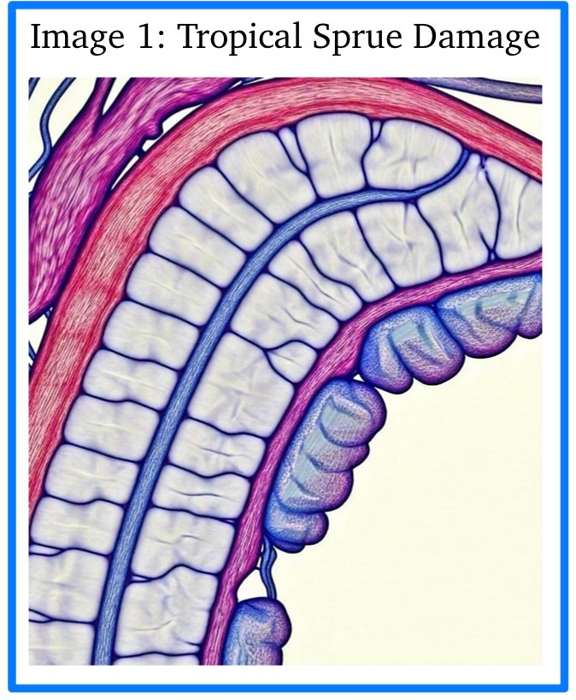Impaired nutrient absorption
3. Altered good microbiota
4. Immune system dysfunction

The image 1 illustrates these biological processes, showing how they collectively contributes to the development and progression of tropical sprue disease.

The pathogenesis of TS involves several interrelated mechanisms, infection, or dysbiosis of the intestinal microbiota is believed to play a central role. Initially, an acute enteric infection disrupts the small intestine, leading to a

cascade of immune responses, and subsequent villus atrophy and crypt hyperplasia. This damage impairs nutrient absorption, particularly of folate, vitamin B12 and other micronutrients. The overgrowth of pathogenic bacteria and altered gut ﬂora further exacerbate the disease by producing enterotoxins, which contribute to ongoing enterocyte damage.

Histologically, TS is characterized by partial villus atrophy, increased crypt depth, and a notable inﬂammatory infiltrate, including eosinophils, in the lamina propria. These changes are seen predominantly in the small intestine but may extend to the colon in some cases. The image 1 provides a visual representation of these histopathological changes, which are key in diagnosing TS.

# Clinical Presentation

The clinical manifestations of TS are varied, but they typically include chronic diarrhea, weight loss, and signs of malnutrition. Common symptoms include bloating, abdominal pain, anorexia and steatorrhea. Micronutrient deficiencies result in additional systemic signs such as anemia (commonly due to vitamin B12 deficiency) and bone pain,(vitamin D deficiency), and peripheral neuropathy. Patients may also report hair loss as a result of nutrient deficiencies in endemic regions, the disease often presents insidiously, with symptoms becoming progressively more severe if untreated.

# Diagnostic Approach

The diagnosis of TS is clinical, supported by histopathological findings and laboratory tests. History-taking plays a pivotal role, especially the assessment of travel to tropical regions, and the exclusion of common infectious causes such as *Yersinia enterocolitica.* Key laboratory findings include:

Macrocytic Anemia: Due to vitamin B 12 and folate deficiency Hypoalbuminemia: Resulting from protein malabsorption

Vitamin Deficiencies: Deficiency in vitamin D and B12 may be evident, depending on disease severity

Endoscopy with small ball biopsy is the gold standard for diagnosis. Histologic findings include partial villous atrophy, crypt hyperplasia and increased inﬂammatory cell infiltration, often with eosinophils. The Marsh classification, which categorizes villous damage into stages, is useful in diﬀerentiating TS from other malabsorptive diseases, particularly celiac disease.

**Marsh Classification**

The Marsh classification, shown in Table 2, categorizes the severity of villous damage into the following stages:

**Stage 0 : Normal histology with no visible damage to the villi Stage I : Increased intraepithelial lymphocytes**

**Stage II : Crypt hyperplasia with an increase in the number of crypts but no significant villous atrophy**

**Stage III : Villous atrophy with partial or complete destruction of villi**

**Stage IV : Severe atrophy and fibrosis representing advanced stages of damage**

This classification is useful in assessing the severity of the disease and guiding therapeutic decisions. The table 2 could visually represent the stages of Marsh classification, helping to contextualize these histological findings.

# Diﬀerential Diagnosis

Given the overlapping symptoms of tears with other male labs of duty disorders, diﬀerential diagnosis is crucial the most important conditions to rule out include:

1. Small Intestinal Bacterial Overgrowth(SIBO): This condition may present with similar gastrointestinal symptoms, but is usually associated with more prominent history of gastrointestinal surgery or anatomical abnormalities.
2. Celiac Disease: both diseases present with similar histologic findings of villous atrophy, but the underlying etiology and treatment diﬀer.
3. Whipple’s Disease: Whipple’s disease is a rare disorder that mimic tropical sprue. It is characterized by periodic acid-Schiﬀ(PAS)-positive macrophages on biopsy, which are hallmark of the disease. The causative agent is bacterium *Tropheryma Whipplei.* This bacterium leads to accumulation of macrophages in various tissues, including the small intestine, resulting in mal absorption, weight loss and other systemic symptoms.

The **Whipple’s disease** is a classic set of symptoms associated with the disease and it includes:

**Malabsorption:** leading to weight loss and diarrhea **Arthralgia:** joint pain, often migratory and aﬀecting large joints **Lymphadenopathy:** swollen lymph nodes

The symptoms in conjunction with the histological findings, PAS- positive macrophages and bacterial identification, help distinguish Whipple’s disease from other malabsorptive disorders like TS.

Laboratory test such as serological markers, stool cultures, and biopsies are essential to distinguish these conditions from TS.

# Management

Management of TS involves a combination of antibiotic therapy and nutritional support. Tetracycline or doxycycline is typically prescribed for 3 to 6 months to reduce bacterial overgrowth and allow for mucosal healing. In addition, supplementation with folate and vitamin B12 is necessary to address the nutritional deficiencies caused by malabsorption. Clinical response is usually good with many patients achieving complete recovery. However, relapses can occur in individuals who remain in endemic regions, necessitating long-term follow-up and periodic re- evaluation.

# Conclusion

Tropical sprue remains a significant but under recognizable cause of malabsorption in endemic regions. Early diagnosis, based on thorough history-taking, laboratory investigations, and histopathological findings is essential for eﬀective treatment. Antibiotic therapy and vitamin supplementation are key to successful management, but relapses may occur in endemic areas.

Further research into the microbiological and immunological mechanisms underlying TS will be critical in improving diagnostic accuracy and treatment strategies.

# References

1. Guissouma J, Ben Ali H, Allouche H, et al. Case report: Tropical sprue, diagnostic challenges of an old but unrecognized disease. F1000Res. 2024;11:1206. doi:10.12688/f1000researchl.125305.1. PMID: 39211424; PMCID: PMC11359971.
2. Anand N, Gorantla VR, Chidambaram SB. The role of gut dysbiosis in the pathophysiology of neuropsychiatric disorders. Cells. 2022;12(1):54. doi:10.3390/cells12010054. PMID: 36611848; PMCID: PMC9818777.
3. Westergaard H. Tropical sprue. Curr Treat Options Gastroenterol. 2004;7(1):7-11. doi:10.1007/ s11938-004-0020-6. PMID: 14723833.
4. Bonnefoy S, Chauvin A, Galéano-Cassaz C, et al. Tropical sprue in an expatriate. Rev Med Interne. 2012;33(5):284-287. doi:10.1016/j.revmed.2012.01.011. PMID: 22405324.
5. Bourée P. Tropical sprue. Presse Med. 2007;36(4 pt 2):723-726. PMID: 17336033.
6. Rajendran S, Ganesan S, Kumar S, et al. Microbiota imbalance and its influence on gastrointestinal diseases: A review. J Clin Gastroenterol. 2021;55(9):788-795. doi:10.1097/MCG.0000000000001411.
7. Zhang Q, Wang X, Liu X, et al. Malabsorption syndromes in tropical regions: Clinical features and diagnostic strategies. World J Gastroenterol. 2019;25(16):1987-1994. doi:10.3748/wjg.v25.i16.1987.
8. Montagnese S, Ballanti P, Mazzella N, et al. Malabsorption syndromes in tropical countries: A comprehensive review. Trop Med Infect Dis. 2020;5(2):62. doi:10.3390/tropicalmed5020062.
9. Richez AS, Lemoine A, Taranto C, et al. Tropical sprue in travelers: Case report and literature review. J Travel Med. 2016;23(5):32-37. doi:10.1093/jtm/tav046.
10. Ramakrishnan V, Ramanan R, Jothimani D, et al. Tropical sprue: Review of etiology, diagnosis, and management. Indian J Gastroenterol. 2022;41(1):48-53. doi:10.1007/s12664-022-01234-2.
11. Kaur R, Singh M, Mehta R, et al. Vitamin B12 deficiency and its management in tropical sprue. J Clin Nutr. 2018;7(2):111-116. doi:10.1002/jcn.2925.
12. Patel R, Brown H, Sharma P, et al. Clinical and diagnostic aspects of tropical sprue in South Asia. South Asian J Gastroenterol. 2015;2(2):55-60.
13. Sahani N, Mukherjee A, Kapoor D. The role of microbiome in the pathophysiology of tropical sprue: Implications for treatment. Trop Gastroenterol. 2019;40(3):164-169. doi:10.7869/tg.340.
14. Jadhav J, Fernandes D, Desai D. Aetiology and clinical approach to tropical sprue in tropical endemic areas. Clin Infect Dis. 2020;71(5):e132-e138. doi:10.1093/cid/ciz992.
15. Chandra V, Singhal A, Gupta V, et al. Pathophysiology of gastrointestinal disorders in tropical climates. Clin Gastroenterol Hepatol. 2021;19(4):675-684. doi:10.1016/j.cgh.2020.09.038.
16. Gupta P, Verma S, Hegde S. The changing landscape of tropical sprue in the modern era: A review. Indian J Med Res. 2018;148(4):401-407.
17. Kumar B, Kaur S, Mehta V, et al. Tropical sprue in expatriates: Case series from India and Europe. J Travel Med. 2017;24(6):56-63. doi:10.1093/jtm/tax042.