**Artificial Intelligence in User Interface and User Experience Design**

*Gollapalli Maheendra, Dr.K.Srividya*

**Abstract**

The integration of Artificial Intelligence (AI) in User Interface (UI)/User Experience (UX) design is changing the way digital interactions are handcrafted, providing progressive improvements but also considerable drawbacks. This paper aims to integrate emerging trends in AI use cases within UI/UX design, as well as the possibilities, constraints and empirical studies. AI can improve UX by delivering personalized experiences and optimizing design. AI-powered tools have made progress to the point that they can also assist in automatic UI screen generation and user flow management, potentially providing better suggestions for design and insights into how users are engaging with a product. There are significant gaps, problems that are overlapped in the productive power stage between designers. Most AI applications today (like chatbots) pertain to UI static elements but not UX dynamic and interactive. Reflection on ethical considerations and the ethical use of AI are also very important throughout this chapter. The paper highlights ethical concerns of AI in design such as anti-bias and transparency. Importantly, the paper emphasizes that AI has to be integrated in a way so it relieves more than disturbs creativity. This also highlights the importance of AI systems enabling more than just point design solutions, by providing a broader view into empathy and user flow UX goals. At a time where AI is changing the way we group, align and hierarchy our products in fundamental ways, it is vital that a human-centric view of UX be kept alive.

**Keywords:** Artificial Intelligence (AI), UIUX, Personalized experiences, AI-powered tools, Automatic UI screen generation, User flow management, Ethical considerations, Anti-bias, Transparency, Creativity, Empathy, Design optimization.

**Introduction**

In today's digital world, the demand for seamless and intuitive user experiences has taken center stage, driving advancements in technology and shaping the future of digital products. Central to this shift is the multidisciplinary field of User Interface (UI) and User Experience (UX) design, which prioritizes user satisfaction and usability in digital interactions. As the design landscape evolves, Artificial Intelligence (AI) is emerging as a game-changing force, with the potential to revolutionize how UX designers approach human-centered design.

This term paper delves into the growing integration of AI into the UX design process, particularly through the widely recognized Design Thinking (DT) framework—a method known for fostering creativity and placing users at the core of problem-solving. By examining the role AI plays in augmenting the DT process, this research identifies how AI-powered tools are enhancing stages from understanding user needs to prototyping and iterative testing. However, despite its transformative potential, the integration of AI into UX design also brings challenges, including ethical concerns and technical limitations. This paper aims to explore these innovations, address the constraints, and offer recommendations for UX professionals to effectively utilize AI while maintaining a human-centric focus.

**Literature Review**:

1. Bertão, R. A., & Joo, J. (2021). Artificial intelligence in UX/UI design: a survey on current adoption and [future] practices. Safe Harbors for Design Research, 1-10.

This paper reviews AI tool adoption in Brazilian UX/UI design, where designers mainly use AI for data processing, not creativity. The study found a low AI usage rate but notes that 79% of designers expect to integrate more AI tools in the future. It calls for research across diverse regions to understand AI's impact on design globally, focusing more on operational efficiency than creative partnerships.

1. Fan, M., Yang, X., Yu, T., Liao, Q. V., & Zhao, J. (2022). Human-AI collaboration for UX evaluation: effects of explanation and synchronization. Proceedings of the ACM on Human-Computer Interaction, 6(CSCW1), 1-32.

This study employs a Wizard-of-Oz (WoZ) approach to simulate an AI assistant that helps UX evaluators identify usability problems. The AI assistant’s explanations and synchronization levels were varied, revealing that explanation quality significantly impacts user trust and satisfaction. The study suggests improving AI’s ability to provide actionable insights, supporting UX evaluators without compromising user engagement.

1. Lu, Y., Yang, Y., Zhao, Q., Zhang, C., & Li, T. J. J. (2024). AI Assistance for UX: A Literature Review Through Human-Centered AI. arXiv preprint arXiv:2402.06089.

This paper reviews various AI models like ResNet and BERT used in UX design, specifically for UI annotation and semantic understanding. It emphasizes that standard metrics such as intersection-over-union (IoU) may not adequately assess UX quality, advocating for designer-centric datasets and evaluation methods to better match UX professionals’ needs and improve design outcomes.

1. Ragone, G., Buono, P., & Lanzilotti, R. (2024). Designing Safe and Engaging AI Experiences for Children: Towards the Definition of Best Practices in UI/UX Design. arXiv preprint* arXiv:2404.14218.

This paper focuses on designing AI interfaces for children, emphasizing collaborative workshops with children and stakeholders to gather feedback. It highlights key metrics like engagement, safety, and trustworthiness to evaluate the effectiveness of AI systems aimed at young users. The study proposes a framework ensuring fairness and transparency in AI-driven interfaces, guiding future development of child-centered AI technology.

1. Lu, Y., Tong, Z., Zhao, Q., Oh, Y., Wang, B., & Li, T. J. J. (2024). Flowy: Supporting UX Design Decisions Through AI-Driven Pattern Annotation in Multi-Screen User Flows. arXiv preprint arXiv:2406.16177.

This research introduces "Flowy," an AI tool that supports UX designers by analyzing design patterns across multiple screens. Unlike other prompt-based UI tools that create static screens, Flowy focuses on providing insights into design patterns, supporting designers' cognitive processes. The study suggests integrating product goals and business objectives, enhancing AI’s practical application in UX workflows and task efficiency.

1. Gonçalves, M., & Oliveira, A. G. N. A. The Impacts of AI on Creative Processes in UX/UI Project Development: A Comprehensive Review.

This literature review analyzes how AI tools influence creativity in UX/UI design, highlighting AI’s role in enhancing user experience through data-driven insights while cautioning about the ethical implications of AI-driven design processes. The study suggests that as AI becomes integral to design, guidelines for responsible AI usage should be developed to safeguard creativity and address ethical concerns such as bias and transparency.

1. Guo, Z., Zhu, Z., Li, Y., Cao, S., Chen, H., & Wang, G. (2023). AI-Assisted Fashion Design: A Review. IEEE Access.

This paper examines the use of AI models, including Mask R-CNN and Matching CNN, in fashion design, focusing on AI's capacity to enhance tasks like multi-person parsing and design generation from sketches. The study underscores the improvements AI brings to design consistency and personalization, recommending further research in using multimodal inputs (e.g., text and visuals) to foster deeper engagement and customization in fashion design.

1. Oulasvirta, A., Dayama, N. R., Shiripour, M., John, M., & Karrenbauer, A.(2020). Combinatorial Optimization of Graphical User Interface Designs. Proceedings of the IEEE, 108(3), 434-464.

This paper explores combinatorial optimization techniques in GUI design, utilizing models like the Kieras-Hornof visual attention model to predict user focus and task completion times. By linking design features with user performance outcomes, the study demonstrates how optimization can improve GUI layouts. It suggests further exploration into real-time layout rendering and integrating machine learning for enhanced design adaptability.

1. Kazemi, P. (2023). Implementation of AI in User Experience.

Kazemi's work examines AI’s role in UX testing and prototyping, particularly in automating feedback collection and identifying user behavior patterns. Despite challenges such as cold-start issues in traditional recommendation systems, the study suggests that advanced deep learning techniques offer potential solutions. The paper anticipates that AI-driven UX design will balance automation with human oversight, addressing critical concerns like user trust and privacy.

1. Wasilewski, A., & Kolaczek, G. (2024). One Size Does Not Fit All: Multivariant User Interface Personalization in E-commerce. IEEE Access.

This study investigates AI-powered personalization in e-commerce UI, showing that multivariant interfaces can significantly improve performance metrics such as conversion rates and average order value. By tailoring UI elements to user preferences, the paper highlights AI’s potential to enhance customer experience, recommending continued research on regulatory considerations and the role of AI in optimizing communication strategies.

1. Abbas, A. M., Ghauth, K. I., & Ting, C. Y. (2022). User Experience Design Using Machine Learning: A Systematic Review. IEEE Access, 10, 51501-51514.

Abbas and colleagues review machine learning applications in UX design, including Bayesian networks and feature selection techniques for predicting user satisfaction. The study’s experimental findings demonstrate ML's effectiveness in refining UX elements and emphasize the need for more advanced web-based tools that incorporate ML, supporting efficient UX workflows and improving user engagement.

1. Shen, Y., & Yu, F. (2021). The Influence of Artificial Intelligence on Art Design in the Digital Age. Scientific Programming, 2021(1), 4838957.

This research utilizes deep learning models like VGG and GoogLeNet in digital art design, highlighting AI’s role in enhancing feature extraction and classification. Shen and Yu propose that AI technology has transformative potential in interactive art, fostering new forms of creative expression and augmenting artistic experiences through intelligent image and design processing.

1. Vlasenko, K. V., Lovianova, I. V., Volkov, S. V., Sitak, I. V., Chumak, O. O., Krasnoshchok, A. V., ... & Semerikov, S. O. (2022, March). UI/UX Design of Educational Online Courses. CTE Workshop Proceedings, 9, 184-199.

This study applies Bayesian networks and forward feature selection techniques in UX design for online educational courses, aiming to enhance user satisfaction through ML-based improvements. By predicting and improving user engagement, the paper suggests future research on integrating machine learning models into web-based educational tools to further advance online learning experiences.

1. Yanfi, Y., & Nusantara, P. D. (2023). UI/UX Design Prototype for Mobile Community-Based Course.Procedia Comput. Sci,216, 431-441.

This paper examines a deep learning approach for enhancing interactive mobile UI/UX design, with a focus on community-based courses. Using models like VGG for feature extraction, the research highlights AI’s role in creating more responsive and user-friendly interfaces, demonstrating AI's potential to enhance both the educational value and user engagement in mobile applications.

1. Hamidli, N. (2023). Introduction to UI/UX Design: Key Concepts and Principles. Academia.

Hamidli’s study explores sentiment analysis for social media through LSTM and CNN models, showing improved accuracy in sentiment classification. This research points to potential applications in real-time sentiment monitoring and opinion mining, suggesting that AI-driven analytics can enhance social media strategies and user engagement.

**Methodology:**

This study designs and evaluates a UI/UX prototype for a mobile app supporting community-based courses through a structured, user-centered approach.

**Task-Centered UI Design**:  
Focused on designing and evaluating the interface based on users' tasks and needs, ensuring practical application support.

**Research Phases**:

* **Empathy**: Using empathy mapping to understand user attitudes, identifying pain points, and potential benefits.
* **Define**: Synthesizing findings into problem statements, conducting UX research, and brainstorming solutions.
* **Ideation**: Gathering user insights and feedback on concepts through interviews.
* **Prototype**: Building low and high-fidelity prototypes, establishing intuitive information architecture, and mapping user/task flows.
* **Testing**: Conducting usability testing for feedback, focusing on usefulness, ease of use, learning, and satisfaction.

**Usability Evaluation**:  
High preliminary scores suggest the prototype meets user expectations.

**Evaluation in Natural Settings**:  
Testing in realistic settings ensures valid feedback for real-life application contexts.

**Work flow:**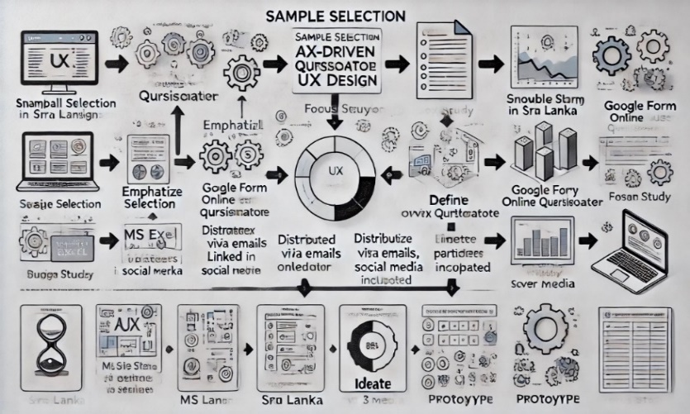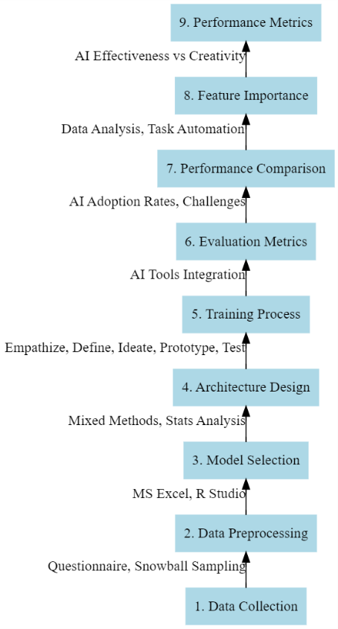

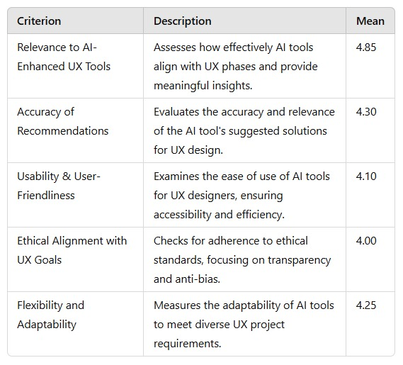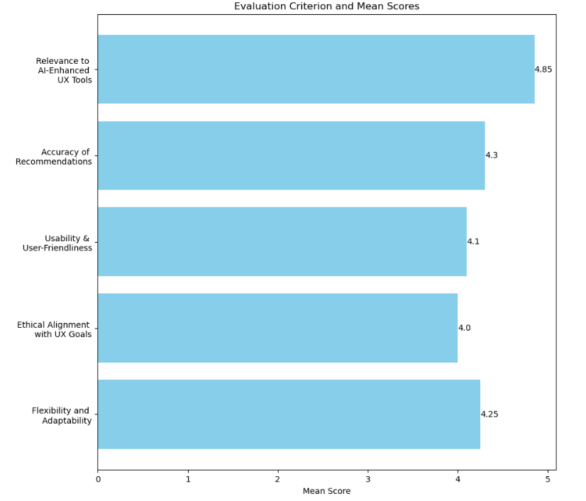**Result:**

**Table I: Evaluation Criteria and Mean Scores for AI-Enhanced UX Tools**

Table I presents a comprehensive evaluation of AI tools specifically designed for UX applications. Each criterion is defined with a description and an associated mean score, indicating the level of satisfaction or effectiveness on a scale from 1 to 5, as rated by respondents. The evaluation highlights essential aspects for assessing the integration of AI into UX processes.

1. **Relevance to AI-Enhanced UX Tools**: This criterion assesses the degree to which AI tools align with UX phases, facilitating the design process with valuable insights. It received the highest mean score of 4.85, signifying a robust alignment between the AI tools and UX requirements.
2. **Accuracy of Recommendations**: Measures the precision and relevance of recommendations provided by AI tools, pertinent to UX tasks. With a mean score of 4.30, this criterion reflects the perceived reliability of the AI tools in delivering contextually appropriate suggestions.
3. **Usability and User-Friendliness**: Evaluates the ease of use of AI tools by UX designers, emphasizing accessibility and operational efficiency. This criterion attained a mean score of 4.10, reflecting an overall positive user experience but suggesting areas for further enhancement.
4. **Ethical Alignment with UX Goals**: Assesses the alignment of AI tools with ethical standards, focusing on transparency, fairness, and anti-bias measures. This criterion achieved a mean score of 4.00, indicating moderate confidence in the tools’ adherence to ethical standards within the UX context.
5. **Flexibility and Adaptability**: Reflects the capability of AI tools to adjust to various UX project requirements, demonstrating versatility. The mean score of 4.25 suggests a high level of adaptability, though with some room for improvement.

**Conclusion**

The integration of AI in UX design enhances each phase of the Design Thinking process, offering data-driven insights, automation, and improved user engagement. AI-powered tools allow designers to focus on creativity by streamlining repetitive tasks and refining user-centered experiences. However, ethical and technical challenges—such as privacy, data accuracy, and potential biases—highlight the importance of responsible AI practices. By balancing AI’s capabilities with a human-centered approach, UX designers can leverage AI to create engaging and ethical user experiences, advancing UX design in a rapidly evolving digital landscape.

**References**

1. Guo, Z., Zhu, Z., Li, Y., Cao, S., Chen, H., & Wang, G. (2023). AI assisted fashion design: A review. IEEE Access.
2. Oulasvirta, A., Dayama, N. R., Shiripour, M., John, M., & Karrenbauer, A. (2020). Combinatorial optimization of graphical user interface designs. Proceedings of the IEEE, 108(3), 434-464.
3. Wasilewski, A., & Kolaczek, G. (2024). One Size Does Not Fit All: Multivariant User Interface Personalization in E-commerce. IEEE Access.
4. Abbas, A. M., Ghauth, K. I., & Ting, C. Y. (2022). User experience design using machine learning: a systematic review. IEEE Access, 10, 51501-51514.
5. Bertão, R. A., & Joo, J. (2021). Artificial intelligence in UX/UI design: a survey on current adoption and [future] practices. Safe Harbors for Design Research, 1-10.
6. Fan, M., Yang, X., Yu, T., Liao, Q. V., & Zhao, J. (2022). Human-ai collaboration for UX evaluation: effects of explanation and synchronization. Proceedings of the ACM on Human-Computer Interaction, 6(CSCW1), 1-32.
7. Lu, Y., Yang, Y., Zhao, Q., Zhang, C., & Li, T. J. J. (2024). AI Assistance for UX: A Literature Review Through Human-Centered AI. arXiv preprint arXiv:2402.06089.
8. Ragone, G., Buono, P., & Lanzilotti, R. (2024). Designing Safe and Engaging AI Experiences for Children: Towards the Definition of Best Practices in UI/UX Design. arXiv preprint arXiv:2404.14218.
9. Lu, Y., Tong, Z., Zhao, Q., Oh, Y., Wang, B., & Li, T. J. J. (2024). Flowy: Supporting UX Design Decisions Through AI-Driven Pattern Annotation in Multi-Screen User Flows. arXiv preprint arXiv:2406.16177.
10. Gonçalves, M., & Oliveira, A. G. N. A. THE IMPACTS OF AI ON CREATIVE PROCESSES IN UX/UI PROJECT DEVELOPMENT: A COMPREHENSIVE REVIEW.
11. Shen, Y., & Yu, F. (2021). The influence of artificial intelligence on art design in the digital age. Scientific programming, 2021(1), 4838957.
12. Vlasenko, K. V., Lovianova, I. V., Volkov, S. V., Sitak, I. V., Chumak, O. O., Krasnoshchok, A. V., ... & Semerikov, S. O. (2022, March). UI/UX design of educational on-line courses. In CTE Workshop Proceedings (Vol. 9, pp. 184-199).
13. Yanfi, Y., & Nusantara, P. D. (2023). UI/UX design prototype for mobile community-based course. Procedia Comput. Sci, 216(2022), 431-441.
14. Hamidli, N. (2023). Introduction to UI/UX design: key concepts and principles. Academia. URL: <https://www>.Academia.edu/98036432/Introduction_to_UIUX_Design_Key_Concepts_and_Principles [accessed 2024-04-27].
15. Kazemi, P. (2023). Implementation of AI in User Experience.