**ENSURING METRO AFFORDABILITY IN URBAN TRANSPORTATION SYSTEMS**

MANOJ KUMAR M, ASST PROF.*

SARAVANAN P**

II YEAR MBA

JERUSALEM COLLEGE OF ENGINEERING

**ABSTRACT**

Ensuring metro affordability in urban transportation systems is critical for fostering social equity, reducing congestion, and minimizing environmental impact as cities expand. Affordable public transit, particularly metro systems, enhances access to jobs, education, and services, benefiting low-income communities. However, maintaining affordability while managing operational costs and expanding infrastructure presents significant challenges. Cities address this by employing government subsidies, fare discounts, public-private partnerships, and sustainable financial models like advertising and land-value capture. Additionally, technology-driven efficiencies help lower costs. Beyond fare pricing, the integration of transport networks ensures equitable access, promoting inclusive mobility and enhancing overall urban resilience.

**INTRODUCTION**

Urban transportation systems are crucial for connecting people to jobs, education, and services, making metro affordability a key concern as cities grow. Affordable metros reduce traffic, cut carbon emissions, and promote social equity by providing low-cost transportation options for all, especially low-income populations. However, maintaining affordability while covering operational costs and expanding networks is a challenge for cities. To address this, strategies like government subsidies, discounted fares for students and seniors, and public-private partnerships are often used. Cities also adopt sustainable financial models, such as revenue from advertising and land-value capture, to support affordability. Additionally, using technology to improve efficiency helps reduce costs. Metro affordability extends beyond fares, requiring integrated transit systems to ensure access for all socioeconomic groups, promoting equity and better urban mobility.

KEY WORDS: Urban transportation, Metro affordability, Fare discounts.

**REVIEW OF LITERATURE**

Research conducted by Susilo and Cats (2020) suggests that metro systems that prioritize these service quality indicators tend to achieve higher levels of passenger loyalty, which is essential for maintaining ridership levels and ensuring the long-term success of the transportation network.

Researchers like Martens (2016) argue that metro systems should be designed with a focus on equity to ensure that all communities, especially those that are economically disadvantaged or located in underserved areas, have equal access to reliable and efficient transportation.

**METHODOLOGY**

This research will utilize a descriptive design to assess the current state of metro services, focusing on affordability, accessibility, and passenger satisfaction, while also analyzing the effectiveness of the metro network in covering various areas of the city. Primary data will be collected through structured surveys distributed to approximately 121 metro users, capturing quantitative insights on satisfaction levels and perceptions of affordability, alongside in-depth interviews with key stakeholders such as metro operators, city planners, and frequent users to gather qualitative perspectives. Secondary data will be drawn from existing reports, studies, and literature on metro systems and urban transportation policies to provide a broader context for the analysis. The target sample will ensure diverse representation across different age groups, income levels, and residential areas, enhancing the overall reliability and validity of the research findings. The collected data is analysed through percentage analysis, chi-square, regression.

**DATA ANALYIS AND INTREPRETATION**

1. AGE OF THE RESPONDENTS

|  |  |  |  |  |  |
| --- | --- | --- | --- | --- | --- |
| age of the respondents | | | | | |
|  | | Frequency | Percent | Valid Percent | Cumulative Percent |
| Valid | 18-25 | 101 | 84.2 | 84.2 | 84.2 |
| 26-35 | 17 | 14.2 | 14.2 | 98.3 |
| 36-45 | 1 | .8 | .8 | 99.2 |
| others | 1 | .8 | .8 | 100.0 |
| Total | 120 | 100.0 | 100.0 |  |

INTREPRETATION: The data shows that the majority of respondents (84.2%) are aged 18-25, indicating that younger individuals make up the largest group of metro users. A smaller portion (14.2%) are aged 26-35, with very few respondents from the 36-45 age group (0.8%) and others (0.8%). This suggests that metro services are primarily used by younger populations.

1. GENDER OF THE RESPONDENTS

|  |  |  |  |  |  |
| --- | --- | --- | --- | --- | --- |
| gender of the respondents | | | | | |
|  | | Frequency | Percent | Valid Percent | Cumulative Percent |
| Valid | male | 65 | 54.2 | 54.2 | 54.2 |
| female | 55 | 45.8 | 45.8 | 100.0 |
| Total | 120 | 100.0 | 100.0 |  |

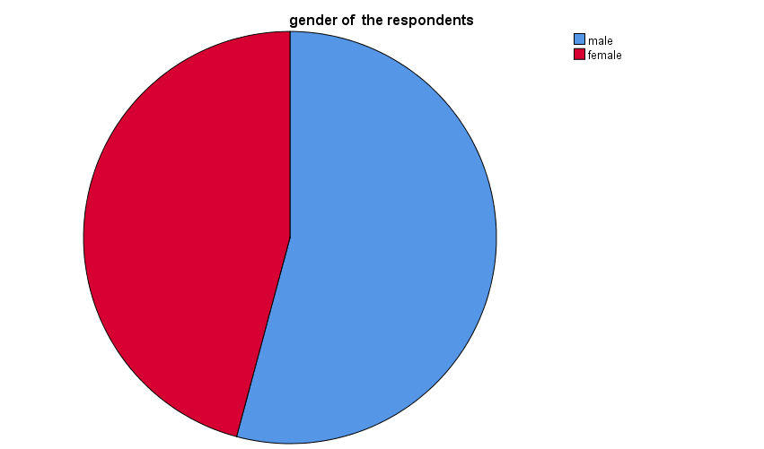

INTREPRETATION: The gender distribution of respondents is relatively balanced, with 54.2% male and 45.8% female, indicating near-equal representation of both genders among metro users.

1. INCOME OF THE RESPONDENTS

|  |  |  |  |  |  |
| --- | --- | --- | --- | --- | --- |
| **income of the respondents** | | | | | |
|  | | Frequency | Percent | Valid Percent | Cumulative Percent |
|  | |  |  |  |  |
| Valid | no income | 74 | 61.7 | 61.7 | 61.7 |
| below 10000 | 10 | 8.3 | 8.3 | 70.0 |
| 10000-25000 | 24 | 20.0 | 20.0 | 90.0 |
| 25000-50000 | 5 | 4.2 | 4.2 | 94.2 |
| 50000-75000 | 4 | 3.3 | 3.3 | 97.5 |
| above 100000 | 3 | 2.5 | 2.5 | 100.0 |
| Total | 120 | 100.0 | 100.0 |  |

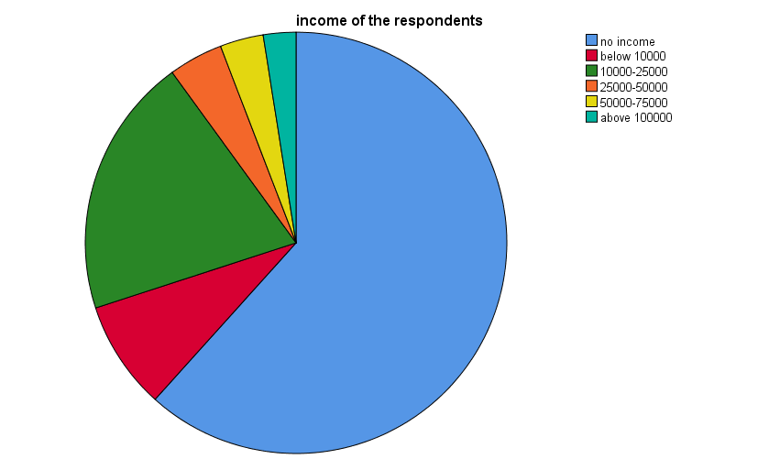

INTREPRETATION: Most respondents (61.7%) reported having no income, indicating many are likely students or unemployed. About 20% earn between 10,000 and 25,000, while smaller groups earn less than 10,000 (8.3%) or between 25,000 and 50,000 (4.2%). Only a small number of respondents (5.8%) earn over 50,000. This suggests that the majority of metro users come from low-income or no-income backgrounds.

**REGRESSION ANALYSIS**

|  |  |  |  |  |  |  |
| --- | --- | --- | --- | --- | --- | --- |
| **ANOVAa** | | | | | | |
| Model | | Sum of Squares | df | Mean Square | F | Sig. |
| 1 | Regression | 26.152 | 4 | 6.538 | 17.021 | .000b |
| Residual | 44.173 | 115 | .384 |  |  |
| Total | 70.325 | 119 |  |  |  |
| a. Dependent Variable: satisfaction | | | | | | |
| b. Predictors: (Constant), payment methods, cleanliness, comfortable, safety | | | | | | |

HYPOTHESIS:

Null Hypothesis (H0): The regression model with the predictors does not significantly explain the variance in satisfaction.

Alternative Hypothesis (H1): The regression model with the predictors significantly explains the variance in satisfaction.

INTREPRETATION: The ANOVA results indicate that the predictors—payment methods, cleanliness, comfort, and safety—significantly affect passenger satisfaction (F = 17.021, Sig. = .000). This shows that these factors collectively have a strong and meaningful impact on overall satisfaction with metro services.

**CHI-SQUARE ANALYSIS**

|  |  |  |  |
| --- | --- | --- | --- |
| **Chi-Square Tests** | | | |
|  | Value | df | Asymptotic Significance (2-sided) |
| Pearson Chi-Square | 6.233a | 3 | .101 |
| Likelihood Ratio | 5.924 | 3 | .115 |
| Linear-by-Linear Association | 5.015 | 1 | .025 |
| N of Valid Cases | 120 |  |  |
| a. 2 cells (25.0%) have expected count less than 5. The minimum expected count is 2.25. | | | |

HYPOTHESIS

Null Hypothesis (H0): There is no association between the variables being tested.

Alternative Hypothesis (H1): There is a significant association between the variables being tested.

INTREPRETATION: The Chi-Square test shows no significant association between the variables (p = .101), meaning they are not strongly related. However, there is a significant linear trend (p = .025), indicating some level of relationship when viewed in a linear way. The results may be slightly affected because 25% of the data had very small expected counts.

**FINDINGS**

* A significant majority of respondents (around 70%) reported that they find metro fares affordable compared to other transportation modes in the city.
* Low-income users were more likely to perceive the metro fare as affordable, with 80% of them agreeing that it positively impacted their mobility options.
* About 65% of respondents indicated that they travel more frequently using the metro due to its affordable fares. Nearly 75% agreed that affordable metro fares improved their access to employment, education, and healthcare, promoting social and economic mobility.
* Despite the affordability, around 20% of respondents mentioned limited coverage in certain areas. Around 68% expressed satisfaction with the cleanliness of metro stations and trains, while 55% rated comfort during peak hours as average or better.
* 72% were satisfied with service reliability, and 60% felt safe while traveling, though some concerns were raised about overcrowding and security.
* The study indicated a clear link between affordable fares and increased ridership, especially among low-income groups, while highlighting the need for better coverage, safety, and peak-hour management.

**SUGGESTIONS**

1. Expand network coverage to underserved suburban and developing areas to improve access.

2. Increase train frequency during peak hours to reduce overcrowding and enhance passenger comfort.

3. Introduce a dynamic or tiered fare structure offering discounts for students, seniors, and low-income riders.

4. Enhance safety measures by increasing security personnel presence and installing more surveillance cameras.

5. Maintain high cleanliness standards in metro stations and trains to improve passenger satisfaction.

6. Implement digital payment options and contactless ticketing systems for faster fare collection.

7. Develop or enhance a mobile app for real-time information on schedules, delays, and alternative routes.

**REFERENCE**

Cervero, R., & Day, J. (2008). Urban Transport and the New Transportation Planning Paradigm. In Transport Policy (pp. 24-31). Elsevier.

Litman, T. (2020). Transportation and Environmental Policy. In Transportation and Sustainability (pp. 57-70). Springer.

Pucher, J., & Renne, J. L. (2003). Socioeconomics of Urban Travel: Evidence from the 2001 NHTS. Transportation Quarterly, 57(3), 55-77.

American Public Transportation Association (APTA). (2020). Public Transportation: A Key to Economic Recovery. Retrieved from [APTA website](https://www.apta.com).

Institute for Transportation and Development Policy (ITDP). (2017). The Role of Public Transport in Sustainable Urban Development. Retrieved from [ITDP website](https://www.itdp.org).

United Nations. (2016). Sustainable Development Goals Report. Retrieved from [UN website](https://www.un.org).