**A STUDY ON BRAND LOYALTY OF APPLE PRODUCTS**

**S. Madhiyarsi, Associate Professor, Jerusalem College of Engineering, Chennai.**

**Kalaiselvi M , MBA, Jerusalem College of Engineering, Chennai**

**ABSTRACT**

This study investigates brand loyalty towards Apple Inc. products, focusing on factors influencing consumer commitment and the relationship between product quality, customer satisfaction, and brand reputation. Apple has established itself as a leading lifestyle brand, characterized by its innovative products like the iPhone, iPad, and MacBook, which have garnered a dedicated customer base. Through a descriptive research design, primary data were collected via questionnaires from 94 Apple product users, supplemented by secondary data from existing research. The findings reveal a balanced gender distribution and highlight significant correlations between product quality, customer satisfaction, and brand loyalty. Notably, demographic factors such as gender and length of product ownership influence loyalty levels. Recommendations include enhancing customer support, targeting marketing efforts towards diverse demographics, and maintaining rigorous product quality standards. This research provides valuable insights into consumer behavior in the tech market, emphasizing the importance of brand loyalty in sustaining Apple’s market dominance.

**Key words :** **Brand Loyalty,** **Customer Satisfaction**, **Product Quality**

**1.INTRODUCTION**

Brand loyalty plays a crucial role in the success of Apple Inc., which has consistently been able to foster a dedicated and passionate customer base. Over the years, Apple has transformed from a tech company into a lifestyle brand, with products such as the iPhone, MacBook, and Apple Watch becoming synonymous with innovation, quality, and a unique user experience.

Apple’s success in maintaining high levels of brand loyalty can be attributed to several factors, including its seamless product ecosystem, the emotional connection it builds with customers, and its constant drive for innovation. Apple’s product launches are highly anticipated events, and the company has cultivated a culture of exclusivity and prestige around its offerings.

Loyal Apple customers often advocate for the brand, and this loyalty extends beyond just the purchase of individual products—it forms a long-term relationship where users consistently choose Apple over competitors. This enduring commitment has allowed Apple to maintain a dominant position in the market and continually expand its global influence.

Apple Inc. is one of the most recognizable and successful brands in the global consumer electronics industry. Known for its innovation, sleek designs, and cutting-edge technology, Apple consistently produces high-quality products that dominate various sectors of the tech market. Apple products include the iPhone, iPad, MacBook, AirPods, Apple Watch, and more, each revolutionizing its respective category. Apple has built a strong reputation for creating premium, user-friendly devices with seamless integration across its ecosystem.

**CONSUMER LOYALTY**

The American Society for Quality (ASQ) defines consumer loyalty as the measure of a consumer's commitment and ongoing relationship with a company’s products, services, and brand reputation. While consumer satisfaction assesses how content consumers are with a company's offerings, consumer loyalty extends this by evaluating the strength and duration of their preference for the brand over time. Loyalty metrics, including repeat purchases, brand referrals, and customer retention rates, enable companies to understand areas for maintaining and strengthening consumer commitment. The primary focus of any organization should be fostering lasting consumer loyalty, ensuring that products and services not only meet but exceed consumer expectations.

**SIGNIFICANCE OF VARIABLE**

Brand loyalty is a vital factor in ensuring the long-term success of any company, especially in competitive markets. For Apple Inc., brand loyalty directly influences customer retention, market position, and profitability. Loyal customers tend to purchase new Apple products, recommend the brand to others, and contribute to Apple’s strong brand image. This creates a ripple effect that attracts new customers while reinforcing Apple’s reputation as a premium, reliable brand.

The loyalty of Apple’s customers also offers financial advantages. Retaining existing customers is often more cost-effective than attracting new ones, as it reduces marketing costs and allows for more predictable revenue streams. This stability enables Apple to invest further in innovation, providing loyal customers with new and enhanced products, thereby reinforcing the cycle of loyalty.

**OBJECTIVES OF THE STUDY**

The study aims to investigate brand loyalty toward Apple products by exploring several key dimensions. First, it seeks to understand the overall brand loyalty of consumers regarding Apple offerings. Additionally, the research will delve into the factors that influence this brand loyalty, examining elements such as customer satisfaction, product quality, and brand reputation. Furthermore, it will analyze the relationship between these factors and their impact on brand loyalty. Lastly, the study will identify how demographic variables, such as age, gender, and income, affect consumer loyalty toward Apple products, providing a comprehensive view of the dynamics that contribute to brand allegiance in the competitive technology market.

**NEED OF THIS STUDY**

* This study helps Apple Inc. understand the key factors that encourage customer loyalty, even with premium product pricing.
* It identifies consumer preferences, behaviors, and areas where customer satisfaction can be enhanced.

**SCOPE OF THIS STUDY**

* Focus on a specific geographical area, targeting Apple product users within a selected region or country.
* Analyze a wide range of Apple products, including iPhones, iPads, MacBooks, Apple Watches, and AirPods, for a comprehensive assessment of consumer behavior.
* Investigate different demographic groups to identify variations in loyalty, satisfaction, and brand reputation perceptions.

**LIMITATIONS OF THE STUDY**

* Sample size may not fully represent the entire population of Apple product users, limiting the generalizability of the findings.
* The study’s reliance on current market conditions and consumer preferences may affect its relevance as trends and behaviors evolve.

**2. REVIEW OF LITERATURE**

**Mel, A., & Berlianto, M. (2022)**  
This study investigates the factors influencing customer satisfaction and brand loyalty among Indonesian Apple users. It highlights that superior after-sales service, high product quality, and emotional competence significantly contribute to customer satisfaction. The findings suggest that these elements play a crucial role in fostering brand loyalty, as satisfied customers are more likely to remain loyal to the Apple brand.

**Thuy Doan, T. N., & Nguyen, H. H. (2022)**  
In their research, the authors focus on Apple’s strategies for value creation and capture, emphasizing that innovation and a premium brand image are key drivers of sustained customer loyalty. The study illustrates how Apple's commitment to continuous innovation and maintaining a strong brand identity helps cultivate a loyal customer base that remains dedicated to the brand.

**Natalia, D., & Elgeka, H. W. S. (2021)**  
This study explores the relationship between consumer-brand identification and brand loyalty. The authors find that Apple’s robust brand identity enhances customer connections, leading to increased loyalty. They emphasize that customer satisfaction and brand trust are pivotal in linking consumer-brand identification to loyalty, suggesting that Apple’s branding efforts effectively resonate with its audience.

**Diputra, I. G. A. W., & Yasa, N. N. (2021)**  
This research examines the impact of product quality, brand image, and brand trust on customer satisfaction and loyalty. The authors confirm that these factors are essential for maintaining high levels of loyalty among Apple users. Their findings underscore the importance of consistent product quality and a strong brand image in fostering a loyal customer base.

**Hussein, F., & Hartelina, H. (2021)**  
This study underscores the critical role of after-sales service in building customer loyalty among iPhone users. The authors argue that effective after-sales support leads to increased customer satisfaction, which in turn reinforces loyalty to the Apple brand. Their findings suggest that investing in quality after-sales service can significantly enhance customer retention.

**Aaker, D. A. (1991)**  
In "Managing Brand Equity," Aaker introduces fundamental concepts related to brand equity, emphasizing that brand loyalty is a significant component that enhances a brand’s overall value. This work is essential for understanding Apple’s approach to brand management and long-term strategies for maintaining a loyal customer base.

**Reichheld, F. F. (1996)**  
Reichheld's study, "The Loyalty Effect," explores how customer loyalty impacts profitability. The author outlines effective strategies that Apple has employed to cultivate and sustain a loyal customer base, highlighting the correlation between loyal customers and business success. This research emphasizes the importance of customer loyalty in driving long-term profitability.

**Kotler, P. (1997)**  
In his classic text on marketing management, Kotler discusses the critical role of brand loyalty in shaping marketing strategies. He provides insights into how companies, including Apple, can develop effective marketing campaigns aimed at cultivating customer loyalty through focused efforts. His framework is valuable for understanding the dynamics of customer retention.

**Oliver, R. L. (1999)**  
Oliver’s research delves into the psychological aspects of consumer loyalty, explaining how satisfaction and consumer attitudes influence loyal behavior. This understanding is vital for Apple as it seeks to maintain a devoted customer base. The study suggests that fostering satisfaction through quality products and services is essential for sustaining loyalty.

**Chaudhuri, A., & Holbrook, M. B. (2001)**  
This study examines the chain of effects from brand trust and emotional appeal to brand performance. The authors highlight that Apple’s strong brand trust and emotional resonance with consumers result in superior customer loyalty and overall brand performance. Their findings emphasize the importance of building emotional connections with customers to enhance loyalty.

**3. RESEARCH METHODOLOGY**

This study utilized a descriptive research design to provide a detailed understanding of Apple users' characteristics and behaviors. Data was collected from Apple product users through questionnaires. A non-probability sampling method, specifically convenience sampling, was applied to efficiently gather responses from readily accessible participants. The study included a sample size of 94 respondents.

Data was collected from both primary and secondary sources. Primary data was obtained through a questionnaire distributed directly to participants, while secondary data was sourced from articles in journals, internet websites, and existing research studies.

**4. DATA ANALYSIS AND INTERPRETATION**

**4.1.1 percentage analysis for Age of the consumer**

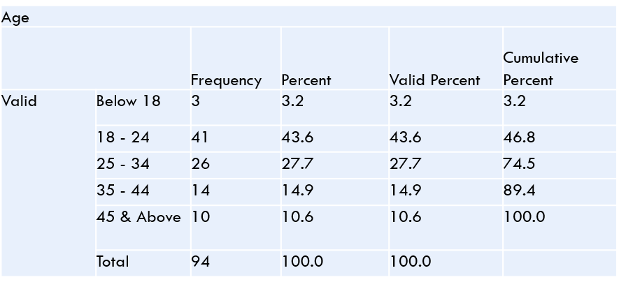**TABLE NO 4.1.1 AGE OF THE RESPONDENT**

**INFERENCE**

From the above table it shows that out of 94 users 3.2% are between below18, 43.6% are 18 to 24, 27.7% are 25 to 34years, 14.9% are 35 to 44 years, and 10.6% are above 45 years.

**4.1.2 Percentage analysis for Gender of the consumer**

**TABLE NO 4.1.2 GENDER OF THE RESPONDENT**

|  |  |  |  |  |  |
| --- | --- | --- | --- | --- | --- |
| gender | | | | | |
|  | | Frequency | Percent | Valid Percent | Cumulative Percent |
| Valid | Male | 48 | 51.1 | 51.1 | 51.1 |
| Female | 46 | 48.9 | 48.9 | 100.0 |
| Total | 94 | 100.0 | 100.0 |  |

**INFERENCE**

From the above table it shows that out of 94 users 51.1% are male and 48.9% are female.

**4.1.3 Percentage analysis for Monthly Income of the consumer**

**TABLE NO 4.1.3 MONTHLY INCOME OF THE RESPONDENT**

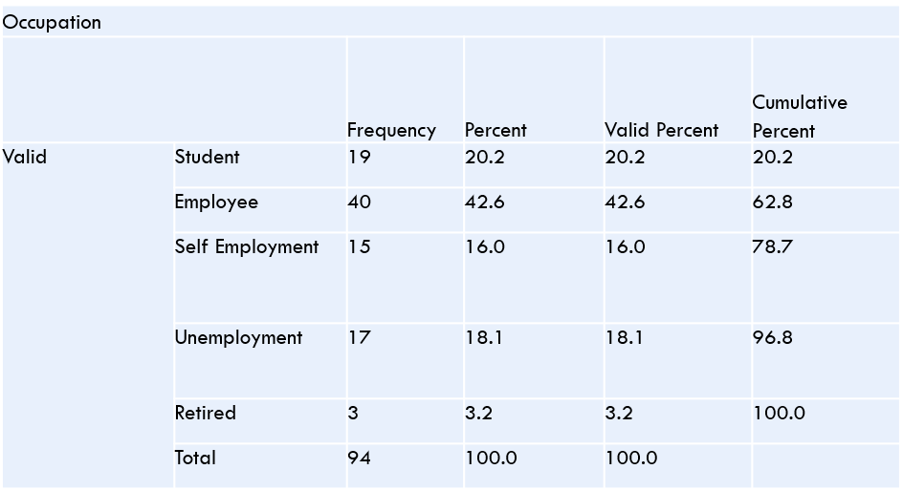

**INFERENCE**

The above data shows that the Monthly income of the respondent Below Rs. 20000 income level with 56% and 13% are Rs.20001-Rs.40000 Income level and 12% are Rs.40001-Rs.60000 income level and 5% are Rs.60001-Rs.80000

**4.2 CORRELATION**

H0: There is no relationship between Quality of apple products compare to other brands

and continue using Apple products based on your satisfaction with their products and services

H1: There is a relationship between Quality of apple products compare to other brands

and continue using Apple products based on your satisfaction with their products and services.

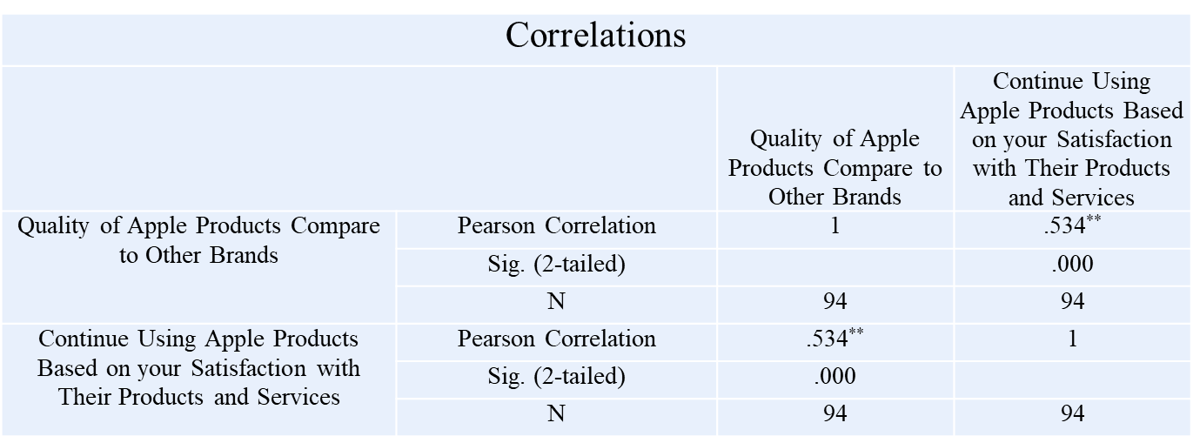

**INFERENCE:**

From the above table, we can find that the significant value is 0.000, which is less than table value 0.05, so the null hypothesis is rejected and alternative hypothesis is accepted.

There is a relationship between Quality of apple products compare to other brands and continue using Apple products based on your satisfaction with their products and services.

**4.3 CHI-SQUARE ANALYSIS**

To find out the association between Gender and duration of apple products usage among consumers.

H0: There is no association between. Gender and duration of apple products usage among consumers.

H1: There is an association between Gender and duration of apple products usage among consumers.

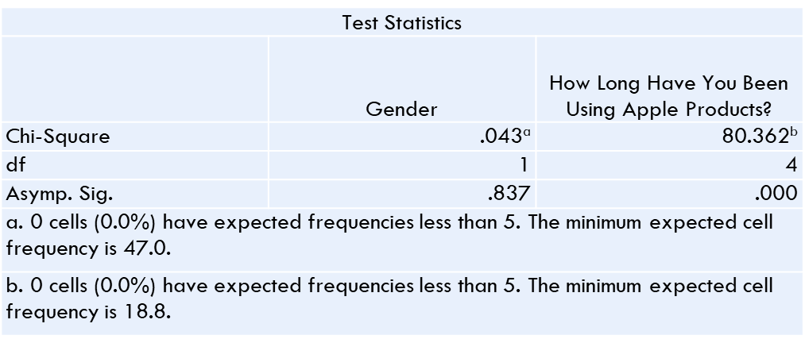

**INFERENCE**

From the above table, we can find that the significant value is 0.000, which is less than table value 0.05, so the null hypothesis is rejected and alternative hypothesis is accepted.

There is an association between Gender and duration of apple products usage among consumers.

**4.3.1 CHI-SQUARE ANALYSIS**

**H0:** There is no association between Gender and improvement would you like to see in future apple products

**H1:** There is an association between Gender and improvement would you like to see in future apple products

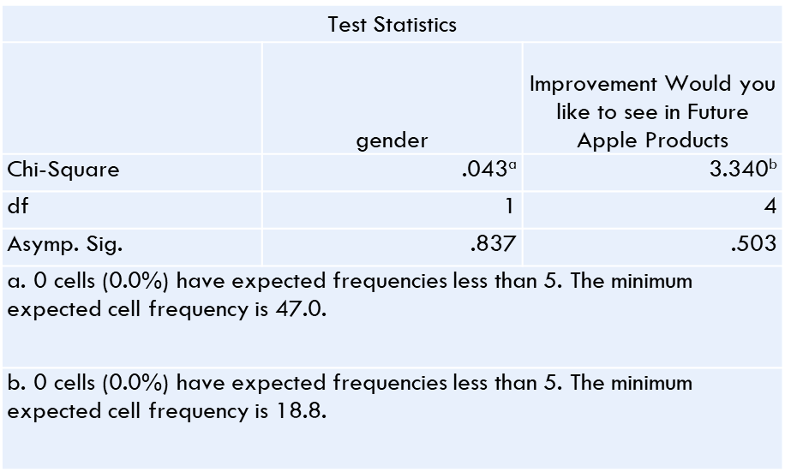

**INFERENCE**

From the above table, we can find that the significant value is 0.503, which is less than table value 0.05, so the Null hypothesis is rejected and Alternative hypothesis is accepted.

There is an association between Gender and improvement would you like to see in future apple products

**4.4 ANOVA**

Null Hypothesis (H₀):  
There is no significant difference in the desired improvements for future Apple products based on how long respondents have been using Apple products.

Alternative Hypothesis (H₁):  
There is a significant difference in the desired improvements for future Apple products based on how long respondents have been using Apple products.

|  |  |  |  |  |  |
| --- | --- | --- | --- | --- | --- |
| **ANOVA** | | | | | |
| Improvement Would you like to see in Future Apple Products | | | | | |
|  | Sum of Squares | df | Mean Square | F | Sig. |
| Between Groups | .770 | 4 | .193 | .067 | .992 |
| Within Groups | 254.932 | 89 | 2.864 |  |  |
| Total | 255.702 | 93 |  |  |  |

**INFERENCE:**

From the above table, we can find that the significant value is 0.992, which is greater than the table value of 0.05. Therefore, the null hypothesis is accepted, and the alternative hypothesis is rejected.

Thus, there is no significant difference in the desired improvements for future Apple products based on the different groups analyzed.

**4.4.1ANOVA**

Null Hypothesis (H₀):  
There is no significant difference in the desired improvements for future Apple products based on the type of Apple product owned by respondents.

Alternative Hypothesis (H₁):  
There is a significant difference in the desired improvements for future Apple products based on the type of Apple product owned by respondents.

|  |  |  |  |  |  |
| --- | --- | --- | --- | --- | --- |
| **ANOVA** | | | | | |
| Improvement Would you like to see in Future Apple Products | | | | | |
|  | Sum of Squares | df | Mean Square | F | Sig. |
| Between Groups | 34.252 | 5 | 6.850 | 2.722 | .025 |
| Within Groups | 221.450 | 88 | 2.516 |  |  |
| Total | 255.702 | 93 |  |  |  |

**INFERENCE:**

From the above table, we can find that the **significant value is 0.025**, which is **less than** the table value of 0.05. Therefore, the **null hypothesis is rejected**, and the **alternative hypothesis is accepted**.

**There is a significant difference** in the desired improvements for future Apple products based on the different groups analyzed.

**5. FINDINGS**

The study’s findings highlight significant demographic and usage patterns among Apple product users, showing a balanced gender distribution and a concentration in the 18–24 age group. Employment status also varies, with most respondents being employees or students. The correlation and chi-square analyses reveal strong associations between gender, product quality perception, satisfaction, and brand loyalty, indicating that satisfaction with Apple’s product quality enhances loyalty. Gender and the specific Apple product owned influence desired improvements, while duration of use does not significantly impact preferences for future improvements. ANOVA analysis further underscores that product ownership type affects desired improvements, confirming that product-specific user needs shape expectations for Apple’s innovations. These insights reflect the strong link between satisfaction, loyalty, and product ownership in shaping user expectations for Apple’s future developments.

**6. SUGGESTION**

To enhance customer satisfaction and loyalty, it is recommended that Apple improve its customer support services and develop targeted marketing campaigns tailored to various demographic groups. Implementing regular surveys will enable the company to gather valuable feedback on desired product improvements, ensuring that consumer needs are met. Additionally, maintaining and enhancing product quality through rigorous testing and innovation is essential for retaining customer trust. Utilizing data analytics can provide personalized user experiences, further strengthening customer relationships. Initiatives aimed at engaging younger demographics should be prioritized to foster brand loyalty, while encouraging community engagement through forums and social media interactions can help build a loyal customer base and enhance brand perception.

**7. CONCLUSION**

In conclusion, the study underscores the significant impact of customer satisfaction on brand loyalty for Apple products. The findings reveal a strong correlation between perceived product quality and the likelihood of continued usage, indicating that satisfied customers are more inclined to remain loyal to the brand. Furthermore, the analysis highlights the importance of demographic factors, such as gender and the type of product owned, in shaping consumer preferences and expectations for future improvements. By focusing on enhancing customer support services, leveraging data analytics for personalized experiences, and engaging younger demographics, Apple can strengthen its brand loyalty and ensure long-term success in a competitive market. Overall, the insights gained from this research provide a valuable roadmap for Apple to enhance customer satisfaction and drive brand loyalty effectively.

**8. REFERENCE**

* Aker, D. A. (1991). *Managing Brand Equity*. Free Press.
* Chaudhuri, A., & Holbrook, M. B. (2001). The chain of effects from brand trust and brand affect to brand performance. *Journal of Consumer Research, 27*(2), 148-159.
* Diputra, I. G. A. W., & Yasa, N. N. (2021). The influence of product quality, brand image, and brand trust on customer satisfaction and loyalty. *International Journal of Innovation, Creativity and Change, 15*(4), 1-18.
* Hussein, F., & Hartelina, H. (2021). After sales service for smartphone iPhone to customer loyalty. *Journal of Business Management and Economic Research, 5*(1), 45-52.
* Kotler, P. (1997). *Marketing Management* (9th ed.). Prentice Hall.
* Mel, A., & Berlianto, M. P. (2022). Factors that affect customer satisfaction and brand loyalty for the Apple brand in Indonesia. *International Journal of Research in Business and Social Science, 11*(4), 59-70.
* Oliver, R. L. (1999). Whence consumer loyalty. *Journal of Marketing, 63*(4), 33-44.
* Reichheld, F. F. (1996). *The Loyalty Effect: The Hidden Force Behind Growth, Profits, and Lasting Value*. Harvard Business Review Press.
* Thuy Doan, T. N., & Nguyen, H. H. (2022). Value creation and value capture: Analysis of Apple Company. *Journal of Business Research, 142*, 329-339.
* Natalia, D., & Elgeka, H. W. S. (2021). Consumer-brand identification and brand loyalty. *Journal of Marketing Management, 37*(5-6), 546-568.