**EFFECT OF SOCIAL TYPOLOGY ON RESIDENTIAL BUILDING DESIGN CONFIGURATION IN SOUTH-SOUTH, NIGERIA.**

**Authors:** Bekeh, Benjamin Zifagha1; Akande, Ifeoluwa2; Edikan, Michael3

1,2,3 Department of Architecture, Bells University of Technology, Ota, Ogun State.

# Abstract

This study aimed to investigate the impact of social typology on residential building design configuration in South-South Nigeria, focusing on examining the socio-typologies, physical characteristics, and spatial configuration of the residential buildings. Data was gathered through a structured questionnaire and observation in the form of a case study analysis. The questionnaire was distributed to residents and achieved a response rate of 74.8%, the result obtained was complemented with a case study report analysis. The findings of the study revealed that most respondents reside within urban areas and belong to nuclear, middle-income families. The predominant residential building types are semi-detached houses, with common construction materials including bricks, concrete, wood, and mud/earth. Privacy and functional layout emerged as a major factor influencing residential design preference according to the respondents. The study demonstrates that social typology encompasses family structure, socio-economic status, and cultural influences that significantly impact residential building configurations. Furthermore, the majority of the respondents indicate that social typology moderately influences building design, emphasizing the importance of privacy, community interaction, and cultural heritage. The study therefore concludes that incorporating socio-typology into housing design guidelines, investment into research and development, preserving cultural heritage, addressing affordability, and advocating for sustainable practices are essential. These strategies will help create housing solutions that are culturally appropriate, sustainable, and responsive to the diverse needs of to South-South Nigeria population.

**Keywords:** *Social typology, social practices, Design configuration, and Residential buildings.*

# 1. Introduction

The study of the many social groupings within a society is known as social typology (Amiryar & Asano, 2022). Spatial arrangements, such as unit type, unit plan, site/building layout, and open space, significantly impact the household's quality of life. When these spatial arrangements compel or suggest methods of life that go counter to a household's expectations, role behaviour, and values, tension is produced (Cruz, 2019.). The organization and layout of the various areas within a residential structure are referred to as the residential building design configuration (Andargie et al., 2019). Housing is crucial to national development and socio-cultural growth in any human society and is universally acknowledged as the second most essential human need after food and is considered a significant economic asset in every nation. The influence of social typology on residential building design configuration in South-South Nigeria is a critical concern in contemporary architectural and urban planning practices (Amiryar & Asano, 2022). However, the subtle effects of the many common socio-typologies in the area on the design and organization of residential configuration are not well comprehended. This information gap prevents the creation of effective housing solutions that are culturally responsive and satisfy the many social demands and preferences in this geographic and cultural setting.

This study aims to examine the impact of social typology on residential building design configuration in South-South Nigeria, to understand the relationship between culture and architecture.

To address the problem statement, the objectives of this study are to

1. examine the diverse socio-typologies in South-South Nigeria.
2. evaluate the physical characteristics and spatial configuration of the residential buildings in the study area, and
3. examine how socio-typology affects design configuration of residential buildings in the study area.

# 2. Literature Review

# 2.1 Residential building configuration

In architectural study, the impact of social typology on residential building design configurations has generated interest. Numerous studies have examined ways to make buildings more socially linked while acknowledging the need for housing, privacy, and community involvement (Mansinghani, 2023). In South-South Nigeria, the configuration of residential buildings is significantly influenced by social typology. Social typology affects the configuration of residential building design in different instances such as family size, gender roles and social status.

# 2.2 Characteristics of social typology

A society's lifestyle may be identified by the unique qualities of its residential units, which are based on socioeconomic and cultural factors (Yıldız et al., 2018). People's interpretations of a location, the meanings they ascribe to it, and their experiences there provide clues on how urbanization impacts residents' lives (Dianati, 2021). A Configuration refers to something altered, modified, improved, or changed. Morakinyo et al. (2018) defined transformation as extending or changing a habitation with easily accessible materials and technology. On the other hand, a metamorphosis is defined as the complete alteration of a structure, changing what is visible in different areas of the building. A room's interior design and painting to structural alterations like adding a room or even demolishing a structure were among the housing-related activities (Albertson et al., 2020). Numerous ideas have been proposed in the literature to explain housing configuration. The housing adjustment hypothesis is one of these theories. (Maina et al., 2021) assert that people usually base their assessment of their living circumstances on cultural and familial conventions. This is so because communities are created to accommodate the residents' requirements, social mores, and lifestyles.

# 2.3 Impact of housing transformation on living conditions of residents

Changes in housing typologies and regulatory infractions have led to various social and environmental issues. Unexpectedly, the number of households grew once apartment complexes appeared. Residents' living circumstances have suffered because of the study area's overabundance of apartment complexes.Data on how socio-economic typology affects residential building design configurations may be found in several studies. (Gang, 2016) Architects have suggested three straightforward design techniques to enhance the social element of tall buildings and make them more sociable and sensitive to urban environments: "exo-spatial design," "solar carving," and "bridging."

# 2.4 Environmental impacts

Natural ventilation is a key component of residential building design in South-South Nigeria, as it enhances the comfort and health of living areas. The main source of natural ventilation is external apertures like windows, which provide enough airflow into the rooms. This airflow is necessary to improve overall living circumstances by lowering humidity, moderating heat, and sustaining indoor air quality. However, the surrounding environment can seriously impair the efficiency of natural ventilation. Residential structures are frequently built next to one another, erecting barriers that block external apertures and restrict airflow into the individual homes. (Amiryar & Asano, 2022). This absence of airflow can result in inadequately ventilated interiors, which can cause mould growth, respiratory disorders, and a general deterioration in indoor air quality, among other health problems. In addition to preventing air from entering the homes, this blockage also reduces the possible health advantages that come with well-ventilated areas. Building orientation and spacing should be given top priority in design plans to guarantee that every residence has access to enough natural ventilation. Furthermore, adding architectural features like open courtyards, ventilation shafts, and bigger windows can improve a home's natural ventilation.

# 2.5 Towards typology

In the broader framework of sustainable development, research into environmental management systems (International Organization for Standardization) (Shoham, 2021) has brought up challenges critical to comprehending appropriate action. Thought has been given to how a building's lifetime, including the design process, may benefit from the actual implementation of such a system (Grierson, 2009). We require ideas of a more sustainable future that may inspire enough of the present generation of planners and designers without limiting their ability to discern what could be the most effective course for change. Simultaneously, we must urgently enhance the built environment's energy and environmental performance worldwide.

Research is still being done, but one solution that has been proposed is an enhanced building design process supported by suitable management tools and regulatory frameworks that address sustainable development challenges (Opoku, 2022).

## 2.6 Impact of socio-physical setting

A socio-physical setting is a concrete environment that supports social interactions. User pleasure is increased by the successful and efficient integration of social and physical phenomena in setups. Consequently, Higher levels of customer satisfaction are attributed to housing characteristics and the physical environment (Türkoğlu et al., 2019). Because they bring activities and environments together, they define patterns and make it easier for people to live. The continuation of native social dynamics in uniform physical environments like public housing redefines the purpose and standards of public housing in Nigeria. Setting. Consequently, social activities occur outside areas intended for them. or outside the original arrangement (Dykstra, 2021). Additionally, academics have debated the knowledge that, just as function determines how space is used, space also determines what work to make accommodations. The latter is a more intricate idea that differs from just identifying areas based on the purpose they serve.

## 2.7 Social use approach in public spaces

Using direct observation as a methodology, sociologist (Zapata & Honey-Rosés, 2022) recorded pedestrian flow and social gatherings in the streets and studied the frequency of use of specific squares in New York in an ordinary and customary manner. This research is considered one of the most important studies on social use in public space.

The main results showed that users were the main attraction factor for other users. The users chose the spaces already occupied and dense by preferring the outer limits or borders for sedentary activities. Zerouati & Bellal, (2020) concluded that the use of spaces is correlated with the number of spaces to sit on and their proximity to the street. Several studies confirmed zerouati’s results, wherein the visibility of other users is an important factor in space occupation (Bada, 2012).

## 2.8 Social typology and building design

The relationship between social typology and the places we live is complex, shaped as much by how we navigate our homes as by the buildings themselves. The form and layout of a building help determine how we access each private space, and our preferred access in turn affects the design. Certain configurations naturally lend themselves to particular access arrangements, leaving less room for variety, while other designs allow for more personalized solutions based on individual needs (Adedayo, O. F. 2010). To truly appreciate how the way we live and interact is intertwined with our built environment, it helps to consider the following insights.

## 2.9 Family structure

The organizational systems of our families and communities shape the pattern of our houses design. The structural blueprint, the skin arrangement, and, eventually, the practical facet of the house is subjected to the family size, composition and the different interactions among themselves. Families, very commonly extended ones, regularly unite under one roof either out of love or support; this poses the need of structures like hoses with such number of bedrooms, gathering spaces, and amenities to be able to meet their needs. Defining the family as being far more than what is within immediate coverage of those who live under our roof and recognizing the various way structures in Nigeria is the beginning of housing solutions that promote togetherness in a way that these families are served according to their family dynamics. Analysing the factored together yet disparate life of a community we can design living environments that have the suitable structure and environment necessary to bring us closer in relation to each other (Adedayo, O. F. 2010).

## 2.10 Cultural norms

Cultural norms shape south-south region of Nigeria residential buildings’ design by configuring spaces’ aesthetics. The orientation, structure, materials, and overall features of dwellings are affected by the indigenous customs, beliefs and social conventions, thus, forming a natural culture stamp. Cultural heritage shaped the architecture of buildings - patios and porches were of paramount importance for outdoor meetings and social gathering of neighbours. Unlocking the culture inheritance diversity in the South –South is fundamental to offering housing solutions that claim a cultural aspect appealing to the residents (Adedayo, O. F. 2010).

## 2.11 Economic status

﻿Economic status is a good-sized aspect influencing the layout and configuration of residential buildings in the South-South vicinity of Nigeria. People's income, resources, and money choices decide the kind of homes they can get and what they want in them. Knowing the different money situations there is vital for making homes that are easy to get, not too costly, and fit for different income groups. Higher-income households tend to occupy large houses with greater expensive finishes and amenities, reflecting their greater financial resources (Omole, F. K., 2001)

# 3. Methodology

A comprehensive investigation of how social typology influences residential building design configurations was made possible by combining quantitative and qualitative data, providing insights that may guide social policy, architecture, and urban planning. The population would only consist of users affected by this social typological issue or those residing in the study area. The population required for this research will facilitate the framing of the sampling process. So, the population size targeted for this research was 131 participants based on the limited research materials. The study employed two methodologies for gathering data. Evaluating the effect of social typology in residential design typically involved a combination of objective and subjective measures (Zerouati & Bellal, 2020). The objective measures made use of case study analysis. The subjective measures involve collecting feedback from occupants about their perceptions regarding social typology in building design configuration. Case study was documented using content analysis method while the quantitative data from questionnaire was analysed using Excel.

**Study Area**

This research is being narrowed down to a single state, Bayelsa, in the south-south region of Nigeria. It is located in the core of the [Niger Delta](https://en.wikipedia.org/wiki/Niger_Delta) (Okechukwu et al., 2021).

**Figure 1: Location of Bayelsa state in Nigeria**

Source: Britannica, (2021)

# 4. Result

# The results obtained through the data gathering phase are in two sections, which include the questionnaire and case study. The Participants for this research included Residents in different social typologies. 131 survey questions were distributed, and 98 were returned, giving a satisfactory response rate of 74.8%.

## Questionnaire Response Analysis

**Demographic characteristics**

50.5% of the respondents in the survey ranged from 31 to 40 (fig. 2), while 11.3% ranged from 51 to 60 years, so the survey cut across all ages. The majority of the respondents which is 73.2 are male and the rest which is 26.8 are female (fig. 2). 41.2% of the respondents are BSc holders (fig. 4) and 33% are Master’s degree holders so 16.5% are OND/HND holders while the rest are either Ph.D., B.Eng. or Pg.D. 43.3% of the respondents are self-employed (fig. 5) while 22.7% are Civil servants and the rest of the respondents are either students, divorced, unemployed, married or private sector employed. 57.4% of the respondents are married (fig. 6) and 38.2% of the respondents are Single while the rest are either divorced/separated or Widowed. Fig. 7 indicates the respondent's household size, the highest household size within the sampled size was 2 at 17.35% while the least was 8 at 1.02%.

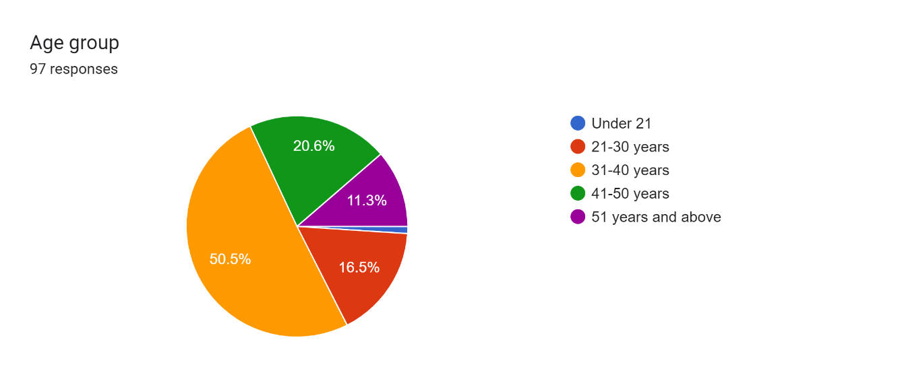

**Figure 2: Respondents’ age group**

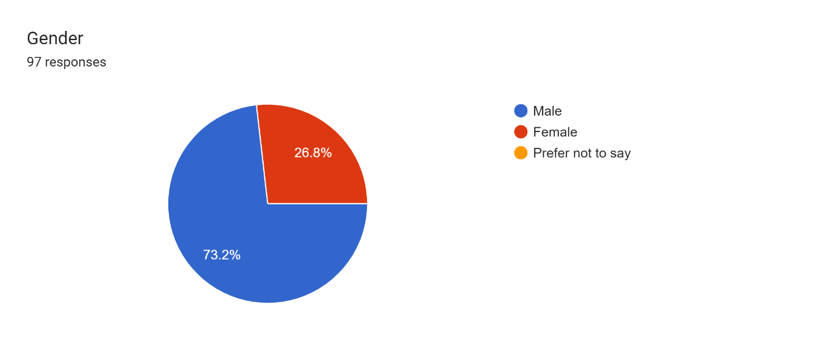

**Figure 3: Respondents’ Gender**

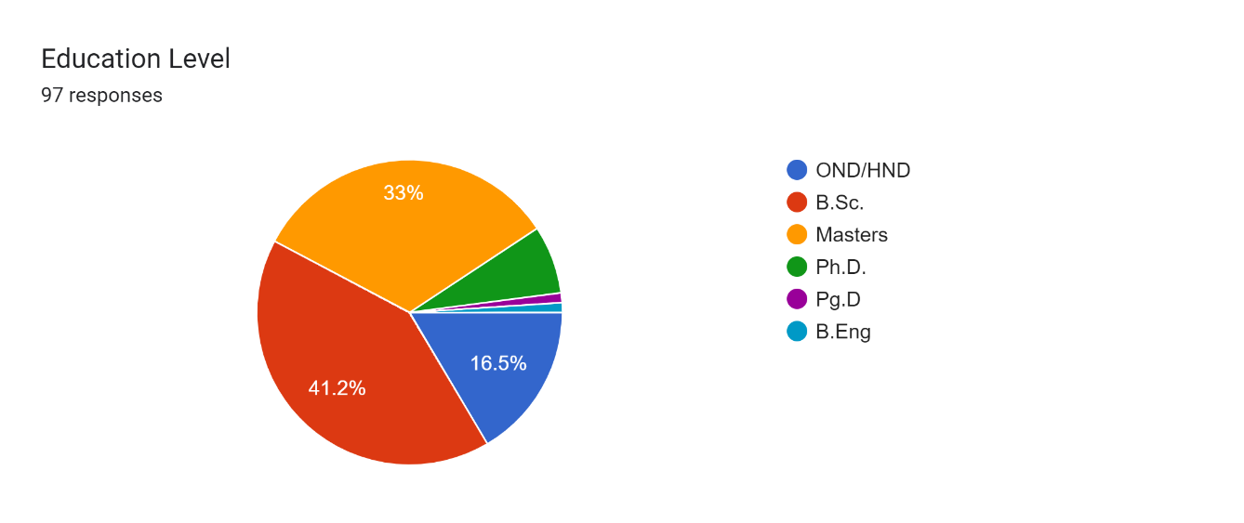

**Figure 4: Respondents Education Level**

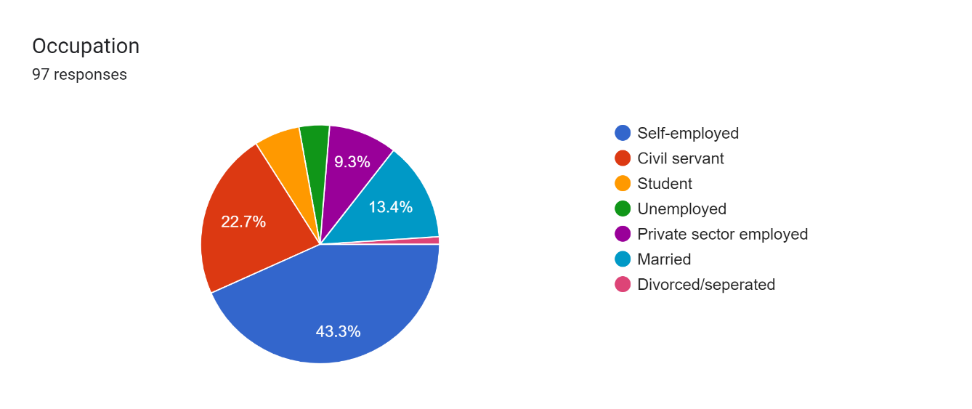

**Figure 5: Respondents’ Occupation**

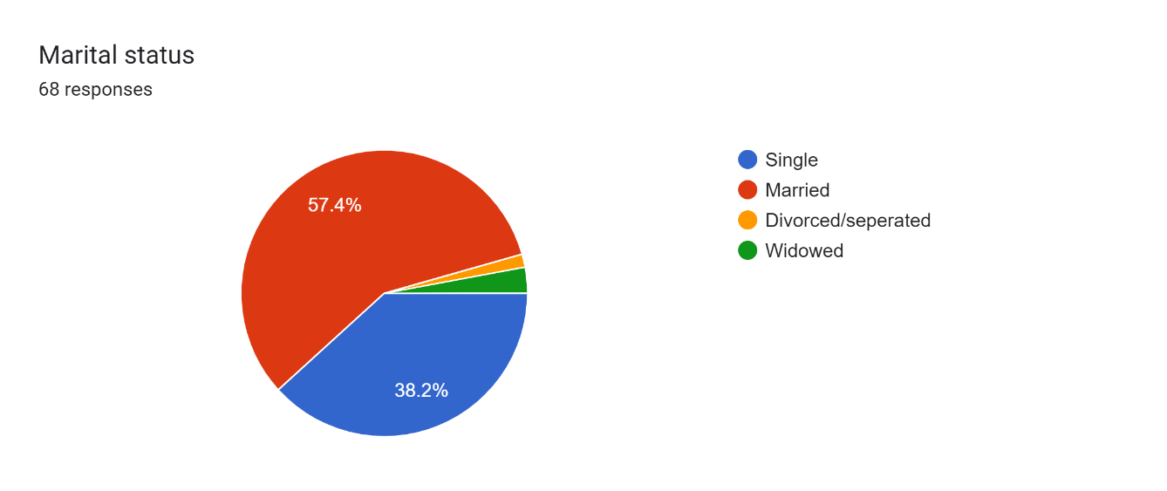

**Figure 6: Respondents’ Occupation**

**Figure 7: Respondents’ Household Size**

### Socio-typologies in South-south Nigeria

53.1 % of the respondents stay in urban areas (fig. 8) while 34.7% stay in suburban areas and 12.2 % stay in rural areas. 63.3% of the respondents are from a nuclear family (fig. 9) while 17.3% are from Traditional extended families and single-person households and the rest are staying in duplexes or rented apartments. 70.4% of the respondents are from Middle-income families (fig. 10), 20.4% are from low-income families and 9.2% are from high-income families. 48.9% of the respondents like in diverse community with minimal interaction among residents (fig. 11), 20.4% stay in Gated communities with restricted social interaction, 20.4% live in close-knit communities with string social ties while the rest stay in gated communities without restricted social interactions.

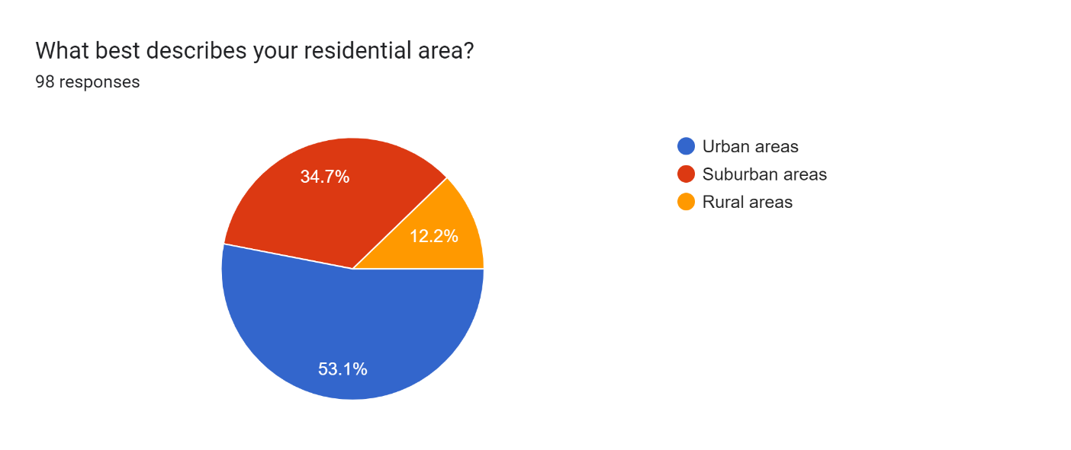

**Figure 8: Type of Residential area**

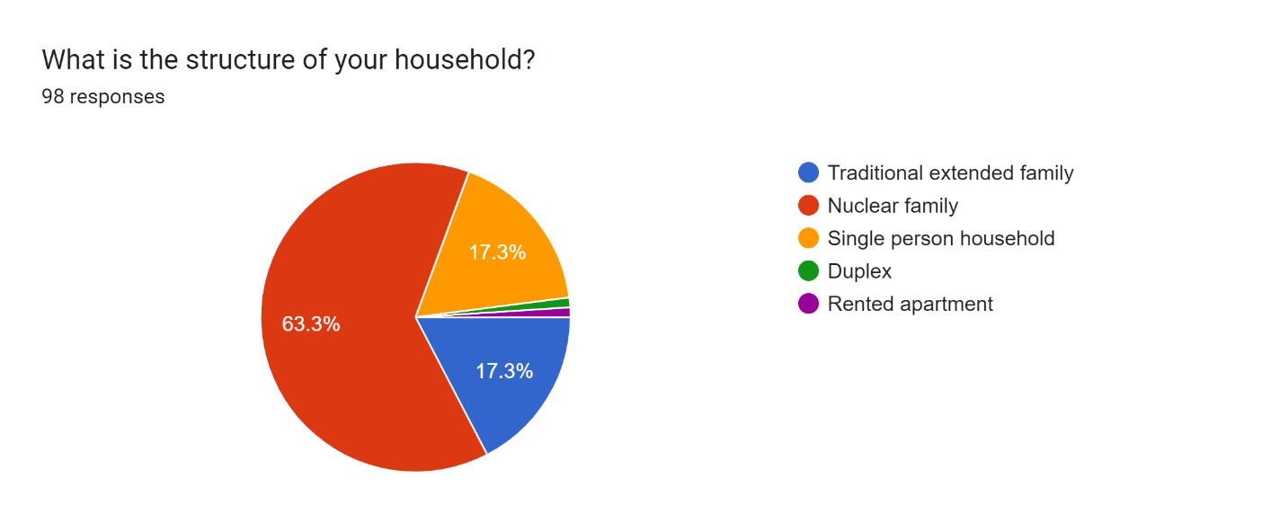

**Figure 9: Household structure**

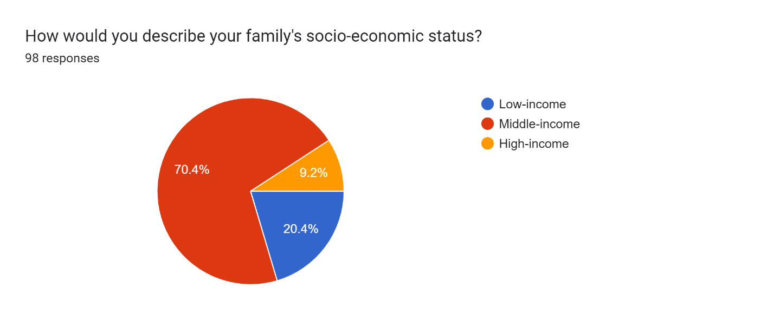

**Figure 10: Socio-economic status**

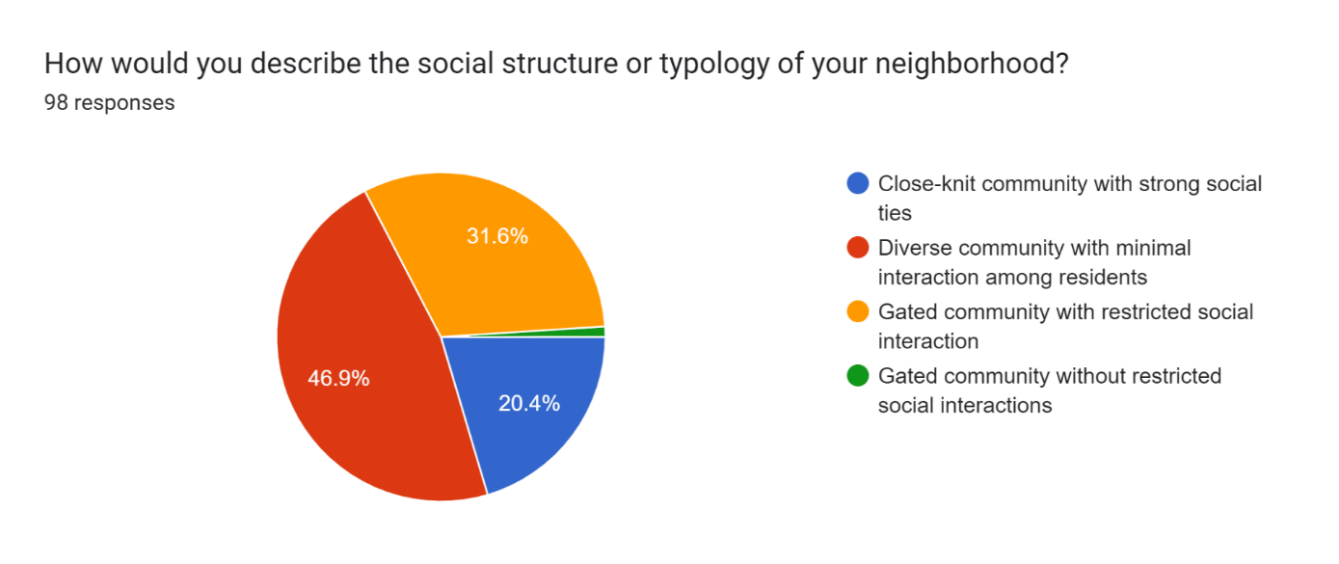

**Figure 11: Social structure or Typology of the neighbourhood**

### Physical characteristics and spatial configuration of the residential buildings in the study area

39.8% of the respondents reside in semi-detached buildings (fig. 12), 34.7% of them live in apartments, 21.4% reside in detached houses and the rest reside in terrace apartments. Most of the respondents have their residential preference influenced by safety and security, cost of living, and also proximity to the workplace (fig. 13). Most of the respondents use bricks, concrete, wood, and mud/earth as construction materials in their residential buildings (fig. 14). The rooms in the respondents’ buildings ranges from one to eight rooms (fig. 15), majority of which are 3 bedrooms. 71.4% of the respondents (fig. 16) rated the spatial layout of the rooms adequate, 18.4% rated it very spacious and 9.2% rate it somewhat cramped.

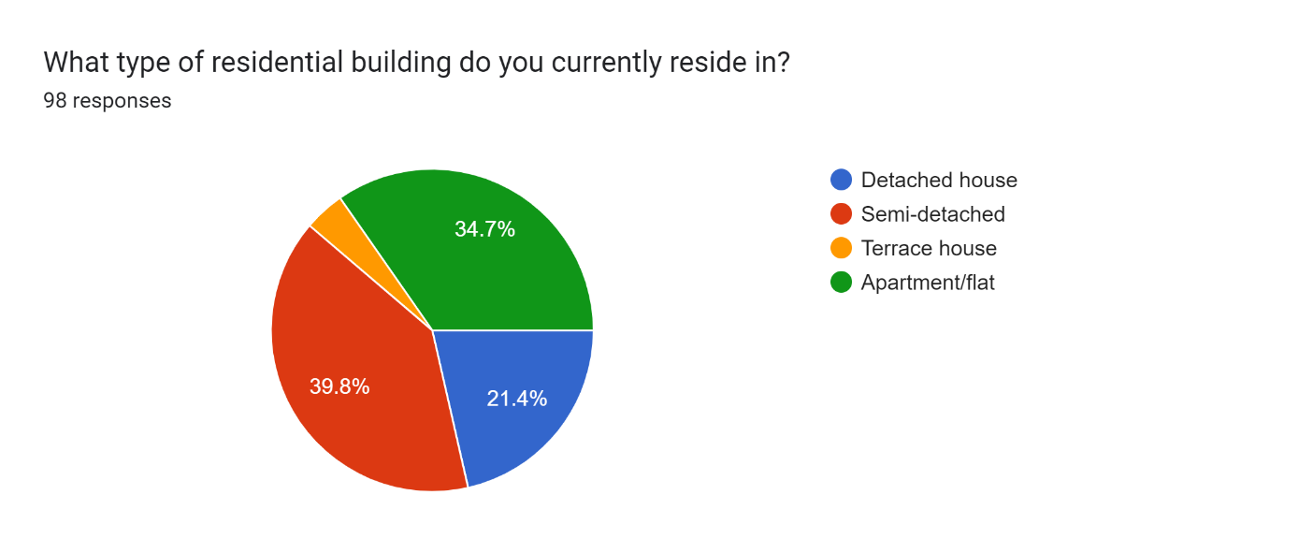

**Figure 12: Type of residential building**

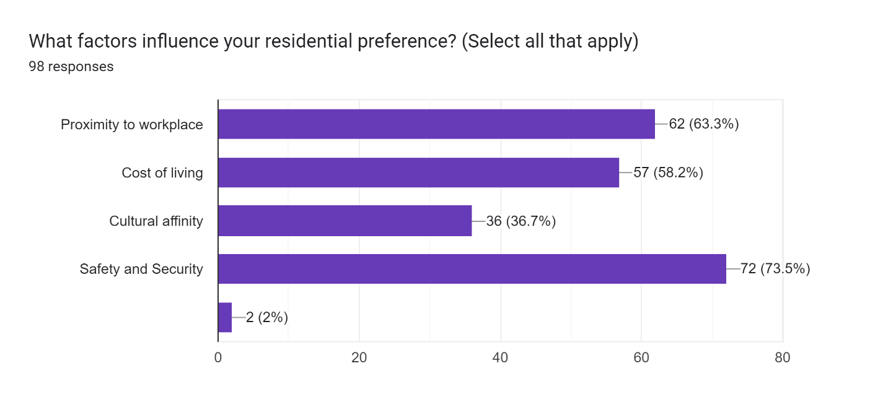

**Figure 13: Factors that influence your residential preference**

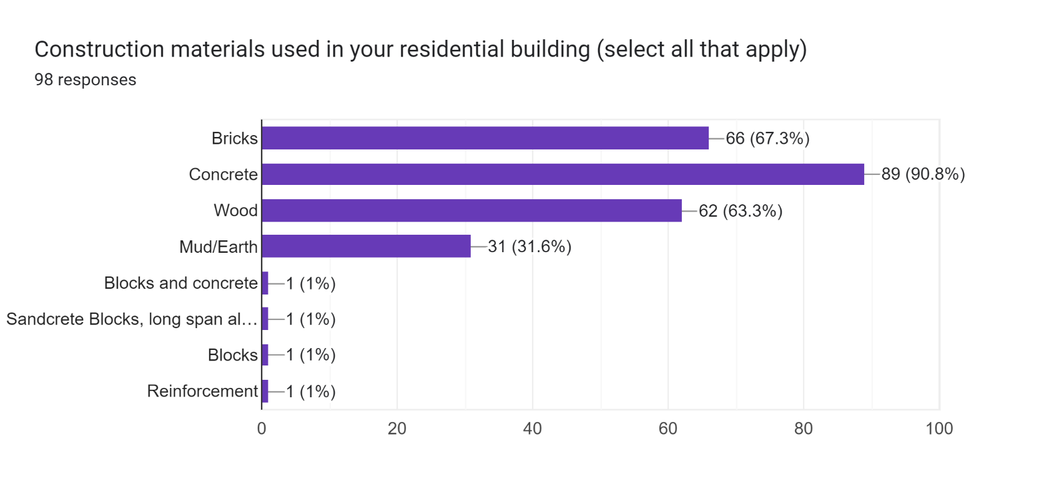

**Figure 14: Construction materials used in the building**

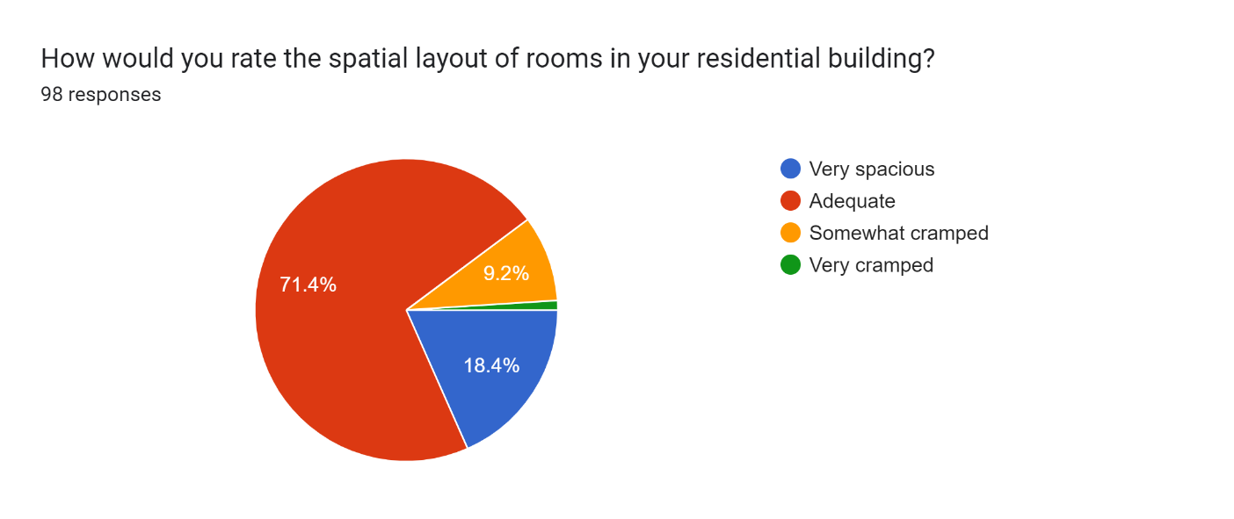

**Figure 15: Rate of the spatial layout of rooms**

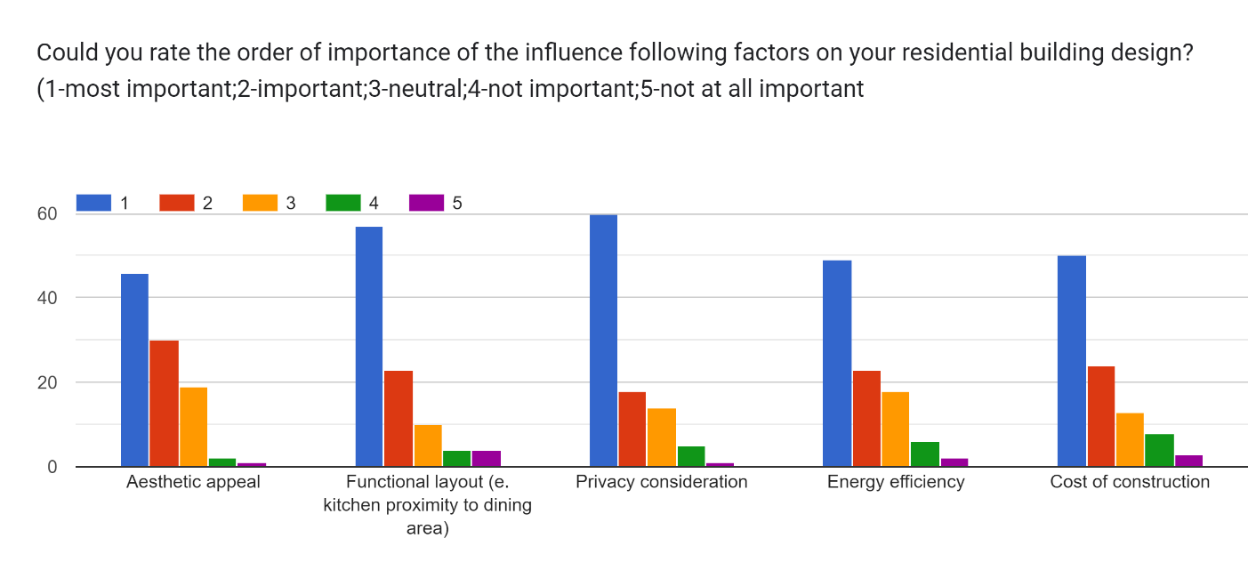

**Figure 16: Factors influencing residential building design**

Figure 16 shows the rating (on a scale of 1 to 5; 1-strongly disagree; 2-disagree; 3-neutral; 4-agree; 5-strongly agree) of the order factors influencing residential building design. Respondents rated privacy consideration as the most important factor in residential building (mean score=4.34), and the least factor for consideration is the cost of construction (mean score=4.12). 53.1 of the respondents think that social typology moderately influences residential building design configurations (table 1), 29.6% strongly influence them, 13.3% slightly influence and the rest do not influence them.

**Table 1: Rate of Influence on the residential building**

|  |  |  |  |  |  |  |
| --- | --- | --- | --- | --- | --- | --- |
| Factors | Most important | Important | Neutral | Not important | Not at all important | Mean |
| Aesthetic appeal | 46 | 30 | 19 | 2 | 1 | **4.20** |
| Functional layout (e. kitchen proximity to dining area) | 57 | 23 | 10 | 4 | 4 | **4.28** |
| Privacy consideration | 60 | 18 | 14 | 5 | 1 | **4.34** |
| Energy efficiency | 49 | 23 | 18 | 6 | 2 | **4.13** |
| Cost of construction | 50 | 24 | 13 | 8 | 3 | **4.12** |

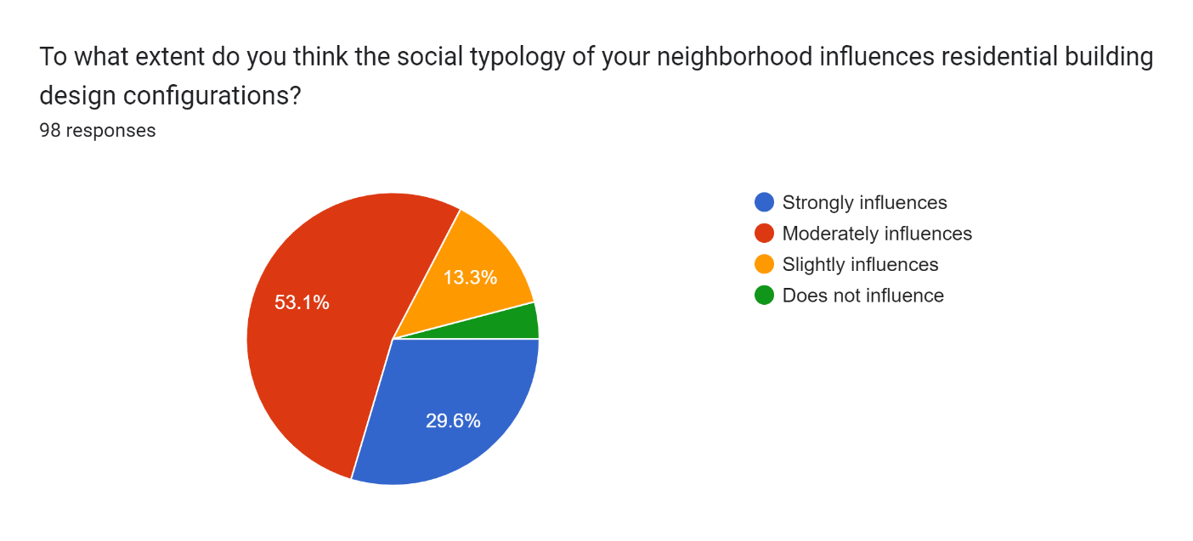

**Figure 17: Extent of how social typology influences residential building design configurations**

### How socio-typology affects the design configuration of residential buildings in the study area

30.6% of the respondents (fig. 18) have building density that influences the social typology of their neighbourhood, 29.6% have privacy measures like fencing and landscaping, 23.5% have layouts of communal spaces like parks and playgrounds, 15.3% have architectural styles like traditional and modern. 41.8% of the respondents (fig. 19) are satisfied with the current design configuration of residential buildings in their neighbourhood, and 24.5% are neutral with the current design configuration. The respondents (fig. 20) have common areas like gardens and community halls, they also have proximity of units to each other, open floor plans, and individualized private spaces. 54.1% of the respondents have a greater focus on privacy and individuality (fig. 20), 29.6 % have more emphasis on communal spaces and interaction then 16.3% have integration of technology for social connectivity. 38.8% of the respondents (fig. 21) strongly influence the extent to which cultural factors influence the architectural style and aesthetics of their residential building. 30.6% minimally influence and 25.5% somewhat influence while the rest do not influence at all.

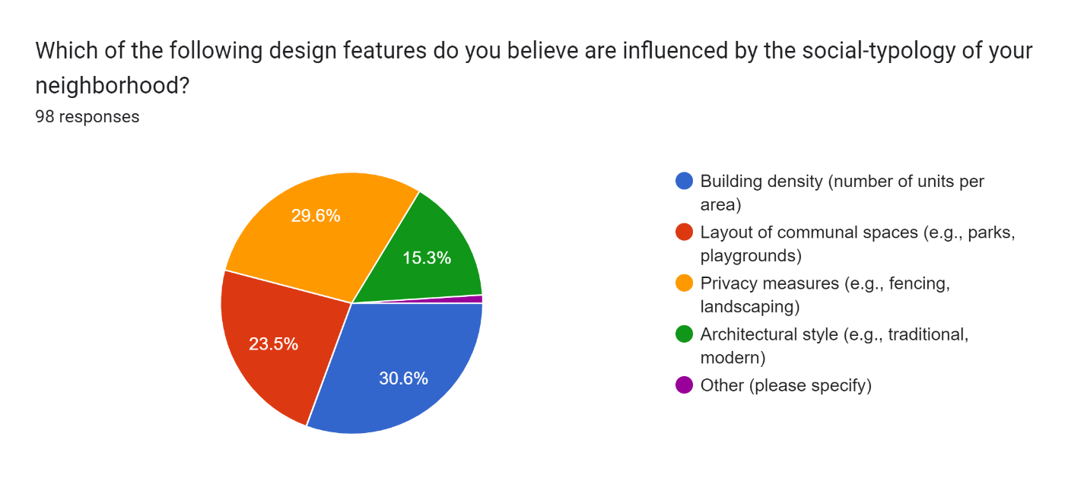

**Figure 18: Design features in the neighbourhood**

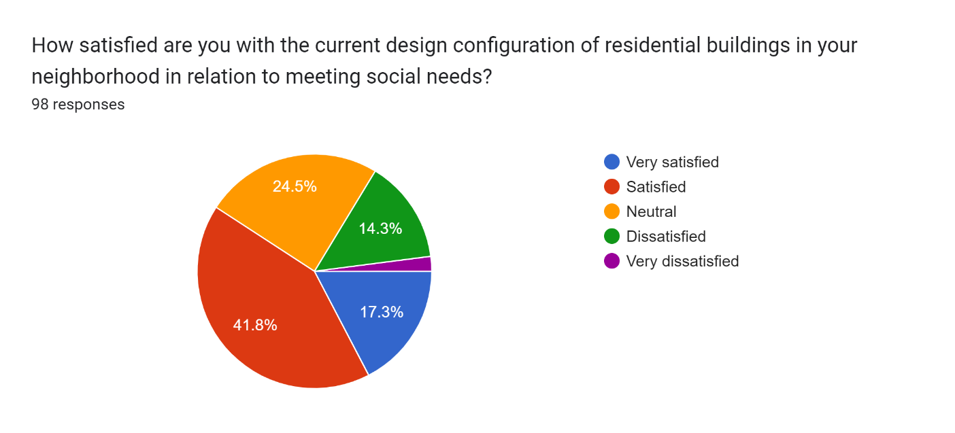

**Figure 19: Satisfaction with the current design configuration**

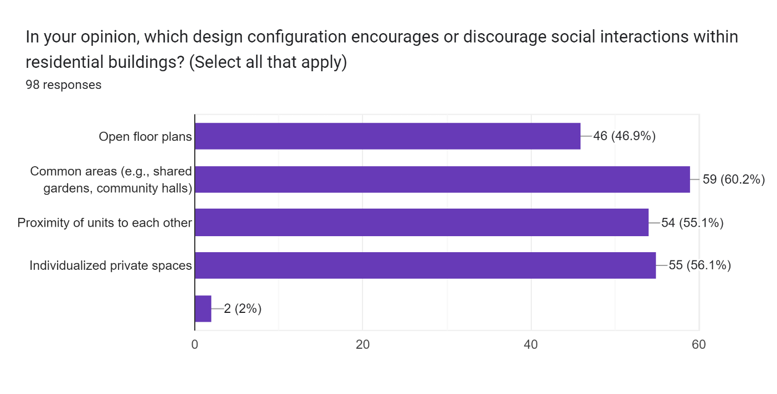

**Figure 20: Encouragement and Discouragement of social interactions within residential buildings**

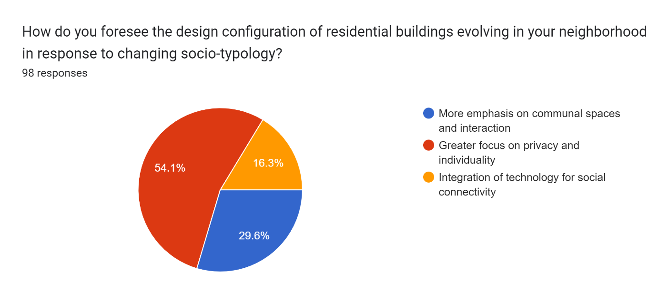

**Figure 21: Evolution of the design configuration of the residential buildings**

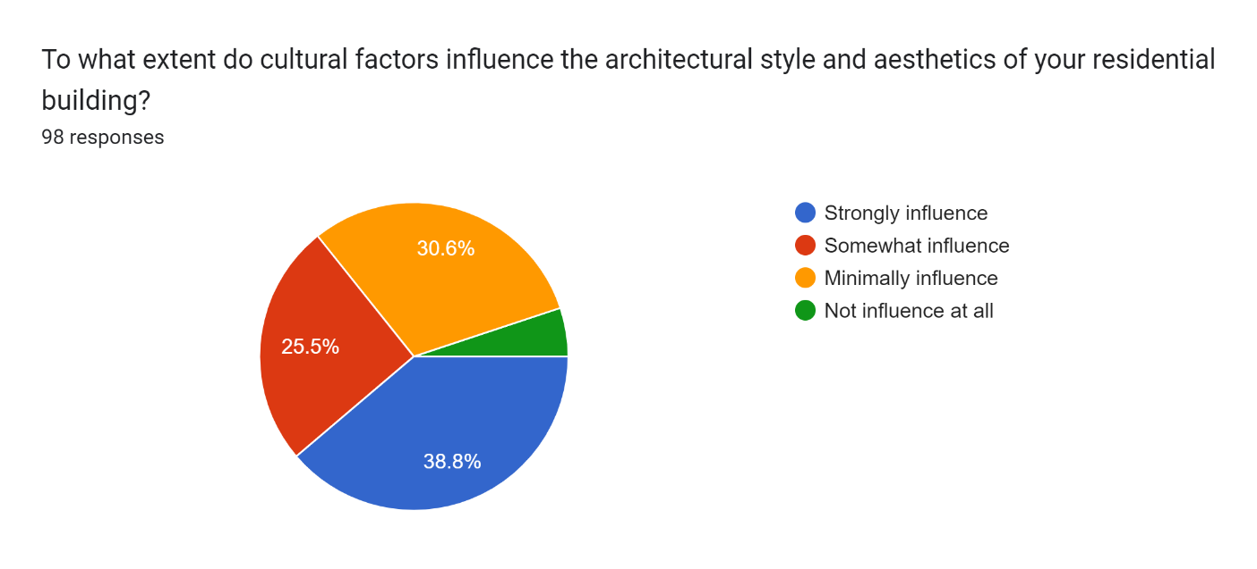

**Figure 22: Extent of influence of cultural factors**

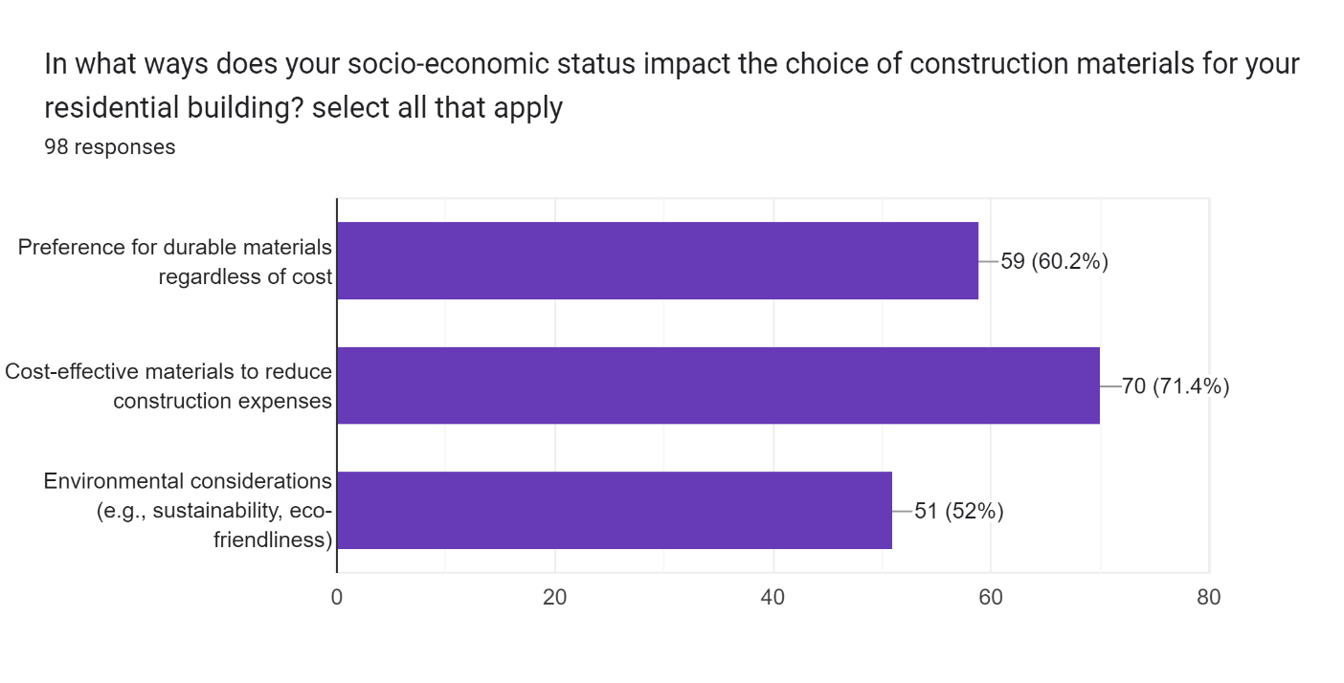

**Figure 23: Impact of the choice of construction materials**

Case study of the Eku Oghel Community

It is positioned in Ughelli, Delta State, the Eku Oghel Cooperative sought to deal with insufficient housing conditions many of the rural farming and fishing community through a collaborative, culturally-rooted improvement model. Led by means of local architects and related to resident input, 20 homes were deliberate and built round a significant courtyard using sustainably sourced nearby materials like bamboo, thatch and dust bricks, with layouts balancing privacy and communal capabilities as favoured. Construction hired each skilled labour alongside voluntary community contributions consistent with means through coins, materials or hard work shares, demonstrating low-cost housing’s capability when empowering residents to cooperatively self-offer according to want. Initial reviews suggest the completed improvement efficiently lifted dwelling standards even as reinforcing social cohesion and mutual help networks through ordinary backyard interactions, imparting lessons for comparable grassroots tasks addressing infrastructure challenges faced in resource-constrained delta settlements via locally-pushed solutions matching form to cultural context and function.

## Conclusion

The results show the need to consider social factors in creating sustainable and culturally appropriate housing solutions. In understanding the diverse social typologies and their implications on design, architects and planners can develop housing solutions that cater to the needs of the different communities, thereby promoting social cohesion and enhancing the overall quality of life. Based on the findings of this study, the study recommends incorporating social typology into housing design guidelines and the Promotion of participatory design approaches. It also encourages Investing in research and development, the Promotion of cultural heritage and identity, addressing affordability and access to housing and promoting sustainable building practices.

The outcomes of the research point to many directions for more study on how South-South Nigerian residential building design configurations are impacted by socioeconomic typology. Examining the effects of social and cultural variables on energy use, traffic patterns, and architectural identity in residential neighbourhoods is one of the main topics. It's crucial to look into how public housing's spatial layout and socio-physical environments affect how its occupants adapt to and change these environments. It is critical to examine how the transition from low-rise to apartment buildings affects tenants' living situations on a social and environmental level. Furthermore, it is crucial to investigate how the objectives of residential development are shaped by the distribution of power, resources, and authority as well as the ideas, values, behaviours, and social structures of various groups. It is also advised to look at how residential architecture functions as a tool for social control and whose interests it serves, as well as popular residential building types and how their shapes and layouts differ throughout communities. These fields demonstrate the importance of conducting multidisciplinary research to comprehend the intricate interactions between social, cultural, political, and economic elements influencing South-South Nigerian residential design.

# References

Adedayo, O. F. (2010). Housing design and its socio-cultural impact on the society: A case study of selected estates in Minna, Niger State, Nigeria. Academia.

Aguilera, D., & Ortiz-Revilla, J. (2021). STEM vs. STEAM education and student creativity: A systematic literature review. *Education Sciences*, 11(7), 331.

Alabbasi, A. M., Paek, S. H., Kim, D., & Cramond, B. (2022). What do educators need to know about the Torrance Tests of Creative Thinking: A comprehensive review. *Frontiers in psychology*, 13,1000385.

Al-Ghaili, A. M., Kasim, H., Al-Hada, N. M., Hassan, Z. B., Othman, M., Tharik, J. H., . . . Shayea, I. (2022). A review of metaverse’s definitions, architecture, applications, challenges, issues, solutions, and future trends. *IEEE Access*, 10, 125835-1258.

Avsec, S., & Jagiełło-Kowalczyk, M. (2021). Investigating possibilities of developing self-directed learning in architecture students using design thinking. *Sustainability*, 13(8), 4369.

Beaty, R. E., & Johnson, D. R. (2021). Automating creativity assessment with SemDis: An open platform for computing semantic distance. *Behavior research methods*, 53(2), 757-780.

Brogden, L. (2020). From product to process and site to system: Disaster resilience and humanitarian design in architecture education. (Doctoral dissertation, Queensland University of Technology).

Casakin, H., & Wodehouse, A. (2021). A systematic review of design creativity in the architectural design studio. *Buildings*, 11(1), 31.

Cavas, B., & Cavas, P. (2020). .Multiple intelligences theory—Howard Gardner. Science Education in Theory and Practice: An Introductory Guide to Learning Theory.

Glăveanu, V. P. (2020). A sociocultural theory of creativity: Bridging the social, the material, and the psychological. . *Review of General psychology*, 24(4), 335-354.

Hernández-Torrano, & Ibrayeva, L. (2020). Creativity and education: A bibliometric mapping of the research literature (1975–2019). *Thinking skills and creativity*, 35, 100625.

Korca, B., & Costa, E. (2021). Directive 2014/95/EU: building a research agenda. *Journal of Applied Accounting Research,*, 22(3), 401-422.

Lindquist, C. (2023). Connecting the Cerebral and Heartfelt: Integrating Creative Problem Solving and Design Thinking.

OSIKHOTSALI, M. (2022). *Population Definition in Statistics and How to Measure It.* Statistic and managemnet Sciences. United states: CIERRA MURRY. Retrieved 02 27, 2023, from https://www.investopedia.com/terms/p/population.asp

Pi, D., Liu, J., & Wang, Y. (2022). Review of computer-generated hologram algorithms for color dynamic holographic three-dimensional display. *Light: Science & Applications*, 11(1), 231.

Ritter, S. M., Gu, X., Crijns, M., & Biekens, P. (2020). Fostering students’ creative thinking skills by means of a one-year creativity training program. , . *PloS one*, 15(3), e0229773.

Rousseau, L. (2021). Neuromyths” and Multiple Intelligences (MI) Theory: A Comment on Gardner. *Frontiers in Psychology*, 3301.

Saleh, M. M., Abdelkader, M., & Hosny, S. S. (2023). Architectural education challenges and opportunities in a post-pandemic digital age. *Ain Shams Engineering Journal*, 14(8), 102027.

Taneri, B., & Dogan, F. (2021). How to learn to be creative in design: Architecture students’ perceptions of design, design process, design learning, and their transformations throughout their education. *Thinking Skills and Creativity*, 39,100781.

Von Zumbusch, J. S., & Lalicic, L. (2020). The role of co-living spaces in digital nomads’ well-being. *Information Technology & Tourism*, 22(3), 439-453.

Yilmaz, B., & Feran, A. Ş. (2018). Urban Landscape Design Criteria in Winter Cities. *JENAS Journal of Environmental and Natural Studies*, 102-115.

Yoon, S. K., Kim, J. H., Park, J. E., Kim, C. J., & Song, J. H. (2020). Creativity and knowledge creation: The moderated mediating effect of perceived organizational support on psychological ownership. *European Journal of Training and Development*, 44(6/7).