**Analysis of Composite Two-Span PSC-I Girder Bridge using MIDAS Software and Machine Learning Models**

**Raj Deepak Verma1*, Sachin Kumar Singh2, Abhishek Mishra3**

1 M. Tech. Scholar, Institute of Engineering and Technology, Lucknow, India, 226021

2,3 Assistant Professor, Institute of Engineering and Technology, Lucknow, India, 226021

*Corresponding author, deepak15kv@gmail.com

**ABSTRACT**

Bridge construction is globally significant, with bridges being essential components of road networks. Pre-stressed girder bridges are increasingly popular due to their stability, serviceability, economy, durability, and aesthetics. For spans over 10 meters, pre-stressed concrete is more efficient than reinforced concrete. These bridges offer stability, serviceability, and economic benefits without disrupting traffic for long periods. This paper analyzed a Composite Two-Span PSC-I Girder Bridge under IRC loadings using MIDAS software, focusing on deflection based on stiffness scale factor. The deflection data is validated using multilayer Artificial Neural Networks (ANNs), achieving an accuracy of 81.80% and losses of 11.5%.

**Key Words:** Bridge, Midas Civil, Composite I-Girder, Prestressed, IRC standards.

1. **INTRODUCTION**

Midas Civil is a Finite Element Analysis (FEA) software developed by Midas IT for bridge analysis and design. It simplifies and accelerates bridge modeling and analysis by integrating extensive pre- and post-processing tools with a fast solver. Additionally, it offers easy-to-use parameter change tools for parametric analysis, enabling efficient and cost-effective design creation.

The engineering design process for developing safe bridge structures involves these phases:

1. Acquiring a comprehensive understanding of the situation.
2. Calculating potential bridge loads according to IRC 6 2000.
3. Combining these loads to determine the maximum potential load.
4. Using mathematical relationships to estimate the material needed to withstand the highest load.

M Jagandatta et al. designing a Composite Single Span PSC-I Girder Bridge under IRC loadings using MIDAS software. The analysis covers bending moments, shear forces, and time-dependent characteristics like creep and shrinkage. The PSC span is designed following IRC standards, considering section properties, moments, prestressing forces, tendon profiles, prestressing losses, and shear stresses **[1]**. Menda Babu Rao et al. focuses on composite pre-stressed I-girder bridges, which are beneficial for rapid construction since girders are pre-fabricated off-site and assembled on-site. These bridges offer good stability, serviceability, and are economical, minimizing traffic disruption. They are also simple to construct and suitable for short spans. The paper details the analysis and design of these bridges using MIDAS civil software **[2]**. Shubham S. Hande et al. compared a pre-stressed concrete bridge under IRC 6: 2000 and ASHTO-LRFD standards, using MIDAS CIVIL for modeling and analysis. Key structural parameters like shear force, bending moment, and torsion were examined. The findings indicate that AASHTO standards are less economical than IRC standards due to heavier vehicle loads. Thus, the study suggests that pre-stressed box girder bridge analysis and design should ideally follow IRC standards for cost efficiency **[3]**. Researchers Oguzhan Hasancebi et al. used artificial neural networks (ANNs) and nonlinear FE models to conduct a thorough load rating analysis technique for condition assessment of bridges. The six independent bridge parameters that control the population's load rating analysis are identified by first performing a statistical analysis in which the degree of dependence between the structural and geometrical properties of the bridges and the commonality of design parameters are examined. The span length (L), beam depth (d), number of T-beams (nb), skew angle (a), end diaphragm presence, and presence of RC parapets are these characteristics **[4]**. Research by Fayaz A. Sofi et al. conducted a study to show that ANNs in conjunction with a small set of refined studies can be used as a predictive tool to estimate the expected outcome for similar approaches and bridges in a population. There were two ANN-based load-rating prediction models that were taken into consideration: committee networks (CN) and single-best networks (SBN) **[5]**. Essam Althaqafi et al. carried out that an artificial neural network (ANN) model can be constructed to enhance the prediction accuracy of bridge deck, superstructure, and substructure deterioration, hence improving the bridge management system (BMS). The suggested ANN models for the deck, superstructure, and substructure components were trained and tested using a sizable dataset of historical bridge condition assessment data; on the testing set, the models' accuracy was 90%, 90%, and 89%, respectively **[6]**. Rayan Assaad at al. study done to create a computational data-driven asset management system that assesses and forecasts the state of bridge deck deterioration. A multi-phase, interdependent process was applied. Initially, the optimal combination of factors influencing the state of bridge decks was determined. Second, utilising ANNs and KNNs (k-nearest neighbours) for computational machine learning, two models were created for the prediction of deck conditions. Third, the models that have been developed are compared in order to determine which is the best model in terms of accuracy. As a result, a framework with a prediction accuracy of 91.44% can assess and forecast deck conditions **[7]**. Mohsen Azimi et al., propose a method for structural health monitoring using convolutional neural networks (CNNs) that uses transfer learning-based approaches to analyse compressed response data. This technique enables damage localization and identification in large-scale systems. The approach is verified by numerically simulating a benchmark model and training CNN models using acceleration response histories and compressed response data as discrete histograms **[8].**

1. **MODELLING AND METHODOLOGY**
   1. **Midas Civil Software:**

Midas Civil, a software for integrated modeling, analysis, and design of civil, bridge, and building structures, is set to revolutionize the engineering profession. It simplifies adjustments and inspires new design ideas, leading to increased accuracy and productivity. The software also enables the creation of high-quality graphics visuals and animations for presentations. Modelling of Two Span PSC I- Girder Bridge was done by using MIDAS CIVIL software. The loading conditions were provided for both the models as per IRC 6: 2000 (Section II).

* 1. **Loading details on PSC I- Girder Bridge:**

Further, there were some common loading conditions in both the models, which are here below as:

1. **Dead load (DL):** The dead load sustained by the girder or component is made up of its own weight, as well as portions of the superstructure's weight and any fixed loads sustained by the member. During designing, the dead load may be anticipated pretty well, and construction and service can be managed. Moreover, weight of SIDL which includes earth-fill, wearing course, ballast, waterproofing, conduits, cables, pipes, etc. are installed on the structure.
2. **Live Load (LL):** Vehicles passing over the bridge create live loads, which are temporary in nature. These loads are impossible to predict correctly, and once the bridge is exposed to traffic, the designer has very little control over them. For the evaluation of a two-lane box girder, the similar categories of loadings are used.

As per IRC - Vehicle Load: Class A and Class 70R; Dynamic Allowance: 33%

* 1. **Modelling:**
* Create nodes in node tool bar. Display node numbers.
* Defining material and section properties in properties tool bar.
* Preparing geometry of PSC I-Girder using node numbers of elements and assigning predefined properties and cross-sectional details.
* Define creep and shrinkage and compressive strength also material links should be defined.
* Define tendon properties in tendon profile generation tool bar.
* Define rigid and elastic link for structure.
* Applying dead load, prestressing load from load tool bar.
* Selecting loading standard of IRC-6.
* Analyze box girder by selecting perform analysis.

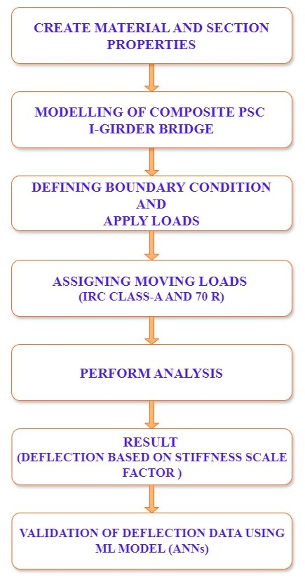

**Fig.1: Work Flow diagram of Methodology**

* 1. **Structural Details:**

**Table.1: Description of Bridge parameter**

|  |  |
| --- | --- |
| **PARAMETERS** | **DESCRIPTION** |
| Bridge Type | PSC Composite (Composite I Girder) |
| Span Length | 2 Span @ 22.8 m each |
| Expansion joint b/w 2 spans | 40 mm |
| Width | 15 m |
| Girder | 5 Precast, post tensioned @ 3m c/c |
| Time Dependent Material  (Creep, Shrinkage, Modulus of Elasticity) | IRC 112 |
| Loads | Static Loads, Pre stress Loads, Moving Loads |
| Moving Loads | IRC 6 |
| Load Combination | IRC 6 (2000) |
| PSC Design Check | IRC 112-2011 |

**Table.2: Description of Material Properties**

|  |  |
| --- | --- |
| **Material Properties** | |
| PSC Girder | M40 |
| PSC Deck | M30 |
| Diaphragm | M40 |
| Substructure | M30 |
| Tendon | Fe540 Steel |

**Table.3: Description of Section Properties**

|  |  |  |
| --- | --- | --- |
| **Section Properties** | | |
| End Diaphragm | Solid Rectangle | 1.4 m X 0.4 m |
| Internal Diaphragm | Solid Rectangle | 1.4 m X 0.3 m |
| Pier | Solid Round | 1.5 m (d) |
| Pier Cap | Solid Rectangle | * 1. m X 1.6 m |

1. **ANALYSIS AND DESIGN**

Using Midas Civil software, both linear and non-linear analyses are conducted. Analytical techniques generate results, reducing structure failure rates, extending their lifespan, and enhancing safety. The models are illustrated in the Fig.2.

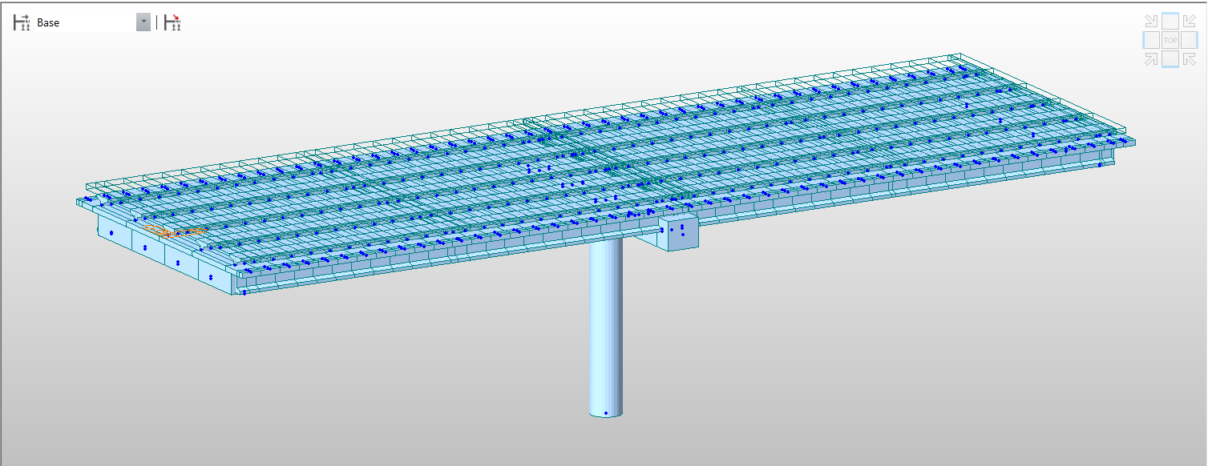

**Fig.2: Generated model of Isometric view in MIDAS Civil (Composite Two Span PSC I- Girder Bridge)**

1. **RESULTS AND DISCUSSIONS**

Following analysis using Midas software, the Composite Two Span PSC I- Girder Bridge result is examined. Under varying loading circumstances, primary structural analysis parameters such as deflection and mode shape are investigated based on various stiffness factors.

The deflection increases on decreasing stiffness factor, i.e., 1.0, 0.95, 0.90, 0.85, 0.80, 0.75, 0.70, 0.65, 0.60, 0.55, 0.50. The deflection of bridge is shown in Table.4.

Table.4: Deflection values based on various Stiffness scale Factor.

|  |  |  |  |
| --- | --- | --- | --- |
| **Stiffness Factor** | **DX (m) Max.** | **DY (m) Max.** | **DZ (m) Max.** |
| 1.00 | 0.133721 | 0.036881 | 0.223405 |
| 0.95 | 0.134984 | 0.037991 | 0.223405 |
| 0.90 | 0.135955 | 0.038103 | 0.249205 |
| 0.85 | 0.136997 | 0.039824 | 0.252695 |
| 0.80 | 0.137984 | 0.040256 | 0.26894 |
| 0.75 | 0.138725 | 0.041568 | 0.278235 |
| 0.70 | 0.139852 | 0.042589 | 0.287125 |
| 0.65 | 0.140865 | 0.043589 | 0.298278 |
| 0.60 | 0.141897 | 0.044895 | 0.298768 |
| 0.55 | 0.142562 | 0.045876 | 0.308546 |
| 0.50 | 0.143566 | 0.046576 | 0.315893 |

Data obtained from different Stiffness Factor an Artificial Neural Networks programme was trained and derived to check the accuracy and losses for ML Model. In ANNs model data accuracy was obtained as 81.80% and loss as 11.5%.

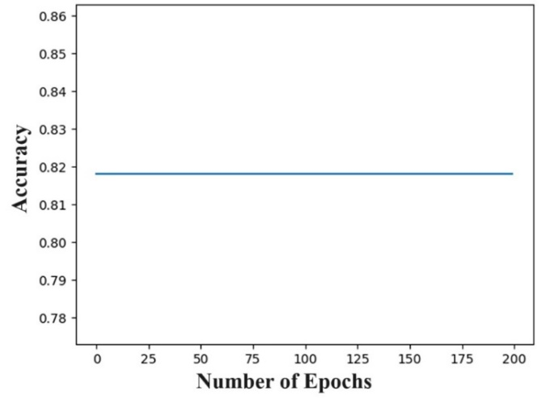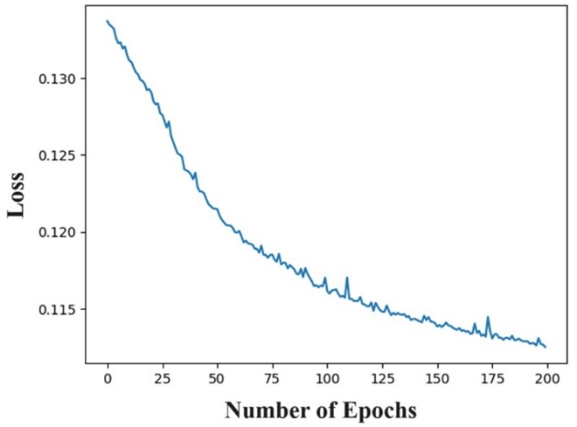

**Fig.3: Number of Epochs vs Accuracy graph Fig.4: Number of Epochs vs Loss graph**

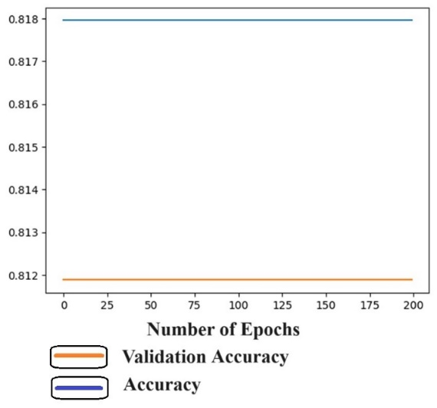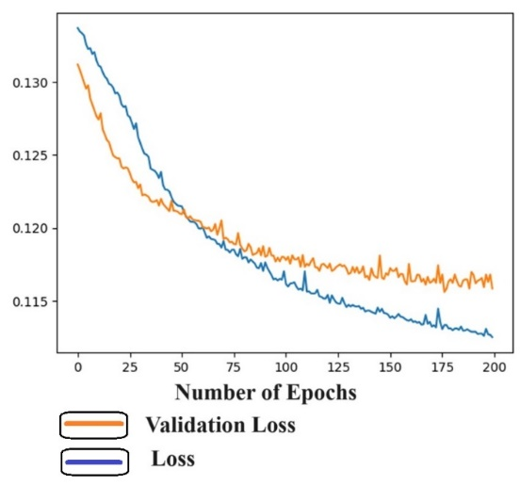

**Fig.5: Number of Epochs vs Accuracy and Fig.6: Number of Epochs vs Loss and**

**Validation Accuracy graph Validation Loss graph**

1. **CONCLUSIONS**

The use of advanced software like MIDAS Civil facilitates this process by providing precise and comprehensive analysis capabilities. Here are the key conclusions drawn from the study:

1. It is very easy and safe to design and analysis the prestressed post tension girders and deck slab using Midas civil.
2. The prestressing tendon profile and forces in the girders can be easily assigned using Midas civil.
3. Midas civil is a civil structural engineering fully integrated solution system.
4. Midas civil is the one step solution for the analysis and design of any model of structures and especially bridges.
5. This research used Midas Civil show the deflection for various stiffness factors of bridges model.
6. Artificial Neural Networks (ANNs) was used to identify the accuracy of deflection data as 81.80% and losses of 11.5%.
7. **REFERENCES**
8. M Jagandatta, G Yaswanth Kumar and S Suresh Kumar, Analysis and Design of Composite Single Span PSC-I Girder Bridge Using Midas Civil, IOP Conf. Series: Earth and Environmental Science 982 (2022) 012078.

<https://doi:10.48049/NQ.2022.20.21.NQ99083>

1. Menda Babu Rao, Toshan Singh Rathour, Aditi Dubey, Analysis & Design of Composite Prestressed Concrete I-Girder Bridge Using MIDAS Civil, Neuro Quantology, December 2022. <https://doi:10.1088/1755-1315/982/1/012078>.
2. Shubham S. Hande, Sharda P. Siddh, Prashant D. Hiwase, Analysis of Pre-Stressed Box Girder Bridge under Different Standard Codes: A Comparative Study, IOP Conference Series: Materials Science and Engineering 1197 (2021) 012068.

<https://doi:10.1088/1757-899X/1197/1/012068>.

1. Oguzhan Hasancebi, Taha Dumlupınar, Detailed load rating analyses of bridge populations using nonlinear finite element models and artificial neural networks, Computers and Structures 128 (2013) 48–63.

<http://dx.doi.org/10.1016/j.compstruc.2013.08.001>

1. Fayaz A. Sofi, Using committees of artificial neural networks with finite element modeling for steel girder bridge load rating estimation, Structures 33 (2021) 533–553. <https://doi.org/10.1016/j.istruc.2021.04.056>.
2. Essam Althaqafi, Eddie Chou, Developing Bridge Deterioration Models Using an Artificial Neural Network, Infrastructures 2022, 7, 101.

<https://doi.org/10.3390/infrastructures7080101>.

1. Rayan Assaad, Hurst-McCarthy, Bridge Infrastructure Asset Management System: Comparative Computational Machine Learning Approach for Evaluating and Predicting Deck Deterioration Conditions, Journal of Infrastructure Systems, ASCE, ISSN 1076-0342 (2020).

<https://10.1061/(ASCE)IS.1943-555X.0000572>.

1. Mohsen Azimi, Gokhan Pekcan, Structural health monitoring using extremely compressed data through deep learning, Computer-Aided Civil and Infrastructure Engineering, 2019.

https:// DOI: 10.1111/mice.12517.

1. IRC 6-2017: Provision for Load and stress.
2. IRC 112-2011: Code of practice for Concrete Road Bridges.
3. IRC 18:2000: Design criteria for prestressed concrete road bridges (Post-Tensioned Concrete).