**A STUDY ON CONSUMER PERCEPTION TOWARDS DIGITAL PAYMENT**

**MADHIYARSI * (Asst Professor)**

**HARISH K\*\***

II YEAR MBA

JERUSALEM COLLEGE OF ENGINEERING

**ABSTRACT**

Mobile payment apps are also known as digital payment apps which are used for easy transactions and payments. These payment apps were introduced to customers for their benefits. There are various payment apps which are used for UPI Payments like Google pay, Phone pe, Paytm, etc. Now the online payment app user are increased dramatically and also the payment options have been spread in local market. The customers are highly beneficial and satisfied towards payment apps. This study is focused on the usage of payment apps by customers and also their satisfaction towards payment apps. This study done using Descriptive Research design method and data collected by primary sources with 100 sample size of customers.

**INTRODUCTION**

The “Digital India” is the Indian Government’s flagship program with a vision to convert India into digitally empowered country. “Faceless, Paperless, Cashless” is one of supposed function of Digital India. Digital Payment System has gained importance nowadays, especially after demonetization. The government is taking essential steps to encourage the public to use payment gateway platforms. To promote gateway, it has declared discounts on purchases of certain products digitally. It has also introduced UPI (United Payment Interface) which is app based to transact across multiple banks. Another improved version is set to be unveiled by a platform called USSD (Unstructured Supplementary Service Data).

**REVIEW OF LITERATURE**

* Singh, S.(2015) The author denotes technological progression in mobile phones has increased the popularity of mobile payments. Users can shop online through a mobile device, which is time-saving and convenient.
* Ghosh,Gourab (2013) Describes that advancement of information and communication technology opened the gateway for modern methods of payments.

**METHODOLOGY:**

The primary objective is about to study the consumer perception towards digital payment mode and the secondary objective is to find out the factors influencing the consumer perception towards digital payment and to identify the problems faced by consumers in the adoption of digital payment and to identify the relationship between level of awareness and digital payment usage. The present study has been confined to study on consumer perception towards digital payments. The type of research used in this study is descriptive research and convenience sampling technique is used in this study. The target respondents are digital payment users both primary and secondary data have been used in this study. Primary data was collected through well structured questionarrie and google forms. Sample size taken for this study is 100 respondents. The collected data is analysed through percentage analysis, annova.

**DATA ANAYSIS AND INTERPRETATION:**

1. **GENDER OF THE RESPONDENTS**

|  |  |  |  |  |  |
| --- | --- | --- | --- | --- | --- |
|  | | Frequency | Percent | Valid Percent | Cumulative Percent |
| Valid | Male | 51 | 51.0 | 51.0 | 51.0 |
| Female | 49 | 49.0 | 49.0 | 100.0 |
| Total | 100 | 100.0 | 100.0 |  |

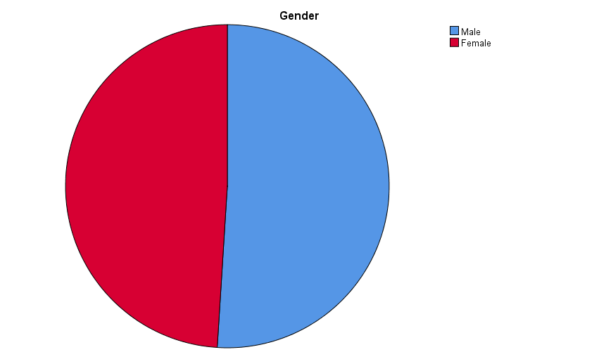

**INTERPRETATION:**

From the above table and chart it is observed that the out of 100 respondents, 51% of them are Male, 49% of them are Female are the major respondents of the study.

1. **EDUCATIONAL QUALIFICATION OF THE RESPONDENTS**

|  |  |  |  |  |  |
| --- | --- | --- | --- | --- | --- |
| **Educational Qualification** | | | | | |
|  | | Frequency | Percent | Valid Percent | Cumulative Percent |
| Valid | higer secondary | 10 | 10.0 | 10.0 | 10.0 |
| under graduate | 47 | 47.0 | 47.0 | 57.0 |
| post graduate | 43 | 43.0 | 43.0 | 100.0 |
| Total | 100 | 100.0 | 100.0 |  |

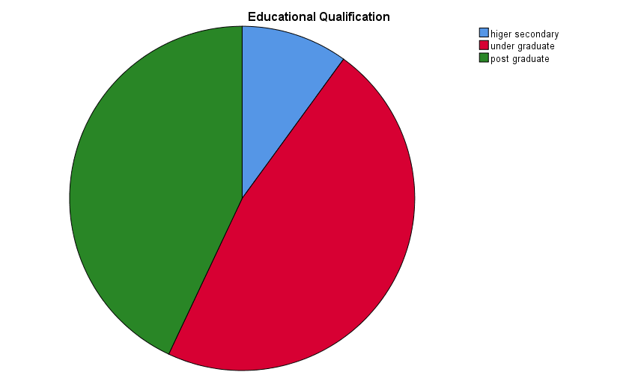

**INTERPREATION:**

From the above table and chart , it is observed that out of 100 respondents, 10% of them are Higher Secondary, 47% of them are Under Graduate, 43% of them are Post Graduate.

1. **AGE OF RESPONDENTS:**

|  |  |  |  |  |  |
| --- | --- | --- | --- | --- | --- |
| **Age** | | | | | |
|  | | Frequency | Percent | Valid Percent | Cumulative Percent |
| Valid | Less than 18 | 5 | 5.0 | 5.0 | 5.0 |
| 18-20 | 14 | 14.0 | 14.0 | 19.0 |
| 21-30 | 72 | 72.0 | 72.0 | 91.0 |
| above 30 | 9 | 9.0 | 9.0 | 100.0 |
| Total | 100 | 100.0 | 100.0 |  |

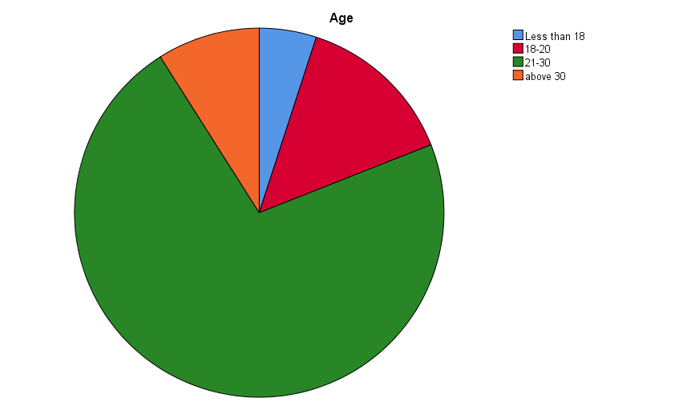

**INTERPRETATION:**

From the above table and chart it is observed that out of 100 respondents, 5% of them are in the group of less than 18, 14% of them are in the group of 18-20, 72% of them are in the group of 21-30, 9% of them are in the group of above 30.

1. **OCCUPATION OF THE RESPONDENTS :**

|  |  |  |  |  |  |
| --- | --- | --- | --- | --- | --- |
| **Occupation** | | | | | |
|  | | Frequency | Percent | Valid Percent | Cumulative Percent |
| Valid | student | 52 | 52.0 | 52.0 | 52.0 |
| working | 38 | 38.0 | 38.0 | 90.0 |
| business | 3 | 3.0 | 3.0 | 93.0 |
| others | 7 | 7.0 | 7.0 | 100.0 |
| Total | 100 | 100.0 | 100.0 |  |

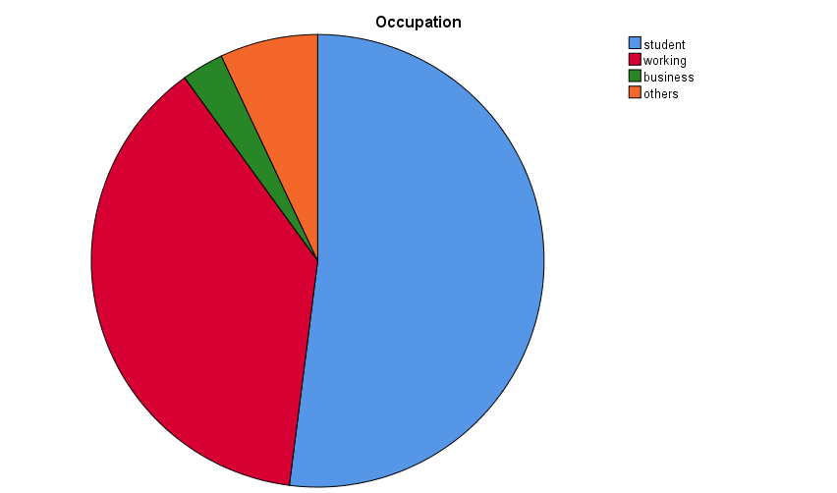

**INTERPRETATION:**

From the above table and chart it is observed that out of 100 respondents, 52% of them are students, 38% of them are working, 3% of them are in business, and apart from these 7% of them are others.

1. **RESPONDENTS OF HOW DO YOU KNOW ABOUT DIGITAL PAYMENT:**

|  |  |  |  |  |  |
| --- | --- | --- | --- | --- | --- |
| **How You Know About Digital Payment** | | | | | |
|  | | Frequency | Percent | Valid Percent | Cumulative Percent |
| Valid | banks | 19 | 19.0 | 19.0 | 19.0 |
| friends | 41 | 41.0 | 41.0 | 60.0 |
| advertisements | 31 | 31.0 | 31.0 | 91.0 |
| others | 9 | 9.0 | 9.0 | 100.0 |
| Total | 100 | 100.0 | 100.0 |  |

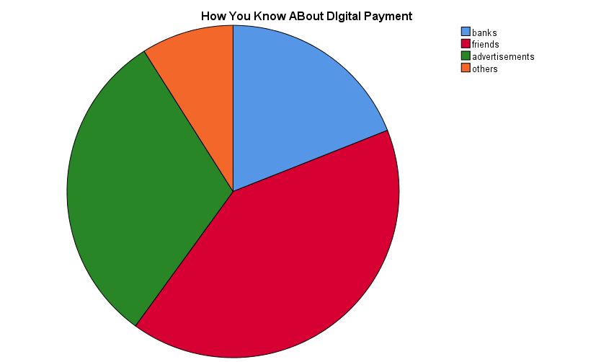

**INTERPRETATION:**

From the above table and chart, it is observed that 19% of them are known by Bank, 41% of them are known by Friends, 31% of them are known by Advertisement, 9% of them are known by Others.

**6)ANOVA TEST:**

* H0 (Null Hypothesis): There is no significant relationship between occupation and reason for using mode of digital payment.
* H1 (Alternative Hypothesis): There is a significant relationship between occupation and reason for using mode of digital payment.

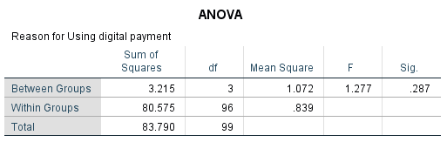

**INTERPRETATION:**

* The calculated significant value is 0.287 is greater than the significant value 0.05(0.287>0.05) Hence H0 is accepted H1 is rejected. There is no significant relationship between occupation and reason for using mode of digital payment.

1. **ANOVA TEST :**

* H0 (Null Hypothesis): There is no significant relationship between occupation and purpose of digital transaction done.
* H0 (Alternative Hypothesis): There is a significant relationship between occupation and purpose of digital transaction done.

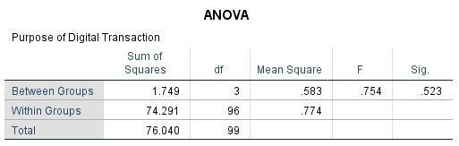

**INTERPRETATION:**

* The calculated significant value is 0.523 is greater than the significant value 0.05(0.523>0.05) Hence H0 is accepted H1 is rejected. There is no significant relationship between occupation and purpose of digital transaction done.

**8) ANOVA TEST :**

* H0(Null Hypothesis): There is no significant difference between purpose of digital transaction done and level of awareness towards digital payment.
* H1(Alternative Hypothesis): There is a significant difference between purpose of digital transaction done and level of awareness towards digital payment.

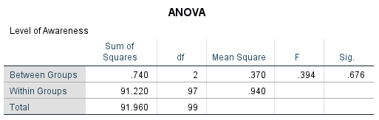

**INTERPRETATION:**

* The calculated significant value is 0.676 is greater than the significant value 0.05(0.676>0.05) Hence H0 is accepted H1 is rejected. There is no significant difference between purpose of digital transaction done and level of awareness towards digital payment.

**9) ANOVA TEST:**

* H0(Null Hypothesis): There is no significant relationship between digital payment app do you use mostly and hindrances faced while digital transaction.
* H1(Alternative Hypothesis): There is a significant relationship between digital payment app do you use mostly and hindrances faced while digital transaction.

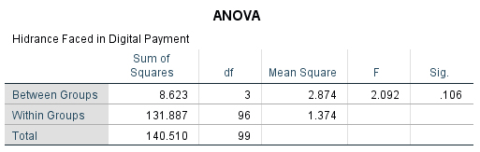

**INTERPRETATION:**

* The calculated significant value is 0.106 is greater than the significant value 0.05(0.106>0.05) Hence H0 is accepted H1 is rejected. There is no significant relationship between digital payment app do you use mostly and hindrances faced while digital transaction

**10)ANOVA TEST :**

* H0(Null Hypothesis): There is no significant relationship between occupation and is digital payment is secured and time saving.
* H1(Alternative Hypothesis): There is a significant relationship between occupation and is digital payment is secured and time saving.

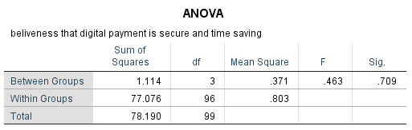

**INTERPRETATION:**

* The calculated significant value is 0.709 is greater than the significant value 0.05(0.709>0.05) Hence H0 is accepted H1 is rejected. There is no significant relationship between occupation and is digital payment is secured and time saving.

**11) ANOVA TEST:**

* H0(Null Hypothesis): There is no significant difference between the most used digital payment and often change pin of mobile banking/internet banking.
* H1(Alternative Hypothesis): There is a significant difference between the most used digital payment and often change pin of mobile banking/internet banking.

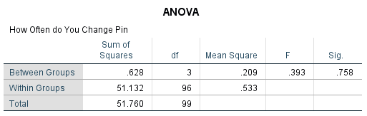

**INTERPRETATION:**

* The calculated significant value is 0.758 is greater than the significant value 0.05(0.758>0.05) Hence H0 is accepted H1 is rejected. There is no significant difference between the most used digital payment and often change pin of mobile banking/internet banking.

**FINDINGS:**

* According to the survey, it is observed that the out of 100 respondents, 51% of them are Male, 49% of them are Female are the major respondents of the study.
* According to the survey , it is observed that out of 100 respondents, 10% of them are Higher Secondary, 47% of them are Under Graduate, 43% of them are Post Graduate.
* According to the survey, it is observed that out of 100 respondents, 5% of them are in the group of less than 18, 14% of them are in the group of 18-20, 72% of them are in the group of 21-30, 9% of them are in the group of above 30.
* According to the survey, it is observed that out of 100 respondents, 58% of them are below 30000, 7% of them are 30000-50000, 11% of them are above 1lakh, 24% of them are above 2lakh.
* According to the survey, it is observed that 19% of them are known by Bank, 41% of them are known by Friends, 31% of them are known by Advertisement, 9% of them are known by Others.

**SUGGESTIONS:**

* The online payment is very handy and useful for the customers but it is also create some security problem while using the apps.
* The online payment app should maintain privacy for the customers order to use safe and secured.
* The payment app should develop their app and also fix the problems of delay in transaction issues faced by the customers in current scenario.
* Online payment apps should be upgraded and create more ideas with the payment system.

**REFERENCE:**

* Ghosh Gourab, “Adoption of digital payment system by consumer Volume 9”, issued on 2nd February 2021.
* Singh “ An integrated model combining ECM and UTAUT to explain users post adoption behavior towards mobile payment systems”.
* Kaur, Puneet (2020) why people use and recommend mobile wallet Volume 56, September 2022.