Design and Implementation of Hostel Allocation System

**Samruddhi G. Bendre1, Vaishnavi S. Labhasetwar2, Pranali R. Sawant3, Srushti P. waghamode4,**

**Prof.T.S.Panmand5**

**[1][2][3][4][5]Computer Engineering, Zeal Polytechnic, Pune, Maharashtra, India**

***Abstract: : This paper discusses the design and implementation of a hostel allocation system aimed at simplifying the process of assigning hostel rooms to students. The system automates room allocation based on student preferences, availability, and hostel rules. It ensures fair distribution of rooms and reduces manual errors. The system also provides an easy interface for students to apply for rooms and for administrators to manage allocations. This efficient solution improves the overall management of hostel resources and enhances student satisfaction by providing a transparent and user-friendly allocation process.***

**KEYWORDS**: Design & implementation hostel allocation system, Administrator Module, Warden Module, Student Module.

# Introduction:

There has been a cosmic increment in the quantity of educational sector particularly over the most recent four decades everywhere throughout the world. This improvement has brought education to the doorstep of individuals. Therefore, it has expanded information and helped create a population of edified residents who can without much of a stretch comply with theprinciples of civilized society. A large portion of the recently established educational institutions, are utilizing the old ordinary procedures for dealing with all the record keeping and especially for managing hostel facilities. This old method of managing records hence have an adverse effect on the efficiency of the institution. The proposed framework overcomes the disadvantages of traditional techniques for hostel administration; it is easier to use, graphical-UI oriented.

The design and implementation of a hostel allocation system aim to simplify the process of assigning rooms to students in a hostel. This system automates tasks such as room allotment, managing student details, and keeping track of available rooms. By using a computerized system, hostel authorities can reduce errors and time spent on manual allocation. It provides an efficient way to handle student requests and ensures a fair distribution of rooms. The system also improves record-keeping, making it easier to access and update student and room information. Ultimately, it enhances the overall management of hostel resources.

# Literature Survey:

The literature survey on the design and implementation of a hostel allocation system highlights several approaches used to automate the process of assigning rooms to students. Traditionally, hostel allocation was manual,

leading to errors and delays. Recent studies focus on developing web-based systems that simplify this process, using algorithms to match students’ preferences with available rooms. These systems often integrate features like online registration, room availability tracking, and payment management. Technologies such as PHP, HTML, and databases like MySQL are commonly used. Automated systems increase efficiency, reduce human errors, and enhance student satisfaction.

Developing this website required 4 languages which are:

* HTML: HTML is the abbreviation of Hyper Text Markup Language which is a standard markup language used for creating web pages and other information that can be displayed in a web browser. It also consists various tags used for different purpose.
* CSS: CSS is the abbreviation of Cascading Style Sheet which is a simple mechanism for adding styles to the web pages. It is designed basically enable the separation of document content from document presentation, including elements such as layout, colors and fonts.

There are 3 types of css:

* + Inline
  + Internal
  + External
* JavaScript: It is client side scripting language. It is used for interacting with the user like inputting a value from the user.

When we want to run any script on the browser then we use JavaScript as a medium.

* PHP: Hypertext Pre-processor is a server- side scripting language designed for web development but also used as a general- purpose programming language. random forests, and k-nearest neighbours. For instance, techniques that mine data were crucial in predicting the recurrence of disease and timely interventions. Applications of deep learning in how hierarchical representations of data are processed permit much greater accuracy in the outcomes of predictability. A proposed system involves developing classification models using Python's scikit- learn library, focusing on feature selection to optimize model performance. Results indicate that

# Problem Statement:

Managing bed assignments for students in hostels, along with providing information on mess details, hostel timings, and fees, can be challenging and time-consuming when done manually. As the number of students grows, there’s a need for a simple, efficient system to make these tasks easier for both staff and students. The project "Design and Implementation of a Hostel Allocation System" aims to create a website using HTML, CSS, JavaScript, and PHP. This website will allow administrators to assign beds to students and keep track of occupancy. Students can also use it to see information on mess menus, hostel timings, and fee structures, all

in one convenient place.

The system will help administrators quickly allocate beds based on availability and keep records up-to-date. Students will be able to view updated details on the mess menu, hostel timings, and fees without hassle. By using PHP and JavaScript, the system will automatically update the website with new information, while HTML and CSS will make it easy to navigate and visually appealing. This project aims to save time, reduce mistakes, and make the hostel management process simpler and more accessible for everyone.

# Possible Solutions:

A possible solution for designing and implementing a hostel allocation system could involve developing a web-based platform that automates the entire process. The system can allow students to apply for hostel rooms online by filling in their details. It would then allocate rooms based on availability, preferences, and student eligibility. Administrators can manage room assignments and update availability in real-time. The platform could integrate payment features for hostel fees and send notifications about room allocations. Additionally, it could generate reports for management on occupancy status.

# Project and Scope:

Hostel Managements System is intended for Hostel (like schools, colleges).

* + There will be pre-characterized criteria for the Reserve to the hostels.
  + He checks the bore witness to application types of the student acquired from the web and confirm it with the

student **database.**

* + If the students are qualified then they are designated to the hostel Room.

The project focuses on designing and implementing a Hostel Allocation System that simplifies the process of assigning hostel rooms to students. It aims to automate room allocation based on student preferences, availability, and hostel rules, reducing manual errors and delays. The system will provide an easy-to-use interface for students to apply, view room availability, and receive their allocation. Administrators can manage room assignments, track hostel occupancy, and generate reports efficiently.

The scope includes developing modules for student registration, room selection, and allocation, along with features for managing hostel data, such as room availability and student records.

# Scope

The scope for designing and implementing a hostel allocation system includes:

1. User-Friendly Interface: Creating an easy- to-navigate platform for students and administrators to manage hostel applications and allocations.
2. Automated Allocation Process: Developing algorithms to match students with available hostel rooms based on preferences and eligibility.
3. Database Management: Storing and retrieving student data, hostel details, and allocation history efficiently.
4. Real-Time Updates: Allowing for instant updates on room availability and allocation status to improve communication.
5. Payment Processing: Integrating a secure payment system for hostel fees and managing transactions seamlessly.
6. Feedback System: Implementing a feature for students to provide feedback on their hostel experience for continuous improvement.
7. Reporting Tools: Generating reports for administrators on occupancy rates, student demographics, and financial status. 8.Scalability: Ensuring the system can be easily expanded to accommodate more students or additional hostels as needed.

# Critical Evaluation

The design and implementation of a hostel allocation system should prioritize user- friendliness and efficiency. It must effectively manage the allocation process, ensuring fair distribution of rooms based on various criteria such as preferences and availability. A well- structured database is essential for storing and retrieving data quickly. The system should also include features for easy registration, real-time updates, and notifications to keep users informed. Testing is crucial to identify and fix any issues before the system goes live. Finally, gathering user feedback can help improve the system over time, making it more responsive to needs. Overall, a successful hostel allocation system enhances the experience for both students and administration.

# Significance:

The design and implementation of a hostel allocation system are crucial for several reasons:

* 1. Efficiency: It streamlines the process of assigning rooms to students, saving time and effort for both administrators and residents.
  2. Fairness: The system ensures that allocations are based on clear criteria, promoting equal opportunities for all applicants.
  3. Transparency: By using a systematic approach, it allows students to understand how decisions are made, reducing disputes and confusion.
  4. Resource Management: It helps manage hostel resources effectively, ensuring optimal use of available space and facilities.
  5. User-Friendly: A well-designed system can provide a straightforward interface for students to apply for rooms easily.
  6. Data Management: It enables better tracking of student information and occupancy rates, aiding in future planning and decision-making.
  7. Communication: The system can facilitate communication between students and administration regarding room availability and policies.
  8. Satisfaction: Ultimately, a good allocation system enhances student satisfaction by meeting their needs and expectations.

# OBJECTIVES

Major objective of the proposed system is to help automating basic hostel management activities.

The basic hostel management activities comprise of activities like:

* Admin can send the approval notice to the students through mail system.
* Insert the student details and other records.
* Students can enroll their complaints in complaints page.
* Hostel employee can calculate the hostel accounts in an easy manner.
* Hostellers can check the status of their hostel fee.
* Room Allotment to the hostellers.
* Student's movement tracking through CCTV
* Providing data integrity of the student using approved login
* To display daily mess schedule managed by the admin
* Mail notifications to the student, guardians, and other hostel worker.
* Providing simultaneousness access to the site.

# EXISTING SYSTEM:

Current situation of hostel administration framework is all the work is done physically. Various information or record copies of the hostel and student data are kept in various divisions. Room is distributed by the room necessities and as per requested by the student. Hostel offices and other data are altogether kept in a booklet or is shown on notice board. Student's data, staff

data, student registration, room status, complaints, occasions news.

# Limitations of Existing system

* + - The current framework makes the data retrieval very difficult because of huge volume of document.
    - Data security and Integration are major concern in current system
    - Current framework is powerless against natural disasters which causes loss of data.
    - The current framework does not have a PC based database for storing of documents
    - The entire process is tedious and a waste of human and material assets.
    - Record management and searching is a very difficult job.
  1. **System Modules:** The proposed framework consists of three different modules:
     + Administrator
     + Employee/Warden
     + Student

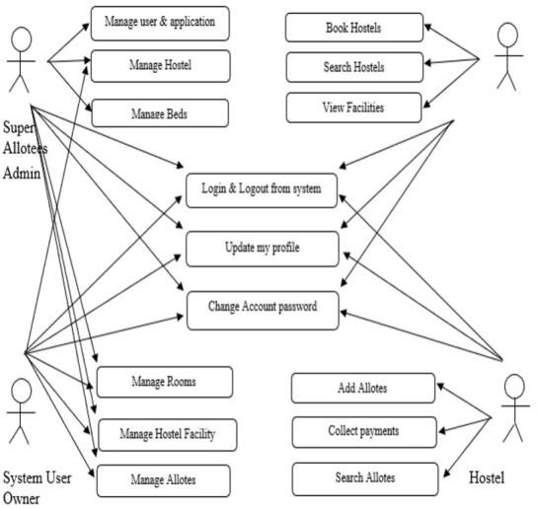

# Fig 6.2: System Architecture

Login to administrator module:

user is allowed to access the information to the website once he/she verifies themselves by providing user account and password.

* + - Profile: User can view and update their profile to make any changes. They can also change their password which requires old password.
    - Rooms: This page has many functionalities. Here user can add rooms, allot rooms to the students, view room allotment and change or remove the rooms.
    - Students: This page allow students. User can add students, update their details, add mess card for the students. Also, they can track movement of the student using RFID device

# Warden Module :

This module will contain the following functionalities:

* Login to Warden module: Only authorized user is allowed to access the information to the website once he/she verifies themselves by providing user account and password.
* Profile: User can view and update their profile to make any changes. They can also change their password which requires old password.
* Rooms: This page has many functionalities. Here user can add rooms, allot rooms to the students, view room allotment and change or remove

the rooms.

* + Students: This page allows user to manage students. User can add students, update their details, add mess card for the students. Also, they can track movement of the student using RFID device.
  + Mess Schedule: In this page user can update daily mess routine which will be updated in the student profile.

# Student Module :

This module will contain the following functionalities:

* + - * Login to Student Profile: Only authorized students are allowed to access the information to the website once he/she verifies themselves by providing user account and password.
      * View Profile: Students can only view their profile and are not allowed to make any changes. If any changes they want to make, they must approach to administrator or warden.
      * Change Password: Students can change or update their password by entering old and new password.
      * Complaint Registration: Students can make register complaints regarding various hostel facilities like furniture, electrical, plumbing, others. Once confirmed student will get a mail notification from warden or administrator.
      * Complaint Log: In this page student can view their logs regarding complaint status.
* Movement Log: This page provides student details with number of times they went outside and came inside the hostel with time and date.
* View Mess Schedule: Student can view daily mess schedule through this page.

# Use Case Diagrams:

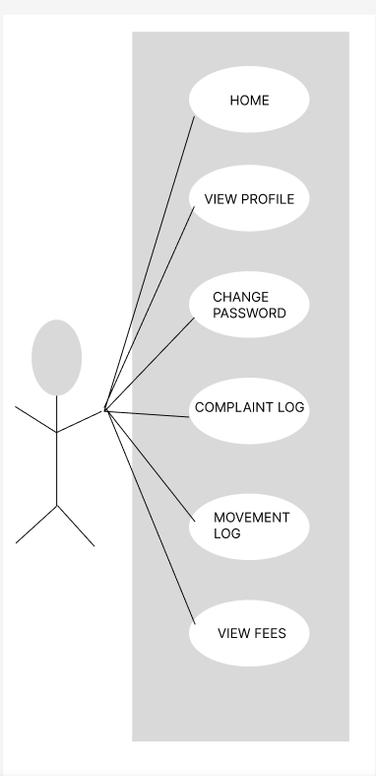

**Fig 11 (a): Student Use Case Diagram**

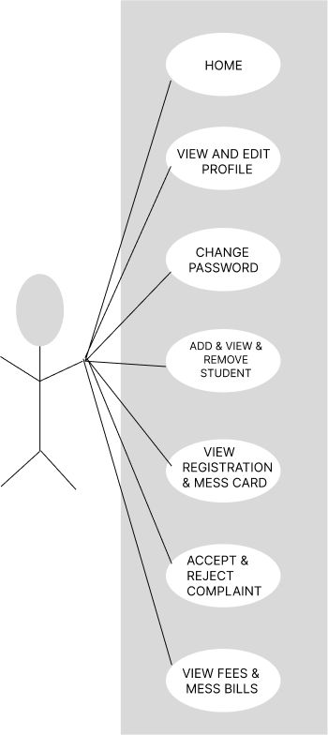

# Fig 11 (b): Warden use case diagram

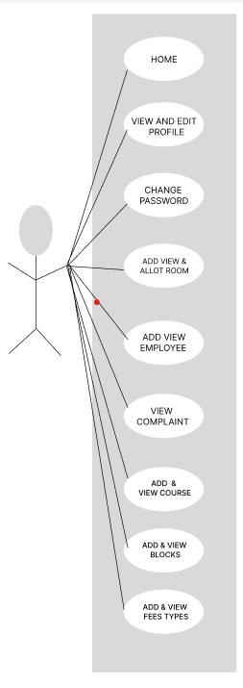

**Fig 11 (c): Admin Use Case Diagram**

# 12.Conclusion

In short about the proposed framework, the project created utilizing HTML, PHP, JavaScript and is in light of the prerequisite detail of the user and the research of the current framework, with adaptability for future improvement. The functionality of the present programming requires a proper approach towards programming advancement. This Hostel administration website is intended for individuals who need to handle different activities in the hostel. As from last few years numbers of colleges/universities are increasing and so is students number which require an automated system which can reduce human effort and make administration easy and in more technological way.

# References:

1. Bikash Choudhary, Deepak Kumar, Deepika Priyadarshini Khatua, Ajit Kumar Patro, “Online Hostel Management System”
2. O. Shoewu; S.A. Braimah; and O. Duduyemi, “Design and Implementation of Hostel Management System (HOMASY): LASU as Case Study”
3. Christoph Jechlitschek, “A Survey Paper on Radio Frequency Identification (RFID)” Iqra Basharat, Farooque Azam, “Database Security and Encryption: A Survey Study”, International Journal of Computer Applications (0975 – 888) Volume 47– No.12, June 2012.
4. lke-Morris. Basics of Web Design: HTML5 & CSS3, 2nd Edition, Addison-Wesley, 2013.
5. Jatinder Manhas,” A Study of factors Effecting websites page loading speed for efficient web performance”, IJCSE ,Vol 1

,Issue 3,Nov 2013.

1. Chandra M, Ramani A.V,”A Study on website quality evaluation based on sitemap”, IJCSE, Vol 2,Issue 2,Feb 2014.
2. Roy Want, “An Introduction to RFID Technology”, 1536-1268/06, 2006 IEEE.