**EXPERIMENTAL INVESTIGATON ON EMBOSSED MACRO FIBRE CONCRETE**

**MD FAIZAN ALI1, THANUJA H P2, HEMALATHA K3**

1PG student, Civil engineering, BIT, Bengaluru, Karnataka, India

2 Assistant Professor, Civil engineering, BIT, Bengaluru, Karnataka, India

3 Assistant Professor, Civil engineering, BIT, Bengaluru, Karnataka, India

**ABSTRACT**

*The aim of this research is to look at how adding EMBOSSED Poly-propylene macro-fibers to concrete affects its mechanical characteristics. Highly engineered poly-propylene macro-fiber will improve a number of the mechanical and concrete's physical characteristics. Among the uses for this substance are mining tunnels, reinforced concrete with polypropylene macro-fiber, precast concrete structures, and commercial and industrial flooring. High strength (M30 grade) concrete with a 0.4 water-to-cement ratio was used in this work. The polypropylene macro-fiber was intended to be utilized in conjunction with aggregates, not as a substitute for them. An extensive array of strength characteristics were investigated and recorded, including compressive, flexural, and tensile strengths.*

**Keywords:** Embossed macro fibre, water to cement ratio, grade of concrete

1. **INTRODUCTION**

Globally, concrete is becoming more and more popular as a member of the most significant building materials. It is utilized in numerous public infrastructure projects and is inexpensive and readily available for use. Conversely, brittleness and resistance to breaking and spreading are the drawbacks of concrete. Fibers are incorporated into concrete in various ways to improve its power and lessen its tendency to fracture because it is naturally poisonous and has very low strength. Improvements to concrete constructions, both in their innovative and lasting forms, have been sought after over time. While the fundamentals stay the same to accomplish the required qualities—such as improved performance.

## 1.1 Advantages and Disadvantages:

They are tightly spaced and shorter than continuous wire bars that serve as reinforcement. These fibers are utilized in several specified cross sections, whereas reinforcing wires or bars are only positioned when necessary. Concrete that has less than one of the following added in small 18 dosages: polypropylene, high density polyethylene, aramid, 6 colyviney alcohol, acrylic, nylon, and poly ester. (Depending on their diameter and format, these fibers' dimensions may change.

Concrete's low strain of fracture, limited tensile strength, and formwork requirement are its drawbacks. The main disadvantage is that when concrete cures, tiny fractures start to appear. The material's low tensile strength is formed by the quick spread of these micro cracks when force is applied.

## 1.2 Applications:

The main area for embossed macro fibre (EMF) applications is as follows:

1. Runway, Airport Parking and Road
2. Tunnel construction and slope stability
3. Explosive-resistant structures
4. Small Shell, Walls, Pipes, and Pits
5. Dams and Hydraulic structure
6. Various applications include machine tool and frames, lighting poles, water and oil tanks and concrete repairs.
7. **LITERATURE REVIEW**

**Perumal et al.** investigated the possibility of a composite construction with a power boost of 25.39% in compressive strength when using mixes containing 1.5% fiber volume. The mix containing 1.5% to the fiber volume showed the largest improvement in split strength, outperforming the reference concrete by more than 5.76%.Analogously, the combination containing 1.5% of the fiber volume had a strong tensile strength, surpassing the reference concrete by 72.5%.

**Chaitanya Kumar:** The study used concrete that was graded M20 and added glass fiber at 0.5%, 1%, 2%, and 3%. Also, the specimens are cast to evaluating the tensile and compressive strengths of the concrete. In this experiment, adding 2% of fiber to concrete results in it becoming stronger; adding 3% of fiber causes the concrete's strength to decrease. After 28 days of ponding, the power of concrete increases to 26.98 Mpa in terms of compressive strength, 2.94 Mpa for flexural strength, and 3.57 Mpa for tensile strength when 2% fiber is added. The experiment's creator stated that the glass fiber lowers the workability of the concrete because it increases its workability.

**Benturet al.** using a floor slab works well when a modest proportion of synthetic fibers are used. Less than 0.3% of the volume of the concrete mixture is considered low fiber content. t. The study's experimental findings on regarding the result of concrete resistance, air content compressive and flexible behavior, low percentages of nylon and polypropylene fibers on decay, and the length of the distorted slump cone are presented in this paper. The fiber percent were employed as 0.15%, 0.22%, and 0.30% by volume of the mixture. Each fiber had a length of 25 mm.

**Zoran Grdic et al**. The writers arrived at the subsequent deduction**.** For all W/C values between 0.5 and 0.7 with regard to the reference concrete, the adding of fibers results in an increase in tensile strength. When concrete's water/cement ratio rises from 0.5 to 0.7, its abrasion resistance decreases. The concrete's resilience to abrasives can be inferred from its extreme compressive and tensile strength (at bending), as these limits have a higher abrasive resistance. Regarding the abrasive-erosive resistance of concrete, the polypropylene fibrillated fibers (PFF) performed better than the monofilament fibers.

**K. Nagamani et al**.'s study on the impact of steel strands on high strength steel fiber reinforced concrete's splitting tensile strength. The steel strands that was crimped had an aspect ratio of 80 and measured 0.45 mm in diameter and 36 mm in length. Tests of employed tensile strength were used on cylindrical specimens measuring 150 mm by 300 mm. When compared to an unreinforced matrix, the employed tensile strength increases by 55.9% and putting steel fibers at a volume percentage of 2.50%. HSFRC showed a moderate increase in compressive strength. A statistical model was created and found to provide a fair fit to the experimental data.

**Anshida Haneefa** and associates. This study assessed the effects of fiber loading, content, and hybridization on the characteristics of the composites, including tensile strength, Young's modulus, elongation at break, and flexural properties. With the exception of elongation at break, all mechanical qualities are taken to height of the volume percentage of glass fiber relative to the total fiber content. With an increase in fiber loading (vol %), composites' tensile and flexural characteristics are seen to have increased. Conversely, the best fiber-matrix characteristics are enhanced by poor interfacial adhesion and low resistance to banana fiber alteration. Using the hybrid mixture's additive rule, the hybrid effect was computed.

1. **OBJECTIVES AND METHODOLOGY**
2. The goal is to comprehend the qualities of concrete reinforced with embossed macro fibers in terms of three different strengths: flexural, split-tensile, and compressive.
3. Concreting of M-30 grade will be done, and 55mm embossed macro fibers with a variable in fiber length of 0% to 0.3% of the entire weight of concrete will be working.

## 3.1 Methodology:

Step 1: Literature survey was made by collecting earlier studies that bear similarities to the present study.

Step 2: objectives of the study was documented.

Step 3: Design mix was done with appropriate size.

Step 4: Casting of cube, cylinder. And prism specimens.

Step 5: demoulding of the specimens.

Step 6: Curing of the specimens for 28 days

Step 7: Tests on hardened concrete (compressive strength Test, split tensile test and flexural test)

Step 8: Results

Step 9: Conclusions.

# **4. EXPERIMENTAL WORK**

The experimentation work has been done on cubes, cylinder and prisms. All these specimens were added with embossed macro fiber with different percentages, i.e., 0.1%, 0.2% and 0.3% and were put through tests for flexural strength, split tensile strength, and compressive strength.

## 4.1 Materials used:

#### 4.1.1 Cement

Birla cement 53 grade OPC was the cement utilized in the investigations.

#### 4.1.2 Fine aggregate

In this experimental investigation, zone-II produced sand is employed as fine aggregate for concrete.

#### 4.1.3 Coarse aggregates

#### The coarse aggregate utilized was a 70:30 ratio of two crushed stones, 20 mm and 12 mm in size, that were readily. Accessible nearby throughout the concrete, coarse aggregate with a maximum extend of 20 mm and a minimum size of 12 mm is employed.

#### 4.1.4 Water

There were no dangerously high concentrations of oils, acids, alkalis, salts, sugar, or other organic elements that could damage concrete in the purified water used for adding and curing. According to IS 456-2000, potable water is typically regarded as enough for concrete mixing and curing.

#### 4.1.5 Admixture

The chemical admixture used is Fosroc conplast SP 430 DIS, it enhances the quality and properties of concrete in both plastic and hardened stages.

#### 4.1.6 Embossed macro fiber

Embossed Macro Fiber for Fiber Reinforced Concrete that meets standard Fiber Reinforced Concrete requirements. The Embossed Macro Fiber is to enhance the post-cracking residual strength of concrete by adding high levels of energy absorption, toughness, and durability. Additionally aids in preventing concrete shrinkage cracks from forming.

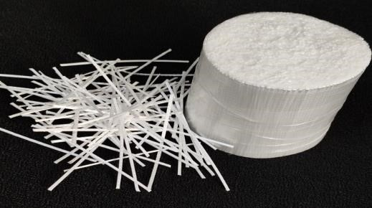

Fig 1 embossed macro fibre

## 4.2 Mix design:

In this experiment, M30 grade concrete was used, and the mix was created according to codal requirement IS 10262 (2009) the quantity of macro-fibre added to the concrete was 0.1to0.3% volume of concrete. The quantity of materials used per m3 is listed in Table.

Slump = 100 mm

Water/ cement ratio = 0.40

Chemical admixture = 7.9 Kg/m3

Water = 158 Kg/m3

Cement = 395 Kg/m3

Coarse aggregate = 1223.78 Kg/m3 Fine aggregate = 660.54 Kg/m3

### **4.3 Compressive strength test:**

The strength under compression was based on a 15 x 15 x 15 cm cube specimen. IS 516(1959) was followed in regarding both procedure and methodology. The specimen sample was then positioned so that the load was applied perpendicular to the casting's side. In the compression testing machine, the force was applied at a steady rate of 1000 kg/mm. The specimen's failure load was recorded.

𝐶𝑜𝑚𝑝𝑟𝑒𝑠𝑠𝑖𝑣𝑒𝑆𝑡𝑟𝑒𝑛𝑔𝑡h = Load in N / Area in 2

## 4.4 Split tensile strength test:

The specimen used for the tensile test was shaped like a cylinder and measured 15 cm in diameter and 30 cm in height. IS 5816(1999) was followed in regarding of technique and methodologies. In the compression testing machine, the stress was applied at a steady rate of 250 kg/mm. The specimen's failure load was recorded, and it will automatically be released. The formula below accustomed to calculate the concrete's tensile strength.

𝑇𝑒𝑛𝑠𝑖𝑙𝑒𝑆𝑡𝑟𝑒𝑛𝑔𝑡h = 2/ 𝜋𝐿D

Where,

P = maximum applied load indicated by the testing machine (N)

D, L = diameter and length of the specimen respectively (mm)

## 4.5 Flexural strength test:

The beam specimen of size 10x10x50cm was used for testing flexural strength of the concrete. Three point test was utilized to assess the concrete's flexural strength. A Flexural testing machine was used to conduct a three-point test in compliance with IS 516 (1959). Flexural testing machine is given in Figure flexural strength formula is given below.

𝐹𝑙𝑒𝑥𝑢𝑟𝑎𝑙𝑆𝑡𝑟𝑒𝑛𝑔𝑡h = 𝑃𝑙/ 𝑏𝑑2

Where,

P = ultimate load applied (N)

L, b, d = length, width, depth of the specimen respectively (cm)

# **5. RESULTS:**

The investigation's goal was to evaluate the flexural and compressive strengths of concrete at various fibre content replacement levels.

To evaluate the flexural and compressive strengths of concrete at various fibre content replacement levels.

5.1 Compression test outcome**:**

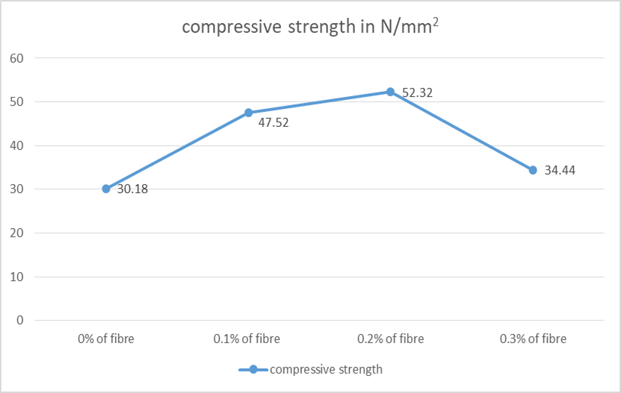

Fig 2: Compressive strength of EMF concrete

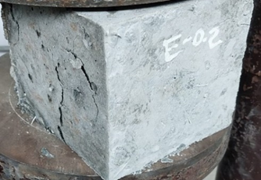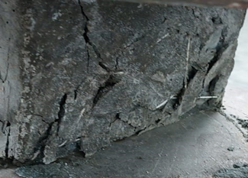

Fig 3: cubes after applications of loads

5.2 Split tensile test outcome:

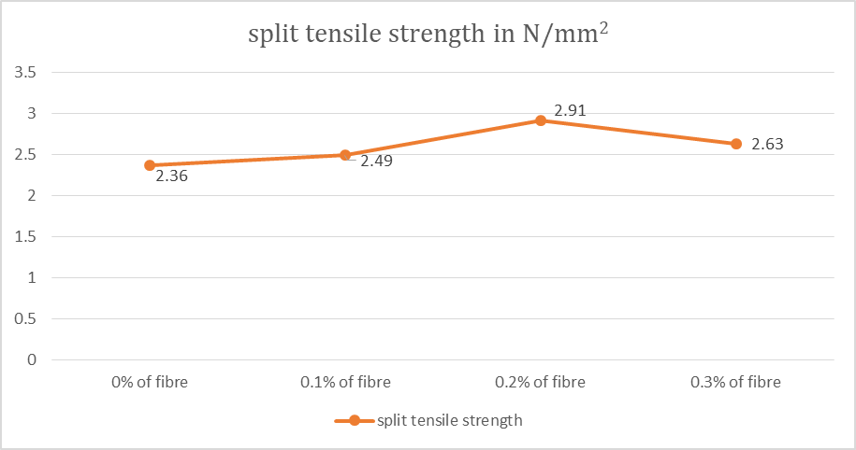

Fig 4: split tensile strength of EMF concrete

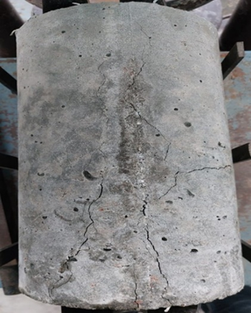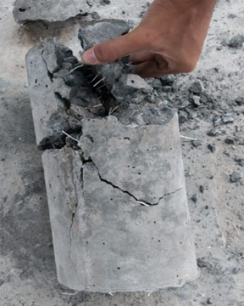

Fig5: cylinders after applications of loads

5.3 Flexural test outcome:

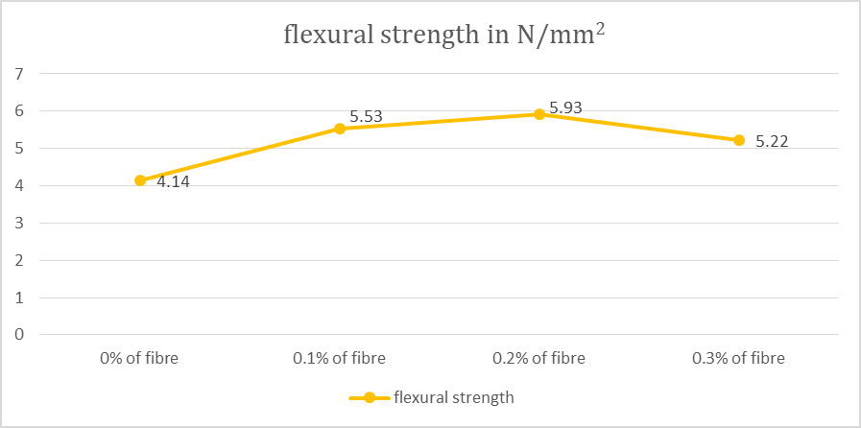

Fig 6: flexural strength of EMF concrete

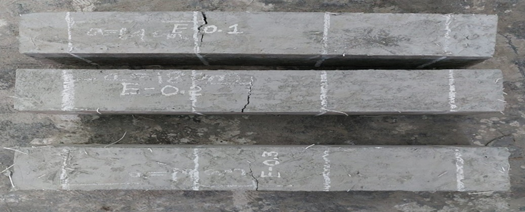

Fig 7: prisms after application of loads

**6. CONCLUSION:**

1. The compressive strength of concrete is increased with the increase in the percentage of fibre till 0.2% then the strength decreased, the percentage increase is 42%.
2. The compressive strength of concrete is increased with the increase in the percentage of fibre till 0.2% then the strength decreased, the percentage increase is 42%.
3. The compressive strength of concrete is increased with the increase in the percentage of fibre till 0.2% then the strength decreased, the percentage increase is 42%.
4. The optimum percentage of fibre is 0.2%.

**7. REFERENCES:**

1. Dr. P. Perumal and Dr. J. Maheswaran, “Behavioural study on the effect of AR-Glass Fibre reinforced concrete”, NBW & CWOctober2006, (pp174-180).
2. D Chaitanya k. and Tekwari, B. (2012), “Glass fibre Reinforced concrete”, Yahoo Group – Civil Engineering Portal, pp.1-7.
3. Anshida Haneefa et al., M. Effect of Fiber Content on Compressive Strength of Wheat Straw Reinforced Concrete for Pavement Applications. IOP Conf. Ser.: Mater. Sci. Eng. 2018.
4. Zoran J. Gradic (2012) “Abrasion resistance of concrete micro-reinforced with polypropylene fibers”.
5. Code books: IS: 10262-2009, IS: 383-1970, IS: 456-2000.