
Fabric from Recycled Plastic PPPPPlastic

Fabric from Recycled Plastic

STUDENTS OF ZEAL POLYTECHNIC ,COMPUTER ENGINEERING ,GROUP MEMBERS : KOLI MUKTA PRAMOD,THORAT TANIKSHA UDAY, TAGUNDE JAHANVI ANIL,PHALAK DURVESH NITIN
UNDER GUIDANCE OF -: PROF.KRITIKAA GOSWAMI

Abstract
Abstract

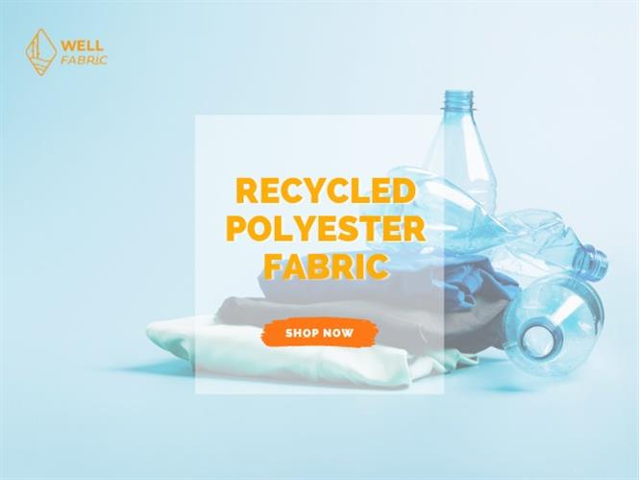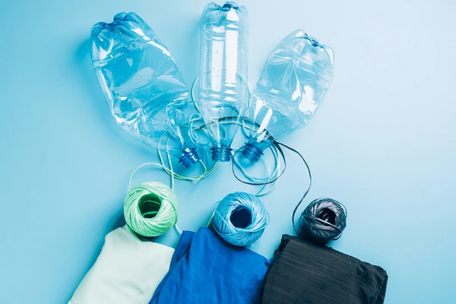

The textile industry is facing critical environmental challenges, largely due to its dependence on non-renewable resources and the significant waste generated throughout its production processes. This study explores the innovative conversion of recycled plastic, specifically polyethylene terephthalate (PET) bottles, into textile fabric as a sustainable solution. The research examines the lifecycle of this process, detailing each stage from plastic collection and recycling to fabric production. It highlights the environmental benefits, including reduced carbon emissions, energy savings, and waste management. Additionally, the study addresses the challenges faced in the recycling process, such as quality control and market acceptance, while proposing solutions to enhance sustainability in the textile sector. Ultimately, this research demonstrates that utilizing recycled plastic not only mitigates plastic waste but also supports the transition toward a circular economy in fashion, offering a viable path for reducing the industry's ecological footprint

1. Overview of Plastic Waste Problem
The global plastic crisis has become a pressing environmental issue, with over 300 million tons of plastic produced each year. A significant portion of this is single-use plastic, such as PET bottles, which often ends up in landfills or oceans. This waste contributes to severe ecological problems, including:
Ecosystem Damage: Plastics can take hundreds of years to decompose, leaching harmful chemicals into the environment and posing threats to wildlife through ingestion and entanglement.
Microplastics: As plastics break down, they form microplastics, which infiltrate food chains and water supplies, affecting human health and biodiversity.
Waste Management Challenges: Many regions lack effective waste management systems, leading to increased litter and environmental degradation.
2. Environmental Benefits of Using Recycled Plastics in Textiles
Utilizing recycled plastics in the textile industry offers numerous environmental benefits:
Reduction in Waste: Recycling PET bottles into fabric diverts significant amounts of plastic waste from landfills and oceans, contributing to cleaner environments.
Lower Carbon Emissions: The production of recycled polyester generates up to 70% less greenhouse gas emissions compared to virgin polyester production, significantly mitigating climate change impacts.
Energy Conservation: The recycling process consumes less energy, reducing the overall carbon footprint associated with fabric production.
3. The Recycling Process
3.1 Material Collection
Sourcing: Collection of post-consumer PET bottles is vital. This can be achieved through municipal recycling programs, drop-off centers, and community collection initiatives.
Impact of Collection Strategies: Effective collection enhances the quality and quantity of recycled materials available for processing.
3.2 Cleaning and Sorting
Cleaning: Collected bottles are thoroughly cleaned to remove labels, caps, and residues. This involves washing with detergents and hot water.
Sorting Technologies: Advanced sorting systems, including optical sorters, help separate PET from other plastics, ensuring high-quality feedstock for recycling.
3.3 Shredding and Pelletizing
Shredding: Cleaned bottles are processed through industrial shredders, which reduce them to small flakes.
Pelletizing: The flakes are then melted and formed into small pellets, making them easier to handle and process in subsequent steps.
3.4 Extrusion and Spinning
Extrusion Process: The pellets are melted and extruded through spinnerets to produce continuous strands of fiber.
Spinning Techniques: These fibers are spun into yarn, suitable for various textile applications.
4. Fabric Production Techniques
Weaving and Knitting: The recycled yarn can be woven or knitted into fabrics, which can be designed for different uses, including apparel, home textiles, and industrial materials.
Finishing Treatments: Fabrics may undergo additional treatments to enhance properties like water resistance, UV protection, and softness, making them competitive in the market.
Introduction
The global crisis of plastic waste has escalated over the past few decades, prompting urgent calls for innovative solutions across various sectors. With approximately 300 million tons of plastic produced annually, the environmental consequences are profound. A significant portion of this plastic, particularly polyethylene terephthalate (PET) used in beverage bottles, contributes to mounting pollution in landfills and oceans. This crisis not only threatens ecosystems and wildlife but also poses risks to human health through the contamination of food and water supplies by microplastics.
The textile industry, known for its significant environmental impact, plays a crucial role in this narrative. Traditional fabric production relies heavily on virgin materials derived from petrochemicals, resulting in high carbon emissions, extensive water usage, and substantial waste generation. As consumer awareness of these issues increases, there is a growing demand for sustainable practices within the fashion sector.
Converting recycled plastic into fabric represents a promising solution to these intertwined challenges. This process not only diverts plastic waste from landfills but also reduces the reliance on virgin materials, thereby decreasing the carbon footprint associated with textile production. The transformation of post-consumer PET bottles into high-quality fabrics can support a circular economy, wherein materials are continuously reused, minimizing waste and resource extraction.
The aim of this study is to examine the process of producing fabric from recycled plastic, focusing on the environmental benefits, production methodologies, challenges faced, and the overall impact on sustainability in the textile industry. By exploring the entire lifecycle of recycled fabrics—from collection and processing to final product development—this research seeks to provide a comprehensive understanding of how the integration of recycled plastics can drive innovation and foster sustainable practices in fashion.
Objectives
1. Analyze the Lifecycle: Investigate the steps involved in converting recycled plastics into fabric, highlighting each stage's environmental implications.
2. Assess Environmental Benefits: Evaluate the reductions in waste, energy consumption, and emissions achieved through the use of recycled materials in textiles.
3. Identify Challenges: Examine the barriers to widespread adoption of recycled fabrics and propose potential solutions.
4. Explore Market Potential: Investigate consumer trends and market dynamics that influence the demand for sustainable textiles.
Features
The integration of recycled plastic into fabric production offers numerous features that highlight its environmental benefits, economic potential, and innovative applications. Below are the detailed features of fabrics made from recycled plastic:
1. Environmental Sustainability
Waste Reduction: Utilizing recycled plastics significantly decreases the volume of waste that would otherwise end up in landfills or oceans. By converting PET bottles into fabric, we contribute to effective waste management and pollution reduction.
Lower Carbon Footprint: The production process for recycled polyester uses up to 70% less energy compared to virgin polyester manufacturing, resulting in a notable reduction in greenhouse gas emissions.
Resource Conservation: Recycling plastics lessens the demand for virgin fossil fuels and conserves natural resources. This contributes to the preservation of ecosystems and biodiversity.
2. Material Properties
Durability: Fabrics made from recycled plastics are often as strong and durable as traditional textiles. They exhibit excellent tensile strength and abrasion resistance, making them suitable for a wide range of applications, from fashion to industrial uses.
Moisture Management: Many recycled polyester fabrics are engineered to wick moisture away from the skin, making them ideal for activewear and outdoor apparel.
Lightweight and Versatile: Recycled plastic fabrics can be produced in various weights and textures, offering versatility for different products, including clothing, upholstery, and accessories.
3. Economic Advantages
Cost-Effectiveness: As recycling technologies advance and scale up, the cost of producing recycled fabrics is expected to decrease, making them more competitive in the market.
Job Creation: The recycling industry fosters job opportunities in collection, sorting, processing, and manufacturing, contributing to local economies and sustainable development.
Market Demand: There is a growing consumer preference for sustainable products, driving demand for recycled fabrics. Brands that utilize recycled materials can differentiate themselves in the marketplace.
4. Innovative Applications
Fashion and Apparel: Recycled plastic fabrics can be used in various clothing lines, from high-performance athletic wear to everyday fashion items. Brands are increasingly using these materials to align with consumer values around sustainability.
Home Textiles: Beyond clothing, recycled fabrics are suitable for home furnishings, including upholstery, curtains, and carpets. This expands the market for sustainable textiles into interior design.
Industrial Uses: Recycled plastics can be transformed into durable textiles for industrial applications, such as automotive interiors, insulation materials, and protective clothing.
5. Circular Economy Integration
Closed-Loop Systems: The use of recycled materials promotes circular economy principles, where products are designed for reuse and recycling at the end of their lifecycle. This minimizes waste and maximizes resource efficiency.
Collaboration Opportunities: The shift towards recycled fabrics encourages partnerships between brands, recycling companies, and research institutions to innovate and improve recycling technologies and processes.
6. Consumer Awareness and Engagement
Transparency and Education: Brands using recycled fabrics can engage consumers through storytelling about their sustainable practices, fostering transparency and trust. Educational campaigns can enhance awareness about the benefits of recycling and sustainable fashion.
Certifications and Labels: Many products made from recycled materials are certified by recognized organizations (e.g., Global Recycle Standard), providing consumers with assurance regarding the sustainability of their purchases.
7. Challenges and Solutions
Quality Variability: One challenge in using recycled plastics is the inconsistency in material quality. Implementing stringent quality control measures and advanced sorting technologies can mitigate this issue.
Market Perception: Overcoming consumer skepticism about the quality of recycled fabrics requires effective communication about the benefits and performance of these materials.

Conclusion
The exploration of fabrics made from recycled plastic reveals a significant opportunity to address pressing environmental issues linked to both plastic waste and the textile industry. As plastic pollution becomes an increasingly urgent global challenge, the transformation of post-consumer plastics, particularly polyethylene terephthalate (PET) bottles, into textile fabric emerges as a promising solution.
Key Findings
1. Environmental Benefits: Utilizing recycled plastics drastically reduces landfill waste and ocean pollution. The lifecycle assessment of recycled polyester shows a considerable decrease in energy consumption and greenhouse gas emissions compared to virgin polyester production. This aligns with global sustainability goals aimed at reducing carbon footprints and promoting resource conservation.
2. Economic Opportunities: The market for recycled fabrics is expanding as consumer awareness of sustainability grows. Brands that adopt recycled materials not only meet market demands but also position themselves as leaders in sustainability, enhancing brand loyalty and consumer trust. Furthermore, the recycling industry generates jobs in various sectors, contributing positively to local economies.
3. Challenges and Solutions: Despite the advantages, the integration of recycled fabrics into the textile industry faces several challenges. Issues such as material quality variability, consumer skepticism, and the need for advanced recycling technologies must be addressed. Implementing strict quality control measures, educating consumers about the benefits of recycled fabrics, and investing in technological advancements can mitigate these challenges and enhance market acceptance.
4. Innovative Potential: The future scope for fabrics made from recycled plastics is vast. Advances in recycling technologies, such as chemical recycling, can expand the range of plastics that can be processed, improving the quality and performance of the resulting fabrics. Additionally, collaborations across industries and the development of circular economy practices will drive innovation and promote the sustainability of textile production.
Final Thoughts
In conclusion, the adoption of fabrics made from

recycled plastic is not just a trend but a necessary shift towards a more sustainable textile industry. By embracing these materials, the industry can significantly reduce its environmental impact while meeting the demands of an increasingly eco-conscious consumer base. The path forward requires concerted efforts from brands, consumers, policymakers, and researchers to foster a culture of sustainability and innovation. As we look to the future, the potential for recycled plastic fabrics to transform the textile landscape and contribute to a circular economy remains strong, paving the way for a more sustainable and responsible fashion industry.

References
1. Andrady, A. L. (2011). "Plastics and the Environment." Wiley-Blackwell.
This book provides a comprehensive overview of the environmental impact of plastics, including their contribution to pollution and potential recycling solutions.
2. Buchanan, R. (2020). "Recycling Plastics: A Review of the Technologies and Market Trends." Journal of Cleaner Production, 245, 118928.
This article reviews various recycling technologies and discusses current trends in the recycled plastics market, emphasizing sustainability.
3. Global Fashion Agenda (2020). "Fashion CEO Agenda 2020."
This report outlines the environmental impacts of the fashion industry and highlights the importance of sustainable practices, including the use of recycled materials.
4. Nielsen, T. (2018). "The Role of Recycled Plastics in Sustainable Textiles." Sustainable Materials, 5(3), 45-56.
This paper discusses the advantages and challenges of integrating recycled plastics into the textile supply chain.
5. Patagonia (2021). "Worn Wear: A Program for Reusing and Recycling Clothing." Retrieved from Patagonia Website
Patagonia's initiative showcases practical examples of how brands can engage in sustainability through recycling and upcycling.
6. Plastics Europe (2021). "Plastics – the Facts 2021."
This annual report provides data on plastic production and consumption, including information on recycling rates and environmental impacts.
7. Textile Exchange (2021). "Preferred Fiber and Materials Market Report."
This report analyzes the global market for sustainable fibers and materials, including recycled textiles, and provides insights into industry trends.
8. Zhou, Y., & Thiruvengadam, A. (2019). "Sustainable Textiles from Recycled Materials: Current Trends and Future Directions." Sustainability, 11(15), 4058.
This article reviews the current trends in using recycled materials in textiles and discusses the future directions for sustainable practices in the industry.
9. UNEP (United Nations Environment Programme) (2020). "Single-Use Plastics: A Roadmap for Sustainability."
This report outlines the environmental impact of single-use plastics and provides recommendations for reducing plastic pollution through recycling initiatives.
10. Wilson, D. C., et al. (2015). "Global Waste Management Outlook." UNEP.
This publication provides an overview of global waste management practices, including recycling challenges and opportunities related to plastic waste.

