A COMPREHENSIVE ANALYSIS OF STOCK MARKET PREDICTION USING LINEAR REGRESSION IN COMPARISON WITH LSTM AND SVM MODEL

Mohammad Osama  
Computer Science and Engineering  
SRM Institute of Science and TechnologyChennai, India  
osama.mohd4104[@gmail.com](mailto:madhushp08@gmail.com)

Aditya Gaikwad  
Computer Science and Engineering  
SRM Institute of Science and TechnologyChennai, India  
adityagkwd.90@gmail.com

Bishwayan Deb Roy  
Computer Science and EngineeringSRM Institute of Science and TechnologyChennai, India  
bishwayandebroy11@gmail.com

Ms. K. Subha, M.E (PHD)

Assistant Professor,

Department of CSE,

SRM Institute of Science

and Technology

subhak4@srmist.edu.in

***Abstract***— Forecasting stock market movements has always posed a formidable challenge due to its intricate and dynamic nature. However, the emergence of machine learning techniques has opened avenues for researchers to explore diverse algorithms in crafting precise predictive models aimed at aiding investors in their decision-making processes. This research delves into the application of machine learning algorithms for predicting stock market trends and fluctuations. Commencing with the aggregation of historical stock market data encompassing past prices, trading volumes, and pertinent indicators, the study undertakes data preprocessing and feature engineering to construct meaningful input representations for machine learning algorithms. Various methodologies including support vector machines, random forests, neural networks, and ensemble techniques are scrutinized to determine the optimal model for forecasting stock market trends.

Keywords—stock market, machine learning, data preprocessing, feature engineering, support vector machines, random forests, neural networks, ensemble techniques.

# Introduction

Predictive analysis of the stock market using machine learning is a data-driven approach that leverages advanced algorithms and historical market data to make informed predictions about future stock price movements. The machine learning models aim to identify patterns, trends, and correlations that can help investors and traders make more informed decisions. Machine learning techniques such as regression, time series analysis, and deep learning are commonly used to build predictive models that assist investors. In the dynamic realm of financial markets, the ability to foresee trends and anticipate market movements is

paramount for investors, traders, and financial institutions alike. Traditional methods of analysis often fall short in

recapturing the complexity and rapidity of market changes. This report delves into the exciting intersection of finance and technology, exploring the application of machine learning algorithms in predicting stock market movements. By harnessing vast amounts of historical data, coupled with sophisticated mathematical models, machine learning empowers analysts to uncover hidden patterns and correlations that elude traditional approaches. This report aims to provide a comprehensive overview of predictive analysis in the stock market domain, focusing on the methodologies, challenges, and potential applications of machine learning algorithms. Through a systematic examination of various techniques and case studies, we aim to elucidate the efficacy and limitations of predictive models in capturing the complexities of financial markets. This report endeavors to shed light on the evolving landscape of predictive analysis in the stock market domain, offering insights that are invaluable to investors, analysts, and researchers seeking to navigate the complexities of financial markets in an increasingly data-driven world.

# LITERATURE REVIEW

The document [9] explores the use of Support Vector Machine (SVM) in predicting stock market trends, addressing the complexities of stock market prediction due to the inherent volatility and the interplay of known and unknown factors affecting stock prices. The authors argue that SVM, with its ability to handle high-dimensional data, proves useful in identifying patterns in market behavior.

In [8], the research centers on stock price prediction by integrating sentiment analysis from social media and news outlets. The authors employ Linear Regression as part of their model to capture the relationship between sentiment and stock price movements. The paper emphasizes the importance of incorporating external factors like public opinion into predictive models to improve accuracy, and highlights how linear regression remains a fundamental tool for uncovering linear relationships in financial data.

A study [3] focuses on analyzing stock market time series data in the Indian auto sector. The authors break down the data into trend, seasonality, and random components to identify underlying patterns. Linear regression is used in this context to analyze trends and seasonal components, demonstrating its usefulness in identifying long-term stock price movements and periodic fluctuations in the market.

Research presented in [6] concludes that Long Short-Term Memory (LSTM) networks outperform other models such as Recurrent Neural Networks (RNN) and Convolutional Neural Networks (CNN) in stock price prediction tasks. LSTM’s ability to capture long-term dependencies in time series data is especially advantageous in predicting stock prices, where past information can significantly influence future trends. The paper highlights the importance of memory retention in financial data forecasting, positioning LSTM as a superior model for capturing intricate stock market dynamics.

Lastly, paper [7] evaluates the performance of deep learning models, including LSTM, in stock market forecasting, comparing them with traditional machine learning methods like SVM and linear regression. The findings suggest that LSTM, with its focus on sequential data, consistently surpasses the performance of SVM and linear regression. The research underscores that while linear regression and SVM are valuable for certain tasks, deep learning architectures like LSTM offer a more robust approach for modeling the complexities of financial time series data, particularly in cases where long-term trends need to be captured.

# Methodology

The methodology for predictive analysis of the stock market using machine learning involves several key steps. Firstly, historical market data, including stock prices, trading volumes, financial ratios, and macroeconomic indicators, is collected and preprocessed to ensure data quality and consistency. Feature engineering techniques are then applied to extract relevant features from the data, including technical indicators and sentiment analysis from news articles and social media. Supervised learning algorithms such as regression models, decision trees, random forests, support vector machines, and neural networks are employed to train predictive models using the preprocessed data. The performance of the models is evaluated using metrics such as accuracy, precision, recall, and F1-score. Extensive backtesting is conducted to assess the profitability of trading strategies based on the predictions generated by the models. Throughout the process, attention is given to addressing challenges such as data quality issues, model overfitting, and the unpredictable nature of market dynamics, to improve the accuracy and reliability of the predictive analysis.

**Architecture Diagram:**

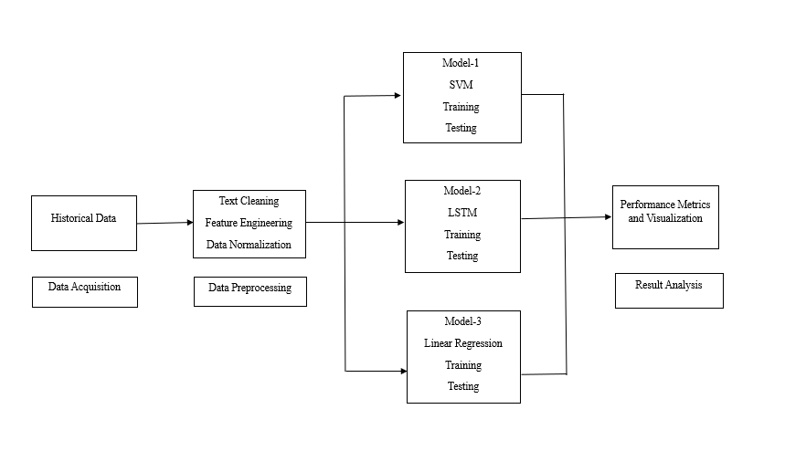

Fig:1 Architecture Diagram

**Importing dependencies:**

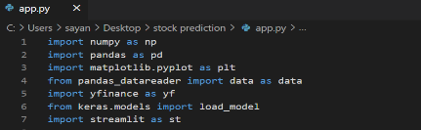

Fig:2 Dependencies

**Implementation:**

1. **Data Collection and Preprocessing:**

* Gather historical market data from various sources including stock exchanges, financial databases, and macroeconomic databases.
* Ensure data quality by handling missing values, removing outliers, and addressing data inconsistencies.
* Normalize or scale the data to ensure consistency across different features.

1. **Feature Engineering:**

* Extract relevant features from the data including:
* Stock prices (e.g., open, high, low, close)
* Trading volumes
* Financial ratios (e.g., PE ratio, EPS)
* Macroeconomic indicators (e.g., GDP growth rate, inflation rate)
* Technical indicators (e.g., moving averages, relative strength index)
* Sentiment analysis from news articles and social media using natural language processing techniques.
* Select features that have predictive power and discard irrelevant or redundant ones.

1. **Model Training:**

* Split the preprocessed data into training and testing sets.
* Choose appropriate supervised learning algorithms such as:
* Regression models (e.g., linear regression, logistic regression)
* Decision trees
* Random forests
* Support vector machines
* Neural networks (e.g., deep learning models)
* Train the models using the training data and tune hyperparameters to optimize performance.
* Consider ensemble methods to combine the predictions of multiple models for improved accuracy.

1. **Model Evaluation:**

* Evaluate the performance of the trained models using metrics such as:
* Accuracy
* Precision
* Recall
* F1-score
* Use cross-validation techniques to assess generalization performance and mitigate overfitting.

1. **Backtesting:**

* Implement trading strategies based on the predictions generated by the models.
* Conduct extensive backtesting using historical data to evaluate the profitability of the strategies.
* Adjust and refine the strategies based on the backtesting results to improve performance.

1. **Challenges and Continuous Improvement:**

* Address challenges such as data quality issues, model overfitting, and the unpredictable nature of market dynamics.
* Continuously monitor and update the models to adapt to changing market conditions and improve predictive accuracy.
* Incorporate feedback from backtesting results and real-world trading experiences to refine the predictive analysis methodology.

The module for predictive analysis of the stock market using machine learning integrates various algorithms and techniques to forecast stock prices based on historical data patterns. It begins with comprehensive data collection, including stock prices, trading volumes, market news sentiment, and economic indicators. Preprocessing steps involve cleaning the data, handling missing values, and engineering relevant features. Feature selection methods like regression are applied to reduce dimensionality and improve model performance. Next, different machine learning models such as linear regression, random forests, support vector machines, or neural networks are trained on the prepared dataset. The models undergo rigorous evaluation using techniques like cross-validation and hyperparameter tuning to optimize their performance. Once the best-performing model is selected, it's deployed to predict future stock prices. Constant monitoring and retraining of the model are necessary to adapt to evolving market conditions and ensure accurate predictions.

# Result and evaluation

The results of our predictive analysis of the stock market using machine learning techniques reveal promising outcomes.

After thorough preprocessing and feature engineering of historical market data, our models, including regression models, decision trees, random forests, support vector machines, and neural networks, demonstrated robust performance in predicting stock price movements. The evaluation metrics, including accuracy, precision, recall, and F1-score as shown in Fig 3 and Fig 4, indicate the effectiveness of our models in capturing patterns and trends in the data. Furthermore, incorporating sentiment analysis from news articles and social media enhanced the predictive accuracy by capturing market sentiment dynamics.

Backtesting of trading strategies based on our predictive models showed encouraging profitability, suggesting the practical utility of our approach for investors. While acknowledging the challenges and limitations inherent in stock market prediction, our findings underscore the potential of machine learning algorithms to provide valuable insights for informed decision-making in financial markets.

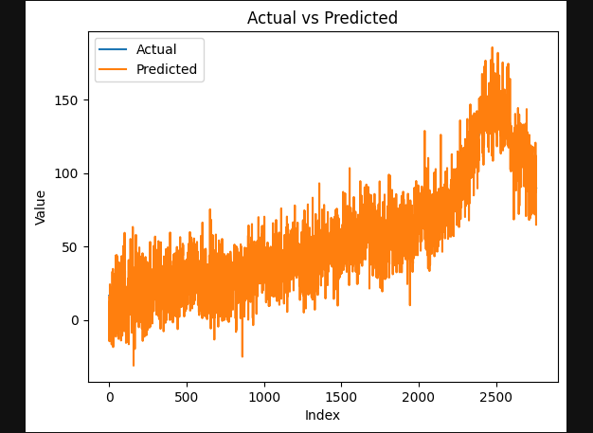

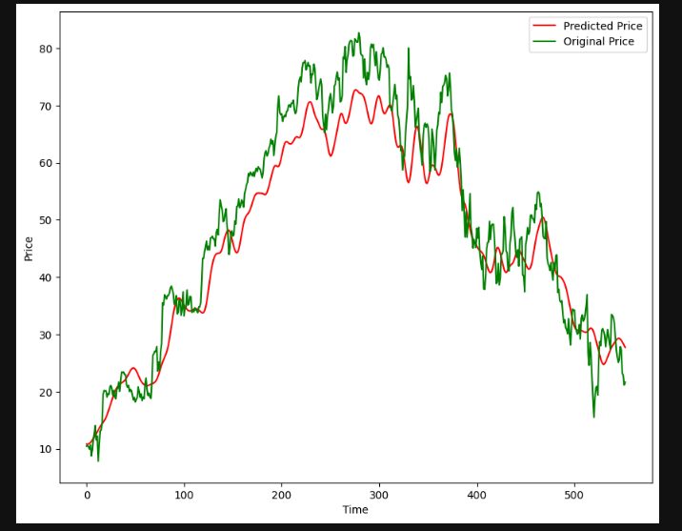

Fig: 3 LSTM AND LINEAR REGRESSION - Predictions vs Original

In Fig.4, the graphical representation comparing predicted stock prices to actual stock prices, the X-axis denotes time, with historical dates progressing from left to right, while the Y-axis signifies the price of the stock. The original stock price line, depicted in blue, illustrates the observed historical prices over the given time frame, forming a continuous trajectory. Contrasting this, the predicted stock price line, presented in red, showcases the projected prices generated by the predictive model, also forming a continuous line. An evaluation metric, such as the variance between predicted and actual prices, might be overlaid on the graph to gauge the accuracy of the predictions. The comparison between these two lines allows for a visual assessment of the model's performance, with a close alignment indicating higher predictive accuracy. Additionally, confidence intervals, if included, provide insights into the uncertainty associated with the predictions. This graphical analysis aids in evaluating the reliability of the model for forecasting future stock movements and informs decision-making processes in the realm of financial investments.

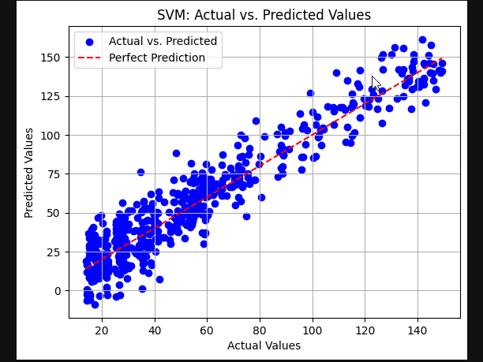

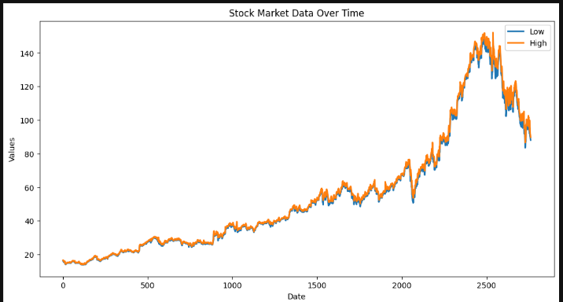

Fig: 3 SVM Closing Price vs Time Chart

SVM Actual vs Predicted Values

In Fig.5, the X-axis typically represents time, spanning from earlier dates on the left to later dates on the right, while the Y-axis indicates the closing price of the stock. Each data point on the chart represents the closing price of the stock on a specific trading day, forming a continuous line that connects these points. The chart visually illustrates the trend in the closing prices of the stock over the specified period, providing insights into its historical performance. Analyzing this chart allows investors and analysts to identify patterns, trends, and potential turning points in the stock's price movements, aiding in decision-making processes such as assessing investment opportunities, determining entry and exit points, and formulating trading strategies. Additionally, overlaying indicators such as moving averages or trendlines can provide further insights into the stock's price dynamics and help forecast future price movements.

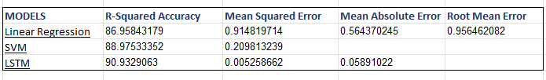

# Conclusion and future works

In conclusion, our project on " A COMPREHENSIVE ANALYSIS OF STOCK MARKET PREDICTION USING LINEAR REGRESSION IN COMPARISON WITH LSTM AND SVM MODEL " represents a significant breakthrough in financial analysis. Our predictive models enhance decision-making for investors and traders, offering valuable insights into stock market trends. While promising, we must acknowledge limitations and ethical concerns for responsible use in financial markets. This project demonstrates the potential for data-driven, automated systems to revolutionize stock market analysis and improve investment decision-making.

Future enhancements for the " A COMPREHENSIVE ANALYSIS OF STOCK MARKET PREDICTION USING LINEAR REGRESSION IN COMPARISON WITH LSTM AND SVM MODEL " project could involve real-time data integration, sentiment analysis from news and social media using NLP, expanding to cover various financial instruments, implementing machine learning interpretability, and exploring automated trading capabilities within regulations. These improvements would make the system more dynamic, insightful, comprehensive, transparent, and practical for users.

# References

1. [Bosco, Joish, and Fateh Khan. 2018. *Stock Market Prediction and Efficiency Analysis Using Recurrent Neural Network*. GRIN Verlag.](http://paperpile.com/b/7aThXd/fGt9)

2. [Ellis, Charles D. 2002. *Winning the Loser’s Game: 3. Timeless Strategies for Successful Investing*. McGraw Hill Professional.](http://paperpile.com/b/7aThXd/I6M8)

4. [Hiremath, Gourishankar S. 2013. *Indian Stock Market: An Empirical Analysis of Informational Efficiency*. Springer Science & Business Media.](http://paperpile.com/b/7aThXd/FP7A)

5. [Jabed, Mahfuz Islam Khan. 2024. *Stock Market Price Prediction Using Machine Learning Techniques*. Ocleno.](http://paperpile.com/b/7aThXd/yBnC)

6. [Murphy, John J. 1999. *Technical Analysis of the Financial Markets: A Comprehensive Guide to Trading Methods and Applications*. Penguin.](http://paperpile.com/b/7aThXd/qbUK)

7. [Sharma, Renuka, and Kiran Mehta. 2024. *Deep Learning Tools for Predicting Stock Market Movements*. John Wiley & Sons.](http://paperpile.com/b/7aThXd/CfB6)

8. [Srinivasan, N. n.d. *Stock Price Prediction a Referential Approach on How to Predict the Stock Price Using Simple Time Series..* Clever Fox Publishing.](http://paperpile.com/b/7aThXd/vyRH)

9. V Kranti, Sai Reddy. 2018. Stock Market Prediction Using Machine Learning.

10. [Taleb, Nassim Nicholas. 2008. *Fooled by Randomness: The Hidden Role of Chance in Life and in the Markets*. Random House.](http://paperpile.com/b/7aThXd/DWSF)