***Review On Formulation and Development of Anti ulcer Gummies***

***Name* : Shubham. N. Tandale**

***Guided By* : Prof.MR.DNYANESHWAR S.VYAVHARE , DR.MEGHA.T.SALVE**

***College Name* : Shivajirao Pawar College of Pharmacy ,**

**Pachegaon ,Tal .Newasa ,Dist .Ahmednagar.**

***EMAIL*-** [**tandaleshubham324@gmail.com**](mailto:tandaleshubham324@gmail.com)

***CORRESPONDING AUTHOR* - SHUBHAM. N. TANDALE**

***Abstract :***

Herbal mouth ulcer gummies are a accessible and potentially effective way to address oral discomfort. generally invested with soothing constituents guava leaves these gummies aim to reduce inflammation and promote mending in the mouth. still, while they may give temporary relief severe or patient mouth ulcer should estimated by a healthcare professional. Guava leaves are known for theiranti-inflammatory and antimicrobial parcels. Incorporating guava leaves excerpt into gummies provides a accessible and palatable way to witness the benefits of this traditional remedies.

***Introduction :***

Apthous stomatitis or mouth ulcer is an ulcerative condition that's related to the oral mucosa and is characterised by repeating ulcers in the throat and oral depression. 1 Mouth ulcers are generally generated by a number of causes, similar as smelling the inner subcaste of impertinence, food disinclinations, hard teeth brushing, hormonal changes, vitamin scarcities, bacterial infection and conditions. 2 Treatment of mouth ulcers may include soothing/ antiseptic mouthwashes, similar as chlorhexidine mouthwash or povidone iodine mouthwash or use of antibiotic or anaesthetic gel phrasings Semi-solid phrasings include gel having a liquid phase which are also thickened by other factors. Topical gels are intended for the operation on skin or to certain mucosal shells for original action or percutaneous penetration of cure medications. 4 A large number of Indian medicinal shops are attributed with colorful pharmacological conditioning as they contain diversified classes of phytochemicals. As the conventional synthetic medicines suffer from a multitudinous side goods, these herbal constituents give a good volition As a mortal being we all are constantly waging a war against complaint, mama nature has blessed us with colorful important munitions to fight against the conditions we're suffering from mouth ulcers are unheroic or white depression with red margination in the mucus filling of the mouth depression, characterized by inflammation and pain.

Mouth ulcers are also known as canker blisters or aphthous ulcer. The product formulated is claimed to show its medium of action by colorful routes. Traditional herbal drug exploration has been heavily funded by China, India, Nigeria, the United States of America( USA, and world health organisation. The present exploration deals with a gel expression using ethanol excerpt of guava leaves for the treatment of mouth ulcers. Guava is known for its medicinal parcels. It's rich in antioxidants, vitamin C, fibre and numerous other nutrients. The leaves are high in limonene about 42.1 and caryophyllene about 21.

3. Guava leaves contain numerous unpredictable composites. Guava’s antibacterial parcels may also prop oral health. There are numerous different types of ulcers, including vaginal, oesophageal, and mouth ulcers. These are painful round or round blisters that generally appear on the inside of the cheeks or lips and inside the mouth. presently available topical operation for the treatment of mouth ulcers is a gel or cream base that must be applied to the body, which Is painful and frequently insolvable to fluently pierce the ulcer.

***• Inner lips*.**

These blisters are frequently painful and can make eating, drinking and speaking uncomfortable. Types of ulcers on the base of ulcer size and number, mouth ulcer can be classified as minor, major and herpetiform.

***The main types of mouth ulcer are :***

**1. Minor ulcers**

This are the most common( 8 in 10 cases). They're small, round, or round and are lower than 10 mm across. They look pale unheroic but the area around them may look blown and red. Only one ulcer may develop but up to five may appear at the same time. Each ulcer lasts 7- 10 days and also goes without leaving a scar. They are n't generally veritably painful.

**2. Major ulcers**

It occurs in about 1 in 10 cases. They tend to be 10 mm or larger across. generally only one or two appear at a time. Each ulcer lasts from two weeks to several months but will heal leaving a scar. They can be veritably painful and eating may come delicate.

**3. Herpetiform ulcers**

It occurs in about 1 in 10 cases. These are bitsy pinhead- sized ulcers, about 1- 2 mm across. Multiple ulcers do at the same time but some may join together and form irregular shapes. Each ulcer lasts one week to two months. Despite the name, they've nothing to do with herpes or the herpes contagion. Despite the name, they've nothing to do with herpes or the herpes contagion .

**4. Ulcerative Conditions**

Mouth ulcers are veritably common and are substantially due to trauma similar as from ill- befitting dentures, fractured teeth, or paddings. still, vivisection or other disquisition should be done for cases with an ulcer of over three weeks duration to count malice other serious conditions similar as habitual infections.

**Infections :** Bacterial, viral or fungal infections may beget mouth ulcers

**Foods and Drinks**

Mouth ulcers may be touched off by acids in certain foods, including oranges, failures, pineapples, strawberries, tomatoes, and others.

Toothpaste or Oral Rinses Pastes or rinses that contain sodium lauryl sulphate may contribute to the appearance of mouth ulcers.

Vitamin scarcities A insufficiency of vitamins similar as B- 12, iron, folate or zinc could also be a cause of mouth ulcers. Herbal Remedies for Mouth Ulcer As from the ancient period photogenic agents are used by for the forestallment and treatment of mouth ulcer.

Some of the botanical composites withanti-ulcer exertion include flavonoids( i.e., quercetin, naringin, silymarin, anthocyanosises, sophoradin derivations) saponins( i.e., from Panaxjaponicus and Kochia scoparia), tannins( i.e., from Lin deraeumbellatae), epoxies and gum’s( i.e., goo guar and myrrh). Among herbal medicines, liquorice, aloe gel and capsicum( chilli) can be used considerably having major effect in treatment of mouth ulcer. Ethnos medical systems employ several factory excerpts for the treatment of ulcer. me of the Sauces that can be used asanti-ulcer medicines

1. Harra( Terminalia chebulic)() masticated after regale cures mouth ulcers.

2. Basil leaves( Ocimum sanctum)( 7) and Tomato juice( Lycopersicum esculentum) are taken for mouth ulcers.

3. Greasepaint of nirgund( Vitex negundo) and Musli( Chlorophytum borivilicum) is set and can be taken four times a day for mouth ulcers

4. Mulberry( Morus Alba) juice is given to babies for this disease.

5. Akar kara( Spilanthes calva) flower is masticated in mouth ulcers. It gives strength to the teeth .

***Mouth ulcer treatment :***

One of the parcels of mouth ulcers are that they can heal within 2 weeks without treatment but drug and treatment may give relief. Treatment can numb the pain, cover the ulcer from farther damage or drop the chances of a bacterial infection; some drugs may speed up the mending if used beforehand enough. Paste treatments, gel treatments, mouth wetlands, liquid makeup treatments, negativing acid and deadening of the pain, pain killers, corticosteroids.

Collection of accoutrements

***Azadirachta Indica :***

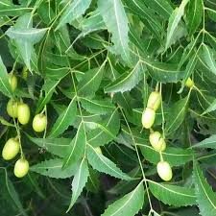

***Fig 1 : Azadirachta Indica***

The leaves of Azadirachta indica, were collected from the medicinal theater and authenticated from Department of Botany, RTMNU, Nagpur. Carbopol 934 was carried from Colorcon, Asia. All the other detergents were of logical grade 2.2. Preparation of excerpts The juice of Aloe leaves was soddened with ethanol 95 for 3 days and separated by centrifugation at 3000 rpm to gain the ethanolic excerpt of aloe( EEA) The leaves of Azadirachta indica and were dried to retain the phytoconstituents and soddened independently with ethanol and separated by centrifugation to gain ethanolic excerpt of Ocimum tenuiflorum( EEO) and ethanolic excerpt of Azadirachta indica( EEZ) independently.

All the excerpts were stored at room temperature. 2.3. Phytochemical webbing All the below set excerpts were subordinated to primary phytochemical webbing tests 9,10 to identify Scientific bracket .

***Guava fruits :***

• Kingdom Plantae – shops

• Subkingdom Tracheobionta Vascular shops

• Superdivision Spermatophyta Seed shops

• Division Magnoliophyta Flower shops

• Class Magnoliopsida Dicotyledonous

• Subclass Rosidae

• Order Myrtales

• Family Myrtaceae

• Subfamily Myrtoideae

• Tribe Myrtaceae

• Gender Psidium

• Species Psidium guajava The origin of guava is Psidium Guajava.

It belongs to the Myrtaceae family.

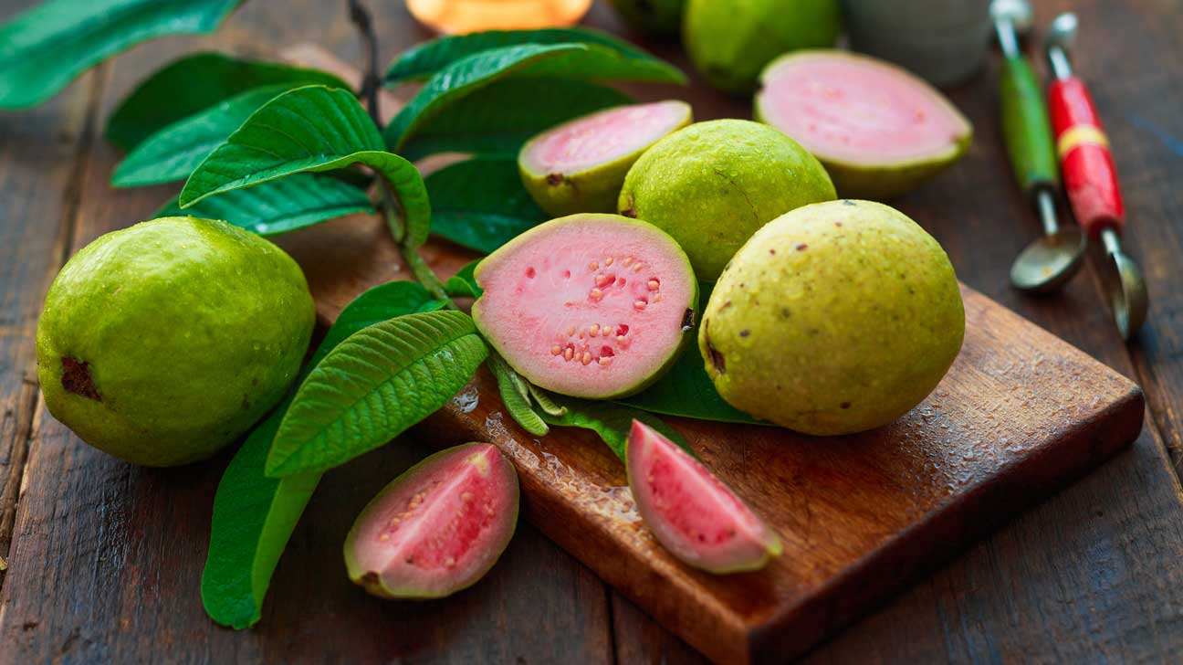

***Fig2 : Guava fruits***

Shape Guava fruits are generally 4 to 12 centimeters( 1.6 to 4.7 elevation) long and round or round in shape, depending on the species. They've a clear and precise smell, evocative of bomb peel, but less sharp. The skin can be hard, frequently bitter, or soft and sweet. The skin can vary in consistence and is generally green before growth, but can turn unheroic, maroon or green as it matures. The pulp outside can be sweet or sour, white( “ white ” guava) to dark red( “ red ” guava). The number and hardness of the seeds in the average weight varies from variety to variety.

Factory part used leaves Chemical composition Guava leaves contain carotenoids and polyphenols similar as()- gallocatechin and leucoanthocyanins. Red- orange guavas contain further polyphenols and carotenoids than yellowishgreen guavas, as some of these phytochemicals are responsible for skin color and texture. Guava leaves contain essential canvases similar as isopropyl alcohol, menthol, α- pinene, terphenyl acetate, limonene, β- pinene, caryophyllene, βbisabolene and Oleanolic acid. Use Due to its high pectin content, guava is extensively used to make goodies, preserves, jellies, logjams and marmalades( similar as Brazilian goiabada and Colombian and Venezuelan bocadillo) and as a bright jam. Red guava can be used as a base in the medication of spices similar as sauce, especially in place of tomatoes to reduce acidity. The drink can be made from the leaves and juice of guava leaves, which is called “ tea ” and is considered drug. Guava( Psidium guajava) For the herbal treatment of a number of oral conditions.

***Constituents :***

Flavonoids are phytochemicals set up in numerous shops, fruits, vegetables and leaves and can be used in medicinal chemistry. Flavonoids have numerous medicinal parcels, including antibacterial, antifungal, antiviral and antibacterial parcels. They also have neuroprotective and cardioprotective goods. These conditioning depend on the type of flavonoid, its( possible) mode of action and bioavailability.

These cost-effective medicinal constituents have important natural functions and theiranti-inflammatory goods have been demonstrated. Recent studies have concentrated on their insulation, conflation of analogues using colorful ways and beast models, and their goods on mortal health. Thousands of flavonoids have been successfully insulated, and this number is constantly adding . thus, we tried to epitomize insulated flavonoids with important functions to more understand their goods on mortal health. Flavonoids are abundant and wide throughout the factory area. They're made from three corridor acetate and one part phenylpropane( via the shikimate pathway). further than 2000 species are known; About 500 of these live in the free form( aglycones) and the remainder are O- or C- glycosides

***HONEY***

***A. Synonyms***

-Madhu, Madh, Mel

***B .Biological Source***- Honey is a viscid and sweet stashing stored in the honey comb by colorful species of notions, similar as Apis mellifera, Apis dorsata, Apis herbages, Apis indica and other species of Apis, belonging to family Apideae.

***c) Geographical Source***- Honey is available in cornucopia in Africa, India, Jamaica, Australia, California, Chili, Great Britain and New Zealand.

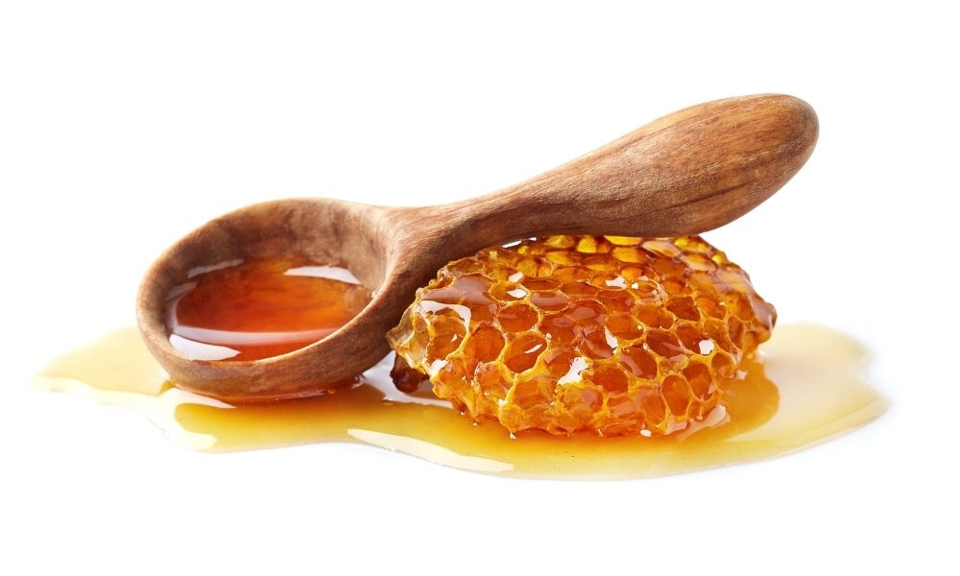

***Fig 3 : Hoeny***

***d) Chemical composition-*** The average composition of honey is humidity 14 – 24, dextrose 23 – 36, levulose( Fructose) 30 – 47, sucrose 0.4 – 6, dextrin and epoxies 0 – 7. either, it's set up to contain small quantities of essential oil painting, beeswax, pollen grains, formic acid, acetic acid, succinic acid, maltose.

***e) Uses Honey*** shows mild laxative, bactericidal, dreamy, antiseptic and alkaline characters. It's used for cold, cough, fever, sore eye and throat, lingo and duodenal ulcers, liver diseases, constipation, diarrhoea, order and other urinary diseases, pulmonary tuberculosis, marasmus, rickets, scurvy and wakefulness. Honey is an important component of certain poultices, cosmetics, detergents, creams, redolences, restroom waters and inhalations. It's applied as a remedy on open injuries after surgery. It prevents infection and promotes mending .

***Antimicrobial Activity :***

The antimicrobial exertion of all seven gel phrasings and a retailed moth ulcer gel( Hiora gel) was carried out by well prolixity system. 15 Two microbial societies Candida Albicans( fungi) andE-coli( bacteria) were used. The antibacterial exertion of the set gel phrasings was performed by agar well prolixity system. The plates of the nutrient agar media were prepared. Each plate was invested with an aliquot( 0.1 ml) of the bacterial suspense which was spread unevenly on the face of the medium of the plate. After 15 min, wells with 6 mm periphery were made with the help of a sterile cork borer in the solid medium and filled with 0.5 g of gel. All the plates were incubated at 37 ◦ C for 24 h. The antibacterial exertion was assessed by measuring the periphery of the zone of inhibition( ZOI) in mm. Trifectas were carried out for each excerpt against each of the test organism. For the antifungal exertion, the plates of the sabouraud dextrose agar media were prepared. Each plate was invested with an aliquot( 0.1 ml) of the fungal suspense which was spread unevenly on the solid media

***Evaluation of gel :***

All the set gel phrasings were estimated for parameters similar as physical appearance, pH, unity, spread capability and density. The observation reveals that the gels were having smooth texture and were elegant in appearance. The pH of all set gels was set up to be in range of 6.5- 7.0. All the gels showed good spreadability. Also from the below data it was observed that increase the attention of factory excerpt increases the spreadability. All the set gels showed good unity with absence of lumps. The developed medications were important clear and transparent.

Different evaluation test were performed on final expression of gummies which are as follows

***1. Physical evaluation***

Physical parameters similar as color, appearance, Odor and taste was estimated for the set expression.

***Color-*** The color of the expression was estimated against white background.

***Odor-*** The Odor of the gummies was checked by mixing the sticky in water and taking the smell.

***Taste-*** The taste of the sticky was estimated by placing a slice of sticky in the mouth. Visual

***Examination***- The shape of the gummies was checked visually and size of the gummies was checked Determination of pH 1 result of sticky sample was prepared by dissolving it in boiling water. The result was allowed to cool at room temperature. pH was checked of the result using pH cadence. 4. dissipation time Gummy was placed in 100 ml of distilled water along with a glamorous stirrer and was placed on rotator. The dissipation time was noted.

***Primary market research on herbal anti-mouth ulcer gummies by survey***

Primary request exploration by carrying out check to check the acceptance, compass and likability of the herbalanti-mouth ulcer gummies. In this exploration a check form was generated with the following questions

1. What do you understand by the term" mouth ulcer"?

2. How numerous ulcers are there during each occasion/ time?

3. How frequently do you witness mouth ulcers

4. How long do your mouth ulcers generally last?

5. What do you suppose are the common causes of mouth ulcers?

6. Which of the common symptoms do you encounter during each occasion? 7. How do you treat your mouth ulcers?

8. What type of specifics do you use for mouth ulcers?

9. Are you familiar with using gummies as a treatment or relief for mouth ulcers? 10. Would you like to use gummies as a treatment for mouth ulcers?

10. What factors would impact your decision to use gummies as a treatment for mouth ulcers?

Results of evaluation tests of final formulation

EVALUTION PARAMETERS INFERENCES

1. PHYSICAL APPERANCE

a) Colour : Brown

b) Odour : chocolatey

c) Taste : sweet chocolate flavour

2. Visual examination

a) shape : flower, heart

b) size : length-1.3cm

breadth-2.5cm

3 Weight variation : Complies the standard 7% deviation ra

4 Determination of PH : 6.65

5 Dispersion time : 11 min

***Conclusions :***

currently there's a lot of demand for herbal phrasings in the request due to their cost effectivity and absence of any side goods. From the below experimental data it's clear that a gel expression with herbal constituents similar as aloe, neem and tulsi has good characteristics, density and also possesses a good antimicrobial exertion which is necessary in the operation of mouth ulcers

***REFERENCE :***

1. Rad F, Yaghmaee R, Abadi PM, Khatibi R. A relative clinical trial of topical tricin lone( adcortyle) and a herbal result forthe treatment of minor aphthousstomtitis. Armaghane Danesh. 2010; 15( 3) 191 – 9.

2.Shaikh S, Shete A, Doijad R. expression and Evaluation Pharmaceutical waterless gel of pulverized Guava leaves for Mouth Ulcer Treatment. Pharma Tutor. 2018; 6( 4) 32 – 5

3. Anjali Teresa, Krishnakumar K, Dinesh Kumar B, Anish John. J.Bio.Innov, 2017; 6( 4) pp 521- 527.

4. Jerry Kennard, what to do about Ulcers in the Mouth, 2018.

5. Deepak Acharya. Medicinal shops for curing common Affections in India, listed in herbal drug, 2004; 102.

6. Praveen Sharma, et al, Antiulcerogenic exertion of Terminalia chebula fruit in experimentally convinced ulcer in rats, Journal of Pharmaceutical biology, 2011; 49( 3).

7. Sai Krishna G. “ Tulsi- the wonder Herb( Pharmacological Conditioning of Ocimum sanctum), American Journal of Ethnomedicine, 2014; 1( 1) 089- 095

8. Jenna Fletcher, everything you need to know about mouth ulcers, 2018.

9. Mouth Ulcers, NHS, 2019.

10. C.K.Kokate, A.P.Purohit, S.B. Gokhale, Textbook of Pharmacognosy, Abhyudaya Pragati, 1312 Shivaji Nagar, Off J.M.Road, Pune 411005, Nirali prakashan, 55th edition.

11.P.H. Ferguson, Evaporation, Uses in the Food Industry, Encyclopedia of Food lores and Nutrition . Charde K, Upadhye KP, Gholse YN, Chaple DR. Current updates on intermittent aphthous stomatitis etiology, pathogenesis and operation. World J Pharm Pharm Sci. 2020; 9( 5) 448 – 462.

12. Deshmane S. A review on oral mouth ulceration. Int J Pharm. 2014; 1

13. Mohd, Ad, Sakarkar DM, Kosalge SB, Shafiq S. ” Formulation Development and Evaluation of Unit Moulded Herbal Semisolid Jelly useful in treatment of Mouth Ulcer. J Pharma Biomed Anal. 2011; 31705 – 13