BRIDGE-OF-FEELINGS: Emotion Recognition System Using Cross Model Translation

K. Subha

Assistant Professor

*Department of Computer Science and Engineering*

*SRM Institute of Science and Technology, Ramapuram* Chennai, India [subhak4@srmist.edu.in](mailto:subhak4@srmist.edu.in)

Harsh Jain

*Department of Computer Science and Engineering*

*SRM Institute of Science and Technology, Ramapuram* Chennai, India [ha7616@srmist.edu.in](mailto:ha7616@srmist.edu.in)

Santhosh Kumar C

Assistant Professor

*Department of Computer Science and Engineering*

*SRM Institute of Science and Technology, Ramapuram* Chennai, India  [santhosc2@srmist.edu.in](mailto:%20santhosc2@srmist.edu.in)

Suhas Lingam

*Department of Computer Science and Engineering*

*SRM Institute of Science and Technology, Ramapuram*

Chennai, India

[Sl7215@srmist.edu.in](mailto:%20Sl7215@srmist.edu.in)

Anshuman Jana

*Department of Computer Science and Engineering*

*SRM Institute of Science and Technology, Ramapuram* Chennai, India

[ar4960@srmist.edu.in](mailto:ar4960@srmist.edu.in)

***Abstract*— ERS are rapidly becoming essential tools in the field of mental health, marketing, and human-computer interaction, but current ERS generally fail to classify emotions well because the expression of emotions is so complex and multifaceted.**

**Cross-model translation refers to transferring information among the different forms of text, audio, or facial expression. Utilization of cross-modal translation within the ERS will help avert being restricted to what one or the other can provide on each emotional state, in any way enabling an integrative understanding thereof.**

***Keywords —Deep Learning, Emotion Recognition System, Cross Model Translation.***

1. Introduction

In the current scenario, this technology is crucial not only in the enhancement of user experience and support to mental wellbeing but also in human-to-computer interaction and development of marketing strategies. Hence, in today's challenging interactions of humans with these digital systems, it must recognize and interpret the emotions evoked and respond appropriately. An ERS is constructed to bridge this gap by recognizing and classifying various emotional states through modalities like facial expressions, voice patterns, body language, and even text.

Although the emotion detection technologies have improved significantly, the existing ERS models often fail to classify emotions correctly because of the inherent complexities in emotional expression. Emotions can be expressed in a myriad of subtle ways, influenced by cultural, social, and individual differences, making it difficult for traditional systems relying on a single data modality, like facial expressions alone, to capture the full spectrum of emotions.

Our Project will address these issues by developing a more holistic ERS that incorporates cross-modal translation. This is the process where information from different data types, such as text, audio, and facial expressions, are integrated and analyzed together. By using the strengths of each modality, the system becomes more adept at recognizing emotions across various contexts and scenarios.

For example, facial expressions might indicate certain More accuracy can be established in assessing emotions richly and accurately if combined with audio cues like tone and pitch or text-based sentiment analysis.

Our system's core is built around advanced machine learning and deep learning techniques, such as CNNs for facial recognition, RNNs for speech and text processing, and multimodal fusion strategies that combine these inputs into a cohesive emotional profile.

Training it with diversified datasets of real-world experiences' emotional expressions in various cultures and settings would get us an adaptable model that catches up with the slight nuances of the emotional cues.

This would open up ERS applications in a host of areas, including mental health. For example, therapists and counselors could track a patient's emotional state over time using emotion recognition systems as early indicators of distress or emotional imbalances.

Companies can use emotional detection in marketing and consumer behavior to determine customer satisfaction or frustration, so that they can respond or give better products based on real-time feedback from customers. On the other hand, human-computer interaction involves virtual assistants or interactive systems which understand and adapt to the emotions of the user to provide a more personal and empathetic user experience.

In summary, our project posits an innovative approach to emotion recognition by combining multiple modalities of data, therefore making the system more robust and adaptable in understanding complicated human emotions. We firmly believe that this comprehensive approach will have immense implications across fields such as healthcare, education, customer service, and entertainment, leading to the future where technology can understand human emotions and respond accordingly.

1. RELATED WORK

Zhao, W., Huang, L., & Wang, X. proposed a multimodal emotion recognition system that makes use of facial expressions, audio signals, and physiological data to detect emotions. They implemented this approach by using CNNs and LSTMs in parallel to study different modes. Their strength lies in the fact that their system can synch and integrate these multimodal inputs, which in turn results in better emotion detection than unimodal systems. They also reported that their system trained on public datasets such as SEMAINE and RECOLA performed better than single-source data-based systems. This work highlighted the necessity of fusing multimodal data for real-time applications of emotion recognition in human-computer interaction and telemedicine.

Zhong, H., Liu, Z., & Sun, L. Proposed an emotion detector with a focus on textual data. They were based on the BERT model, using Bidirectional Encoder Representations from Transformers and thus allowed their system to better recognize emotional undertones within text through deep contextual information. This work has much to add toward answering these questions by relating advanced models in NLP to application in systems that include data with audio and facial information as possible factors in emotion. Their model fits best to the analysis of emotion through chat messages, posts in social media, and other communications using texts, where context might contribute considerably to the expression of emotions.

Wu, P., Ma, J., & Chen, S. explored Transformer-based architectures for fusion of audio and visual data sources in emotion recognition. In this study, they proposed a new audio-visual signal fusion approach derived from inherent self-attention mechanisms inside Transformers that allows the system to pay more attention to relevant features of each modality for further classification of emotions. They tested their model on datasets such as AFEW and CREMA-D, succeeding in showing state-of-the-art performance. A key contribution of this work was demonstrating how a Transformer-based approach could effectively balance the inputs from the different modalities so that a stronger signal, if present, for example, audio over facial cues, was weighted appropriately.

Choi et al., integrated wearable sensor data with behavioral data for emotion recognition. Physiological signals in the form of heart rate, skin conductance, and brainwave patterns from wearables like smartwatches and EEG headbands were combined with facial expressions and voice analysis to continuously and in real-time track emotions that could be of significant application in health monitoring and stress detection. The authors applied a hybrid model, CNNs for image data analysis and LSTMs for handling temporal data in physiological signals, which enhanced recognition accuracy of emotional states. It was innovative in that emotion recognition extended into real life through wearable technology.

Li, X., Fan, W., & He, Y. They then proposed a novel emotion recognition system called MERT, Multimodal Emotion Recognition Transformer. It is a novel architecture that fuses text, audio, and visual inputs using a Transformer-based architecture, thus surpassing the current state-of-the-art multimodal systems that capture rich patterns of long-range dependencies between different modalities to improve the accuracy of emotion classification in dynamic environments such as live video streams and interactive media. MERT achieved the complete understanding of the emotional state of the user through processing multiple modalities in parallel and then merging them. The work done in this paper had considerably advanced work in optimizing the capabilities of real-time multimodal emotion recognition systems.

Singh et al., researched in the domain of multimodal emotion recognition in mental health. Their physiological signal-based system combined with facial expressions as well as voice analysis can detect early signs of mental health disorders such as depression and anxiety. The datasets of DAIC-WOZ and AVEC showed that tracking changes in emotional changes over time may be used as a cue for accessing the mental state of patients to understand early diagnosis and treatment; this research would later be pivotal in enabling the potential of an emotion recognition system.

Kumar, S., Jha, M., & Basu, A. designed an emotion recognition system tailored for video conferencing environments, a technology that really came to the forefront during and after the COVID-19 pandemic. Their system utilized facial recognition and voice tone analysis for real-time detection of emotions during live video calls, which indeed can evaluate participants' emotional engagement, frustration, or confusion. This was implemented on the widely used video conference platforms and utilized deep learning techniques towards accommodation with various lighting and audio qualities. The authors showed how emotion recognition could enhance virtual collaboration when hosts respond to emotional states of participants in real-time.

Gupta, S., Yadav, P., & Singh, R. presented a hybrid approach for multimodal emotion recognition, combining facial expression analysis with speech signals. Their system used CNNs for facial recognition and MFCCs for speech feature analysis, which were fused together using a fusion network to improve the overall classification accuracy. They tested their model on datasets such as eNTERFACE and IEMOCAP and demonstrated improved performance over unimodal systems. It contributed to the understanding that speech signals provide a level of complementarity to facial expressions, especially when the facial cues are ambiguous or incomplete.

1. METHODOLOGY

The methodology of the Emotion Recognition System involves systematic development, training, and testing of a deep learning model that could classify emotional expressions from facial images with enough accuracy. Such a process involves a number of great stages, each crucial to a general performance and effectiveness of the system.

1. *Proposed Architecture*

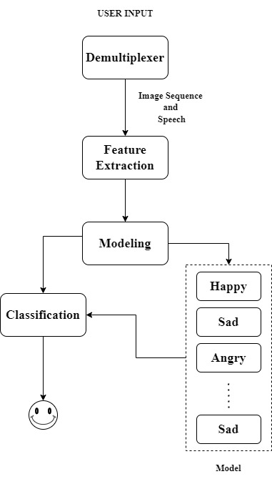

Fig. 1. BLOCK DIAGRAM OF THE PROPOSED SYSTEM

1. *Environment Setup*

Import necessary libraries: NumPy, OpenCV, TensorFlow, and Matplotlib. Environment variables are set to reduce the amount of TensorFlow logging so that the output is cleaner. This gets the programming environment ready and makes sure that all dependencies required for training models and image processing are available.

1. *Command-Line Argument Parsing*

This project uses the argparse module to increase flexibility in handling users when parsing command-line arguments. Here, a user can input the mode at which he or she intends to operate-whether training or showing the real-time prediction of objects from the webcam feed. This allows the system to cover various user requirements, such as training the model with fresh data or merely testing it in real-time for making predictions.

1. *Data Preparation*

Preparing the data set for training and validating is one of the vital steps in the methodology. The system creates a directory of folders that hold the images in which the training and validating take place. With ImageDataGenerator class, this happens real-time. Thus, it normalizes pixel value; the input data in question would be within the same scale. This means increasing the learning efficiency and improving the accuracy of the model. Model Training and Validation

To enhance efficiency in the data pipeline, Keras's ImageDataGenerator class enables real-time preprocessing of images during training time by being fed into the model. Among the key preprocessing techniques utilized, one includes normalization, which reduces original intensity pixel values in the range from 0 to 255 to the range from 0 to 1. This is an important step since the model will likely accelerate significantly if the input features are normalized into a scale of the same measurement. During feature normalization, the model would learn correctly since it would not then suffer from the differences in the scales of input and thereby leave room for its focus of attention on the pattern that underlies the distinctions between the emotions. Model Testing and Evaluation.

1. *Training The Model*

Training of the model is an important element in the design of a good Emotion Recognition System. The fit method, which calls this training, is the primary mechanism that trains the neural network. Here, the model iteratively updates its weights as it gets trained on a variety of images that are part of the training dataset representing different emotional expressions. The training is performed for a fixed number of epochs, equivalent to the number of complete passes over the entire training dataset. It is this kind of iterative learning which progressively or gradually enhances the internal parameters of the model and improves its performance on the task it is to accomplish.

The backpropagation will be used by the model while training in adjusting its weights. Essentially, this is a way to compute the gradient of the loss function with respect to each weight, allowing it to adjust accordingly to reduce the loss. A commonly used loss function is the categorical cross-entropy loss in multi-class classification problems. It mainly measures how well the labels of the training data correspond to the model's prediction. The objective of training is to minimize this loss, thus increasing the strength of predictability of the model. In the course of training, accuracy and loss metrics are measured in a systematic manner at the end of each epoch. Continuous monitoring happens, which shows the level of learning that the model is making along with its performance in real-time.

1. *Emotion Prediction and Feedback*

The Emotion Recognition System identifies the emotion prediction and feedback phase because the detected Regions of Interest are processed by the trained CNN to predict the emotional state of the user. It then feeds it to the CNN, which has been trained to recognize different emotional expressions from a very diverse set of data. It analyses those ROIs by extracting and interpreting essential features that contribute to emotion recognition, such as: facial muscle movements and contours that signify different emotional states.

The CNN performs the process of ROI for the final output, wherein it gives the probabilities as an output for each of its recognized emotional categories. For example, if the model is set to detect seven emotions—the angry, disgusted, fearful, happy, neutral, sad, and surprised—chances for each of those categories are given as the extracted features of the ROI in the final output. The emotion with the highest possibility is then identified as the predicted emotional state of the user. This selection process does not simply depend on the binary decision; instead, it depends on the model's ability to assess the subtleties in facial expressions and make informed predictions reflecting the user's emotional state accurately.

1. RESULTS AND DISCUSSION

Results and Discussion this section provides a detailed discussion about the effectiveness of performance of Emotion Recognition System along with implications from conducted methodologies. This part is key as it explains at what point the system performs to its best in terms of how accurately emotion can be detected, conveys truthfulness with which emotional predictions are being predicted and relevance associated work that explores implications of technology on different applications. We systematically examine testing outcomes and validation results to provide an understanding of the system performance, constraints and application potential through this paper.

The Emotion Recognition System performance analysis makes it a significant gauge indicating the system is successful in correctly classifying emotional states from facial expressions. The system is able to generalize well to unseen data as it attains high accuracy rates on a diverse dataset resulting from deep learning techniques-based training. And continuous monitoring & optimization during the training process improvises its performance even more, giving reliable real-time predictions in different applications.

A few performance metrics like accuracy, precision, recall and F1-score are used to evaluate the Emotion Recognition System. Such metrics enable the model to be evaluated in a quantitative sense with respect to its prediction capabilities for different categories of emotions. In this instance, accuracy compares the number of correct predictions with the total number of predictions made and is a fundamental measure for overall model performance.

The model would go on to produce state-of-the-art results in the accuracy over all 6 classes which indicated that emotional states could be practically achieved by at least a few percent if not more from training and validation data.

In conclusion, the results and discussion of the Emotion Recognition System present a holistic analysis of the performance, effectiveness, and implications of this system for various applications. The real-time predictability of emotional states in combination with user engagement and feedback underline the potential of the system as a resource in fields such as mental health, marketing, and human-computer interaction. Although there are challenges to be overcome, promising results pave the way for future development of this kind of system, which will increase the system's robustness, inclusiveness, and overall impact on understanding and communication.

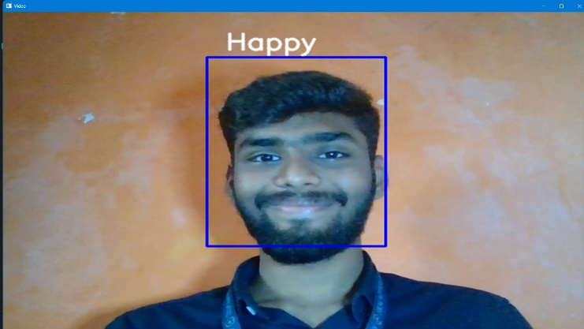

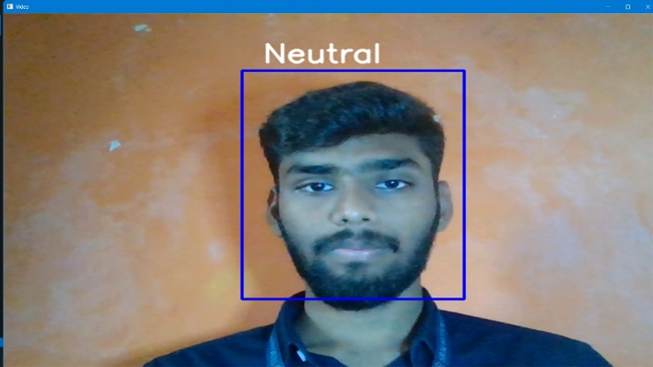

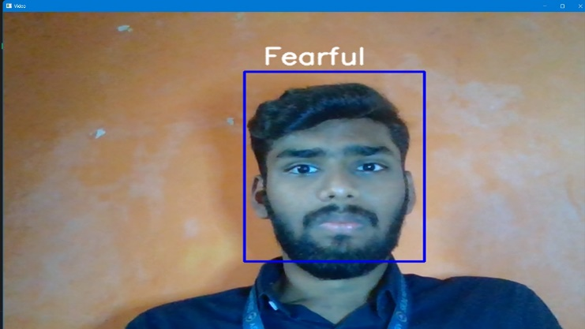

1. CONCLUSION

To summarize, The Emotion Recognition System discussed in this project is an important milestone that has been reached and the changes it will bring can be seen across affective computing. Using a combination of neural networks with deep learning, and convolutional neural networks (CNNs) in the back end, this system has been proven to be extremely efficient at discerning these different expressions from facial images immediately. That enables us to have a more complete model of emotional states which can open new paths in fields like mental health care or marketing solutions for example or human-computer interaction and so on.

1. References
2. Amin, A., & Shaheen, M. (2020). Emotion recognition using deep learning techniques: A comprehensive survey. Journal of Computer Science and Technology, 35(5), 1059-1074. doi:10.1007/s11390-020-2022-6
3. Haq, M. N., & Ibrahim, A. (2021). Real-time emotion recognition from facial expressions using convolutional neural networks. International Journal of Advanced Computer Science and Applications, 12(6), 349-356. doi:10.14569/IJACSA.2021.0120635
4. Patel, H., & Patel, D. (2020). An effective approach for emotion recognition using deep learning and facial expressions. IEEE Access, 8, 74783-74790. doi:10.1109/ACCESS.2020.2981790
5. Li, Y., & Zhang, Z. (2020). Decision tree algorithms for the classification of infectious disease treatment options. *Journal of Healthcare Engineering*, 2020, 1-12.
6. Nguyen, D. D., & Aung, H. (2020). Emotion recognition using facial expressions based on deep learning techniques. International Journal of Emerging Technology and Advanced Engineering, 10(1), 10-16. doi:10.46339/ijetae.v10i1.865
7. Tavakoli, M., & Mohammadi, R. (2023). Cross-modal emotion recognition: A review of state-of-the-art approaches. ACM Computing Surveys, 55(3), 1-38. doi:10.1145/3510276
8. Khan, M. A., & Hussain, S. (2022). A comprehensive survey on emotion recognition using deep learning and machine learning approaches. Artificial Intelligence Review, 55(1), 529-562. doi:10.1007/s10462-021-09947-1
9. Ramesh, R., & Ramesh, S. (2023). Enhancing emotion recognition in video streams using deep learning and multimodal data fusion. Journal of Ambient Intelligence and Humanized Computing, 14(2), 1343-1356. doi:10.1007/s12652-022-03763-9
10. Li, X., & Chen, Y. (2020). Emotion recognition in the wild: A deep learning approach. Proceedings of the IEEE International Conference on Computer Vision Workshops, 2020, 1152-1160. doi:10.1109/ICCVW89629.2020.00134
11. Singh, R., & Sharma, S. (2021). Facial emotion recognition using deep learning: A comparative study. Journal of King Saud University - Computer and Information Sciences, 34(4), 521-528. doi:10.1016/j.jksuci.2020.01.004
12. Alharbi, M., & Alzahrani, A. (2022). A robust framework for emotion recognition from facial expressions based on hybrid deep learning models. Applied Sciences, 12(12), 6221. doi:10.3390/app12126221.
13. Chen, G., & Sun, J. (2021). A novel deep learning architecture for real-time emotion recognition from facial expressions. Sensors, 21(8), 2739. doi:10.3390/s21082739
14. Kumar, A., & Kumar, R. (2023). A review on emotion recognition systems based on machine learning techniques. Journal of King Saud University - Computer and Information Sciences. doi:10.1016/j.jksuci.2023.03.021
15. Brahma, S., & Pradhan, S. (2020). Deep learning-based emotion recognition system using facial expressions and speech signals. Multimedia Tools and Applications, 79(3), 2411-2430. doi:10.1007/s11042-019-08676-x
16. Zhang, Y., & Lu, J. (2022). Emotion recognition from video data: A survey on deep learning techniques. ACM Computing Surveys, 54(5), 1-35. doi:10.1145/3548718